Hydrothermal Vent Formation

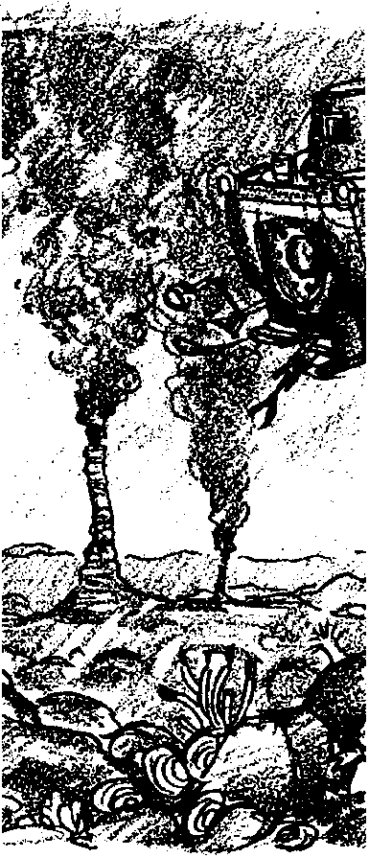
Key Concepts
1. Hydrothermal vents are found along spreading centers on the ocean floor.
2. More salt can be dissolved in water if the temperature is increased.
3. Once the temperature of a supersaturated solution is reduced, some of the solute (dissolved substance) will precipitate out.

Background

Scientific study of mid-ocean rifts, ridges, and hydrothermal vents has a relatively brief history. In 1972, observations near the Galapagos Islands revealed plumes of hot water rising from hydrothermal vents, not unlike underwater hot springs, along the Galapagos Rift, a valley which lies between the East Pacific Rise and the South American mainland. Measurements of water temperature and chemistry near the Galapagos Islands showed active circulation of seawater through newly formed oceanic crust.

The French-American Mid-Ocean Ridge Undersea Study (FAMOUS) began direct observation of the Mid-Atlantic Ridge in 1974, using a small French submersible called the Cyana and the U.S. submersible Alvin. The submersibles descended nearly 3,000 meters, into the rift valley that runs along and splits the mid-ocean ridge. In the rift valley almost new crust appeared to be formed in a 1-km-wide zone. New crust was also being formed in areas outside of the rift. An incredible amount of information was gathered in a series of 50 dives.

In 1977, attention shifted back to the Galapagos. Alvin made 24 dives to the 2500 m deep rift. The crew of two scientists and a pilot were able to observe the vents directly. The ridge crests were dotted with numerous hydrothermal vents. Mineral laden hot water with temperatures of near 17° C, compared to 2° C for the surrounding seawater, issued from the vents. Rocks near the vents were coated with chemical deposits rich in metals precipitated out of the vent waters. The crew also made observations that shocked the scientific world: large, complex communities of never-before-seen animals living in a world of total darkness far removed from surface food sources.

Alvin returned to the Galapagos in 1979 with a crew of biologists to study these incredible communities. Alvin also traveled north to investigate ocean floor hot springs near the tip of Baja California. Once again, remarkable things were observed. Mounds and chimney-shaped vents 20 m high were ejecting streams of black mud found to contain particles of lead, cobalt, zinc, silver, and other minerals. Incredible water temperatures up to 350° C were recorded at the mouths of these “black smokers” as the chimneys came to be called. These chimneys form as salts precipitate out of the water and collect around the edges of the vent.

Scientists wondered from just where the water issuing from the vents came. Along the spreading centers, sea water seeps deep into cracks in the crust and down to the mantle, as far as 10-12 km. There, the water is superheated, perhaps as high as 1000° C. As the water is heated, it dissolves particles in the crust, mostly sulfides. The water eventually returns to the ocean floor through a restricted area called a vent. The sulfides are carried back to the ocean with the rising water. As the hot water escapes into the colder ocean water through the vent opening, its temperature decreases and the sulfides precipitate out. Over time, the precipitated sulfides collect on the sides of the vent opening, eventually forming tall chimneys, some as high as 20-30 meters. The largest chimney yet observed, called “Godzilla”, is some 50 meters tall and is located on the northern end of the Juan de Fuca spreading center, about 270 miles off northern Washington.

The salinity of the water escaping through the vents is extremely variable. Salinity of 253 parts per thousand, as compared to the salinity of normal sea water at 35 parts per thousand, has been recorded at some vents. At others, the water is actually less salty than seawater. These waters are apparently the “vapor phase” from boiling hydrothermal fluids .

In addition to the metallic sulfides, the water escaping through the vent chimneys is rich in hydrogen sulfide gas (H₂S). Hydrogen sulfide is poisonous to virtually every animal. In the vent community, however, it is the basic source of energy which supports all life.

The water escaping through the vents is very hot. In fact, when the Alvin attempted to make initial temperature readings, the PVC housing for the thermistor melted when it came in contact with the water. Temperatures of 350° C at the vent openings are not unusual. This is considerably higher than the average water temperature of 2-4° C normally found at these depths. The turbulent nature of these hot water plumes, however, means that the hot water quickly mixes with the surrounding cold seawater. Within a few centimeters of the 350° C jets, the water temperatures are virtually that of the ambient ocean.

While hydrothermal venting through chimneys is spectacular, most escaping water, according to prevailing thought, flows through “diffuse” venting from widely distributed seeps.

Materials

For each lab group:
• 250 grams of Epsom salt

• 750 ml of water

• 1000 ml beaker

• heat source

• spoon

• stirring rod

• balance scale

• thermometer

• plastic bag with twist tie

• ice

• safety glasses

• beaker tongs or pot holder

Teaching Hints

“Hydrothermal Vent Formation” replicates the process of precipitation that leads to the formation of deep sea hydrothermal vents. In this activity, students will conduct an experiment which simulates the precipitation of materials out of a hot salt water solution.

1. With your students, discuss hydrothermal vents, their locations, formations, and discovery. You may wish to provide them with the information in a lecture format or duplicate the teacher background materials for them to read.

2. Explain to the class that this activity is a simulation of the occurrences around the hydrothermal vents. Scientists often use simulations and models to help them understand things that occur in nature.

3. The salt and water ratio given in this activity is approximately equivalent to the salinity of the water being emitted from the hydrothermal vents.

4. Students should be very careful when they add the salt to the heated water. Be sure students are wearing eye protection.

5. When students calculate the parts per thousand, they should be reminded to divide the mass of the salt by the sum of the mass of the salt plus the mass of the water. 750 milliliters of water has a mass of 750 grams.

Key Words

hydrothermal - water heated by close contact with magma

parts per thousand - in a thousand grams of a solution, the number of grams of the indicated substance

precipitate - a substance that falls out of solution

salinity - amount of salt dissolved in a salt water solution

saturated - a solution in which no more solute can be dissolved

solute - the substance being dissolved

solution - a homogeneous mixture, displaying no settling, which retains its constitution in subdivision to molecular levels

solvent - the substance that dissolves a solute

spreading centers - locations where the tectonic plates are moving away from each other

supersaturated - a solution that contains more solute that would be expected

Extensions

1. Students may want to construct a 3-dimensional model of the hydrothermal vent community.

Answer Key

1. Answers will vary depending upon the accuracy of the measurements.

2. Answers will vary depending upon the accuracy of the measurements.

3. This question and question 6 require some rudimentary knowledge of molecular theory. As the water temperature increases, there is more space between the water molecules for the salt particles to fit.

4. Answers will vary depending upon experimental results. When the ice packet is added to the hot salt-water solution, usually the salt begins to precipitate out.

5. a. This question asks for an opinion. Most students will say that the precipitate is salt.

b. Strategies for identifying the precipitate will vary but may include: tasting the precipitate (a potentially dangerous approach), testing reactivity, or examining physical properties.

6. As the water cools, the molecules move closer together, squeezing the salt out of solution.

7. If the ice had not been put in the plastic bag, the water would have mixed with the salt-water solution, and the salt would not have precipitated out.

8. Answers will vary but may include: change types of salts, increase temperature, or increase pressure.

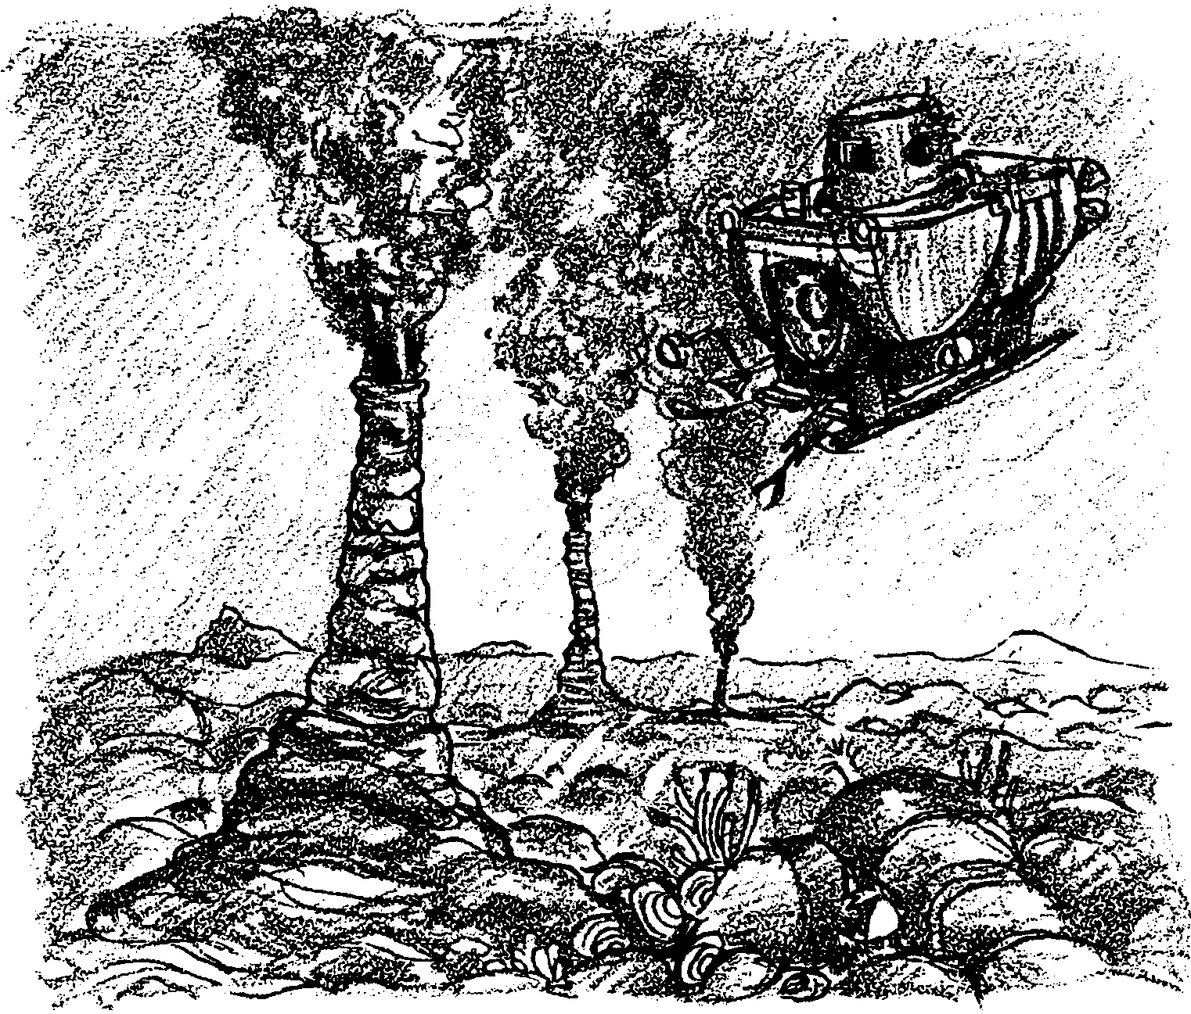
Hydrothermal Vent Formation

The spreading centers of the ocean floor are active places. Hydrothermal vents are found along these spreading centers. The vents are formed by sea water seeping deep into cracks in the crust. The water moves down to the mantle, as far as 10-12 km. There, the water is superheated, perhaps as high as 1000° C. As the water is heated, it dissolves particles in the earth’s crust.

This very hot water eventually returns to the ocean floor through a restricted area called a vent. The salinity of the water escaping through the vents has been measured at 253 parts per thousand. This is over eight times the 35 parts per thousand salinity of normal sea water.

As the water escapes through the vent into the colder ocean water, the dissolved particles precipitate out. The particles, called precipitates, collect around the edges of the vents. Over time, the precipitates may form chimneys as high as 20-30 meters around the vents. The precipitates which remain suspended in the rising hot water give the appearance of smoke, hence the name smokers.

In this activity, you will examine how hydrothermal vents are formed as you investigate how substances can be dissolved in hot water and then how those same substances can precipitate out when the temperature of the water drops.
Materials
• 250 grams of Epsom salt
• 750 ml of water
• 1000 ml beaker
• heat source
• teaspoon
• stirring rod
• balance scale
• thermometer
• plastic bag with twist tie
• ice
• safety glasses
• beaker tongs or pot holder

Procedure
1. Measure out 250 grams of salt. Set the salt aside.

2. Measure 750 milliliters of water into the 1000ml beaker. Record the temperature of the water.

° C

3. Add one teaspoonful of salt to the beaker of water. Stir until completely dissolved.

4. Continue adding and stirring the salt one teaspoonful at a time, until no more salt can be dissolved.

5. a. Use the balance to find the mass of the remaining salt.

grams

b. Calculate the amount of salt in the solution. (Hint: What was the mass of the salt with which you began?)

c. Calculate the parts per thousand. Since you know the mass of salt added to the water in the beaker, you can do this as a simple proportion:

mass of salt added = unknown mass of salt
750 ml of water 1000 ml of water
6. Place the beaker on the heat source and begin heating the water. BE SURE you're wearing your safety glasses or goggles.

7. As the water warms, add more salt, one spoonful at a time, until no more salt can be dissolved. Do not heat the water past 100° C (the usual boiling point of water). You can tell you’re nearing 100° C when small bubbles begin to form on the bottom of the beaker.

8. a. Find the mass of the remaining salt. (Hint: Remember the mass of the salt you had at the beginning of this step was 250 grams less (minus) the amount you added in step 4.)

grams

b. Calculate the amount of salt in the solution.

c. Calculate the parts per thousand. (Hint: Use the same proportion you solved in step 5.)

9. Use the tongs or pot holder and carefully remove the beaker from the heat source. Place the beaker on a heat resistant surface.

10. Place 5-8 ice cubes in the plastic bag and secure it with a twist tie.

11. Float the plastic bag in the salt water solution. Observe and record your observations.

Analysis and Interpretation

1. a. What was the temperature of the room temperature water?

b. How much salt were you able to dissolve in the room temperature water?

c. How many parts per thousand was the resulting solution?

2. a. What was the temperature of the hot water?

b. How much salt were you able to dissolve in the hot water?

c. How many parts per thousand was the resulting solution?

3. Why were you able to dissolve more salt in the hot water than in the room temperature water?

4. What happened to the salt water solution when you put the plastic bag of ice in it?

5. When solid particles fall out of solution, they are called precipitates.

a. In your opinion, what substance precipitated out of the salt water solution?

b. What could you do to find out for sure?

6. Why did the precipitates fall out of solution once you put the ice in the supersaturated salt water solution?

7. Why was the ice put in a plastic bag before it was added to the salt solution?

8. At the hydrothermal vents, the precipitates fall out and collect to form a chimney surrounding the vent. What changes could be made to this lab activity to better simulate what actually occurs at the hydrothermal vents?

