Packages
Lesson edited by Linda Hagelin Saratoga, CA

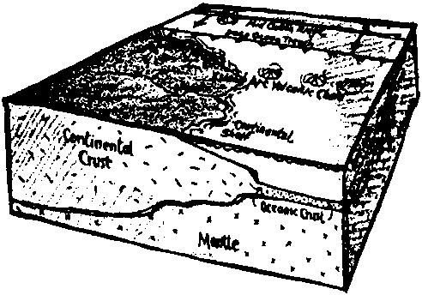
Key Concepts
1. Continual convection currents move the earth’s crust resulting in the formation of islands and deep oceanic trenches.
2. Core drilling has produced information regarding the movement and density of the oceanic and continental crust.

Background

The theory of plate tectonics and continental drift hypothesizes that the continents are in relative motion. This implies that the positions and shapes of the continents we see today are not the same positions or shapes seen in the past.

The internal structure of the earth is, in-part, composed of the core, mantle and two types of crust: continental crust and oceanic crust. The continental crust is less dense than the oceanic crust, so it floats higher in the mantle. It is also thicker and is, therefore, found deeper in the mantle. The crusts float on the mantle much like an ice cube floats in a glass of water. (Refer to the diagram).

The earth’s core is thought to be comprised primarily of very dense nickel and iron compounds in a molten state. Fission reactions occur deep in the core and produce intense heat. The heat causes convection currents to form in the more “plastic” mantle.

As the mantle material is heated, its density is decreased and it moves toward the crust. In some places, where the crust is thin, some of the mantle material seeps through and as it cools, creates new crust. The Mid-Atlantic Ridge was formed in this manner. Sometimes this new crust rises above the water’s surface to form islands. Once it reaches the crust, the mantle material moves laterally beneath the crust. In this manner, it is thought to drag the plates along with it.

Cooling of these convection currents results in a downward movement of material under some regions of the continental crust and oceanic crusts. As parts of the oceanic crust move downward under the continental and other oceanic crusts, deep ocean trenches are formed.

As the oceanic crust moves downward under the continental crust, remelting of the crust occurs, producing new mantle. In these areas, molten rock is often found rising through the oceanic crust to create volcanic islands. Hawaii, the Philippines, the Marshalls, Tuamolo, and Fiji are examples of Pacific volcanic islands. The Azores are examples of Atlantic volcanic islands.

Materials

For each student:
• earth package sheet

• colored pencils

• fine tipped felt markers

• scissors

• glue or tape

Teaching Hints

“Packages” provides your students with an opportunity to study fundamental earth processes while constructing and labeling a simple three dimensional model of the earth’s crust.

Duplicate the activity pages. One set is recommended per student. The model making is simple but does provide a good exercise in following directions. Ideally, each student should make their own model. You may wish to have a completed model available for demonstration. Students may want to color the crust, mantle, and ocean with different colored pencils before assembling. Use fine tipped felt markers for labeling. Upon completion, provide time for a discussion of the “Analysis and Interpretation” questions.

Key Words

continental shelf - submerged edge of the continent

convection currents - pattern of movement in unevenly heated fluids

volcanic island arc - series of volcanic islands found at a subduction zone

Extensions

1. In addition to the cut and paste model included in “Packages”, you may wish to have your students use a variety of textures (e.g. sand, oatmeal, sawdust, barley, grits, etc.) to build a cross section of the earth in a pint or quart jar. The model can be simple or complex. Complex models would show ridges, plate collision, trenches, etc. These models can serve to reinforce the concepts of continental drift and plate tectonics.

2. As a culminating activity for this unit, consider allowing your students to present the demonstrations and activities in this section to parents or another class. This strategy increases the learning by allowing your students to “teach” the concepts illustrated by these activities.
Answer Key

1. a. The continental crust is thicker than the oceanic crust.

b. The continental crust floats higher above the mantle. This question is likely to cause some confusion. While the bottom of the continental crust is lower than the bottom of the oceanic crust, the top of the continental crust is also higher than the top of the oceanic crust. You can use the analogy of an ice cube floating in a glass of water.

c. Continental crust must, therefore, be less dense than oceanic crust.

2. A completely labeled “earth package sheet” is found below.

3. a. A completely labeled “earth package sheet” is found below.

b. New crust is formed at the mid-ocean ridges of the deep ocean basin.

4. a. A completely labeled “earth package sheet” is found below.

b. The Azores Island group is the classic example of a volcanic island arc. Other volcanic island arcs include: the Philippines, the Marshall Islands, the Tuamoto Islands, and the Fiji Islands. The Hawaiian Islands are not an example of arc volcanism. The Hawaiian Islands (and Emperor Seamounts) are the classic example of “hotspot” islands; islands which are a record of uplift and volcanic activity reflecting a relatively persistent region of molten rock in the crust and upper mantle. At the hot spot magma rises from inside the earth, melts a hole in the plate and pours out as lava building a volcanic island. Plate motion carries the volcanic island away from the hot spot. As new plate moves over the hot spot, the process starts again. Hawaii is the last volcano to be built over the Hawaiian chain hotspot. A new volcano, called Loihi, is now growing over that hot spot.

5. Deep ocean trenches are thought to occur where plates meet and one dives under the other.

6. A completely labeled “earth package sheet” is found on the following page.

7. The theory of plate tectonics and continental drift hypothesizes that the continents are in relative motion and that the positions of the continents we see today are not the positions (or the continents) of the past. The positions of the continents are changing.

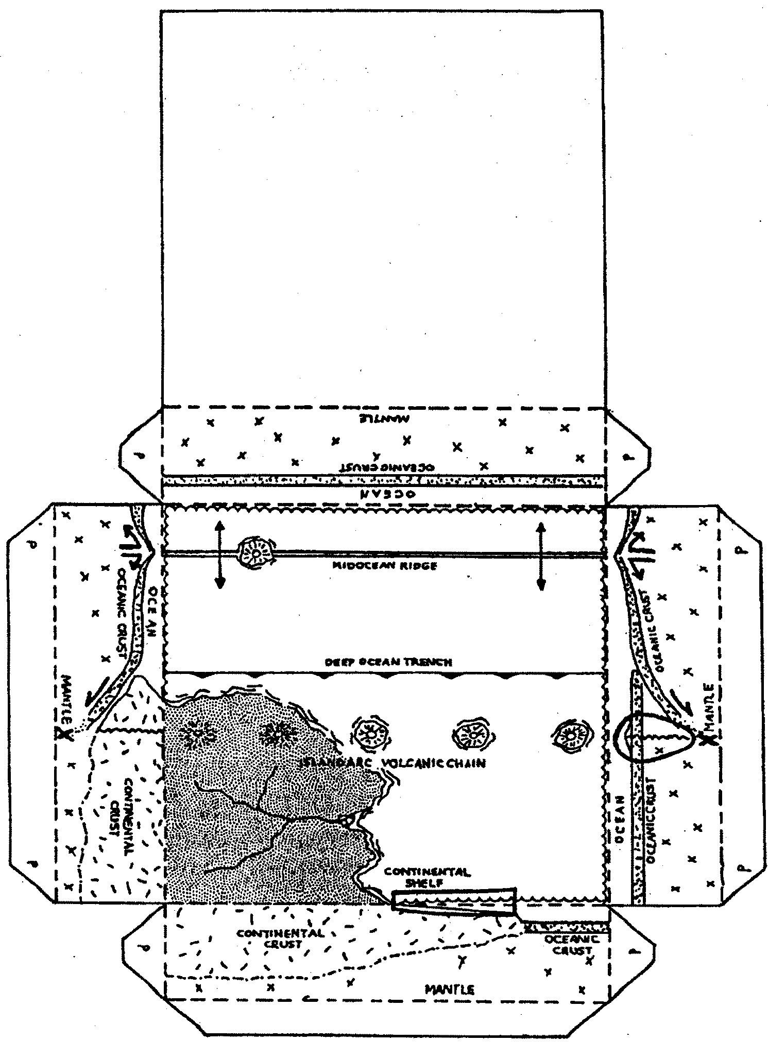

Packages

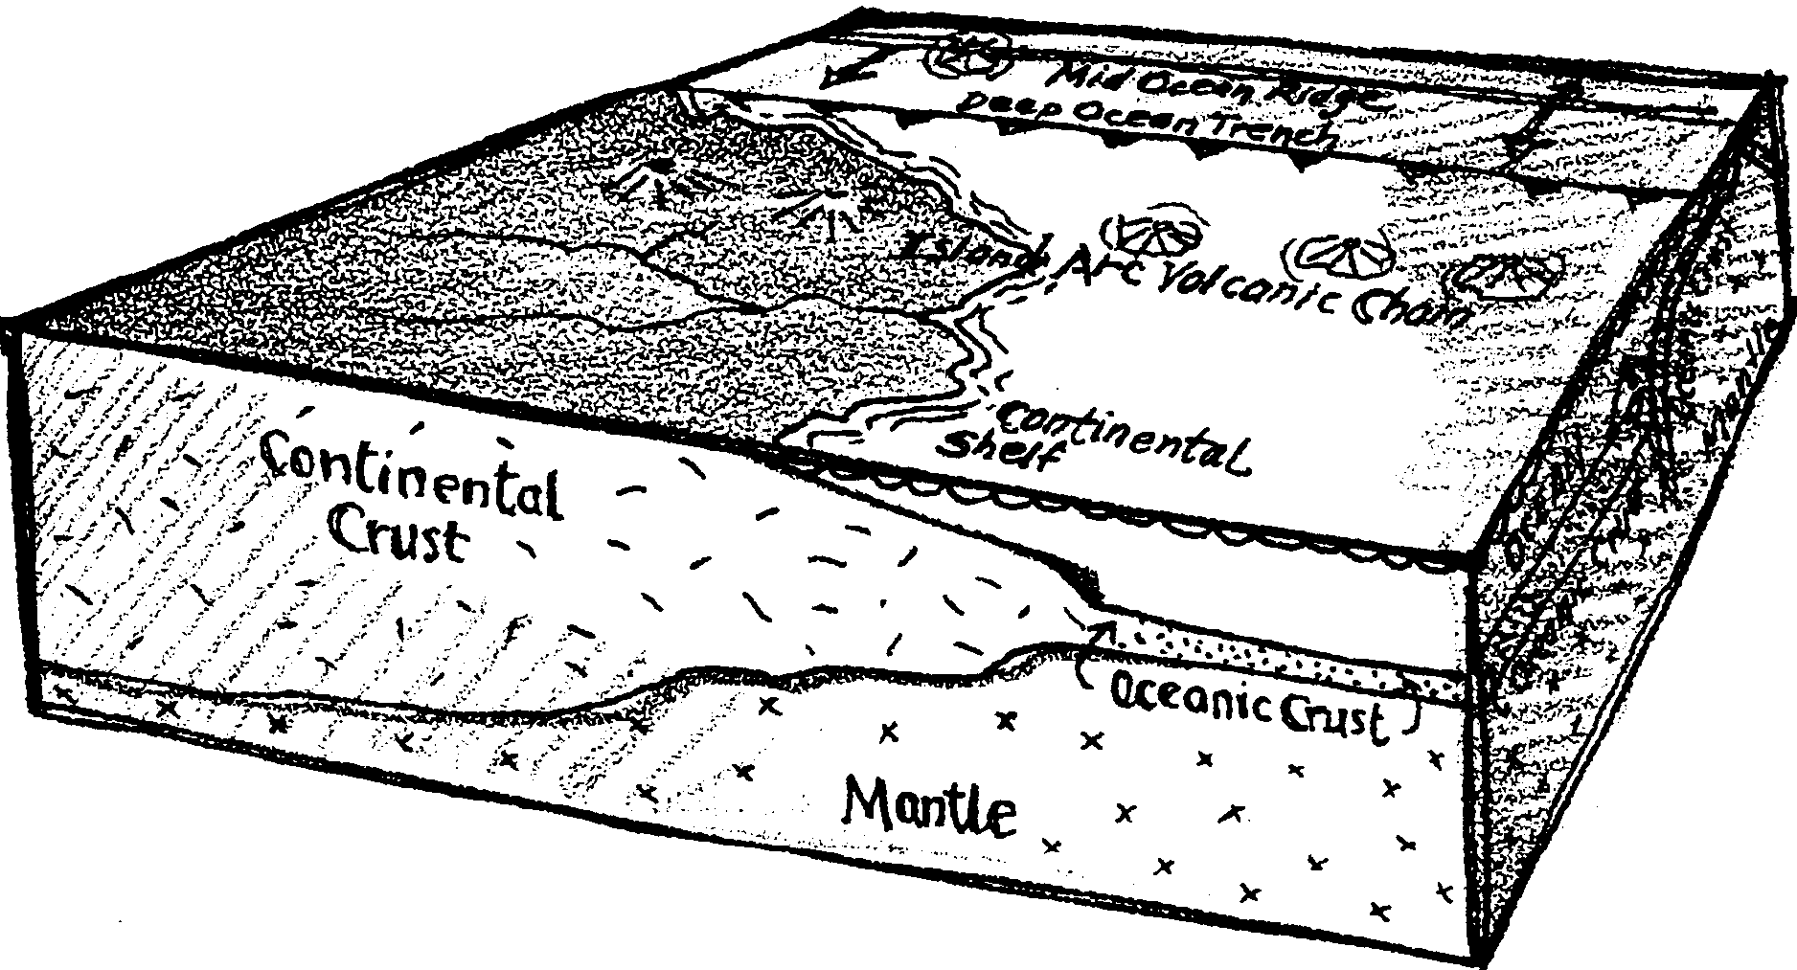

It seems that the more we know about the earth, the more questions we have. It is difficult to visualize a three dimensional earth on two-dimensional paper. In this activity, you will construct a three dimensional model of part of the earth’s surface. Recall that scientists now think that the earth’s surface is composed of large PLATES of crustal material. These plates are moving apart from each other at the mid-ocean ridges. Trenches form where one plate meets and dives under another. The leading edge of the diving plate is heated as it descends. The edge eventually melts and the plate once again becomes MANTLE material. The earth’s crust is recycled! The model you will make shows some of what we now know about these and other features and events.

Materials:
• copy of the earth package sheet
• colored pencils
• fine tipped felt marker
• scissors
• glue or tape

Procedure:

1. Obtain an “earth package sheet” and scissors.

2. Cut along the outside solid lines.

3. Fold on the dashed lines.

4. Paste the model together where the small “p’s” appear on the flaps.

5. Use the fine tipped marker and colored pencils to answer the following questions with your model.

Analysis and Interpretation:

1.a. Which crust, the oceanic or the continental, is thicker?

b. Which type of crust (oceanic or continental) floats higher above the mantle?

c. Which type of crust must, therefore, be less dense?

2. Use arrows to draw in convection currents beneath the surface of the mid-ocean ridge.

3. a. Place an X at the point(s) where the oceanic crust is remelted to form the mantle.

b. If the amount of crust remains the same, new crust must be formed to replace the crust that is remelted. Where is the new crust formed?

4. a. Circle the path of molten rock from the mantle to the top of an oceanic volcano.

b. The Pacific Ocean has many volcanic islands. There are also volcanic islands in the Atlantic Ocean. Name an island group that is an example of a volcanic island arc.

5. What is thought to cause deep-ocean trenches?

6. Draw a box around the side view of the continental shelf.

7. What does the theory of plate tectonics and continental drift say about the positions of the continents?

