Slippin' & Slidin' - Plate Tectonics
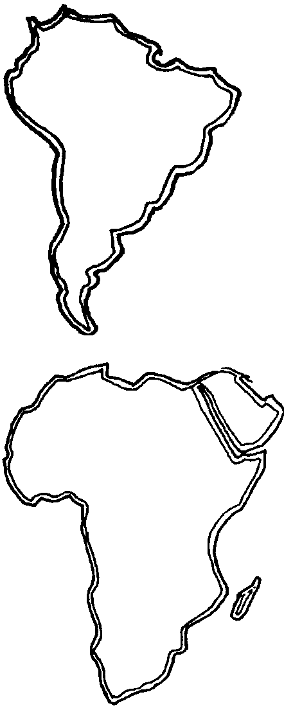

Key Concepts
1. The earth has changed over time.
2. Current research can give clues to the earth’s past.
3. The earth’s crust is made of large pieces called plates.
4. The plates have moved over time.
5. Some features of the ocean floor are determined by actions that occur at plate boundaries.

Background

Our view of the earth and the processes that have shaped its surface have undergone dramatic changes in the past two decades. “Slippin’ & Slidin’” gives your students an introduction to the concept of plate tectonics. Plate tectonics gives new life to the old ideas of continental drift and explains the distribution of many large scale geologic features and zones of activity. The broad outlines of the theory of plate tectonics are now widely accepted.

Essentially, the earth’s surface is comprised of several large plates of crustal material. These plates are in motion relative to one another. The plates appear to be moving apart from each other along the mid-ocean ridges. The ridges are also the location of the formation of new ocean floor material. Where the plates collide, one plate (usually an oceanic plate) dives beneath another (usually a continental plate). This process is called subduction. As the plate continues to descend, the rocks which form it become heated and eventually melt forming new mantle material. Narrow belts of mountains, volcanic activity and earthquakes occur at these plate boundaries. Once such belt of activity is called the Ring of Fire. Agreement on the mechanism causing the movement is not universal. Although present thought has large, slow moving convection currents in the earth’s mantle supplying at least some of the force necessary to move the plates, most geophysicists now think that the plates are, because of their higher density than underlying relatively hot crust, falling into the upper mantle. While the predominance of opinion seems to favor the “plate pull” of the falling plates rather than the “plate push” of convective forces at the mid-ocean ridges, the forces actually driving the plates are unknown. An excellent historical perspective of the theory may be found in the Scientific American publication:

Continents Adrift and Continents Aground with introductions by J. Tuzo Wilson. 1976. W.H. Freeman and Company. San Francisco, California 230 pages.

Materials

For each student:
• “Slippin’ & Slidin’” activity sheets

• “Puzzling Plates” vocabulary review puzzle sheets

Teaching Hints

Duplicate the student handout pages. One set is recommended per student. Note that the text questions immediately follow the section to which they pertain. This approach serves to reinforce and/or expand the topic in the most logical location. This activity lends itself well to completion by individual students as a homework or in-class assignment. Either way, plan to allow time for a class discussion of the materials.

Key Words

continental drift - theory proposed by Alfred Wegener to explain the movement of continents

convection current - current caused by the density differential caused by the uneven heating of liquids or gases

core - the innermost part; in this case, the centermost layer of the earth

crust - outermost solid layer of the earth

fossil - preserved evidence of an organism

geology - the study of the earth

hypothesis - an “educated guess” used as the basis for experimentation and offered to explain observations

mantle - the layer of the earth between the core and the crust

meteorologist - a scientist who studies weather and climate

molten - made liquid by heat, melted

Pangaea - the single, supercontinent that began to break up 200 million years ago

Ring of Fire - a zone which surrounds the Pacific Ocean, marked by deep ocean trenches, numerous volcanoes, and active faults

static - not moving

submarine ridges - underwater mountain ranges

theory - a commonly accepted hypothesis which has been proven many times

topography - detailed mapping of a given region

trench - very deep ocean features which parallel the continental margins; formed by subduction of tectonic plates

Extensions

Plate Movement Demonstration
This demonstration models the processes of subduction producing island arc systems, volcanic activity, and additions to a landmass.

Materials:

• two large, flat, sturdy crackers (AK-MAK crackers work well)

• peanut butter

• jelly

• knife for spreading

Procedure:

1. Spread peanut butter on one of the crackers (representing the oceanic plate) and jelly on the other cracker (representing the continental plate).

2. Move the peanut butter cracker (oceanic plate) under the jelly cracker (continental plate) to demonstrate the accretion of sediments at the subduction zones.

This demonstration was originally eaten at the Marin Headlands Institute, Golden Gate National Recreation Area.

Demonstrating Continental Drift

The theory of drifting continents producing the existence of a single, super continent, called Pangaea, was postulated by Alfred Wegener, a German scientist. This activity is useful when introducing students to the evidence used by Wegener that may have created the theory.

Materials:

• the classified ads section of a newspaper

Procedure:

1. Tear the classified ads section of the newspaper into strips.

2. Distribute the strips randomly to students and have them try to piece the paper together again. Ask them to identify the evidence or clues used to find matching pieces. Can they correlate their observations to those made by Wegener?

edge of the newspaper = coastline of the continents

matching word patterns = rock formations or
or pictures existing fossils

Answer Key

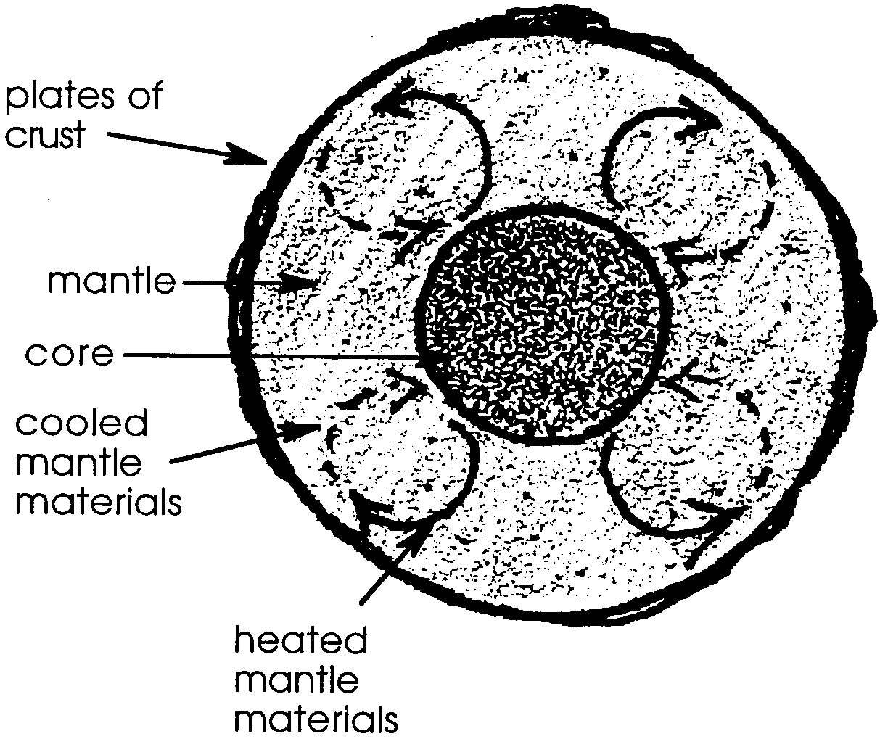
1., 2.

3., 4. The answers depend upon your location but can be readily determined by reference to the map included in the text.

5. 200,000,000 years x 2.5 cm. = 500,000,000 cm. wide
yr.

6. a. 500,000,000 cm. = 5,000,000 meters wide
100 cm./m

b. 5,000,000 m = 5,000 kilometers wide
1000 m/km

c. The actual width of the Atlantic Ocean basin and the width calculated in part b. are the same.

d. The information above indicates that sea floor spreading alone could indeed account for the size of the Atlantic basin.

7. As it sinks into the hot mantle, the crust is heated. The farther it descends, the hotter it becomes until it finally becomes molten mantle material itself.

8. The “Ring of Fire” is shown below:
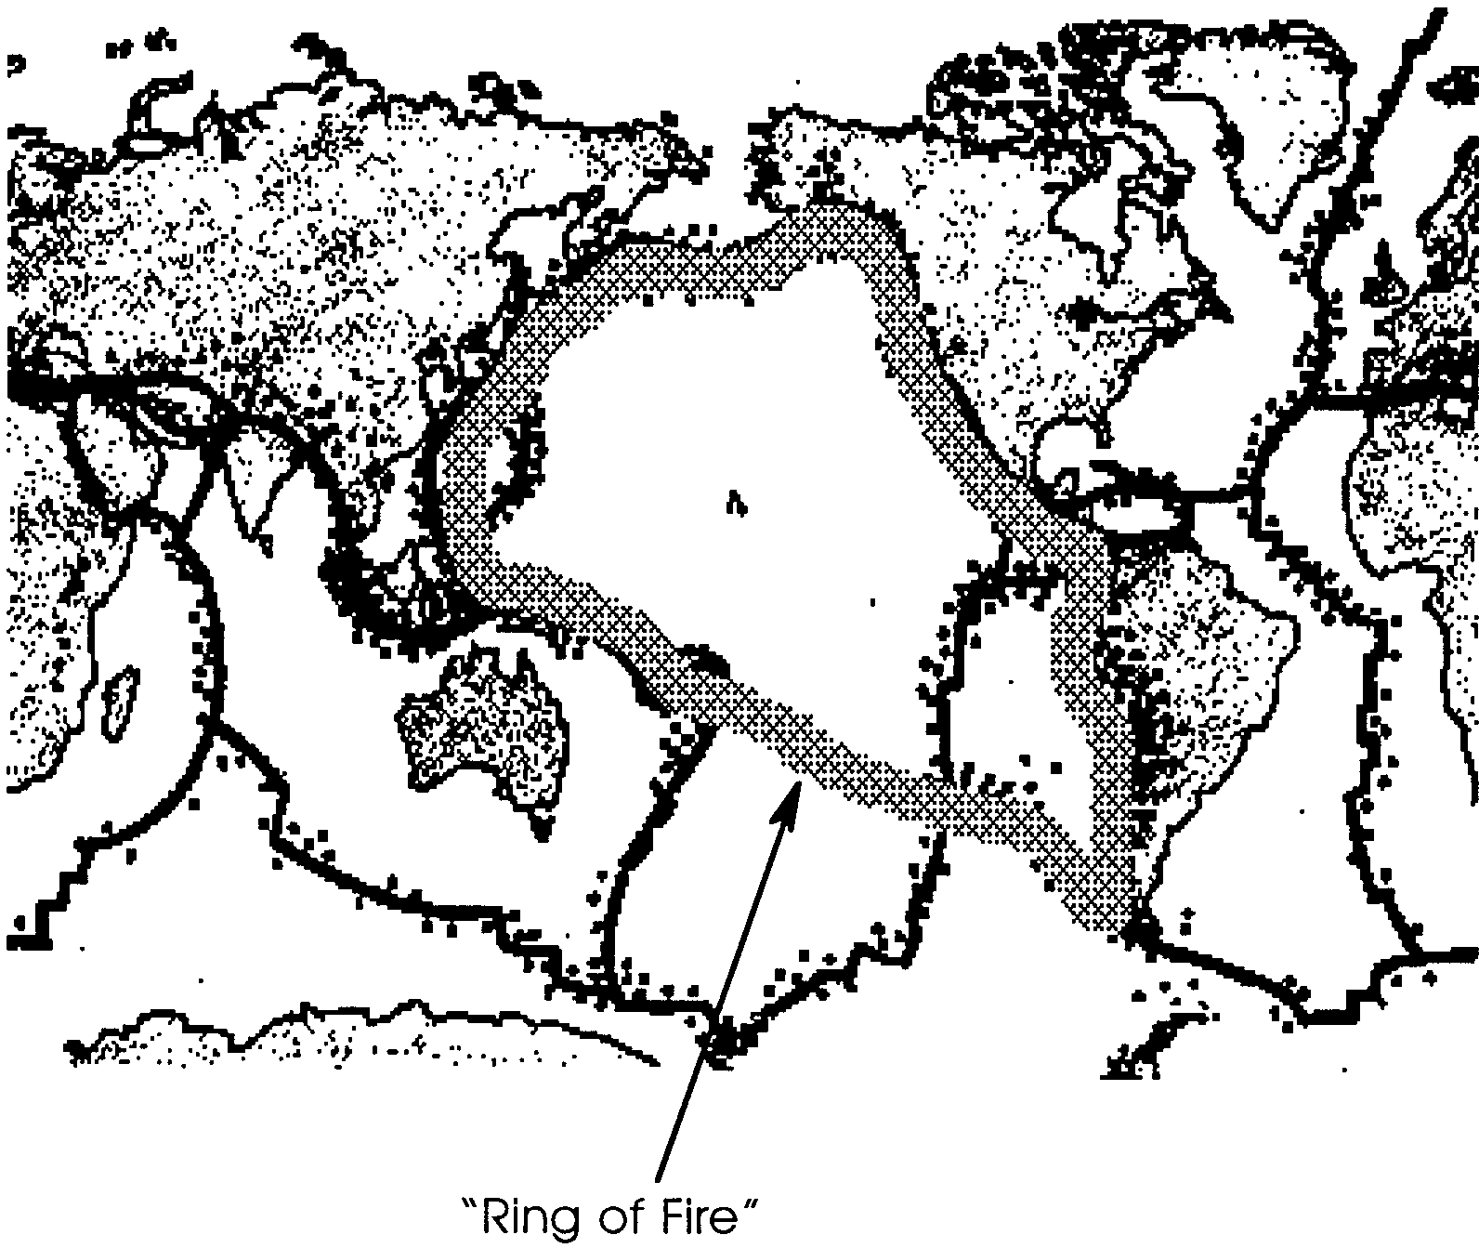

9. The answer depends upon your location but, once again, it may be readily determined by reference to the map included in the text.

“Puzzling Plates” answer Key follows on the next page.

“Puzzling Plates”

When completed, the puzzle reads:

THE SURFACE OF THE EARTH
IS MOVING IN LARGE PLATES
THE PLATES MOVE APART AT
THE MID OCEAN RIDGES AND
FORM DEEP TRENCHES WHERE
THEY COLLIDE

b. CONVECTION
c. MANTLE
d. RIDGES
f. PLATES
g. SUBDUCTION
h. DRIFT
i. HYPOTHESIS
j. VOLCANOES
k. WITH

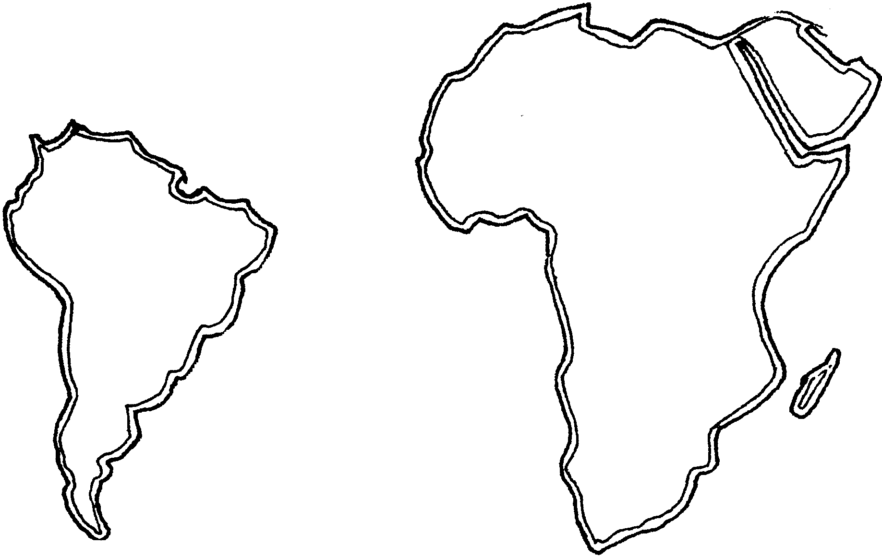
Slippin' & Slidin' - Plate Tectonics

Before there was the whale, the earth was. What forces shape our planet? Has the earth always looked the way it does today? In the early 1900’s most scientists would have said, “Yes, the earth’s surface has looked the same throughout its history.” Have the ocean basins and the continents always been where we find them today? What observations made people question the theory of an unchanging earth? On the map above, look at the east coast of South America and at the west coast of Africa. It does not take much imagination to see that the two coasts look very much like jigsaw puzzle pieces that could fit together.
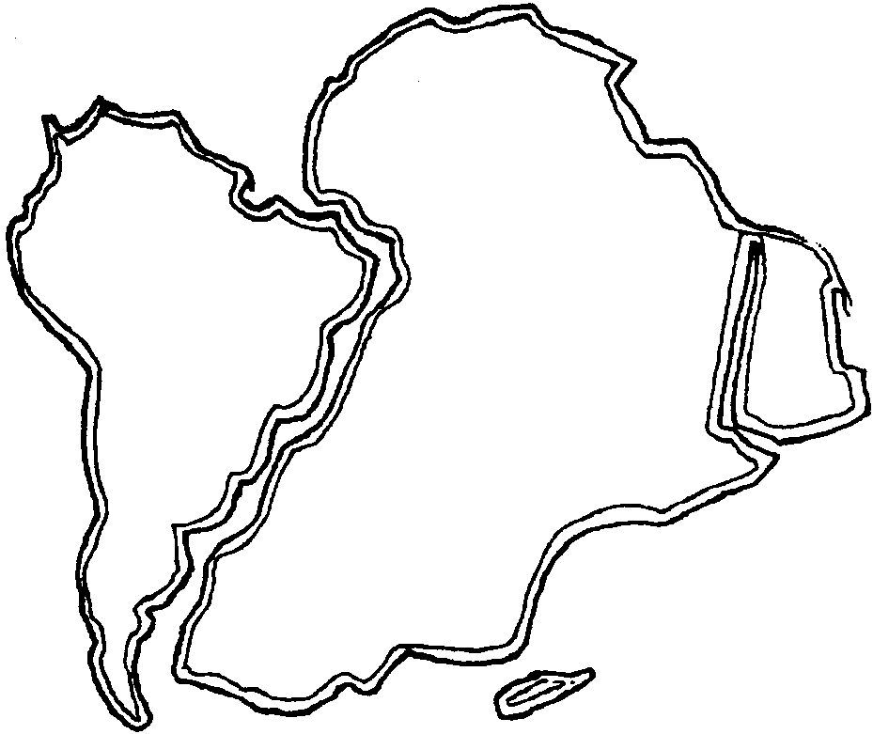
Perhaps we can place them together like this:

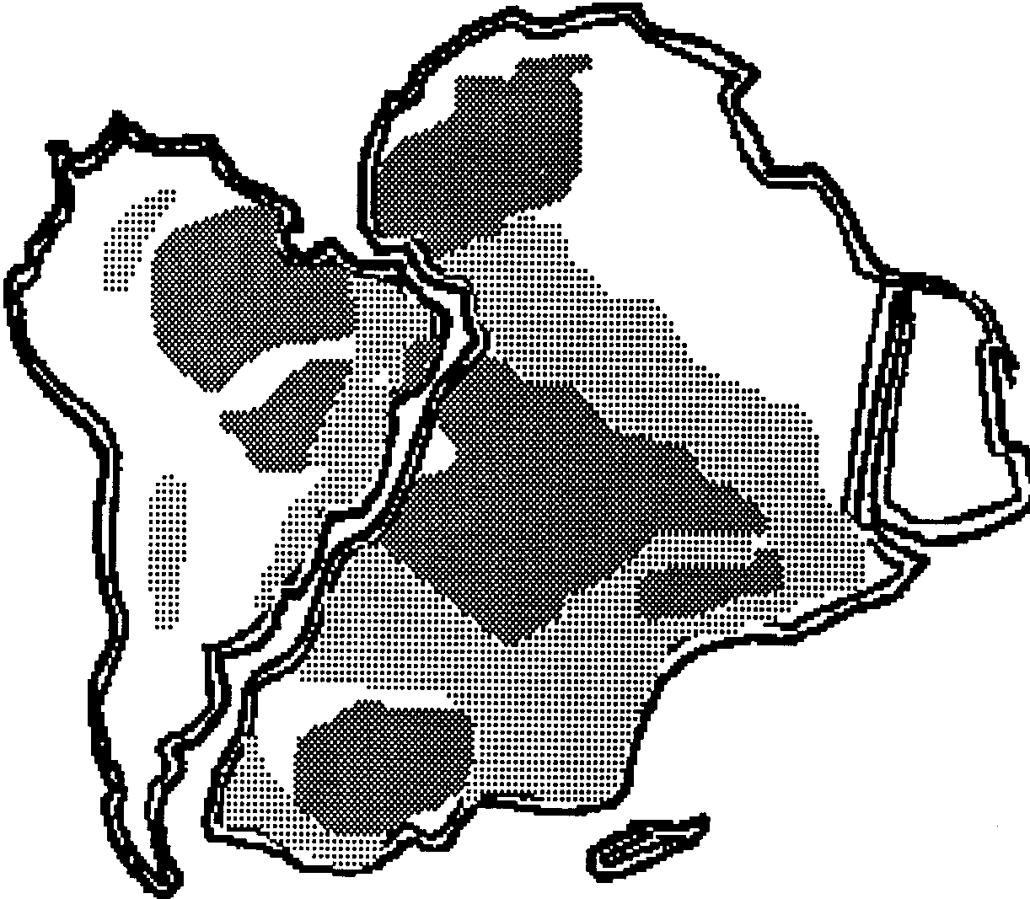
Other observations were made. Distinctive rock formations were found to suddenly end at the continental margins (edges) of both Africa and South America.

Similar or identical plants and animals were found in the fossil records of distant continents. For example, Mesosaurus was a small reptile that lived about 270 million years ago. Its fossils are found in Brazil on the South American continent and in South Africa on the continent of Africa and nowhere else in the world. Had these animals crossed from one continent to another on land bridges which later disappeared? The idea of an ancient land bridge now sunk beneath the ocean seemed unlikely.

Further study of the earth’s crust indicated that it is made up of two different materials. The crust that makes up the continents is made mostly of granite, and is many miles thick. The oceanic crust, much thinner than the continental crust is made mostly of basalt. The oceanic crust is much more dense than continental crust. This discovery also failed to fit into a picture of unchanging continents. Unchanging continents would have a single layer crust.

If the observations do not fit the theory, perhaps the theory needs to be discarded or modified. What theory could explain all of the above observations? In 1912, Alfred Wegener, a meteorologist, set forth the hypothesis that the continents had moved or drifted into their current positions. Wegener’s hypothesis of Continental Drift started a debate that continued for over half a century.

It now appears that Wegener’s general hypothesis was correct. Our planet Earth is an unstable ball. The continents are moving. Here’s how scientists think the earth has changed over the past 200 million years:
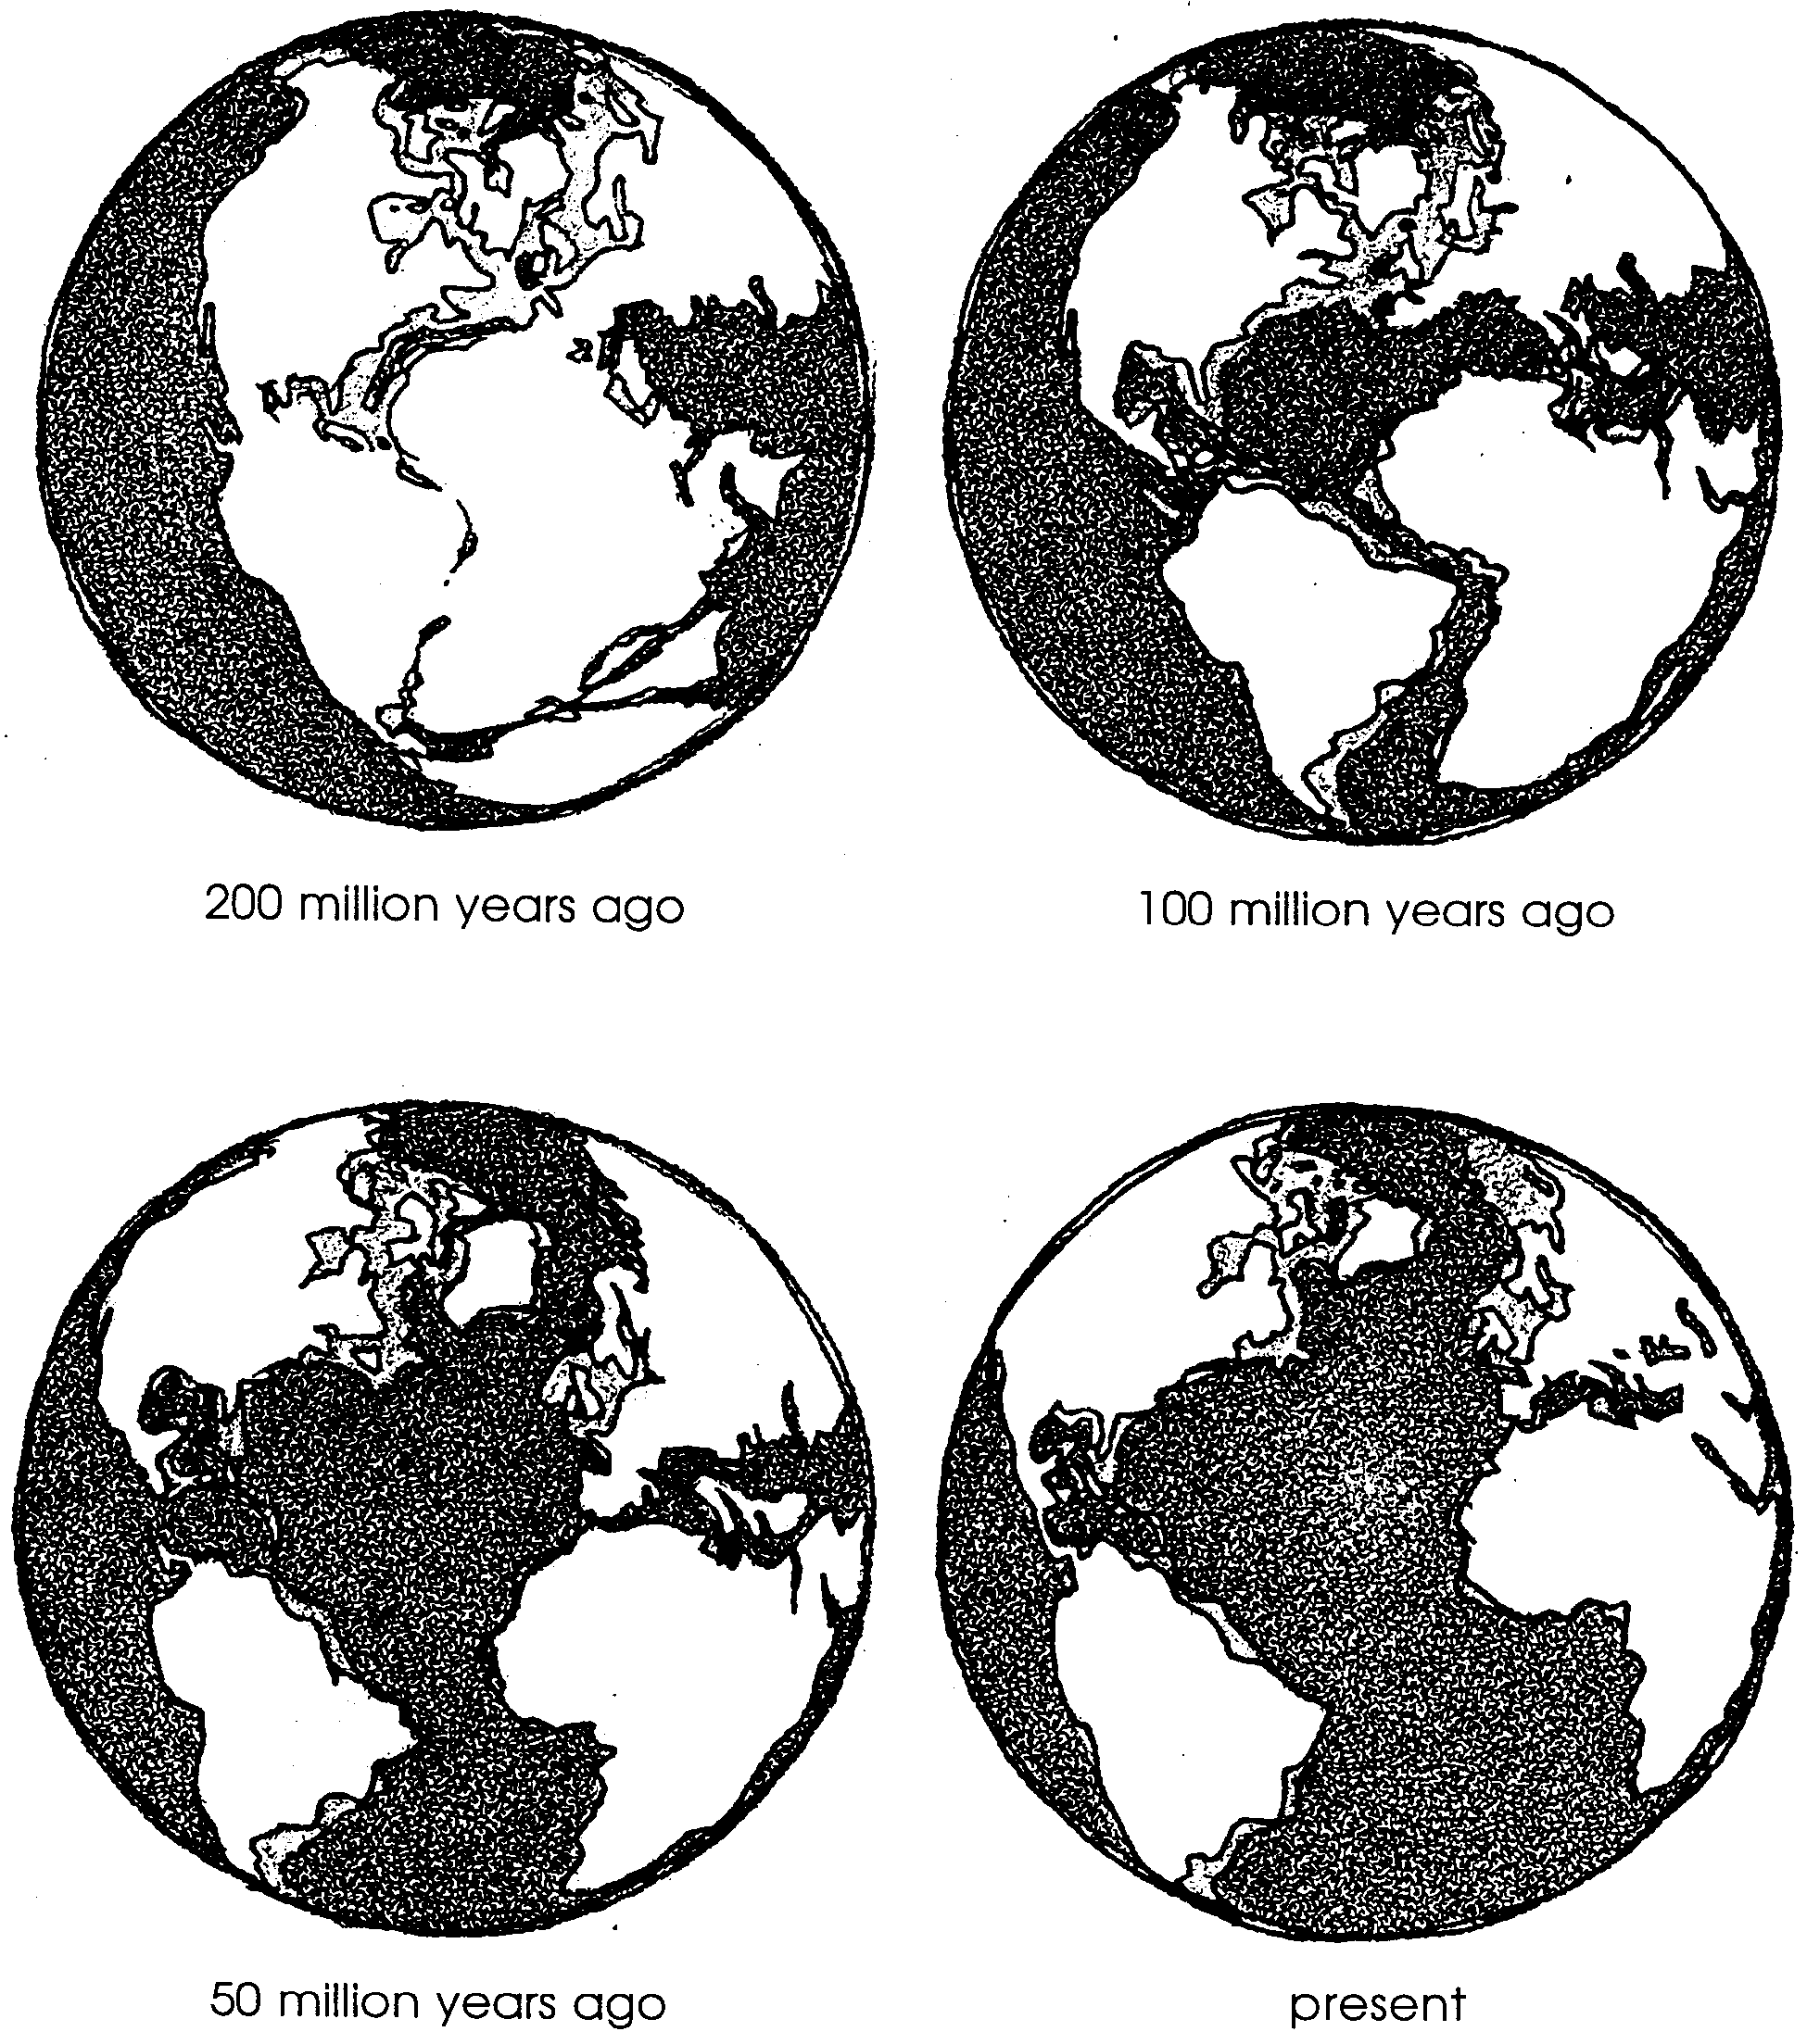

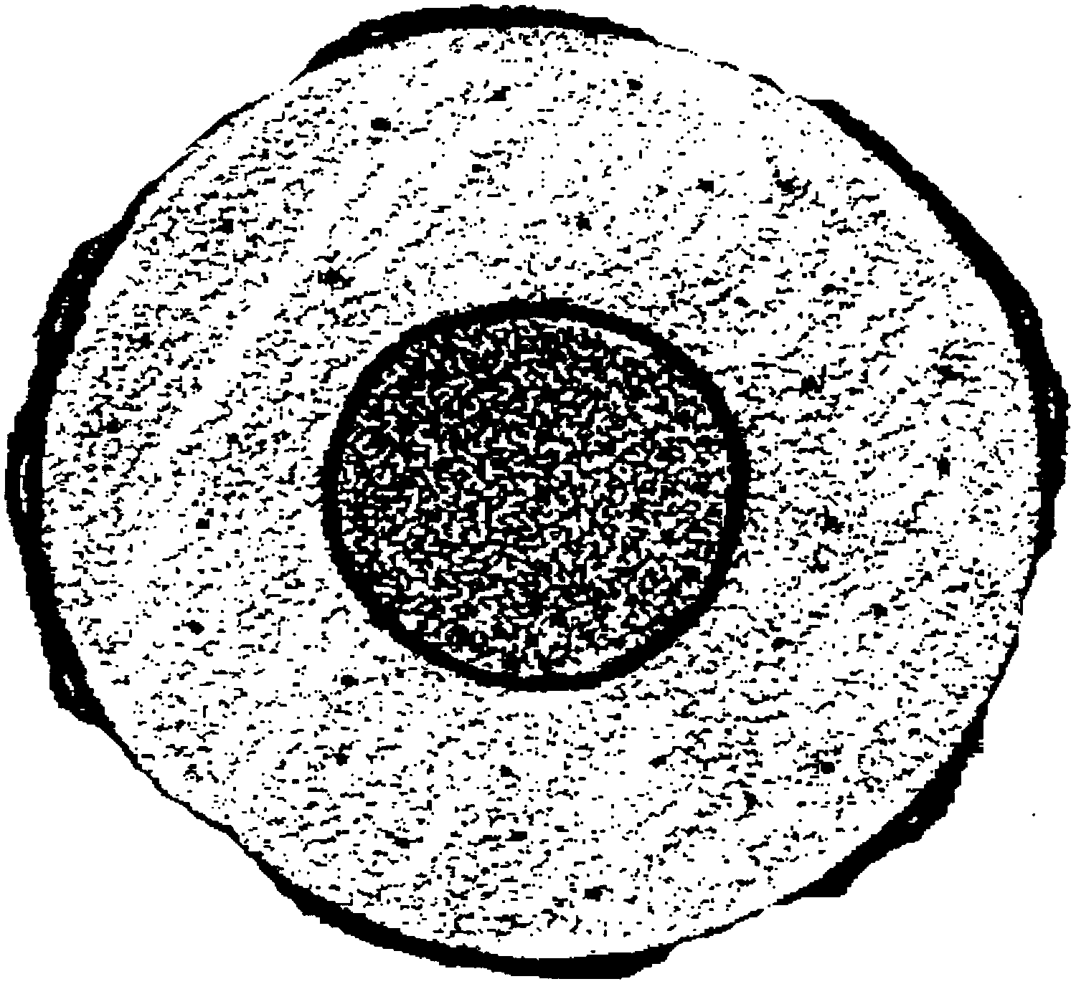
The earth’s surface is covered with large moving sections of crust called plates. These plates float over the earth’s mantle, a layer of molten rock. The molten rock flows in slow moving circular streams known as convection currents. Below the mantle, the earth’s core acts like a giant burner. The core superheats the mantle material and forces it to rise just as hot liquids rise. We call the theory that explains the movement of the plates, the Plate Tectonic Theory.

1. The drawing above shows a cross section of the earth. Label the
a) plates of the crust
b) mantle
c) core

2. Hot liquids tend to rise, while cold ones sink. On the drawing above, use a solid arrow to show the direction of movement of heated mantle materials and a dotted arrow to show the movement of cooled mantle materials.

There are seven very large plates and a dozen or more small plates moving over the mantle. The figure below shows the major plates.
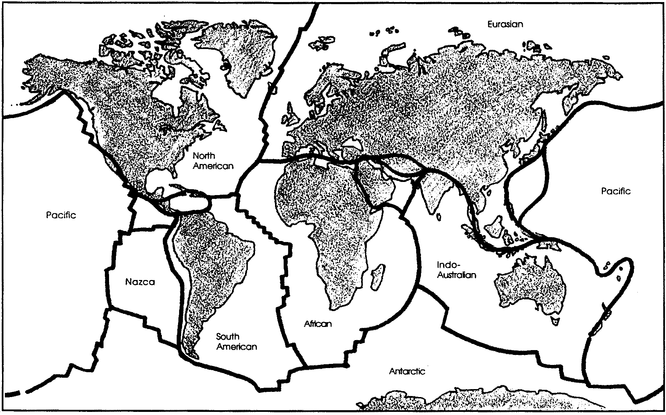

3. On which plate do you live?

4. Do you live near the edge or the middle of the plate?

All of the plates are moving relative to all others. Some plates are moving apart, some are colliding. Areas where the plates are moving away from each other are called spreading zones. Long systems of great submarine ridges in the world’s oceans are found at some of these spreading zones. The rising molten rock from the mantle wells up into the gap between the two plates, helping to push the plates apart. As the molten rock cools and solidifies, it becomes new ocean floor.

5. The oldest ocean floor is estimated at 200 million (200,000,000) years. The convection currents carry the plates over the surface at the rate of from two to 15 centimeters (one to six inches) per year. Movement at the Mid-Atlantic Ridge is generally about 2.5 cm per year. At this rate, how wide would the Atlantic Ocean be in centimeters? Show your work.

6. Scientists use centimeters to measure short distances and kilometers to measure long distances. There are one hundred centimeters in a meter and one thousand meters in a kilometer.

a. Divide the width of the Atlantic Ocean in centimeters (your answer to #5) by 100 to find its width in meters.

cm = meters wide.

100

b. Divide the width of the Atlantic Ocean in meters (your answer to a) by 1000 to find its width in kilometers.

m = kilometers wide

1000

c. The actual width of the Atlantic Ocean basin is about 5,000 kilometers. How does the actual width compare with your calculated width from b. above?

d. Could sea floor spreading alone account for the size of the Atlantic Ocean?

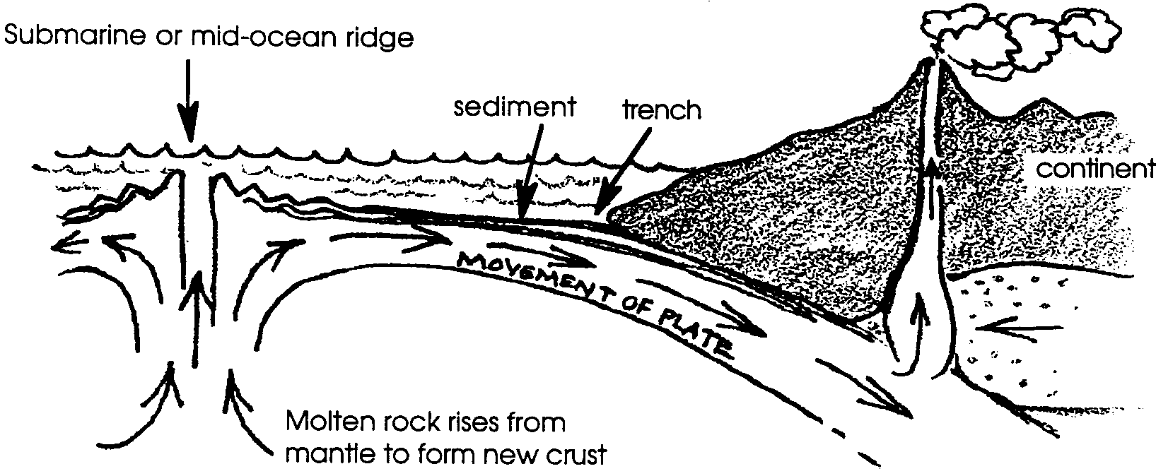
Evidence seems to indicate that the amount of crust has remained the same over very long periods of time. If this is true, the formation of new crust must mean that crust is being destroyed somewhere else. Where does this older crust go? A study of colliding plates gives us the answer. The earth’s crust is not the same all over. The continental crust, made of granite, is “thicker” and less dense. The continental crust “floats” on the more dense oceanic crust. When an oceanic crust plate and a continental crust plate collide with one another, the denser oceanic plate tips down and slides beneath the continent. This process is called subduction. The plate sliding beneath has its ocean floor sediment scraped off by the over-riding plate. The sediment is also subducted. This scraping and subducting forms the deep ocean trenches we find located off of volcanic coasts.

7. What is likely to happen to the crust as it sinks into the hot mantle?

Earth scientists have mapped many of these subduction zones, where the oceanic crust dives under the continental crust. An example is the Ring of Fire which circles the Pacific Ocean. The huge Pacific plate is being subducted by plates on the east and west sides of the Pacific Ocean. As the oceanic plate dives under the continental plate, the continental margin cracks, forming faults. The oceanic crust is re-melted as it nears the mantle. The re-melted crust then seeps through the faults along the continental margin and forms volcanoes. Volcanic and earthquake activity is quite frequent in the Ring of Fire. The deepest trenches are also found in subduction zones.
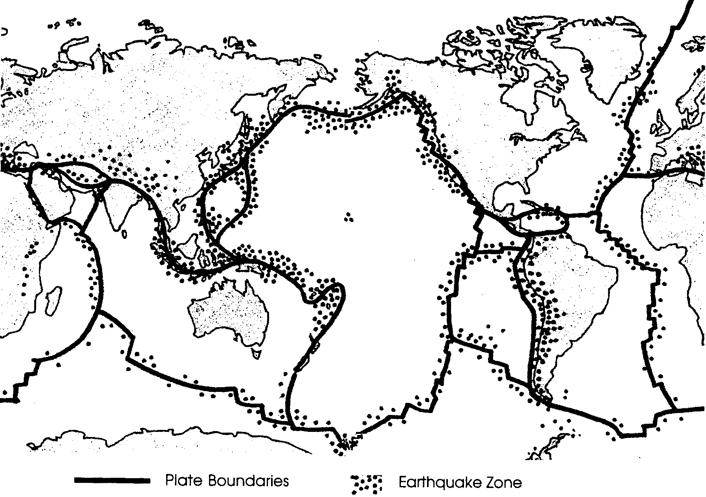
8. The map above shows the location of earthquakes of magnitude 8.0 and higher. Connect the Pacific basin earthquakes to form the “Ring of Fire”.

9. Are you closer to a ridge (spreading zone) or to an area of subduction? Use this map and the map of the major plates to determine if you live closest to a ridge or to an area of plate collision (subduction).

How does this theory of moving plates account for the similar coast lines of South America and Africa? How does it account for identical fossils and geological formations found on distant continents? Geologists and oceanographers have traced the plate movement back 200 million years. They conclude that the present continents formed one large super-continent called Pangaea. As Pangaea tore apart, the similar edges moved apart. Unique geologic and fossil formations moved apart with the continents.

This gradual process of plate movement forms new ocean floors. It destroys old ocean floors and formed the surface of the world as we see it today. As time passes, the movements of the earth’s crustal plates will create yet another, entirely different global design of continents and oceans.

Puzzling Plates
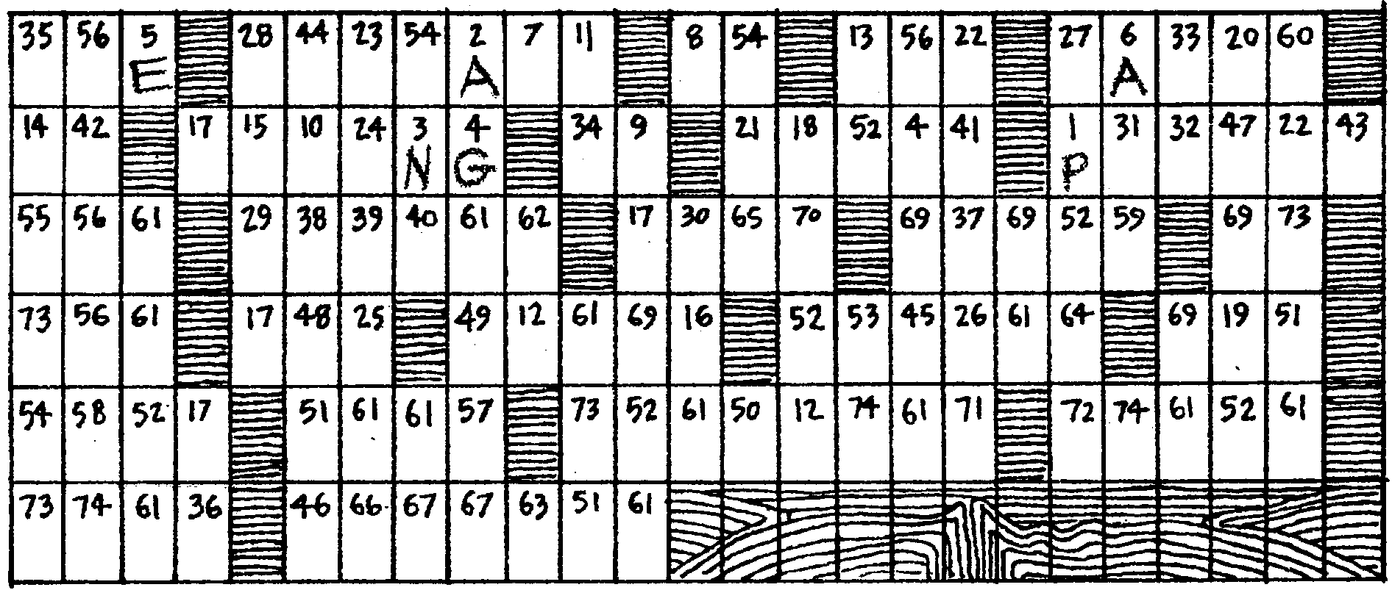
Directions:

To solve this puzzle, fill in the letters of as many words as you can in the spaces alongside the clues given below. When you have written in a word over the dashes, each letter is then moved to the box above which has the corresponding number. When all the boxes have letters, you will have a complete scientific statement. Guessing missing letters of incomplete words in the boxes will provide additional clues for unsolved words below.

The first one is done for you. Letter e is partly completed. Move each letter to the box in the puzzle which has the corresponding number.

a. The super-continent which existed 200 million years ago is called
P A N G A E A
1 2 3 4 5 6

b. The plates of crustal material are moved by these currents.

7 8 9 10 11 12 13 14 15 16

c. The layer of the earth between the crust and the core is called the

17 18 19 20 21 22

d. The giant plates of the earth’s crust are moving apart at the mid-ocean

23 24 25 26 27 28

e. An important piece of evidence supporting the theory of continental driftcomes from readings of the magnetic

P O L A R I T Y

29 30 31 32 33 34 35 36 of rocks.

f. Where meet, one tips down and slides
23 24 25 26 27 28
beneath the other.

g. A type of plate collision is also called
43 44 45 46 47 48 49 50

h. The idea that the land masses move is sometimes called the theory of continental

51 52 53 54 55 56

i. Alfred Wegener set forth the testable statement or

56 57 58 59 60 61 62 63 64

j. The “Ring of Fire” is made up of many
65 66 67 68 69 70 71

k. The earth is an unstable ball covered sections of crust.
72 73 74
