The Force

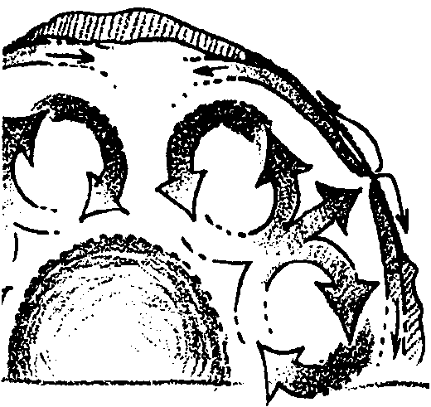
Key Concepts
1. Convection currents form when fluids are heated unevenly.
2. Convection currents in the earth’s mantle have been proposed as the force responsible for moving the earth’s crustal plates.

Background

Much of the original debate concerning the theory of continental drift centered on the motive force. What could provide the force necessary to move these giant continents? Original proponents postulated that tidal forces were moving the continents apart. Calculations quickly showed that this was not possible. Unfortunately, scientists confused disproving the mechanism of drift with disproving the theory of drift. As it would turn out a half century later, the theory had merit even if the hypothesized force was incorrect.

It was next postulated that convective forces within the earth’s mantle were providing the forces for moving the plates. Much debate and study has focused on the role of convection in continental drift. Although present thought has large, slow moving convection currents in the earth’s mantle supplying at least some of the force necessary to move the plates, most geophysicists now think that the plates are, because of their higher density than underlying relatively hot crust, falling into the upper mantle. While the predominance of opinion seems to favor the “plate pull” of the falling plates rather than the “plate push” of convective forces at the mid-ocean ridges, the forces actually driving the plates are unknown. The single force or combination of forces effecting the motion have yet to be discovered, perhaps by one of your former students. In “The Force” your students will have an opportunity to construct a model of a convection cell and watch the movement of “crustal material.”

Materials

For each group:
• 500 ml Griffin beaker

• ring stand and ring

• tap water

• Bunsen burner or alcohol lamp

• food coloring

• dropper

• fine dirt

• sawdust or fine wood chips

Teaching Hints

Duplicate the activity pages. One set is recommended per student. This activity is best accomplished in small groups. It is possible to do this activity as a demonstration. While the demonstration method is less preferred than the “hands on” approach, it is more preferred than omitting the activity. Before embarking on “The Force”, caution your students about the proper use of Bunsen burners and/or alcohol lamps. Review fire safety and evacuation procedures. Familiarize your students and yourself with the location of fire extinguishers. Remind your students that “the drop and roll” technique is the best way to put out burning clothing.

For best viewing of convection currents, the water should be heated slowly. The flame should be placed near one edge of the bottom of the beaker rather than centered. If you have trouble locating fine dirt, you can dry your not-so-fine dirt in an oven and then have your students pulverize it with a mortar and pestle. Provide pot holders and remind your students that cold glass and hot glass look the same. As the activity is being conducted, circulate through the lab. Be especially attuned to unstable setups. Care will pay off in a successful experience. After cleanup or during the next class meeting, provide time for a discussion of the procedure and the results.

Key Words

convection - heat transfer by fluid motion between regions of unequal density that result from non-uniform heating in a liquid or a gas

currents - movement of masses of liquid or gas due to uneven pressure and/or temperature

force - in this activity, a push or a pull

laterally - to the side

rifted - split

upwell - to move up from below

Answer Key

1. Convection currents in the beaker are caused by warm water (less dense) rising and cool water (more dense) sinking. As the water directly above the flame is heated, it rises to the surface. At the surface, it flows laterally, gradually giving its heat to the adjacent water and air. As it gives up its heat, it becomes cooler and more dense. It eventually sinks and travels across the bottom to be reheated and begin another cycle.

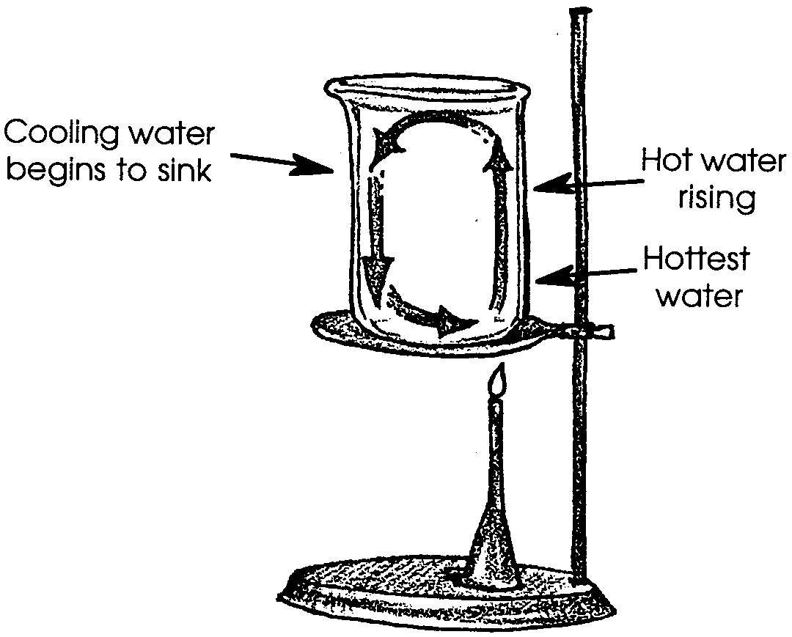
2.

3. a. While the answer depends upon the experimental results, the sawdust generally begins to pile up at the beaker’s edge. This piling up is reminiscent of the mountain building we see in certain parts of the globe.

b. Trenches occur where crustal plates collide.

4. The addition of sawdust where the convection current upwells would make our model more realistic. The sawdust would represent the ocean floor building that occurs along the mid-ocean ridges. This question provides an opportunity for the discussion of models in science and their role in helping us to understand complex systems. Have your students suggest other ways in which the model could be made more realistic.

5. The question calls for an opinion. As such, accept any reasonable answer. In discussion, again emphasize that the forces actually driving the plates are unknown. As noted, most geophysicists now think that the plates are being “pulled” into the trenches rather than being “pushed” by convection at the mid-ocean ridges. In effect, the plates are, because of their higher density than underlying relatively hot crust, falling into the upper mantle. Reiterate that these theories are evolving as experiments are designed, conducted, and data is collected.

The Force

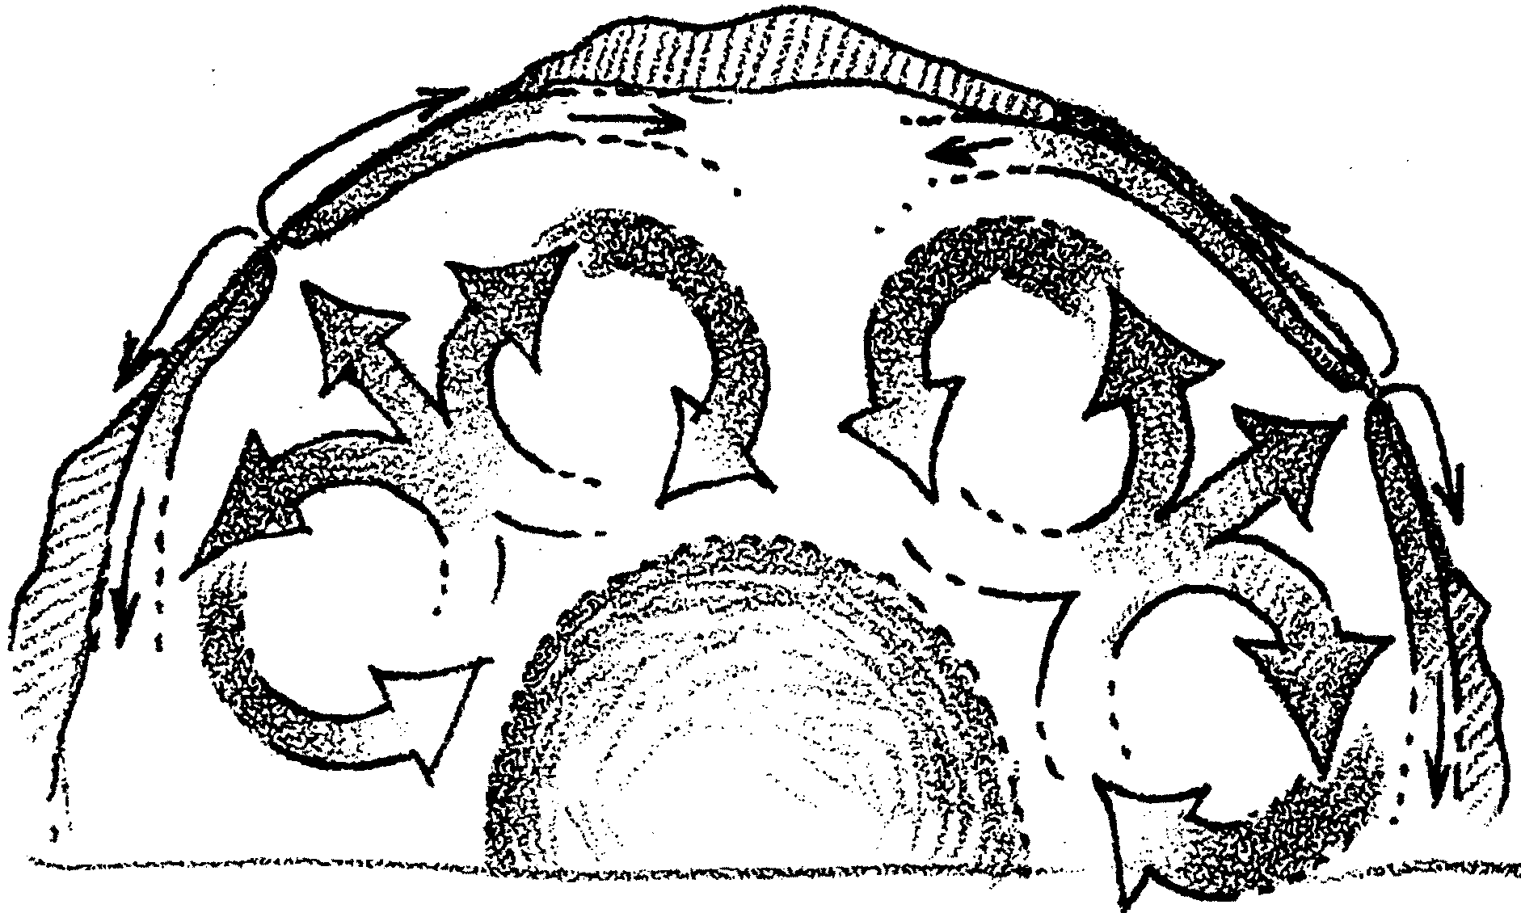
Convection Currents in the Earth

Evidence was mounting to support the “theory of plate tectonics” (from the Greek word “tekton” meaning builder). The theory now involved sea floor spreading, continental movement and mountain building. What was the force behind these moving events?

The growth of the mid-oceanic ridges and the spreading of the sea floor may result from movements below the earth’s crust. Here’s how.

Convection currents in circular patterns are thought to occur in the mantle. The currents form as mantle material is heated and rises. The heated material moves laterally (“sideways”) beneath the crust. This lateral movement drags the thin oceanic crustal layers. These layers are split, or rifted, in the midoceans and spread laterally toward the ocean sides as the cooling current moves back toward the core. The layers pile up and are rammed under the edges of the continents.
In the following activity you will have a chance to see how convection may be responsible for the movement of the earth’s crust.

Materials:
• 500 ml Griffin beaker
• ring stand and ring
• tap water
• Bunsen burner or alcohol lamp
• food coloring
• dropper
• fine dirt
• sawdust or fine wood chips

Procedure:

1. Add tap water to the 500 ml beaker until it is about 3/4 full. Place the beaker on a ring stand.

2. Heat the water slowly by placing the Bunsen burner flame on one side of the bottom of the beaker.
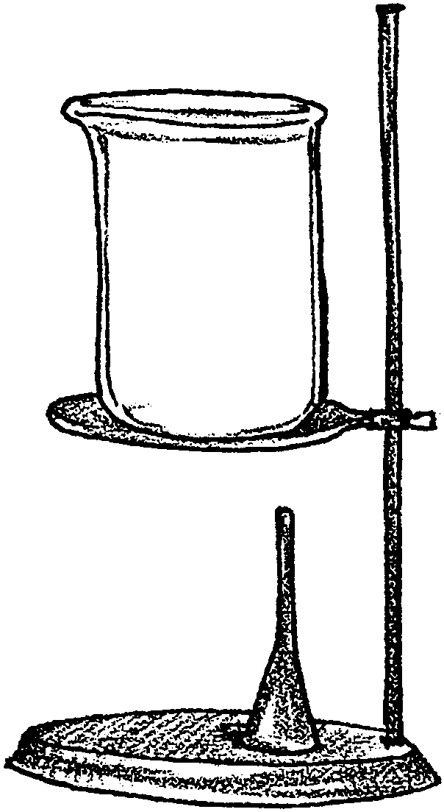
3. As boiling just begins, add one or two drops of food coloring to the water above the flame. The pattern you see is caused by convection. In the beaker to the right, sketch the pattern as you see it.

4. Turn off the Bunsen burner.

5. Add a handful of fine dirt to the beaker. Mix thoroughly.

6. Carefully spread a thin layer of sawdust or fine wood chips over the top of the water.

7. Relight the Bunsen burner. Heat the beaker very slowly (again, one side) and observe the flow of the fine dirt in a convection pattern. Observe what happens to the sawdust as boiling takes place.

Analysis and Interpretation:

1. What caused the convection currents observed in your beaker?

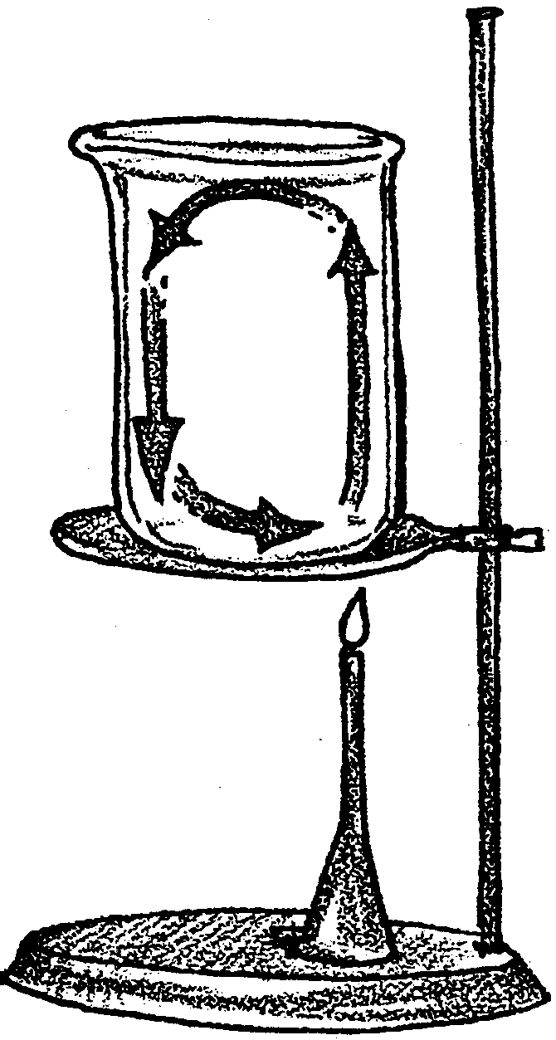
2. On the drawing to the right, label the following:

a. the hottest water

b. the place where cooling water begins to sink

c. the place where hot water is rising

3. a. What happened to the sawdust as it moved sideways and ran into the edge?

b. What feature of the earth’s surface occurs where crustal plates run into each other?

4. The beaker is a model of the earth. It shows some of the same characteristics we see in the earth. To make it a better model, what should we be adding to the surface where the convection current upwells?

5. The forces actually driving the plates are unknown. Most scientists now think that the plates are being “pulled” into the trenches rather than being “pushed” by convection at the mid-ocean ridges. What do you think could cause the plates to be pulled into the trenches? (Hint: The plates are more dense than the hot crust over which they are moving.)

