The Plot Thickens - Paleomagnetism

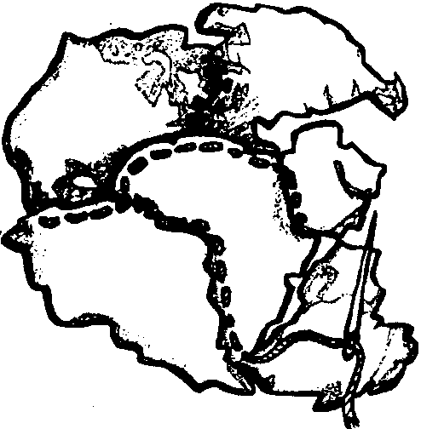
Key Concepts
1. The earth’s magnetic field has shifted many times throughout earth history.
2. Paleomagnetic readings have provided evidence of sea floor spreading.

Background

The study of paleomagnetic readings (the magnetization found within rocks) provided the evidence needed to convince most scientists that the continents had been, and indeed are, in motion. The research which revealed the importance of these paleomagnetic readings is a classic detective story. The evidence provided a major breakthrough and enabled earth scientists to bring together in a cohesive theory many seemingly disparate pieces of evidence. In this activity, your students will have an opportunity to do some of their own paleomagnetic detective work.

Paleomagnetic studies are based on the observation that many igneous and sedimentary rocks contain small crystals of magnetite, a form of iron. When igneous rocks such as the basalts are being formed, the magnetic moment and direction of the magnetite crystals is locked in as the rocks cool. In the case of sediments, a record of paleomagnetism is preserved by alignment of magnetite particles precipitated from the overlying water column and successively buried. In each case, the magnetite crystals act like tiny compasses. The crystals become aligned with the direction of the earth's magnetic field at the place and time where they form or are deposited. Once solidified or precipitated, the magnetic crystals are “frozen” in position and cannot change. These rocks preserve a record of polarity history and plate motions.

Materials

For each student:

• student handouts

• highlighter pens or pencils

Teaching Hints

Duplicate the activity pages. One set per student is recommended. “The Plot Thickens” may be completed as an individual homework assignment or as an in-class assignment. It may also be completed by pairs of students. Both techniques have merit and the method you choose should be the one that best serves the needs of your particular class. Use yellow highlighter or orange felt pens to color in the north oriented domains. These colors permit your students to see the arrows through the color. You can obtain the same result by light shading with a pencil. It is helpful to be able to see the arrows through the shading because it allows a ready check of accuracy. Allow time for a discussion of the concepts involved in this activity and to provide answers for the “Analysis and Interpretation” questions.

Key Words

anomalies - deviations from common rule

crustal plate - section of the earth's crust; may be made of oceanic crust, continental crust, or both

magnetite crystals - common black iron oxide

magnetometer - device used to read the intensity of a magnetic field

mid-ocean ridges - underwater mountain ranges found at spreading zones

paleomagnetism - the study of the polarity found in old rocks

polarity - the alignment of magnetic particles in response to a magnetic field.

Answer Key

1. The oldest/youngest rocks are closest to the mid-ocean ridge. (The correct answer is underlined)

Analysis and Interpretation

1.,2. See accompanying “Magnetometer Readings” key.

3. a. This question requires a value judgment by your students. As such, there is no right or wrong answer. Historically, the evidence was sufficient to convince some scientists, not sufficient to convince others. This question should serve as a springboard for a discussion of the acceptance of new ideas by the scientific (or any) community. People, including scientists, find it very difficult to abandon old beliefs even in the face of large amounts of evidence showing that their current ideas are not valid. It takes an overwhelming amount of evidence to convince scientists to change their outlook on fundamental matters. It has been said, in fact, that scientists never do change their minds. They just die off and the new generation accepts the new ideas. There may be some truth in this theory.

b. Yes, the evidence becomes more convincing when you add information about the shapes of the continents and the similarities of plants, animals, and rock formations from distant continents. The more information and the greater the number of sources of origin of the information the more difficult it becomes for people not to accept a theory.
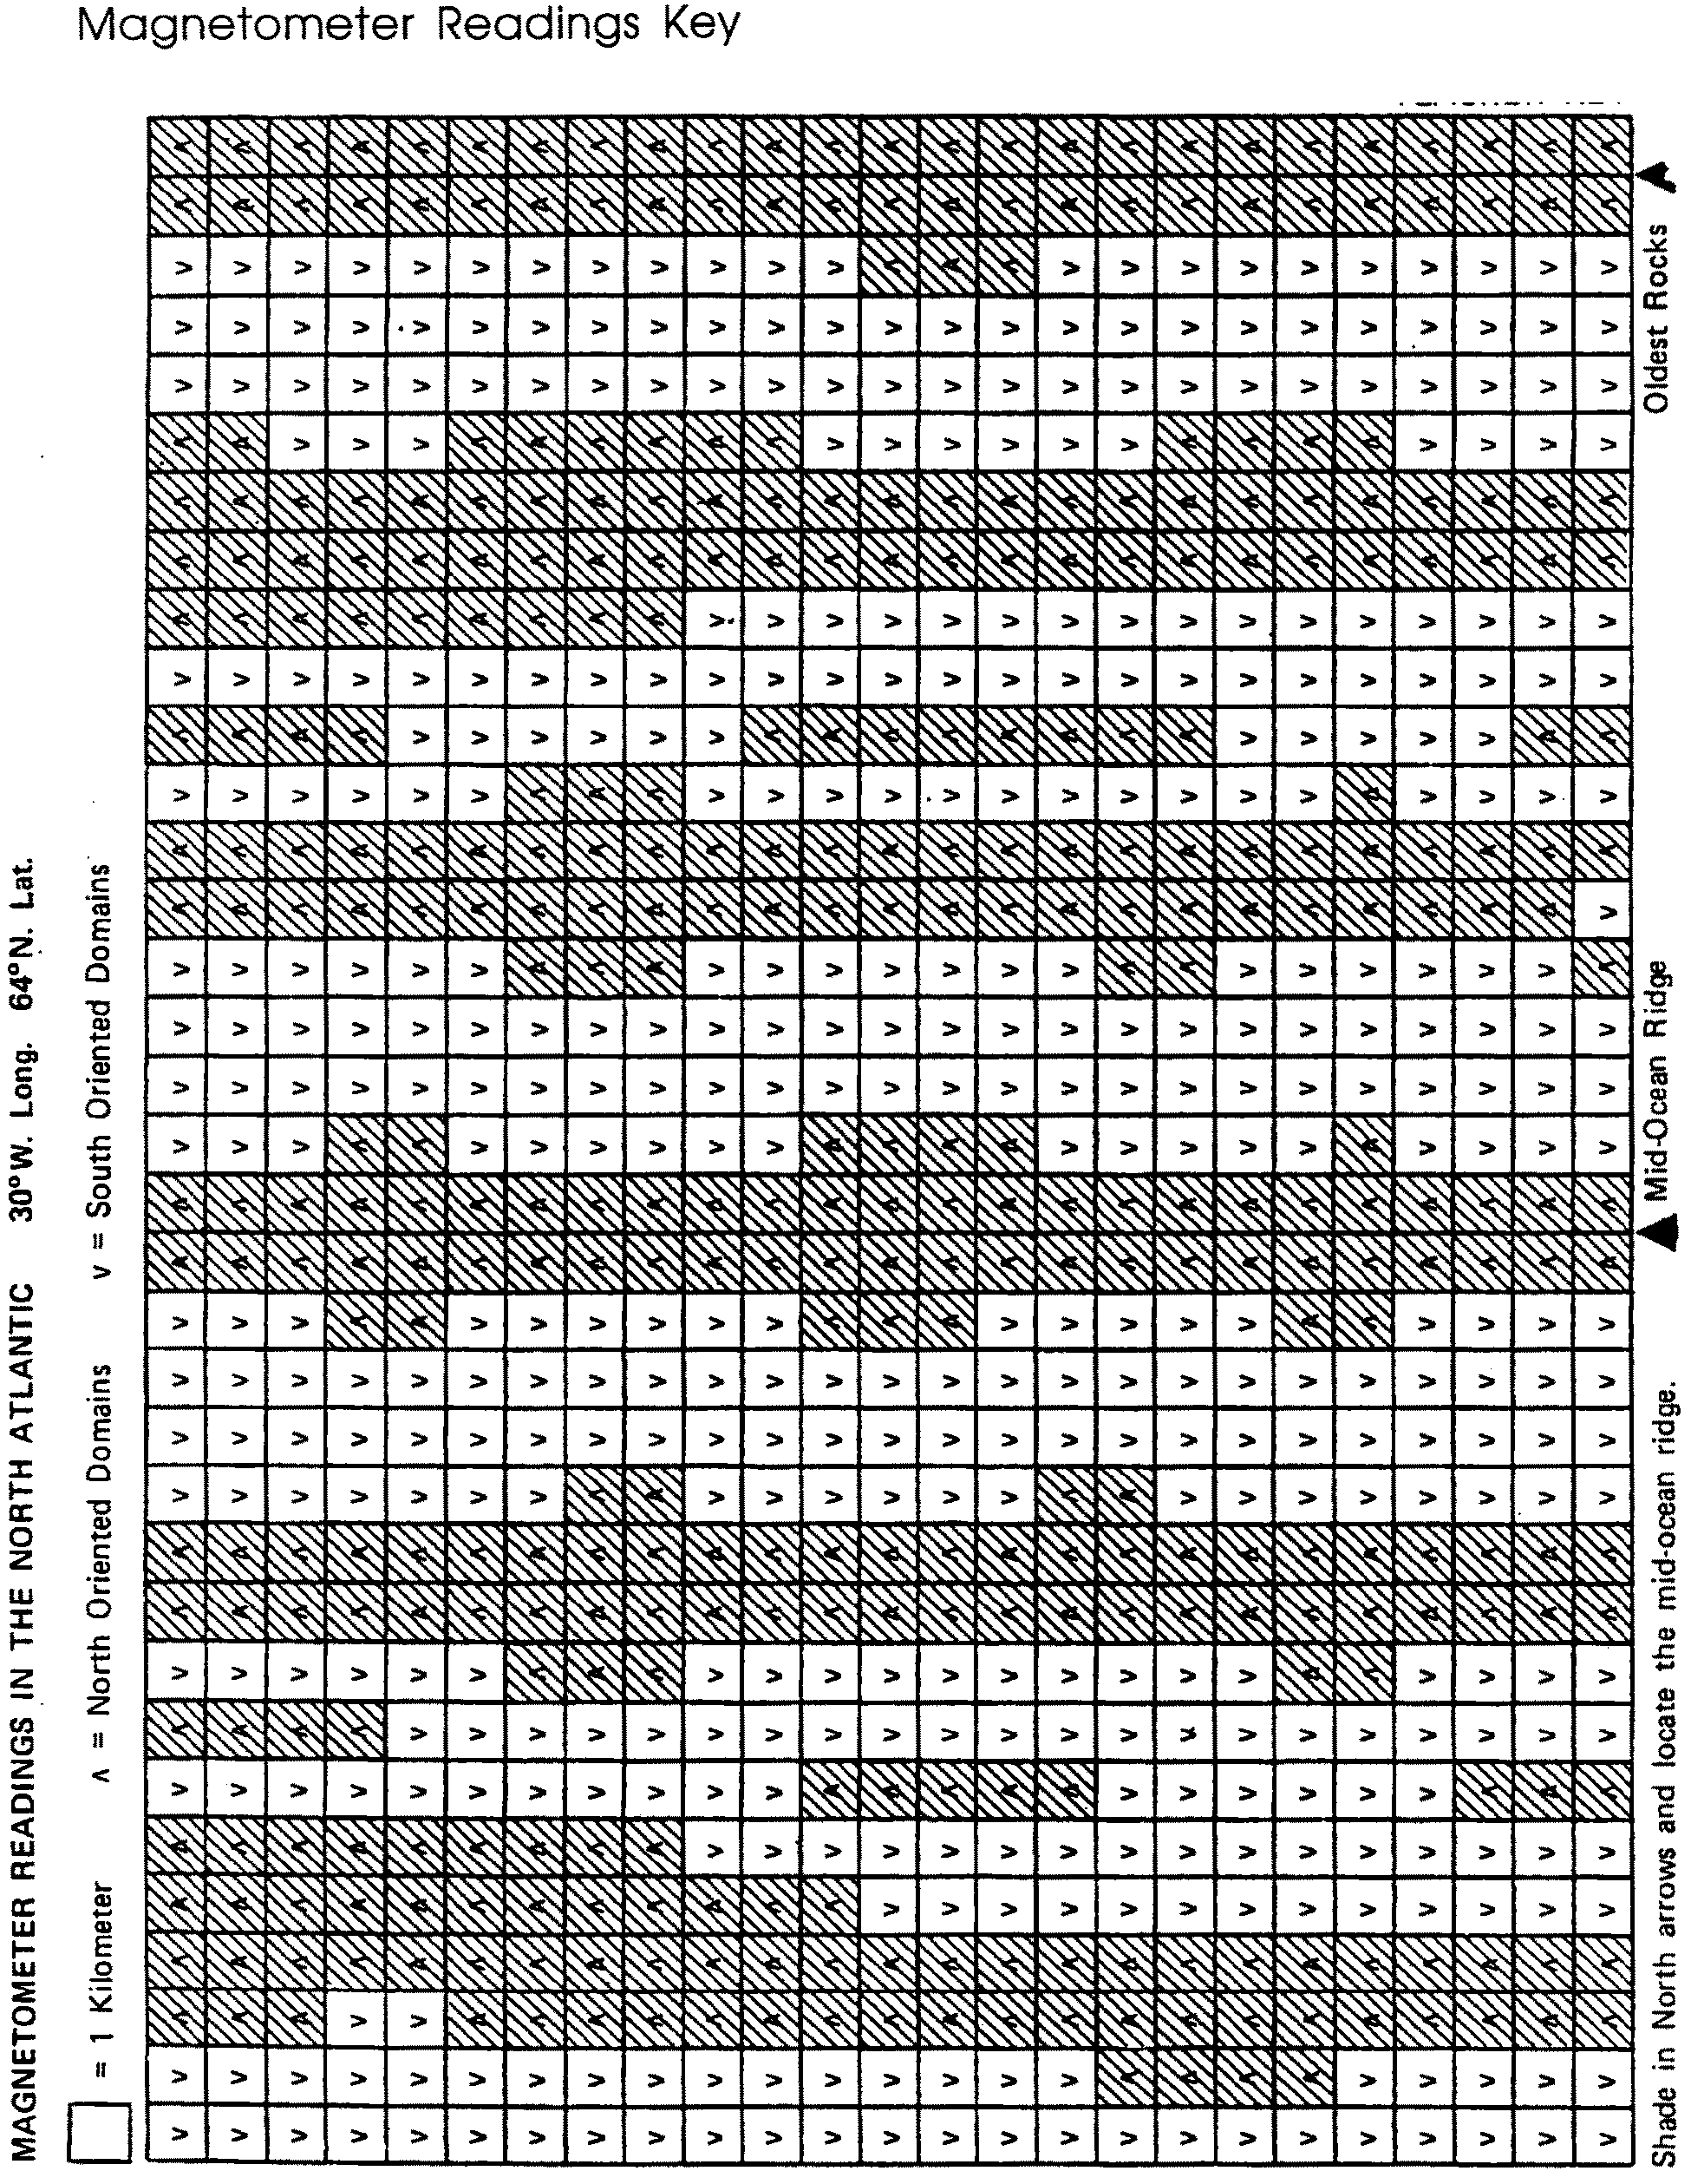

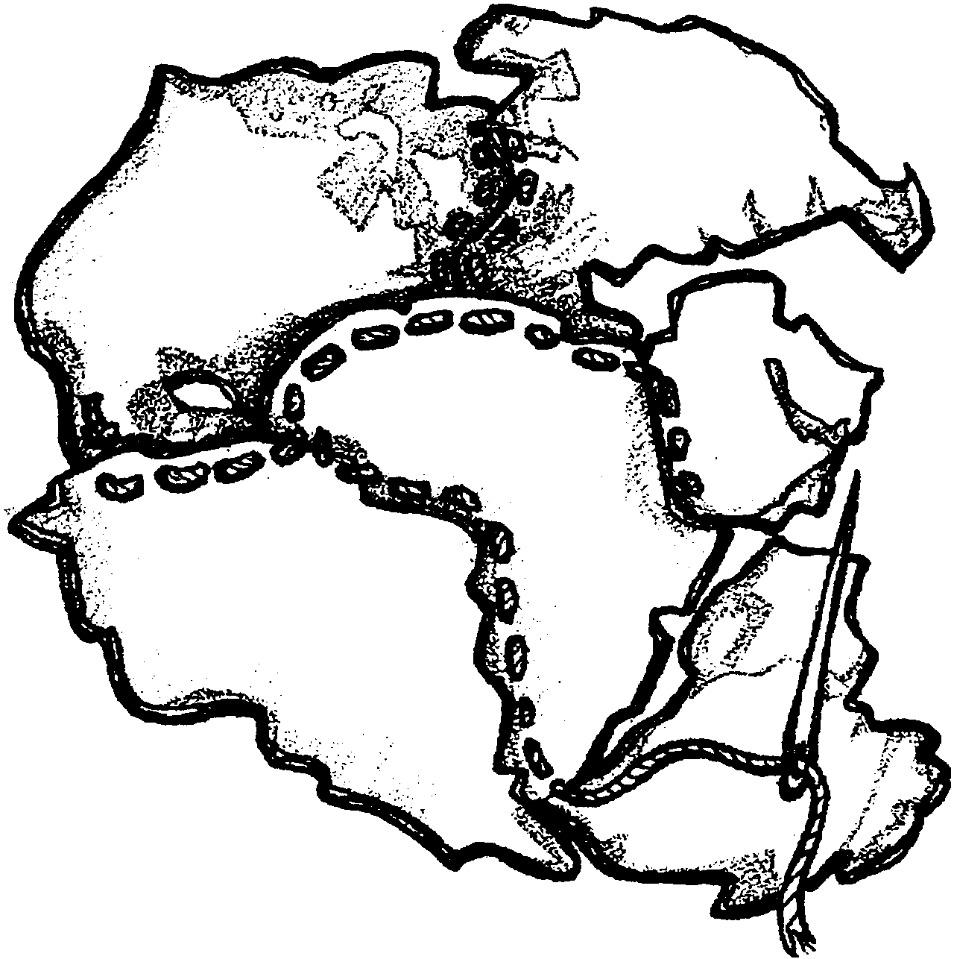
The Plot Thickens - Paleomagnetism

Similar coast lines and similar plants and animals in the fossil record of distant continents were interesting. Interesting, but not enough evidence for most geologists to accept the idea of continental drift. For the first half of this century, the hypothesis of continental drift was not accepted by scientists. In the 1960’s new evidence came to light.

Many rocks contain small crystals of magnetite. Magnetite is a form of iron. When those rocks are being formed, the magnetite crystals act like tiny compasses. The crystals become aligned with the direction of the earth’s magnetic field at the place and time where they form. Once solidified, the magnetic crystals are “frozen” in position and cannot change.

Rocks forming today show crystals which point to the magnetic north pole. But, measurements of the polarity directions in older rocks show that many contain magnetite crystals which do not point to the magnetic north pole. This information suggests that:
1) the rocks have been moved to their present positions;
2) the earth’s magnetic field has changed over time; or
3) both of these events have happened.

During a study of paleomagnetism at the mid-ocean ridges, an interesting pattern was observed. Alternating bands of rock were found. One band showed the magnetite crystals aligned to the north; the next band showed the particles aligned to the south; the third band showed the particles aligned to the north again. Over and over, across the entire width of the Atlantic Ocean, these alternating bands of rock were seen. This banding seemed to support the idea that the earth’s magnetic field has changed over time.

The bands were of varying widths, but eventually a pattern was discovered. The pattern of magnetic shifts east of the mid-oceanic ridge was essentially a mirror image of the pattern to the west of the mid-oceanic ridge.
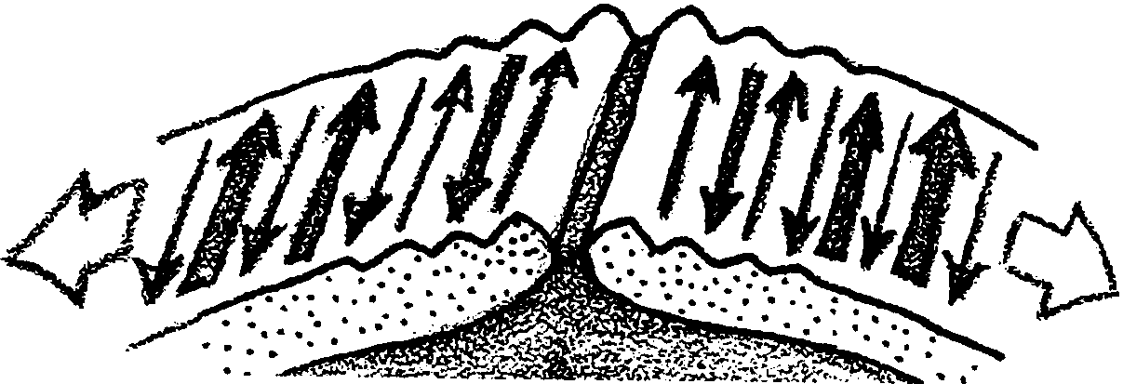

This pattern supports the idea that as new crust is formed at the mid-oceanic ridge, it pushes the older crust out of its way. Some crust is pushed to the east and an equal amount to the west. Any change in the earth’s magnetic field would be “recorded” in the new crust as it formed. Essentially, then, the sea floor spreads out from the mid-ocean ridge.

The following diagram shows the expected pattern as the sea floor expands.
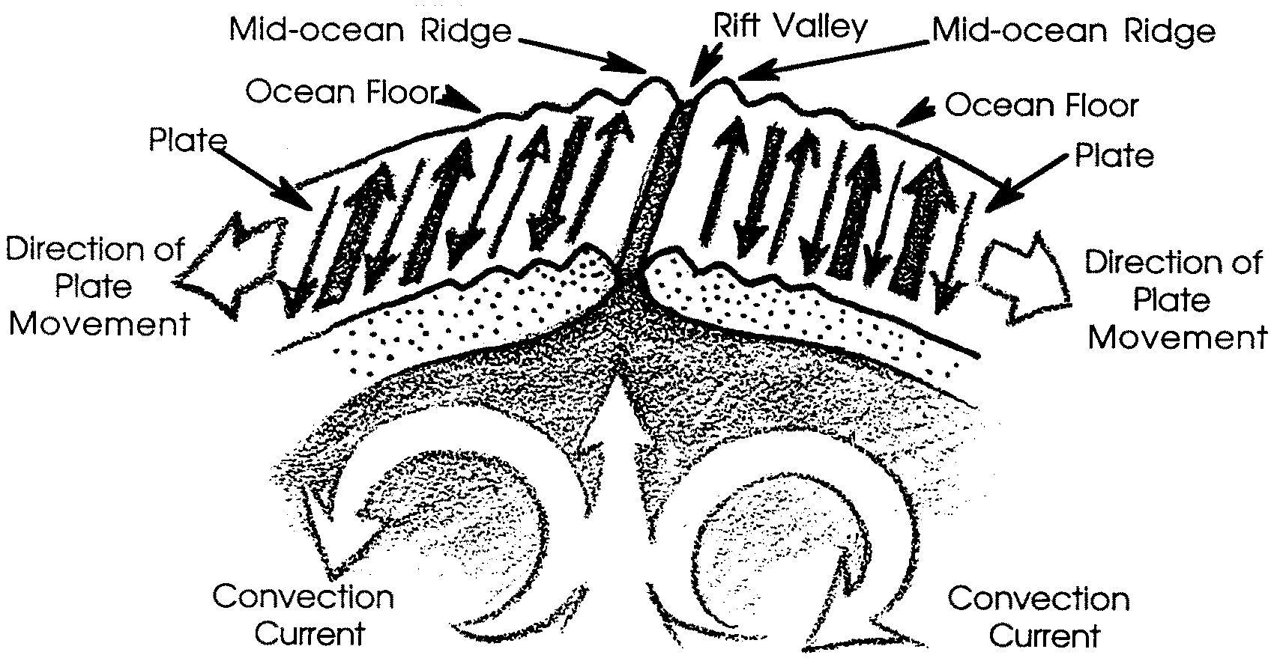

1. The oldest / youngest rocks are closest to the mid-ocean ridge. (Circle the correct answer).
In the following activity you will have an opportunity to use paleomagnetic readings to locate the mid-Atlantic ridge.

Materials
• magnetometer readings sheet
• pencil or felt tip marker

Procedure

1. Obtain a magnetometer readings sheet. A magnetometer is the instrument used to collect paleomagnetic readings.

2. Use your pencil or highlighter to shade in the North arrows.

Analysis and Interpretation:

1. On your sheet, locate the mid-Atlantic ridge and place a circle around it. (Hint: look at the diagram on the proceeding page).

2. Place an X where the oldest rocks are found.

3. a. Would you say that the information gained from the investigation of sea floor spreading is sufficient to convince scientists that continental movement occurred?

b. Does the evidence become more convincing when you add information about the shapes of the continents and the similarities of plants, animals and rock formations in distant continents?

