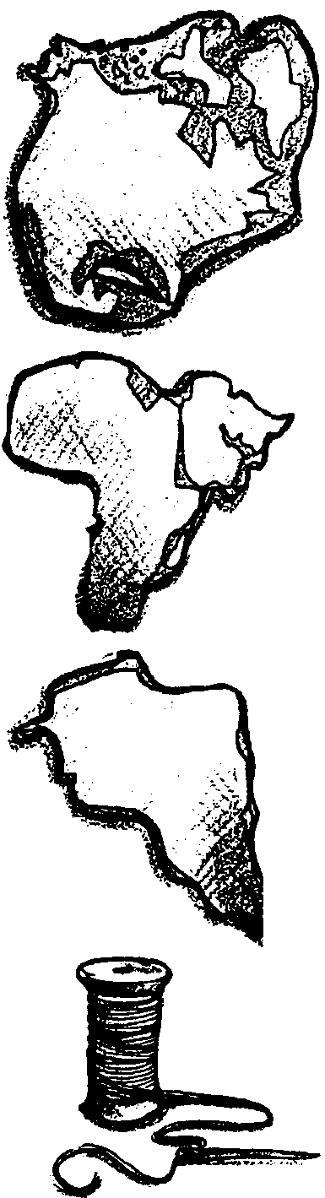
Reunite Pangaea
Lesson by Mike Vollmert - Oxnard, CA

Key Concepts
1. The land masses on our earth are slowly changing shape and have been moving for many millions of years.
2. Present coastlines give scientists an idea how the continents may have fit together to form the supercontinent of Pangaea.
3. Fossil and geological evidence that the land masses of the world were once united was uncovered long before plate movement was understood or accepted.
4. Using logical reasoning, it is possible to reconstruct a map of the supercontinent Pangaea with this evidence.

Background

As early as 1650, writers were commenting on the similarities of the coastlines of eastern South America and western Africa. The idea that the earth is changing was considered unthinkable at that time. Even as late as the 1940’s few scientists were taking the idea of continental drift seriously. No one had been able to explain HOW the continents could move. So where did this theory of drifting continents come from? What gave anyone the idea that certain parts of continents might have been joined to other continents? In this activity your students will have an opportunity to reconstruct the super-continent, Pangaea, using the available evidence.

A little historical background makes the story of continental drift more interesting to your students:

From the late 1700’s through the early 1900’s scientists had attempted to explain the formation of the Earth, its oceans, and its land masses. Three scientists: James Hutton (late 18th century geologist), Alfred Wegener and Alexander du Toit (early 20th century) were the prime players in proposing what is today the prevailing theory of how our continents and oceans came to be. That is, “the Theory of Plate Tectonics and Continental Drift.”

In Hutton’s time, the thought of drifting continents was considered biblical blasphemy. In Wegener’s time, it was considered ludicrous, because no one could explain how the continents moved.

It wasn’t until the symmetry of seafloor magnetic anomalies and the midocean ridge spreading zones were discovered on the ocean floor in the 1960’s that the continental drift idea was accepted as scientific fact. Continental drift was unified with the theory of plate tectonics (plate movement) to explain how the Earth’s crust is composed of sections, or “plates”. These plates move on currents in the mantle below, and carry the continents with them.

Teacher reference:

Hallam, A. “Alfred Wegener and the Hypothesis of Continental Drift”, Scientific American February, 1975. pp 88-97.

Materials

For each student:
• world map sheet

• “Reunite Pangaea” student worksheet

• scissors

• tape or glue

• globe, atlas, or world map available for reference

Teaching Hints

“Reunite Pangaea” is the first of several activities designed to trace the observations which led to the formulation of the hypothesis of continental drift and the theory of plate tectonics. Students will examine 10 pieces of evidence for the theory, and use those pieces to reconstruct the super-continent of Pangaea.

This activity works well with groups of two or three. The globe or atlas will enable students to find the places discussed on their worksheets. Once the places are located, students mark their worksheet maps, showing the locations of the evidence. They will then cut out the worksheet map and reassemble it to form Pangaea, based on the evidence they marked on the map. When they have made their most informed guess as to how Pangaea was configured, the students glue or tape the pieces to a blank paper.

Library paste or glue sticks provide quick-drying adhesives. Rubber cement allows the continents to be removed and replaced. Encourage independent work by noting that we can’t give “right answers”, we can only give “best” estimates based upon the information we presently have. Plan to discuss the “Questions to Ponder” upon completion of the activity. Display the finished maps on a bulletin board. The display will enable different classes to compare their maps and it will engender considerable curiosity among other classes.

Key Words

continental drift - theory proposed by Alfred Wegener in 1912 to explain the similarity of coastlines of Africa and South America, and the fossils and rock formations that relate to each other if the land masses are connected. Not taken seriously until a mechanism for moving continents could be explained in the 1960’s.

Pangaea - the single supercontinent that began to break up 200 million years ago

plate tectonics - theory that explains the way continents can move over time: large pieces of the earth’s crust, called “plates” move over the mantle below. Continents are located on crustal plates and move with those plates. Although various theories have been proposed, the forces driving the plates are unknown.

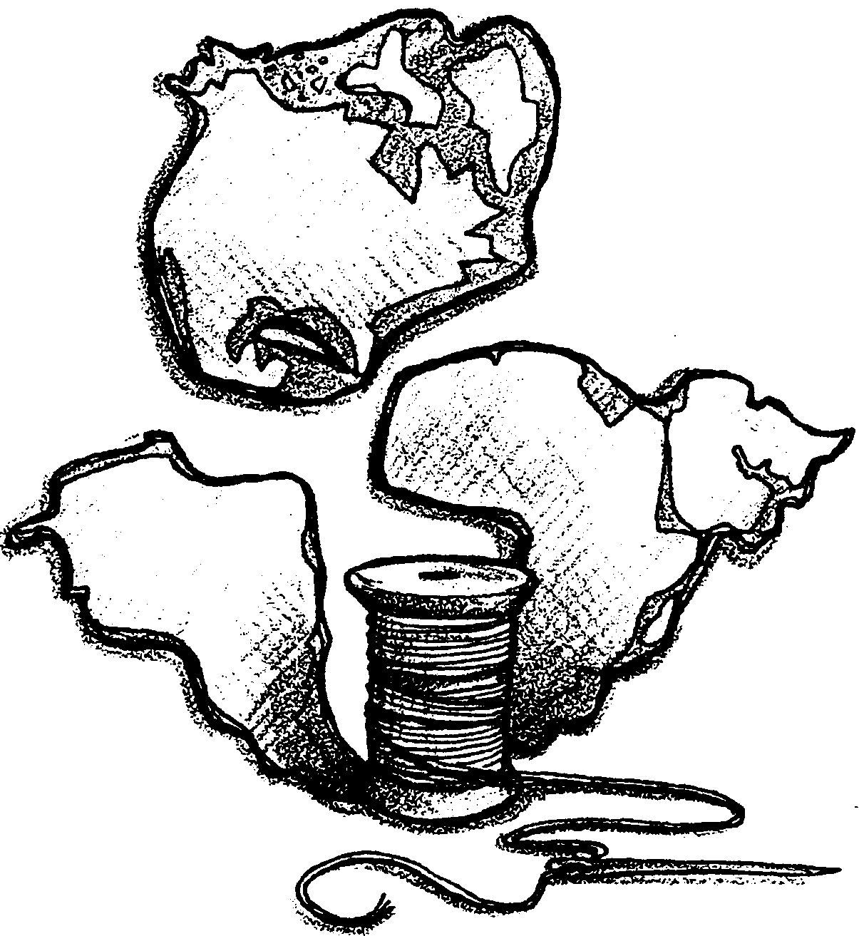
Reunite Pangaea

How did the oceans come to be? For thousands of years people have asked this question. From the late 1700’s through the early 1900’s scientists drifted across continents, making observations. They were attempting to explain the formation of the earth, its oceans, and its land masses. James Hutton (late 18th century), Alfred Wegener and Alexander du Toit (early 20th century) were among those scientists. Each proposed important parts of what is today the prevailing theory of how our continents and oceans came to be. We call their hypotheses “The Theory of Plate Tectonics and Continental Drift”.

In Hutton’s time, the thought that continents were drifting was considered Biblical blasphemy. In Wegener’s time, it was considered ludicrous, because no one could explain HOW the continents moved. As late as the 1940’s few scientists were taking the idea seriously. One prominent geologist, in 1944, asserted that the idea should be abandoned completely. He noted that “further discussion of it merely encumbers the literature and befogs the minds of students”! Until the symmetry of seafloor magnetic anomalies and midocean ridges were discovered in the 1960’s, continental drift was not taken seriously. Today, the theory is considered one of the most significant advances in the history of science.

So, what was the evidence that first gave Wegener and others the idea that the continents have moved? The pieces of evidence are found in the activity below. Be your own detective and use that evidence to re-create the super continent of Pangaea. REUNITE PANGAEA!

You will need:
• “Reunite Pangaea” worksheets

• scissors

• tape or glue

• world map or globe for help in locating the places named in the evidence

• color pencils, optional

Procedure

1. Label each continent on your world map worksheet (write small).

2. Using maps and/or atlases, locate the places discussed in the following pieces of evidence. Make a brief note about the evidence at the proper locations on your map. You may wish to use color pencils to mark matching locations.

3. Cut out the continents including the continental shelves (shown as dark areas). Be sure to cut along the dotted line that separates India from the rest of Asia.

4. See if you can reunite Pangaea based on the evidence given. Treat the continents like pieces of a puzzle.

5. Glue or tape your map in place. This is PANGAEA!

6. With your group, discuss the questions at the end of the exercise.

7. Compare your findings with others. Then, compare your findings with other resources (textbooks, the library, etc.).

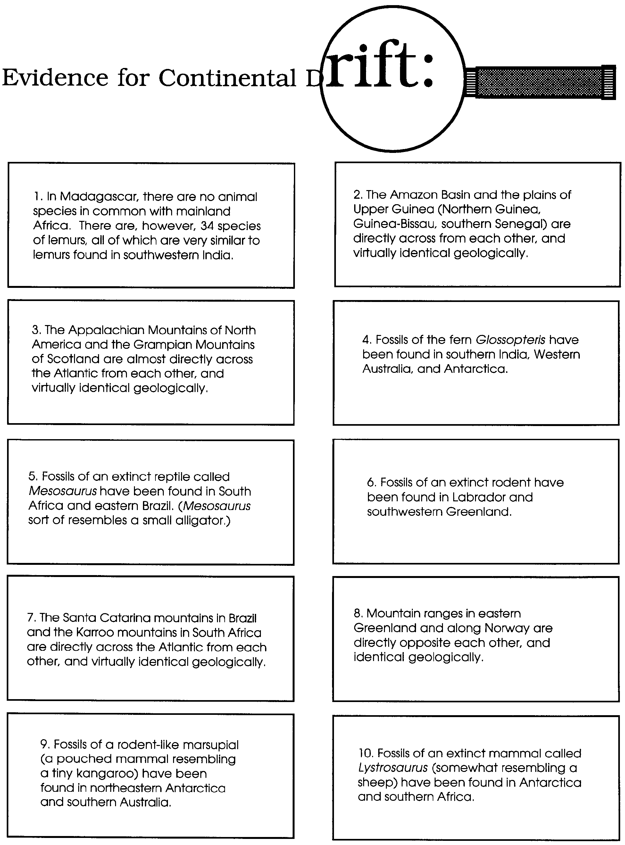
Questions to Ponder

1. There are some very prolific diamond mines in South Africa. What do you suppose the chances are that one could find diamonds in South America?

2. The fossils found in Greenland are of an animal that lived in tropical climates. What does this suggest about where Greenland was once located? What does this suggest about the location of North and South America?

3. The fit between Africa and South America along their coastlines is not exact. How might the fit be better?

4. The dotted line you cut along India is where the Himalayan mountains are located. How do you think those mountains were formed?

5. How would you evaluate the evidence in terms of your fit? Where was the evidence good and where was it bad? Does the evidence suffice, in your opinion, to support the theory of Continental Drift? Please explain your answer.

