The Electronic Whale

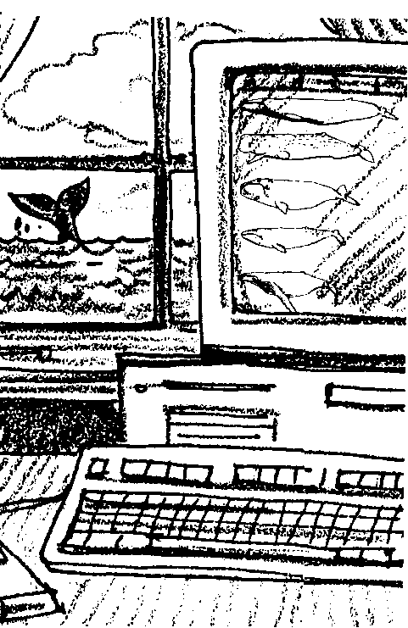
Key Concepts
1. The life environments of the gray whale vary between two extremes, from the frigid feeding waters of the Arctic, to the warm, calm lagoons of Baja California, Mexico.
2. An extensive migration links the gray whale’s dual needs for feeding and for giving birth.
3. Along their migration route, gray whales face obstacles including predators, storms, and whale watchers.

Background

The annual migration of California gray whales from the lagoons of Baja California, Mexico to the frigid arctic is a marvel of endurance. Traversing up to 14,000 miles in a round trip, gray whales may encounter predators, curious humans, schools of food, vessels and a great variety of weather.

“The Electronic Whale” computer simulation models the southern migration of the gray whale. The simulation serves as an effective, and enjoyable, summary activity to look at the greatest migration known to humans.

The following Macintosh computer simulation created by Larry Burtness of Alchemedia is based on a model originally developed by Community Educational Resources of the San Diego County (California) Department of Education and later refined for the FOR SEA curriculum by Michael Schuyler of the Kitsap Regional Library (Washington) for use with Apple II computer systems. A detailed program description follows the “Answer Key” section below. Program disks are available from FOR SEA, P.O. Box 188, Indianola, WA 98342 (206-297-5196).

Overview of Simulation

The California gray whale computer simulation allows your students an opportunity to select real life variables which influence the progress of migrating gray whales from their feeding grounds in the Arctic, to their summer calving grounds in Mexico. Each run of the program allows the individual student to select a starting location, swimming speed, and a final destination. These choices help point out the range where these animals may be found.

The whale is programmed to encounter a variety of natural phenomena such as a Gulf of Alaska storm with varying intensity of the weather, a random food encounter to explain what is thought to happen during such an event, a random killer whale encounter with the potential for attack and destruction of the whale, and random encounters with whale watchers. When the simulation whale reaches the Southern California area, the student will need to choose whether to allow the whale to swim inside the Channel Islands which increases potential harassment by whale watchers, or to swim outside the islands and be free of such disturbance.

The object of the simulation is to get the whale to the lagoon before the time allowed elapses. A 90-day limit is imposed representing the three-month migration. Successful completion is congratulated, and unsuccessful completion generates a suitable remark. The student can then elect to replay the simulation without signing off and restarting.

How The Model Works

Students select one of six starting locations, then one of four destinations. The distance required to travel is calculated within the program. The student then determines an appropriate swimming speed. The speed is required to fall between four and twelve kilometers per hour.

The computer then begins to calculate daily progress by multiplying the student’s speed input times 24 hours. Most scientists agree that a whale will swim continuously in order to arrive at the lagoon on time. A daily progress loop is then entered where the program checks to see if the distance traveled is sufficient to have arrived at the lagoon, or whether the time has run out before the destination was reached.

Along the way, various encounters are possible. Some encounters, such as feeding or predators, are generated randomly within the program. Others are dependent on the specific location of the whale at that moment. For example, one distance dependent item is a storm in the Gulf of Alaska.

Assumptions

The computer program is constructed from the following assumptions. While the assumptions are not without flaws, they provide a reasonable basis for the simulation.

1. Gray whales start from one of six locations. Actually, this is to represent the large area from which whales may start. Many animals migrate all the way north to arctic waters, others only go to British Columbia or somewhere in between. In addition, some gray whales are thought to be local residents along the migration route.

2. Gray whales only go to four principle lagoons in Mexico. In truth, they may be distributed along the range and many lesser lagoons exist in which gray whales are found.

3. Gray whales swim for 24 hours per day. It is believed that they swim continuously although it may be faster sometimes and slower other times. Occasionally one will be observed sleeping near shore, but this is the exception rather than the rule.

4. Gray whales are adversely affected by severe storms. No one really knows what happens for sure. Cetaceans have been seen struggling during severe weather when the surface was covered with foam. Foam does not allow the animal to breathe or support its weight.

5. Gray whales are of interest to killer whales 20 percent of the time, and killer whales are successful in 33 percent of their attacks. These percentages are derived from the work of Rice and Wolman who studied gray whales. No one knows the success rate of these attacks for sure.

6. Gray whales sometimes stop to investigate potential food. Most scientists agree that whales feed very little during migration, but unusual behavior has been reported in areas where squid are known to occur.

7. Gray whales are slowed by whale watching harassment. Since experience has shown that improper techniques can disrupt whales, slow them, and change their course, formulas were estimated to quantify the effect. The more severe the encounter, the longer the delay in reaching the lagoon.

8. Gray whales must reach the lagoon to be successful in this simulation. In reality, gray whales have given birth and mated all along the migration route. However, to have a simulation goal, successfully reaching the lagoon within the 90-day period was selected.

Materials

For each student or pair of students:

• “The Electronic Whale” student activity pages

• record sheet

• program disk

• computer and monitor

For the class:

• several record sheets to compile class results

Teaching Hints

In “The Electronic Whale” computer simulation, students model the southern migration of the gray whale. The activity reinforces the obstacles the gray whales face on their annual migration from their summer feeding grounds in the Arctic to their winter breeding and calving grounds in Mexico. Use this activity to tie together and complete our look at a year in the life of the California gray whale. Hopefully, it has been an interesting and profitable experience.

Duplicate the text and activity pages. “The Electronic Whale” is ideally accomplished as a whole class activity followed by simulation runs by individuals or small groups of students.

The simulation requires a computer terminal and monitor. If you do not have ready access to such equipment, a little exploration within your district will likely reveal the presence of a computer which you could utilize for this activity. On the other hand, if your school has a computer lab you could load the program into each computer so that your whole class could do the simulation simultaneously. In any case, have students record their selections and results on their record sheets.

After everyone has run a simulation and completed an individual record, compile the results onto a class record. Duplicate the record and hand it out. Guide the class in a discussion of the variables. Look for patterns and possibilities that influence a whale’s success. Ask if there are any variables that the students can control (yes, whale watching technique). If so, agree on a control (i.e., make a consistent choice of technique) and run the simulations again using the control. Compare the results.

If you are using “Voyage of the Mimi” with this curriculum, “Episode 2: Setting Sail” and “Episode 6: Home Movies” correlate with lesson.

Key Words

assumption - in this case, a supposition, something supposed to be true

encounter - to come upon unexpectedly; to meet with or contend against

model - a simplified description or conception of a system, used to understand the system or as the basis for further study or investigation of its characteristics

obstacles - in this case, something that hinders the migratory progress of the gray whale

simulation - in this case, a computer program designed to represent the behavior or characteristics of one system through the use of the computer system

technology - in this case, technical means; inventions
Answer Key

2. a. Summer food supply is the greatest at locations 1, 2, and 3 (Pt. Barrow, Bering Strait and Bering Sea).

b. Because of the warm, still waters, a newborn whale would have the greatest chances of survival at locations 9, 10, 11, and 12 (Scammon’s and Guerrero Negro Lagoons, San Ignacio Lagoon, Magdalena Bay, and Yavaros).

3. a. Answers will vary according to the whale speeds chosen.

b. Answers will vary according to the whale’s speed. To set up the problem, multiply 24 hours times the selected speed per hour. For example, at 4 km per hour the problem looks like this:

24 hours x 4 km = 96 km per day

At 4 km the whale covers 96 km per day.
At 5 km, it covers 120 km per day.
At 6 km, it covers 144 km per day.
At 7 km, it covers 168 km per day.
At 8 km, it covers 192 km per day.
At 9 km, it covers 216 km per day.
At 10 km, it covers 240 km per day.
At 11 km, it covers 264 km per day.
At 12 km, it covers 288 km per day.

The Electronic Whale
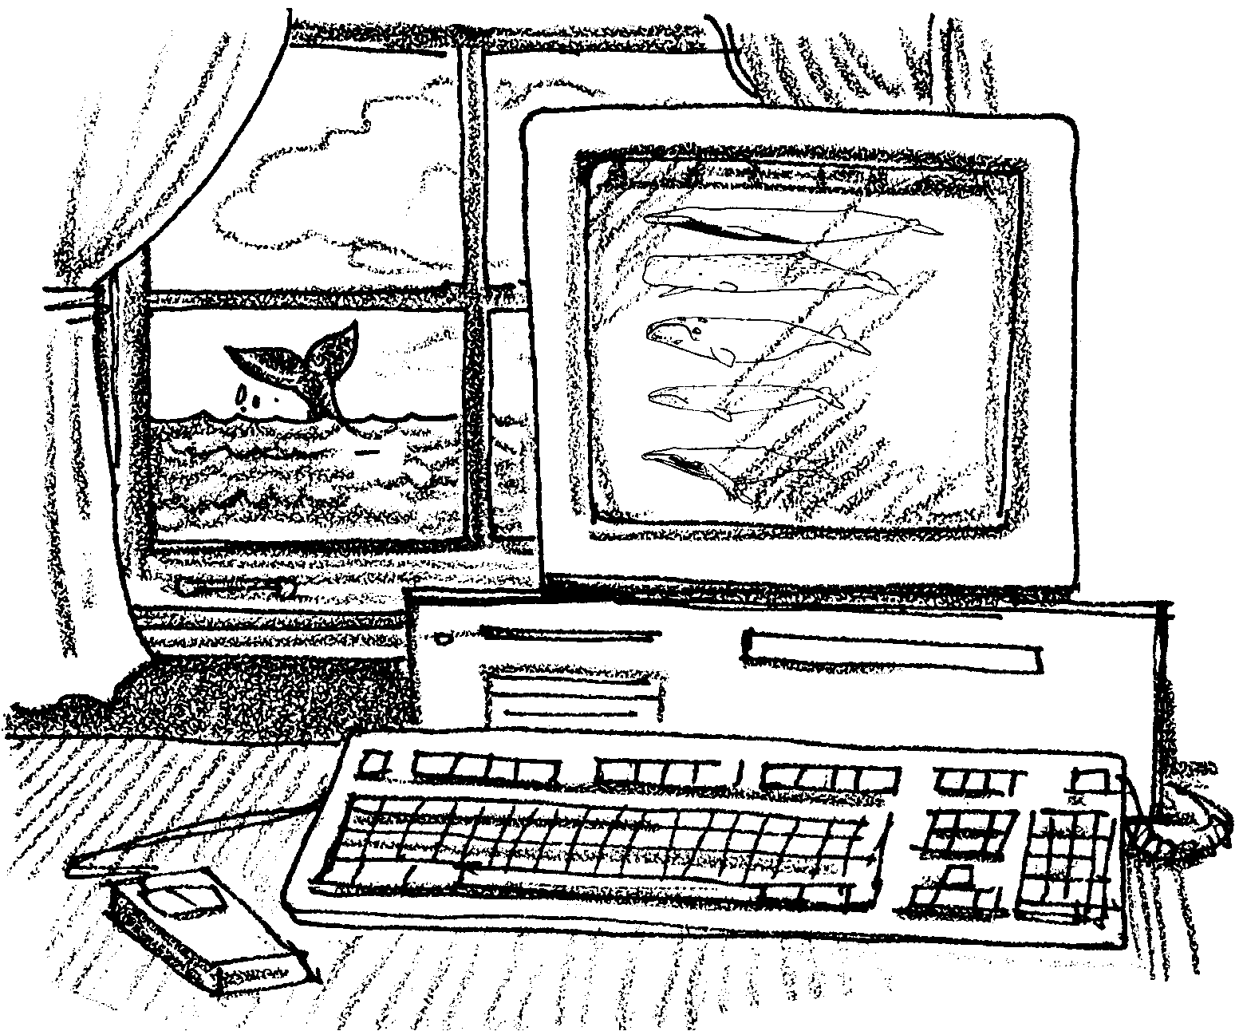
The migration of the California gray whale is a remarkable journey. Gray whales swim from Mexico to the Arctic and back each year. The trip covers some 22,000 kilometers (14,000 miles). The activity which follows is a computer simulation of half of this trip. A computer simulation “models” or represents real life. The “Electronic Whale” allows you to experience some of the things that a gray whale faces on its migration. It also allows you to choose how your whale responds to what it meets. This means that no two runs of the simulation will be exactly alike.

People that create models like this must make some assumptions. An assumption is a statement accepted as true without complete proof. In this model the assumptions are based on what we know about gray whales. Within the limits of our knowledge and technology, the simulation represents a good picture of the migration.

Materials
• record sheet
• pencil
• computer
Procedure

1. Start the simulation. (Confused, already? Your teacher can help.)

2. Your first task is to choose a starting place for your whale’s migration. The map below will help you choose.
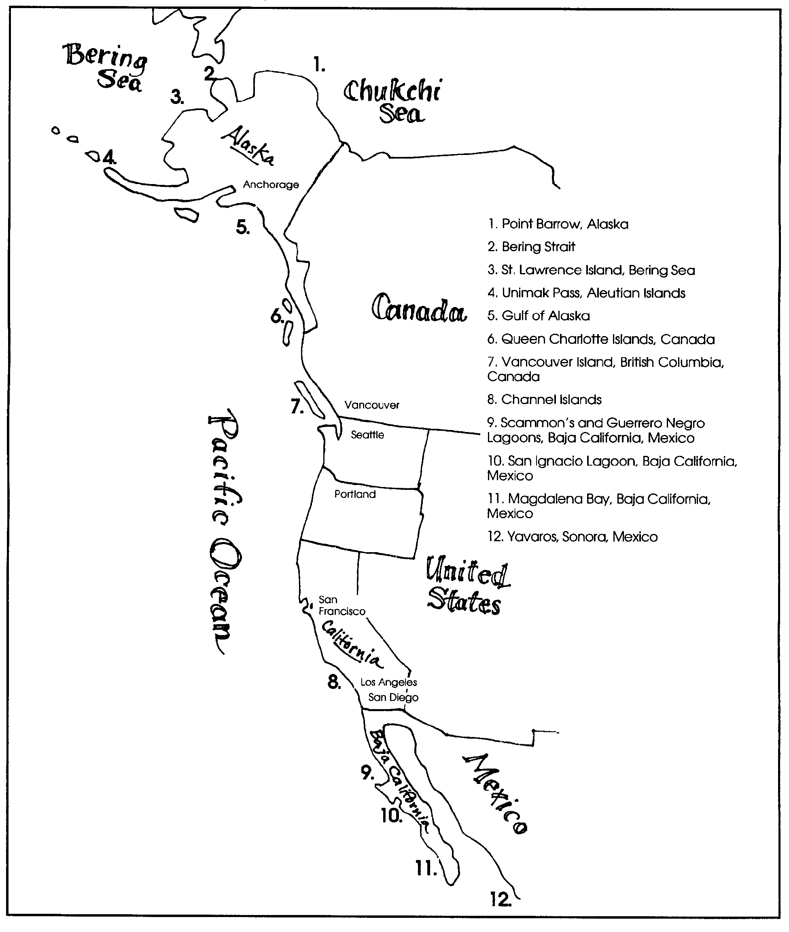

a. At which places would a whale find the most food in the summer?

b. At which places would a newborn whale have the best chances of survival?

3. Next, you need to choose a swimming speed for your whale. Whales can travel for long periods of time at speeds from 3 kilometers to 46 kilometers (2 to 29 miles) per hour. The chart below shows some whales and their long distance swimming speeds.
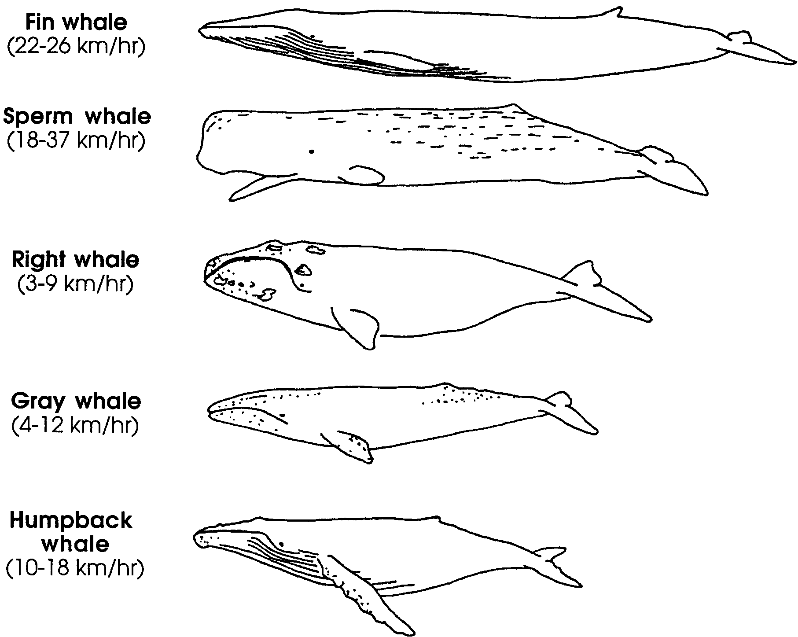

a. Record your whale’s swimming speed here km/hr.
b. Your whale is almost ready to begin the southward migration. The computer is programmed for the whale to swim 24 hours a day. Scientific studies seem to support this assumption.

At your chosen speed, how many kilometers per day would your whale cover? (Hint: There are 24 hours per day).

4. During the trip, the computer presents storms, predators, and some of the other things gray whales face in real life. Read each problem carefully. Then, choose a solution for each problem. RECORD your whale’s progress on the record sheet. Save your record to compare and discuss with others.

5. If time permits, run the simulation a second time. Try to make different choices in each run. When you are finished, compare the two results.

Good luck to your whale and have fun.
