
Whale Symposium

Key Concept
1. Through symposia scientists and others share their discoveries and help each other solve problems.

Background

As an integral part of the scientific method, scientists share their findings with others. Often this sharing takes place in symposia. A symposium is a meeting or conference for the discussion of a particular subject, especially, a meeting at which several speakers talk on or discuss the topic before an audience. Often the opinions expressed or articles contributed by the presenters are collected and published. Such symposia are fertile grounds for the exploration of new ideas and make a significant contribution to the advancement of knowledge.

Materials

• reference materials

• art supplies - (these will vary with the individual projects and your scheme for managing the displays and presentations.)

• large, relatively open space - (if you are going to display everything at once and hold the symposium as a fair, space such as the gym or cafeteria is needed)

Teaching Hints

“Whale Symposium” is a concluding activity in which students plan and conduct a symposium to share projects created from independent and small group research, discuss issues, and make action plans about protecting the gray whale. In conjunction with “The Electronic Whale”, this activity brings you and your students to closure through a celebration of the gray whale.

Your whale symposium may be simple or complex. Do only as much as you have time and energy to do well. While you may choose to act as the facilitator, make students responsible for as much of the planning and preparation as possible. Assign specific tasks and give students a time line for completing the tasks. Consider posting a large calendar which displays important milestones. Make adjustments in the schedule as needed. In making assignments, consider individual strengths and weaknesses and monitor progress to avoid frustration (your’s, as well as the students’).
A list of possible symposium topics is included at the end of this section. You may choose to limit the symposium to one topic from the list and have the whole class make projects and presentations about that topic. Alternatively, you might wish to choose a general topic such as “protecting gray whales” and have individuals and/or small groups make presentations about each of the topics listed. Of course, topics not listed below, but of interest to your students, may be substituted or added to the list.

Read the student text ahead of time. Duplicate the pages and assign the reading as an in-class or homework task. Brainstorm the possibilities and make lists of who will do what. Post the lists where everyone can see them. Be sure each committee and sub committee has a chair and a co-chair who can keep the group on task.

Suggest that students enhance the symposium atmosphere with gray whale art, music (sea chanties), films, and posters showing gray whale biology, anatomy, and geographical distribution. Consider creating characters such as a “sailing whaler”, a “native whaler”, and/or a “whale watcher” to invite to your symposium. Also invite people from your community who have experience with gray whales or any of the topics you have studied in this curriculum.

On the day of the symposium, parents and other volunteers can be helpful in managing symposium details and supervising subcommittees. Since this activity can be good for school public relations, be sure to invite media to help celebrate the learning that takes place at the event, as well as the learning that has taken place during your study of the gray whale in this curriculum.

Most of all, enjoy your students. Celebrate the gray whale. And have fun, yourself!

Topics to Consider for your Whale Symposium:

Marine Sanctuaries - Several national marine sanctuaries lie along the gray whale migration route. Have students research questions such as these: Where are the boundaries of the sanctuaries? What are their regulations? How do they protect the gray whale? How would gray whales be impacted if each adjacent country along the gray whale’s migration route were to make its waters a marine sanctuary?

The Endangered Species List - Have students research the Endangered Species List, Threatened Species List and Protected Species List and then answer questions such as these: What are these lists? How does an animal become listed or de-listed? What protection does the animal receive? How is the protection enforced?
Protecting Critical Habitats - Critical habitats are those places which meet important food, shelter, or protection needs in the life cycle of a species. Critical habitats for the gray whale include the calving lagoons and the feeding grounds. Also important are the areas along the migration route. Have students explore such questions as: What has the Mexican government done to protect the gray whales in the calving grounds? What else needs to be done? What, if any, human activities might impact gray whales on the feeding grounds? How safe and healthy are the gray whale’s critical habitats? How will these places be protected in the future?

Whale Watching and Marine Mammal Harassment - Whale watching is not without its critics and its advocates. Have students investigate questions such as: Is whale watching “good” for the gray whale? Why or why not? What are the best techniques for whale watching without harassing the animals? Should whale watching be regulated? What regulations might be needed? How would the regulations be enforced?

Controlling the Gray Whale Population - Since whaling for gray whales ended, their population has steadily increased in size. Some observers fear that the gray whale population will increase too much. Have students investigate questions such as: Should harvest of gray whales be allowed to control the over abundance of the gray whale population? Is the gray whale population now be in danger of eating itself into trouble? Has the whale population gotten too large for its food supply? Is the commercial value of gray whale products less than their esthetic value to whale watchers? Why or why not?

Whales and Marine Mammals in Captivity - Scientists have learned much from whales and smaller cetaceans in captivity. The captured whales delight and educate people. Have students explore such questions as: Is capturing whales, and keeping them, harmful to the animals? Can it be fatal? How does the lifespan of whales in captivity compare with that of those in the wild? How does captivity affect reproduction? How does the survival rate of whales born in captivity compare with the survival rate of those born in the wild? Should whales be captured and kept in captivity? Why or why not?

Key Words

research - diligent and systematic inquiry or investigation into a subject in order to discover or revise facts, theories, applications, etc.

symposium - a meeting or conference for the discussion of a particular subject, especially, a meeting at which several speakers talk on or discuss the topic before an audience

Extension

1. To celebrate the successful return to Scammon’s Lagoon, have symposium participants each make a mosaic tile (or two) to contribute to a life-size mosaic of a baby gray whale. Use an 8 square x 20 square grid to enlarge the following pattern of a gray whale calf to make a mural about 15' x 6'. Make and label up to 160 mosaic squares, each 9" x 9". Some squares will be water, some whale, some both. Cut 1" squares of colored paper and textured materials to glue to the 9" x 9" squares. Glue the finished 9" x 9" squares to butcher paper and display the mosaic proudly.

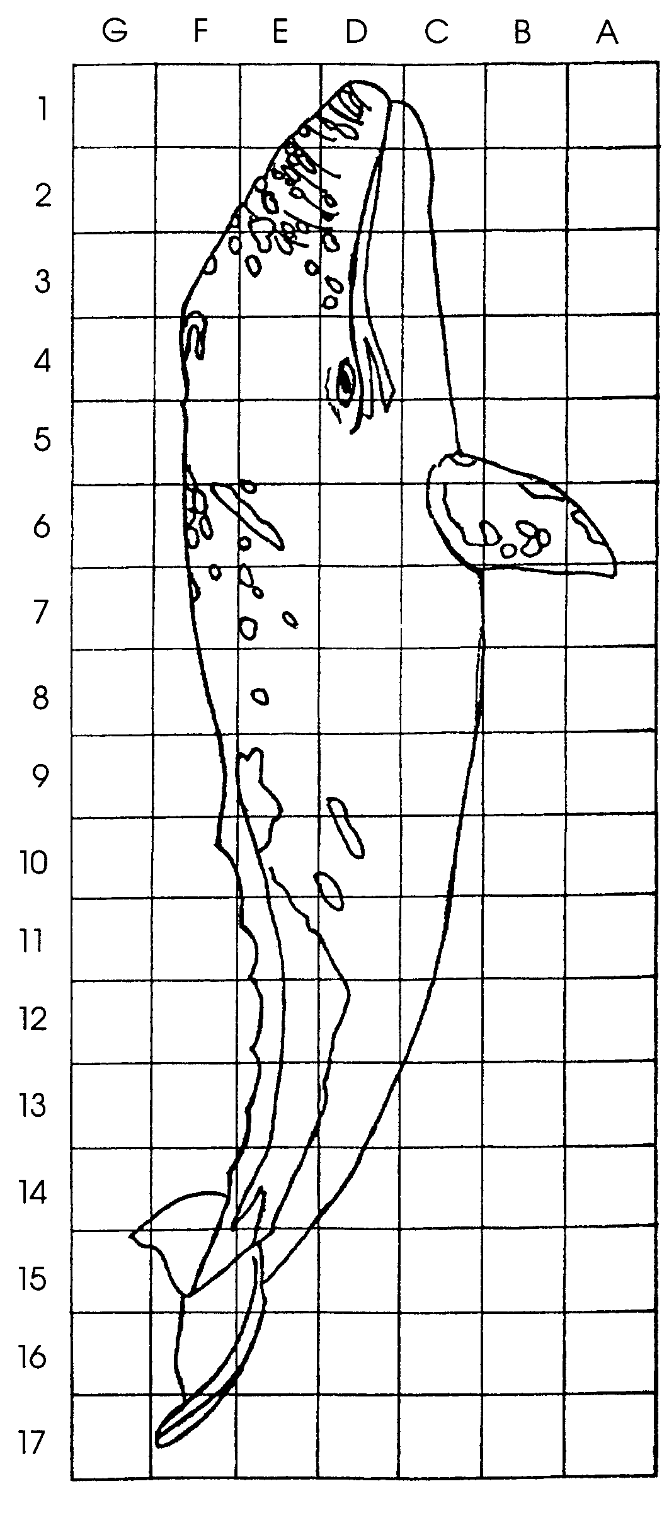


Whale Symposium

Scientists who study whales often meet to share information. Other groups which are concerned about whales also meet often. They share information about issues and make action plans for protecting the whales. Occasionally, a whale symposium is held.

A symposium is a meeting held to discuss a special subject. At a symposium, speakers share what they know about the subject before an audience. Members of many different groups may go to the same symposium. A symposium on gray whales might attract scientists and representatives from government agencies, industry, and other groups concerned about whales. Marine educators, students, politicians, and concerned citizens might also attend.

In this activity you will plan and conduct a whale symposium. Your goal is to bring together people interested in whales. Some people may have information to share. Others may have a problem that needs to be solved. Your task is to help them to share their ideas and to solve problems together.

Here’s what you will need:

• Chairperson (or co-chair persons) - The chairperson leads the Conference committee that runs the symposium. He or she also introduces speakers and events at the symposium.

• Conference Committee - This committee helps plan, run, and clean up from the symposium. On the day of the symposium, committee members may also participate as presenters or audience members. The members of this committee:

• prepare invitations to the symposium

• “call for presentations” from those who will be attending the symposium

• make a “Presenter’s Form” for the presenters to fill out. On the form ask for:
• a description of the subject of the talk
• how the subject will be presented
• the background of the presenter
• special equipment needed, such as a slide projector or overhead projector
• size of room needed

• determine the order in which the presentations are given

• tell each presenter how much time is allowed for each presentation.

• arrange for the location of the symposium

• arrange for food, if it is to be provided

• make an agenda for the program

• make copies of the agenda for those who attend the symposium so everyone knows where to go, what to do, and when to be there

• decorate for the symposium

• provide opportunities for symposium participants to relax and get to know each other (The committee might organize games, prizes, and contests relating to the gray whale.)

• greet and sign in participants at the symposium

• host the symposium (This means making sure everyone is comfortable and understands what to do and when to do it.)
• Presenters and Participants - These people present research information and problems to solve. They share their experiences and knowledge. Differing viewpoints on the problems are also shared. They represent scientists, educators, government agencies, industries, citizens, and others who have an interest in whales. When they are not presenting, they attend presentations and vote to make decisions. These people may be members of the Conference Committee, as well.

Here’s what to do:

1. Your teacher will share with you the subject of the symposium. Your teacher will also provide questions to research and present at the symposium.

2. Choose a question to research and present at the symposium. Presentations can be in the form of:
• interactive discussions,
• speeches,
• dramatic performances,
• videos,
• musical compositions and songs,
• slide shows,
• displays,
• posters,
• booklets, or
• book reviews.

3. Fill in a “Presenter’s Form” about your question.

4. Give your presentation. Learn something. Celebrate the gray whale. Have fun!

Perhaps someday you will attend or help plan a professional whale conference. For now, say good-bye to the gray whale you have followed throughout your studies.

