Count 'Em High, Count 'Em Low


Key Concepts
1. Animal populations in the wild are often difficult to count accurately.
2. One method of estimating populations is by marking and recapturing animals.
3. Population estimates are used to list or delist an animal on the threatened or endangered species lists and to determine quotas for hunting regulations.

Background

Counting animals in the wild can be difficult under the best of circumstances. Counting animals that only show themselves briefly and traverse a 14,000 mile migratory circuit can be more than difficult. As such, a wide variety of methods have been developed to help scientists obtain data from which gray whale population estimates may be made.

Traditionally, three methods of data collection have been most frequently used:

• aerial surveys of the winter range in Mexican waters,
• shore-based sighting surveys along the coast of northern California and at Unimak Pass, Alaska during migrations, and
• aerial or ship surveys on the summer range in the Bering and Chukchi Seas.

In addition, individual whales are photographed in the calving lagoons and elsewhere and photo identification catalogs are assembled. Today, satellites are even used to track migrating whales.

Although estimating whale populations by the mark and recapture method presented in this activity is difficult, the method has provided valuable population data. In addition, the principals of the Lincoln Index (i.e., a certain identifiable individuals are proportional to the population size) are useful to whale researchers employing other methods of population estimation.

The International Whaling Commission (IWC), the only worldwide organization with any responsibility for controlling whaling, is particularly interested in accurate estimates of whale population sizes. The scientific committee of the IWC makes estimates of whale populations and sets harvest quotas based on these estimates. Population estimates are also used to determine if an animal should be placed on the threatened or endangered species lists or removed form those lists. In 1994, the gray whale was the first whale to be “delisted” from the endangered species list.

The scientific committee bases its recommendations on the theory that a population can replace itself if not too many of its numbers are taken. The maximum sustainable yield (MSY) is the term given to the largest number of animals which can be taken from a population and still allow the remaining population to make good the deficiency. The calculations of the MSY however, requires a knowledge of the original population size. Present whale populations are difficult enough to estimate, and estimates of the original populations of the great whales are not much more than educated guesses. These guesses are made on the basis of sightings by whalers (a statistic suspect in itself), by mark and recapture techniques and by comparing the number of whales caught, to the effort involved.

Over the years, conservationists have had many criticisms of the statistical assessments of the IWC. One problem is that the MSY estimate is a technique used to regulate the fishing industry, but may not be useful to control whaling. Fish have a much higher reproductive rate and can more easily replace their numbers than can whales. There is also evidence that social disruption (such as killing members of a group) may reduce reproductive ability of whales. Some studies seem to indicate that below a certain population density, whales may never be able to reproduce enough to recover their losses.

Although once dominated by whaling nations, the make up of the IWC has changed over time. The United States has a powerful role in the IWC which is now almost completely made up of non-whaling nations. In fact, this shift has prompted the few remaining whaling nations to actually consider withdrawing and forming a new commission comprised solely of whaling nations! As an indication of the philosophical changes accompanying the changes in membership, the IWC has taken stands to promote whale conservation, including the enactment of a whaling moratorium and the designation of a whale sanctuary in Antarctica.

Against this changing background, scientists use the tools available to make their best estimates of the sizes of whale populations. A 1991, National Marine Fisheries Service (NMFS) review of the California gray whale in the eastern North Pacific Ocean determined that the stock size had been increasing in recent years at a rate of over three percent a year. In 1993, the members of the International Whaling Commission Scientific Committee and other scientists estimated this gray whale population to be over 21,000, a figure higher than the estimated 1846 prewhaling population of 15,000 to 20,000 for this group. Based on these figures, in 1994 the gray whale in U.S. waters was removed from the endangered species list, although it does remain subject to prohibitions against harm under the Marine Mammal Protection Act of 1972. The NMFS is monitoring the species for five years. If at any time during the monitoring period, the gray whale is threatened, emergency protective regulations will be issued. Unfortunately, the gray whale population in the western North Pacific Ocean has not yet recovered from commercial whaling and remains endangered.

Additional information regarding whale population estimation may be found in:

Allen, K. Radway. 1980. Conservation and Management of Whales. University of Washington Press, Seattle.

Buckland, S. T., J. M. Breiwick, K. L. Cattanach, and J. L. Loake. “Estimated Population Size of the California Gray Whale”. SASS Environmental Modeling Unit, Aberdeen, Scotland and National Marine Mammal Laboratory, Alaska Fisheries Science Center, NMFS, Seattle, in “Marine Mammal Science”, 9(3):235-249, July 1993.

Poole, Michael. 1984. The Gray Whale. Academic Press, Inc. (Harcourt Brace Janovich, Publishers) San Diego, California. Chapter 16, “Migration Corridors of Gray Whales Along the California Coast”.

Reilly, Stephen B. “Population Biology and Status of Eastern Pacific Gray Whales: Recent Developments”. Southwest Fisheries Science Center, NMFS, La Jolla, Ca., in “Wildlife 2001: Populations”, October 1992.

In addition:

The NOVA production, “Swimming with Whales”, narrated by Gregory Peck, shows researchers conducting an ocean transect survey of Humpback whales. The video shows how the transect is set up using latitude and longitude coordinates and how the research vessel is run the along transect lines in search of whales. Populations of gray and orca whales near Vancouver, B.C. are also featured in the production.

Materials

For each pair of students:

• paper bag

• “gray whales” (white beans)

• “other baleen whales” (red beans)

• data sheet

• pencil or marker

• “Count ’em High, Count ’em Low” student text
Teaching Hints

In “Count ’em High, Count ’em Low”, students use red and white beans to simulate the mark and recapture scientific method of counting the gray whale population of the North Pacific Ocean. Part 1 - Direct Counting serves as an introduction to the mechanics of “whale” sampling. Part 2 - The Lincoln Index is slightly more complex than Part 1 and requires that your students carefully read and follow the directions.

Prepare materials ahead of time. Before class begins, prepare brown paper bags of “whales”. Add about 50 ml of white beans plus 100 ml of red beans to each bag. The exact numbers and proportions are not critical.

Duplicate the activity pages. One set is recommended per student. This activity is best performed by pairs of students, as an in-class assignment.

Introduce Part 1- Direct Counting with a brief discussion of the role of models in science. The sampling approach utilized (i.e., selecting a “pinch” of the red and white beans) does not give sufficient information to make a reasonable estimate of the entire population and is included to show the futility of one of the approaches which has been used in the past to estimate whale populations.

Part 2 - The Lincoln Index may profit from an on-the-board demonstration of the proper way in which to complete the Data Chart. Note that the sampling and marking procedure is performed 10 times. By real-life field standards, this is a large number of samplings. It was chosen to demonstrate that the estimates tend to become more similar to each other as the sampling regime is repeated. Estimates also tend to become more accurate as the sample size increases. At its simplest, a good mark-recapture could be done with just two large samplings (the first one being the marking). For example, Cascadia Research Collective’s work with a modified Lincoln Index (called the Peterson Mark/Recapture) with humpback and blue whales usually uses two samples: the whales photographed in one season, and the whales photographed in the next season. The object of this student exercise is not to exactly duplicate actual whale sampling but to show that techniques exist to improve the accuracy of whale population predictions.

Plan to discuss the Analysis and Interpretation sections after your students have finished the activity.

If you are using the “Voyage of the Mimi” in conjunction with this curriculum, “Episode 4: Counting Whales” and “Episode 7: Fastening On” correlate with this lesson.

Key Words

baleen whales - any whale having plates of whalebone (baleen) on the sides of the upper jaw for filtering plankton and/or other food from the water

calculate - to determine by mathematical methods

direct counting - in this case, determining the size of a population by enumerating each individual

endangered species - a species at the risk of extinction because of human activity, changes in climate, changes in predator-prey ratios, etc.; especially when officially designated as such by a governmental agency

estimate - an approximate judgment or calculation

extinction - a coming to an end or dying out; as in the extinction of a species

International Whaling Commission - a quasi governmental organization, with voluntary membership, charged with regulating whale harvest

Lincoln Index - a method for estimating the size of an animal population through marking and recapturing individual animals

population - all the individuals of one species in a given area

quota - in this case, the share or proportional part of the whales to be hunted that belongs to a particular nation

ratio - a proportional relation

sample - in this case, a subset of a population

species - related individuals that resemble one another, are able to breed among themselves, but are not able to breed with members of another species; the basic category of biological classification

threatened species - a species likely, in the near future, to become an endangered species within all or much of its range

Answer Key

Part 1 - Line Transect Sampling

1. Most of your students will be willing to admit that their estimates are not likely to be very accurate.

2. While answers will vary, the estimates are basically guesses.

3. a. While answers will vary, to most students a line transect will not seem like a very reliable way to estimate the gray whale population in the North Pacific.

b. Most students will not think that the observers see all of the gray whales.

c. Answers will vary. As noted, one technique would be to estimate the portion of the ocean surveyed and from this information extrapolate the number of whales in the larger ocean.

4. a. Answers will vary. One possible way would be to take a bigger handful, i.e., a larger sample.

b. Answers will vary. One possible improvement would be to have more observers, i.e., more data (again, a larger sample).

Part 2 - The Lincoln Index

1. & 2. Answers will vary but should appear on the Data Chart and be mathematically sound.

3. a. Your student’s best estimates of the gray whale population will probably be the estimate from Trial 10.

b. Generally the last four estimates will be more similar to each other than the first six are to each other.

c. Answers will vary depending upon the population estimates.

d. In most instances, the average will be the new best estimate for the gray whale population. Exceptions might occur where single estimates are appreciably different and suspect. In cases where one estimate is suspect, an average based on three estimates would prove a better estimate.

4. Answers will vary. If you have counted the white beans before their addition to the bags, you will know the actual numbers.

5. Answers depend upon the experimental results.

6. The mark and recapture technique gives a better estimate of the whale population than the direct count (barring the rare lucky guess).

7. a. Birth causes the population to increase.

b. Death causes the population to decrease.

c. Answers will vary. Generally, with limited data it is not safe to assume that the number of births equal the number of deaths in a gray whale population. For example, during its height, the adverse impact of whaling caused the number of deaths to exceed the number of births. Since the cessation of commercial whaling, births have exceeded deaths resulting in a net increase in population size. These questions are included to allow you to remind your students that our simplistic population model did not take all of the basic factors into consideration.

8. Since the questions calls for an opinion, answers will vary. The question is included to encourage students to recognize that decisions regarding whaling and similar issues are made on the basis of social policy, as well as on scientific knowledge.

By way of background, the Makah Tribe of northwestern Washington state hunted whales from canoes for at least 2,000 years prior to the gray whale’s decimation by commercial whaling. In 1995, the Tribe wrote:

“In the spirit of cooperation, we are seeking IWC approval of our interim ceremonial and subsistence whaling activity to provide our members with the certainty that they can begin to exercise their treaty whaling rights on limited basis without legal impediment”.

While many agree that from a scientific standpoint, the gray whale population could withstand limited hunting, many fear that any resumption of hunting will open the door to renewed pressure for world-wide whaling. As with any complex issue, many points-of-view and many pieces of data must be considered in making decisions.

9. The safest number at which to set whale quotas, based on questionable data available, is zero. Quota numbers greater than the reproductive recruitment of the population threaten whale populations with extinction. The IWC enactment of a whaling moratorium seems to reflect a wise policy that it is best to err on the side of conservatism in establishing quotas. In the future, new data on population size may allow the establishment of higher quotas. Recall that it is always possible to increase the quota if we find there are more whales than we currently think. It will never be possible to recreate a whale that is hunted to extinction.


Count 'Em High, Count 'Em Low

Twice within the last century the gray whale has been on the brink of extinction. We know there are more gray whales now than in 1938 when gray whale hunting was banned. But how many are there anyhow?

The International Whaling Commission must establish quotas (numbers of whales that may be killed). They need to know “how many.” Well, that should be simple enough, just count the whales. In the following activity you will have a chance to see just how easy it is to estimate population size. We are interested in making our best “guess,” or estimate, of the number of gray whales in the North Pacific.

RARE & ENDANGERED CETACEAN SPECIES
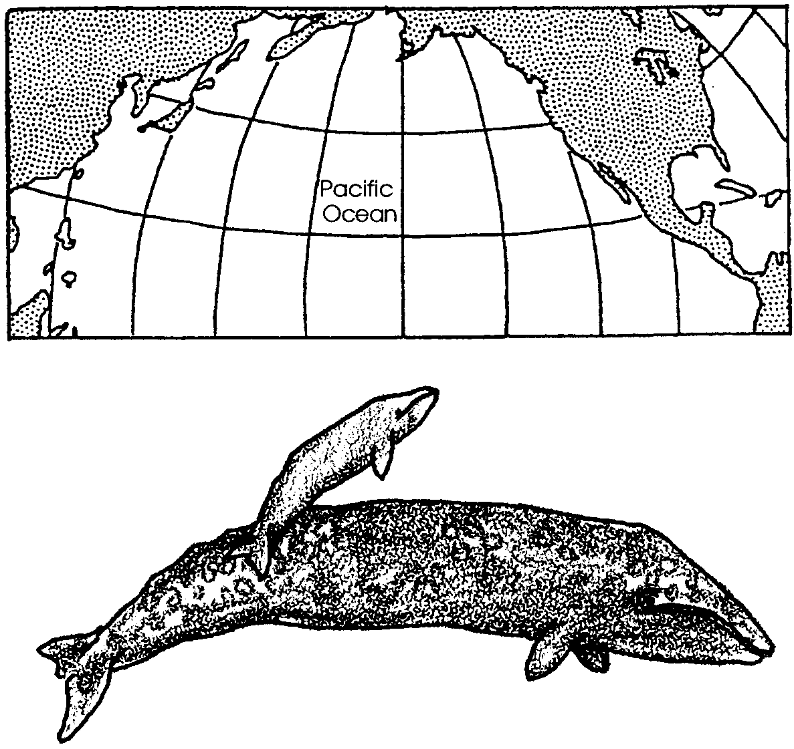
Black right whale

Bowhead whale

Sei whale

Fin whale

Blue whale

Humpback whale

Gray whale

Indus susu (dolphin)

Sarawak dolphin

Pygmy killer whale

Cochito

Spectacled porpoise

Dall’s porpoise

Sperm whale

Pygmy sperm whale

Dwarf sperm whale

Tasman beaked whale

Northern bottlenose whale
Materials:
• paper bag
• “gray whales” (white beans)
• “other baleen whales” (red beans)
• data sheet
• pencil or marker

Part 1 - Line Transect Sampling

One way to estimate the number of animals in an area is by making a “line transect”. To make a line transect, a scientist moves through a known area. As she moves, she counts individual animals. The number of animals seen in the area moved through is assumed to be “proportional” to the number of animals in the whole area. For example, if half the area is moved through and 100 animals are seen, the whole area may be assumed to contain 200 animals. The area moved through is called the “sample area” and the number of animals counted is called the “sample”. Now, make your own line transect to sample gray whales. Here’s how.

Procedure

1. Obtain a paper bag with an unknown number of whales. Place your initials on the bag. DO NOT look into the bag. The bag represents the North Pacific Ocean. The bag contains the population of whales you are interested in counting.

2. Make a line transect of the whales. How? Easy. Reach into the bag and pull out a “pinch full” of whales (no more than 20 or 30). The “reach” is your “transect”. The “pinch full” of whales is your “sample”. The white individuals are gray whales. The red individuals are other baleen whale species.

3. Count the number of “gray whales” (white). Record this information on the data chart. Do the same for the “other baleen whales.”

4. You have now taken a sample of the whale population. From your sample, estimate the total number of gray whales in the North Pacific. Record your estimate on the data sheet.

Analysis and Interpretation

1. As an International Whaling Commission scientist, how accurate do you think your estimate is?

2. On what did you base your estimate?

3. Real whale population sizes are estimated using a similar technique. Observers travel through the waters in which whales live. As they travel they count the whales.

a. Does this seem like a very reliable way to estimate the gray whale population in the North Pacific?

b. Do you think they see all of the gray whales?

c. They don’t think so either. They have to guess the percentage of whales they see. How might you go about guessing the percentage?

4. a. How might you improve your estimate?

b. How might scientists improve their estimates?

Part 2 - The Lincoln Index

How can scientists improve their estimates? In 1930, F.C. Lincoln described the mark and recapture technique for estimating animal populations. The method involves the capturing, marking and releasing of animals into a given population. These marked animals supposedly return to the places they had in the original population as they had before capture. After a certain time, a sample of the population is taken. An estimate of the total population is computed by the ratio of marked to unmarked individuals. Mark and recapture methods are used to estimate whale populations. The following activity will give you an opportunity to use the Lincoln Index mark and recapture method.

Procedure

1. Return the sample of gray and other baleen whales you counted in Part 1 to the North Pacific Ocean bag. Again, reach into the bag and pull out a “pinch full” of whales (no more than 20 or 30). Recall that the white individuals are gray whales. The red individuals are other baleen whale species. Try to maintain this sample size with each grab into the North Pacific Ocean.
2. Count the number of gray whales you grabbed out of the bag (trial one). This number will be designated by the symbol “C” for captured. Enter this number in the column indicating number captured for Trial #1, on the Data Sheet.

3. Once the sample has been counted, mark a simple line on both sides of the bean.

4. Count the number of marked gray whales. Enter this number on the Data Sheet (Trial #l) in the column labeled “Newly marked and released in each trial”. For Trial #1, this figure will be the same number you entered in Column “C”. (See sample Data Sheet)

5. After all the gray whales in this sample have been marked and counted, release them back into the North Pacific bag.

6. Shake the bag well to insure that the newly marked gray whales “swim” randomly back into the population.

7. You are now ready to begin your second catch (Trial #2). BEFORE beginning, look at the first column (Column “M”) of the Data Sheet. It reads, “Total marked in population at start of each trial”. In this case, this would be the number of animals you marked in Trial #1. Enter this number in Column “M”.

8. Now proceed to grab a sample of whales for Trial #2. Use the same technique as you did in step 1. Record this number in Column “C”, Trial #2.

9. If there were any gray whales already marked on this capture, enter their number in Column “N”.

10. Mark the rest of the gray whales in the sample. Count them and enter the number in the column labeled “Newly marked and released in each trial”.

11. For now, leave blank the last two columns of your Data Sheet.

12. Now begin Trial #3. Remember, Column “M” is to be computed BEFORE you grab your sample. ALWAYS compute “M” before each trial by adding the “M” for the previous trial and the column entitled “Newly marked and released in each trial” of the previous trial.
For example, look at the sample Data Sheet. The figure for “M” in Trial #3, is the sum of “M” and the “Newly marked and released in each trial” column of Trial #2.
“M” for each trial is the TOTAL number of individuals you have marked in the population and have put back into the bag . “M” gets greater as you do more trials .
13. Once “M” has been calculated in Trial #3, you may grab a sample and proceed as you did in previous trials. Count, mark, release, and fill in the appropriate columns.

14. Continue the above process through 10 trials. After the tenth trial, return the newly marked gray whales to the bag. Set the North Pacific bag aside.

Analysis and Interpretation

Lincoln’s Index states that the total marked individuals in the population is to the total population as the number of marked individuals captured in the sample is to the number of individuals captured in the sample. Confusing? It may help to write this ratio as follows:

Total marked in population = Number marked in sample
Total number in population Number of individuals in sample

(or) M = N
P C

We are trying to estimate (P), the population size. Since we know (M), (C) and (N) from our sampling, we can rewrite the formula:

P = (M) x (C)

N

1. For trials 1 to 10 fill in the M x C column.

2. For trials 1 to 10 estimate the population (P) by dividing M x C by the appropriate N.

For example, look at the third trial on the sample data sheet. M x C equals 1000. Divide 1000 by N (in the case of trial #3, N = 2) to obtain a population estimate of 500 gray whales, in the North Pacific Ocean.

3. a. What is your best estimate of the gray whale population?

b. Are the last four population estimates more similar to each other than the first six are to each other?

c. If the answer to (b) is yes, determine the average of the last four estimates. (This is easy: Add the four estimates and divide the total by four). Record the average. gray whales.

d. Generally, the average gives us the best estimate. What is your best estimate of the gray whale population? gray whales

4. The moment of truth has arrived. Pour out your bag’s contents. Count the number of gray whales (white). Record the actual number on your Data Sheet, and here:

Actual number = gray whales.

5. The actual number of gray whales is less than/greater than the estimated number of gray whales. (Circle the correct answer).

6. Did the mark and capture estimate give you a better estimate of the whale population than the line transect?

7. These estimates do not include birth and death.

a. How does birth influence population size?

b. How does death influence population size?

c. Is it safe to assume that the number of births equal the number of deaths in the gray whale population?

8. Scientists also use other techniques. Gray whales passing near shore give more information. Scientists are pretty confident in their population estimates for gray whales. They think the population is now about 21,000. The Makah Tribe of Native Americans want to hunt gray whales again. Do you think the International Whaling Commission should let them? Why or Why not?

9. Many scientists say reliable population estimates for other whales are not available. With this in mind, what is the safest number at which to set quotas for these whales? Why?

