The Numbers Game - December 17

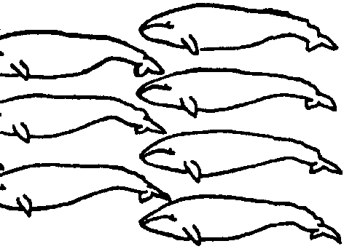
Key Concepts
1. The California Gray whale has been hunted nearly to extinction, but through regulation has recovered.
2. Scientists collect, analyze, and interpret data about the gray whale population.

Background

Twice within the last century humans have nearly exterminated the California gray whale. Fortunately for both whale and humans, changes in the economics of price, supply and demand caused a shift away from the gray whale. Each shift away allowed the gray whale a period during which the species could regroup.

The California gray whale is the only whale population that, following severe depletion, has recovered to near-original numbers. Today, gray whales in U.S. waters are protected under the Marine Mammal Protection Act. They were taken off the Endangered Species List in June 1994 because their numbers had recovered to where they were before exploitation.

We cannot be entirely optimistic about its future, however. The new Baja California Highway has made some of the whale’s calving lagoons readily accessible to small boats hauled overland. Industrialization and pollution of the lagoons will likely accelerate as the human population grows. In addition, proposed oil drilling on or adjacent to the lagoons poses another threat to the future of the California gray whale, the great mammalian migrator. We can only hope that the education we provide today to tomorrow’s decision-makers will enable them to make ecologically sound choices.

Materials

For each student or pair of students:

• “The Numbers Game” student activity pages

For the class:

• overhead transparency of each table and graph to use for demonstration and corrections
Teaching Hints

In “The Numbers Game”, students model gray whale population growth in the Eastern North Pacific using a set of stated assumptions and actual population data. Emphasis is on the population fluctuations caused by whaling, as well as the comeback potential of the gray whale.

The model used in this activity is a simplified version of the elaborate computer-based simulations used by biologists to estimate animal populations. Before embarking on the activity spend a few moments discussing the role of modeling in science. Models help us to pull together a number of seemingly diverse observations into a cohesive, meaningful whole.

“The Numbers Game” involves modeling population growth using a set of stated assumptions. Go over the four assumptions stated in the introduction to the activity. Have your students pass judgment on their reasonableness. In your discussion, note that scientists would make other assumptions to increase the reliability of their results. For example, the model assumes that all of the females produce a calf every other year. Since some of the females in the population will be sexually immature, an additional assumption would be made regarding the percentage of females which are sexually mature.

Duplicate the activity pages. One set is recommended per student. While this activity may be completed by individual students or pairs of students as an in-class or homework assignment, you may wish to have students work together in small groups for this activity. If so, explain that scientists often share their work and data with each other.

It is also possible to combine individual and group approaches by having students complete the activity pages as individual class or homework assignments, then having students meet in small groups to compare answers before a class discussion.

Regardless of approach, each student should have a copy of the questions, tables, and graphs to complete. This helps keep individuals involved in the activity and will indicate the level of understanding of each student. Depending on the time available, Parts I and II may be assigned on consecutive days.

Make an overhead transparency of the tables and graphs to help explain the procedures to the class. You might ask individuals or groups to demonstrate how to fill in the tables and graphs. Be prepared to offer any assistance that may be required to help your students complete the data tables and graphs.

Allow time for a discussion of the “Analysis and Interpretation” sections after your students have completed the activity pages. The overhead transparencies can be helpful during review and correction. Have students keep this activity to use in the following activity, “Whale Symposium”.

If you are using the“Voyage of the Mimi” with this curriculum, “Episode 4: Counting Whales” correlates with this lesson.

Key Words

analyze - in this case, to examine critically so as to bring out the essential elements

assumption - in this case, a supposition; something that is supposed

birth rate - the proportion of births to the total population in a place in a given time

calculate - to determine by mathematical methods

data points - in this case, a point on a graph representing a particular piece of information

death rate - the proportion of deaths to the total population in a place in a given time

esthetic value- worth pertaining to a sense of the beautiful or concerned with pure emotion and sensation, as opposed to economics

estimate - an approximate judgment or calculation

extinction - a coming to an end or dying out; as in the extinction of a species

interpret - to provide or give the meaning of; explain; elucidate

plot- in this case, to determine and mark points by means of coordinates on a graph

population - all the individuals of one species in a given area

predict - to declare or tell in advance

species - related individuals that resemble one another, are able to breed among themselves, but are not able to breed with members of another species; the basic category of biological classification

variable - something that may or does vary

Extensions

1. Have students find out about the population growth and decline of other species of whales that have been hunted. Compare the dates and numbers with the data about the gray whale including the times when other whales been protected or hunted.

2. Using information in the text and other sources, have students make a graph showing the Gray whale population estimates from 1938 to the present.

3. Engage students in the creation of a time line showing the dates of gray whale hunting and protection. The dates and numbers of the population estimates can be included on the time line.

Answer Key

Text questions

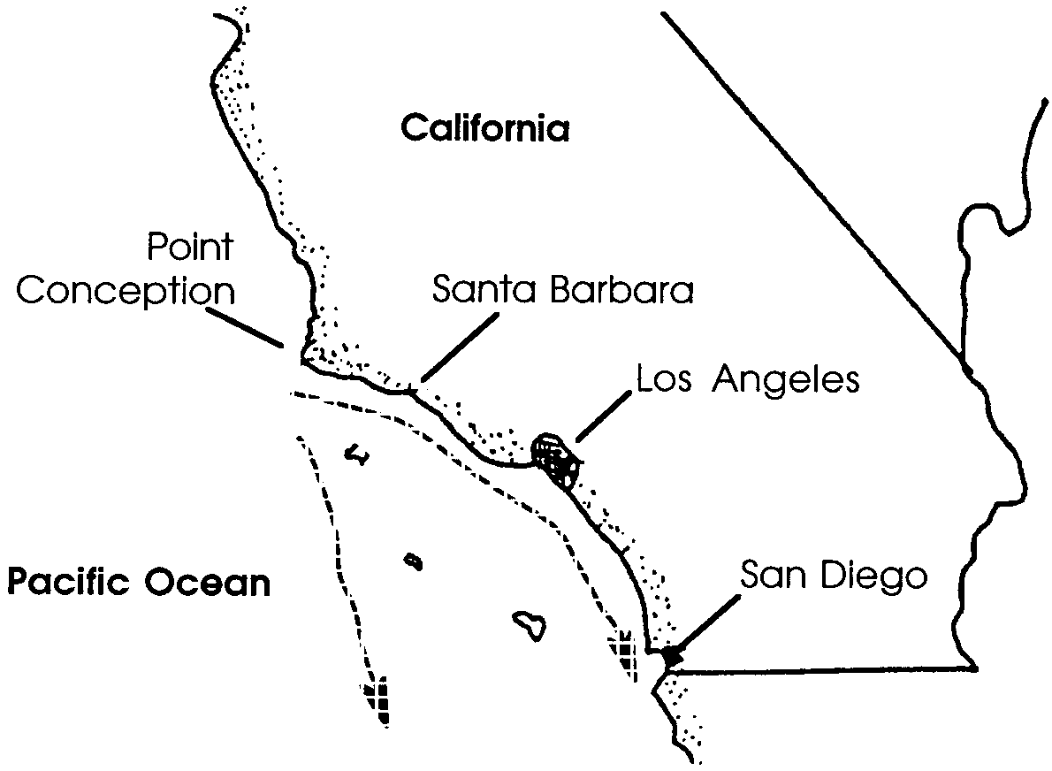
1.

2. If the birth and death rates are the same, the total population size will remain constant from year to year.

3. The last assumption (i.e., 10% of the total population is killed each year by whalers) will cause the size of the whale population to decrease.

Part 1 - The Hunt Is On

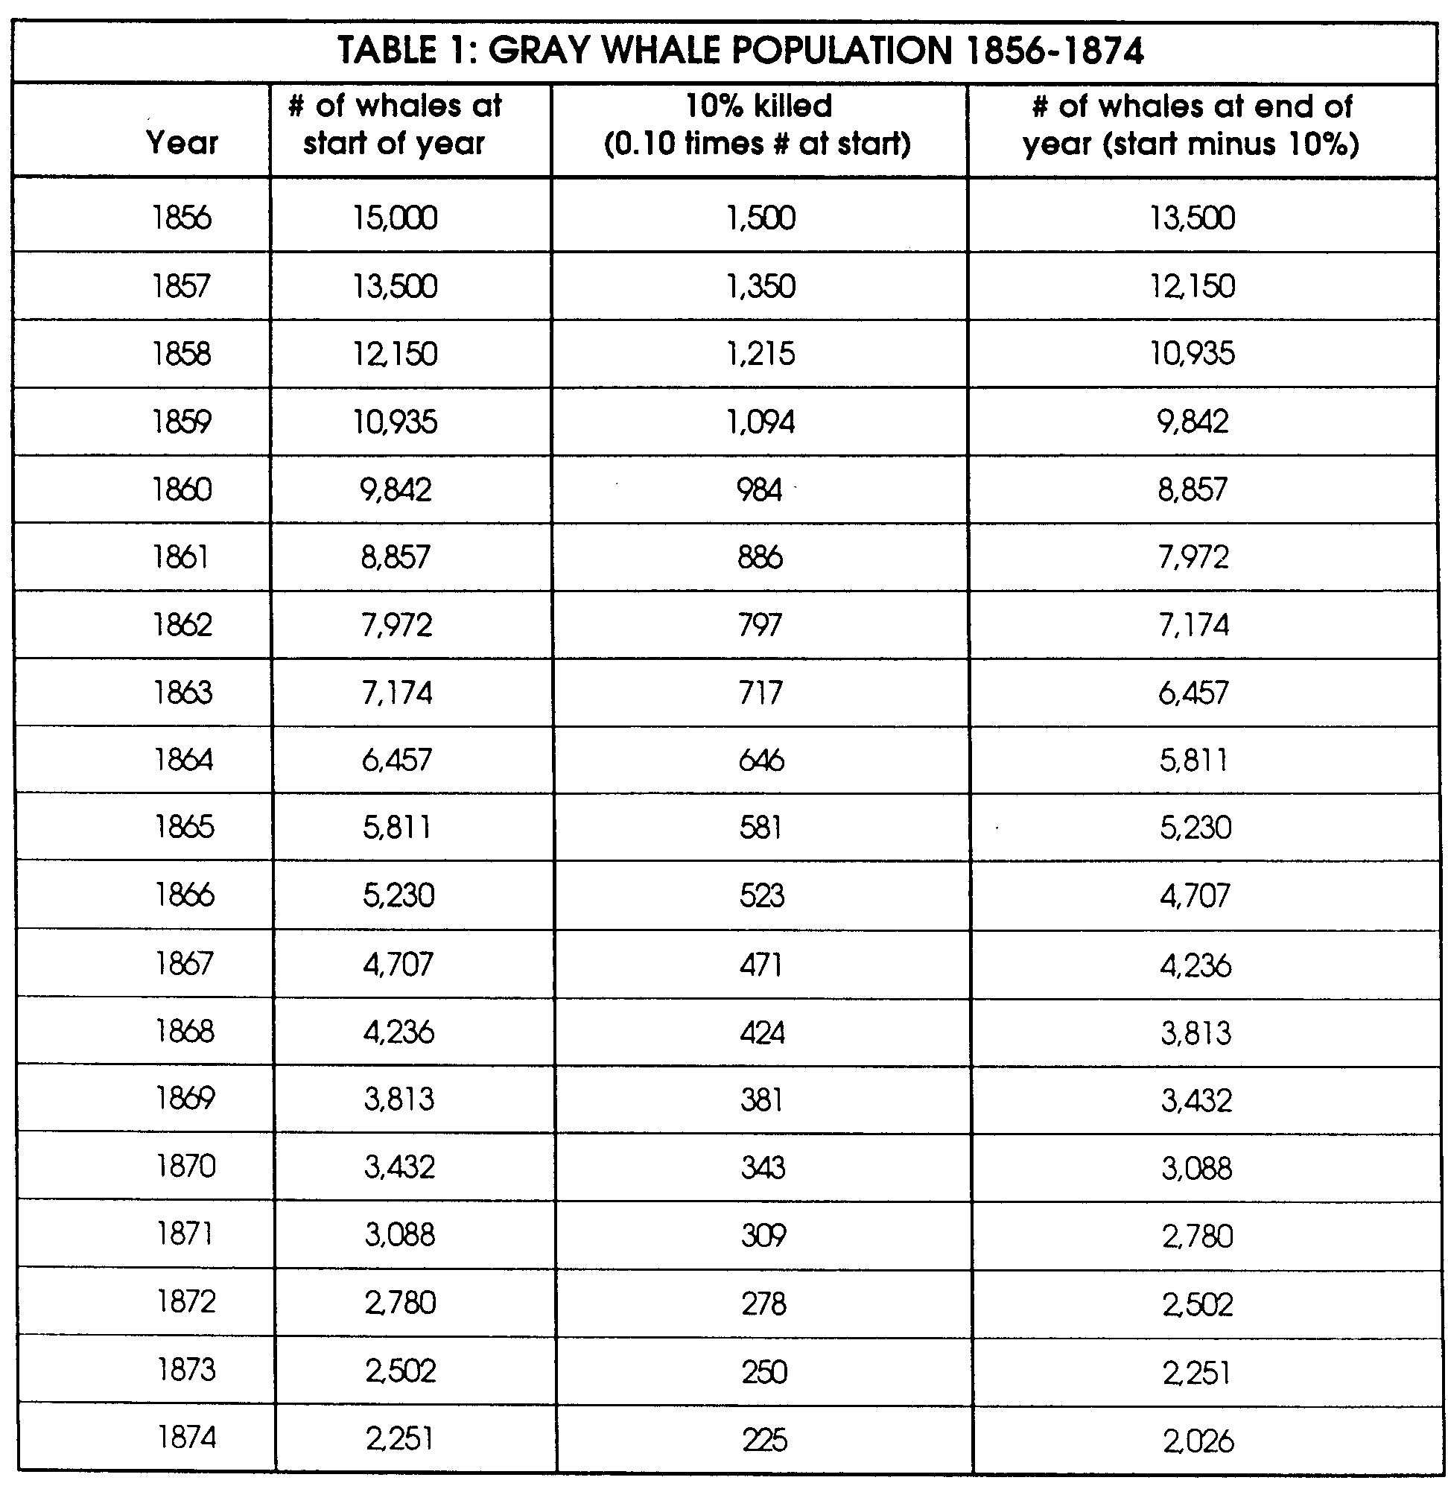
1., 2., 3. A completed data chart and graph follow.

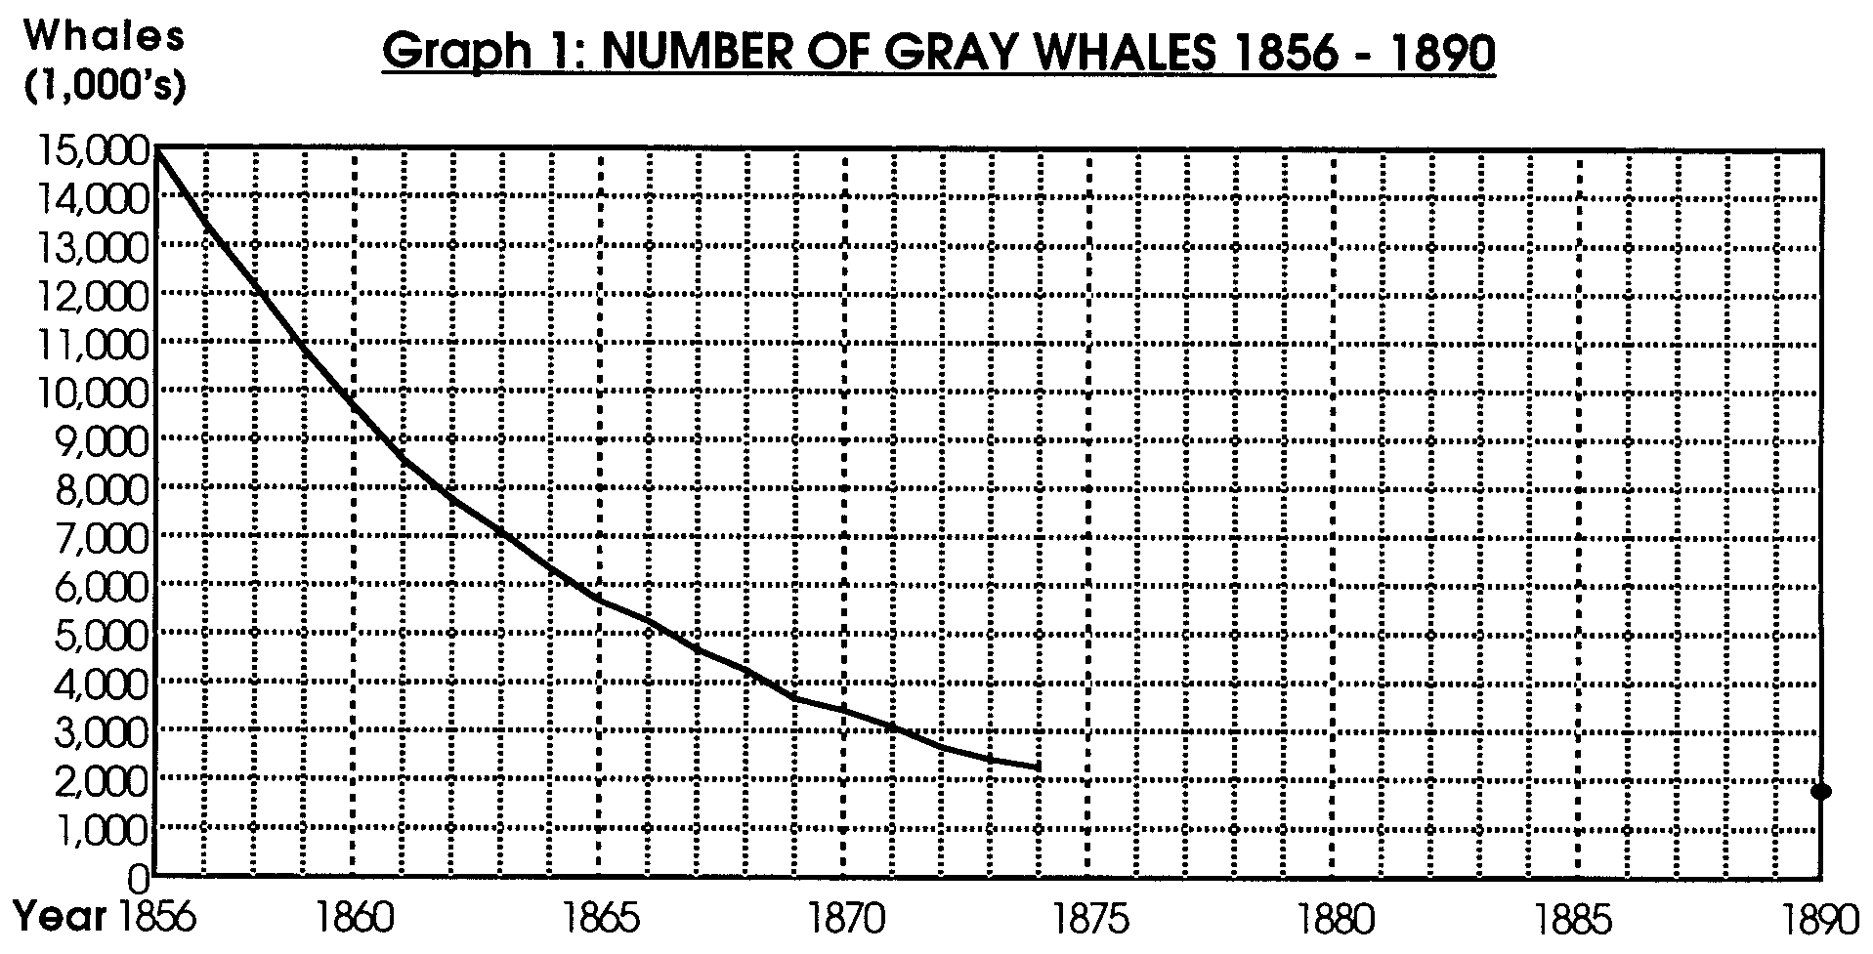

Analysis and Interpretation

1. From 1856 to 1874 the gray whale population was decreasing.

2. If the trend of the line on the graph continued, the gray whale population would soon be extinct.

3. The 1890 population estimate of 1,800 gray whales should be added to student graph.

4. A reasonable estimate for the gray whale population would fall around:
1882 2,000 whales

Note that if the trend plotted from 1856 to 1874 had continued there would have been 872 whales in 1882. By 1882 whalers were looking to other, more abundant species for their catch.

Part 2 - Ups and Downs

1., 2., 3. A completed data chart and graph follow:

TABLE 2: GRAY WHALE POPULATION 1900 - 1920

# of whales at 5% increase # of whales at end of
Year start of year (0.05 times # at start) year (start plus 5%)

1900 1,939 97 2,036

1901 2,036 102 2,138

1902 2,138 107 2,245

1903 2,245 112 2,357

1904 2,357 118 2,475

1905 2,475 124 2,598

1906 2,598 130 2,728

1907 2,728 136 2,865

1908 2,865 143 3,008

1909 3,008 150 3,158

1910 3,158 158 3,316

1911 3,316 166 3,482

1912 3,482 174 3,656

1913 3,656 183 3,839

1914 3,839 192 4,031

1915 4,031 202 4,233

1916 4,233 212 4,444

1917 4,444 222 4,666

1918 4,666 233 4,900

1919 4,900 245 5,145

1920 5,145 257 5,402

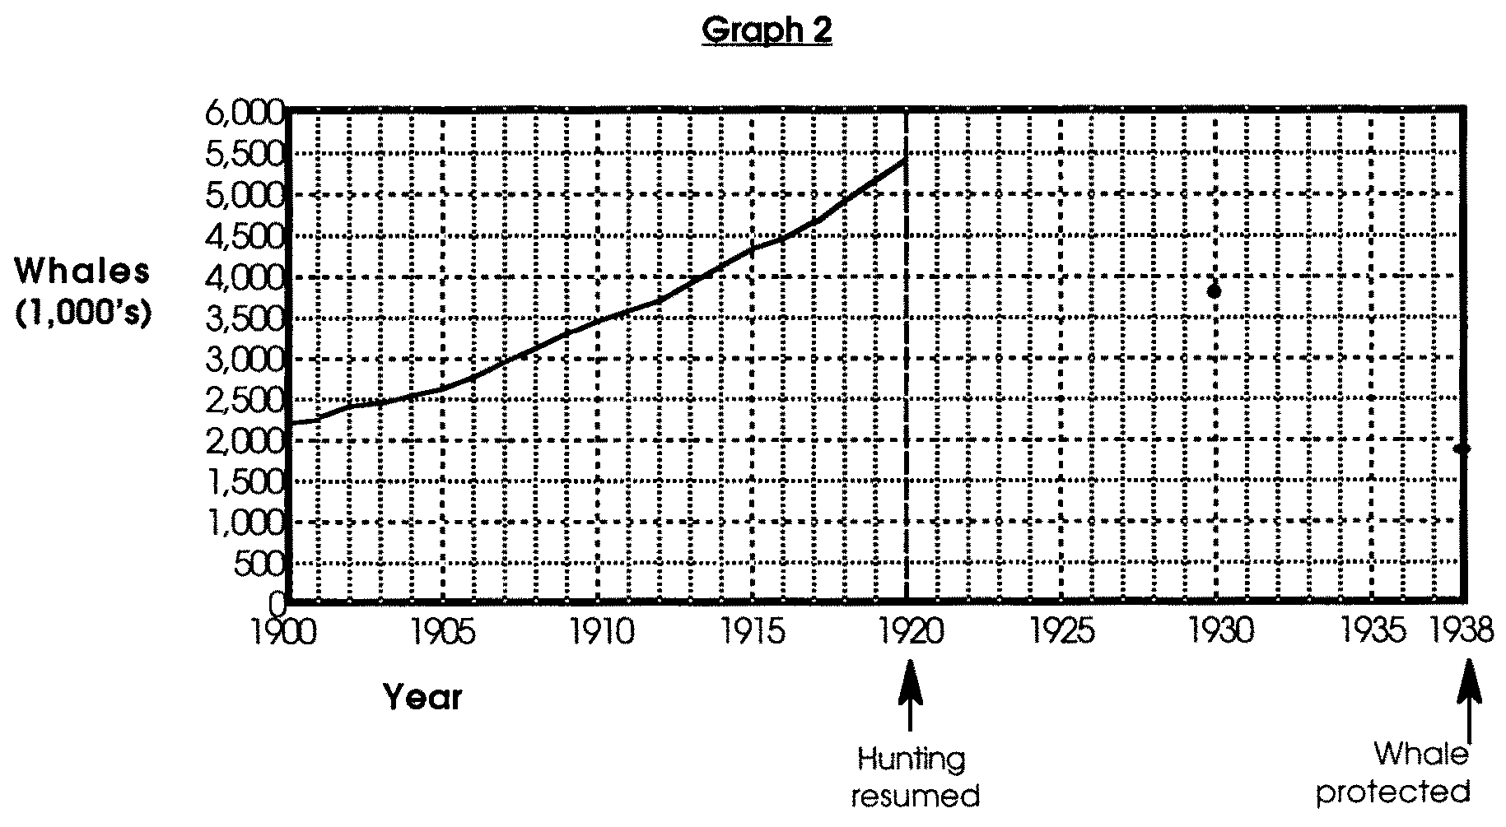
Analysis and Interpretation

1. From 1900 to 1910, the gray whale population was increasing in number.

2. a. The 1920 population estimate (5,402) is about one third of the 1856 estimate (15,000).

b. Gray whale hunting resumed in 1920.

c. Between 1900 and 1920 the gray whale population was increasing in number. This question is repeated here for emphasis.

d. Predictions may vary. Most of your students will predict that beginning in 1920 the gray whale population will again decrease due to whaling.

Note: Gray whale population figures for these years were gathered from a variety of observations and anecdotal sources. The numbers presented here may be considered “best estimates”. For this activity, the absolute numbers are not important. What is important are the trends shown by the increasing and decreasing numbers.

3. a. From 1920 to 1938, the gray whale population was decreasing in number.

b. If the gray whale had not been protected in 1938, the likely fate of the gray whale would have been extermination.

4. a. Three factors that cause death in whales include:
A. disease
B. old age
C. hunting

b. Births cause the whale population to increase.

c. The birth rate must have been less than/equal to/greater than the death rate. (The correct answer is in bold face type.)

d. Gray whales eat small bottom dwelling animals. As the gray whale population increases, the numbers of these small animals will likely increase/ decrease (The correct answer is in bold face type.)

Note: In nature, things are not always as simple as they might seem. Oliver Slattery, a scientist studying gray whales, reports that prey densities were actually higher in areas ("excavations") where gray whales had fed a phenomenon he calls "prey cultivation"!

e. Encourage a discussion of this topic. If no one chooses to limit gray whale population by hunting, you may have to play the devil's advocate. Historically, the gray whale seems to have limited its own population size (or to have had its population limited) at about 15-20,000 individuals. Some people fear that the seas are now different and that the factors which held whale populations in balance might no longer operate. These people advocate management through hunting rather than allowing the whale populations to build up to high numbers only to have them crash. Basically, we do not have a definitive answer to the gray whale management question. We can be sure of one thing, however, overhunting is not the answer. The question of managing gray whale population and whaling will be explored in more detail in subsequent activities.

f. From past experience, it appears that the gray whale population ahas a high/low potential for coming back from near extinction. (The correct answer is in bold face type.)

g. From past experience, it appears that humans could/could not hunt gray whales out of existence. (The correct answer is in bold face type.)
5. a. Answers will vary depending upon student experience. While students may have other answers, scientists could do field work to determine birth rates, mortality, gender, etc.; or conduct library or business record searches for information about kill rates.

b. Answers will vary depending upon choices made.

c. While answers will again vary depending on student experience, variables such as predators or capture by oceanariums are additional factors which could change the size of the gray whale population.

The Numbers Game - December 17
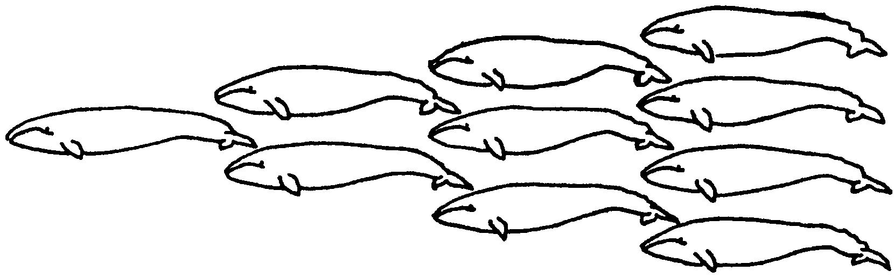

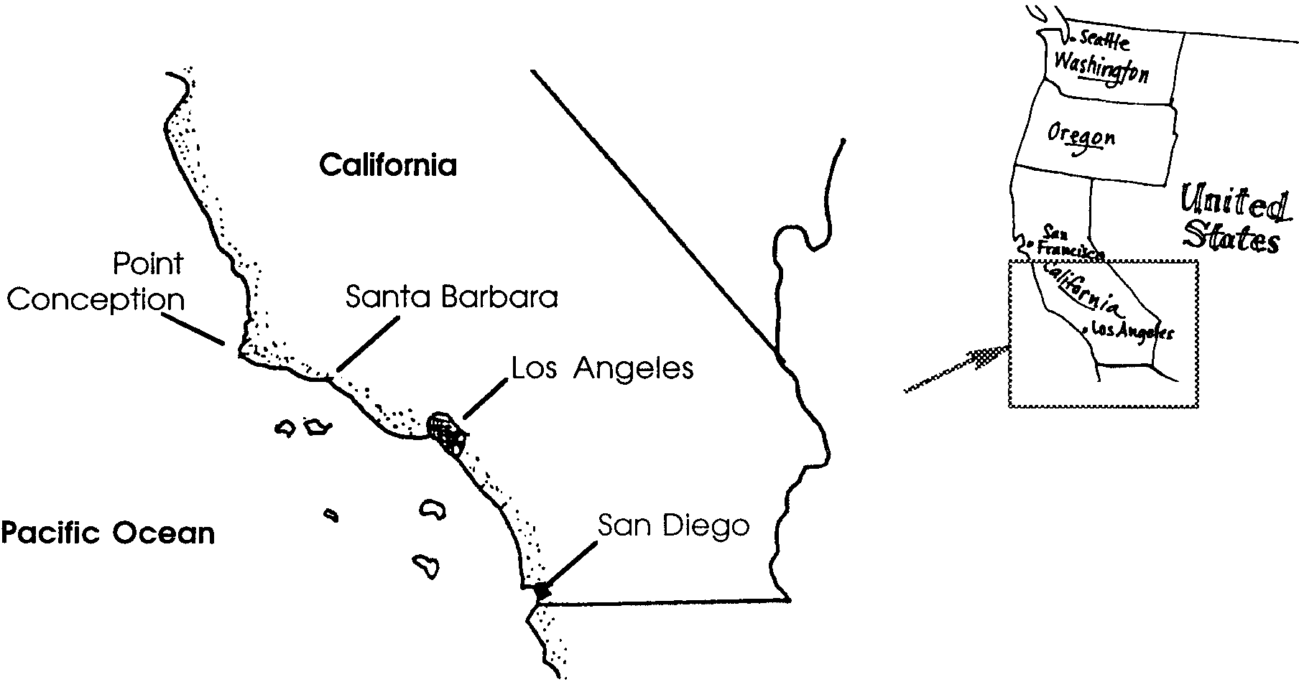
Our whale has now traveled more than 4,000 miles. It has been more than two months since she has seriously eaten. She moves south along the California coast. Her senses of taste and smell locate the mouths of rivers. Her senses also locate other gray whales swimming south. She passes close to land where the land juts into the Pacific Ocean. She swims farther off shore as she passes coastal bays.

In the company of other whales, she nears Point Conception west of Santa Barbara. Here, some of her companions swim directly south. Returning to the coast, this group follows a chain of offshore islands near San Diego. Our whale hugs the coast line following the second main group of whales.

1. Use dotted lines to trace the paths of the two major groups of gray whales from Point Conception to San Diego.
Many of the whales traveling with her will give birth to calves this year. At the height of whaling, more adult whales were killed than calves were born. The gray whale population was decreasing in size.

How many calves are born each year? How many need to be born to keep the population size the same? How many to allow the whale population to increase? The following activity will help to answer some of these questions.

Before we begin, we need to make some assumptions. An assumption is a statement we will suppose to be true. We will assume that:

• 50% (half) of the gray whale population is female (does this seem reasonable to you?)

• Each female produces a calf every other year (gray whales remain with their young for 20 months, so this seems reasonable)

• 25% of the population die each year from disease and old age (this seems reasonable), and

• 10% of the total population is killed each year by whalers (this number is based on historical records).

Under our assumptions, the births and the deaths would balance. In other words, the same number of whales die as are born.

2. If the birth and death rates are the same, what will happen to the total population size from year to year?

3. The second assumption causes the population size to increase. How will the last assumption change the size of the whale population? (Hint: The last assumption is that 10% of the total population is killed each year by whalers.)

Part 1 - The Hunt Is On

Before scientists go to the field or lab, they usually go to the library. They look for information that will help them in their work. Information from historical records and from other scientists is important.
In this activity you will use real data from historical records from whaling ships and from scientific research. You will use the data to make tables and graphs. The tables and graphs will help you interpret information about gray whale population growth and decline.

1. Whalers sailing to the Pacific Ocean from New England began to heavily hunt the gray whale about 1850. In 1874, Captain Charles M. Scammon published an account of Pacific whaling. He estimated the gray whale population in 1856 at less than 30,000 individuals. Today, scientists think the number was closer to 15,000. We will use this number as a starting point. Complete the following TABLE 1 :

TABLE 1: GRAY WHALE POPULATION 1856-1874

# of whales at 10% killed # of whales at end of
Year start of year (0.10 times # at start) year (start minus 10%)

1856 15,000 1,500 13,500

1857 13,500

1858

1859

1860

1861

1862

1863

1864

1865

1866

1867

1868

1869

1870

1871

1872

1873

1874
2. Use the figures you calculated in TABLE 1 to complete the following Graph 1. This is easy. First, move across the year line until you find 1857. Now move straight up the page until you are just above line with the number 12,000. (12,150 is the number of whales at the end of 1857.) Make a dot at this point (a data point). Do the same for each year until 1874.

3. Now connect the dots (data points) from 1856 to 1874 with a smooth line.
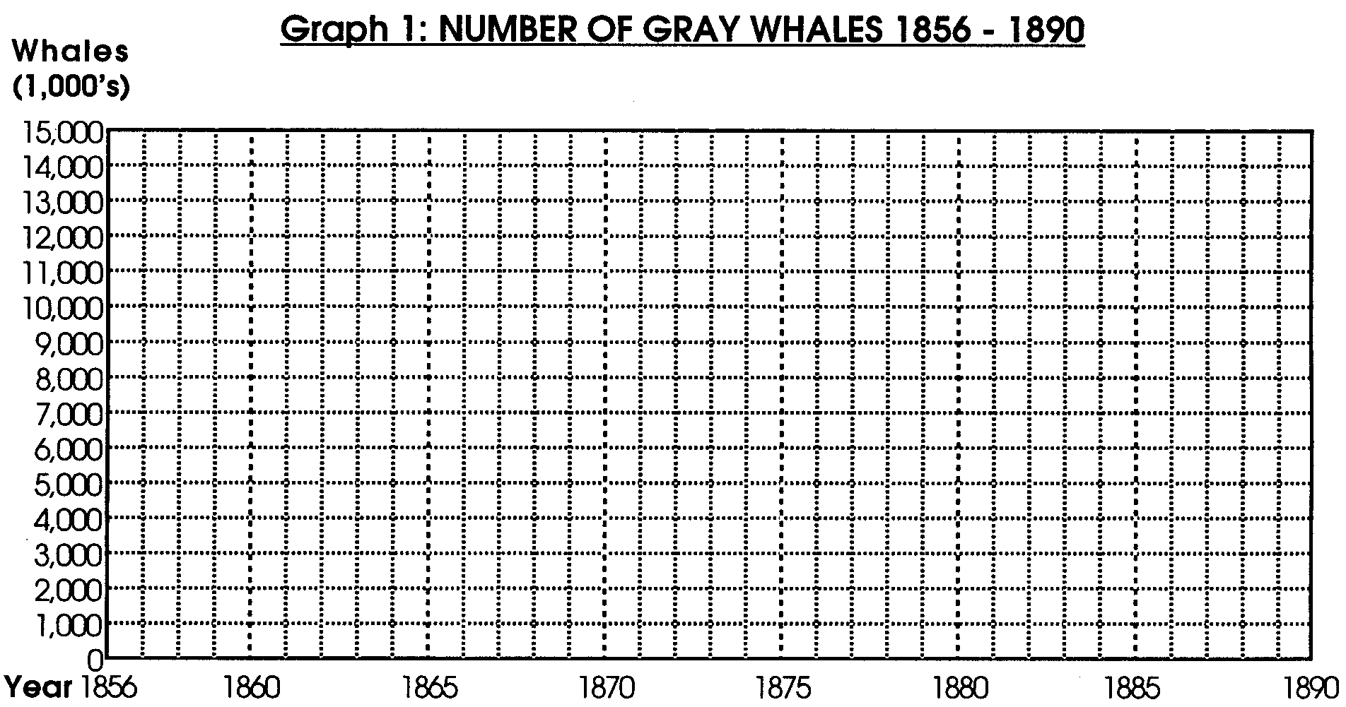
Analysis and Interpretation

Analyze and interpret your data. When scientists analyze information they study it and summarize it. When they interpret the data they make statements about what the information might mean. Analysis and interpretation of gray whale population data are useful. It can help people make decisions about resuming whaling or protecting the population.

1. What was happening to the gray whale population from 1856 to 1874?

2. If the line on the graph were continued, what would be the ultimate fate of the gray whale population?

3. The population in 1890 was estimated to be 1,800 whales. Add this figure to your graph. Use a smooth line to connect this year to the smooth line you have drawn connecting 1856 to 1874.

4. Use your graph to estimate the whale population in 1882. Record your estimate in the space to the right:
1882 whales

Part 2 - Ups and Downs

By 1900 gray whales became hard to find. The whalers turned to other species of whales. The gray whale had a chance to rebuild its population. The 1900 population was estimated to be 1,939 whales. Once whaling stopped, births exceeded deaths by about 5% per year. Complete the following TABLE 2:

TABLE 2: GRAY WHALE POPULATION 1900 - 1920

# of whales at 5% increase # of whales at end of
Year start of year (0.05 times # at start) year (start minus 10%)

1900 1,939 97 2036

1901 2036

1902

1903

1904

1905

1906

1907

1908

1909

1910

1911

1912

1913

1914

1915

1916

1917

1918

1919

1920

2. Use the figures you calculated in TABLE 2 to complete Graph 2 at the end of this lesson. This is easy. Follow the procedure you used in Part 1. Plot each year from 1900 to 1920.

3. Now connect the dots (data points) from 1900 to 1920 with a smooth line.

Analysis and Interpretation

1. What was happening to the gray whale population from 1900 to 1920?

2. The population in 1920 was estimated to be 5,402 whales. In 1920 gray whale hunting resumed.

a. How does the 1920 population estimate compare with that of 1856?

b. When did gray whale hunting resume?

c. What was happening to the gray whale population between 1900 and 1920?

d. What do you predict will happen to the gray whale population beginning in 1920?

3. The gray whale population in 1930 was estimated to be 3,866 individuals. In 1938, the population was estimated to be 1,957. In 1938, the gray whale was protected from further hunting. Add the population estimates from 1930 and 1938 to your graph. Use a smooth line to connect these years to the smooth 1ine you have drawn to connect 1900 to 1920 .

a. What was happening to the gray whale population from 1920 to 1938?

b. If the gray whale had not been protected in 1938, what would have been the likely fate of the gray whale?

4. Once the gray whales were protected, they were able to again rebuild their population. By 1961, the population had reached about 10,000 individuals. By 1988, the population was estimated at over 21,000. The population had returned to the levels existing before modern whaling.

a. The death rate causes the whale population to decrease. What are three factors that cause death in whales?

A.

B.

C.

b. What causes the whale population to increase?

c. Historically, the gray whale population remained stable at about 20,000 individuals. The birth rate must have been less than / equal to / greater than the death rate. (Circle the correct answer.)

d. Gray whales eat small bottom dwelling animals. As the gray whale population increases, the numbers of these small animals will likely increase / decrease. (Circle the correct the answer.)

e. Some people feel that the gray whale population is now in danger of eating itself into trouble. They say that the whale population is too large for its food supply. These people feel that limited hunting of gray whales should occur. Others argue that the commercial value of gray whales is less than their esthetic value to whale watchers. This group favors no hunting.

What is your position in this argument? Why?

f. From past experience, it appears that the gray whale population has a high / low potential for coming back from near extinction. (Circle the correct answer.)

g. From past experience, it appears that humans could / could not hunt gray whales out of existence. (Circle the correct answer.)

5. Think about the four assumptions we made in the beginning. The assumptions may not be correct. Scientists try to test their assumptions.

a. List some ways scientists could test the correctness of their assumptions.

b. Now look at your list. Which test would you do first? Why?

c. Think about the population of gray whales in the ocean. What other variables could change the size of the gray whale population?

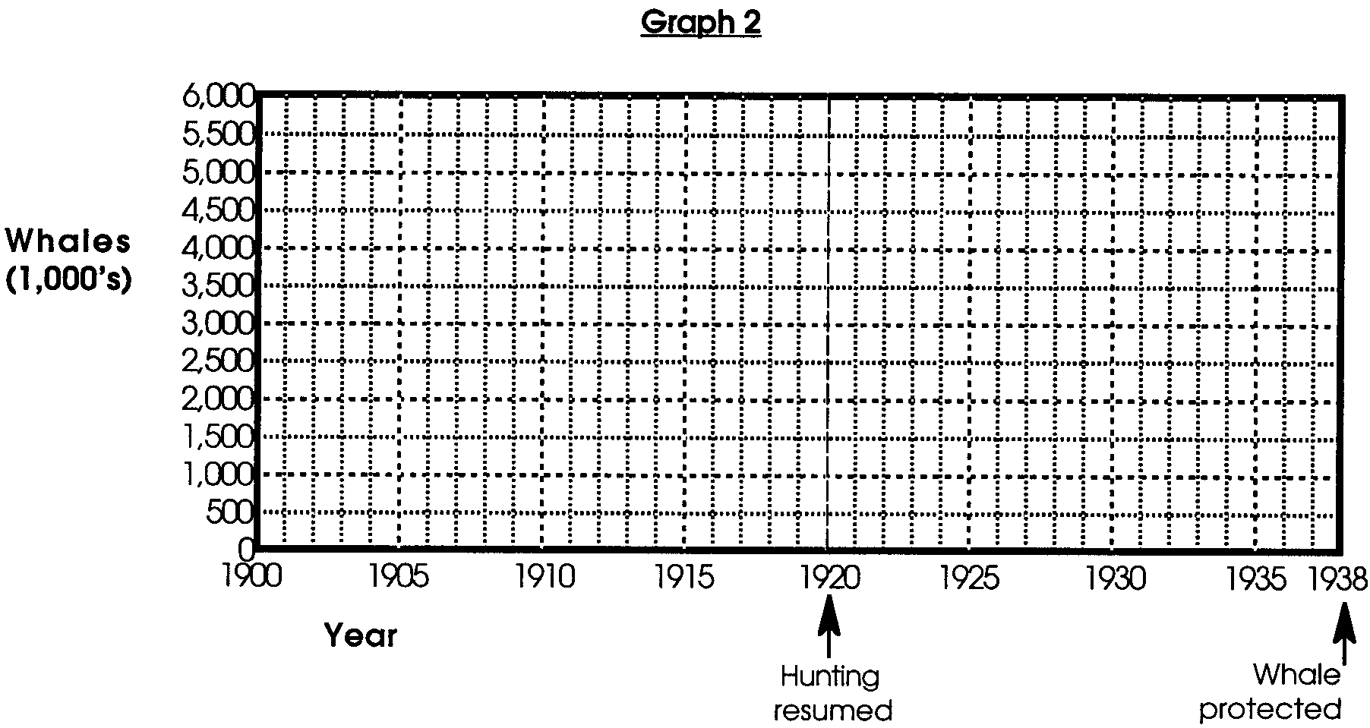
Graph 2: GRAY WHALE POPULATION 1900 - 1938

