December 15 - Days of Whaling:

Modern Whaling

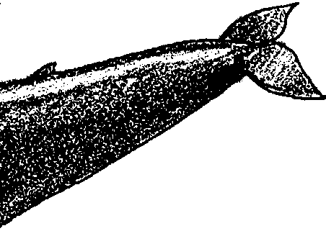
Key Concepts
1. The whaling industry has played a significant role in domestic and international economics.
2. Technological advancement and human greed expressed in over harvesting have greatly affected whale populations.

Background

The story of human interaction with the whale has been, and continues to be, a tale of nearsighted self-interest. Historically, it is convenient to consider three major periods in whaling: native whaling, sailing whaling, and modern whaling. As a case study, whaling shows the complexity of ocean management problems. Biology, sociology, economics, and politics are all deeply involved in deciding the future of whale species.

Materials

For each student:

• “December 15 - Modern Whaling” student activity pages

For the classroom:

• displays of pictures, books, periodicals, maps about the people and places that participated in the whaling industry

• strip of computer paper or butcher paper for time line

• large sheet of butcher paper for technology chart

Teaching Hints

“Modern Whaling” is the third lesson of the activity, “December 15 - Days of Whaling” and gives your students an historical overview of the issues surrounding whale hunting as they read and review whaling history, construct a time line, and chart technological developments.

In toto, “December 15” is divided into three major sections: Indian Whaling, Sailing Whaling, and Modern Whaling. While the three sections present a unified whole, separate text and investigations are provided for each as the entire “December 15” is long for a single assignment. These sections lend themselves to completion by individuals or small groups as homework or in-class assignments. Each section has a separate Teacher Background section, although the last two are somewhat abbreviated.

The reinforcement activity, “Whale History” focuses on sorting and arranging facts and events.

Additional Teaching Hints are found in the preceding activity, “December 15 - Days of Whaling: Native Whaling”.

Duplicate the student text materials. One set is recommended per student. Your students will profit from a review and discussion of the materials presented in these sections.

If you are using “Voyage Of The Mimi” in conjunction with this curriculum, “Episode 7: Fastening On” correlates with this lesson.

Key Words

factory ships - in this case, a large ship that accompanies the fleet and which possesses a slipway by which whales are hauled onto the deck to be processed

krill - shrimp-like animals that reproduce explosively during the Antarctic summer

rorqual - a group of fast swimming whales including the blue and fin whales

slipway - a ramp on a factory ship for hauling aboard carcasses of whales for processing

Extension

1. Have students create replicas of historical artifacts and models of whaling villages, shore stations, and ships in order to make a classroom “whaling museum”. Then, have them conduct tours for other classes and parents.

Answer Key

1. Three factors which threatened to end the whaling industry in 1880 are:

a. whalers had hunted the small and slow moving whales into extinction or near extinction.
b. kerosene replaced whale oil as a fuel for lamps.

c. a large number of whaling ships were crushed by Arctic ice.

2. Blue whales were not hunted by sailing whalers because the speed of the blue whales let them out-distance the sailing ships.

3. a. Before the blue whale could be hunted the following three problems had to be solved:

A. The fast speed of the whales had to be matched by a chase vessel.

B. A harpoon capable of killing the giant animal had to be created.

C. Dead whales had to be kept from sinking.

b. Svend Foyn, a Norwegian captain, solved these three problems.

4. The major factor that made whalers look for whales in Antarctic waters was that the whalers had decimated blue whale populations in the Northern Hemisphere. Other factors your students may mention spring from the above and will most likely deal with economics.

5. About three million pounds of krill are needed to make a 150 ton whale. A convenient way to set up the problem is shown below:

150 tons x 2000 pounds x 10 pounds krill = 3,000,000 pounds krill
whale ton 1 pound of whale

Note that this simplistic solution does not take into account the pounds of krill required to maintain the whale as it grows.

6. Your students may have a variety of suggestions. Basically, an agreement, between all whaling parties, which limited the number of whales killed to a number which the whale population could sustain without an overall annual reduction in numbers would have protected the population while still providing whalers with income. The whale is a classic example of a “common good”. Since no one owns the whale, there is no incentive not to take all you can right now. After all if I let a pregnant cow swim away, there is no guarantee that I’ll get to catch her after she has given birth. In fact, I can be sure (or so I’ll think) that you’ll kill her as soon as you see her. So “better me than you” spelled the doom for several whale species. It may spell the doom for several more.
7. A factory ship is a large ship that accompanies the whaling fleet. It has a slipway by which whales can be hauled onto the deck for processing. It has all of the equipment necessary to completely process the killed whales.

8. Answers will vary but some of the businesses that profited from modern whaling include: shipbuilding, chandleries, provisioners, canneries, foul weather gear makers, explosive makers, metal fabricators, and pet food manufacturers.

This question is included to underscore the interrelated nature of any environmental or endangered species question. It’s often easy to point at the whalers as the “problem” as we scoop a canful of “Meaty Treaty” cat food (once made of whale meat) into Rascal’s dish. Emphasize that we, including each of your students, all have a role to play in solving these complex questions.

December 15 - Days of Whaling:

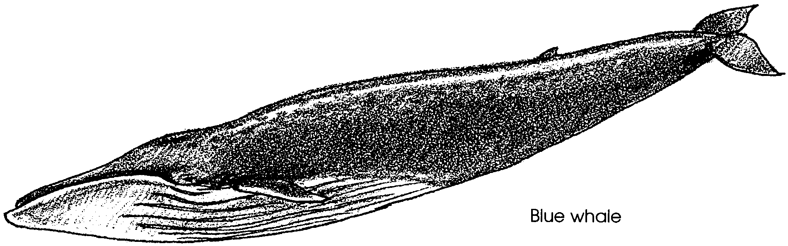
Modern Whaling

By 1880 the entire whaling industry was in serious trouble. The sailing whalers, like the shore whalers, had hunted the small and slow whales to near extinction. Only the large, fast swimming whales remained. They were more difficult to catch. They also had less oil and “whale bone” to harvest.

The drilling of America’s first successful oil well in Pennsylvania in 1859 dealt another blow to whaling. The well produced kerosene. Kerosene was cheap and smokeless when burned. It soon replaced whale oil as the fuel for lamps.

Other changes were taking place. In 1871, 33 ships were caught in Arctic ice off the northern whaling grounds. The ships had to be abandoned and were crushed by the ice. In 1876, another dozen were lost in the ice. The fleet was being destroyed.

1. What are three factors which threatened to end the whaling industry in 1880?

a.

b.

c.

Into this picture sailed, or rather motored, Svend Foyn. Svend Foyn was a whaling captain from Norway. Foyn had led many whaling expeditions to the Arctic. He saw the right whales decrease in number. He saw the whale catches decrease from year to year. He also saw the blue whales and the other fast swimming rorqual whales. He saw their great numbers. He saw that their speed let them out-distance the sailing ships.
2. Why were blue whales not hunted by sailing whalers?

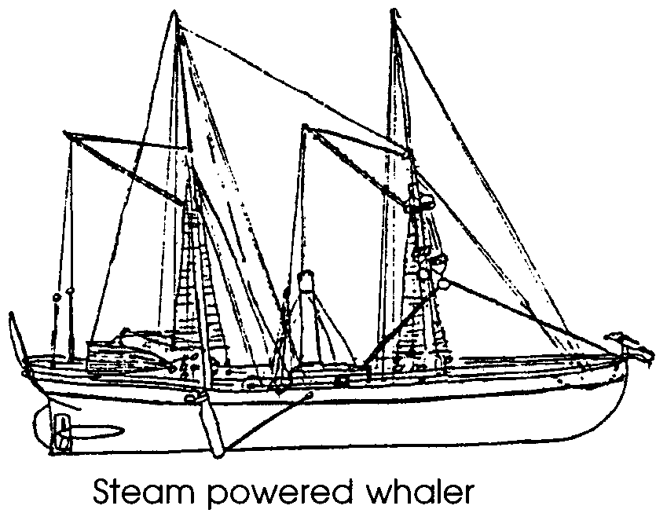
In response to what he observed, Foyn adapted the steam engine to his whaling ship. The first motorized whaling ship had been born. The steam powered ship could maintain speeds of seven knots (over 8 mph). The fast swimming rorquals could now be chased. Two other problems still remained to be solved. For one, the harpooning techniques used on the slower moving whales could not be used on the rorquals. Secondly, unlike right whales, the rorquals sink after death.

Svend Foyn solved the first problem by building a cannon-fired harpoon. The harpoon had an explosive head. The heavy harpoon was fired into a whale. Within seconds, the black powder charge in the head exploded inside the whale. Svend Foyn could now catch and kill the giant blue whale.

The problem of keeping these large whales afloat still remained. To solve this problem, Svend Foyn pumped compressed air into the body cavity of the dead whale. The large, fast-swimming whales were no longer safe from the hunt.

3. Sailing whalers did not hunt the fast-swimming blue whale.

a. What three problems had to be solved before the blue whale could be hunted?

A.

B.

C.

b. Who solved these problems?

By 1888, Norwegian whalers were killing a thousand blue whales a year within a short distance of their shores. Foyn’s technique was so effective that by 1903 the blue whale was no longer found in the Northern Hemisphere. Once again the whalers had put themselves out of business.
Having destroyed their livelihood in the Northern Hemisphere, the whalers looked south. The waters off Antarctica are protected by the world’s stormiest weather. Few early whalers had sailed in Antarctic seas. Modern whalers in 120-foot long steam powered ships turned into the turbulent Antarctic waters.
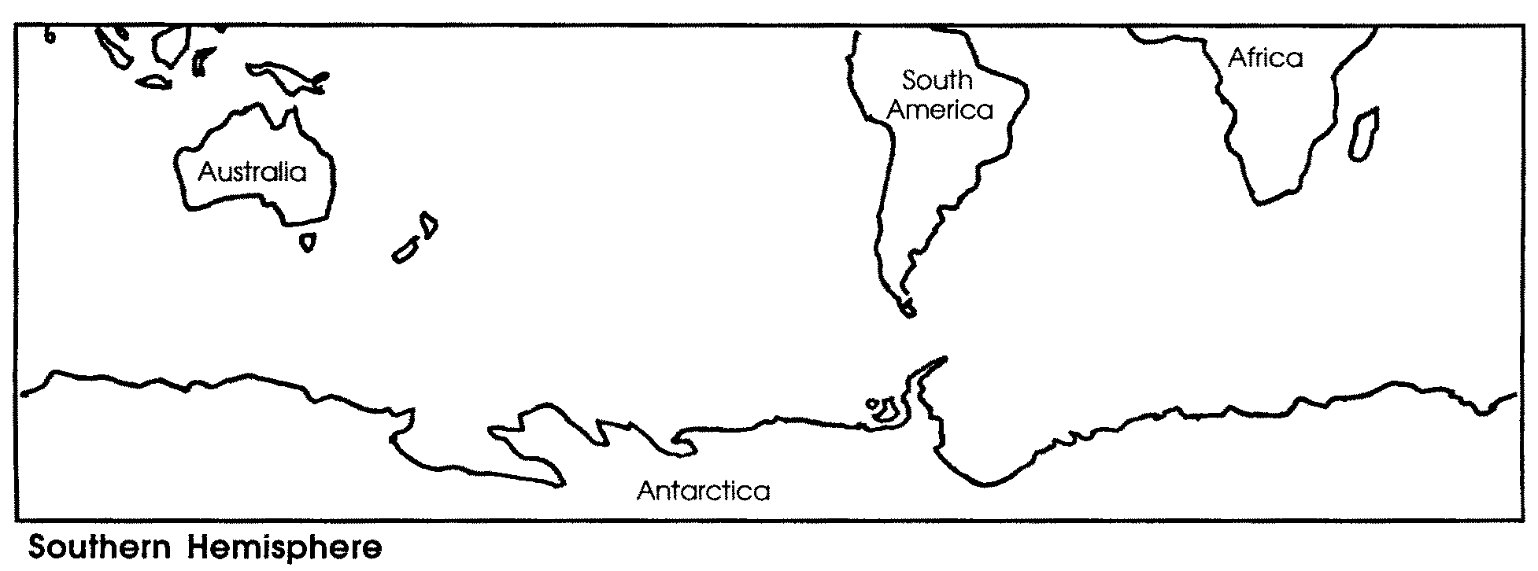
4. What was one factor that made whalers look for whales in Antarctic waters?

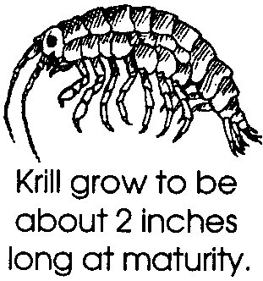
The first Norwegian fleets to sail in the Antarctic returned home with reports of whale herds of tremendous size. Hundreds of thousands of huge fin, blue and humpback whales lived in the Antarctic. The whales fed on millions of tons of “krill”. Krill are shrimp-like animals that reproduce explosively during the summer. Early visitors to the whaling grounds told of seeing hundreds of blue whales from a lookout at one time. The hunt was on.

5. It takes about 10 pounds of krill to make one pound of whale. How many pounds of krill would it take to make a 150 ton blue whale? Please show your work. (Hint: one ton = 2,000 pounds)

The herds were so bountiful, whalers were wasteful. One out of every four whales killed floated away before they could be skinned. As in the early days of whaling off California, shore stations were built to process the whales. The whalers refused to learn any lessons from their experiences in the North Atlantic. They picked the slowest species in the Antarctic, the humpback whale, to hunt. And they hunted it with no mercy. In 1911 8,500 humpback whales were killed. By 1925, only 9 humpback whales could be found to kill.

6. Destroying your source of income does not seem to make much sense. How might the whalers have protected the whale population and still remained in business?

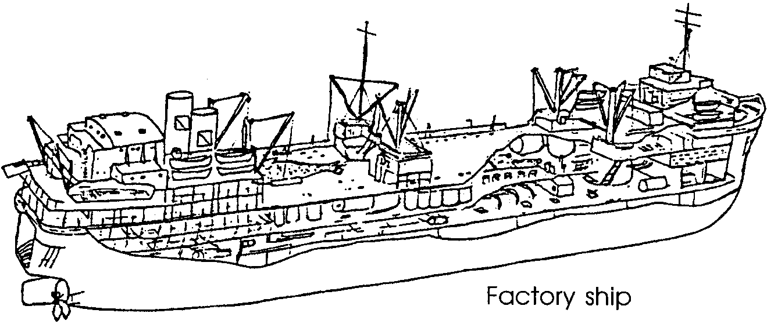
Norwegian whalers were soon joined by the British, French and Japanese. The whalers succeeded in killing off the whales that bred near the shore stations. This “success” forced the whalers to go out to sea to find whales. Hauling the dead whales back to the shore stations was expensive. In the spirit of Svend Foyn, another Norwegian captain solved this problem. He constructed a large “factory” ship that could accompany the fleet out into the Antarctic ocean. The ship had a slipway by which the whale was hauled onto the deck to be processed. The idea was a success. Within five years, thirty-eight factory ships were operating. Whaling catches increased from 10,500 per year to 40,200.

7. What is a “factory ship”?

8. Think about all of the people involved in catching whales. Whalers certainly profited from whaling. What are some other types of business that profited from whaling? (Hint: In the days of sailing whalers, cotton growers profited because they sold cotton to make sails.)

Gone were the days of the personal challenge to nature’s largest animals. In its place was a large, well-knit unit that used speed and explosives to kill the whale. The extinction of all whales was now possible.

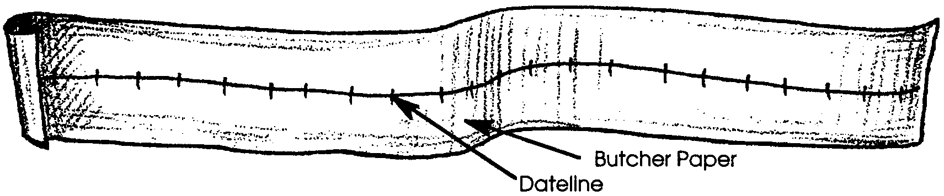
Modern Whaling: Whaling History

Part 1 - Time Line
From canoes to factory ships, whaling changed a lot. Show these changes on a time line. Here's how.
1. Lay out several sheets of paper or a length of computer paper or butcher paper.
2. With a straight edge, draw a line across the paper. (your time line can be vertical or horizontal.) Title the time line "Whaling History".
3. Review the text beginning with "Native Whaling".
4. On one side of the line, write the date of an event. On the other side, next to the date, write a brief description of what happened.
5. Draw some illustrations along your time line to highlight important events or changes.

Part 2 - Changes in Whaling Technology
From seal skin floats to exploding harpoons, people developed tools to help them capture whales. Part of technology is tools, part is the knowledge of how to do something.

Chart the development of technology that people created to help them in their whaling efforts. You can make your chart on paper or in a computer data base. The computer data base can sort and organize categories for you. Follow the example below:
