Scrimshaw

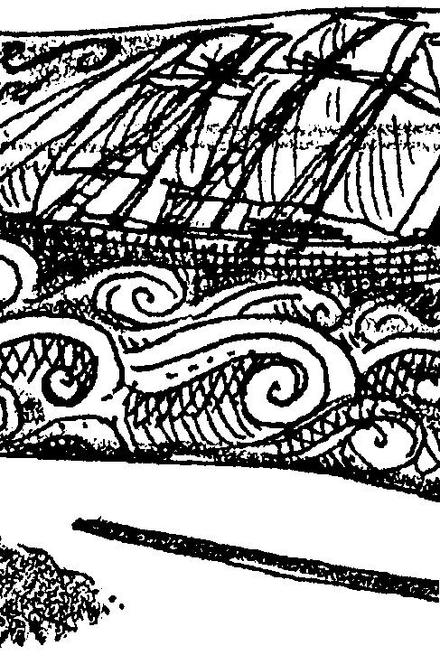
Key Concepts
1. Scrimshaw, carving or engraving into whale ivory, baleen, or the like, is an American folk art of the nineteenth century, made by whalers as a leisure occupation
2. Federal law protects marine mammals from being killed for the production of handicrafts.
3. Some Alaskan Natives may legally produce and sell scrimshaw and handicrafts created from marine mammals.

Background

Whales and whaling cannot help but conjure up images of sailing ships and days gone by. As we have seen, the days are, unfortunately, not entirely gone. The years long voyages provided sailors with ample opportunity to engage in hobbies. Many whalers took to carving or engraving, especially of whale ivory, whalebone, or the like. The engraved articles became known as scrimshaw, a word believed to have come from Anglo-Dutch terms meaning “lazy fellow or shirker”. Those whalers who engraved the whalebone were called “scrimshanders”.

Clearly, scrimshanders were not the first people to carve or engrave whale parts. For thousands of years Arctic people used bone and ivory for tools, utensils, and decorative items. Almost all of these were carved and engraved so that each piece was not only functional, but pleasing to its maker and to the spirits. Today, Yupik and Inuit (the peoples formerly referred to as Eskimos) and Aleut people in Alaska produce scrimshaw and other art from marine mammals. Under the terms of the Marine Mammal Protection Act, they are allowed to take a small number of whales annually for subsistence purposes. The number of whales taken usually ranges from 3-10 animals. While the Yupik, Inuit, and Aleut prefer bowhead whales, gray whales are occasionally taken. These people are also allowed to process art for sale from these animals. They sell their art, including scrimshaw, to supplement their income.

This group of Alaskan Native Americans is the only group of U.S. citizens permitted by the U.S. government to hunt marine mammals. While it is legal to bring the products these people create into the lower 48 states and Hawaii, products not produced by Yupik, Inuit and Aleut people may not be sold in the United States. Authentic, legal products produced by Alaskan Native Americans are certified as such. Other products not made by Alaskan Native Americans that were produced before the Marine Mammal Protection Act of 1972 are allowed in the U. S., if they have been certified. Products not so certified are confiscated by customs officials when found since it is illegal to import handicrafts made from endangered species into the United States.

While all Arctic people have for thousands of years engraved on ivory and bone, scrimshaw refers to the nineteenth century folk art. The range in artistic ability found in scrimshaw pieces runs from fine art to primitive. On many whalers everyone from the captain to the lowest crewman would have a piece of scrimshaw in progress. The favored pieces to carve were teeth and baleen or “whale bone”. The baleen became elaborate corset stays, while the teeth sometimes retained their shape and other times became pastry wheels or other domestic articles. The art form was so absorbing that lookouts would ofttimes not report the sighting of a whale so as not to disturb their carving.

Scrimshaw and other products made from parts of whales brought money to the sailors and to the investors who owned the ships and the whaling businesses. Today some people still make and sell such products, legally and illegally. As long as people buy these products whales and other animals will be killed for profit. In many cases, artificial materials can be used to substitute for authentic materials in producing high quality and high priced replica products.

Some excellent examples of artistic scrimshaw are shown and discussed in the following articles:

Carroll, Geoff. “Local Harvest On the North Slope”. ALASKA’S WILDLIFE, The Magazine of the Alaska Department of Fish and Game, Vol. 24, No. 1, Jan-Feb. 1992.

Gorman, Brian E. “Scrimshaw and Scrimshanders, Whalebone and Whalers”. NOAA, Vol. 7, No. 4, Oct. 1977.

Loeb, Paul. “On the Cutting Edge of Scrimshaw”. Pacific Northwest, Dec. 1980.

Miller, Tom. 1975. The World of the California Gray Whale. Baja Travel Publications, Santa Ana, California. p. 28.

Nickerson, Roy. 1987. The Friendly Whales. Chronicle Books, San Francisco. p. 30, 31.

Materials

• modern whalebone: smooth plastic as from lids from yogurt containers and bleach bottles, soap bars, bone (see Teaching Hints for ideas)

• carving tools: nails, compass, single edged razor blades or any type of engraving tools

• sandpaper

• darkening agents: crayons, lampblack or charcoal, pastel chalks

• pencil

• paper towel

• soft cloth

Teaching Hints

“Scrimshaw” serves to introduce your students to a truly American folk art form. In place of whale teeth and baleen, this activity has students create scrimshaw from “modern whalebone”. The activity is enjoyable and clearly reveals the patience possessed by the seamen. It also provides an opportunity to introduce current political issues regarding the illegal trade of products made from endangered species

Modern Whalebone:

Plastic

Modern whalebone may be found in abundance. It is the smooth plastic found in many disposable containers. Yogurt containers work particularly well. Bleach bottles and similar containers also work well.

The containers should be cut into manageable size pieces (1 1/2" X 3" or 4") before class. Cup size yogurt container lids work very well and may be made into an attractive mobile upon completion of the activity. Your students can often supply the containers although it is recommended that you do not tell them what the containers are for until you introduce the activity.

Ivory Soap

While plastic containers seem to be the most manageable material for students, other mock whalebones are available. Ivory soap may be easily carved or inscribed. Incised lines may be filled in with permanent felt markers and the excess pigment may be carefully wiped off with a damp (not wet) paper towel. The final step is a polishing with a soft cloth.

Plaster of Paris

Plaster of Paris also provides a substitute. Prepare plaster of Paris “teeth” by mixing the plaster with water. Drop small spoonfuls on wax paper. When sufficiently hardened, remove from paper. These “teeth” will be fairly round. Your students may use nails to sketch their designs. If a pendant is desired, carefully make a small hole at top with a nail.

Use a fine brush and black tempera paint to paint over lines of design. Rub firmly but carefully over entire piece to smear paint. String yarn through hole for hanging. You may experiment with other pigments. A word of caution: the plaster is porous and tends to absorb felt pen and similar coloring agents. A gentle scraping with a dull knife can remove most of the absorbed pigment. Unfortunately, it can also remove much of the drawing. To minimize frustration, should you elect this method, practice the technique yourself before having your students perform the activity.

Beef Bones

The above materials are soft in comparison with whale teeth and baleen. Your students can obtain a more realistic idea of the difficulties involved in scrimshaw by using the inside of hard shell clams or the outside of beef bones. In the event you have students who express an interest in “advanced scrimshaw”, the technique for preparation and use of beef bones is provided below.

Soup bones provide the raw material for this advanced activity. Most butchers are willing to cut soup bones into 2 1/2 inch lengths for you if you explain how you are going to use them. If your butcher is very friendly, she may cut the lengths in half lengthwise so that the pieces more nearly resemble whale teeth.

There are two ways to prepare the beef bones:

1. Boil bones for 2 1/2 to 3 hours to remove meat and gristle. (Make soup with the broth!) Scrub bones and remove all excess meat and debris. Reboil the bones for half an hour in a strong detergent solution to remove the grease. Pat bones dry and leave to dry for 3 to 4 days. You may wish to put them in the oven on racks for a few hours for drying.

2. Boil bones for 2 1/2 to 3 hours to remove meat and gristle. (Make soup with the broth!) Scrub bones and remove all excess meat and debris. Reboil the bones for half an hour in a strong detergent solution to remove the grease. Soak in sodium hydroxide for 5 days to 2 weeks to remove excess meat, gristle and marrow. Pat dry and leave to dry for a day.

Provide sufficient sandpaper for your students to smooth the bone surfaces. One four-inch square of coarse and two four-inch squares of finer grit papers are required for each student. The choice of carving tools is limited only by your imagination. The traditional tool was the ubiquitous sailor’s pocket knife.

The highlighting materials used by whalers ranged from soot from the fires used to render or “try” the oil from the blubber, to paint, to tar and India ink. Most often the pigments were black, but red, green and blue highlighting is also seen on some pieces. A variety of pigments may be used by your students. Lampblack may be found in some old, well-stocked hardware stores. Charcoal, pastels and crayons also work well. Felt tip pens tend to penetrate the bone and as a result do not work well. Let your students be as creative in their pigment choice as the original artisans. Disasters may be sanded away with a little effort!

Duplicate the activity pages. One set is recommended per student. Caution your students about the use of sharp carving tools and circulate through the room as the activity is performed to minimize the likelihood of accident. Plan to display the finished pieces (perhaps in the library or some other central location). You may provide extra “whale bone” or bones for interested students to take home and carve. Provide resources and the incentive to follow up on the scrimshaw with reading and projects dealing with early whaling. This activity provides an excellent opportunity for favorable “P.R.” for your program and for the school. Make the most of the opportunity.

If you are using “Voyage Of The Mimi” with this curriculum, “Episode 7: Fastening On” correlates with this lesson.

Key Words

baleen - an elastic, horny substance growing in place of teeth in the upper jaw of certain whales, and forming a series of thin, parallel plates on each side of the palate; “whalebone”

engraving - the art of forming designs by cutting on the surface, in this case the surface of whalebone or similar items

scrimshander - one who creates scrimshaw

scrimshaw - a carved or engraved article, especially of whale ivory, whalebone, or the like, made by whalers as a leisure occupation

subsistence - in this case, the means of supporting life; a living or livelihood

whalebone - an elastic, horny substance growing in place of teeth in the upper jaw of certain whales, and forming a series of thin, parallel plates on each side of the palate; baleen

Scrimshaw

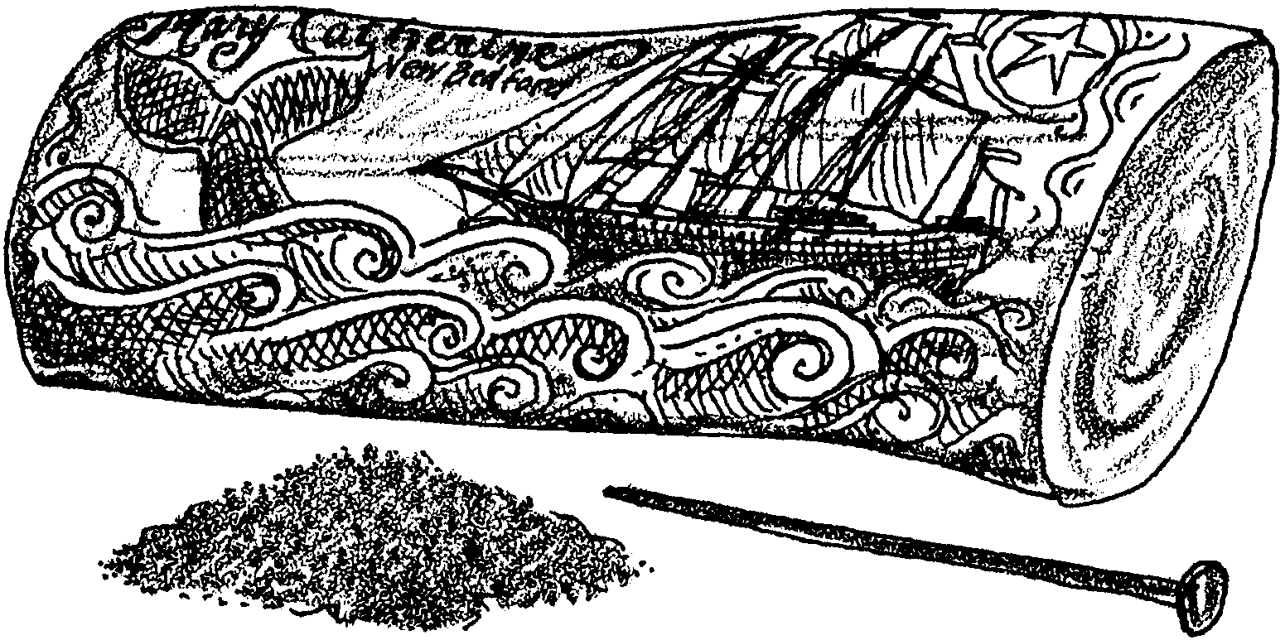

Sailors aboard the sailing whaleships were gone from home for long periods. Cruises of two, three or four years were not uncommon. Sailing was hard work in bad weather and there was very little free time. In fine weather, the crew of a sailing whaler had enough spare time to engage in hobbies. Whalemen passed the time of day carving designs or scratching pictures into whale teeth or into “whalebone”, the baleen of the non-toothed whales. This carving or scratching is known as scrimshaw. No one is positive of the origins of the word. Some say it comes from Anglo-Dutch terms meaning “lazy fellow”.

Sailors sketched sea scenes, initials, designs, their ship and the catch and other scenes from life at sea. From these works of art we have a good idea of those things about which a sailor thought. We also have an idea of those things which he appreciated most during his years at sea.

Whales are now protected by United States law. Except in rare cases, new whalebone and whale products are not permitted into the country. In the following activity you will use “modern whalebone” to try your patience as a “scrimshander”.

Materials
• modern whalebone
• nails, compass, single edged razor blades or any type of carving tools
• crayons, lamp black or charcoal, pastel chalks
• pencil
• paper towel
• soft cloth
• sand paper

Procedure

1. Draw a design lightly on the “whale bone”. The first time, keep it simple. It does not have to deal with whaling.

2. Carve out design with a nail or other carving tool.

3. Fill in design with lamp black or other pigment. (Caution: A little lamp black goes a very long way.) Be sure to fill in all the crevices.

4. Use a paper towel to wipe off the surface of your “whale bone”. The black should wipe off the unscratched surface of the “whale bone” leaving only the lines colored.

5. If the design needs more carving, do it and refill.

6. Polish the bone with a soft cloth for the final gleam.

7. Display your scrimshaw work of art.

