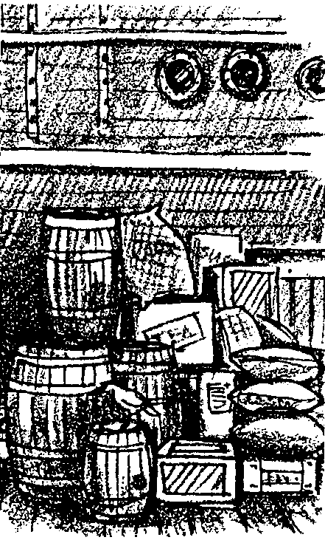
Blood Money

Key Concepts
1. Whaling is a business endeavor in which decisions affecting whale populations are made on the basis of how the decision will affect business profit or loss.
2. In the days of sailing whalers, investors in the voyages took advantage of the seamen.

Background

With the passage of time, things such as whaling voyages become blurred. So many accounts of whaling adventures are available to the public that it is easy to overlook the fact that these adventures were business endeavors that cost money and that made or lost money.

In the logs and business records of long past voyages can be found the actual cost figures for the outfitting and purchase of a whaling ship and also some figures related to wages and compensation. The figures are interesting, at the onset, because of the price increases we see in commodities we recognize (remember the “good old days” of paying 3.5 cents a pound for rice?). The lists of articles are interesting because of what they tell us about life on a sailing whaler.

Materials

For each student:

• “Blood Money” student activity pages

For the classroom:

• magazines and newspapers with pictures of supplies for the ship with current prices for display and discussion

Teaching Hints

In “Blood Money”, your students use actual cost figures for the outfitting and purchase of a whaling ship, plus wages and compensation, to answer a series of questions designed to uncover the story behind these lists and figures. This activity provides your students with an opportunity to exercise their critical reading skills. Since many students are unfamiliar with current prices, you may wish to post and discuss current newspaper advertisements or similar sources of price information.

Introduce the activity by having students brainstorm a list of supplies needed for a whaling voyage in the 1800s. Write the list on the board or on a large chart paper. Ask students to guess the price of these items in the early to mid 1800s and currently. Write the guesses by each item. You may wish to have students find pictures of the items in magazines and newspapers and bring them to class. Have them find out the real current price for each by looking at adds, going to a store and pricing them, and calling suppliers (i.e., lumber and duck). Make a bulletin board display or posters showing the items and their prices. Then start the “Blood Money” activity pages.

Duplicate the activity pages. One set is recommended per student. This activity is best accomplished by individual students as a homework assignment or as an in-class assignment. “Blood Money” profits from a post-activity discussion in which you paint a picture of life on an American sailing whaler by drawing together the answers provided by your students.

Key Words

cask - a container made and shaped like a barrel; especially one larger and stronger, for holding liquids.

cordage - fiber and wire ropes, lines, hawsers, etc., taken as a whole, especially with reference to the rigging and other equipment of a vessel

duck - a heavy, plain-weave cotton fabric for tents, clothing, bags, etc., in any of various weights and widths

profit - returns, proceeds, or revenue from investments; the monetary surplus left to a producer or employer after deducting wages, cost of materials, etc.

sheathing - in case, a covering or outer layer of copper on a ship’s bottom

try pots - kettle in which blubber is rendered for oil

Extensions

1. Have your students make a list of everything a modern whaling voyage would need, the cost per item, and the total cost for the supplies. Also have them find out the profit the ship makes today for the voyage, then make a chart to compare with the one prepared for the sailing voyage.

2. Have students make a list of the foods a modern ship would take on a voyage (remind them to include all the food groups), then compare the list to the one prepared for the sailing voyage. What is the same? What is different? Why?

Answer Key

Part 1

1. Whalers sought whale oil derived from the blubber.

2. Twenty types of food were stocked (this includes two varieties of tea).

3. a. The foods taken on the whaling ship are placed in their proper place in the chart which follows:

MEATS EXTRA FOODS
(including beans, FRUITS AND BREADS AND (soda pop,
peas, peanut butter) VEGETABLES CEREALS MILK candy, etc.)

beef corn flour cheese vinegar
pork dried apples corn meal butter molasses
beans raisins rice tea, black
peas potatoes tea, hyson
cod fish sugar
coffee

b. The milk group had the fewest listings, most probably because of the lack of refrigeration.

c. Most students will say that the sailors had “no variety” in their meals. They could have added fish to their diet, as well as whale, although sperm whale meat is considered inedible because of its strong taste.

4. Two possible uses for duck on a whaling ship include:
a. sails
b. clothing

5. Copper sheathing was “worn” on the bottom of the ship as copper plating.

6. The try pots were large pots used torender (boil out) oil from the blubber.

Part 2

1. a. The annual gross for this sailor was $65.56.

b. The daily gross was $.17 (yes, seventeen cents).

2. The owner also collected the other “deductions”. Pay levels for officers and men were little short of robbery.

3. a. Upon completion of the voyage, the owner had to pay the seaman $54.17.

b. Four years of this sailor’s life cost the owner $104.17.

4. a. From Part 1, the total combined cost of vessel and outfit was $50,999.47.

b. The value of the cargo for this four year cruise was $64,000.00.

c. One cruise would pay for the for the entire ship, outfitting and salaries (i.e., $50,999.47 + $10,000 which is less than the $64,000 gross income).

5. a. At 50%, two years would be required to pay off the investment.

b. The owner earned about 25% per year (actually 26%/year).

Blood Money
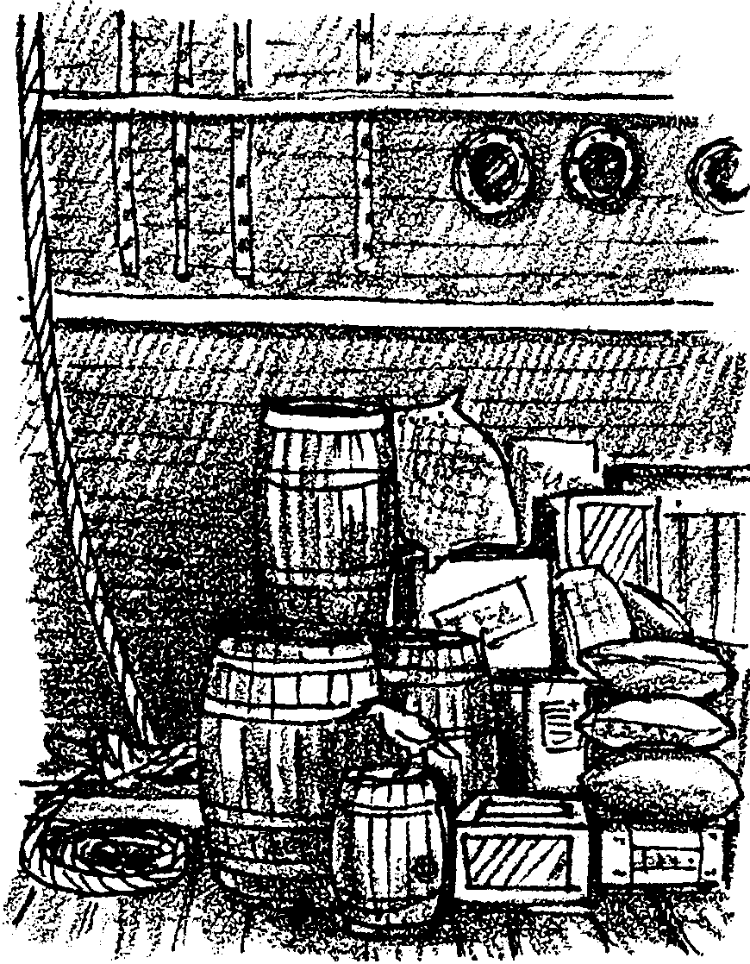
Article Amount Price Cost

Oil casks 2,000 Bbls. $ 1.25 $3,500.00

Beef and pork 240 Bbls. 8.50 2,040.00

Flour 220 Bbls. 5.25 1,155.00

Corn 75 bushels .55 41.25

Beans and peas 14 bushels 1.25 17.50

Corn meal 5 Bbls. 3.50 17.50

Rice 2,500 lbs. .11 275.00

Potatoes 1,200 lbs. .035 42.00

Cheese 150 bushels .35 52.50

Butter 800 lbs. .07 56.00

Dried apples 900 lbs. .13 117.00

Vinegar 600 lbs. .04 24.00

Cod fish 10 Bbls. 3.50 35.00

Molasses 800 lbs. .03 24.00

Tea, black 1,600 gals. .27 432.00

Tea, hyson 250 lbs. .35 87.50

Raisins 20 lbs. .60 12.00
Part 1
Typical Cost of Whaling Voyage

On the right is a list of the principal articles required to outfit a vessel for a sperm whaling voyage. The amount of each article and the cost at the prices which prevailed on January 1, 1844, are also shown. Use this information to answer the questions that follow.

Sugar 200 lbs. .05 10.00

Coffee 1,000 lbs. .07 575.00

Tobacco 1,000 lbs. .08 80.00

Duck, heavy 60 pieces 18.00 1,080.00

Duck, light 36 pieces 8.00 288.00

Tar 20 Bbls. 2.25 45.00

Whale boats 6 boats 60.00 360.00

Oars 7 sets 8.50 59.50

Boards 4,000 feet 20.00 80.00

Nails, composition 700 lbs. .22 154.00

Copper, sheathing 8,500 lbs. .21 1,785.00

Cordage 8,500 lbs. .10 850.00

Tow lines 3,000 lbs. .12 360.00

Try pots 3 pots 60.00 180.00

Cloth 6,000 yards .09 540.00

Iron, whaling crafts 4,000 lbs. .15 600.00

Clothing, ready-made 2,800.00

Labor in port 2,500.00
From: The American Whaleman
by Elmo Paul Hohman
Total cost of outfit 19,774.75
Cost of a typical vessel 31,224.72
1. What was the whale product sought by the whalers?

2. How many different types of food were stocked on the ship?

3. a. Nutritionists (people who study balanced diets) place food in five groups. The groups are listed below. Place the foods taken on the whaling ship in their proper place.

MEATS EXTRA FOODS
(including beans, FRUITS AND BREADS AND soda pop,
peas, peanut butter) VEGETABLES CEREALS MILK candy, etc.)

b. Which group had the fewest foods? What is one possible reason for this group having so few listings?

c. Do you think the sailors had a lot of variety in their meals? What foods not listed might they have been able to add to their diet?

4. Duck is a fine, white canvas-like material. What are two possible uses for duck on a whaling ship?

a.

b.
5. Copper sheathing is used to protect wood from attack by marine “worms”. Where do you suppose the copper sheathing was “worn” by the ship?

6. What were the try pots?

Part 2

The costs shown in Part 1 had to be paid before the ship sailed. Other costs had to be paid when the trip was over. The wages for the captain and crew made up most of the after-cruise expenses. The following are the wages for one seaman’s four year voyage in 1849.

Sailor’s share in money $262.25

Less: Fitting, shipping, medicine chests -10.00

10% discount on share - 26.22

3% insurance share - 7.86

Money advanced for voyage - 70.00

Interest on same - 16.80

Cash advanced on voyage - 30.00

Interest on same @ 1%/month - 7.20

Clothing drawn - 40.00

Amount paid at end of voyage $54.17

1. This figure is called the gross wages. (The “before tax” figure).

a. What did this sailor make (gross) for each year of the four year cruise?

b. How much was this per day? (Hint: There are 365 days per year.)

2. This figure and the “Clothing drawn” help pay back what the owner spent to outfit the ship. Who also collected the other “deductions” from the seaman’s pay?

3. a. How much cash did the ship’s owner really have to pay this seaman?

b. The total cost for a seaman was the amount paid in cash at the end of the voyage plus fitting and clothing expenses. What was the total amount it cost the owner for 4 year’s of this sailor’s life?

4. a. From Part 1, what was the total combined cost of vessel and outfit?

b. The whaleships brought in an average of $16,000 a year. What would be the value of the cargo for this four year cruise?

c. Total crew salaries amounted to $10,000. How many similar four year cruises would be required to pay for the entire ship, outfitting and salaries?

5. Ship’s owners took advantage of their crews. Owners made from 25 to 50 percent a year clear profit on their investments.

a. At 50% profit, how many years would be required to pay off the investment?

b. About what annual percentage did the owner described above in question 4 earn?
(Hint: annual percentage = annual income to owner - total of sailors annual salaries x 100 )
total combined cost of vessel and outfit

