Save My Story!

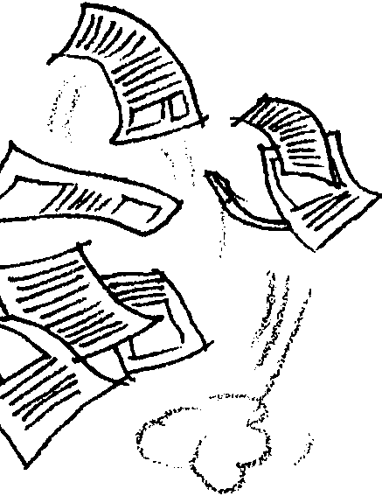
Key Concepts
1. The whaling industry has played a significant role in domestic and international economics.
2. Story lines in books usually have a logical sequence with a beginning, middle, and end.

Background

Background for “Save My Story” is found in the preceding activity, “December 15 - Sailing Whaling”.

Materials

For each student:

• “Save My Story!” student activity pages

• Text and Illustration pages to cut up

• scissors (can be shared)

• desk or table top

• 2 sheets of blank copy (typing) paper

• glue or tape

Teaching Hints

In “Save My Story!”, students organize the contents of a small booklet that tells about sailing whalers. They sequence the story and match text with illustrations. Then they layout each page, glue the text and illustrations in place and complete the booklet by designing and illustrating the book cover. Following this activity students may choose to write small booklets about topics related to the gray whale. Encourage students to use the computer as a tool for word processing, illustrating, and page layout. This activity can have many creative applications for written expression and assessment of content learning.

Duplicate the student activity pages. This activity can be completed by individuals or small group as an in-class assignment or homework. It is best for students to arrange the text and illustrations on a desk top before gluing them on the pages.

Have students create and illustrate a cover page for the outside of the booklet. The first page in the book is for the title page which should include author, illustrator, publisher (student makes up own name), copyright date here. The facing page (page 2) is the first page for text and illustration. On the back of the booklet, the students may write a short description about the author or a note about the current status of the gray whale or whaling history.

Key Words

layout - in this case, the arrangement and relationship of the illustrations and text

publish - to issue for distribution to the public

Answer Key

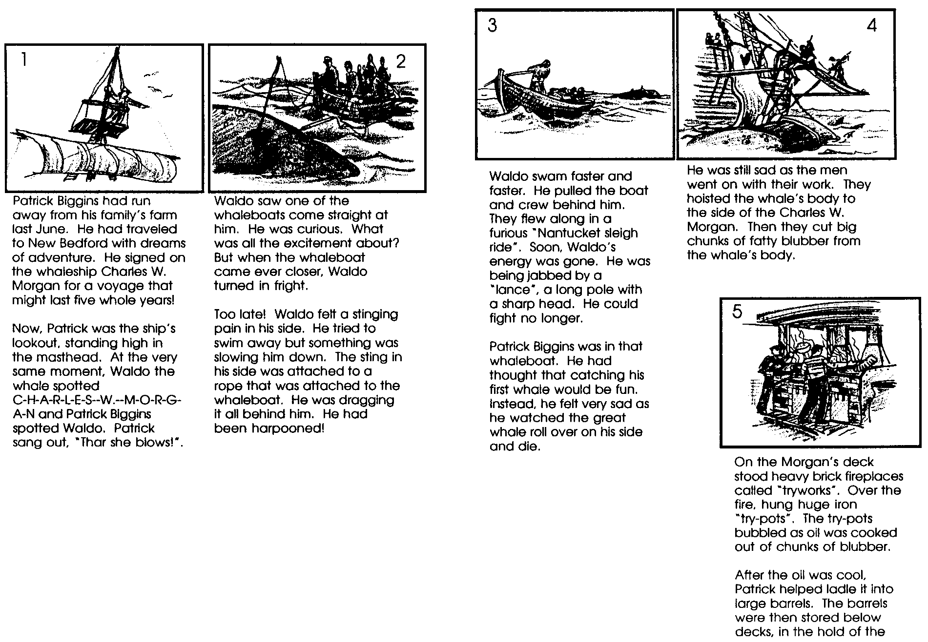

Mixed-up text and illustration pages to cut out

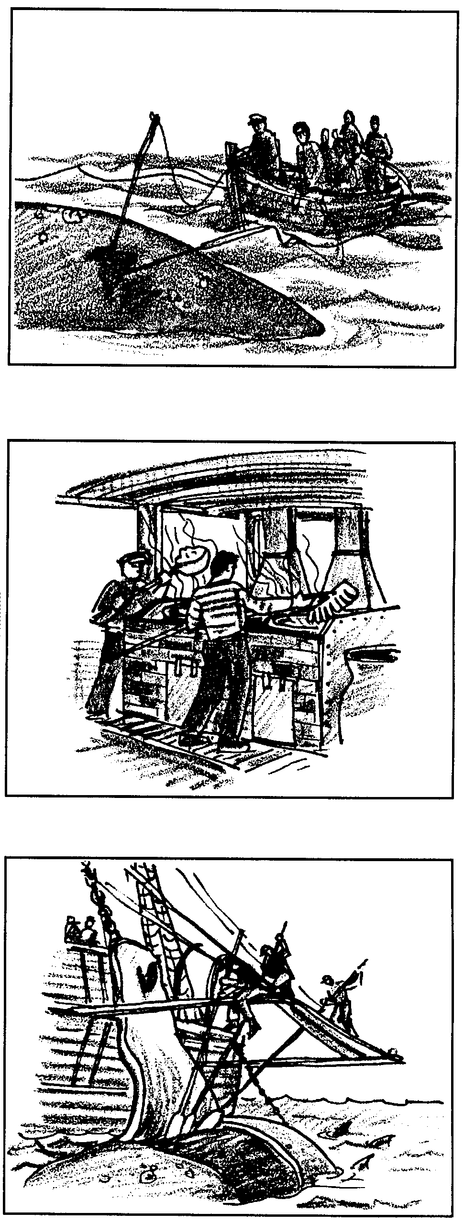
On the Morgan’s deck stood heavy brick fireplaces called “tryworks”. Over the fire, hung huge iron “try-pots”. The try-pots bubbled as oil was cooked out of chunks of blubber.
After the oil was cool, Patrick helped ladle it into large barrels. The barrels were then stored below decks, in the hold of the ship.

Waldo swam faster and faster. He pulled the boat and crew behind him. They flew along in a furious “Nantucket sleigh ride”. Soon, Waldo’s energy was gone. He was being jabbed by a “lance”, a long pole with a sharp head. He could fight no longer.
Patrick Biggins was in that whaleboat. He had thought that catching his first whale would be fun. Instead, he felt very sad as he watched the great whale roll over on his side and die.

Waldo saw one of the whaleboats come straight at him. He was curious. What was all the excitement about? But when the whaleboat came ever closer, Waldo turned in fright.
Too late! Waldo felt a stinging pain in his side. He tried to swim away but something was slowing him down. The sting in his side was attached to a rope that was attached to the whaleboat. He was dragging it all behind him. He had been harpooned!
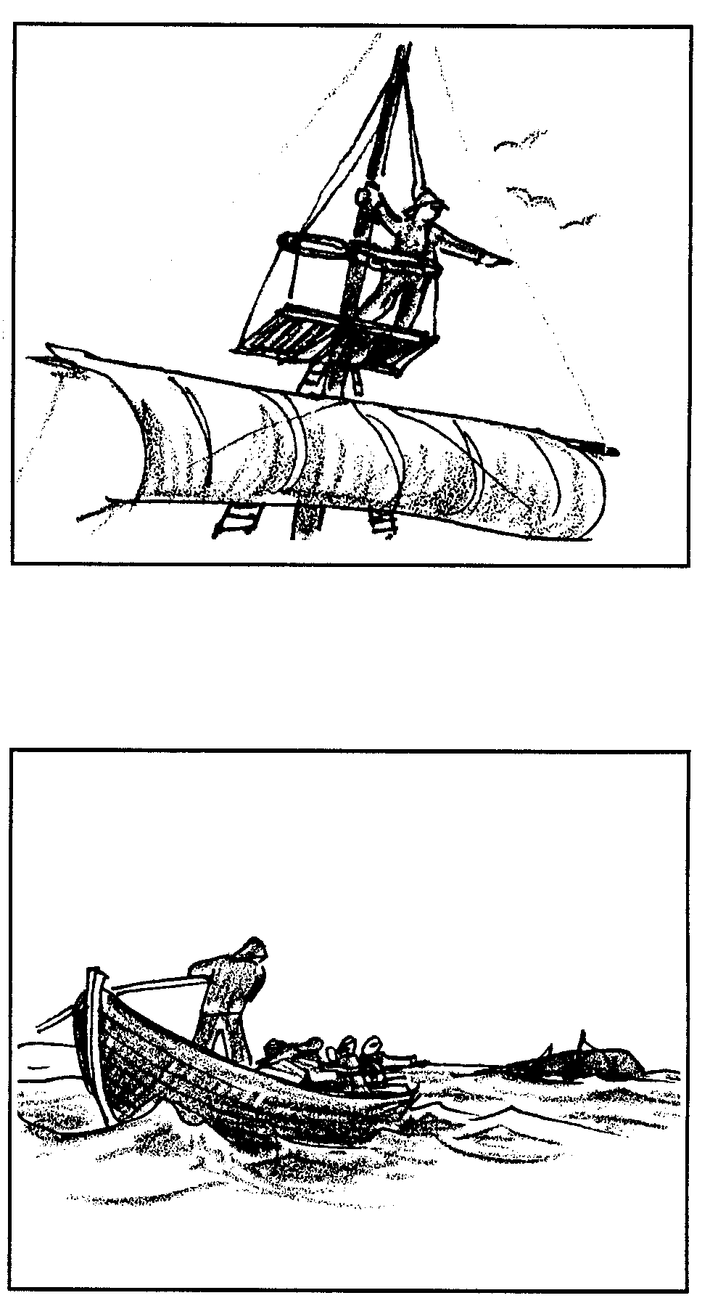

He was still sad as the men went on with their work. They hoisted the whale’s body to the side of the Charles W. Morgan. Then they cut big chunks of fatty blubber from the whale’s body.

Patrick Biggins had run away from his family’s farm last June. He had traveled to New Bedford with dreams of adventure. He signed on the whaleship Charles W. Morgan for a voyage that might last five whole years!
Now, Patrick was the ship’s lookout, standing high in the masthead. At the very same moment, Waldo the whale spotted C-H-A-R-L-E-S--W.--M-O-R-G-A-N and Patrick Biggins spotted Waldo. Patrick sang out, “Thar she blows!”.

Save My Story

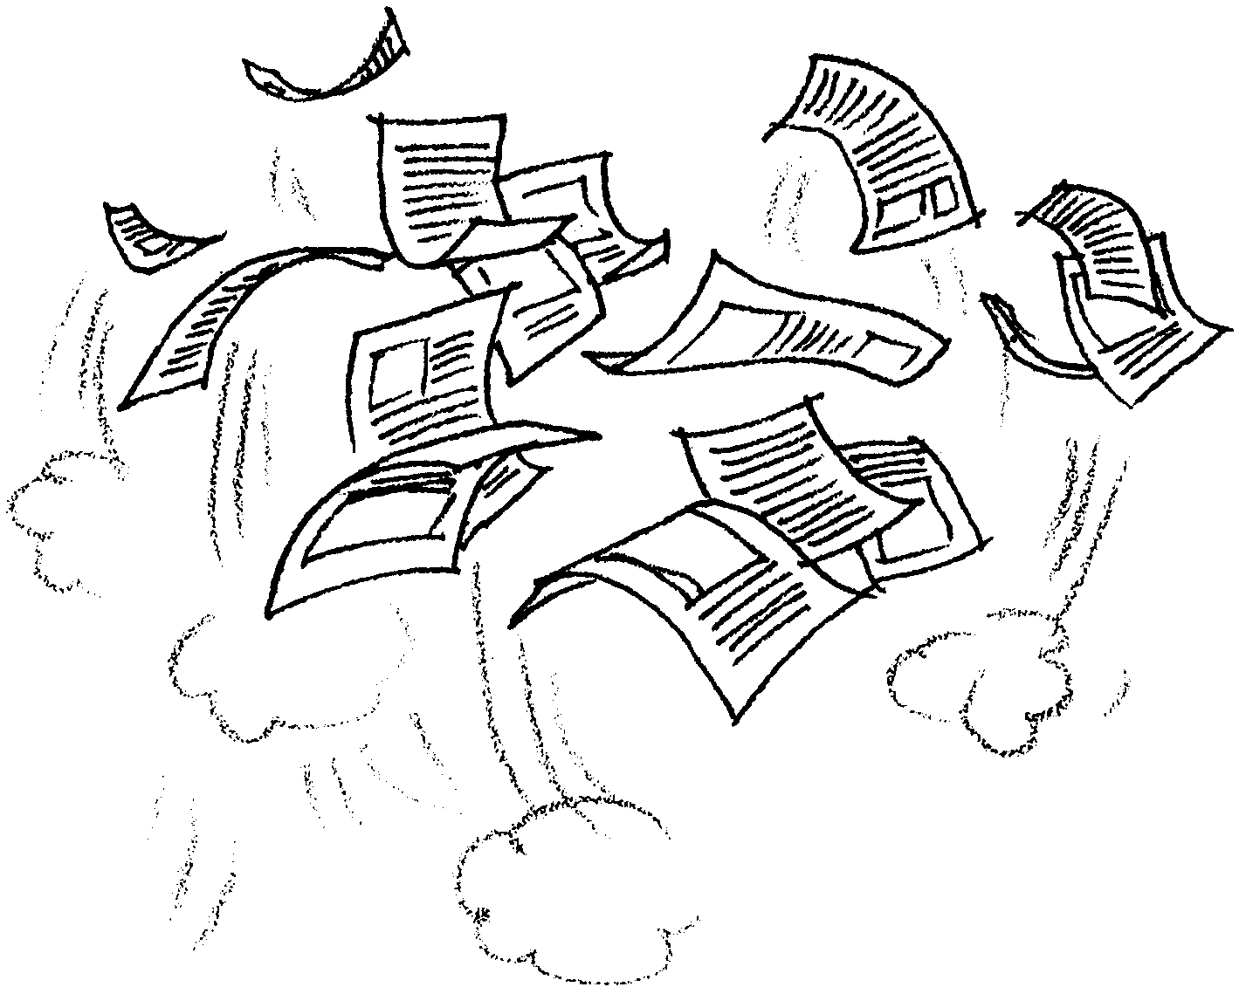

The last sailing whaling ship is now a floating museum at the Mystic Seaport Connecticut. Judith A. Meyers works in the Education Department at the museum. Ms. Meyers has just finished the final draft of her book, Waldo the Whale. As she walks along the shore, she reads the draft. “Oh! No!” Can it be? Ms. Meyers has stepped in a hole left by a discourteous clam digger. Up in the air goes Waldo the Whale. Down on the sand land the pages, out of order.

What can you do? On the next page, are the text and illustration boxes for Ms. Meyers’ book. The boxes on the left are the text pages. The boxes on the right are the illustrations. Help Ms. Meyers organize the text boxes and match them to the illustrations. Then help her layout and publish her book.

Here’s what you’ll need:

Materials
• pages of text and illustrations boxes
• scissors (can be shared)
• desk or table top
• 2 sheets of blank copy (typing) paper
• glue or tape

Procedure

1. Read through all the instructions before you begin.

2. Clear your desk or table top and obtain the materials you will need.

3. Read the all the text boxes. Examine all the illustration boxes.

4. Cut out the text boxes and the illustration boxes.

5. On a desk top or table, place the text boxes in order from the beginning to the end of the story. Arrange the illustration boxes to match the text boxes. Match the words and the pictures.

Remember, the pictures represent a time sequence. Place the picture you think happens first next to the text you think happens first. Continue until you have placed all five pictures in their proper order.

6. When you think you have all the boxes in the correct order, ask someone to check your work. (This is what an editor does for a living.) When you are satisfied, leave the text and illustrations alone for now.

7. Prepare the pages for the book. Here’s how. Stack the two sheets of paper. Fold them across the length so that they are creased in the center like a book. Counting the outsides of the book, you should have 8 pages.

8. In pencil, lightly mark the pages to help you remember what to put on each page. Later you will erase these marks. Lay the book so that is opens like other books.

Here’s what to put on each page:

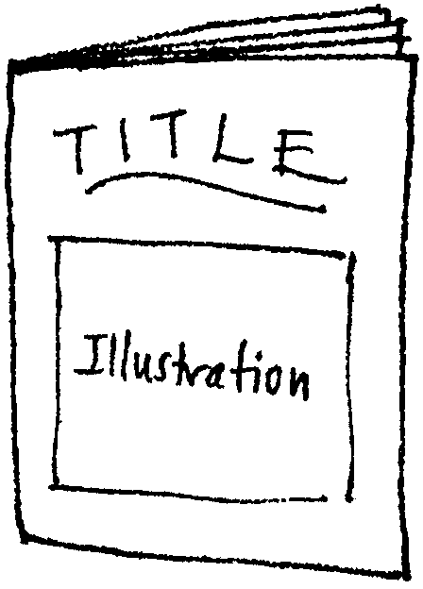
The outside page is for the title of the book and an illustration you will create.

Open the page. The inside of the first page, on the left is for page 1 of the book. Write page “1”.

The facing page is page 2. You will put the beginning text box and its matching illustration box here later. Write page “2”.
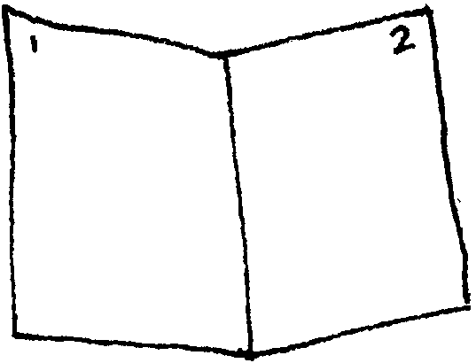

Turn the page. You should see the “center fold” of the book. On the left page write page “3”. On the right side write page “4”. Turn the page.

On the left page write page “5”. On the right side of the page write page “6”. This is the last page of the book, except for the back cover. You will finish the story and put the text and illustration here. Turn the page to the back cover.

On the back cover page write “back”. This is where you might write about the author, a note about the gray whale or about whaling history.
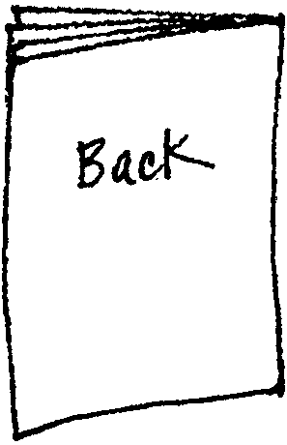

8. “Lay out” the pages. Place the first text box and illustration on the page in the way you will want the book to look. Try different arrangements. You might put text at the top of the page with the illustrations below. You might do just the reverse. You might want to put text and illustrations side by side on a page. The page layout does not have to be the same throughout the book. It needs to be pleasing to look at, sensible, and in the correct sequence (order).

9. Proofread the story. Is the text in correct order? Does each illustration match the text on the page? Does it look good? Are the boxes parallel to the edges of the page? Make corrections and adjustments now.

10. Glue (or tape) the text and illustration boxes on the pages of the book.
11. Make a cover design. On scratch paper, practice writing the title of the book, Waldo the Whale. Write it the way you will want it to look on the cover. Design an illustration for the cover. Cut out the title and illustration and arrange them as you like on the cover. Glue them in place. If you prefer, write and draw them directly on the cover.

12. The boxes with the ending to the story are missing! In the space below finish the story of Waldo the Whale. Use the box on the left for your text and the box on the right for your illustrations.
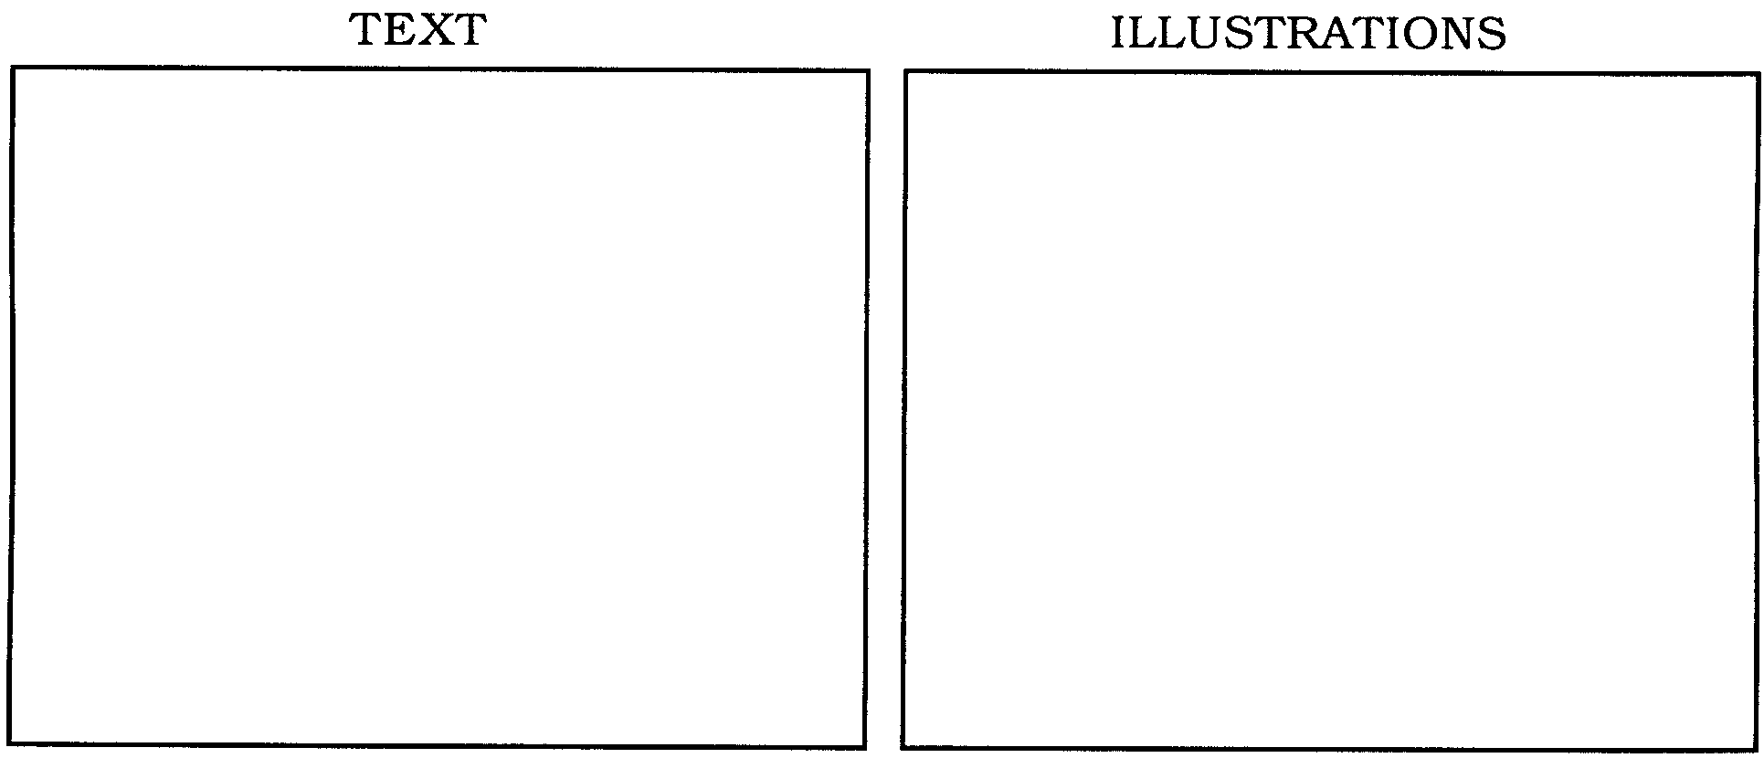

13. Back page. On a separate paper write a short description about the author, the gray whale or whaling history. You might use some of the information from the introduction to this activity. Revise and proofread your descriptions. Then neatly write it on another paper. Cut it out and glue it on the back cover. If you prefer, write it directly on the back cover.

If you like, color the illustrations. Share your book with others. They’ll enjoy it!

