December 15 - Days of Whaling:

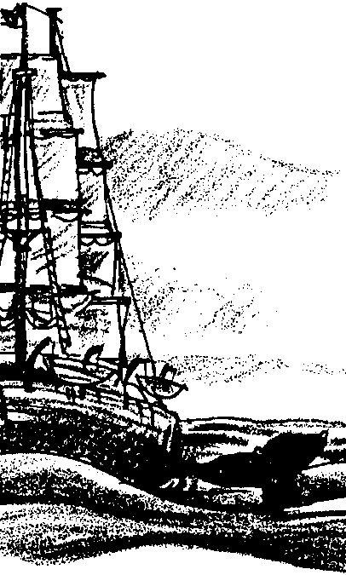
Sailing Whaling

Key Concepts
1. The whaling industry has played a significant role in domestic and international economics.
2. Technological advancement and human greed expressed in over harvesting have greatly affected whale populations.

Background

The story of human interaction with the whale has been, and continues to be, a tale of nearsighted self-interest. Historically, it is convenient to consider three major periods in whaling: native whaling, sailing whaling, and modern whaling. As a case study, whaling shows the complexity of ocean management problems. Biology, sociology, economics, and politics are all deeply involved in deciding the future of whale species.

Materials

For each student:

• “December 15 - Sailing Whaling” student activity pages

For the classroom:

• displays of pictures, books, periodicals, maps about the people and places that participated in the whaling industry

Teaching Hints

“Sailing Whaling” is the second lesson of the activity, “December 15 - Days of Whaling” and gives your students an historical overview of the issues surrounding whale hunting as they read and review whaling history, construct a time line and chart technological developments.

In toto, “December 15” is divided into three major sections: Indian Whaling, Sailing Whaling, and Modern Whaling. While the three sections present a unified whole, separate text and investigations are provided for each as the entire “December 15” is long for a single assignment. These sections lend themselves to completion by individuals or small groups as homework or in-class assignments. Each section has a separate Teacher Background section, although the last two are somewhat abbreviated.

Three separate activities reinforce and extend the material introduced in “Sailing Whaling”. “Save My Story!” stresses sequencing skills as it reinforces the material in this lesson. “Blood Money” uses actual business ledger figures to sharpen critical reading skills, while “Scrimshaw” provides hands-on extensions.

Additional Teaching Hints are found in the preceding activity, “December 15 - Days of Whaling: Native Whaling”.

Duplicate the student text materials. One set is recommended per student. Your students will profit from a review and discussion of the materials presented in these sections.

If you are using “Voyage Of The Mimi” in conjunction with this curriculum, “Episode 7: Fastening On” correlates with this lesson.

Key Words

baleen - an elastic, fingernail-like substance growing in place of teeth in the upper jaw of certain whales, and forming a series of thin, parallel plates on each side of the palate; “whalebone”

loggerheads - a rounded post in the stern of a whaleboat, around which the harpoon line is passed

scrimshaw - a carved or engraved article, especially of whale ivory, whalebone, or the like, made by whalers as a leisure occupation

spermaceti - oil taken from the case located on the upper part of the head of a sperm whale, used to make perfume, smokeless candles and to lubricate watches and other delicate machinery

try works - large brick furnaces containing two huge iron caldrons (pots) in which blubber was boiled

Extension

1. Have students create replicas of historical artifacts and models of whaling villages, shore stations, and ships in order to make a classroom “whaling museum”. Then, have them conduct tours for other classes and parents.
Answer Key

1. The drawing below shows a correctly labeled lookout.
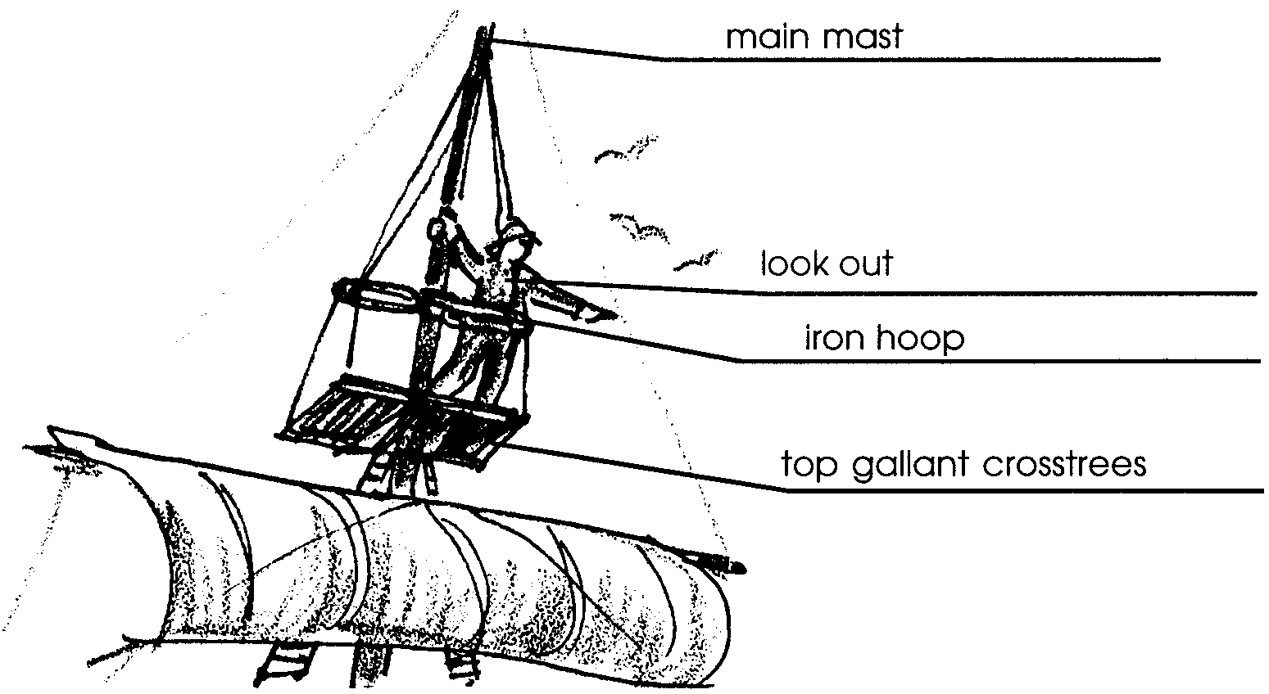

2. The harpooner, a crew member who sat in the bow, threw the harpoon. Although his principal job was to fasten on to the whale, he also helped row the whaleboat.

3. A “Nantucket sleigh ride” occurred when a harpooned whale swam across the sea at great speed while towing behind the whalers in their small whaleboat.

4. The crewman that harpooned the whale was/was not the same person who killed the whale. The correct answer is in bold face type. The steersman (helmsman), who was the officer-in-charge or boat header, came forward to the bow, exchanging places with the harpooner, to plant the killing lance into the whale.

5. The drawing below shows a correctly labeled “cutting in”.
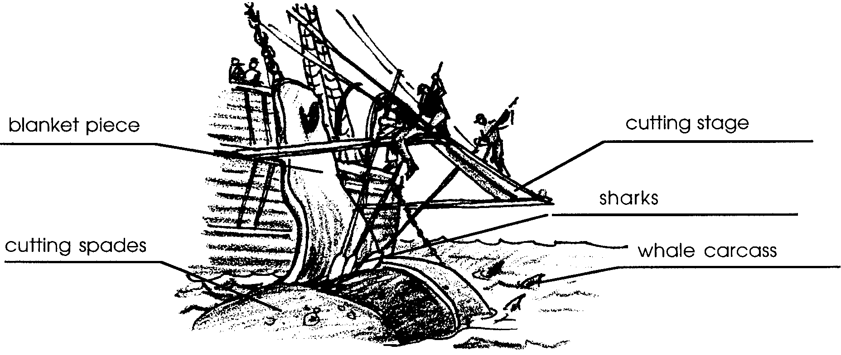

6. This question involves some thought by your students. Basically, whaling ships could hold more oil in casks than in raw blubber. As a result, rendering on-board increased the quantity and, hence the value, of the cargo. It also decreased the need to return to shore stations. The decreased connection with shore stations was important because it allowed whalers to venture farther from shore. The ability to go farther was important because the whalers had effectively slaughtered the near-shore whales. A second factor also came into play. As the Nantucket crews began to whale in latitudes nearer the tropics, they found the blubber turned rancid in the heat. The rancidity reduced the value substantially. Rendering the blubber on board solved this problem. Whalers could mix blends of lesser grade oil with that of higher grade and deliver the mix as the higher grade for more profit than if they had delivered the oil in its true condition. From the above, it should be evident that ship-board try works were a major breakthrough for the sailing whalers.

7. Three products the Nantucket whalers derived from whales include:
a. spermaceti for lubricating oil and smokeless candles.
b. fuel oil from blubber
c. teeth for scrimshaw.

A fourth product not mentioned but of great value in the later days of sailing whalers was the baleen used in corset stays, umbrellas and a variety of other commodities.

8. Shore whalers hunted blue/gray/humpback)/ fin whales in waters near the coast. The correct answers are in bold face type.

9. Shore whaling lasted for only about 30 years.

December 15 - Days of Whaling:

Sailing Whaling
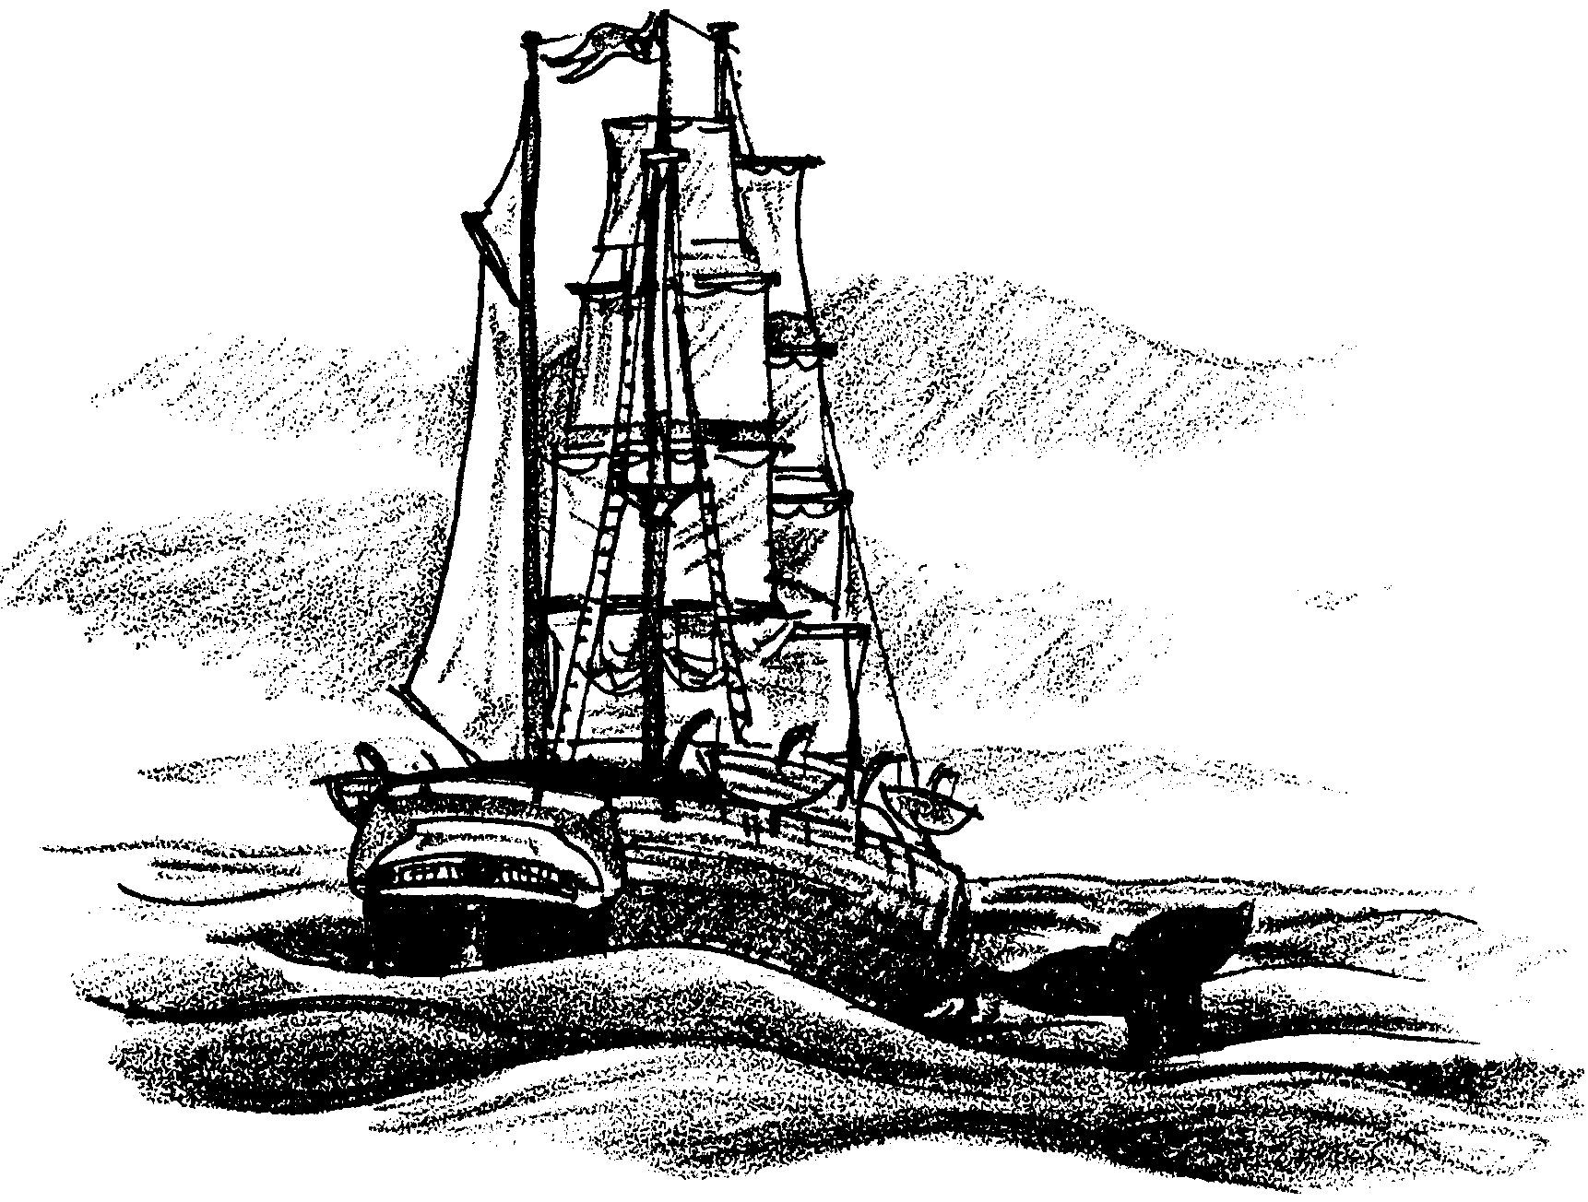

The arrival of the Portuguese in Monterey signaled the beginning of another era in whaling. In 1851, a small group of Portuguese from the Azores Islands of the Atlantic arrived in Monterey, California. This group built the first shore whaling station in California. But they were not the first non-native whalers in the Pacific. By 1746, whaling schooners from Nantucket, Massachusetts were cruising to Africa and the South Atlantic. In 1787, the first whaler to sail around Cape Horn and enter the Pacific Ocean waters sailed from Nantucket. By 1820, Nantucket whalers were sailing the waters of the North Pacific. What was life like on a Nantucket whaler?

It is hard to imagine that men ever dared to attack the whale with harpoons thrown from small wooden boats. For pure size and power, the whale has no rival. But for the Nantucket whaleman, this dangerous combat was a way of life.

When under sail, a man was always posted as lookout on two small boards called the “top-gallant crosstrees”. The top-gallant crosstrees were fastened to the main mast of the ship. He was steadied by a waist-high iron hoop attached to the mast a hundred feet above deck. He swayed back and forth for two dizzying hours before being relieved.
When a whale was sighted, the lookout cried, “A-a-a-ah blows! Thar she blows!” The ship below him erupted into action. His long drawn out cry sent a thrill through every man in the ship.
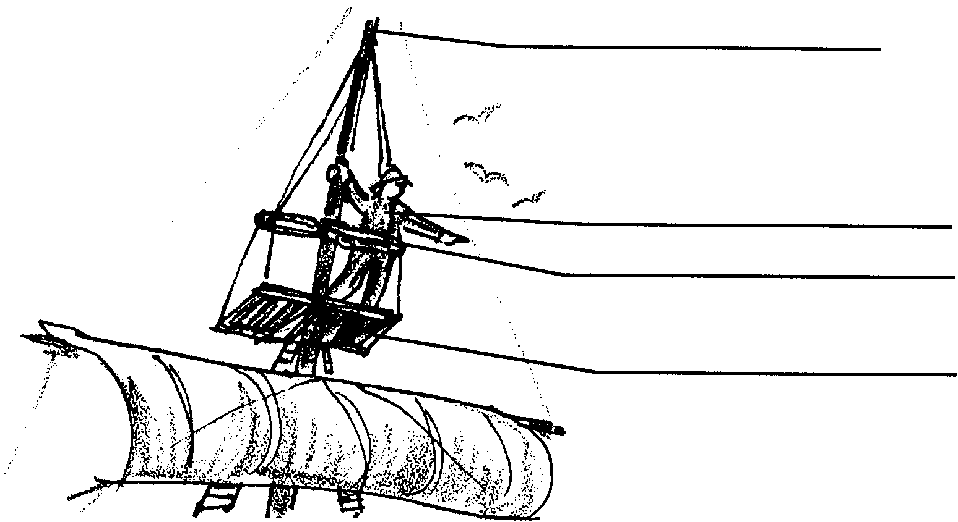

1. The drawing above shows a look out on a Nantucket Whaler. Label the (a) top gallant crosstrees, (b) the look out, (c) the iron hoop, and (d) the main mast.

Small boats with crews of six were lowered. The chase had begun! With much colorful and downright profane yelling, the officer-in-charge, or “boat header”, urged the crew onward toward the spot. The crew pulled toward the spot perhaps 3.2 km (about 2 miles) away, where they expected the whale would reappear. When the whale came up for air, the whaleboats would be waiting. “Pull lads! Put your back into it, me heroes!” As the boat approached throwing range, the harpooner rowing in the bow of the whale boat put away his oar and stood up with his feet on the forward platform. He braced his knee against the “clumsy cleat” at the bow. With all his might, he harpooned the whale. The line whipped out of the tubs and whistled around the loggerheads so fast that the men poured water over the line to keep it from catching fire from the friction. The harpooner had finished his job of fastening on to the whale.

2. Which crew member threw the harpoon?

Boat and whale were then fated to fight it out. The whale might dive or lash his tail with thundering blows that could smash the boat to splinters. Sometimes the crew was forced to abandon the boat. They had to sacrifice the catch to save their lives. Sometimes the whale swam across the sea with terrifying speed. The whalemen were towed on what was called a “Nantucket sleigh ride”.

3. What was a “Nantucket sleigh ride”?

The whale towed the boat until the whale tired in its attempt to escape. Exhausted, it lay in the water near the boat. The officer-in-charge changed places with the harpooner in the bow of the small whaleboat. It was the task of the officer-in-charge to kill the whale with the plunge of a long iron lance (blade) into the heart or lungs of the whale.

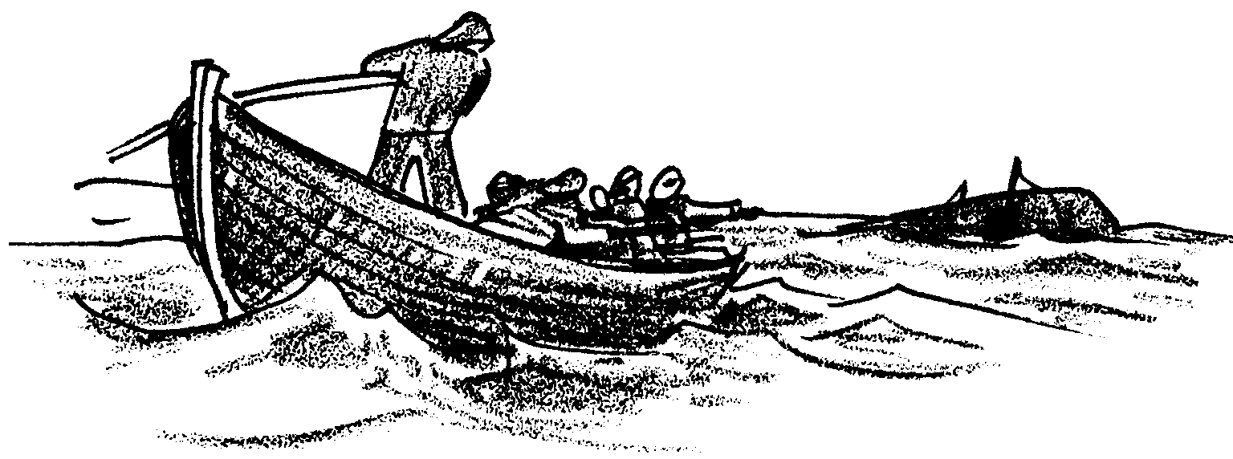

4. The crewman that harpooned the whale was/was not the same person who killed the whale. (Circle the correct answer)

The crew towed the enormous body back to the ship. Other whale boats and crews assisted if they did not also have a whale in tow.

Once the whale was back at the ship, the “cutting in”, or removal, of the blubber began. The seamen stood on a narrow platform called a cutting stage. From the stage, they labored with sharp spades. First they separated the whale’s head from the body. The blubber was then cut in a continuous strip as the body rolled over and over. As the men worked, the carcass was often surrounded by sharks. Large sections of blubber “blanket pieces”, were lifted aboard and stored temporarily in the ship’s hold. When all the blubber had been removed, the stripped carcass was set adrift to be torn apart by the sharks.

At first, these whale hunters were interested only in the oil resource found in the blubber. Years later, more of the whale would be used for other products.

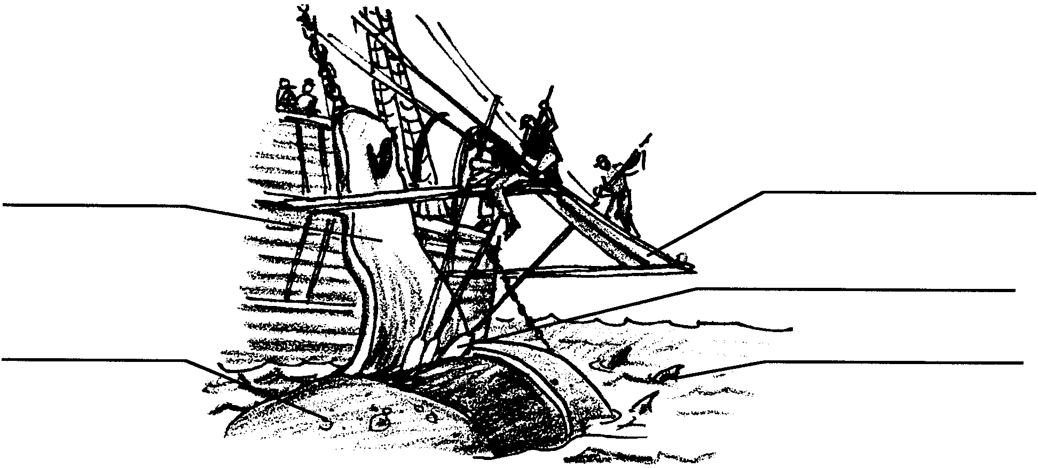

5. The drawing above shows the crew of a whaler “cutting in”. Label the (a) cutting stage, (b) cutting spades, (c) blanket piece, (d) whale carcass, and (e) sharks.

The blanket pieces were sliced to smaller “horse pieces”. The horse pieces were further minced into smaller “bible leaves” resembling open pages. These pieces were thrown into the “try works”. The “try works” were large brick furnaces containing two huge iron caldrons (pots) in which blubber was boiled. The men labored day and night for several days at the roaring try works. The stench was incredible and the smoke suffocating. As the oil rose to the tops of the kettles, it was scooped off, cooled, strained, and stored in barrels. Each barrel contained 119 liters. After all the oil had been stored in barrels below deck, the whalers spent several more days scrubbing the ship clean. The hunt for more whales would then resume.
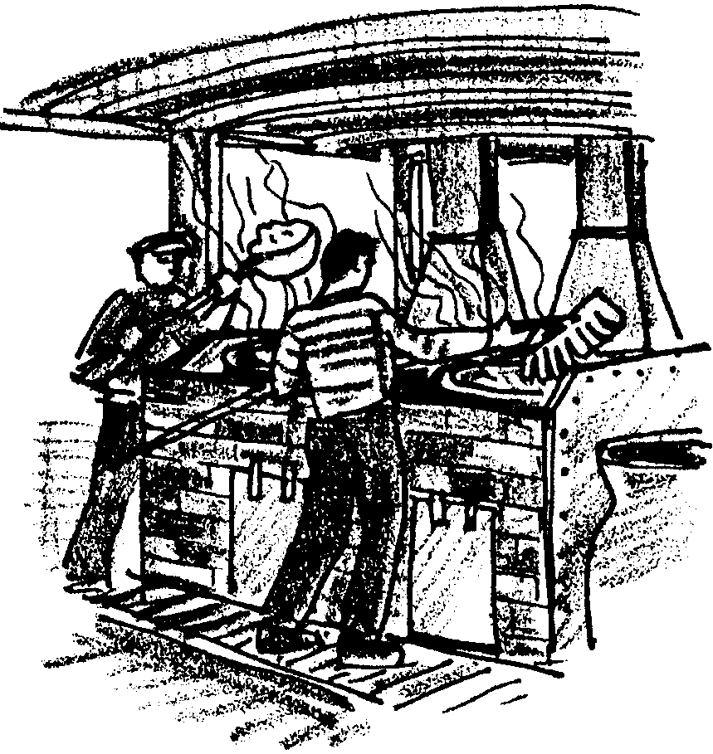

6. Sailing whalers were made of wood. The try works required hot fires. The first whalers with try works aboard caught on fire and sank. What is one possible reason that whale men were willing to risk fire to have the try works on board?

Sailing whalers killed a variety of whales. Even so, the sperm whale was the preferred prey. The real treasure was the head of the sperm whale. The case located on the upper part of the head contained up to 1,892 liters of high grade oil. This oil, called spermaceti, was used to make perfume, smokeless candles and to lubricate watches and other delicate machinery. The spermaceti was bailed out with buckets and stored in specially marked barrels.

Sperm whales’ teeth were also valuable. When turned into art works, they found a good buyer’s market. Pulling whales’ teeth was tricky. But the whalemen had mastered the process and the teeth popped out like peas from a pod.

Gray whales yielded little oil and so, at first, were seldom hunted. That all changed in 1858. In that year, Captain Charles Scammon found gray whales in the lagoons of Baja California.

7. What were three products the Nantucket whalers derived from whales?
a.
b.
c.

Shore whalers

How did the shore whaling stations fit into the picture? The shore stations existed by hunting whales close to shore. The Monterey station was located in a protected cove. The small whaling boats were launched from the cove. The whalers hunted humpback and California gray whales. Captain Charles M. Scammon gives us an eye-witness description of life at the Monterey station:

“The one which most interested us is half-hidden in a little nook, on the southern border of the Bay of Carmel, just south of Point Pinos. Scattered around the foothills, which come to the water’s edge, are the neatly whitewashed cabins of the whalers, nearly all of whom are Portuguese, from the Azores or Western Islands of the Atlantic. They have their families with them, and keep a pig, sheep, goat, or cow prowling around the premises . . . It is a pleasant retreat from the rough voyages experienced on board the whale ship.
Under a precipitous bluff, close to the water’s edge, is the station, where, upon a stone-laid quay, is erected the whole establishment for cutting-in and trying-out the blubber of the whales . . . Nearby are the try-works, sending forth volumes of thick, black smoke from the scrap-fire under the steaming cauldrons of boiling oil. A little to one side is the primitive storehouse, covered with cypress boughs. Boats . . . swing at their moorings in the bay. Seaward, on the crest of a cone-shaped hill, stands the signal-pole of the lookout station. Add to this the cutting at the shapeless and half-putrid (rotten) mass of a mutilated whale, together with men shouting and heaving on the capstans, the screaming of gulls and other sea-fowl, mingled with the noise of the surf about the shores and we have a picture of the general life at a California coast whaling station.”

The next 20 years, until 1871, saw a rapid increase in shore whaling. The shore whalers were effective. By 1880, California gray whales and humpback whales became too scarce to be hunted profitably. The shore whaling stations had hunted themselves out of business.

8. Shore whalers hunted blue / gray / humpback / fin whales in waters near the coast. (Circle the correct answer(s)).

9. Shore whaling lasted for only about years.

