Canoe Building

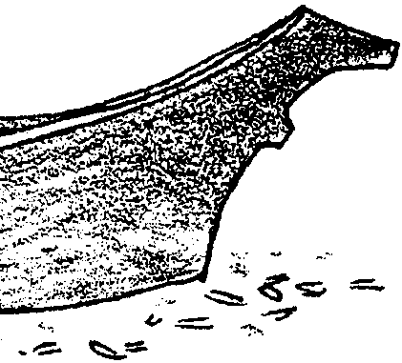
Key Concept
1. Native canoe builders used available tools and technology to make seaworthy vessels.

Background

Over the centuries, Northwest Coast native peoples developed canoe building into an art form. A whaling canoe was a prized possession. It was also vital equipment to the harpooner and his crew. High prices were paid for the best built canoes. Some of the best canoes were built by the people of the coasts of Vancouver Island and Washington State. These canoes were traded along the entire coast. Certain men were known to be the best canoe builders. Such canoe builders passed on their knowledge and skill, usually within their families but sometimes to other select people. The ocean-going whaling canoe well reflects the woodworking skills of the natives of the North Pacific Coast.

Although the most preferred ocean-going canoe was made of yellow cedar from Vancouver Island or the mainland of Canada, red cedar was also used. Red cedar was more available on Washington’s coast. The whaling canoe was usually about 35 feet long. Larger canoes were built for carrying cargo and people on long trading or war voyages. Smaller canoes were also built and used for family and personal travel, for hunting other marine mammals, fishing, or gathering sea food.

The term “dugout” canoe more accurately describes East coast or inland canoe building techniques than those applied to making vessels for use on the Pacific Ocean. While some of the wood was removed from the inside of the log by hand (i.e., “dug out”), much of it was burned out by coals. As a result, “cedar canoe” is the term to use for these ocean going vessels of the Pacific coast. The canoe was widened and shaped with hot water and steam. The outside of the canoe was often sanded with shark skin and coated with oil from marine mammals.

Additional background for “Canoe Building” may be in found in the previous activity, “December 15: Native Whaling”.

Materials

• half a red cedar log of length up to 40'

• adze

• chisel

• stone maul

• needle

• cedar withes (tough, flexible twigs)

Teaching Hints

The brief introduction to North Coast native cultures provided in “Native Whaling” oftentimes generates a deeper interest in these peoples. The following directions provide you with an opportunity to extend your activities dealing with native cultures.

The instructions reflect the techniques used by North Coast natives in constructing their canoes. Adapt the authentic native methods and materials to those you have available while maintaining touch with the procedures used by the Native Americans.

A model canoe can be made by scaling down these materials.

Key Words

adze - an axe-like tool, for dressing timbers roughly, with a curved chisel-like head mounted at a right angle to the wooden handle

bow - the forward end of a vessel

cedar - in this case, any of a variety of coniferous trees but especially Western Red Cedar, Thuja plicata

“dugout” canoe - a slender boat, tapering at both ends, made by hollowing out a log

gunwale - the upper edge of the side of a vessel

maul - a heavy hammer

pitch - the sap that exudes from bark of pines and certain other coniferous trees; any of various resins

port - the right hand side of or direction from a vessel, facing forward

starboard - the left hand side of or direction from a vessel, facing forward

stern - the back end or rear of a vessel

thwart - in this case, a crosswise board spreading the gunwales of a canoe

withe - a tough, flexible twig or stem suitable for binding things together

Extensions

1. Collect pictures of Northwest coast canoes and tools to display in your classroom.

2. Visit a museum, tribal center, or site that has canoes on display. Whaling canoes are displayed at the Makah Cultural and Research Center in Neah Bay and at the Olympic National Park Visitor’s Center in Port Angeles, Washington.

3. Try to find a native canoe builder to visit your classroom.

4. Have students build models or collect pictures of other types of whale boats, such as: the sealskin “baidarra” of the Aleutian Islands; other skin canoes of Alaska and Siberia; canoes of Japanese shore whalers; boats that were carried on whaling ships; sailing whaling ships and modern factory ships.

Canoe Building

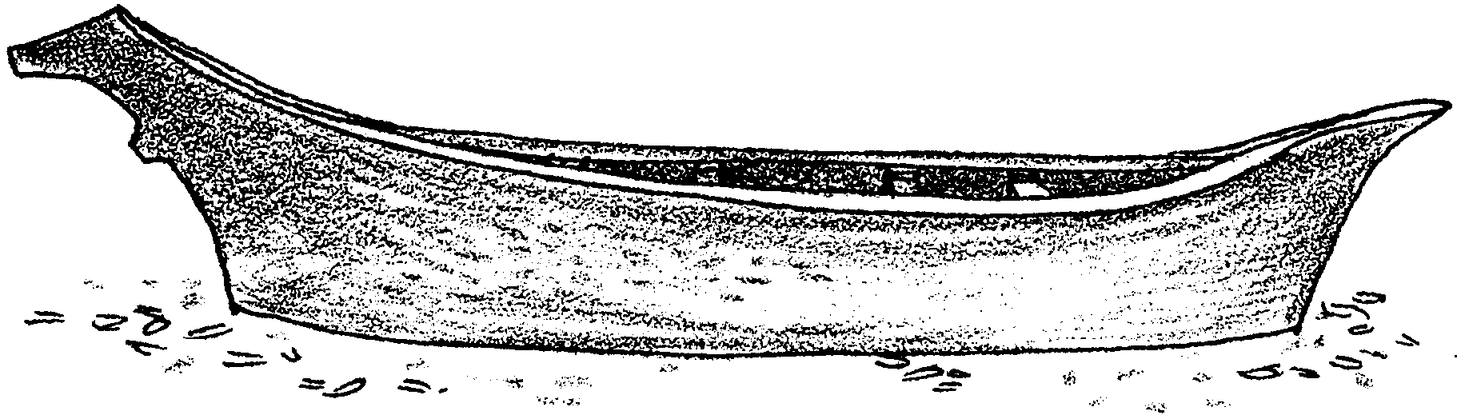

Northwest Coast Native peoples have developed canoe building into an art form. Canoes are usually made from a cedar log hollowed by burning and chiseling. An ocean canoe has a graceful, upswept bow, or front. The carefully styled stern is build to withstand a high following sea. The gunwales, shaped by steaming with hot rocks, flare outward. The flare turns away the waves. Sleek and beautiful, such a canoe cuts through ocean waves with little effort.

Follow these instructions to build a replica of a whaling canoe. You could build a small model from a section of a branch of a cedar tree. Or if you can find just the right cedar log, you can build a full size canoe.

Materials
• half a red cedar log of length up to 40'
• adze
• chisel
• stone maul
• needle
• cedar withes (tough, flexible twigs)

Procedure

1. Shape outside of hull with adzes and chisels.

2. Hollow the inside. Carefully split and chop away the wood. If necessary, use coals from a fire. Give the boat a graceful and seaworthy form.

3. Try to make the hull the same thickness all over. Here’s a trick that can help. From the outside, drill a hole the depth of the thickness you want. Insert a wooden plug into the hole. (Pound it in until it reaches the bottom of the hole). Now go back to removing wood. When you reach the plug, the hull is the proper thickness. (You might want to drill and plug at several spots.)

4. Here’s how to widen the sides. Put water in canoe to a depth of a few inches. Heat the stones in a fire. When they are red hot, place them in the water to make it boil. At the same time, build a slow fire (coals) under the sides of the canoe. This steaming makes the canoe spread apart easily and flattens the bottom.

Use wood thwarts (boards) to help spread the sides apart. Here’s how. Start with a thwart just a little longer than opening is wide. Gently pound it into place. Increase the length of the thwarts as you spread the sides apart. After you have the shape you want, permanently attach those thwarts. Use care not to let the canoe crack from heat.

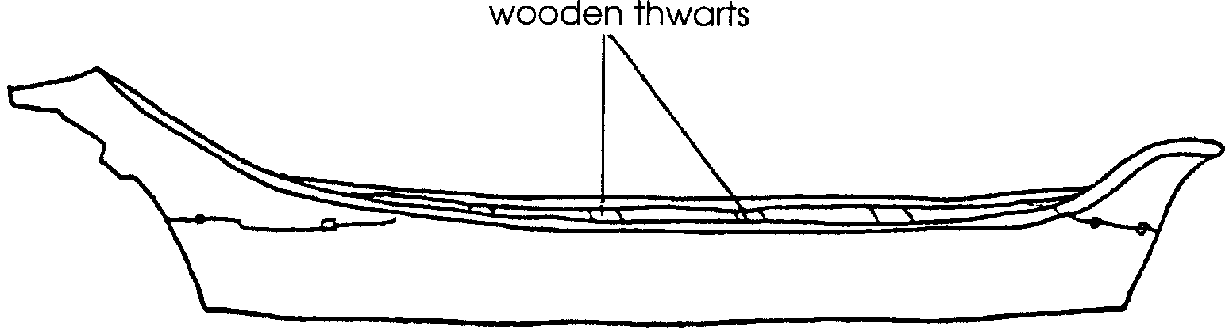

Sometimes a Native canoe would crack during construction. The crack was patched with pitch, the sap from certain pine trees. The pitch was applied with hot rocks handled with tongs.

5. Make and fit the bow and stern pieces. Sew them to the hull with cedar withes. (A withe is a tough, flexible twig or stem.)

In whaling canoes, the center of the bow piece was hollowed. This hollow would hold the harpoon shaft.

6. Cap the gunnels with a thin strip of wood. You’ll have to carve and bend the wood to fit. Once, it’s on, smooth the cap.

7. Borrow (or make) paddles and you’re ready to go. Smooth sailing.

