Holding On
adapted with permission from ORCA Project
Pacific Science Center, Seattle, Washington

Key Concepts
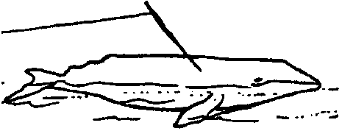
1. Native American whaling people made whaling and fishing lines from available natural fibers.
2. Strength of a rope or line is increased by the multiple strands of the yarn and the opposing twists which hold the rope fast.

Background

Surrounded by the wonders of technology as we are, it is difficult to comprehend what hunting the whale was like for Native Americans. The lines used to secure the harpooned whale and the boat had to be strong. A broken line usually meant a lost whale.

A look at how ropes are made today provides some insight into the complexity of the issues with which Native American whalers grappled.

A rope is composed of three strands twisted together usually in a right-hand spiral. Occasionally a left-hand lay is used, but this is not common. The direction of lay is defined as being right-hand when the strands spiral away from you in a clockwise direction, and left-hand when they spiral in an counterclockwise direction.

Each strand is itself composed of yarns twisted together in the opposite direction to that of the rope’s lay. That is to say they are laid up in a left-handed pattern in the strands of a right-hand laid rope.

Finally each of these yarns is made up of fibers twisted together in the opposite direction to the lay of the yarns in the strands (i.e., in the same direction as the lay of the rope). Thus it can be seen that the strands, yarns, and fibers are each laid up in a direction opposite to their internal composition. This is done to ensure that the rope binds snugly within itself and tends to stay laid up and not to unravel.

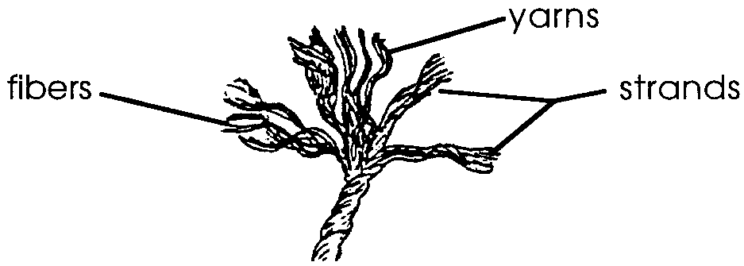
The figure to the right shows (from left to right) fibers, yarns, and two strands, making up a three-strand right-hand laid rope.
Materials

Part 1
For each pair or small group of students

• assorted kinds and sizes of line cut in two foot lengths (at least one line per two students)

Parts 2 and 3

For each pair or small group of students

• scissors or knives to cut lines
• buckets (one for each two students)
• water (used as weights)
• graduated cylinder or measuring cup
• the innermost layer of the two layers of the cedar bark
• cedar limbs (up to 1/2" diameter)

Teaching Hints

“Holding On” gives your students an opportunity to examine rope making, one small facet of the complex business of native whaling. In “Part 1 - The Anatomy of a Rope”, students examine a modern rope. In Parts 2 and 3, students construct ropes from natural fibers.

These activities require natural fibers, preferably cedar bark, limbs and/or roots. In areas with native cedar trees grow, recently logged areas provide an abundant supply of cedar bark. Caution your students not to strip the bark from living trees. The bark, limbs, and roots are best gathered in spring when the sap is flowing. The material can be stored for months, then soaked in water to restore its flexibility. Many Native American people still practice line making and basketry. A call to a tribal center near you may put you in touch with someone who can take you gathering and show the proper technique.

In areas without cedar trees, it is possible to substitute other locally available fibers. For example, hemlock and spruce fibers can be used for line making. Note that a line’s intended use, as well as material availability, determined its material and size. For example, a strong fish line was twisted from nettles.

Best results will be obtained if you have an opportunity to practice these techniques prior to introducing them to your students.

Caution: Some people are allergic to cedar. Be aware of this in case a student begins to itch or cough.
Duplicate the activity pages. One set is recommended per student. This activity is best accomplished in pairs or small groups. If only a small supply of natural fibers is available, you may wish to have groups perform Parts 2 and 3 as a class demonstration. Upon completion of the activity, allow time for a discussion of the results.

Key Words

cedar - in this case, any of a variety of coniferous trees but especially Western Red Cedar, Thuja plicata

fiber - filamentous matter from various parts of plants including bark, roots, stems; also the basic filament in rope construction

sinew - a cord of dense, touch, inelastic, white, fibrous tissue; tendon

strand - in this case, one of a number of yarns that are plaited or twisted together to form a rope

tendon - a cord of dense, touch, inelastic, white, fibrous tissue; sinew

yarn - the thread, in the form of a loosely twisted aggregate of fibers of which rope is made

Extensions

1. Contact a nearby tribal centers to find a person who can visit your class and teach the techniques or rope or basket making.

2. Have students collect lines and ropes of different sizes, materials, and construction, then compare and contrast them. Students may wish to make a display and show how the lines and ropes are made and how they are meant to be used.

3. Students may wish to make lines from other materials and test their strength.

Answer Key

Part 1 - Anatomy of a Rope
1. The observations recorded on the “Rope Chart” depend upon the particular rope sample in question.

2. a., b., c. Answers depend upon the experimental data.

d. The answer depends upon the experimental observations. In general, the relationship between fiber thickness and strength is that the thicker the fiber, the greater the strength.

4. a. Your students should find that it is more difficult to pull the twisted fibers than the untwisted ones.
4. b. The effect of twisting observed to this point is that twisting makes it more difficult to pull individual strands from the rope.

c. The increased contact of surface area provided by twisting increases the frictional resistance to sliding making it more difficult to pull single strands from the rope.

d. More twisting increases the difficulty with which single strands may be removed.

5. The volume of water recorded depends upon the experimental results.

6. a. Twisting increases the total strength of the five fibers.

b. While answers will vary, a strong rope could be made from twisting together many small fibers. A yet stronger rope could be made by twisting these twisted “yarns” into strands. The twisted strands could then be twisted into a finished, strong rope.

Part 2 - Making Cedar Bark Lines

4. a. The handmade rope and the machine made rope are alike in that they are made from a group of small fibers twisted together.

b. While the handmade rope and the machine made rope are both made from small fibers twisted together, they differ in the pattern of twisting. The fibers in the modern rope are twisted into yarns which are then twisted into strands and finally again twisted into the complete rope. The handmade rope would be equivalent to a large yarn.

c. This question is provided to stimulate discussion. Modern rope may be considered “better” if strength per cross section is the criterion. Native American rope may be considered “better” if ease of construction by hand is the criterion. The important thing to stress is that each type of rope fulfilled a particular function and was, (or is) indeed, the “best” option available.

Part 3 - Cedar Branch Lines

4. a.- c. The questions and answers are the same as those found in Part 2.

“Holding On” is adapted with permission from activities originally appearing in “Early Fishing People of Puget Sound” an Activity Packet from the ORCA Marine Education Project of the Pacific Science Center in Seattle, Washington.

Holding On

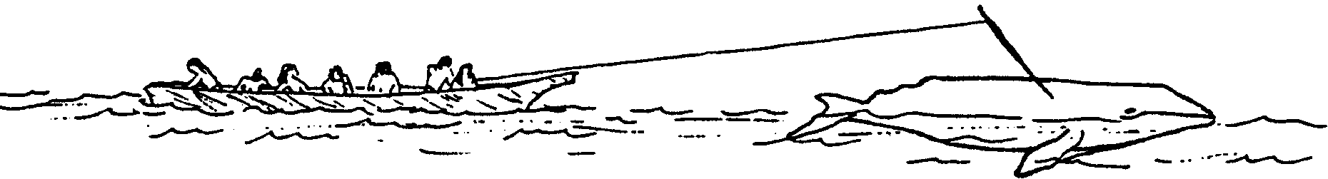

For the Native American whalers, hunting whales was a complicated business. Tradition and experience determined how everything was done. The canoes were built to speed through rough water. The harpoon was made to pierce the flesh and to stay in place. The ropes were made to withstand the fury of an injured whale. How were these ropes made? What kinds of experiences led to rope design? In the following activity you will have an opportunity to learn a little about ropes. You will also have a chance to make the type of line used by west coast whale hunters.

Materials
• assorted kinds and sizes of rope cut in two foot lengths
• scissors or knives to cut ropes
• bucket
• water
• graduated cylinder or measuring cup
• the innermost layer of the two layers of the cedar bark
• cedar limbs

PART 1 - Anatomy of a Rope

Ropes are more complicated than they first appear. For example, many ropes are made of three strands. Each strand is made up of four yarns. Each yarn is made up of a great many fibers.
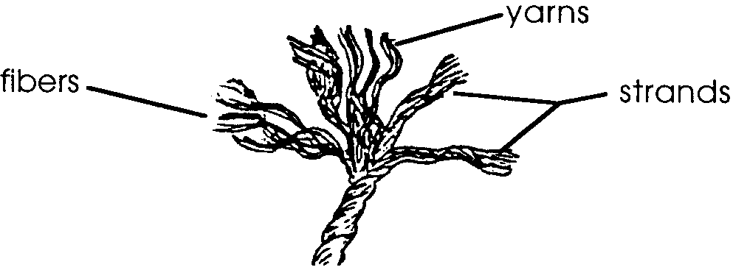

Procedure

1. Obtain a two foot section of rope. Carefully untwist a few inches of the rope. Examine the rope end-on, and record what you see on the chart:

ROPE CHART

My rope is 2 feet long and inches in diameter.

Number of strands =

Strand twist direction = clockwise or counterclockwise
(circle correct term)

Number of yarns per strand =

Yarn twist direction = clockwise or counterclockwise
(circle correct term)

Number of yarns in whole rope =

Number of fibers per yarn (count exact number) =

Number of fibers per strand (estimate) =

Fiber twist direction = clockwise or counterclockwise
(circle correct term)

2. Separate all the fibers from 1 or 2 yarns into 3 or 4 piles according to their length.

a. What do you observe about fiber length?

b. What do you observe about the thickness of fibers?

c. Can you split a fiber into two or more fibers?

d. Test some single fibers for strength. What is the relationship between fiber thickness and strength?

3. Take 1 yarn and loosen all the fibers. Untwist them and spread them back two or three inches apart. Put the fibers back together without twisting. Pull out 1/3 of the fibers.

4. Put the fibers together again and twist them 5 to 10 times. Now pull out 1/3 of the fibers.

a. How is this different from pulling the untwisted fibers?

b. What effect does twisting have?

c. Why do you think this is so?

d. What happens when you twist even more?

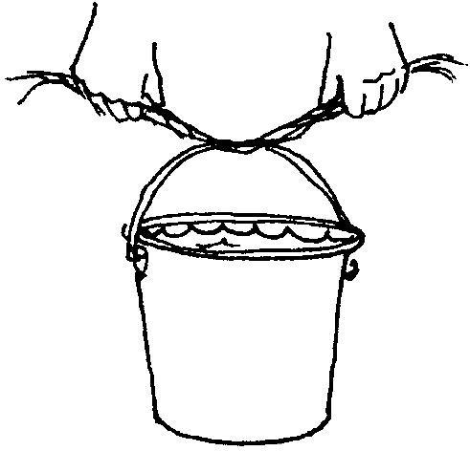

5. Bunch five long fibers together. Don’t twist them. Lift a bucket or can as shown. Add water to the bucket until the fibers break. Record the volume of water which the fibers broke. ml of water.

6. After the five fibers break, twist the five long pieces together quite tightly and repeat the experiment. Record the volume of water at which the fibers broke. ml of water.

a. Does twisting have any effect on the total strength of the five fibers?

b. As a Native whaler you have a supply of fibers. How would you make a strong rope?

PART 2 - Making Cedar Bark Lines

The Makah, Quinault, and Quillayute native people used cedar bark lines to secure the whales they harpooned. One of the qualities which makes bark so useful is its straight grain. This allows cedar to be easily split or stripped. To obtain fibers, bark was stripped from the tree by making a shallow horizontal cut in the trunk. Long strips were pulled off using alternate hands (figure A). The bark has two layers. The two layers were separated and the soft inner layer used for fibers (figure B). The inner layer is thick enough to be separated into several layers (figure C).

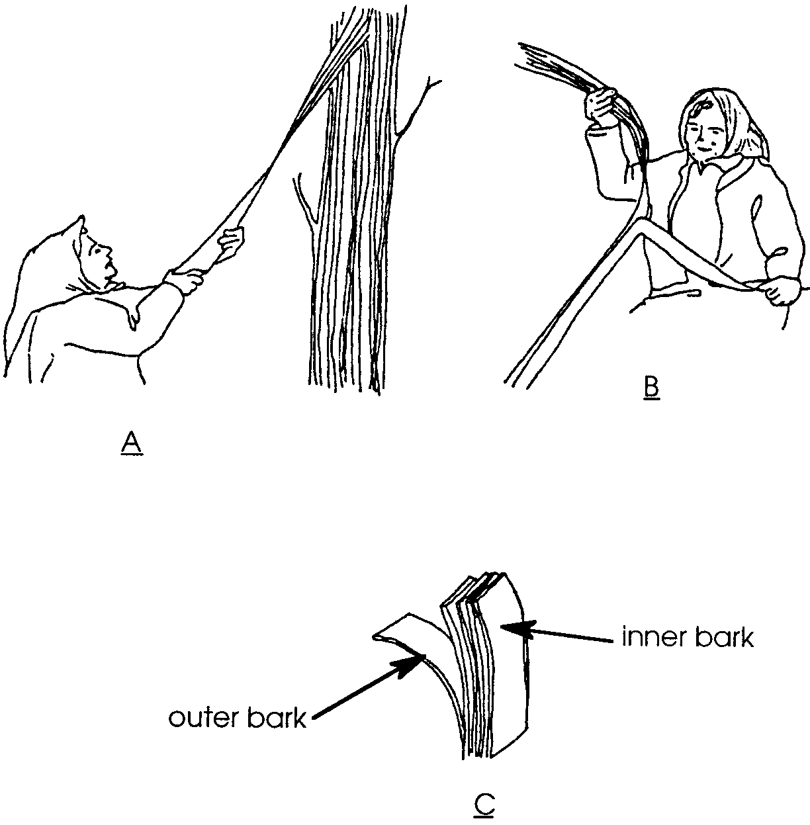

Procedure

1. Obtain a bark strip about 2 feet long. Separate the layers of bark keeping a strip of inner bark about 2 feet long.

2. Split the inner bark into thin strips about 1/2 inch wide. Soak the strips in water to make them pliable.

3. Twist three of these thin lines into a strong rope.

4. Compare the handmade rope to the machine made rope you examined in PART 1.

a. How are they alike?

b. How are they different?

c. Is one method of rope making better than the other? Why or why not?

PART 3 - Cedar Branch Lines

Native whalers used several types of lines to secure their whales. The line attached to the harpoon head was made from fibers from whale tendons (sinew). This sinew line was attached to a line made from cedar limbs. You can make your own cedar branch lines using the following procedure.

Procedure

1. Obtain three or four cedar limbs. Strip the limbs of leaves.

2. Soak the limbs in water for 24 hours or longer.

3. Twist the limbs into a rope. These ropes have remarkable strength.

4. Compare the handmade rope to the machine made rope you examined in PART 1.

a. How are they alike?

b. How are they different?

c. Is one method of rope making better than the other? Why or why not?

