December 15 - Days of Whaling

Native Whaling

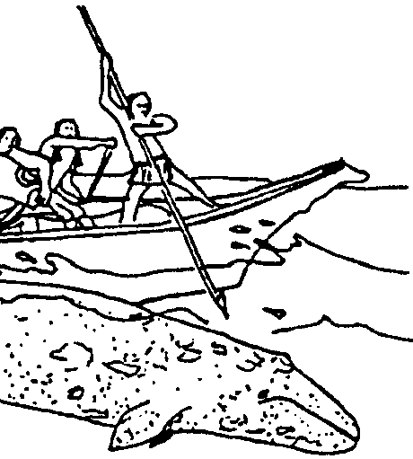
Key Concepts
1. The whaling industry has played a significant role in domestic and international economics.
2. Technological advancement and human greed expressed in over harvesting have greatly affected whale populations.

Background

The story of human interaction with the whale has been, and continues to be, a tale of nearsighted self-interest. Historically, it is convenient to consider three major periods in whaling: native whaling, sailing whaling, and modern whaling. As a case study, whaling shows the complexity of ocean management problems. Biology, sociology, economics, and politics are all deeply involved in deciding the future of whale species.

Materials

For each student

• “December 15” student activity pages

For the classroom

• displays of pictures, books, periodicals, maps about the people and places that participated in the whaling industry

Teaching Hints

“December 15 - Days of Whaling” gives your students an historical overview of the issues surrounding whale hunting as they read and review whaling history, construct a time line and chart technological developments. It cannot claim to be an in-depth look at a complicated issue. It does claim to be an introduction and, hopefully, it will arouse you and your students to further study and to action.

“December 15” is divided into three major sections: Native Whaling, Sailing Whaling, and Modern Whaling. While the three sections present a unified whole, separate text and investigations are provided for each as the entire “December 15” is long for a single assignment. These sections lend themselves to completion by individuals or small groups as homework or in-class assignments. Each section has a separate Teacher Background section, although the last two are somewhat abbreviated.

Two included activities, “Native Whaling - Find that Word” and “Whale History” reinforce the text while treating different reading skills. “Native Whaling - Find that Word” builds vocabulary skills. “Whale History” focuses on sorting and arranging facts and events.

In addition, the separate activities “Holding On”, “Canoe Building”, “Save My Story!”, “Blood Money”, and “Scrimshaw” provide hands-on extensions of Native Whaling and Sail Whaling.

Bring whaling history to life with artifacts, pictures, slide shows and videos as much as possible. Consider supplementing this section with some of the high quality audio-visual materials now available. Film and video cassettes from the NOVA program entitled “Umealit: The Whale Hunters” are available from Time/Life. The program offers an incredible look at aboriginal bowhead whale hunting. Greenpeace, General Whale, and The Whale Protection Fund all offer free and low cost teaching aids and materials dealing with modern whaling and with whale preservation. Do not overlook your students as a resource for supplementary materials.

Duplicate the student text materials. One set is recommended per student. Your students will profit from a review and discussion of the materials presented in these sections.

If you are using “Voyage Of The Mimi” in conjunction with this curriculum, “Episode 7: Fastening On” correlates with this lesson.

Key Words

blow - in this case, condensed water vapor from a whale’s breath

blubber - the fat layer between the skin and muscle of whales from which oil is made

bow - the forward end of a vessel

gunwale - the upper edge of the side of a vessel

port - the right hand side of or direction from a vessel, facing forward

saddle - the oil-rich hump of a gray whale

starboard - the left hand side of or direction from a vessel, facing forward

stern - the back end or rear of a vessel

Extension

1. Have students create replicas of historical artifacts and models of whaling villages, shore stations, and ships in order to make a classroom “whaling museum”. Then, have them conduct tours for other classes and parents.

Answer Key

1. The lack of salmon has been cited as a major contributing factor to native whaling. The whale served as an important substitute for the protein not available from salmon.

2. Native whalers faced many difficulties including, but not limited to:
a. cold water
b. rough water
c. no metal tools
d. small boats
e. the whale’s powerful tail which could easily destroy the boat.
f. the whale could pull the canoe far out to sea.
g. stormy weather

3. Native whalers observed rituals and taboos before hunting the whales in the hopes that the spirits of the whales would look kindly on the whalers.

4. a. Answers will vary but the general problem centers around the fact that a very large whale would be difficult to bring ashore and to process into useful products without much waste.

b. Answers will vary but the general problem centers around the fact that a whale too small would mean more work for the hunters and the tribe because they would have to take more whales.

5. A correctly labeled North Coast Indian canoe is shown below.
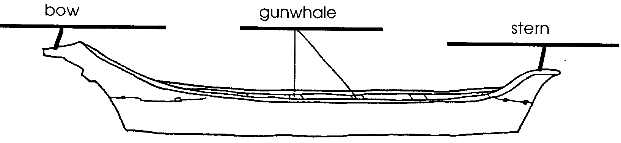

6. The three different “jobs” found in a native whaling crew were:
a. captain or harpooner
b. paddler
c. steersman

7. A correctly labeled harpoon head is shown below.
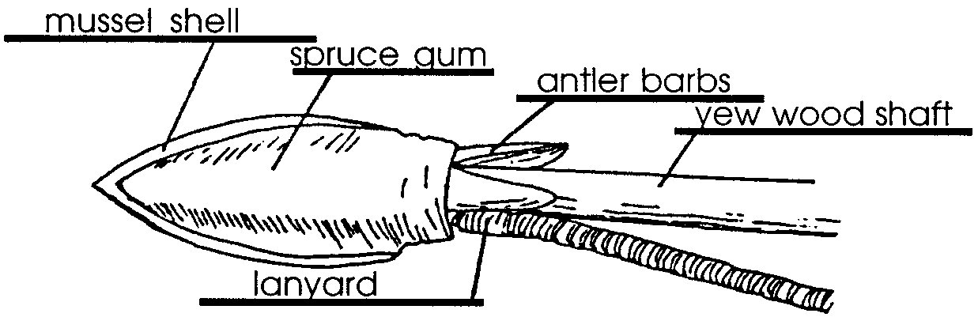

8. The hide floats were used to keep the line afloat near the surface. Aside from providing a method for keeping the line in sight, the floats may have increased the drag on the swimming whale.

9. After a whale was harpooned, the steersman turned the canoe away from the whale’s giant flukes (tail).

10. The choice pieces of blubber were awarded to people by rank and by the role they played in the hunt. The elders of the tribe and the harpooners usually received the select pieces.

11. The whale was used completely. The blubber was rendered to remove the oil. The cooked blubber was dried and eaten. The oil was used as a food dressing. The bones provided tools and building materials.
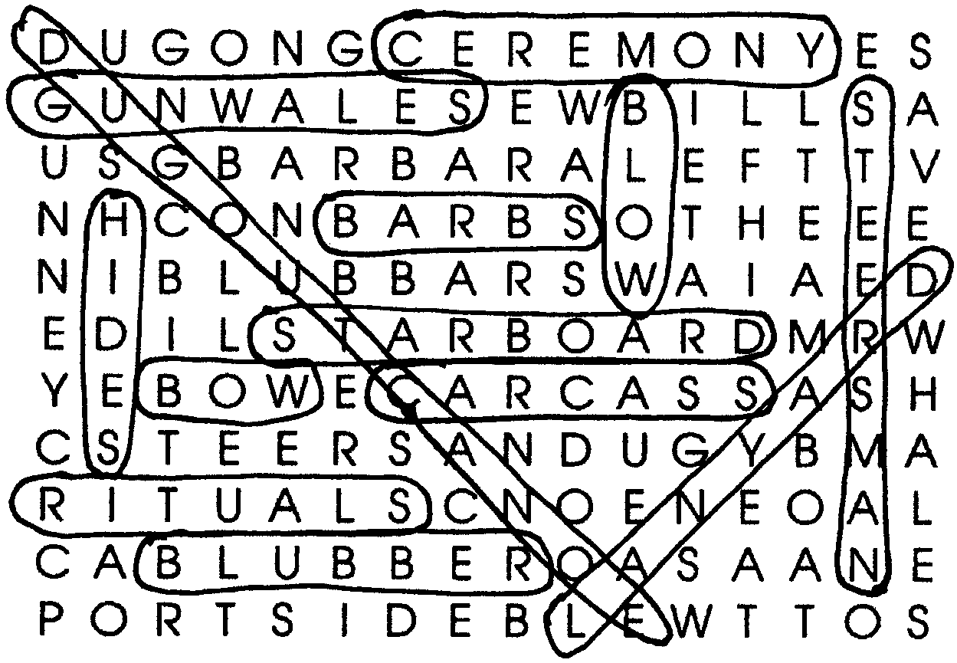

Native Whaling
Find That Word

December 15 - Days of Whaling:

Native Whaling

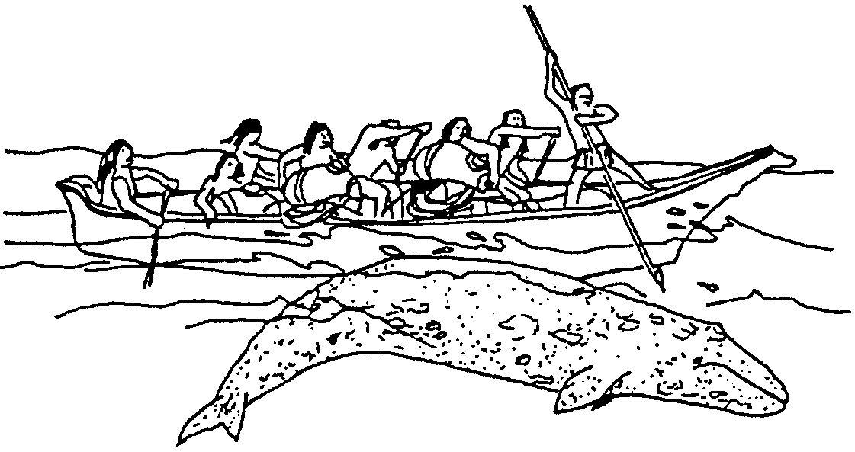

Swimming, breathing, swimming, breathing, the move south continues. Our whale will soon leave the U.S. coast. For gray whales, that coast holds many memories. But even her oldest memories can not reach back to the years that nearly spelled the end of her kind. In 1851, Monterey became the first shore-whaling station on the coast of California. Within thirty years so few gray whales could be found near shore that the shore stations all closed down. How could people have had such a great effect on the gray whale?

Long before the Portuguese arrived in Monterey, early people of the coast used the whale as a natural resource. Occasionally, weak or dead whales washed ashore near coastal villages. These giant dead mammals provided products from oil to ivory. Not all of the native peoples were content with the occasional stranded whales nature provided. Native tribes from Washington state to the frozen arctic waters hunted whales. The Moachat, Ahousat, and Clayoquot of Vancouver Island’s west coast hunted whales close to their villages. So did the Makah, Quillayute, and Quinault peoples from the ocean shores of Washington. Sometimes, their hunts took them 30 miles out to sea. Often, they lasted for several days

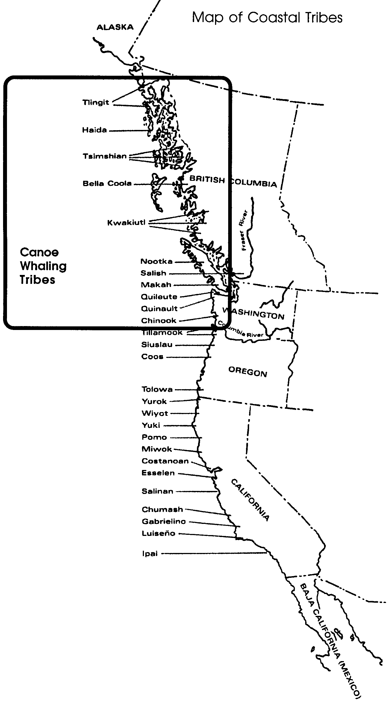

1. Native whalers lived in areas with no important salmon streams. How could this lack of salmon help explain why the Indians became whalers?

Native whalers hunted the California gray whale and the humpback whale. Conditions facing the whale hunters were difficult. To lessen some of the difficulties, native whalers hunted during the warm months of spring and summer. The whaling season began with the hunting of California gray whales in the spring.

2. Think of yourself in a small boat. What were two difficult conditions faced by native whalers?

a.

b.

To native whalers, hunting was more than a job. Hunting was their life. Whalers prepared year round for the hunt. Each crew member had his special tasks to prepare and maintain equipment. Each crew member also practiced his special hunting tasks. They also practiced together to be able to work quickly and smoothly in the hunt.

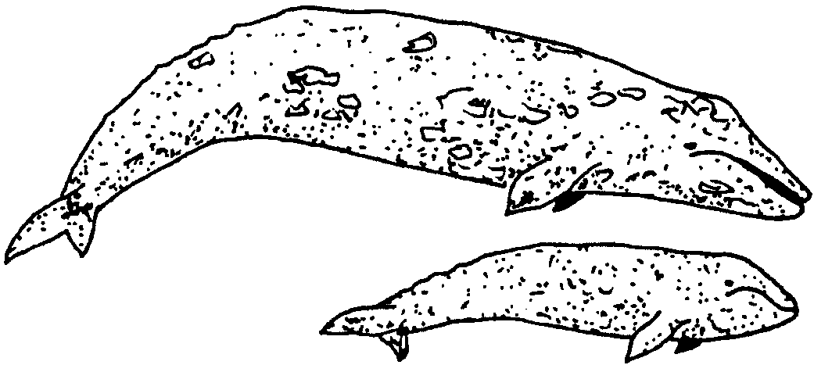
Before the actual hunting took place, the whalers and their wives had many rituals to perform. Rituals are special religious ceremonies. They also had many taboos, or things they could not do, to observe. The rituals and taboos were performed to assure that the spirits of the whales would look kindly on the whalers.

3. Why did native whalers observe rituals and taboos before hunting whales?

The hunters understood the danger of the hunt. They also understood and respected the importance of the whale populations. Whalers watched whales that swam near their shores. They learned about their sizes, behaviors and tempers. They selected whales that would be a good size for the resources they needed. Hunters also selected whales that would be less vigorous and dangerous. They wanted their hunts to be safe and successful.

4. Think about capturing a whale from a small boat.

a. What problems might you have if you captured a very large whale?

b. What problems might you have if you captured a small whale?

The day of the hunt has arrived. Eight men move down the beach toward their boat. The red cedar canoe lies in readiness. Designed for the ocean, the canoe has a graceful, upswept bow or front. The stern, or back, is also carefully styled to withstand a high following sea. The gunwales (say gun’ls), or top of the sides, flare outward to turn away the waves.

The canoe was made from a single log, hollowed by burning and chiseling. Steam, from water heated by rocks from a fire, was used to flare the sides. The bow piece, grooved to hold the harpoon shaft, and a stern piece were then fitted onto the canoe.

The sleek canoe cuts through ocean waves with little effort.

5. The picture below shows a north coast Indian cedar canoe. Label the drawing by placing the correct name in the blanks.
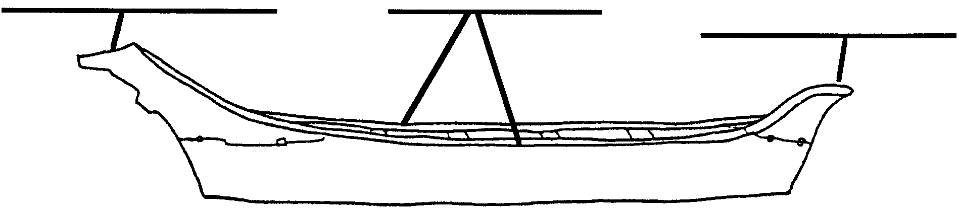

The whaling crew reaches the boat. The captain has checked his equipment. The harpoon, lines and floats all lay on the starboard side (the right side when facing forward). The lines (ropes) are neatly coiled in baskets. The captain steps into the bow. The steersman climbs into the stern of the canoe. The six paddlers push the canoe into deeper water and climb aboard.

Another crew climbs into a second canoe and moves away from shore. Working with the outflowing tide, the paddlers push the canoes into deeper water. On shore, tribal members, especially the wives of the whalers, are very still. They hope that the whale also will be still and easy for the hunters to kill and bring back to the beach.

The captain checks his harpoons again. The harpoon has a shaft (pole) three fathoms (18 feet) long. Made of yew wood, the shaft has two or three sections that are joined together. Yew wood is very hard and strong. The sections make the shaft a little flexible and less likely to break. If the shaft does break, it is easier to replace a section than the whole shaft. One end of the shaft is fitted with a harpoon head. The captain will push the harpoon head into the whale. The shaft will then be withdrawn. A second harpoon head will be placed on the shaft.

6. What were three different “jobs” found in a native whaling crew?

a.

b.

c.

The harpoon head has a sharp mussel shell point and barbs made of antlers. Spruce gum holds the head together. The captain checks the lanyard, or rope made of twisted whale tendon, which is attached to the head. At the end of the short lanyard, he checks the line (rope) made from cedar branches. The cedar branch line ends where a cedar bark line begins. Several harpoon heads and lines are ready to be fitted into the harpoon shaft when they are needed.

7. The drawing below shows a mussel shell harpoon head. Label the drawing by placing the correct name in the blanks.


The captain checks the floats. The floats will keep the line near the surface. They are made from the skins of seals, turned inside out. Each line has four floats attached to it. The first four floats are ready. The others wait to be inflated by a crew member as needed.
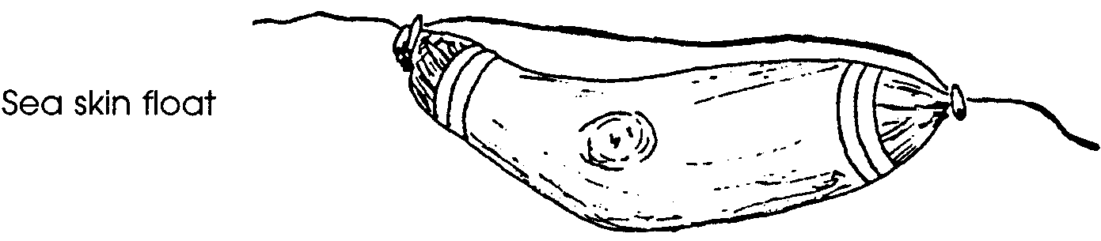

8. What was the role of the floats in canoe whaling?

All is ready. The paddlers spot the “blow” of a California gray whale. The “blow” is water vapor from the whale’s breath. They pull toward the gray whale. They turn the canoe. Carefully, they approach the whale from its left flank (side). The captain stands in the bow, harpoon in hand. The canoe and the giant whale are side by side. The whale begins to sound (dive). At the same moment, the captain sinks the harpoon deeply into the flesh behind the flipper of the great whale. The harpoon head turns sideways. The line and floats are towed overboard. The captain pulls back the harpoon shaft and fits it with another harpoon head.

The canoe comes alive with action. Paddlers on the starboard side handle the lines to keep them free. The port paddlers and steersman turn the canoe away from the whale’s powerful tail flukes. The captain readies a second harpoon. Two of the paddlers blow up more floats and lay a second line. The remaining paddlers pull in chase of the whale.
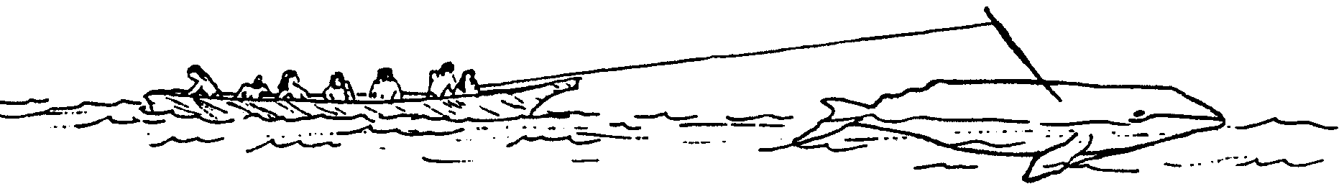

Now the crew of the second canoe moves near the action. Their captain has been called to help. He plants a second harpoon in the whale. The two canoes add floats and lines as the whales pulls them through the water. The crews sing songs and prayers to turn the whale toward shore. They do not want the whale to pull them further out to sea. They want the whale to swim toward their village. They sing to the whale about the welcome its spirit will receive when it reaches their village.
The exhausted whale slows. The first captain kills it with a lance. The whale is dead but work still remains. One of the crew dives into the water. He stitches the giant mouth closed. This keeps the whale from taking in water while it is being towed to shore. The paddlers stroke to tow the whale home. Finally, the dead whale is floated ashore at high tide. In a thanksgiving ceremony, the whale is welcomed by the tribe as an honored guest. The body is showered with eagle down (feathers) to please the spirit of the whale.

9. After a whale was harpooned, what was the job of the steersman?

Choice pieces of blubber are cut off the whale. They are given to people according to rank and also to the role they played in the hunt. The first piece cut is the oil-rich saddle or hump. As a special honor, this piece is hung in the captain’s house. The saddle is an important piece. The captain will carve its likeness in wood. The carving will hang permanently in the captain’s house. Although the captain has brought home the whale for his tribe, he does not eat the whale meat.

10. Which people in the tribe received the choice pieces of blubber?

The tribal members now settle down to using the whale. Oil is cooked from the blubber. This oil is used as a dressing for dried fish and for berry cakes. It is also a valuable trade product to be exchanged with other tribes for goods. After the oil is removed from the blubber, the meat is dried and eaten. The bones provide tools and building materials. The tendons are made into strong whaling lanyards and halibut lines. In a real sense, the whale gives his spirit to the community.

The life of these north coast Indian peoples was tied directly to the whale. For hundreds of years, they hunted gray whales with little harm to the whale population. The arrival of the Portuguese in Monterey, however, signaled the beginning of another era in whaling.
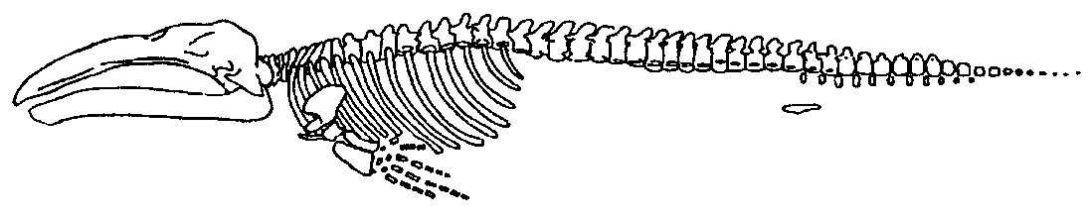
11. How was the whale used by north coast Indian peoples?

Native Whaling — Find That Word
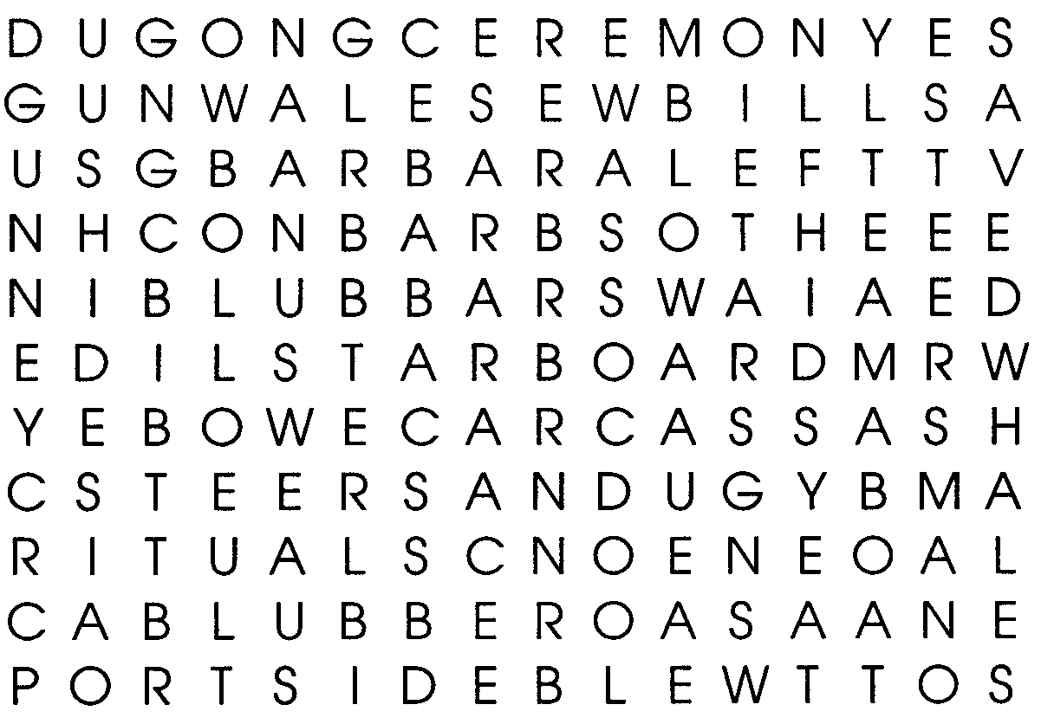

Directions:

The word search above contains a number of words related to native whaling. It also contains other unrelated words. Find and circle ONLY those words which answer the clues given below. It may help you to first write the word in the blanks provided. Then search the above maze of letters for the word you have written. The words may be written horizontally, vertically, or diagonally.

Clues:

1. Northwest coast native whalers used this special boat (2 words).
2. After a successful hunt, the native whalers towed this back to camp.
3. The upper sides of a boat or ship.
4. Native whalers placed their ropes on this side of the boat (the right side when facing forward).
5. The choice pieces of this were given to important people in the tribe.
6. These were inflated, blown up, to make the line float.
7. Part of this special event included placing eagle down on the whale.
8. This rope was attached to the harpoon head.
9. This person turned the boat away from the whale’s giant tail.
10. These were performed to gain the favor of the whale spirits.
11. These were made of antlers and kept the harpoon from pulling out.
12. The captain stood in this part of the boat.
13. This is seen when a whale exhales.

