Grand Banks

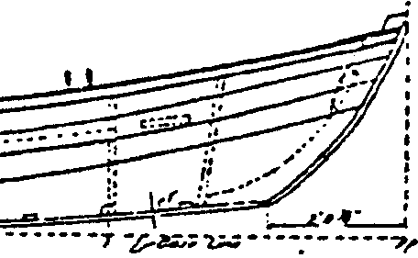
Key Concepts
1. Constructing a small boat using hand and power tools provides insight into why boats float.
2. Boats are important tools for scientists, whale watchers and others.

Background

“Grand Banks” provides you with an opportunity to integrate your science program with your school’s industrial arts curriculum. In this activity your students will construct an inexpensive rowing dory.

An actual Grand Banks dory used for fishing would have been larger and constructed of planks rather than plywood. In this case, a single sheet of plywood will build a 6-foot dory. It is jointed by fiberglass and suitable for ponds, lakes and other calm “inland seas”. The plans provide a very simple introduction to boat construction.

The originator of the plans used in this lesson writes about this boat saying, “She has been a fun, safe dory for the past two years, and has never even come close to capsizing, except intentionally. My two boys have learned about taking care of their own boat in the best way - by experience.” While this activity presents some logistical challenges, we can paraphrase the boat builder’s sentiments - the best way for your students to learn about boats is through building one.

After your students have build their dories, but before they sail off into the sunset, plan to spend some time completing Parts 4 and 5 which provide basic water safety information. Most water-related fatalities stem from inappropriate action. On water, small mistakes or miscalculations can have serious consequences. The activities included in “Trim or Swim” are adapted from ideas found in Girl Scout Camping Standards publications #86-96 and #92-96. These flyers are available from the Girl Scouts and are recommended reading. Additional information about water safety and PFDs may be obtained by contacting your state boating authority, U.S. Coast Guard Auxiliary, U.S. Power Squadron, Red Cross, or your nearest unit of the U.S. Coast Guard.

Parts 4 and 5 are designed primarily to provide actual experience in and on the water. Advance planning and contact with your local swimming pool are necessary for success. Exercise utmost caution in these activities. Work with trained instructors and do not force unwilling students to participate. Find out which of your students cannot swim and arrange special help for them with the lifeguard at the pool. Swim-in-clothes training is recommended before doing “Part 4 - PFD” if you plan on having your students wear clothing during the PFD activity.

“Grand Banks” is a challenging, fun activity that will introduce your students to boat building. Take the risk and try it!

Materials

For each dory:

• one 4' x 8' x 1/4" or 3/16" sheet of A-C/X plywood

• one wooden batten (a flexible stick about 3/4" x 1/4" x 8 ')

• 20-30 shingle nails (1 3/4" galvanized)

• framing square

• saw

• hammer

• pliers

• drill and 1/8" drill bit

• iron tie-wire

• one 12 1/2" x 26 1/2" piece o f 3/8" or thicker exterior plywood

• two 1/2" x 3/4" x 8' fir or pine strips

• pencil

• tape measure

• chalk line

• 1 - 2" x 4" ( 6 feet long)

• 2 - 2" x 4"(16" long)

• 2 - 2" x 12" (10" long, approximately)

• 10 - lOd nails

• 2 - 6" C-clamps

• 4" fiberglass cloth (about 20 feet length)

• resin

• scissors

• long rubber gloves

• respirator or dust mask

• paint brush
Teaching Hints

In “Grand Banks”, your students make a small replica of the dories used during the mid-1800’s where they were launched from larger sailing boats to fish for cod or halibut some 100 miles northeast of Newfoundland, Canada. Several approaches are possible with this activity. For example, you might build a demonstration model with your class. You might make special arrangements with the shop teachers to have the students you share in common build a dory under the shop teacher’s supervision. You might have parents help in the construction at home. Finally, you might elect to have small groups of students construct dories in your classroom.

Check with your industrial arts department to learn what specific safety precautions they recommend for students working with hand tools and hand-held power tools. Provide goggles for eye protection and warn your students about the dangers inherent in wearing loose fitting clothing and long hair when operating power tools. The loose clothing or long hair can be pulled into the moving parts causing injury to the student. Warn your students to demonstrate similar caution when using sharp tools. Follow the manufacturer’s directions when using fiberglass resin and cloth. Marine epoxies are also suitable for this application. Regardless of the product, provide ample protection for your students through adequate ventilation, dust masks and/or respirators, and gloves.

You will need enough working space to lay out and cut one 4' x 8' sheet of plywood and to build a 6' dory. For the fiberglass application you will need a very well ventilated room or an outdoor area.

While the actual layout and construction is simple, it is recommended that you build a sample dory before you turn your students loose on the project.

By working through one first yourself, you will have ideas on how to make the project more successful for students. For example, you may wish to use screws or supports to strengthen the joints prior to applying fiberglass. The directions which follow in the student section of this guide give directions for only the boat itself. Oars and oarlocks may be purchased, or alternatively, they may be made from ash or spruce using the drawings below:

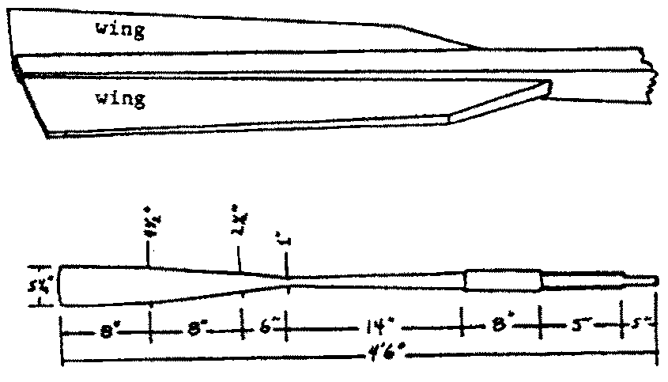
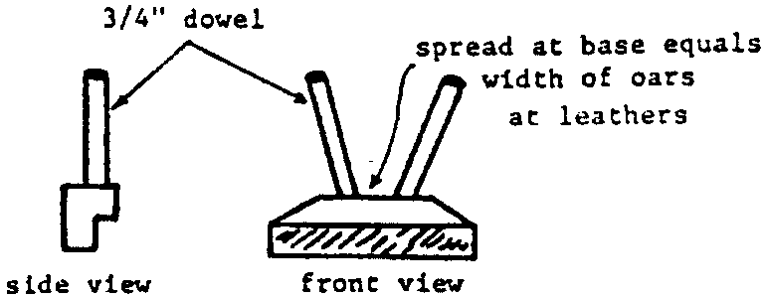
Three pieces of wood are needed for each oar; the long main piece or loom which also incorporates the middle part of the blade, and the wings or side pieces of the blade. Mahogany and cedar are often used for the wings of oar blades in glued oars. Two tholepins units patterned after the one shown below can be used in place of conventional oarlocks.

Further information, including additional dory plans may be found in:

Gardner, John. 1978. The Dory Book. International Marine Publishing Company.

For more about wooden boat construction, repairs, maintenance, and history see the magazine “Wooden Boat”, P.O. Box 492; Mt. Morris, ME 61054. (1-800-877-5284)

The plans for the rowing dory were modified from and presented here with the permission of “National Fisherman”, October 1980.

If you are using “Voyage of the Mimi,” in conjunction with this unit, “Expedition 12: Boatshop” correlates with this lesson.

Key Words

batten - a light strip of wood

catalyst - a substance which sets off a chemical reaction in another substance, such as fiberglass resin

centerline - the line down the center of a boat from bow to stern

chalkline - a sting rubbed with chalk dust which will leave a straight chalk mark on an object when pulled taut and snapped

dory - small boat used for fishing

fiberglass - material made from filaments of glass embedded in a hardened resin

flared - spread gradually outward

flush - even

framing square - a tool for obtaining a right angle

galvanized - iron coated with zinc to prevent rust

HELP - acronym standing for “Heat Escape Lessening Position”, a position designed to help a person keep warm in cold water

HUDDLE - a position designed to help a person keep warm in cold water in which people group for warmth

joint - places where parts of the boat come together

lofting - laying out the pattern for the boat’s parts

oarlocks - structures through which the oars will pivot when the boat is rowed

PFD - acronym standing for “Personal Floatation Device” also called a “life jacket”

resin - liquid which will solidify upon addition of catalyst

rocker - curved piece forming bottom of boat

rub rails - rails mounted on upper edge of boat which may at times rub against the dock

tombstone - a triangular piece of the hull at the stern of the boat

treading water - maintaining the body erect in the water with the head above the surface usually by a pumping up-and-down movement of the legs and sometimes the arms

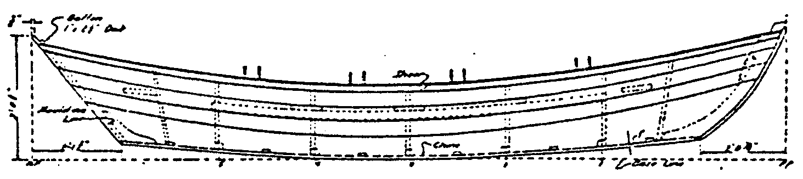
Grand Banks
Boats have always played an important role in the relationship of people and the sea. Marine scientists and whale watchers study whales from boats of all kinds. In this activity you will have a chance to build your own small boat.

Small boats are made for specialized purposes. The boat you will build is a small version of a Grand Banks dory. These boats were used for fishing. During the mid-1800’s, sailing boats fished for cod or halibut off the Newfoundland, Canada coast. When the sailing boats reached the fishing grounds, or “grand banks,” the fishermen lowered the dories into the water. The sailing boat would disappear. The dory and its one or two person crew were left behind to fish. Using hand lines the fishermen would fish all day. Later the large sailing boat, or “mother ship” would return to collect the dories.

Dories were perfectly adapted for being carried aboard a mother ship. The flared sides allowed a half dozen dories to be nested one inside the next. In the water, the high ends kept the boats dry even with great loads of fish. The classic dories from the Grand Banks inspired the boat you are about to build. Build it with care and you’ll have a fun, safe vessel.

Building the Grand Banks Dory

Before You Begin

Find a place to work where you’ll have plenty of room to spread the materials out. Later you’ll need a well-ventilated room, or better yet, some space outdoors for working with fiberglass. Get all the materials you will need together and prepare yourself by reading through the instructions before you start.

Materials you’ll need
• one 4' x 8' x 1/4" or 3/16" sheet of A-C/X plywood
• one wooden batten (a flexible stick about 3/4" x 1/4" x 8 ')
• 20-30 shingle nails (1 3/4" galvanized)
• framing square
• saw
• hammer
• pliers
• drill and 1/8" drill bit
• iron tie-wire
• one 12 1/2" x 26 1/2" piece o f 3/8" or thicker exterior plywood
• two 1/2" x 3/4" x 8 ' fir or pine strips
• pencil
• tape measure
• chalk line

Part 1: Lofting

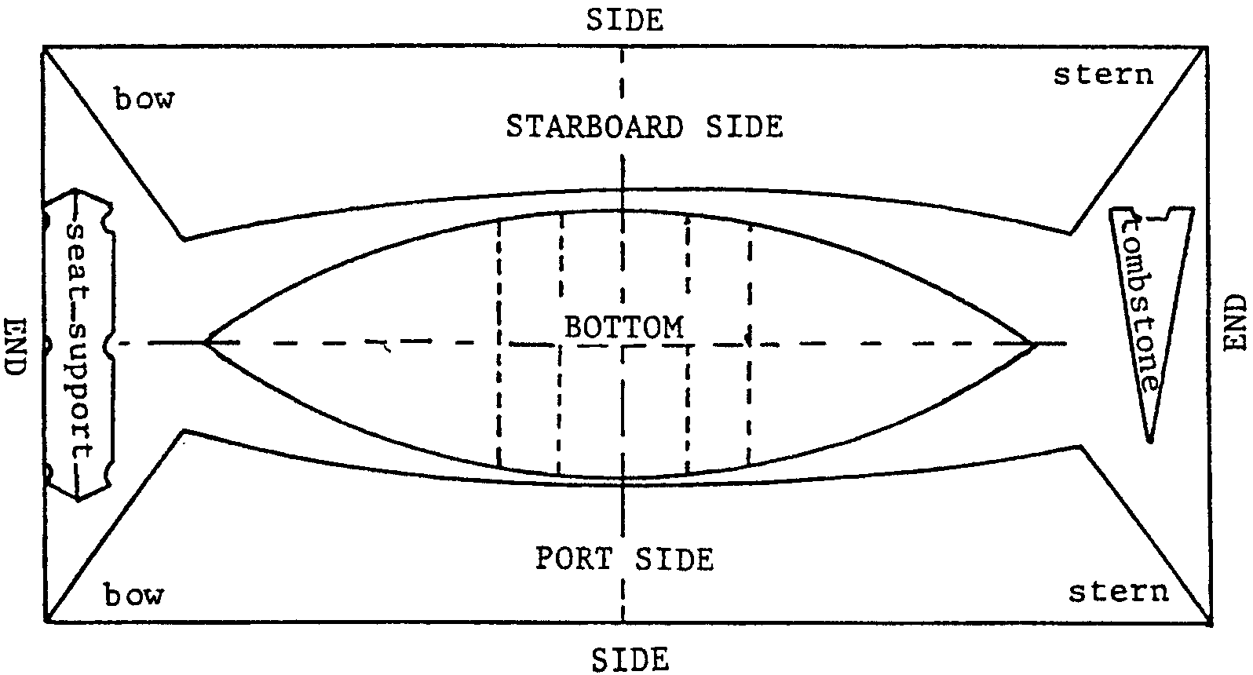
The first step in building the Grand Banks Dory is to lay out all the pieces on the sheet of plywood before you cut. This is called “lofting the boat.” When you are finished the sheet will look something like the picture below. Notice that if you are careful, you can cut all the major pieces from a single sheet of plywood.

The Bottom

1. Lay the plywood sheet on a convenient working surface. Use the tape measure, pencil and chalkline to divide the sheet in half lengthwise. This is easy. Along one end, measure up two feet from the bottom and make a pencil mark. Do the same thing on the other end. Have your partner hold one end of the chalk line on one of the marks. Pull the string tight and lay it across the second mark. While holding the string tightly, pick up one end of the string and let it go. This procedure is called “snapping a line.” If all has gone according to plan, your sheet of plywood will have a line running lengthwise down the center. Your sheet should look like this:
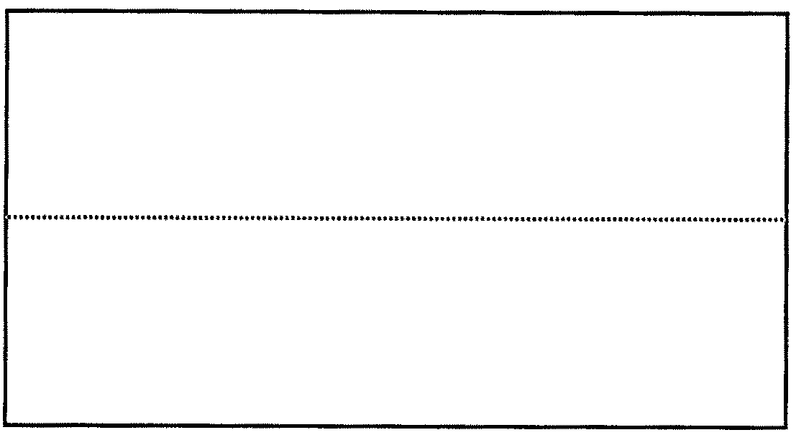

2. Use the same technique to divide the sheet of plywood in half, widthwise. Instead of measuring up two feet, you will need to measure across four feet. Snap a line at the four foot mark. Your sheet of plywood should now look like this:
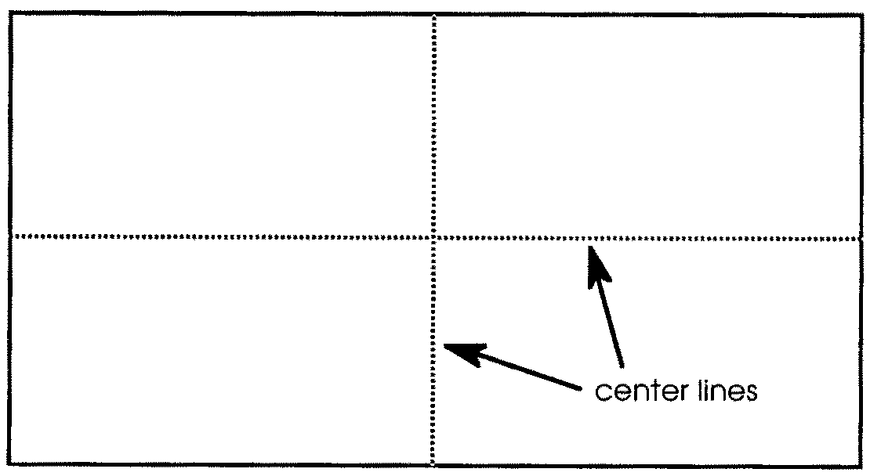

3. The center of the sheet of plywood is the point where your lines cross. Use your tape measure and pencil to make pencil marks 3 feet from the center along the length. Also make pencil marks one foot from the center along the width. Your sheet of plywood should look like this:
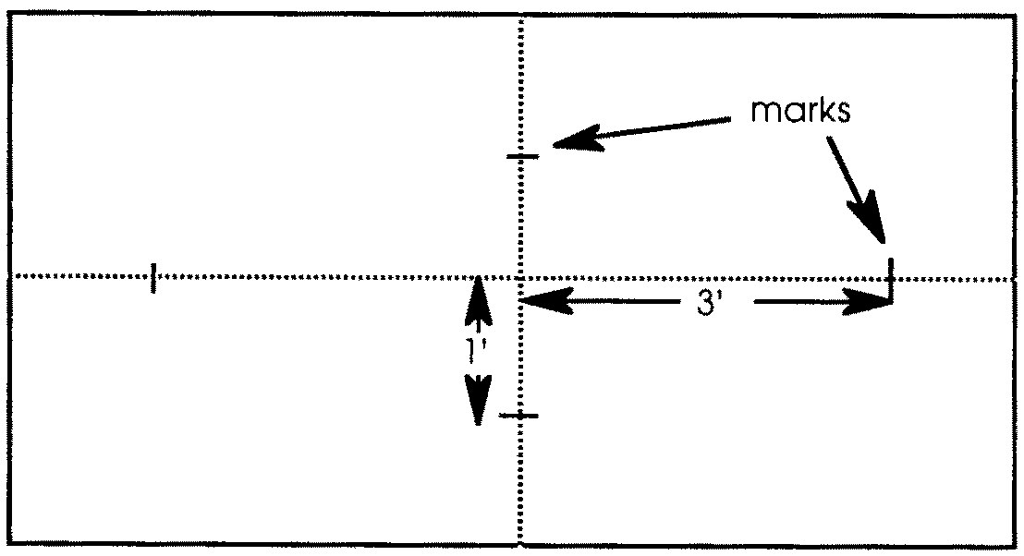

4. Use your tape measure to make two more pencil marks 2' 3" from the center along the length. Your sheet of plywood should now look like this:
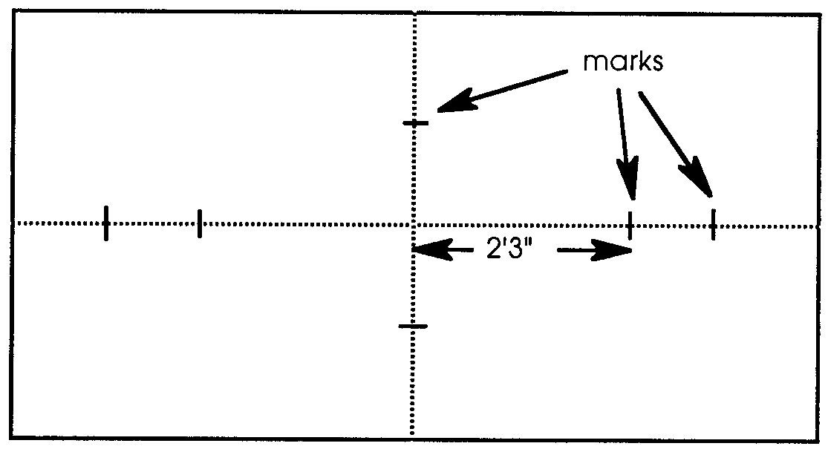

5. Use your framing square and pencil to make pencil marks 6" above and below your 2' 3" marks. The drawing below shows you how to do it.
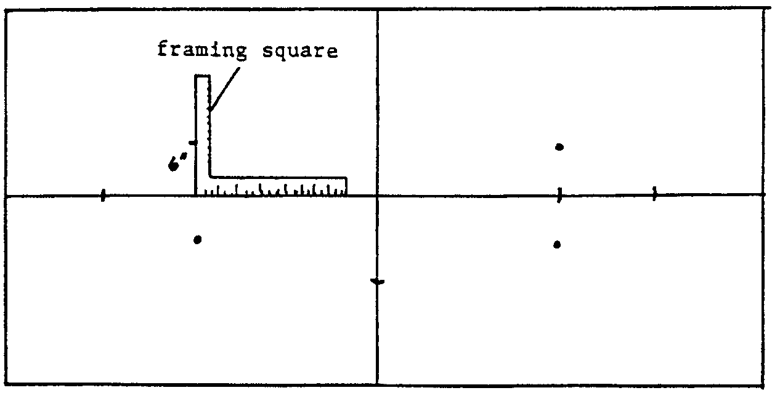

6. Set a nail at each of the four marks you made in step 6. This means that you will hammer in one shingle nail at each of the marks. Take care not to drive your nail all the way through the sheet of plywood. Set nails at the one foot and three foot marks from the centerline. Your sheet of plywood should look something like this:
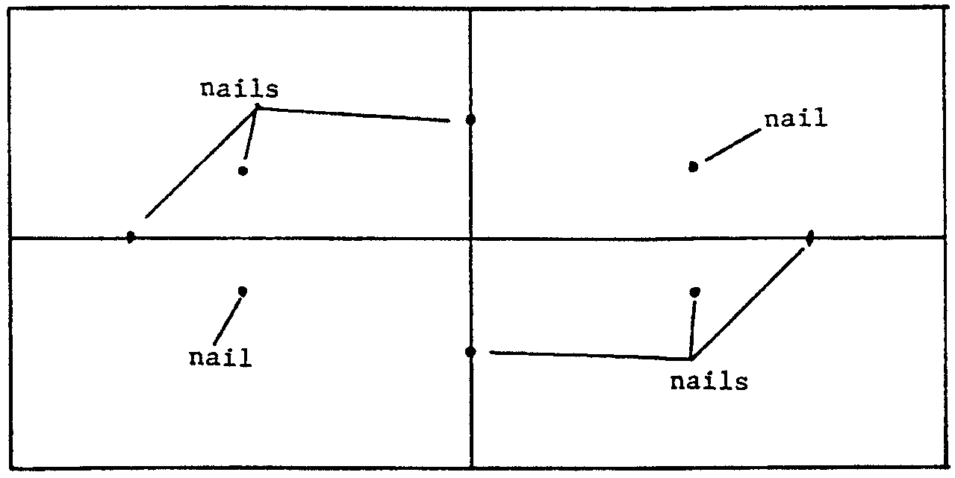

7. Have your partner hold one end of the batten against one of the 3' nails. Gently curve the batten around the 2', 3', and 1' nails until it is against the other 3' nail. Your batten and plywood should look something like this:
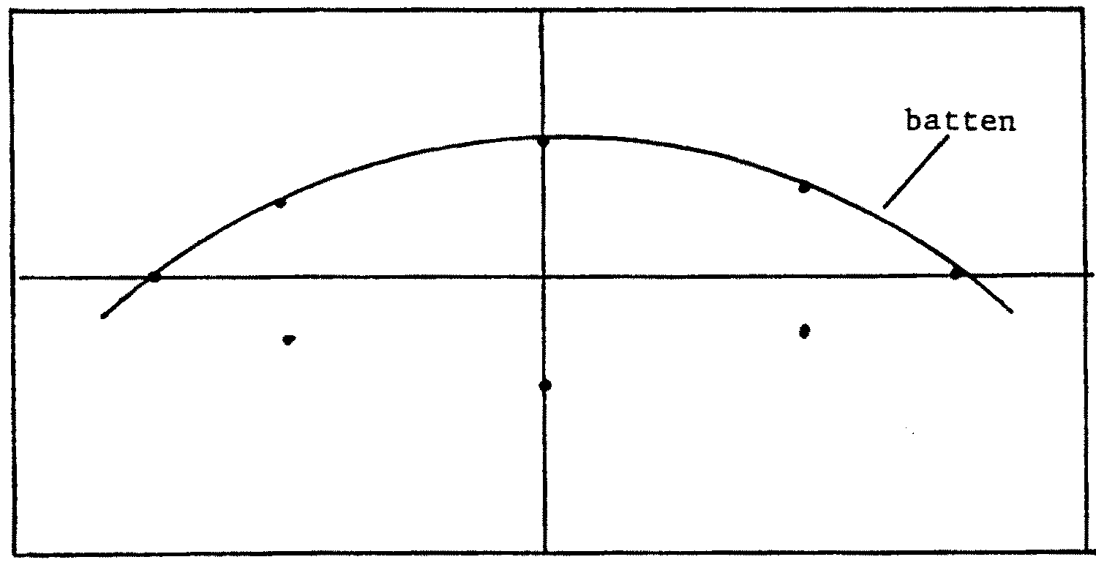

8. Have another person hold the second end. (Or, you may secure it with a nail alongside the batten.) The curve of the batten will determine the shape of the bottom of the boat. Run your pencil lead along the base of the batten to draw the curve on your sheet of plywood.

9. The right half and left half of the dory are mirror images. Follow steps 10 and 11 to draw the curve for the other side of the dory. Remove batten and nails. Your sheet of plywood should now look like this:

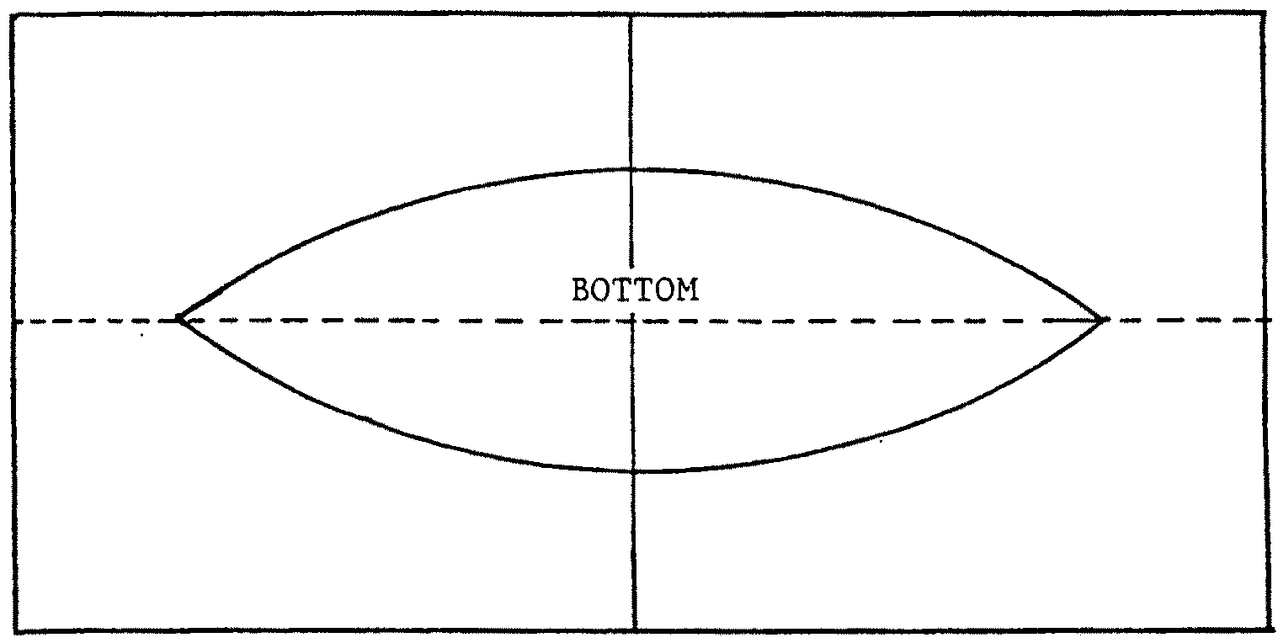

10. The layout of the bottom is finished except for two pairs of marks. Use your tape measure, framing square and pencil to make lines across the bottom 6" and 12" from the centerline. Your completed bottom should look like this:
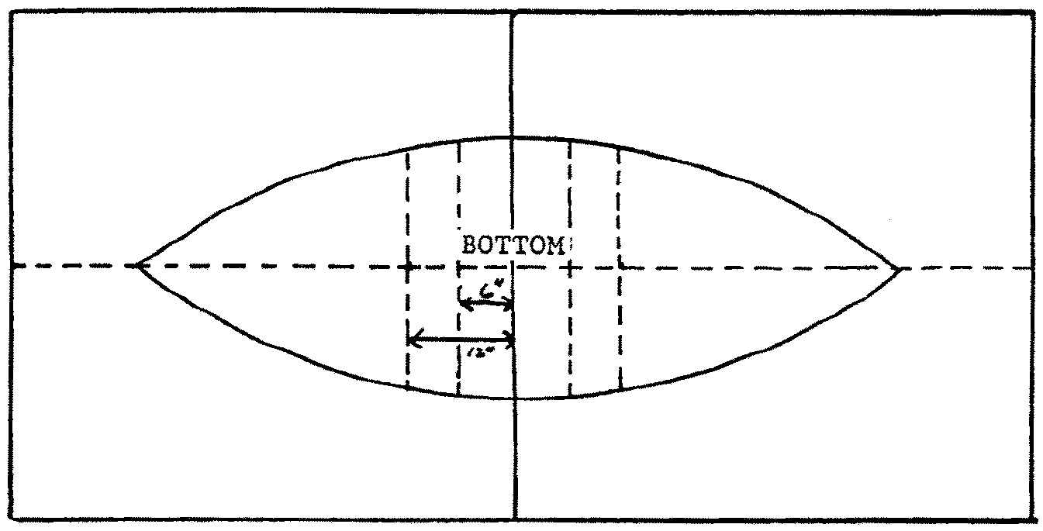

The Sides

1. Using your tape measure and pencil, make pencil marks along one of the long sides of your plywood sheet at the following distances from one end: 10 1/2 inches, 24 inches, 48 inches, 72 inches, and 88 1/4 inches.

2. Use your framing square to measure in 17 inches from the 10 l/2" mark you just made. Set a nail at this point. This nail will help determine the shape of the side. Use the same procedure at the other four marks you have made. The distances in from the side are given below:

Distance from end Distance in from side (location of nail)
10 1/2" 17"
24" 14 1/4"
48" 11 1/2"
72" 11 1/2"
88 1/4" 14 1/2"

Your plywood sheet should now look something like the picture below:
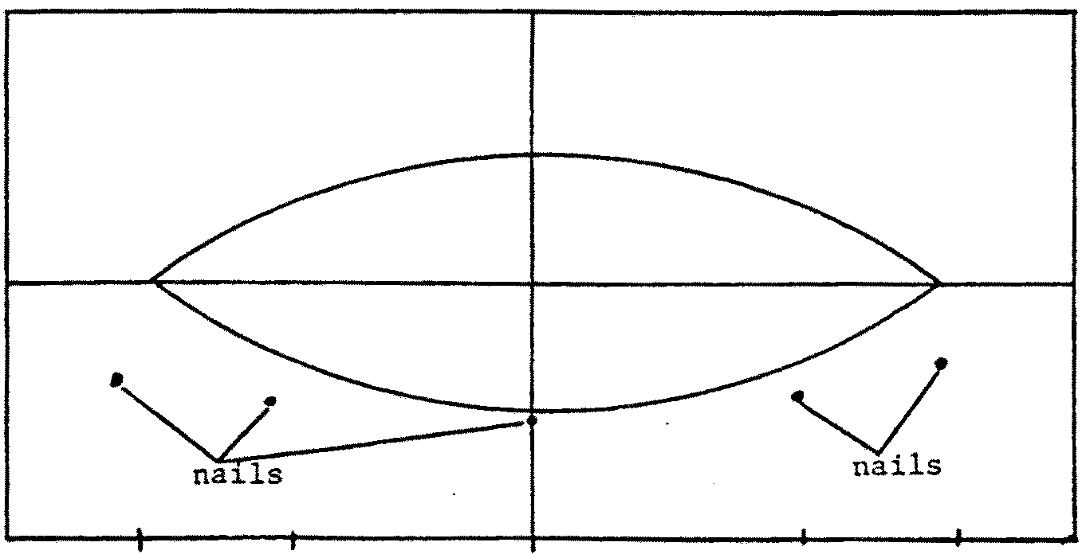

3. With a straight edge, make a pencil line to connect the closest corner of the plywood sheet with the nail 10 1/2" in from the end.

4. Make a pencil line along a straight edge to connect the closest corner of the plywood sheet with the nail 88 1/4" in from the end. Your plywood sheet should now look something like this:
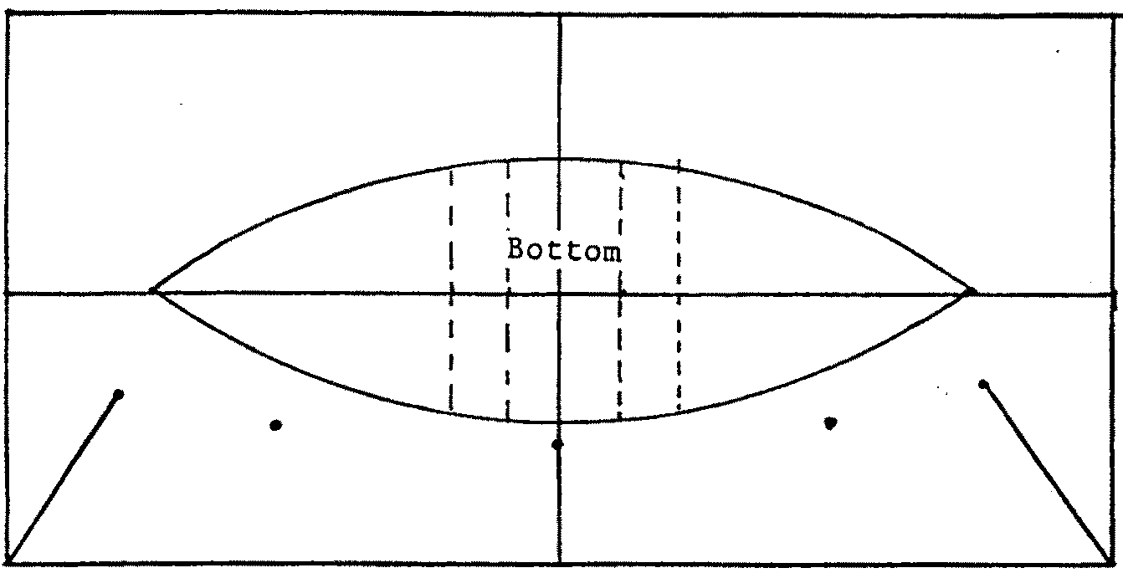

5. Have your partner hold one end of the batten against the 10 1/2" nail. Gently curve the batten around the 24", 48" and 72" nails until it is against the 88 1/4" nail. Secure one end with a nail alongside the batten. The curve of the batten will determine the shape of the side. Run your pencil lead along the base of the batten to draw the curve on your sheet of plywood. Remove batten and nails. Your plywood sheet should look something like this:

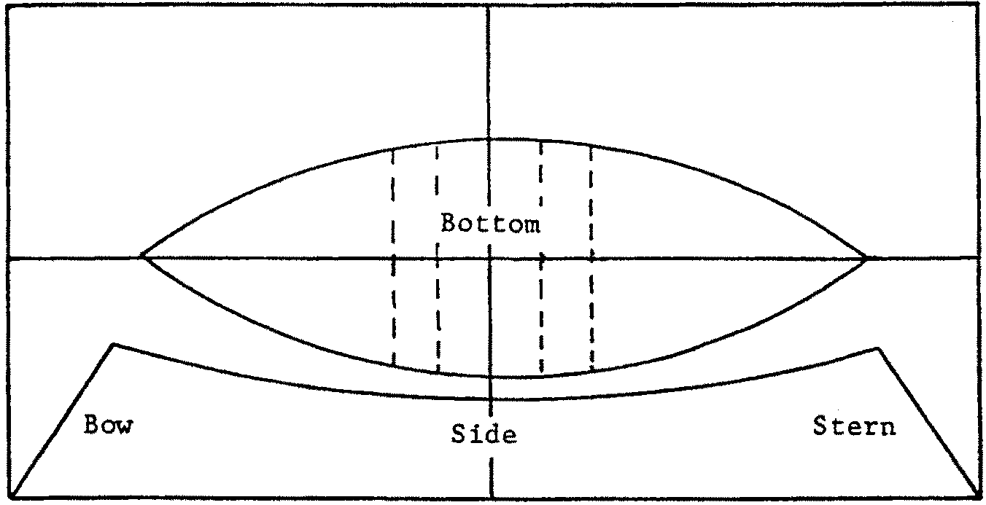

6. Repeat steps 1 through 5 to lay out the other side. When both sides are laid out, your plywood sheet should look something like this:
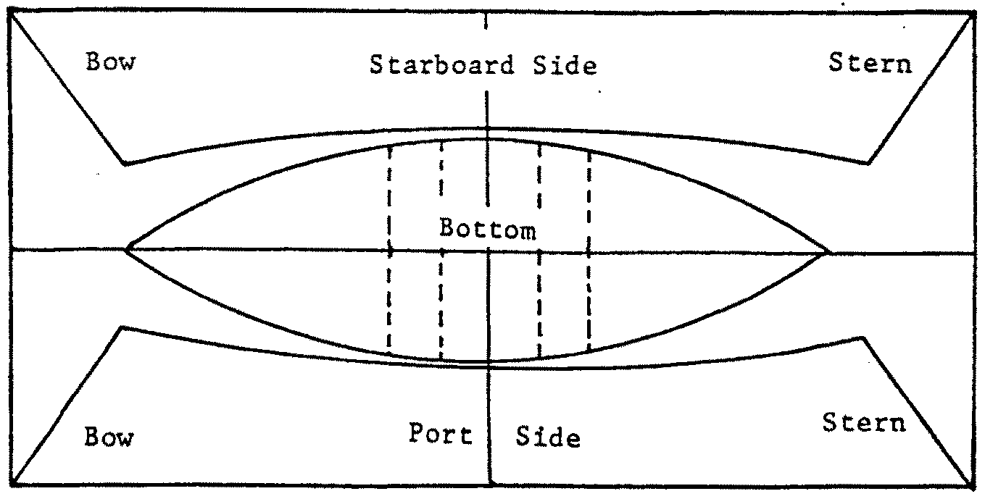

7. With your pencil, label the parts as in the illustration.

The Tombstone

The tombstone is a triangular stern piece which holds the two sides together.

1. Draw a line 4 1/2" in from the “stern” end of the sheet of plywood and parallel to the end.

2. About 10" in from one side make a pencil mark crossing your parallel line.

3. From your 10" line, measure along the parallel line for a distance of 18 1/2." Make another cross mark at this point. This part of your sheet of plywood should now look like this:
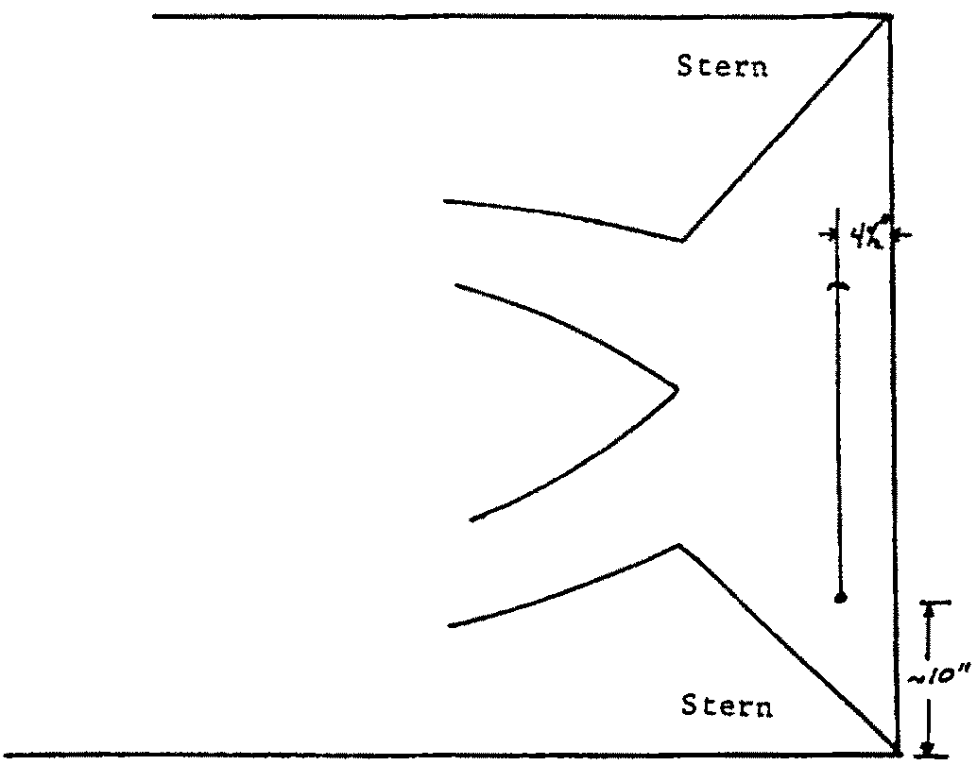

4. Use your framing square to measure in 4 1/2" from your 18 1/2" mark. Use your framing square again to draw a line from the edge of the sheet to the point 4 1/2" in from the parallel line.

5. Use a pencil line to connect the ends of your line at the 18 1/2" mark to the pencil mark you made about 10" in from the side. Your plywood sheet should now look something like this:

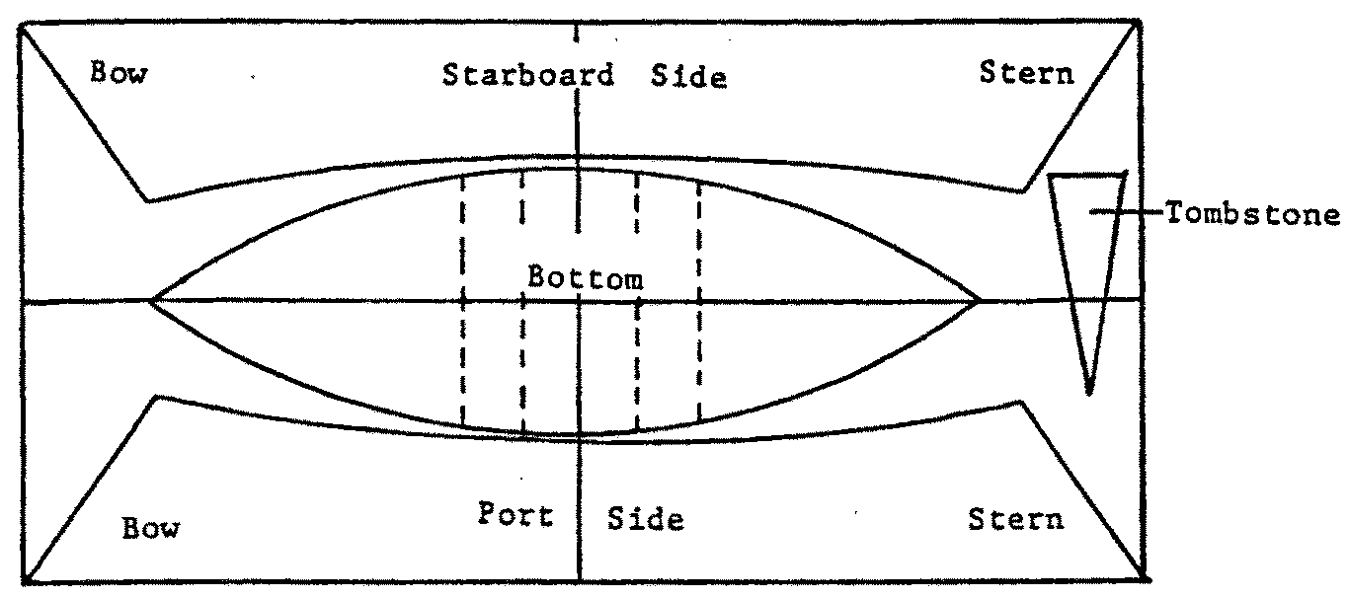

6. To give your tombstone a little class, you can finish off the end by making the following changes:

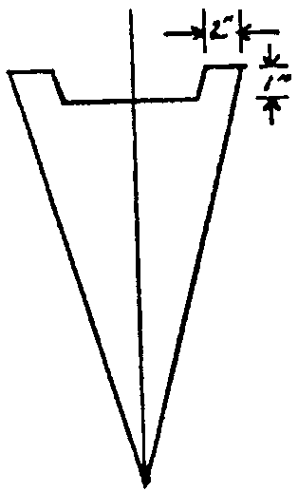

The Seat Supports

1. Draw lines 3" and 6" in from the “bow” edge of the plywood sheet and parallel to the edge.

2. Your parallel lines will cross the chalkline you made earlier to mark the centerline of the plywood sheet. Along your 3" line, measure 13 1/4" from the center line toward each side. Mark these points. This part of your sheet of plywood should look something like this:
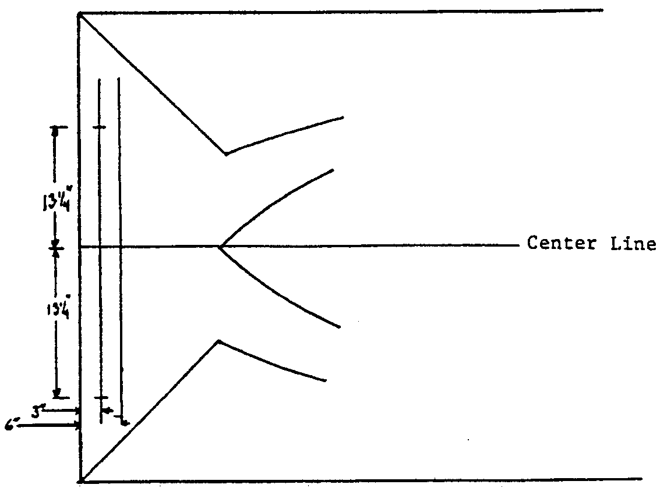

3. Along the edge and along your 6" line, measure 11 1/2" toward each side. Mark these points.

4. Use a straight edge and mark a pencil line to connect your 13 1/4" marks with your 11 1/2" marks. This part of your sheet of plywood should now look like this:
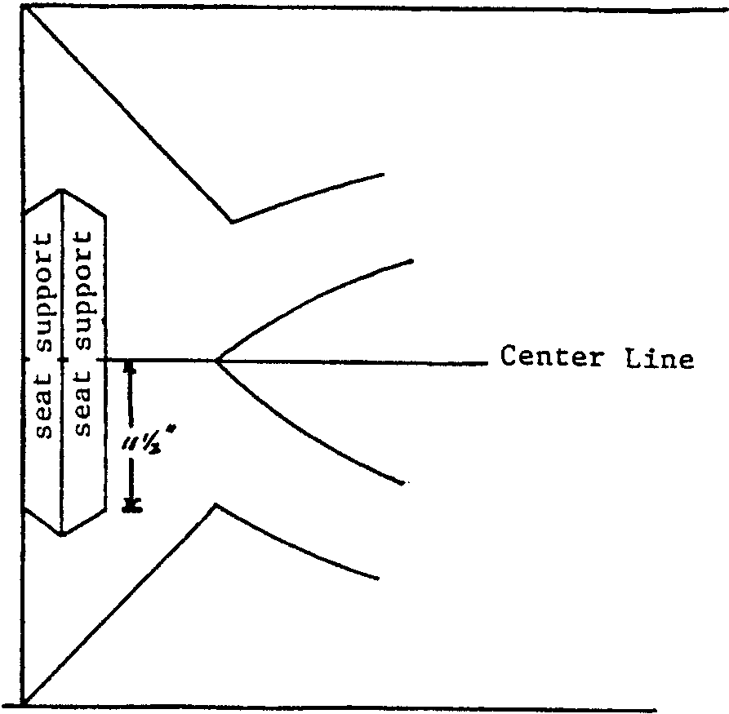

5. Your seat supports will run across the bottom of the boat. Pencil in three drain holes (called the limber holes) along the edges of the seat supports. The holes are shown in the next picture. Your completely laid out dory will look like the picture below:
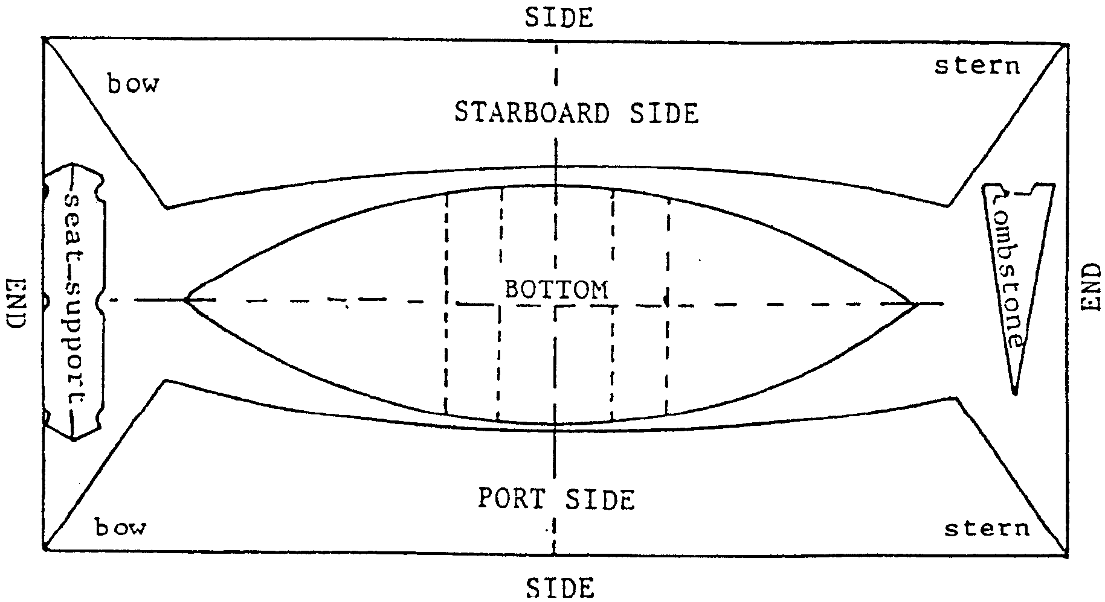

Part 2 - Assembling the Dory

Materials you’ll need:
• 1 - 2" x 4" ( 6 feet long)
• 2 - 2" x 4" (16" long)
• 2 - 2" x 12" (10" long, approximately)
• 10 - lOd nails
• 2 - 6" C-clamps

Cutting out the Parts and Building Frames

1. Use a saw to cut out the sides, bottom, tombstone and two seat supports.

2. Assembling the sides and hull will be much easier if you first two identical frames. You’ll need the 2" x 12"s and short 2" x 4"s, above. Use the drawings below as a guide:
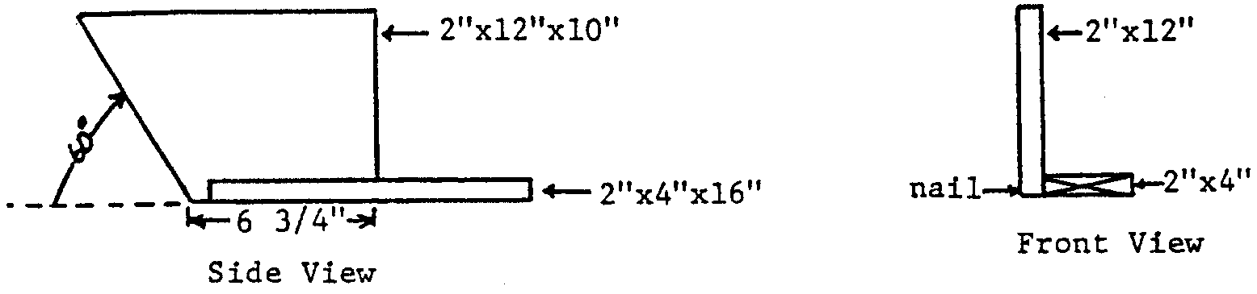

Curving the Bottom

1. Place the two frames on the bottom of the boat, along the marks for the seat supports and 12" from the mid-line. Have the 2" x 4"s crossing the centerline, as shown in the drawing below. You may want to tack the frames in place or have your partner hold them while you go on to the next step.

2. Lay the six foot long 2" x 4" along the center line and on top of the two 2" x 4"s of the braces.

3. Place a C-clamp at each end of the six foot 2" x 4". Tighten the C-clamps to bring the bottom piece up to the 2" x 4" at the ends. This curve in the bottom is called a rocker and will make your boat easier to row. The completed set-up should look something like this:

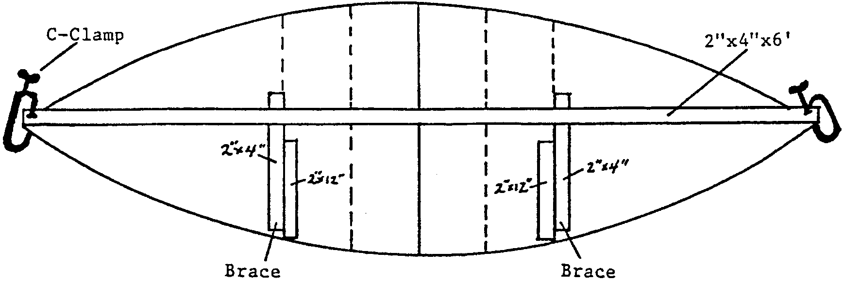

Joining the Stern, Sides, and Bottom

1. Position one side so that the stern end of the curved edge is flush with one end of the bottom. Drill 1/8" matching holes in the bottom and side near the end. Thread a short length of tie-wire through the two holes. Use your pliers to twist and tighten the wire. You will use this technique to hold your boat together. The stern should look something like this:
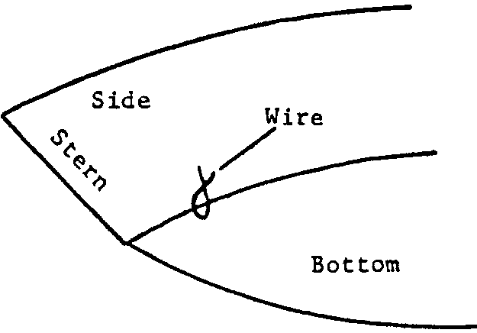

2. Gently curve the side around the frame. Hold in position at the bow. If necessary, you may let the side hang over the bottom by 1/4". Drill and wire the side to the bottom near the bow.

3. Near the top of the side, tack the sides to the frames with a single nail.

4. Drill and wire the side to the bottom. Make your ties 4 or 5 inches apart.

5. Remove the two frames and place them so they may be used to support the remaining side. Follow steps 3-10 to attach the second side to the bottom. Remove the six-foot 2" x 4" after you have the stern in position.

6. Drill and wire the two sides together at the bow. If necessary trim the sides to secure a good fit.

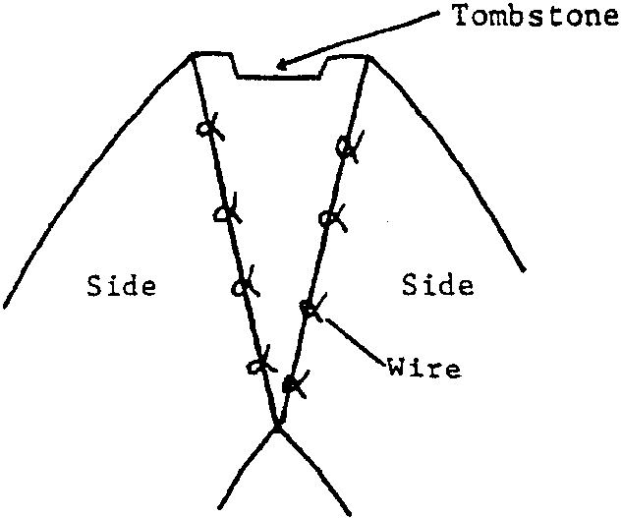
7. Use your drill and wire technique to attach the tombstone to the two sides at the stern. Your tombstone should look something like the picture below:

Securing the Seat Supports

1. Remove the frames. Position the two seat supports on the marks you made on the bottom. Secure the supports with a nail through the end of the support into the side.
Attaching Rub Rails

1. Use two 1/2" x 3/4" x 8' fir (or pine) strips for rub rails. These are attached by drilling and wiring to the top of each side.

Part 3 - Finishing the Dory

Materials you’ll need:
• 4" fiberglass cloth (about 20 feet length)
• resin
• scissors
• long rubber gloves
• respirator or dust mask
• paint brush

Sealing the Joints with Fiberglass

1. By now your sheet of plywood should look like a boat. You may notice that there are a lot of holes along the seams and a lot of wires. The next step is to seal the joints with fiberglass.

Note: It is hazardous to breathe or handle fiberglass cloth and the bonding resin. Follow manufacturers directions for mixing the resin and catalyst. Plan to wear long rubber gloves and a high quality mask when working with these materials. It is highly recommended that you carry out this portion of the project out of doors.

Obtain some 4" wide 10 ounce fiberglass cloth and a pair of scissors. Cut lengths of cloth to fit between all of the pieces of wire. Mix the resin and catalyst according to the directions. Use a paint brush to saturate the pieces of cloth you have placed between each pair of wires. Clean the brush and let the resin dry overnight.

2. Remove the wires. Cut additional pieces of fiberglass cloth to cover the wire holes. Lay the pieces along the joint covering the wire holes. Again, use a paint brush to saturate the pieces of cloth. Clean the brush and allow the resin to dry before proceeding.

3. Cut two pieces of fiberglass cloth the length of the outside bottom joint, a piece the length of the bow joint and two pieces the length of the stern joints. Again, use a paint brush to saturate the pieces of cloth. Clean the brush and allow the resin to dry.

Fastening the Seat to the Supports

1. The 12 1/2" x 26 1/2" piece of 3/8" or thicker plywood will serve as the seat. Use the galvanized nails to fasten the seat to the supports.
The Finishing Touches

1. Your boat is now finished except for paint, oarlocks and oars. You can obtain these items at a local sporting goods store. Decide on a name for your boat and paint it on her stern. Happy boating!

Part 4 - Keeping Safe

“PFD” stands for Personal Flotation Device. PFDs used to be called life jackets. A PFD can mean the difference between life and death. Be sure you have a PFD. Before you venture out on the water, try it in a swimming pool.

1. Obtain your PFD from its usual storage. Put on the PFD and secure all fastenings (tie, hook, snap, zip, etc.).

2. Adjust to fit.

3. Get in groups of 3 or 4 students. Enter the swimming pool and experiment with floating.

4. The HELP and HUDDLE positions are shown below. These positions help you keep warm in cold water.
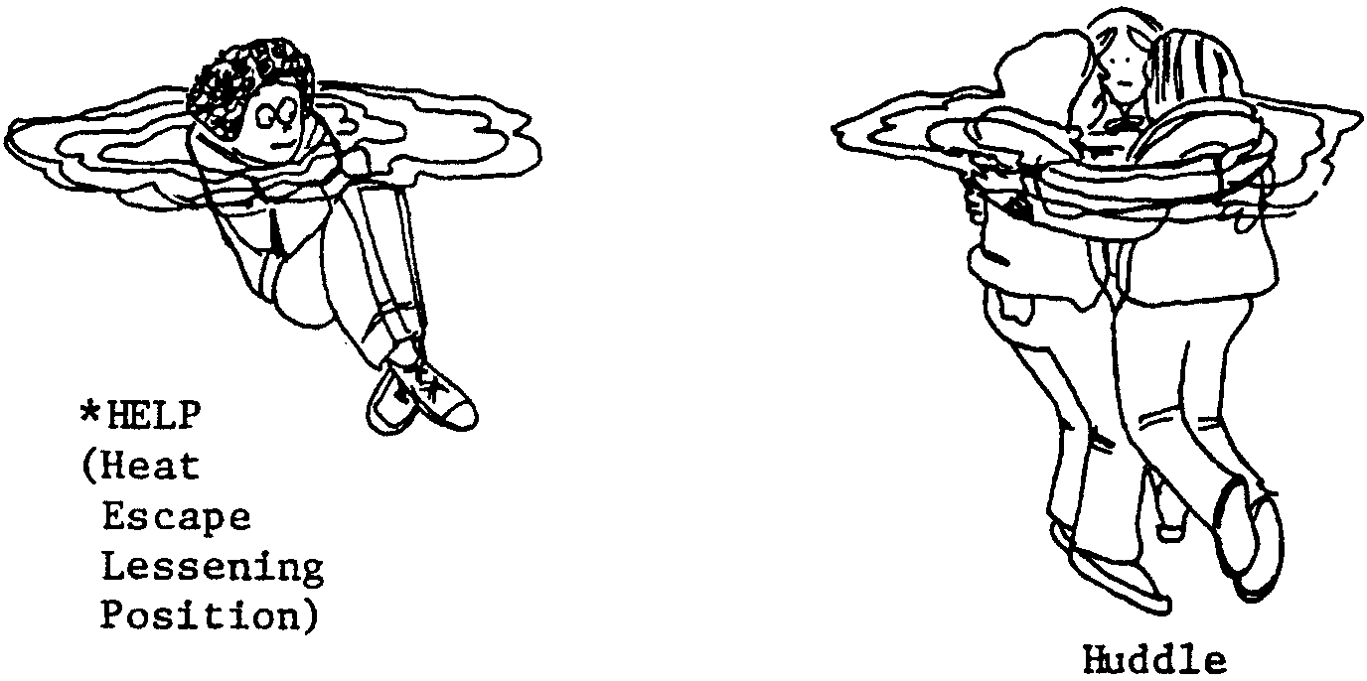

5. Assume the HELP (Heat Escape Lessening Position). Wait in HELP for the start signal from your teacher.

6. At signal, race to form a HUDDLE with the other members of your group.

7. In the HUDDLE, sing a chorus of “Row, Row, Row Your Boat”. The first HUDDLE to finish the song wins.

8. Here is one more activity to do before leaving the pool area. Get out of the water. Throw a PFD to one of your teammates in the water. The receiver should put on, fasten and adjust the PFD while treading water. Reverse roles and be the receiver yourself. Be sure you are familiar and comfortable with your PFD.
Part 5 - For Real

Now you are ready for the real thing. If you can, try out your boat in a swimming pool or small pond. Be sure and wear a PFD. Real life is a bit different from the toy boats. With real boats, everyone in a boat is a loser when it swamps or capsizes. Remember what you learned in “Keeping Afloat” and follow the safe boating practices listed below:

• Board one person at a time.

• Keep hands free. Do not carry gear when boarding.

• Hold boat alongside dock (better than over bow or stern).

• Board when boat is afloat (not beached or aground).

• Transfer weight smoothly (not by bumping or lunging).

• Step to center along the keelson (not on thwart or gunwale).

• Stay low, hold on to both gunwales.

• Distribute weight evenly (slightly down in the stern).

• Sit on thwart of boat or bottom of boat (not on gunwale).

• Sit down to pass gear aboard.

• Secure loose objects.

• Stow (not sit on) PFDs handy to each person (non-swimmers wear PFDs).

• Allow ample freeboard for power and weather. (Motors or sails cause more tilt than oars or paddles).

• Plan moves (don’t everybody change at once!)

• Single person alone in a boat:
Trim toward amidships
Avoid bow or stern, especially in a wind
Have a buddy ashore or in another boat

Be safe and have fun!

