Keeping Afloat

Key Concepts
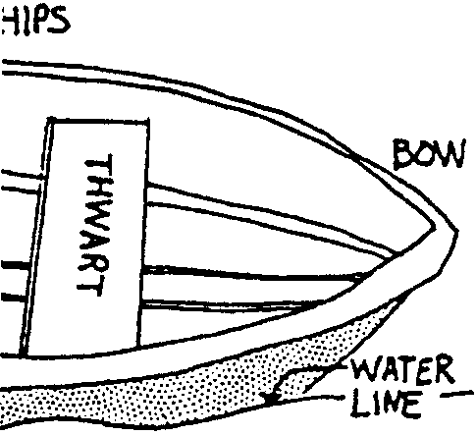
1. An object placed on the water’s surface, such as a boat, will sink just far enough to move aside, or displace, a weight of water equal to that of the object.
2. A boat will float even if it is made from materials heavier than water because part of the volume of the water it displaces is filled with air.
3. Hull design determines how well a boat floats and how much weight it can carry.
4. The position of cargo in a boat, especially its center of gravity, can strongly influence the boats stability

Background

Why do boats float? What causes them to sink? Any object placed on the water’s surface will sink just far enough to move aside, or displace, a weight of water equal to that of the object. If the object is dense, like a block of clay, it will sink. The clay can be made to float, however, if it is shaped like the hull of a boat so that it encloses a volume of air. If the weight of the clay and the enclosed air together weigh less than an equal volume of water, the clay boat will float.

This principle also influences the amount of weight a boat can hold. A boat’s buoyancy depends on the weight of the materials in the boat, and on its internal volume (since the internal volume of the boat determines how much water is displaced by air). It stands to reason that a boat built from light materials with a large internal volume will be able to carry more weight than a boat built from heavy materials and only enclosing a small internal space. Likewise a circular boat will hold more weight than a narrow boat.

Materials

Part 1 - Where’s the Bailer?

For each student or pair of students:

• dish pan, large plastic container, or other container of water for floating boats

• plasticine-type clay (about 1/4 to 1/2 pound)

• 8-10 marbles

• aluminium foil, about 14"

• 8-10 washers
For each group of 4-5 students

• balance and weights as needed

• sponges, paper towels for clean-up

Part 2 - Hit the Deck!

• Dish pan, or container used in Part 1

• 8-oz milk cartons, cut in half

• marbles or washers

• hole punch

• string

• clothespins

Teaching Hints

“Keeping Afloat” is a two part activity in which students investigate the buoyancy properties of boats. In “Part 1 - Where’s the Bailer?”, students vary the design of clay and foil boats and draw conclusions about how design affects buoyancy. In “Part 2 - Hit the Deck!”, students explore the concept of center of gravity as they vary cargo locations and quantity.

Part 1 - Where’s the Bailer?
“Where’s the Bailer?” is an inquiry activity. You may guide your students with questions, but you should control any desire you may have to suggest answers! No data sheet is provided here because it might limit the direction you and your students choose to take. You will probably want to have students record their experiences and thoughts, but look for ways which can be adjusted as new ideas surface. The sequence of questions and challenges provided here is only a suggestion. Do some experimentation yourself with ways of presenting these experiences so as to keep your students involved and challenged by these problems.

For example, depending on your playfulness and the dynamics of your class, you can create a challenge scenario such as: “A family of marble-people is trapped on an island and they have only this block of clay for a boat. How many family members can this boat carry at a time?” Or, “What is the minimum amount of clay needed to carry a family of 6?”

In this activity, students can work individually or in pairs. Groups larger than this tend to discourage full participation and are therefore not recommended. Do encourage students to discuss their findings with others working near them.
For boat construction, plasticine clay such as “Clayola” works well and can be re-used. Marbles and washers are suggested for boat cargo because of their uniform sizes, but other objects may serve equally well. This activity will undoubtedly cause water spills. Provide ample sponges and paper towelling to clean up the excess water.

Procedure
1. Give students a strip or block of clay, a tub of water, and paper and pencil. Ask students to predict what the clay will do if dropped in the water. Allow them to put the clay into the tub of water to see that it will sink.

Ask students to try making their clay into a shape that will float. Give them time to experiment. After every student has been successful, ask them to draw on their paper a shape that didn’t float, and a shape that did float.

2. Have the students divide their clay into three equal pieces. Ask them to make three different “boats,” each of a different shape. Then provide marbles as weights. Ask students to test their boats to find out how many marbles each boat will hold. Students might record the results of these experiments by drawing their boats and recording each boat’s marble capacity beside the drawing.

3. Have students set aside their “best” boat (the one which holds the most marbles) and experiment with their other pieces of clay to see if they can come up with a design which holds even more marbles.

4. Have students compare “best” designs within their groups or within the class as a whole.

Ask them to brainstorm in small groups, a list of characteristics of these “better” boats.

5. As students discuss their ideas, notice whether the size of the original block of clay becomes an issue. As this question is raised, provide balances so that students can compare the weights of their boats.

Ask whether they think there is a “maximum” number of marbles that each boat could possibly hold.

One way to focus on this question is to have students make a chart to compare boats of similar weights to see if they also have similar capacities. If differences still exist between boats of the same weight, challenge students to describe how the boats do differ in design, and what effects these differences might have on floating characteristics.

6. Give students a further challenge. Ask them to use the least amount of clay they can to create a boat that is capable of floating 6 marbles (or some number appropriate to the amount of clay students have to work with). Have them use balances to test their designs until they are confident the amount of clay cannot be reduced.

Have students find and record the weight of their boats. Have them also record the weight of the boats’ cargo.

7. Provide them with washers, another unit of weight. Ask students to predict how many washers their boats can hold up. Can they also predict the weight of the washers their boats can hold?

When students have had the chance to test their predictions, have them compare the maximum weight of marble-cargo with washer-cargo.

8. Give students three pieces of aluminum foil. Ask them to make three boats from foil: one with high sides, one with medium sides, and one with low sides. Before putting the boats in the water, have them predict which will hold the most marbles.

Have them keep the foil boat which can carry the greatest number of marbles. Ask students to make a clay boat the same size as this foil boat. Have them predict which of the boats will float the most marbles.

After they have tested this problem, have students discuss ideas for why the foil boat can hold so many more than the clay boat.

9. To assess and summarize the students’ thinking as a result of these experiences, have them write answers to questions such as those which follow. Afterward, you might have them discuss their ideas in small groups or as a class. Consider asking questions such as:

• What have you learned about how to design a boat to hold the maximum amount of weight possible?

• If you needed to know how many pennies one of your boats could hold, how could you find out without actually testing the materials in the water?

• If the following two boats are the same size, which boat will hold up more weight, a clay boat or a foil boat? Why do you think this is?

10. The law of displacement states that any object placed on the water’s surface will sink just far enough to move aside, or displace, a weight of water equal to that of the object. Students may not be able to state this principle as a result of their experiments, but you can take this opportunity to help them derive the concept through your final discussion if you choose. Even if you choose not to carry the discussion this far, students will have had a personal experience with density and displacement which will help them understand such concepts when they are introduced in later science classes.

Part 2 - Hit the Deck!

“Hit the Deck!” deals with where one places the center of gravity of a boat’s cargo. Students will quickly discover that cargo placed anywhere but low in the center of the boat will cause the boat to become unstable.

Part 2 can be carried out by the students themselves as an extension to Part 1. They will use some of the same materials as in the previous activity, but with the exception of the boats: in this case the boats are constructed from small milk cartons cut in half. You might ask students to save these from the lunch room, rinse them out and cut them in half for you.

The goal for Part 2 is for students to discover what happens to the stability of a boat when the weight of the cargo (or the passengers) is placed in different parts of the boat. In debriefing the activity you will probably want to make sure that students can apply their experience with the small boats to real situation on the water.

If you are using “Voyage of the Mimi” in conjunction with this unit, “Expedition 12: Boatshop” correlates with this lesson.

Key Words

buoyancy - the power to rise up or stay afloat in a liquid

capsize - to turn over

center of gravity - the center of an object’s weight or mass

density - the weight (or mass) of a given volume of a material

displacement - the moving aside of a fluid as an object is submerged in it

gunwale - the upper edge of a boat’s side (pronounced gun-nel)

stability - steadiness of a boat; its capacity to resist change

swamp - to fill with water

volume - the amount or size of something in three dimensions

waterline - the part of a ship’s hull that is just at water level; a painted line at that level

Extensions

1. Have students add a cup of salt into the water and retest the floating characteristics of their boats to explore how a change in water density affects these experiments.

2. Some of the original clay boat activities appeared in the booklet, Clay Boats, from Elementary Science Study, Educational Services Incorporated, Watertown, MA, 1966. Find a copy of the booklet for additional activities.

Answer Key

Part 2 - Hit the Deck!

Activity 1 - Sink or Float

1. Answers will vary depending upon experimental results.

2. The freeboard of the toy boat is reduced as the marbles are added.

3. The freeboard of a real boat is reduced as you add weight. The point to begin emphasizing here is that overloading a boat with people and/or gear reduces freeboard and increases the danger of swamping. Boaters need to stay within the load limits of their boat.

4. The likelihood of swamping your boat increases/decreases as you reduce the freeboard. (The correct answer is in bold face).

Activity 2 - Stormy Weather

1. Waves cause the boat to rock.

2. Waves reduce the freeboard, increasing the danger of swamping.

3. Your students will want to avoid stormy weather in small boats to reduce the risk of swamping. Adverse weather reduces the freeboard and increases the danger of swamping. Emphasize the fact that small boat operators need to be aware of and allow for weather.

Activity 3 - Trim

1.-3. Answers will vary depending upon the experimental results.

4. Answers will vary depending upon the experimental results. Generally, the combination of clothespins on the gunwale and towing proves to be the most unstable and, hence, to take the fewest clothespins to effect swamping.
5. The stability of the boat decreases as weight is added or moved. Emphasize that shifting weight causes a decrease in stability. Weight needs to be balanced to increase stability.

6. A sudden application of power decreases the boat’s stability. Gentle rowing and gentle take-offs with power boats, reduce the instability that occurs when a boat gets underway.

7. In a small boat, the most stability is attained by sitting near the center (actually, just slightly toward the stern, along the center line).

Activity 4 - Standing Up
1. Answers will vary depending upon the experimental results.

2. Raising the center of gravity decreases the stability of the boat.

3. The most obvious way to raise the center of gravity in a real boat is to stand up.

4. The conditions listed are correctly noted below.

Adding extra weight Unstable

Moving all weight to the stern Unstable

Sitting in the center of the boat Stable

Moving all weight to the bow Unstable

Standing up in the boat Unstable

Sitting low in the boat Stable

Pushing or pulling boat rapidly Unstable

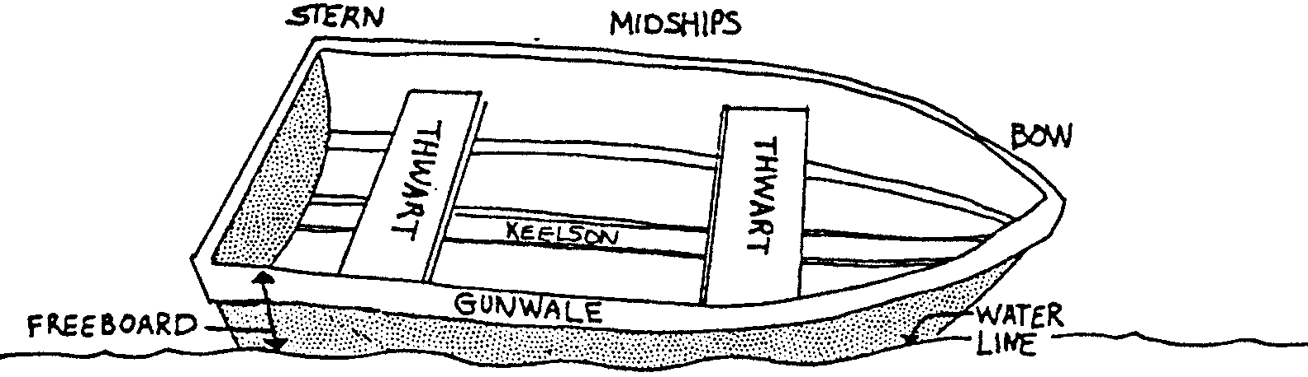
Keeping Afloat Part II - Hit the Deck!

Stern, port, starboard...all of these words tell us something about boats. Compass rose, charts, courses...all of these words tell us something about boating. But none of these words tell us how a boat works. Why do boats float? In the following activities you will have a chance to explore this question. The drawing above will help you complete the following activities.

You’ll need these things for the following experiments:
• a milk-carton boat
• a water tub
• marbles or other weights
• some string and a hole punch
• clothes pins

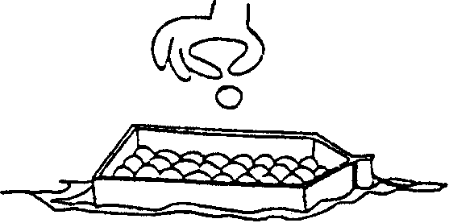
Activity 1 - Sink or Float

Float the milk-carton boat in the tub of water. Add marbles or other weights to your boat one at a time.

1. How many weights does it take to sink the boat?

2. What happened to the freeboard (see drawing above) of your toy boat as you added weights?

3. What happens to the freeboard of a real boat as you put more people into it?

4. The likelihood of swamping your boat increases/decreases as you reduce the freeboard. (Circle the correct answer).

Activity 2 - Stormy Weather

Empty and refloat your boat.

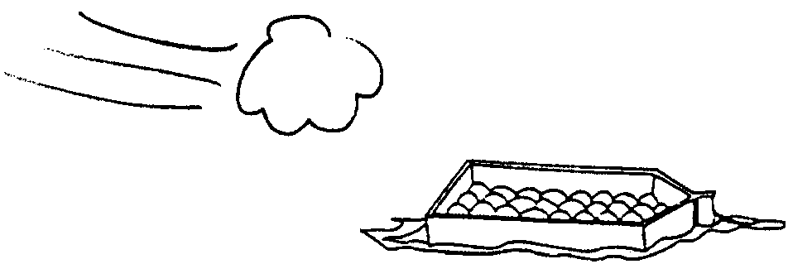
Put into the boat one half of the number of weights it took to swamp your boat.

Make waves on the water surface by gently blowing from one end of the dish pan or gently stirring the water with one hand.

1. What do waves do to the boat?

2. What effect do the waves have on the freeboard?

3. Why would you want to avoid stormy weather when riding in a small boat?

Activity 3 - Trim

Empty and refloat your boat. Clip clothespins to the stern until it becomes unstable.

1. How many clothespins does it take to swamp the boat?
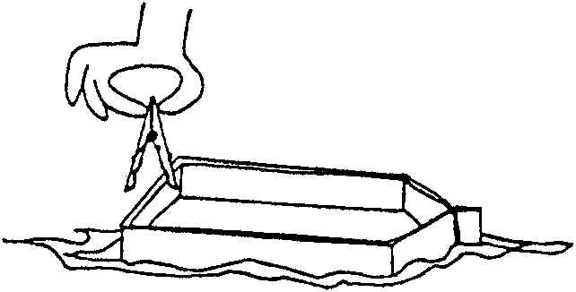
Empty and refloat your boat from step 1.

Clip clothespins to one gunwale until it becomes unstable.

2. How many clothespins does it take to swamp the boat this time?

Now add a tow rope to your boat. Punch a hole near the top of the bow. Tie a string through the hole in the bow. As in step 3, take turns adding clothespins to one gunwale. Between each addition of a clothespin gently pull the boat across your water container. Have the person who added the clothespin do the pulling.

3. How many clothespins does it take to swamp the boat now?

4. Which condition (clothespins on stern, gunwale, or gunwale and towing) took fewest clothespins to swamp the boat?

5. What happens to the stability of the boat as weight is added or moved to one part of the boat?

6. The string was a power source for your boat. What is the effect of a sudden application of power on the boat’s stability?

7. In a small boat, where should you sit for the most stability?

Activity 4 - Standing Up

Empty and refloat your boat.

Take turns adding clothespins to both gunwales. After each gunwale has three clothespins, begin clipping a second row onto the top of the first set of clothespins.

1. How many clothespins does it take to capsize (roll over and swamp) the boat?

Clipping the second row of clothespins to the first raises the center of gravity of the boat. The center of gravity is the center of the boat’s weight. It is also called the balance point for the boat.

2. When you raise the center of gravity of the boat, what happens to the stability of the boat?
3. What is one way a person might raise the center of gravity in a real boat?

4. The following situations may occur in small boats. Some of the situations tend to make the boat stable. Others tend to make the boat unstable. After each of the following statements, write whether the action would make a boat more stable or more unstable.

Adding extra weight

Moving all weight to the stern

Sitting in the center of the boat

Moving all weight to the bow

Standing up in the boat

Sitting low in the boat

Pushing or pulling boat rapidly

