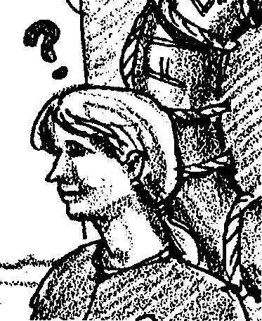
Whazzat?

Key Concepts
1. For persons spending time on boats, knowledge of nautical terms is essential for quick communication and teamwork.

Background

Cetologists, whale watchers and others of us who spend time on the water find it important to learn the terminology associated with boats. Having a familiarity with boating terms helps speed communication and thereby increases efficiency and safety on the water. Boating has a large and complex vocabulary best learned by use. “Whazzat?” provides an introduction to some of the more common boating terms. Two activities are provided: a paper and pencil exercise to familiarize students with new vocabulary and a kinesthetic activity in which students role play sailors quickly following orders called out by their captain.

The real learning of the terminology can only be accomplished through repetitive use. Incorporate the terms into your vocabulary and look for fun and playful ways to use them with your class. The terms will be used again in the activities on boats which follow “Whazzat?”

Materials

For each student:

• 1 set of nautical terms and dot-to-dot activity with instructions

For the class:

• large open space for running, such as a gym or playground

• 10 traffic cones or other marking devices

Teaching Hints

For persons spending time on boats, knowledge of nautical terms is essential for quick communication and teamwork. “Whazzat?” is a two part activity which provides students with an opportunity to learn to use to some of the more common boating terms. In “Part 1 - Sail Away” students complete a dot-to-dot illustration by making correct vocabulary choices. In “Part 2 - Running Aground”, they role play “sailors” under the command of the “captain” in an active, kinesthetic game
Part 1 - Sail Away:
Completion of the dot-to-dot illustration is best accomplished by individual students as a homework assignment or in-class assignment. Begin by introducing and discussing the list of terms present in the student activity. Some of your students may find the directions easier to comprehend if you provide a concrete example by completing the first statement. Although this activity is largely self-correcting, your students will benefit from a brief review in which you provide the answers to the statements and show the correctly completed dot-to-dot drawing.

Part 2 - Running Aground:
The active role playing game requires an open area large enough for all of your students to move about freely, but small enough that you can easily be heard. Set up the playing area as shown in the diagram below. Use traffic cones to mark the bow, stern, port, starboard, and brig. A strip of masking tape or a line on the gym floor can serve as the inspection line.

BOW

PORT STARBOARD

INSPECTION LINE

1 2 3 4 5

BRIG

STERN

As captain, you call out commands, and students quickly take the action called for by that command. Students who make a mistake are sent to the “brig” or jail. Look over the list of commands to become familiar with them before introducing the activity to students. The command “Roll Call” brings all sailors out of the brig to begin the game anew. The “Roll Call” command is more complex and goes as follows:

Divide students into 5 “watch crews” or teams (depending on class size, you may wish to increase or decrease the number of teams). Watch crews line up behind the boundary markers on the “Inspection Line”. For example, if you have 25 students, there will be five in each watch crew, standing at attention in a straight line, one behind the other, all behind a marker.

Line #1 is the most important, because the captain always checks this line first. It must be correct, with the right number in the line, the right students in the group, all at attention, or the captain will send all “watches” to the brig. If line #1 is correct, the captain will next inspect line #2.

Line #2 is next important. If line #2 is not correct, lines #2, 3,4, 5 all go to brig. Line #1 is left alone to continue game. If line #2 is correct, the captain goes to line #3.

This sequence continues until all watch lines pass inspection. Note that in repeated roll calls you might alter which team is Watch #1.

In explaining the game to students, stress that you are the captain and will give the “sailors” (students) the terms they need to know about a ship. The sailors must listen and watch very carefully, for the captain will only give the terms and definitions one time. Using the lines and boundary markers, proceed to show once where each term is located and what action is to be associated with that term. If a sailor does not remember the term and its action, that sailor will go to the brig.

Be sure to give students assurance this is all in fun. When they can’t remember a term and/or action, they are sent to the brig, but they won’t be in the brig for long, for the “Roll Call” command will bring them back out. After running the game several times with you as captain, you might consider choosing a student to be the captain. Then you can become a sailor and play the game with the students!

Be firm and picky, as if you were a stern sea captain. The life of a sailor aboard an ocean voyage a century ago was not as full of fun and glamor as students may think. If a sailor isn’t saluting at inspection line, send that sailor to the brig. If sailors are not at port or starboard for man overboard, send them to the brig. For actions that require groups, if a sailor can’t get into a group because each group already has the correct number of sailors, that sailor goes to the brig. You can also challenge sailors by telling them to “Do what I say, not what I do.” You might call “Run to starboard,” but meanwhile you run to stern to see if you can trick any kids into following you.

For students with learning difficulties, start out with fewer nautical terms and work up to using all the terms. Add some more terms when your students have mastered these.

Below are the captain’s commands along with the sailors’ action:

1. Bow: Run to front of ship.

2. Stern: Run to back of ship.

3. Port: Run to left side.

4. Starboard: Run to right side.

5. Inspection line: Run to the line, “toe the line,” face the bow and salute.

6. Climb the crow’s nest: Make a climbing motion.

7. Swab the deck: Make a mopping motion.

8. Hit the deck: Get flat on stomach on floor.

9. Torpedo: Squat down, hands together above head, pointing up.

10. Thar she blows!: Point at the whale spout, any direction in the water.

11. Poop deck, (upper deck at stern of ship): Get on hands and knees at back of ship, facing stern, and make scrubbing motions.

12. Abandon ship: Grab a partner, sit on ground, facing partner, with feet together, hands joined, pulling back and forth as though rowing a boat.

13. Man overboard: Grab a different partner, facing out starboard or port side, one partner on hands and knees, one partner with foot on the back of the other partner, hand above eyes, searching the seas.

14. Mates in the galley: 3 people sitting cross legged, joining hands.

15. Desert island: 1 person standing (being a tree), 3 people sitting around tree, backs to tree, arms together, feet out straight.

16. Roll Call!: (explained above)

If you are using “Voyage of the Mimi,” in conjunction with this unit, “Episode 8, Tracking the Whale” can be used with this lesson.

Key Words

aft - describing the rear or “after” section of a vessel, or things to the rear of amidship and toward the stern; aft is the opposite of fore

aground - sticking to bottom

amidship - describing the mid-section of a vessel

anchor - a heavy piece of forged or cast metal shaped to grip the sea bottom and used to hold a boat in a desired position

bail - to remove water from a boat by pump or bailer

beam - imaginary line across a ship from side to side, at right angles to keel of vessel; also vessel’s width amidship

bearing - the direction of a visible object as read from a compass

below - beneath, or under, the deck; one goes below when going down into the cabin

bilge - the lower internal part of a boat’s hull, adjacent to the keel

bow - the forward part or front of the boat

bulkhead - interior wall on a boat

buoy - a floating, anchored navigational aid or marker

brig - jail for disobedient sailors on board a ship

bunk - bed

cabin - room

capsize - to turn over

compass - the instrument which shows the course, or direction of a vessel

crow’s nest - lookout platform on mast

course - the compass reading toward which the boat is being steered

deck - floor

draft - the depth of the vessel below the water line, measured vertically to the lowest part of the hull

fore - used to distinguish the forward part of a boat or things forward of amidship; the opposite of aft or after

galley - kitchen, dining area

gunwale - the upper edge of a boat’s side (pronounced gun-nel)

head - toilet on board boat

hatch - door

helm - the wheel or tiller by which a ship is steered

hull - the body of a boat

keel - a curved piece of wood or other material which runs from bow to stern underwater along the deepest part of the boat and forms the primary backbone of the boat’s hull

line - rope used on a boat

mast - an upright pole which supports rigging and sails

oar - a long wooden instrument with a flat blade at one end, used for rowing boats

port - the left side of a boat when you are facing toward the bow; also a boat’s destination

starboard - the right side of a boat when you are facing toward the bow

stern - the after end or back of a boat

stow - to pack the cargo

thwart - a seat or structural member extending across a boat, from side to side

topsides - up on deck; the opposite of below

transom - the planking which forms the after-end of a small square-stern boat; outboard motors are usually attached to the transom

Extension

1. Make your classroom resemble a boat, with the front of the room as the bow and the back of the room the stern. Have some students make signs on 5" x 7" index cards and display them in your classroom to label the parts of a boat. On the back of the signs, write the definitions of the terms. Refer to places in the room as if your class were aboard a boat. Use the vocabulary in the nautical terms list for flash cards. Use the index cards like flash cards. If possible, collect actual objects from boats to use with the labels. Otherwise, have students create appropriate representations to display. For example, a pail can be labeled “bailer.” Use a compass to correctly establish directions and post large letters to correctly identify their bearing from the center of your room. Tell the degree for each point, also.

Answer Key

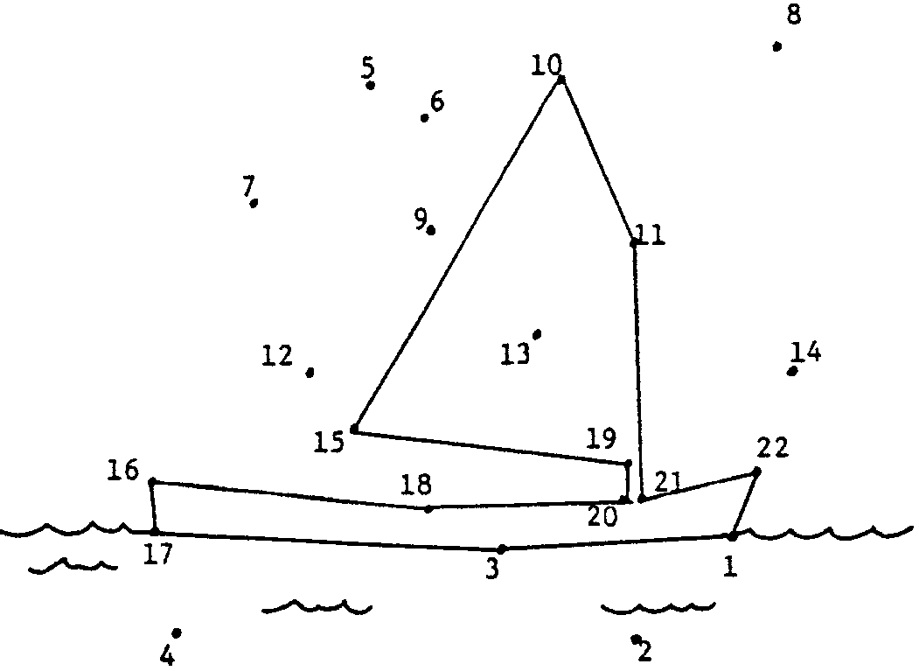
A correctly completed dot-to-dot is followed by a copy of the question statements in which the correct answers appear in bold face print.

A. Captain Flash walked back and forth along the bail (1-2) / gunwale (1-3).

B. He was mad. His ship, the Albatross, was aground (15-19) / aft (11-14).

C. “When I find the sailor that put us here, I’ll dunk him in the bilge (10-11) / keel (9-10).”

D. Sailor Sam was nervous. He had misread the capsize (14-22) / compass (1-22).

E. Sam didn’t know port from fore (5-7) / starboard (16-18).

F. If the Captain found out, Sam would be tied with a line (3-17) / oar (12-15) .

G. Then he’d be thrown over the stern (19-20) / bearing (2-4) and pulled along.

H. Sam crawled forward. In the course (12-15)/ bow (10-15) he’d be safe.

I. “Aha!,” yelled Captain Flash. He grabbed Sam and threw him over the draft (15-16) / stern (16-17).

J. Poor Sam was now the ship’s anchor (11-21) / beam (11-13).

K. No longer could Sam go helm (6-10) / below (18-20) deck for comfort.

L. No longer could Sam sit on his favorite thwart (21-22) / transom (8-14). Justice at sea was harsh and swift.

Whazzat?
Nautical Terms

Aft - Describing the rear or “after” section of a vessel, or things to the rear of amidship and toward the stern. Aft is the opposite of fore.

Aground - Sticking to bottom.

Amidship - Describing the mid-section of a vessel.

Anchor - A heavy piece of forged or cast metal shaped to grip the sea bottom and used to hold a boat in a desired position.

Bail - To remove water from a boat by pump or bailer.

Beam - Imaginary line across a ship from side to side, at right angles to keel of vessel. Also vessel’s width amidship.

Bearing - The direction of a visible object as read from a compass.

Below - Beneath, or under, the deck. One goes below when going down into the cabin.

Bilge - The lower internal part of a boat’s hull, adjacent to the keel.

Bow - The forward part or front of the boat.

Bulkhead - Interior wall on a boat

Buoy - A floating, anchored navigational aid or marker.

Brig - Jail for disobedient sailors on board a ship.

Bunk - Bed.

Cabin - Room.

Capsize - To turn over.

Compass - The instrument which shows the course, or direction of a vessel.

Crow’s Nest- Lookout platform on mast.

Course - The compass reading toward which the boat is being steered.

Deck - Floor.

Draft - The depth of the vessel below the water line, measured vertically to the lowest part of the hull.

Fore - Used to distinguish the forward part of a boat or things forward of amidships. It is the opposite of aft or after.

Galley - kitchen, dining area.

Gunwale - The upper edge of a boat’s side. (Pronounced gun-nel.)

Hatch - Door.

Helm - The wheel or tiller by which a ship is steered.

Hull - The body of a boat.

Keel - A curved piece of wood or other material which runs from bow to stern underwater along the deepest part of the boat and forms the primary backbone of the boat’s hull.

Line - Rope used on a boat.

Mast - An upright pole which supports rigging and sails.

Oar - A long wooden instrument with a flat blade at one end, used for rowing boats.

Port - The left side of a boat when you are facing toward the bow. The word port can also mean also a boat’s destination.

Starboard - The right side of a boat when you are facing toward the bow.

Stern - The after end or back of a boat .

Stow - To pack the cargo.

Thwart - A seat or structural member extending across a boat, from side to side.

Topsides - Up on deck; the opposite of below.

Transom - The planking which forms the after-end of a small square-stern boat. (Outboard motors are usually attached to the transom).
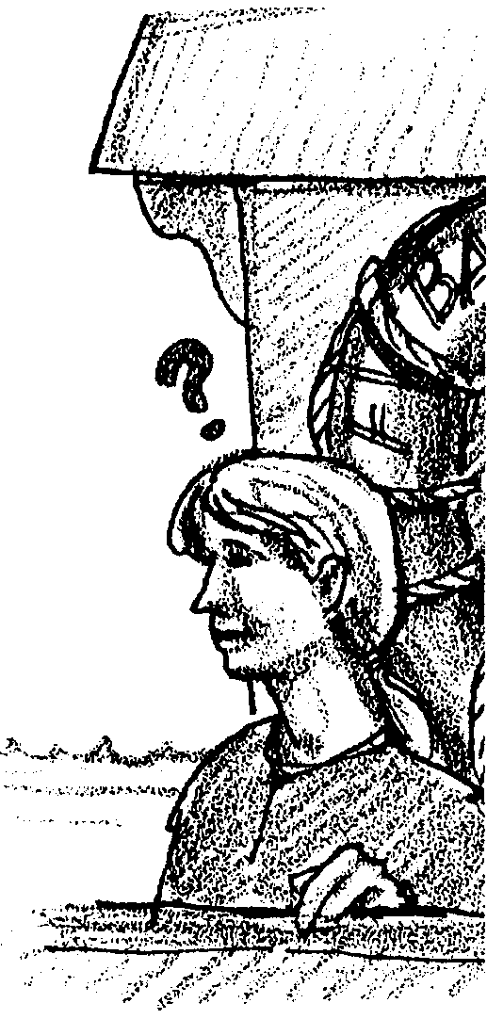

Lea has finally mastered the skill of triangulation. But she is confused by some of the commands she hears the skipper call out to the first mate. She hears words like “gunwale,” “bilge,” and “starboard.” How is she ever going to be a sailor if she doesn’t even know the parts of a ship?

Anyone who spends time at sea should know some nautical terms. How many of the words on this page do you know?
Now Solve this puzzle:

Each statement below may be correctly completed by one of the two choices given. Circle the correct word in each sentence.

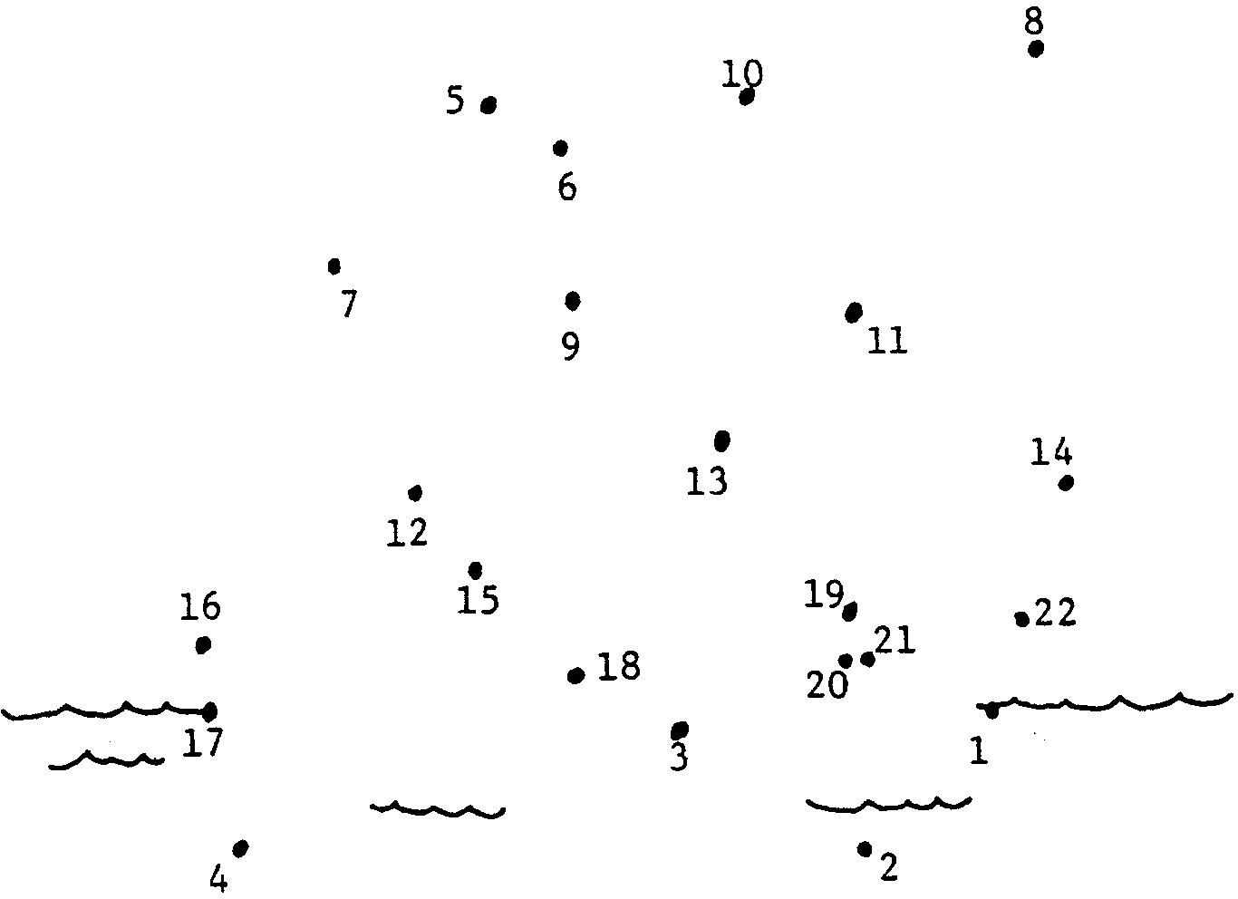
There are two numbers after each choice. The numbers refer to the dot-to-dot drawing. Use a pencil line to connect the two numbers that follow each choice you make. Connecting the numbers following the correct choices makes a picture. If your connect-the-dot drawing doesn’t make sense, neither do your answers to the questions! Use the definitions down the side of the page for help.

A. Captain Flash walked back and forth along the bail (1-2) / gunwale (1-3).

B. He was mad. His ship, the Albatross, was aground (15-19) / aft (11-14).

C. “When I find the sailor that put us here, I’ll dunk him in the bilge (10-11) / keel (9-10).”

D. Sailor Sam was nervous. He had misread the capsize (14-22) / compass (1-22).

E. Sam didn’t know port from fore (5-7) / starboard (16-18).

F. If the Captain found out, Sam would be tied with a line (3-17) / oar (12-15).

G. Then he’d be thrown over the stern (19-20) / bearing (2-4) and pulled along.

H. Sam crawled forward. In the course (12-15) / bow (10-15) he’d be safe.

I. “Aha!,” yelled Captain Flash. He grabbed Sam and threw him over the draft (15-16) / stern (16-17).

J. Poor Sam was now the ship’s anchor (11-21) / beam (11-13).

K. No longer could Sam go helm (6-10) / below (18-20) decks for comfort.

L. No longer could Sam sit on his favorite thwart (21-22) / transom (8-14). Justice at sea was harsh and swift.

