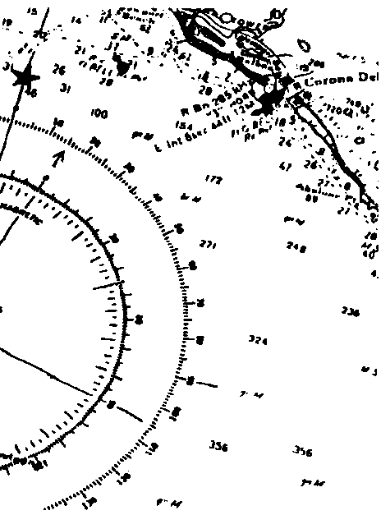
Hmmmm.... Where Did You Say We Were?

Key Concepts
1. The position of a boat on the water can be determined by taking magnetic compass bearings on two fixed objects from the boat.
2. The course position of a boat in the water can be described by the boat’s direction (its magnetic course heading) and by its known starting or ending position.

Background

Most activities on the water, from whale watching to oceanographic sampling, require exact knowledge of the position of the boat. The knowledge gained from reading nautical charts is helpful in establishing the general location of the boat. To determine the precise position, the technique of triangulation is the simplest method to use, providing fixed reference points are in sight. Determining position by triangulation is a basic oceanographic procedure that should be learned by any one who spends time working on the ocean. The same principle is used for celestial and electronic navigation.

Triangulation is also useful for some land-based activities, especially those involving transects. If you have an accurate map of your school grounds, it is possible to give your students some firsthand practice with the mechanics of triangulation. “Hmmmm....Where Did You Say We Were?” provides the introduction to triangulation needed for such an activity.

Successful triangulation depends upon the ability to read a chart, presented in the preceding lesson, “Follow That Whale!”, on the use of a compass, and on the visibility of at least two fixed reference points. Boats out of sight of fixed reference points determine position by radar, sextant, and most commonly today, by electronic means.

Triangulation relies on the ability to determine exact directions. Traditionally the magnetic compass has been the primary tool used in making these measurements. However, magnetic compasses are subject to two types of error.

The first is called variation. Variation is the difference between true north and magnetic north. As you recall, true north lies on the earth’s rotational axis. Magnetic north is related to the earth’s electromagnetic field and is located several hundred miles distant from true north. On a chart, variation is indicated by the angle between the meridian lines of magnetic force which point toward magnetic north, and the meridian lines pointing toward the geographic north pole. Variation is designated as east or west of true north.

Variation is not the same from place to place, for two reasons. First, the earth’s magnetic field is not uniform. Second, the angle between the geographic and magnetic poles changes depending on the distance from the poles. At any one location, however, variation is relatively constant. Most locations experience a very small annual rate of change.

The compass rose on a chart displays variation both graphically and numerically. The outer ring of the rose shows directions in terms of true north. The inner ring shows directions in terms of magnetic north. The difference between bearing marks on the two rings is the variation for that area. The variation and the annual rate of change are also written in the center of the rose.

Most charts have more than one compass rose. This is because variation may change even within the relatively small areas shown on nautical charts. You should always use the rose nearest your location.

In this activity we will use the magnetic compass rose and record positions and headings in magnetic terms. We will not correct for variation to true north as a navigator actually would in recording positions and headings.

Deviation is the second source of error in using a magnetic compass. Deviation is due to the influence of nearby magnetic or metallic objects on the readings of a compass. Unlike variation, deviation does not change with geographical position, though it will change if the compass is moved to a new location on the boat or if an object, such as a portable radio, is placed near the compass. Deviation is not the same for all points of the compass, so many boat operators record the compass deviations at various points of the compass in a deviation table. The deviations are determined by pointing the compass at known magnetic headings and comparing these with the compass readings. Deviation is not introduced in this activity.

For more information on using a compass, correcting compass errors, and making conversions between true bearing, magnetic bearings, and compass bearings the following reference is recommended reading.

Chapman, Charles F. Piloting, Seamanship and Small Boat Handling. Motor Boating and Sailing Book Division, The Hearst Corporation. New York.
Materials

For each student:

• portion of nautical chart of southern California coast from “Follow That Whale!”

• pencil and eraser

• parallel rulers (pattern provided)

• hole punch

For the class:

• 10-20 pairs scissors

• 3-4 hole punches

• 10-20 standard rulers

• several boxes round-head paper fasteners

Teaching Hints

In “Hmmmm....Where Did You Say We Were?”, students use a nautical chart and parallel rulers to plot locations, set course headings, and determine distances. They build on chart-reading skills that were introduced in “Follow that Whale!”. Although navigational skills might seem to have less relevance to students not living near the water, the skills introduced in this lesson do have broad applications in the fields of geography and math. Students will revisit many of these concepts in later lessons.

This activity is best accomplished by individual students or by pairs of students as an in-class assignment. It may be advantageous to divide your class and work with small groups at a time while the others are working on another assignment independently. If at all possible, invite guests from a boater education organization or experienced navigators come to class to help with this activity. Allow ample time for a summary discussion in which students can discuss the questions posed in the student activity.

If you do not have parallel rulers, the pattern which follows the student section provides an inexpensive way to make your own. It is helpful to duplicate or trace the pattern on card stock. Have your students make the parallel rulers before you begin the activity. Since the standard hole punch makes holes larger than the legs of the round head fastener, the two rulers need to be gently pulled apart as they are used, in order to keep them parallel. Demonstrate “walking” the parallel ruler from one part of the chart to another, always keeping the orientation of the ruler parallel with its original position. Allow students time to practice this technique.
As your students perform the activity, circulate through the lab area to be sure that students understand how to use the rulers correctly. A class demonstration prior to embarking on the activity, can save a myriad of later individual instructions. As an alternative to parallel rulers, two triangles are often used to make a line on a chart parallel to that in the compass rose. Moving the triangles is tricky at first but becomes easier with practice.

Explain to students that they will be using magnetic north, the inner ring of the compass rose, instead of true north in this activity.

If you are using “Voyage of the Mimi,” in conjunction with this unit, “Episode 3: On the Shoals” correlates with this lesson.

Key Words

bearing - the angle of sight to a fixed reference point from an unknown location used to establish position

fixed objects or reference points - objects which are not subject to movement from place to place

heading - the angle of the course of direction of a ship with respect to the north-south direction (either true or magnetic)

minute of latitude - 1/60th of a degree of latitude and the equivalent to one nautical mile

nautical mile - unit of distance on the water

prime meridian - latitude meridian which passes through Greenwich, England, from which other latitude meridians are measured

triangulation - establishing position by determining the angles between the unknown position and two fixed reference points

Answer Key

Steps 1 through 6

These steps do not have written answers, but you will want to check that students are successful at each stage of their work. For example:

Steps 2 & 3

Check to see that students are drawing lines in the compass rose from the center through the bearing marks. The lines should be parallel to the lines they drew for their bearings. Lines in the compass rose may be erased later so as not to be confused with new lines that will need to be drawn. The reason for drawing lines in the compass rose is for ease and accuracy in checking your work and in case you have to start over if rulers slip while walking them across the chart.
Steps 5 & 6

The correct position for the boat described in the procedure is shown on the Key Chart which follows this section.

7. The latitude and longitude for the boat are:
latitude: 33 degrees 21' 40" N
longitude: 117 degrees 44' W

8. The correct location is shown on the Key Chart. The exact latitude and longitude are:
latitude: 33 degrees 25' N
longitude: 117 degrees 48' 25" W

9. The correct location and bearings are shown on the Key Chart. The compass bearings are:
a. Tank at Sunset Beach: 5°
b. Stacks between Costa Mesa and Huntington Beach: 53°

10. The precise answers to questions C through E depend upon the course drawn by your students. To save yourself time in checking each course and as a practice for students, you can have them check each other’s course headings and distances. If their answers disagree by more than a few degrees or tenths of a mile, have them work together to correct the problem.

The answers given below are for the typical course found in the Key Chart for “Follow That Whale!”.
Bearing of first leg of course: 75°
Bearing for second leg of course: 290°
Bearing for third leg of course: 0°

The distances for the course legs are:
First leg: 5.4 nautical miles.
Second leg: 12.2 nautical miles.
Third leg: 3.6 nautical miles.

11. Challenge Problem: This question is included to remind your students that triangulation is only useful under a finite set of circumstances.

Checking depth soundings is one way to help determine an area your boat could be in but it is not as accurate as triangulation. Calling on the radio to nearby boats would also be useful.

Radar or other electronic devices are the standard methods for determining position in the fog. It is possible to use a small transistor radio as an aid to position location. The antennas on such radios are highly directional. With the aid of a chart and the radio, it is possible to locate position by triangulation of marked radio station towers. A LORAN gives coordinates and compass headings and can be useful in a fog. However, electronic devices do not take into account objects that may lie between your position and shore, such as ships and islands. Satellite navigation (SAT NAV) uses satellites for plotting location and courses, but on a small area it is not the most accurate. Finally, electronic devices are useful only if they are functioning correctly.

Plotting your course in the fog is easier if you have been taking frequent bearings and recording your positions on your chart regularly. Good navigators are continually aware of their surroundings as well as changes in the weather, in order to avoid such misfortunes as getting caught in the fog!
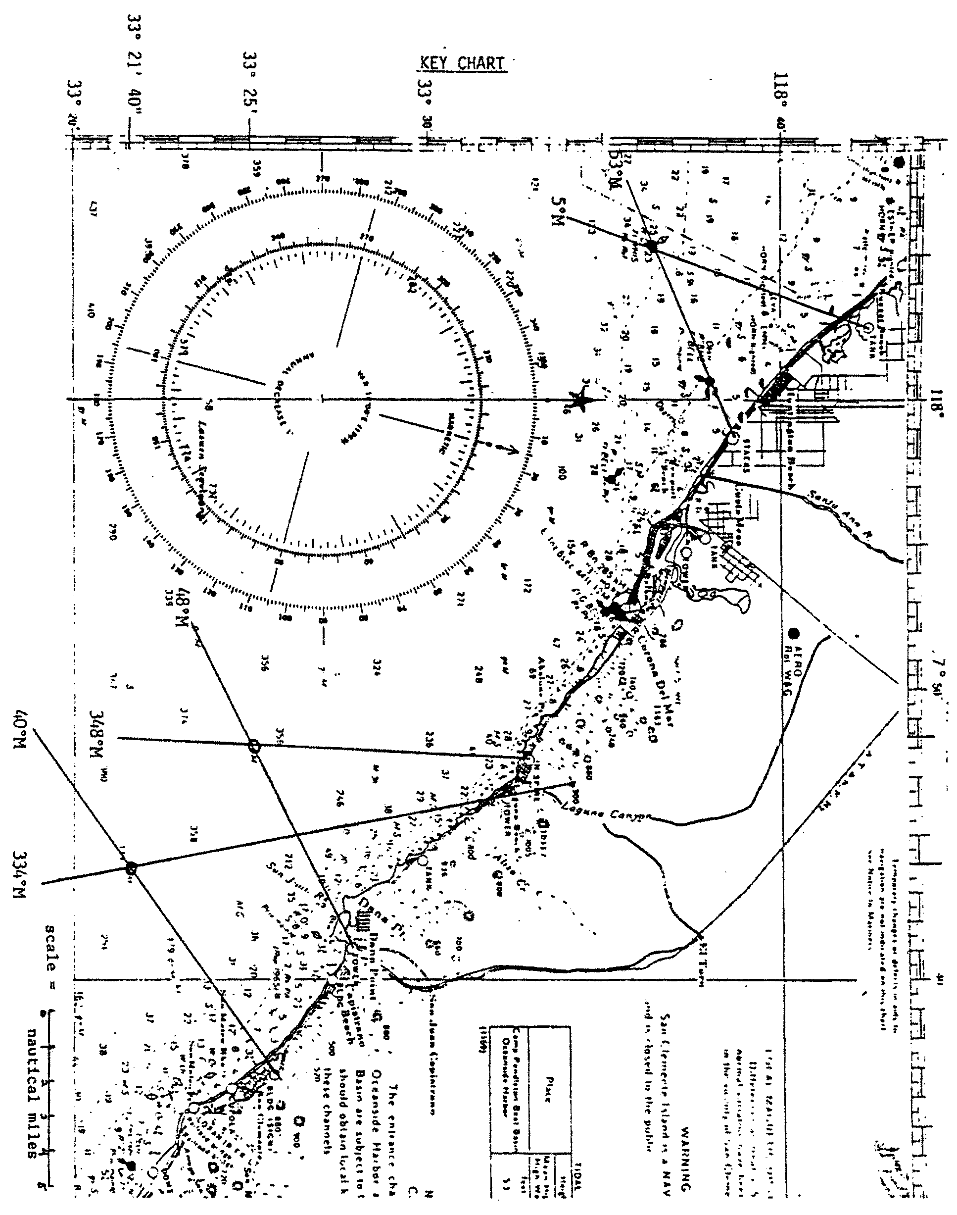

Hmmmm.... Where Did You Say We Were?
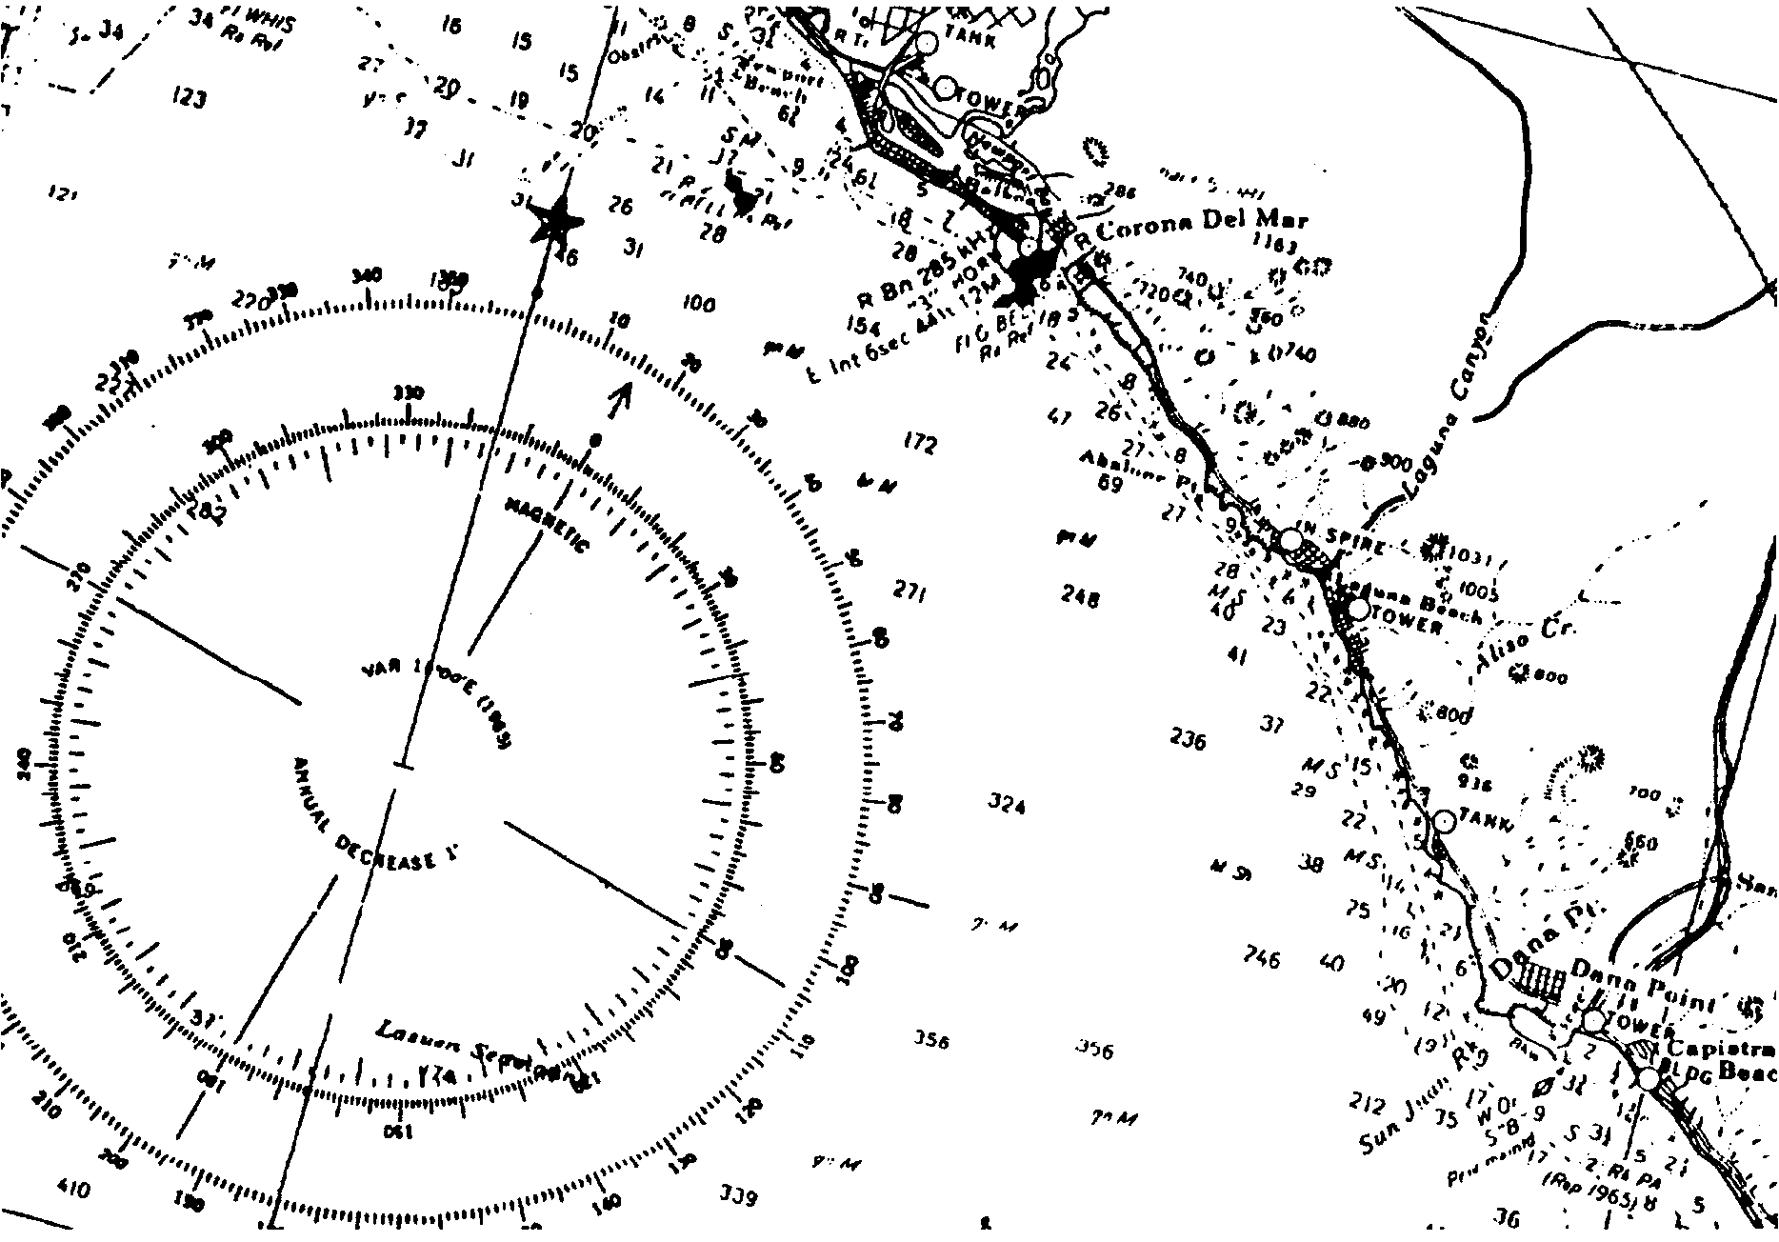
The Balaena is heading out for a day of whale watching. The skipper wants to check the boat’s location. He knows there are hazardous shoals near the harbor entrance. His hands are full in the pilothouse, so he asks Lea to help him. Her job is to find out where exactly the boat is on the water.

On land it is usually easy to figure out exactly where you are. Since roads, buildings, and mountain peaks are shown on maps, you can find your location relative to these features.

Finding your location on the ocean is more difficult. Out of sight of land, mariners use the stars, radio, radar and signals from satellites as guideposts. Most whale watchers sail in coastal waters. There, land is usually in sight. Near shore, aids to navigation and landmarks can generally be seen.

In “Follow That Whale!” you learned to read nautical charts. Now you will learn to navigate using landmarks visible from the boat.

Here’s what you need:
• chart showing a portion of the southern California coast
• a set of parallel rulers
• a pencil and an eraser.

Triangulation

The method Lea uses to locate the boat’s position is called triangulation. Two or more fixed reference points are sighted with a compass. Lines are then plotted on a nautical chart using these compass bearings. Her position is the point where the lines cross. Her two bearing points and her boat’s location point form the three corners of a triangle. This is why the technique is called triangulation. Let’s see how it works.

Lea’s first job is to take bearings from the boat. She uses a hand held compass. To do this, she holds the compass in one hand. Then, she points it at a fixed object and reads off the degrees. The objects she sights on and the compass bearings she reads are listed below:
Laguna Beach tower: 334 degrees
San Clemente Building (Sign): 40 degrees

Follow these steps below to find Lea’s position yourself:

1. Locate the compass rose on your chart. It has two scales. The star on the outer ring represents a reading of true north. The arrow on the inner ring points to magnetic north. Since your readings were made on a magnetic compass, use the inner ring.

2. Find the two compass bearings given above on the inner ring of the compass rose. Make a pencil mark on the compass rose for each bearing.

3. Place one edge of the parallel rulers on the compass rose. Line that edge up with the center of the rose and one of the bearings. Notice that the center of the rose is marked with a “+.” Draw a pencil line from the center of the rose through the bearing mark. Your set-up should look like the figure below.
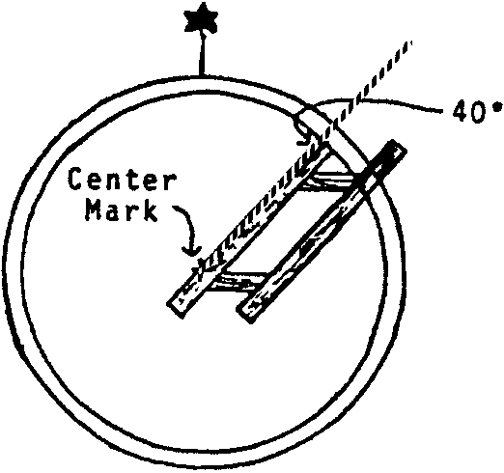

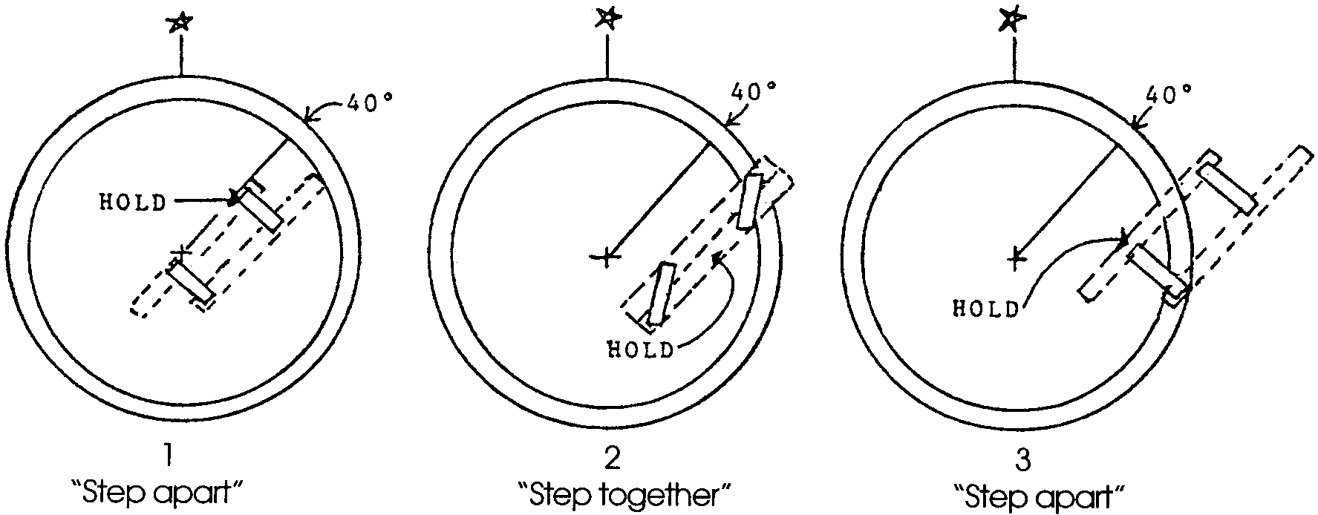
4. The rulers are now set for that bearing. Next, carefully “walk” the rulers to the reference point, San Clemente Building (Sign). To walk the rulers, hold the ruler on the center mark firmly in place. Move the other ruler toward the reference point. Then hold the ruler you moved firmly in place and move the other ruler up to it. By repeating this step you can “walk” across the chart while still maintaining the correct compass bearing. The drawing below shows you how.

Always hold one ruler in place. If they slip, you must start over again at the compass rose.

5. Stop when the ruler is lined up with the reference point. Then, draw a line from the object back toward the position of the boat. This line represents the bearing taken with the hand held compass. The line should be parallel to the line you marked on your compass rose. (Why? Because it passes through the object at the same angle to magnetic north as the compass reading.) The position of the boat must be somewhere along this line. Your chart should look similar to the drawing below.
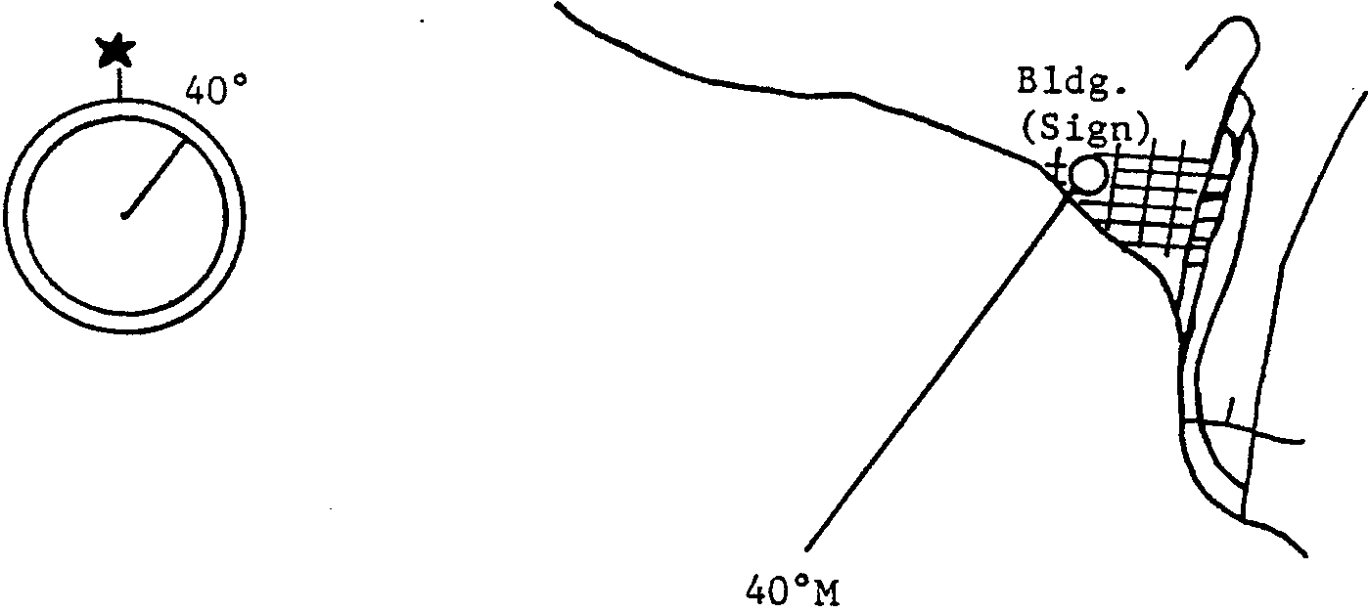

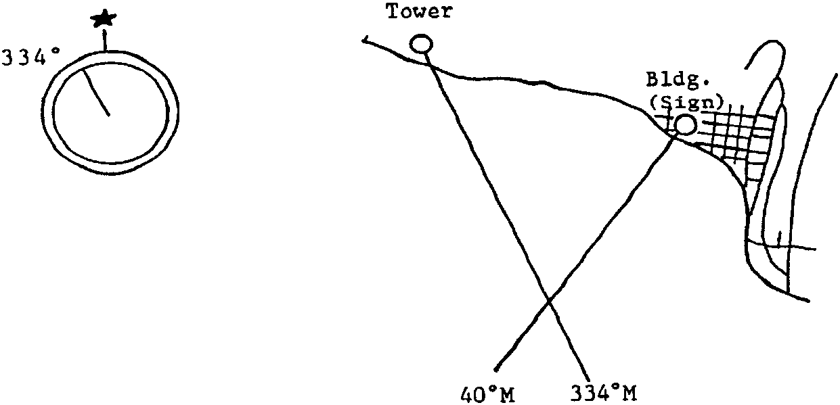
6. Where is the boat along the line? Here’s how to find out. Repeat steps 4 and 5 for the second compass bearing. Hey, the boat must be on that line, too. Since the boat must be located on both of the lines, its exact position is the point where the lines cross. Your chart should now look like the one below.

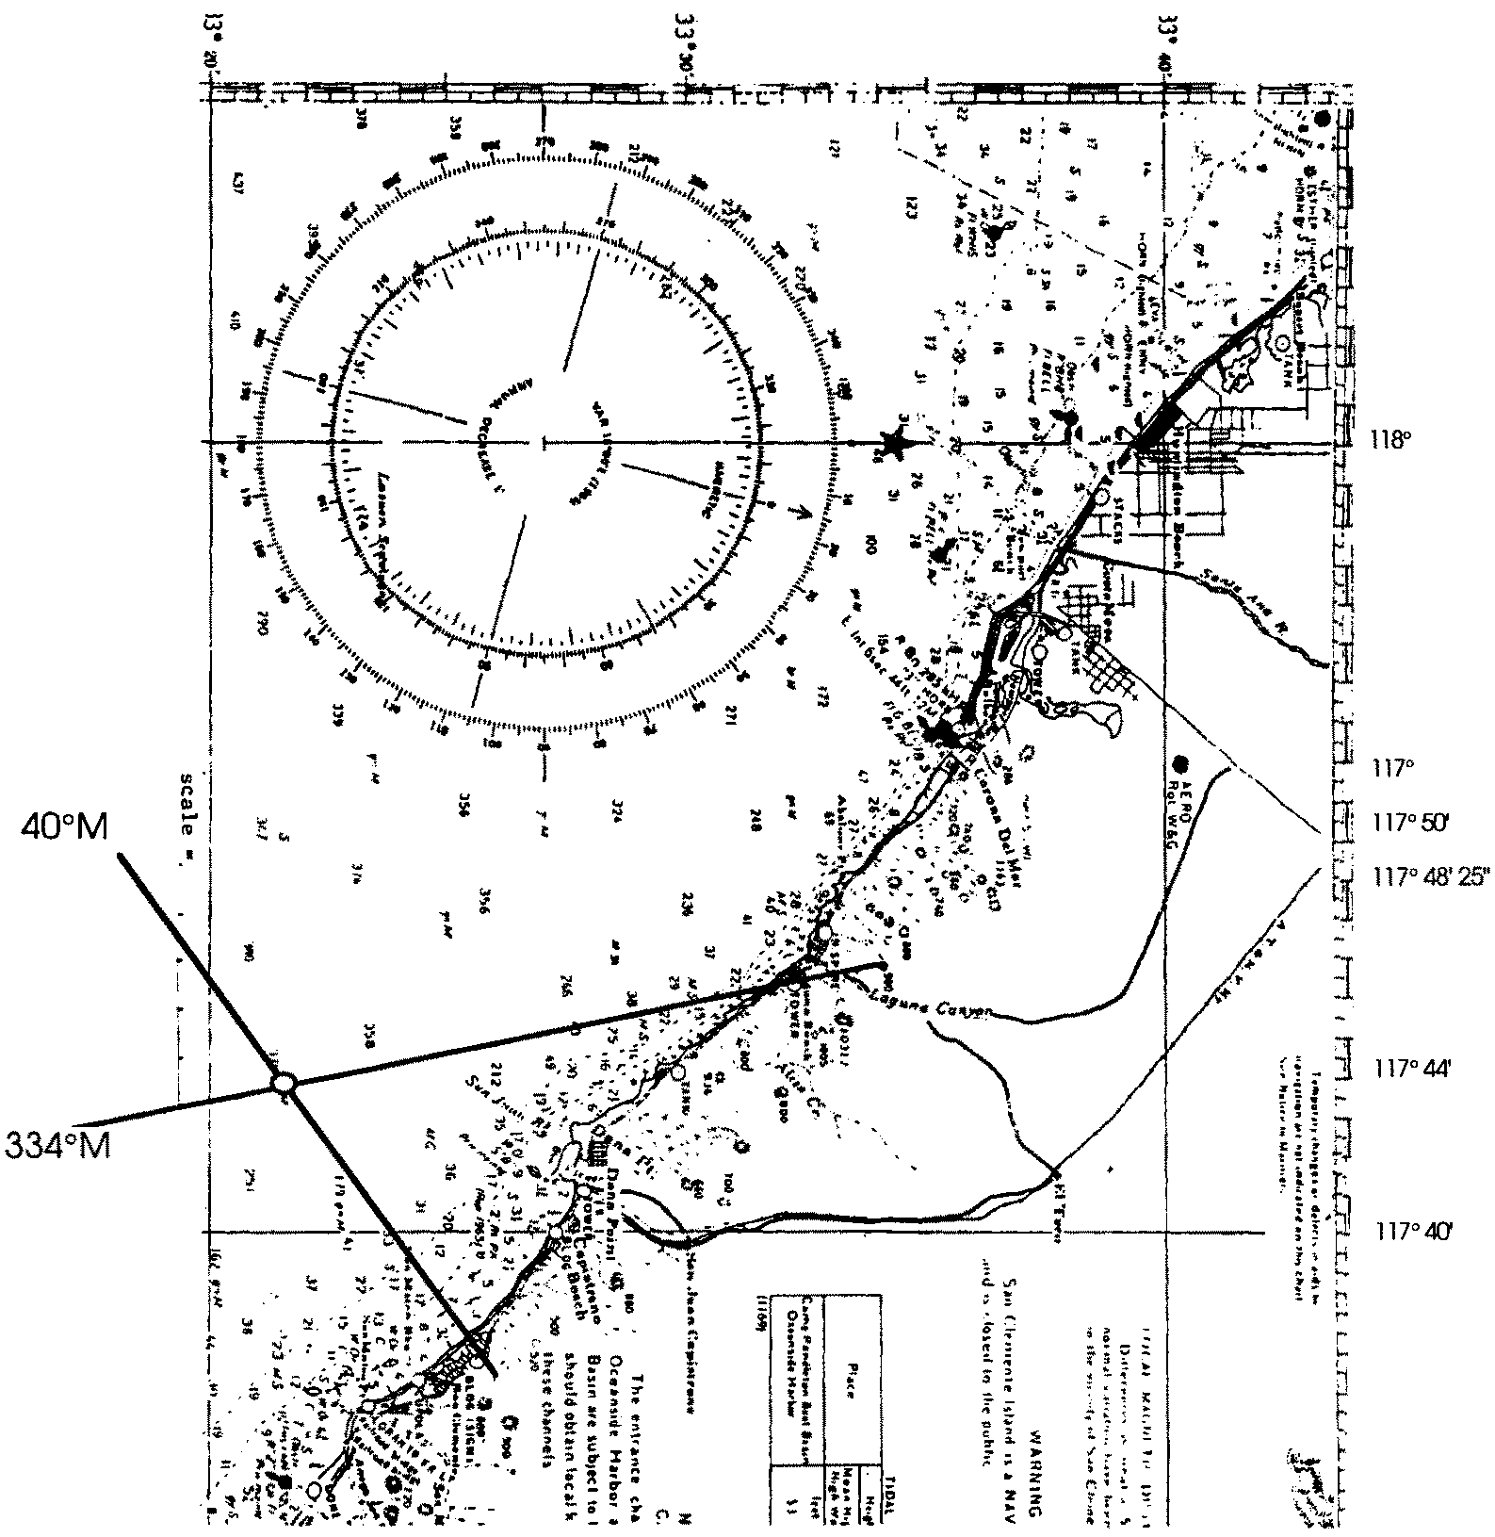
7. The latitude and longitude of this point can be determined. You’ll need to refer to the scales that run along the edges of the chart.

In the space below, record the exact latitude and longitude of the boat.
(Remember to record latitude first and indicate north (N) because you are north of the equator. Then record the longitude next and specify west (W) because you are west of the prime meridian, which passes through Europe.)

latitude

longitude

Lea takes more bearings throughout the day. Plot her location on the chart.

8. The boat is on the water somewhere in the area on the chart. Lea takes two compass bearings:
N. Spire at Laguna Beach: 348 degrees
Dana Point tower: 43 degrees

Plot her location on the chart, and then record the exact latitude and longitude in the spaces below.

latitude

longitude

Here are two more problems to help you sharpen your triangulation skills:

9. The Balaena has just spent an exciting day on the water watching whales. It is now at the white and orange whistle buoy off of Huntington Beach.

a. What is the compass bearing from this location to the tank at Sunset Beach? Record the bearing in the space below.

Tank at Sunset Beach:

b. What is the compass bearing from there to the stacks between Costa Mesa and Huntington Beach? Record the bearing in the space below.

Stacks between Costa Mesa and Huntington Beach:

Plotting a Course

The crew of the Balaena begins to think about the next day of whale watching. The skipper asks Lea to plot the course they will take on the chart. The method is similar to triangulation. A course is simply a line drawn on a chart. It is drawn between where you are and where you are going. For example, the skipper heard of whale sightings near Sunset Beach. The Balaena wants to follow a course from Laguna Beach to Sunset Beach. They need to leave the shore at Laguna Beach. Then, they need to turn and head northwest. Eventually they must turn their boat toward shore to dock at Sunset Beach. Draw the next day’s course on your chart.

Now, you can plot their course by doing the following:

a. Line up one edge of the parallel rulers with their first leg. The first leg is the straight section of the course from Laguna Beach. Draw a line along the edge. Your set-up should look something like the picture below.
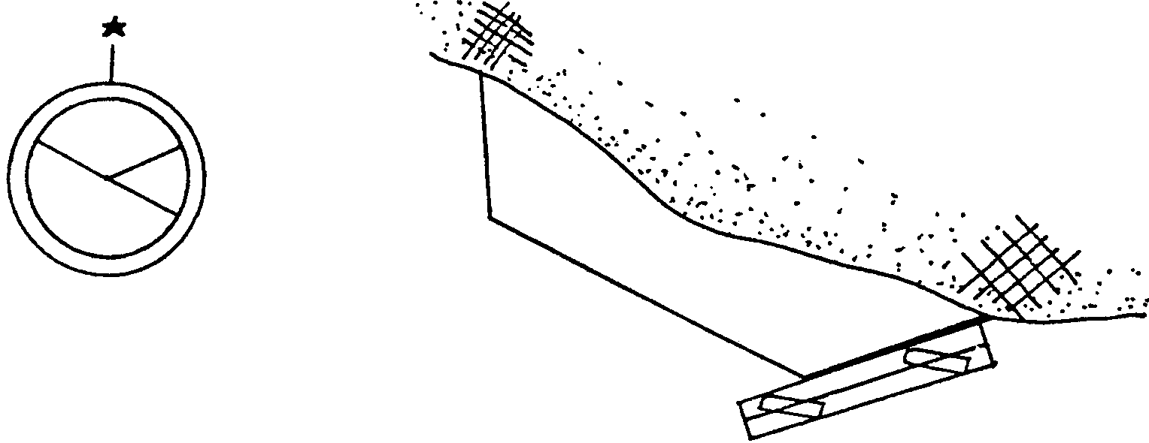

b. Walk the rulers over to the compass rose.

c. Line the edge of the ruler up with the center of the rose. The ruler should now cross the inner (magnetic) ring of the rose at two points. From the center of the compass rose draw a line through the bearing degree in the direction the boat will be traveling.

Read the bearing, in degrees, where this line crosses the magnetic compass rose. This bearing is called the heading. It is the direction on the boat’s compass that the skipper must follow for the first portion of the trip.

Write this compass heading on the course line you drew on your chart. (Remember, this course line is called the first leg of the voyage.) Also, record the heading in the space below.

First leg of course:

d. Repeat steps (a) through (c) for the other legs of your course. Record the heading on the chart and in the spaces below.

Second leg:

Third leg:

e. Now we know the directions. But how far should we go in each? Here’s how to tell how far the boat must travel on each leg of your course. On the water distances are measured in nautical miles. (A nautical mile is a bit longer than a “land” mile.) All you need to know is that one minute of latitude equals one nautical mile. The latitude scale is shown on the left and right sides of a nautical chart. Find the minute interval (the smaller units between degree units) from the latitude scale. Use the minute interval as your unit of measure.

Measure the length of each course leg using a ruler. Convert the lengths to nautical miles using the latitude scale. Record the distances below.

Distances:

First leg: nautical miles

Second leg: nautical miles

Third leg: nautical miles

11. Challenge Problem: Now you’re in trouble. The fog has suddenly rolled in. You cannot see any reference points. What can you do? How might you determine your position?

Parallel Rulers

Parallel rulers are a useful navigation tool. You can make your own using this pattern.

You will need:
• pattern
• medium cardboard, posterboard, or railroad board
• 4 round head fasteners
• scissors
• hole punch

Directions:

1. Mark all pattern pieces on medium cardboard. Be sure to include the “UP’s” and letters.

2. Cut out the four pieces.

3. Punch out the eight marked holes.

4. Assemble the parallel rulers by placing a round head fastener through each pair of holes (A-A, B-B, etc.)

5. Your finished product should look something like the picture below.

