Follow That Whale!

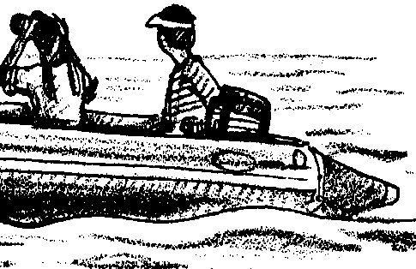
Key Concepts
1. Nautical charts provide important information which enables the navigator to determine position, distances, depth, submerged features, and natural and manmade landmarks.

Background

The ability to read and understand a nautical chart is an essential skill for all who work on the water. For all the information one needs to safely pilot a boat from point to point, the chart is an indispensable guide.

Nautical charts contain a wealth of information. The symbols and abbreviations included in the activity represent but a small part of those in use on charts. For a more complete listing of the symbols and a comprehensive treatment of charts and navigation, the following reference is recommended reading:

Chapman, Charles F. Piloting, Seamanship and Small Boat Handling. Motor Boating and Sailing Book Division, The Hearst Corporation, New York. Latest edition.

The information given on nautical charts is accurate as of the edition date. Any changes in the information since that date are described in the publication, Notice to Mariners, available through the Coast Guard.

There are four types of charts commonly published:

Sailing charts (usually on a scale of 1:1,200,000) cover large areas of coastline and are designed for offshore navigation.

General coast charts (1:400,000 or 1:200,000) are for vessels navigating larger areas of the coast.

Coast charts (1:80,000) are for navigators entering bays, harbors, or navigated inland waterways.

Harbor charts are large scale charts (1:20,000). These show the most detail and are best suited for local coastal navigation.

Most charts are published by the National Ocean Service (N.O.S.). This agency publishes chart catalogues which you can use to select the best chart for your needs.
Materials

For the class:

• nautical charts, posted on walls or otherwise accessible to students

For each student:

• portion of nautical chart, Southern California
• pencil
• ruler

Teaching Hints

In “Follow That Whale!” students are introduced to navigation and piloting. The activities which follow rely on student access to navigational charts. Charts can be purchased at most marinas and marine supply stores. These chart dealers usually have National Ocean Service chart catalogues for distribution or at least one copy you can look at when selecting your charts. Chart information is also available from National Ocean Service, Rockville, Md. 20852.

Nautical charts tend to be expensive. A good way to get old charts to use as instructional aids for your class is to ask the manager of a marine supply store to save his copies of out-of-date charts. To get his money back for unpurchased charts, he simply tears off a corner of the charts and sends the corners in. Instead of throwing away the rest of the chart, the manager can give it to you for class use. You can also purchase training charts (Chart 1210Tr) from the N.O.S. that are intended for instruction in chart use.

Duplicate the activity pages. One set is recommended per student. This activity is best accomplished by individual students or pairs of students as an in-class assignment. Post a variety of nautical charts on the walls of your room or distribute to student work stations. Students will need access to charts to answer the introductory questions. Be available to explain the nuances of the charts to your students. Upon completion, plan to devote some time to a discussion of the concepts presented and the questions asked in this activity.

If you are using “Voyage of the Mimi” in conjunction with this unit, “Episode 3: On The Shoals” correlates well with this lesson.

Key Words

aids to navigation - buoys, signs, and other markers placed to aid in navigators avoid hazards on the water

buoy - an anchored float for marking a channel or a navigational hazard

chart - map used in navigation

compass rose - the part of a nautical chart which allows the chart to be aligned with true and magnetic north

course - the path or direction in which a boat moves

degree - a unit of angle, equal to 1/360 of a circle. In navigation, a unit of latitude or longitude.

fathoms - a unit of depth equal to 6 feet

landmarks - visible locations on land that can be used for orientation

magnetic north pole - the site in the arctic at some distance to the true north pole, which attracts the needle of the compass

margin - border

Mercator projection - a map which depicts the earth or a portion thereof as a rectangle, with longitude lines parallel

minutes - in navigation, 1/60 of a degree of latitude or longitude

nautical mile - a unit of distance used in navigation equal to 6,080 ft.

navigation - the act of directing the course of a ship over the water

scale - the ratio of distances on a map or chart to the corresponding

seconds - in navigation, 1/60 of a minute of latitude or longitude

sounding data - information on the depth of a body of water

true north pole - the northern point of the earth which lies on the earth’s axis of rotation

Answer Key

Part 1: Chart Reading Basics

1-7. Answers will vary depending upon the information on the charts the students are using.

8.a. The degree reading found where the magnetic north line passes through the true compass rose is 348 degrees.

b. Magnetic north is 12 degrees west of true north.

c. The compass rose shown has a variation of 12 degrees West.

Part 2: Navigating the Waters of Southern California
See “Key Chart” for answers to many questions in the sections which follow.

9. Land areas are usually shown in yellow. The word yellow appears on the Key Chart which follows this section.

10.a.-c. The structures are correctly circled on the Key Chart.

11. The degrees of longitude and latitude for Huntington Beach are:
118 degrees, 0 minutes longitude
33 degrees 40 minutes latitude

12.a. If the students’ charts were colored, the shallow water would be colored light blue.

b. The greatest depth (437 fathoms) is circled on the Key Chart. It is found in the lower left corner. The depth in fathoms is 437, and in feet is 2622.

13. The aids to navigation mentioned are circled on the Key Chart.

14. The note to mariners, which is circled on the Key Chart, warns people that San Clemente Island is closed to the public.

Part 3: Setting Sail
15. Any number of courses may be drawn between Laguna Beach and Sunset Beach. A typical course is shown on the Key Chart. The aids to navigation and landmarks for the typical course are shown below:

Start: Laguna Beach

LandmarksAids to Navigation

N. SpireFlG Bell Buoy - Corona del Mar
Radio Tower - Corona del MarFl Bell Buoy - Costa Mesa
Tower - Costa MesaObstrs R “8HB” Fl Bell Buoy -
Tank - Costa MesaHuntington Beach
Stacks - Huntington BeachW Or Fl Whis Buoy - Huntington Beach
Tank - Sunset BeachEMMY Horn - Huntington Beach
EVA Horn - Huntington Beach
ESTHER Horn - Sunset Beach

End: Sunset Beach

16. The total distance covered in the typical course shown on the Key Chart is 21.2 nautical miles (at the scale of the chart, 5/16" equals one minute of latitude). Your students’ answers will vary depending upon the particular course.

17. The red starboard-hand buoy with a flashing-light, bell and radar reflector shown on the chart is off of Costa Mesa. Three landmarks that might be used to help find the location are:
a. Tower - Costa Mesa
b. Tank - Costa Mesa
c. Stacks - Huntington Beach

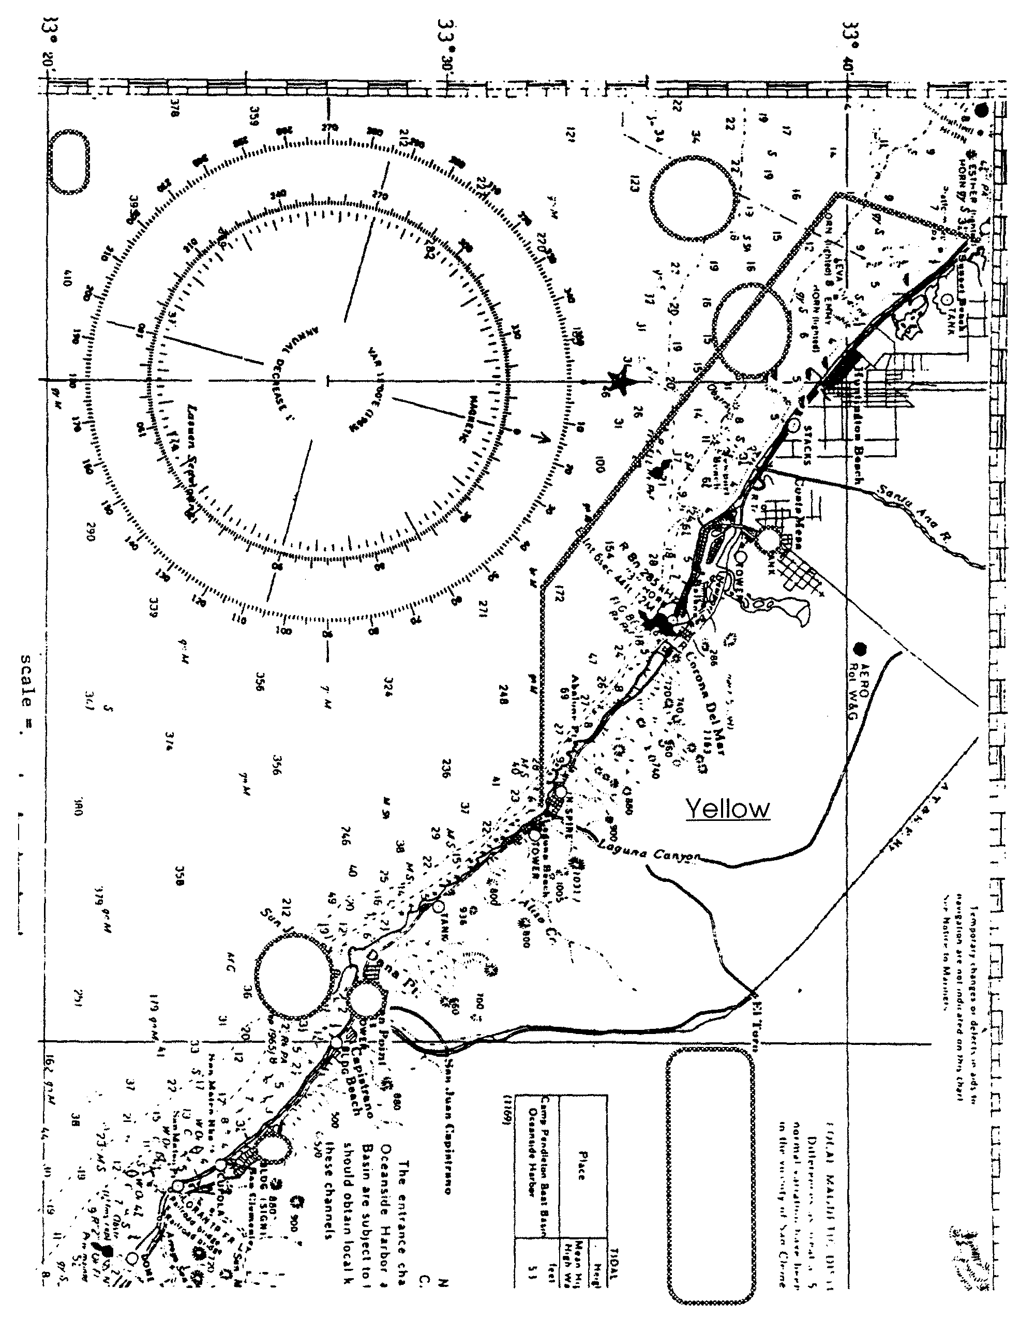
Key Chart

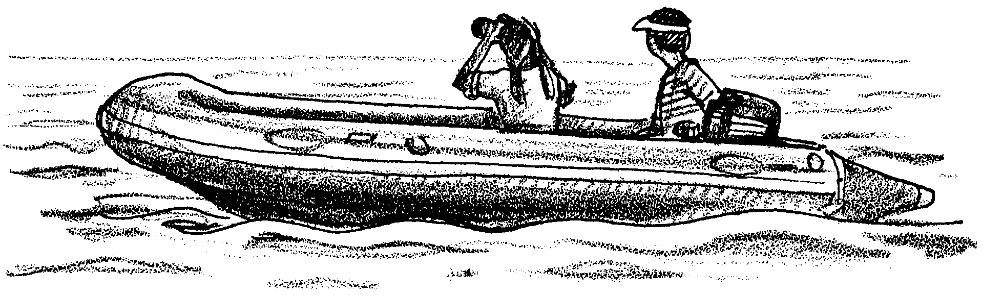
Follow That Whale!

So, you want to become a whale watcher. Before you venture out on the ocean, there are a few things you should know. Traveling on the ocean can be treacherous. Beneath the surface of the water lie jagged rocks, waiting to rip holes in the bottom of your boat. The water surface is in constant motion. The water looks the same from place to place. It is very easy to get lost. Nautical charts, road maps of the ocean, can help you plot a safe and accurate course. In the following activity, you will have a chance to see some of the types of information found on a chart.

A nautical chart has several sections. Each section contains valuable information. Most charts have four important parts: the title block, the outer margin, the compass rose and the main area of the chart.

Part 1 - Chart Reading Basics

Title Block

The title block gives you general information about the chart. Look at one of the complete charts provided for your use and record the following information:

1. Name of the chart
(This tells you the general area covered by the chart).

2. Projection of the chart
(This is found in the title block directly below the name of the chart.) A chart displays the round surface of the earth on a flat piece of paper. There are a variety of ways to represent the earth. All of the ways distort the true picture in some way. For charts, the most common projection is the Mercator. A Mercator projection displays the earth’s surface as though it were projected onto a narrow cylinder.
3. Scale of the chart
(The amount of detail a chart shows is indicated by its scale. The scale is the ratio of the size of objects on the chart to the actual size of the same objects. For example, assume the scale is 1:20,000. This means that things will appear 1/20,000 times smaller on the chart than they are in life. An island two kilometers (200,000 centimeters) across will be ten centimeters on the chart (200,000 cm x 1/20,000 = 10 cm))

4. How big would a five kilometer island appear on the same chart? Complete the equation below.

( cm x 1/ = cm)

5. Sounding data. The chart is covered with numbers that tell the depth of the water. The information on depth in the title block tells the unit of depth.

Soundings in
(Feet or fathoms?)

The second part of the sounding data tells if the depths were measured at low tide, etc.

The Outer Margin
The outer margin (edges) of the chart also contains important information. Use the chart you examined in number 1 above to record the following information:

6. Chart Number
(This is the number you would use to reorder the chart.) Numbers of the charts that cover the area next to the area of your chart are also given in the margins. In the space below, record the numbers of the charts that cover the areas next to your chart.

Chart Number:

Chart Number:

Chart Number:

Chart Number

7. Edition of the Chart
(This is the date of the latest revision of the information found on the chart.) Any changes in the coastline, or aids to navigation that occurred after the edition date are not on the chart. For this reason, always use the most recent charts.

The Compass Rose
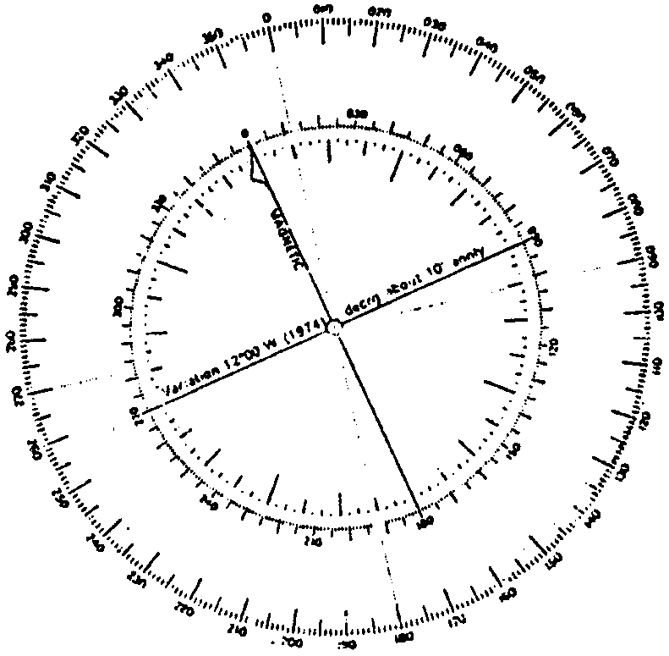
The Compass Rose is shown below. The rose is used as an aid in determining position on the water. Both the inner and outer ring of the rose are marked off in degrees. The star on the outer ring points toward the true North Pole. The arrow on the inner ring points toward the north magnetic pole.

8. On the compass rose above, notice that the magnetic north pole and the true north pole are not the same. Use your ruler to extend the magnetic north line through the true compass rose (the outer ring).

a. Record the degree reading where the line crosses the true rose:

b. On the true rose, 270 degrees is west. Count the number of degrees magnetic north is to the west of true north (each mark is one degree). Record the number of degrees:

c. This difference between magnetic north and true north is called variation. The compass rose shown above has a variation of degrees west. Notice that this variation is also written on the compass rose.

The Main Area of the Chart
The main area of the chart contains the information most important for safe navigation. The chart represents an area of the earth’s surface. It tells you how deep the water is and where it is unsafe to travel. It also tells where there are man-made aids to navigation, and much more. To begin using this part of the chart, move on to Part 2.
Part 2 - Navigating off Southern California

Obtain a copy of a portion of a navigation chart for southern California. On the other charts in the classroom, notice that land areas are shown in a different color than water areas.

9. On the land area of your small chart, write in the color used to show land areas.

10. Major towns and distinctive land marks are shown on the chart. The landmarks can serve as aids to help boaters locate their position. On your chart, locate and circle the following:
a. the water tank in Costa Mesa
b. the tower at Dana Point
c. the building with a sign in San Clemente

11. The chart is crisscrossed with a series of vertical and horizontal black lines. The vertical lines represent the imaginary north/south lines of longitude that encircle the earth. The horizontal lines represent the imaginary east/west lines of latitude that encircle the earth. These lines are labeled in degrees, minutes and seconds (l degree = 60 minutes; 1 minute = 60 seconds). The symbol for degrees is written °. The symbol for minutes is written ', and seconds is written ". On your small chart, locate the longitude and latitude lines that intersect (cross) at Huntington Beach. Record the degrees of longitude in the spaces below:
degrees, minutes longitude
degrees, minutes latitude

12. Boaters must be aware of water depth. The depths are indicated for various points in the water portion of the chart.

a. If your chart were colored, which would be colored light blue: deep or shallow water? Circle the correct answer. (Hint: look at the charts posted in your classroom.)

b. The depths on your chart are in fathoms. One fathom is equal to six feet. Circle the greatest depth shown on your chart.

Record the depth in fathoms: and
in feet:

The Coast Guard and other agencies place and maintain aids to navigation. These aids include horns, bells, light houses and various kinds of buoys and markers. Buoys are anchored floats.
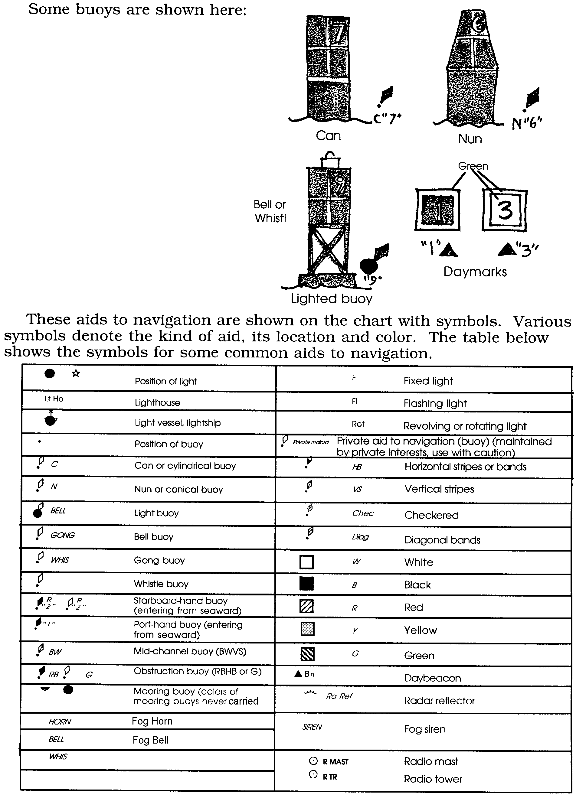
)
13. Using the table above, locate and circle the following aids to navigation on your worksheet chart:

a. a white and orange light buoy, with a flashing light and whistle, off of Huntington Beach.

b. a privately maintained red and black horizontal banded obstruction buoy, with flashing light and bell, near Huntington Beach.

c. a white and orange privately maintained buoy, marking the entrance to the breakwater at Dana Point.

14. Charts also provide information about special hazards, such as submerged rocks or the type of materials which make up the bottom (sand, mud, etc.). Notes of special interest are included on many charts. For example, the note below describes regulations for areas where submarines travel underwater.

Boundary limits of Submerged Submarine Operating Areas are shown by a solid magenta line. As submarines may be submerged in these areas, vessels should proceed with caution. During torpedo practice firing, all vessels are cautioned to keep well clear of Naval Target Vessels flying a large red flag at the highest masthead.

a. A portion of a note involving a Naval Reserve on San Clemente Island is included near the right edge of your chart. Circle the note.

b. What does the note warn people about?

Part 3 - Setting Sail

As captain of the Beluga you are sailing out of Laguna Beach bound for Sunset Beach.

15. Use a pencil and ruler to draw your course on your chart. Then, in the space below, list all landmarks you might use for navigation. Also list all aids to navigation as you pass on your way.

START: Laguna Beach

Landmarks Aids to Navigation

FINISH: Sunset Beach

16. On your chart every minute of latitude equals one nautical mile. For example the distance from 117 degrees 40' to 117 degrees 50' is ten nautical miles. Use your ruler to estimate the total distance you will have covered from Laguna Beach to Sunset Beach. (Hint: What unit on your ruler is the same as one minute of latitude?)

17. In your cautious pursuit of a gray whale you find yourself near a red starboard-hand buoy with a flashing light, bell and radar reflector. What are three landmarks you might use to help find your location?

a.

b.

c.
