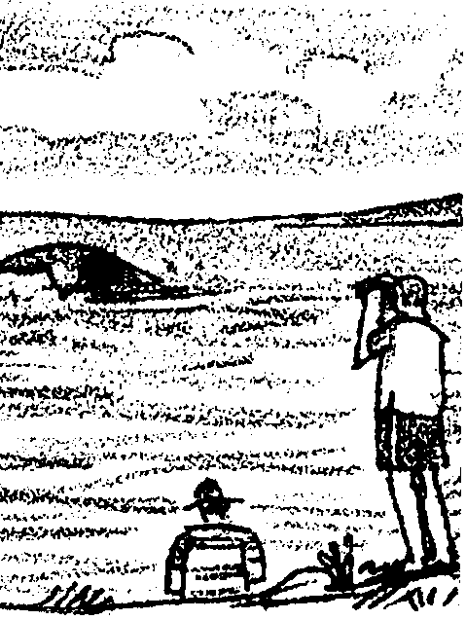
Whale Watching - December 10

Key Concepts
1. People enjoy observing whales, but it is important to avoid intrusive activities which would disturb their natural behaviors.
2. With careful observation, it is possible to identify whales by characteristics visible as they come to the surface to breathe.

Background

The regular migration of the California gray whale along the west coast of the United States is followed by millions of people. Because their migration brings them so close to shore, California gray whales are an especially easy species to watch.

Whales continue to be a source of enormous fascination for people of all ages. It seems likely that the current popular interest whales is only enhanced by the ease with which we can satisfy our curiously about them, through marine mammal exhibits, educational programs, and of course seeing whales in the wild. It might be argued that to keep up the public support for policies which protect marine mammals, experiences such as these are invaluable. Yet contact with people can be extremely stressful for the whales themselves. It is clear that certain kinds of watching disturb the whale.

For this reason, the National Marine Fisheries Service has developed guidelines for watching whales which minimize the likelihood of harassment. Most commercial whale watch boats are now operating well within these guidelines, however there is still the potential for intrusive behavior by boaters unaware of this problem. It would be a shame if we loved the whales to death! The guidelines we present in this activity are still being studied and revised as scientists and whale watchers try to determine the least disruptive techniques for observing whales in their natural habitat.

For more information on whales and whale watching:

Osborne, R., Calambokidis, John, & Dorsey, Eleanor M. 1988. A Guide to Marine Mammals of Greater Puget Sound. Island Publishers, Anacortes, WA.

Nickerson, Roy. 1977. Brother Whale - A Pacific Whalewatcher’s Log. Chronicle Books, San Francisco. An interesting account of watching the Humpback whale.

Oxenhorn, Harvey. 1990. Tuning the Rig - A Journey to the Arctic. Harper and Row, New York. An account of a whale research voyage aboard a square rigger along the east coast of Canada into the Arctic.

Bullen, Frank T., First Mate. 1897. The Cruise of the Cachalot - Around the World in Search of the Sperm Whale. Grosset and Dunlap, New York.

Materials

For each student:

• “Whale Watching - December 10” student text pages

Teaching Hints

In “Whale Watching”, students are confronted with the dilemma: whale watchers are more inclined to support efforts to protect whales from hunting but the presence of whale watchers may have negative effects on whales. The recommended procedures for observing whales are revealed as students learn how to identify whales.

Ask if students have ever seen whales in their natural habitat. If so, have students describe their experiences.

Introduce the dilemma of whale watching. Have students brainstorm the benefits that may come from people being able to witness whales in their natural habitats. Then brainstorm the possible negative impacts whale watching might have on the whales themselves.

Given that students will not know how whales feel about humans intruding into their migration route, ask them to speculate on what are some signs the whales might give that observers are too close. Have them suggest some guidelines for whale watching that might minimize the stress on whales. Perhaps they can also suggest possible ways to study the issue.

Assign the student reading and follow it with brief discussion of study questions. While this activity may be best accomplished by individual students as homework or as an in-class assignment, it can also be completed by pairs or small groups of students working together.

If you are using “Voyage of the Mimi” in conjunction with this unit, “Episode 2: Setting Sail” correlates well with this lesson if you have not used it previously.

Key Words

blow - the visible mist or spray seen above the water as a whale exhales

flukes - a whale’s tail fins

guidelines - recommended practices

harass - to disturb

pod - group of whales traveling together

Extensions

1. If you live along the west coast of the United States, you can give your students an unforgettable experience by taking them whale watching. Gray whales are most likely to be spotted during their northern migration between early March and late May. From land, high cliffs or bluffs are the best places to view migrating whales which may be seen from just outside the breakers out to several miles offshore. The list below gives some recommended areas for observing migrating gray whales. Whale watching boat trips are also a popular way to observe whales. Contact the Chamber of Commerce in the locations noted below to find the names of organizations which run whale watch tours.

MEXICO
Baja California:
Coronado Islands
Punta Banda (Ensenada)
San Martin Island
Santo Tomas Point
Scammon’s Lagoon
Magdalena Bay
Cabo San Lucas

UNITED STATES
California:
Northern California river mouths
Point Reyes National Sea Shore
Fort Ross State Historic Monument
Point Lobos State Reserve
Monterey/Carmel Area
San Simeon
Morro Bay
Montana do Oro State Park
La Jolla
Cabrillo National Monument San Diego
Oregon:
Astoria
Columbia River, as well as all other river mouths
Seal Rocks

Washington:
La Push
Moclips
Neah Bay
Olympic National Park
Queets
Westport

CANADA:
Queen Charlotte Islands (west coast)
Vancouver Island (west coast): Provincial State Park at Long Beach (A few non-migrating whales are present here the year around.)

2. Invite a speaker to your classroom from the National Marine Fisheries Service who is involved with enforcement of the Mammal Marine Protection Act. Have the guest discuss this piece of legislation and explain why there are such stringent regulations governing all contact with marine mammals. As this agency is also the repository of confiscated pelts, bones and teeth of marine mammals, you might suggest that the speaker bring along representative samples for students to see and possibly handle.

3. If you live in an area where whale watching occurs and your students are concerned over the issue of marine mammal harassment, you might involve them in one or more of the following projects:

• Make posters on respectful whale watching guidelines which can be displayed in public places such as waterfront parks or marinas.

• Write and record short video or audio tapes about whales and suggest appropriate practices in observing them. Television and radio stations might be persuaded to play these tapes as a public service announcement.

• Design a bumper sticker, button, or a logo for a T-shirt or shopping bag which suggests respectful interaction with whales. If these products are sold at a profit, the proceeds might be used to take your class on a whale watching excursion or donated to a whale research or education organization.

Answer Key

1. Gray whales migrate very close to the coast of California, Oregon, and Washington, making it easy to observe them. In addition, they travel slowly during their spring migration, probably because of the presence of young calves.

2. The faint cloud is probably the whale’s blow or exhalation. The cloud is actually caused by the rapid expansion of warm, moisture-laden breath in the relatively cool ocean air.

3. Presumably the whales can maintain their distance if boats are not permitted to accelerate. Students might comment, however, that this provision does not make it easy for whales to avoid boats altogether.

4. Some whales do appear to be comfortable around boats, as evidenced by occasional approaches to boats made by whales.

5. The boat should be at least 100 yards from the whale.

6. This whale surfaced only 10 yards (30 feet) from the boat.

7. Answers may vary. Since this question calls for an opinion, accept any reasonable answer. Some students may recall that gray whales feed on the bottom and propose that deep dives are likely for foraging. Some deep dives are undoubtedly for this purpose, but foraging every three or four breaths would make the trip from Baja to the arctic interminably long. It is likely, that in some fashion, the deep dives afford easier or more efficient swimming.

8. The pod of small cetaceans are harbor porpoises.

9. The large mammal with a strange nose is a northern elephant seal.

10. The whale with the distinctive V-shaped blow is the right whale.

11. Answers may vary since students will have to speculate as to how information from observers like Lea might be helpful. Knowing where and how often marine mammals are sighted can give scientists one way of estimating movement patterns and population size of these animals.

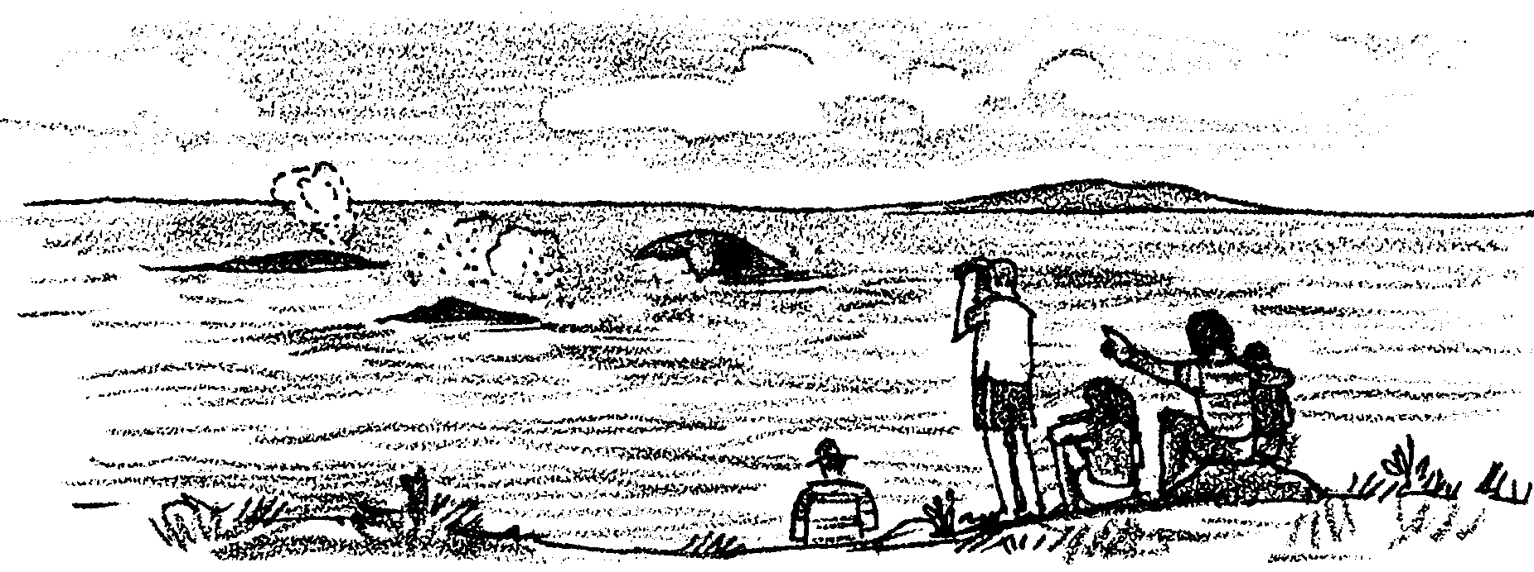
Whale Watching - December 10

December 10th

Swimming stronger now, our whales pass south of Santa Barbara. In these waters and all along the Pacific coast, California gray whales are some of the most watched whales in the world. Because they swim very near to shore, people can watch the Gray whale migration from on land or from boats.

1. Why is it so easy for people to watch the migration of California gray whales?

As the sun appears in the eastern sky, our whales pass San Mateo Point. They pay little attention to the Balaena, a sleek white boat leaving the dock at San Clemente. However the passengers on the Balaena will soon be paying plenty of attention to the whales.
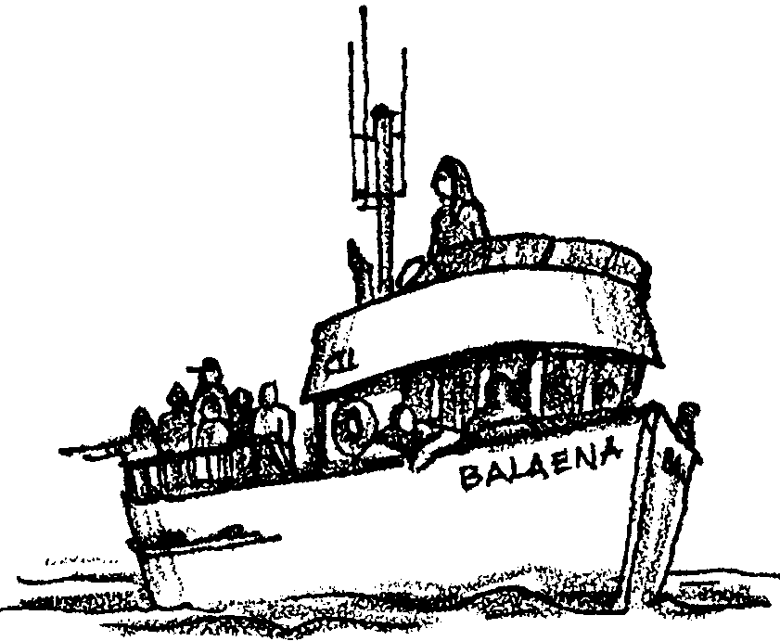
The captain turns the Balaena into deep water. On board, thirty people stand along the rails. Many different kinds of people take part in whale-watching tours. Today, the passengers are a seventh grade class. They look through their binoculars at the glassy, clear morning water.

The captain scans the surface. There is a flashing gleam of light and the water bulges slightly. A faint misty cloud hangs over the water as the hump disappears. No one has seen this whale surface but a young woman, Lea. She is perched above the pilot house, eyes on the water.
2. What probably made the misty cloud over the water?

Lea is the new intern on board the Balaena. She is a high school senior very interested in whales. She is exploring the career of a cetologist. Her teachers and the captain are helping. This month she is learning how to identify whales along the southern California coast.

Several hundred yards ahead, the surface of the water is broken. Then a distinct spout or “blow” appears. It is followed by a dark gray back. With a silent swirl, the tail flips into the water. Thirty pairs of eyes stare at the swirling water.

The captain sets his motor speed to no faster than the whale. The boat moves slowly toward the activity. He is following recommended guidelines for watching marine mammals from a boat. Unfortunately, not all boaters are this respectful. The captain often worries that whales are sometimes harassed by people eager to get a closer look.

Guidelines for Whale Watching Without Harassment

• Watch whales from the shore or from a commercial whale watch boat. Whale watching from private boats is not recommended.

• If you happen to see a whale while out in a boat, stay at least 100 yards away behind and off to its the side.

• Never approach whales at a speed faster than the slowest moving whale.

• Don’t make sudden changes in direction or speed which might startle them.

• Keep in mind that boats traveling too close to whales may hit them, interrupt their feeding, or cause them to try to flee. Acts of harassment are punishable by fines up to $10,000 by the National Marine Fisheries Service.

3. Why do you think boaters are asked to move no faster than the slowest moving whale?

A few seconds later, another whale blows. A dark form appears in the water. Thirty hands point at the spot. The captain puts his engine in neutral and the boat glides to a stop. The propeller stops turning. Still, the whales can still hear the sound of the idling motor. Perhaps the sound reassures them of where the boat rests. Sometimes a gray whale will approach a boat that is floating calmly this way on the water. The captain knows it is better for the whales if he allows then to approach the boat than if he moves his boat toward them.

4. Does it appear that some whales may be comfortable in the presence of boats? Explain your answer.

Thirty feet ahead the water bulges. Spray erupts from the dark surfacing body. The dark gray back arches. With her nose pointed downward, she begins her deep dive. The captain and his crew of whale watchers see her knobby back. Then, the 10-foot wide flukes rise into the air. The water cascades off the trailing edge as the whale disappears from sight. The thirty spectators watch in awe. As the last ripple disappears, they turn to each other in excitement.

The skipper engages the engine. He turns the boat slowly away from the whale. He knows the Balaena is much closer to this whale than the guidelines permit.

5. How far away is the boat supposed to be from the whale?

6. How many yards away was this whale when it surfaced?

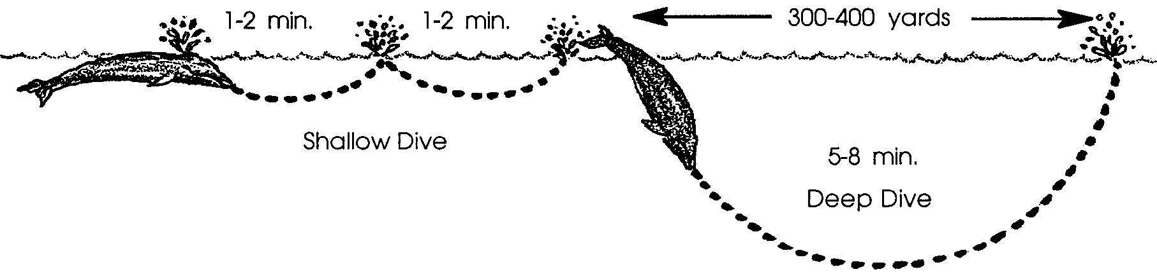
During the next three hours of whale watching the class on the Balaena learns a lot about gray whales. They notice that the pattern of surfacing is always the same. First the head and blow hole appear, then disappear. The back is then exposed. As the back submerges on deep dives, the flukes leave the water. Gray whales usually blow about three times before making a deep dive.

This circular motion helps explain how the whale got its name. The English term whale is linked to the Norwegian “hwal” and the Dutch “wal”. All three terms mean “wheel”. The spinning of a wheel and the swimming of the whale looked similar to early peoples.

7. Why do you think the whales are making deep dives every few breaths?

Lea checks her guide book. It shows her how to recognize whales of the Pacific. She looks at it carefully.

She decides that the whales they have seen that morning do appear to be California gray whales. Later in the day, however, she sees some other marine mammal species.

Use the guide below to help Lea determine which mammal she sees.

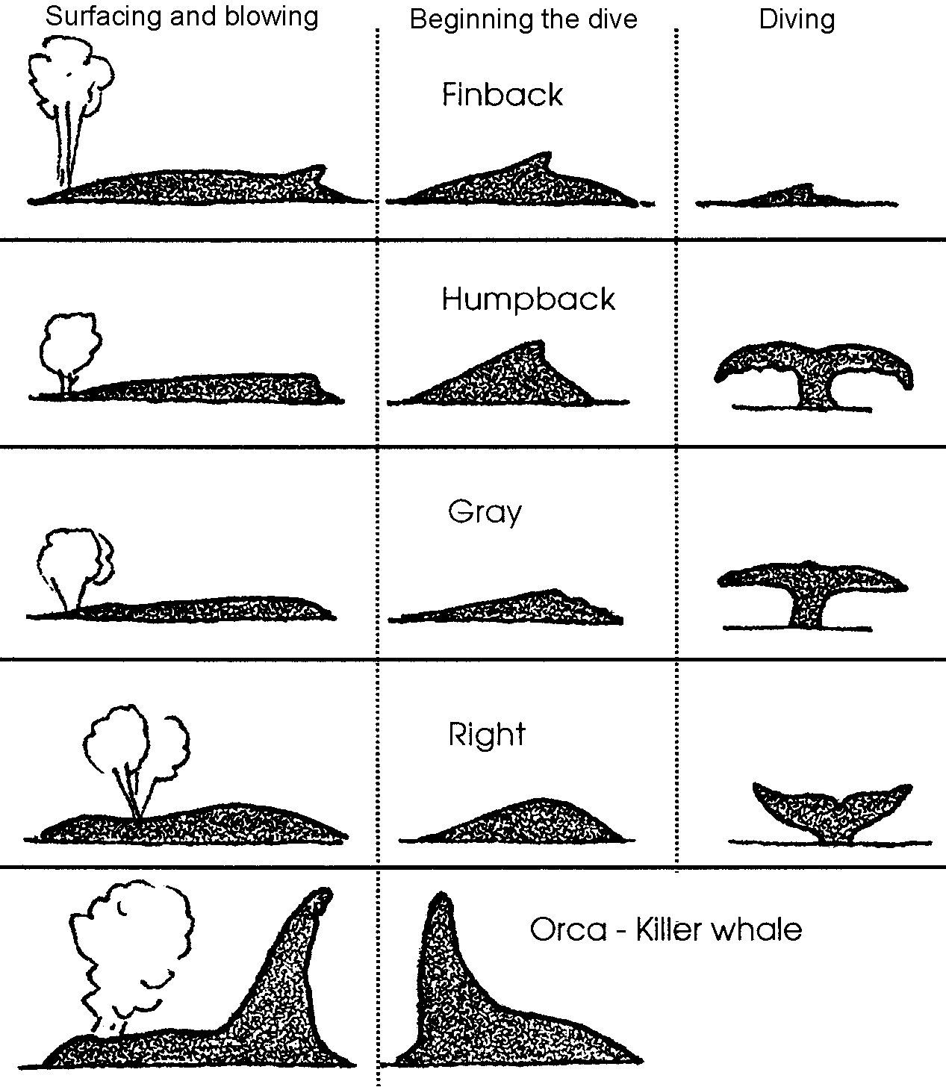
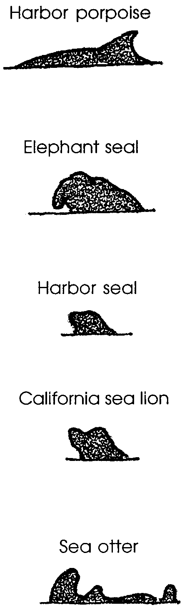

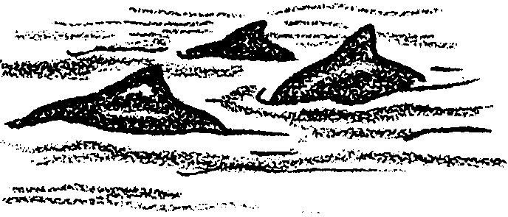
8. A pod of small cetaceans are sited off the port bow of the Balaena.

9. A large mammal with a strange nose surfaces near shore.
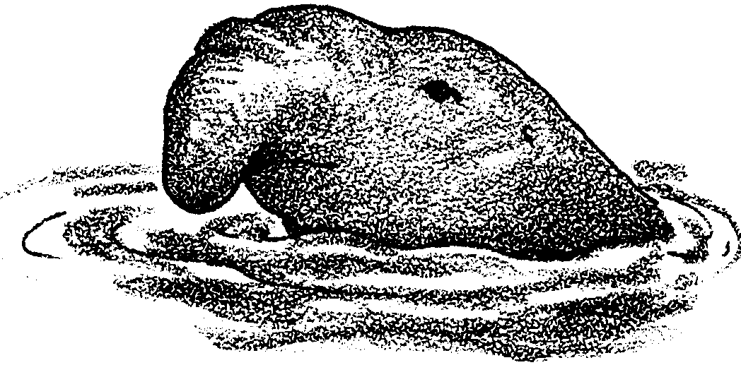
10. Lea notices that one of the whales in the guide has distinctive V-shaped blow. She watches for this whale but doesn’t see it. Which whale is this?

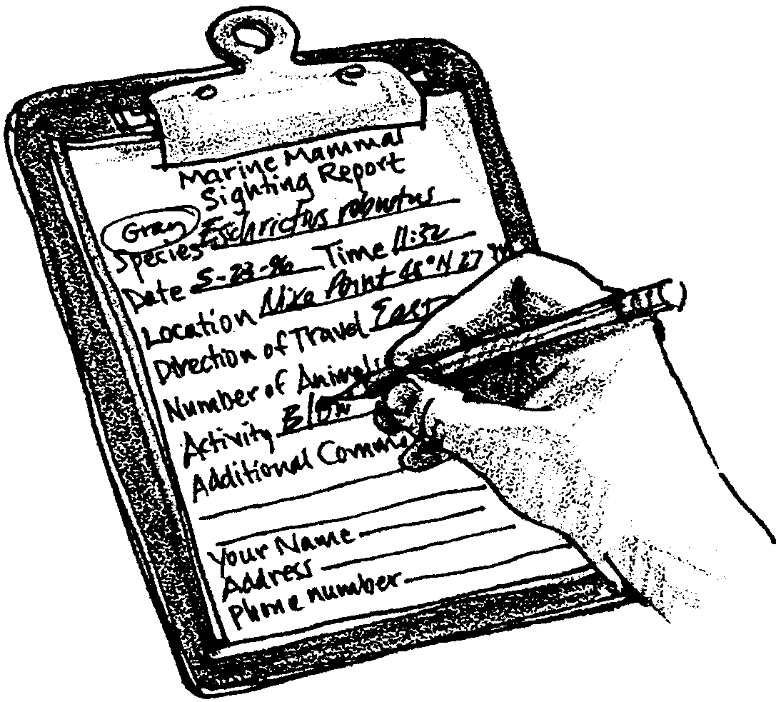
Lea records information on the mammals she observes to a nearby research station.

11. Lately, there has been more protection for marine mammals. Scientists are interested in knowing whether they are now increasing in number. How might information from observers like Lea be helpful?

