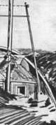
Hypothermia

Key Concepts
1. Hypothermia occurs when the body loses heat faster than it can produce heat.
2. Water conducts heat faster than air, making the risk of hypothermia greater in water.
3. People are wise to prepare before going out on the water, learning how to recognize symptoms and to treat hypothermia.

Background

Prolonged exposure to cold water presents a number of physiological challenges to gray whales and to humans. Maintaining a constant internal core temperature becomes both difficult and crucial. When the temperature cannot be maintained, hypothermia follows. Hypothermia is the lowering of body temperature to dangerously low levels through prolonged exposure to cold. The lowered body temperature causes reduced metabolic and heart rates and impairs mental functions. In severe cases, these symptoms may end in deep coma and death. Treatment involves slowly raising body temperature back to normal.

Additional information about hypothermia may be found in the following publications:

Girl Scouts Camping Standards #77 (which provided much of the background for the activity, “Hypothermia”.

“Four Lines of Defense Against Hypothermia” a brochure from the motion picture “By Nature’s Rules”, available from Jim Lawless, Motion Picture Consultants, Inc. 1545 N.E. 130th St., Seattle, WA 98125.

“Boy Under the Ice”, an episode produced by the science series 3-2-1 Contact about a boy who survives after falling through ice and becoming trapped in freezing water for 20 minutes.

U.S. Coast Guard publications

Washington State Boaters Education Curriculum Guide including a very enlightening and entertaining video with Bill Nye (“the Science Guy”). The curriculum guide and tape are available from Washington State Parks and Recreation Commission, 7150 Cleanwater Lane KY-11, P.O. Box 42650, Olympia, WA 89504-2650, 206-753-5755.

Materials

For each student

• “Hypothermia” student activity pages

For each small group

Role playing

• 1 or more task cards

• props as needed to role play task cards

Before venturing out in the cold, try this...

• cotton sweatshirt

• wool sweater

• cotton sock

• wool sock

• piece of cardboard for fan

Before venturing out in the wet, try this...

• foul weather gear of different materials

• shower or hose

Before venturing out too far from shore, try this...

• life buoys

• PFDs

• emergency flares (under adult supervision)

Before venturing out in wet weather, try this...

• matches

• a variety of match holders (containers)

• pail of water

• fire building materials and area

• sprinkler or rain

Before venturing out on the water, do the following...

• different types of PFDs

• common objects that might be found on a boat that could be used for flotation such as ice chests, inverted pails, empty thermos bottles

Experiments to Do, Things to Try...

• 3 containers (beakers, drinking glasses, or jars) the same size and shape

• aquatic thermometer

• 2 dish tubs or sinks of the same material, size, and shape

• ice (cubes, chips, or block)
Teaching Hints

“Hypothermia” involves your students in creative dramatics, experiments and reading activities to learn about hypothermia. The lesson builds on the information presented in Part C of the previous activity, “Storm Warning”, which chronicles the dangers faced by the crew of the vessel, Starfisher.

The material on hypothermia is especially valuable to your students if you are planning field trips in connection with your course. Even if your plans do not call for a field trip in cold weather or on cold water, the information presented here is valuable for anyone working or playing in the out-of-doors.

Duplicate the task cards, student text, and associated activities. Several approaches are possible with this lesson. You may elect to have your students read the student text and complete the investigations as an in class or homework before assigning groups dramatizations of the task cards. Alternatively, you may wish to assign the task cards and perform the dramatizations before you provide the complete student text and have students conduct the investigations.

Note that adult supervision is suggested for the activities in which students try to start a fire in wet conditions, learn to shoot a flare, or try out flotation devices. With volunteer supervision you could rotate your students through these activities as learning stations before your “field trip.”

Procedure for Dramatization

1. Tell students that they will be working in small groups to dramatize information about preventing, recognizing, and treating hypothermia.

2. Hand a task card to each small group of students. Instruct them to read the information on the card, then to create a skit, rap song, pantomime, or other presentation that will show the class the information on their card.

3. Assist groups in locating and gathering props as needed. You may be able to provide props from items available in the classroom or have students gather props from home.

4. Allow time for groups to prepare and rehearse their presentations and set a time and schedule for the class presentations. You may wish to have students video tape their presentations and show the video to other classes in your building or do live presentations for other classes.

5. During dramatizations of the task cards, have students write summaries of each group’s presentation. They can use these summaries in the follow up analysis/interpretation questions.

6. If possible show one or more of the videos listed in the resources above. Then have a guest speaker come to your class with rescue equipment to demonstrate techniques for preventing and treating hypothermia. For guest speakers call your local boating safety office, law enforcement office, Search and Rescue team, mountaineering club, ski patrol office, Red Cross, American Heart Association, or fire department.

If you are using the “Voyage of the Mimi” in conjunction with this curriculum, “Episode 9, Shipwrecked”, in which the Captain becomes hypothermic, correlates well with this lesson.

Key Words

buoyancy - the power of an object to rise or float in a liquid

hypothermia - the lowering of body temperature to dangerously low levels through prolonged exposure to cold

Personal Flotation Device (PFD) - a life preserver, life jacket or other device for keeping a person afloat in water

Answer Key

1. a. With personal flotation devices, the Barlows could survive for about 3 hours.

b. With PFDs, the Barlows could survive for about 2 hours in 5°C water. Flotation devices greatly increase the survival time by reducing energy losses (less energy is required to stay afloat).

2. Hypothermia is the condition of lowered, deep-body temperature. Hypothermia occurs when the body loses heat faster than it can produce heat.

3. Answers will vary depending on your students’ knowledge of hypothermia. Most of your students will suggest ways to help which involve warming. This question is included to get your students thinking in terms of dealing with emergency situations. Specific preventative and treatment measures are found further on in the student text, as well as in the task cards.
4. Several layers of clothing provide better insulation than one heavy garment because warm air is trapped between the layers close to the body while the infiltration of cooler air is retarded by the outer layers.

5. Constant swimming, splashing, and shouting decrease survival chances because they increase the rate at which you lose body heat. The faster the heat loss, the shorter the time you can survive in cold water. In particular, the swimming and splashing move cold water past the body sides and armpits, cooling the body. In the HUDDLE position arm pits are insulated by the neighboring persons’ bodies.

6. The administration of alcohol to hypothermia victims causes surface blood vessels to dilate, increasing the amount of heat lost and compounding the victim’s problems.

7. “H.E.L.P.” means Heat Escape Lessening Position. In the H.E.L.P. position, the knees are drawn up to the chest to insulate the vital organs from heat loss.

8. a. Shivering, cold hands and cold feet may be treated by helping the victim put on dry clothes. Providing warm, dry shelter is also effective treatment.

b. The time to treat these symptoms is as soon as they appear. Delay increases the danger of hypothermia. Better still, prevention is the key. Begin the excursion with warm clothing to hold body heat.

9. Finding or rigging shelter and rewarming is the treatment recommended for people in the stumbling and numbness stage of hypothermia.

10. Loss of memory and slow, slurred speech in hypothermia victims occur because the brain’s thought control centers are starved for warm, oxygen-rich blood and, as a result, start to shut down.

11. After warming the victim, MEDICAL ASSISTANCE IS CRITICAL. At this advanced stage of hypothermia, cold shock to vital organs, abnormally low blood pressure, and chemical imbalances may be fatal, even hours after warming treatment has apparently “cured” the victim.

12. The first three groups of symptoms of hypothermia are:
a. shivering, cold hands and cold feet.
b. clumsiness, loss of dexterity.
c. loss of reason and recall.
13. Keeping the victim’s head low and feet up gets warm blood to the head first. It also keeps cold blood from circulating as quickly to the heart.

14. Of the four warming techniques mentioned, hot towels, warm air, and buddy warming may be used on unconscious victims.

15. The obvious message in this question is that planning ahead and recognizing potential danger situations reduces the risk of hypothermia.

16. This question reviews whale biology and reminds students that whales are adapted to life in the cold ocean while humans are not. A healthy whale stays warm from the heat it produces by swimming and moving and the insulation of its blubber. An unhealthy whale may not have thick enough blubber and it may not move as much or as efficiently.

Experiments to Do, Things to Try...

1. - 7. Answers depend upon experimental results.

8. Answers will vary. A generalization might be that the temperature of water in a container immersed in water of a different temperature changes to more nearly match the temperature of that water.

9. The temperature of the water in your body will decrease if you are immersed in cold water. In other words, cold water can cause hypothermia!
Hypothermia - TASK CARDS Duplicate and provide one card to each group of students.



Here’s what you need to do ahead of time.

AN ALERT MIND IS THE BEST SURVIVAL TOOL!

Plan ahead for emergencies:
- file trip or float plan
- plan checkpoints and signals
- monitor the weather
- enforce the buddy system
- select a sensible leader
- keep a positive outlook!

A PREPARED BODY IS THE BEST SURVIVAL KIT!

Be in good condition and carry gear to:
- stay dry (rain gear, spare large plastic bag)
- stay warm (spare wool layers, a hat)
- fuel up (energy foods, hot drinks)
- produce heat (dry tinder, waterproof matches)
- stay afloat (life jacket)
- signal distress (whistle, light, flares)

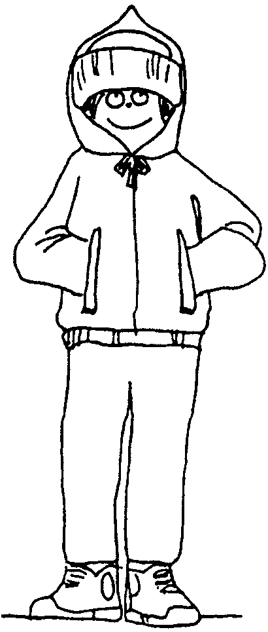
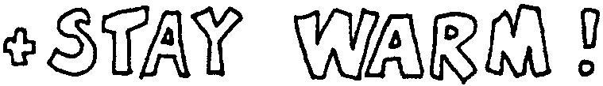
PROTECT CRITICAL HEAT LOSS AREAS:
- “When your feet are cold, put on a hat.” From 25% to 50% of total body heat loss radiates from the head.

- Assume HELP position to protect sides of chest and groin, other major areas where blood vessels are close to the surface.

- If in water without flotation, don’t drownproof (relaxed, face down floating) - with the head under water the combined effect of major head heat-loss and faster water conductivity cuts survival time drastically (75%!). Slowly treading water is twice as effective as drown-proofing.

MAXIMIZE INSULATION:

- Wear layers of wool clothing rather than one heavy garment. Layers insulate as body heat warms the trapped air. Top layer should be windproof and waterproof. Apply this to feet too - leather or rubber shoes are warmer than canvas.

- On water, wear PFD (Personal Flotation Device = life-jacket) on top of other layers. Insulating properties of a float coat quadruple survival time. Fitted foam vest triples time, with kapok vest, then bib-type PFDs least warm.

- Keep collar, hood, and cuffs snug to prevent moving air or water from exchanging cold for warmed layers.

- Insulate against cold surfaces. Avoid sitting, kneeling, or lying down without padding (grass, leaves, newspapers.)

- Wear gloves when handling cold objects.

- Keep metal tools, knives, axes, sheathed away from the body.

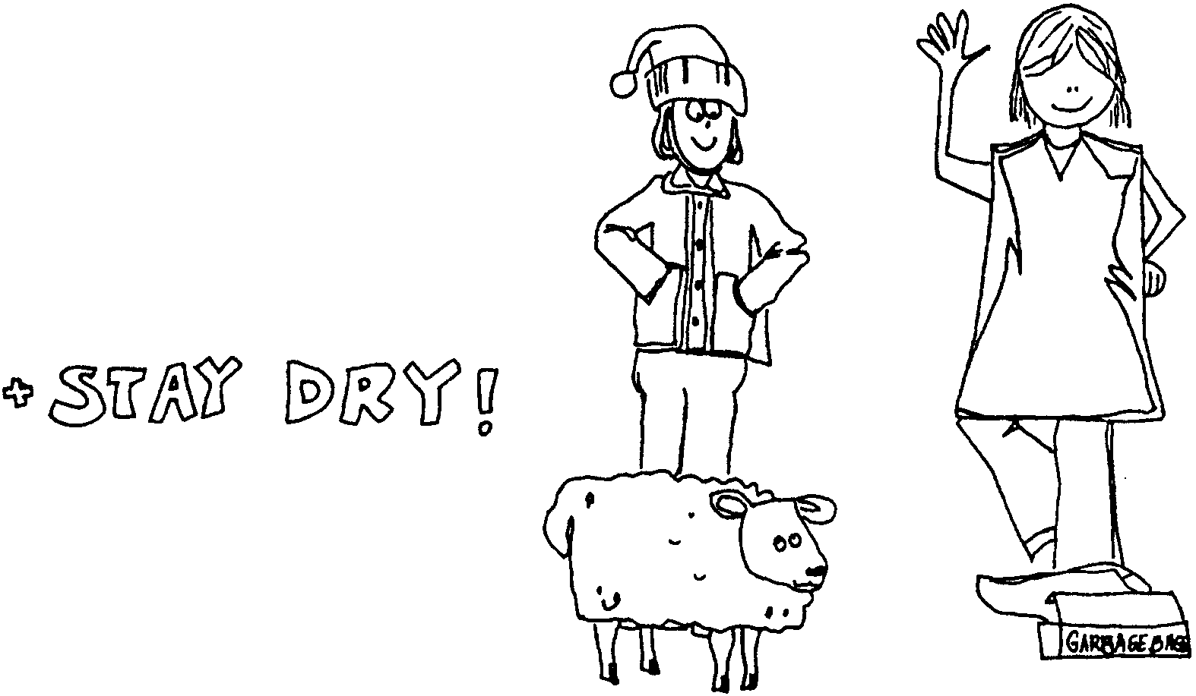

- Cover up before getting wet or change to dry clothes and keep them dry! Wet clothes lose up to 90% of their insulating value.

- Wear wool. It is still 40-60% effective even when wet.

- Avoid cotton. It “wicks,” spreading moisture from fiber-to-fiber making a larger area to cool by evaporation.

- Avoid plastic alone. It has poor insulating qualities and body moisture builds up inside unless well ventilated.

- Avoid wearing a poncho in wet or windy weather. It “leaks” as moisture drips in and heat flows out. Keep one handy to rig a shelter or windbreak.

- Keep up “loft” of down. If down gets wet or matted, insulating air spaces between feathers are lost.



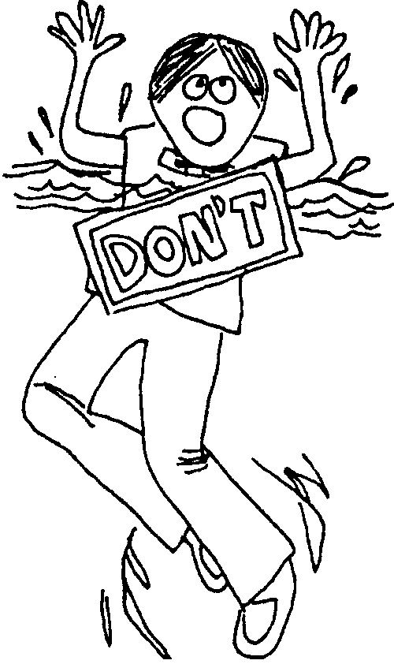
- “Quit while you’re ahead!” means to quit while your head can still think safely. Cool blood slows, delivers less oxygen; the brain suffers. Use energy only to make things snug and sheltered before reserves and reason are lost.

- Reduce perspiration by reducing activity. Perspiration means the body is dumping heat and moisture. Energy can go into producing heat rather than motion if the body is at rest.

- Make short rest stops. Five to seven minutes is long enough for muscles to relieve the “tired feeling.”

- Rig a distress signal to show without constantly expending more energy. Wave, splash, shout, or whistle only when rescuers are likely to see or hear.

- Swim only if it counts. Be certain of reaching a worthy goal (flotation, other people, shore.) Swimming sends warm blood to shoulders and limbs, greatly increasing heat-loss. In 10° C (50° F) water, hypothermia hits a “good” swimmer wearing a life-jacket after swimming only 1300 meters (1400 yards). In 0° C (32° F) water, 185 meters (200 yards) is the limit!

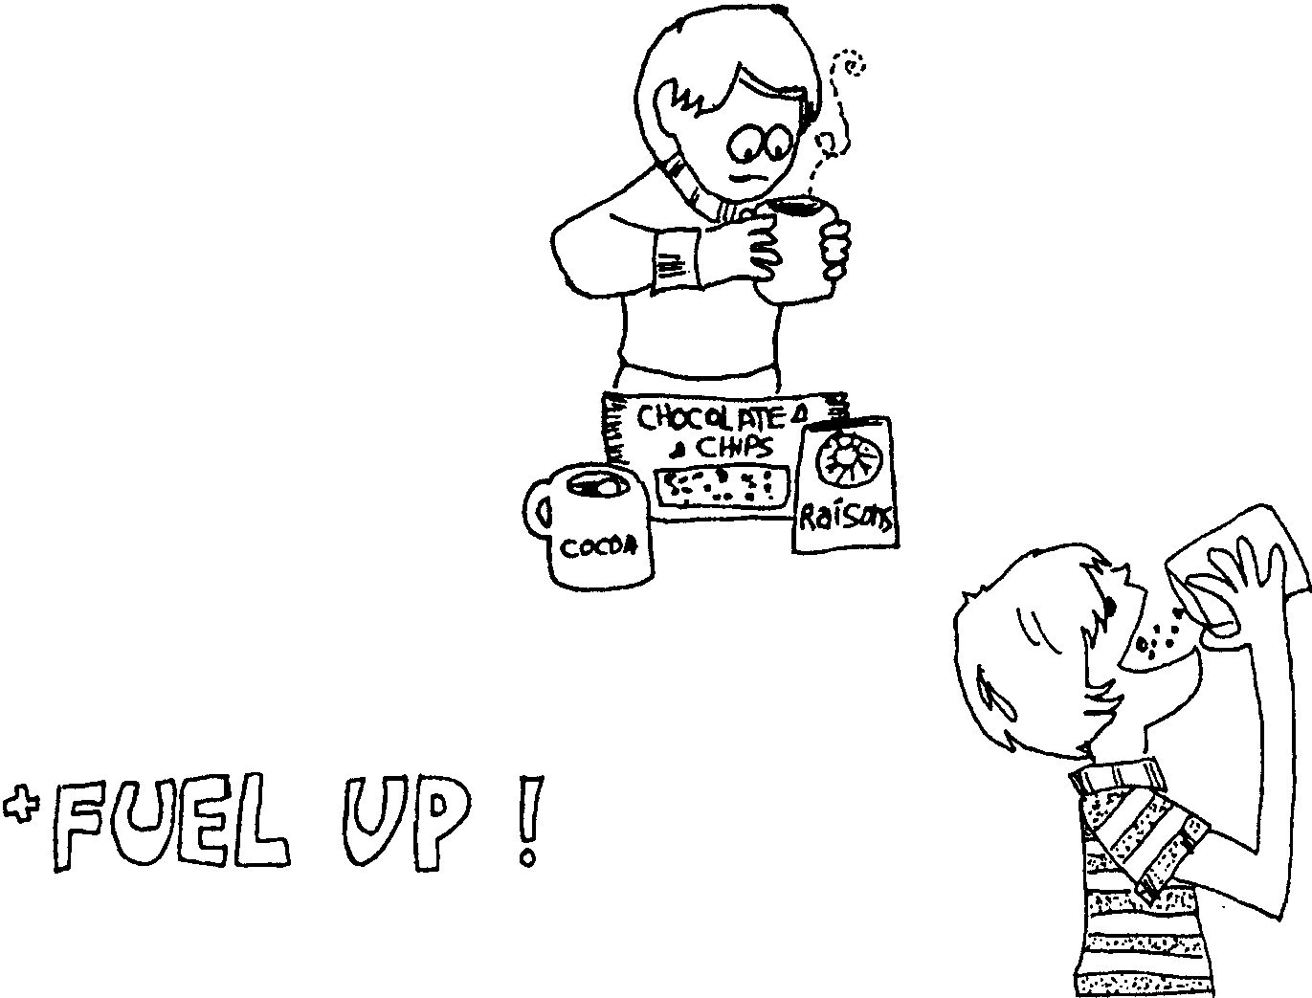

- Eat well regularly. Maintain an energy reserve with a balanced diet.

- For quick, ready energy, have frequent sugary snacks. Gorp, raisins, chocolate, and candy will keep up the body’s heat-production without burning the reserve supply.

- Provide hot drinks to warm the inner core. Energy levels will benefit too, if drinks are healthful (soup, bouillon, broth, cocoa, tea with sugar, or hot fruit drinks.) Avoid too much coffee.

- Don’t have alcoholic drinks. Alcohol gives a false impression of warmth by reducing shivering. Actually, surface blood vessels are relaxing, allowing more blood to circulate and cool more.



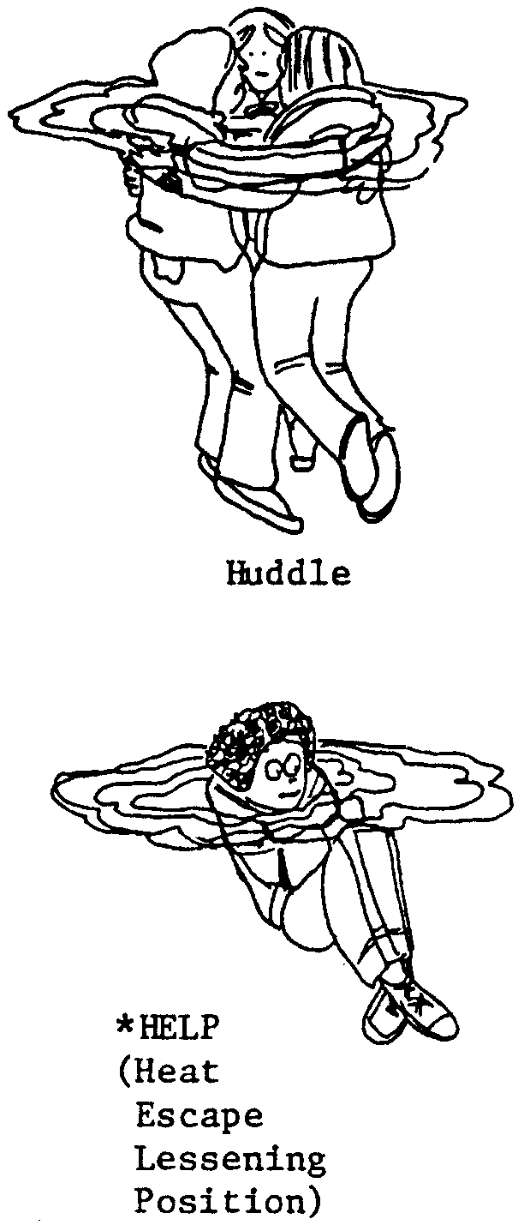
- Put on a Personal Flotation Device (PFD, formerly called a life-jacket)

- If forced to enter the water, go in slowly. Sudden immersion may cause “Immediate Disappearance Syndrome” with uncontrollable rapid breathing, dizziness, and acute pain. Surviving such cold shock may be possible only if wearing a PFD. Relieved of the struggle to keep from gulping water and sinking, the body has a chance to adjust to the cold.

- If forced to jump in, be prepared for cold shock. Increase buoyancy by pinching nose and holding breath, hopefully long enough to surface and control breathing.

- Once in, try to get out of the water and stick with the boat or a nearby floating object. Rig protection from any wind.

- If nothing floating is around, stick with other people. Form a HUDDLE.

- If alone, assume HELP.

- If not wearing a PFD, layers of clothing increase buoyancy. Blow down into front of jacket to improvise flotation. If possible, trap air in boots for buoyancy. Inflated pants make a float too.



Here are the warning signs of hypothermia:
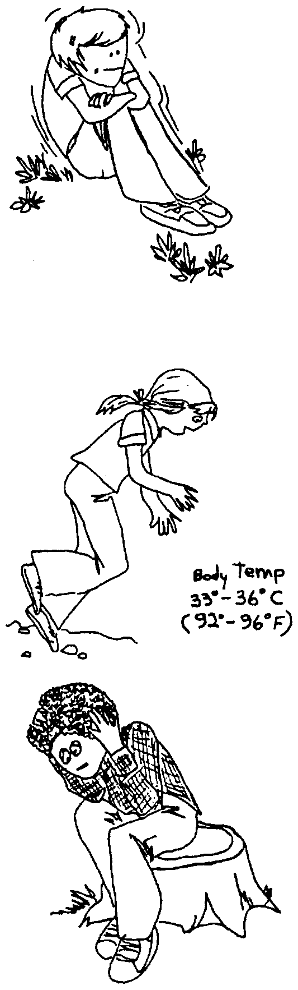
Shivering is usually the first sign of possible hypothermia.

STOP! Recognizing and attending to these first symptoms may only require helping the victim put on dry clothes. Don’t ignore the symptoms.
As the limbs receive less and less warm blood, responsive movement becomes more and more difficult

STOP! Don’t believe a victim’s claim of “I’ll catch up”. She really CAN’T. Find or rig shelter and start rewarming!

The victim acts careless and dazed. Responses may be inappropriate or show loss of memory. Speech is slow and slurred.

STOP! Don’t believe victim’s claims of “I’m okay." The victim really doesn’t know better! Before it’s too late, keep the victim awake and provide protection and heat.



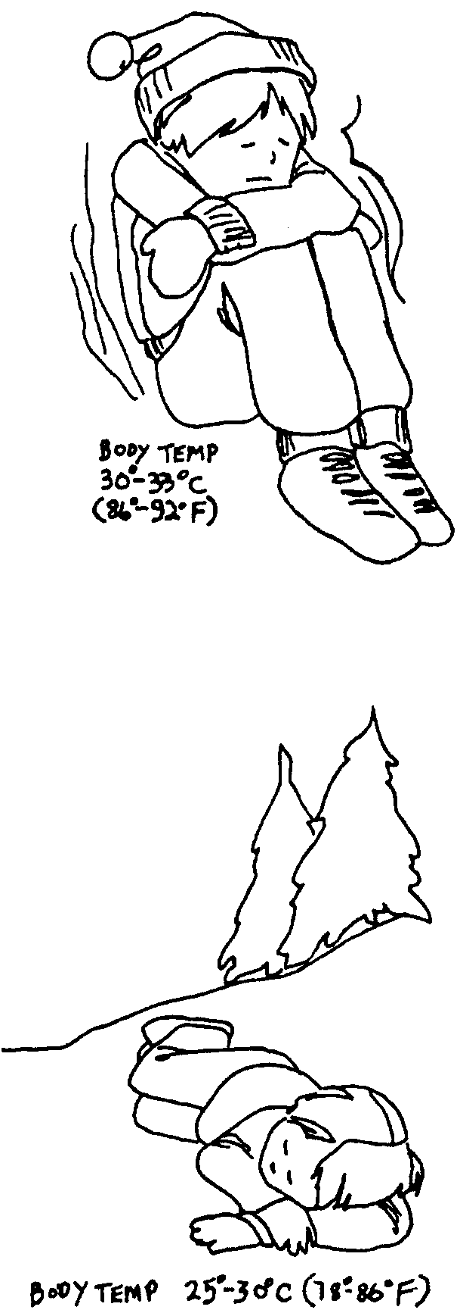
The exhausted body gathers futile and wasteful bursts of energy, at times shaking the victim violently.

BEWARE! Cold shock to vital organs may be fatal, even hours after warming treatment has apparently “cured" the victim. MEDICAL ASSISTANCE IS CRITICAL!!!

When the brain control centers fail, breathing and heart beat finally stop.

DON’T GIVE UP! Although fatal after-drop (a further lowering of body temperature after warming treatment has begun) is likely, don’ t assume death until the victim is warm and dead. MEDICAL ASSISTANCE IS IMPERATIVE.

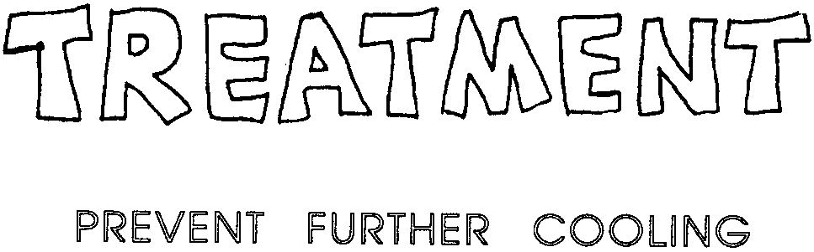

Provide selective and gradual warming to raise lowered body temperature. Take care! Beware of after- drop.


- insulate victim against cold
- protect victim from wind and wet
- minimize movement of victim’s body (even walking takes energy)
- try to keep victim awake
- keep victim’s head low, feet up (get warm blood to head first)
- beware of after-drop
- protect victim from helicopter wind-chill
- SEEK MEDICAL ASSISTANCE



- never leave victim without a heat source
- never massage or rub the victim (especially NOT with snow!)
- never jostle the victim (such movement could cause heart stoppage)
- never give alcohol
- never give a sedative, tranquilizer, or pain reliever
- never give up without medical advice

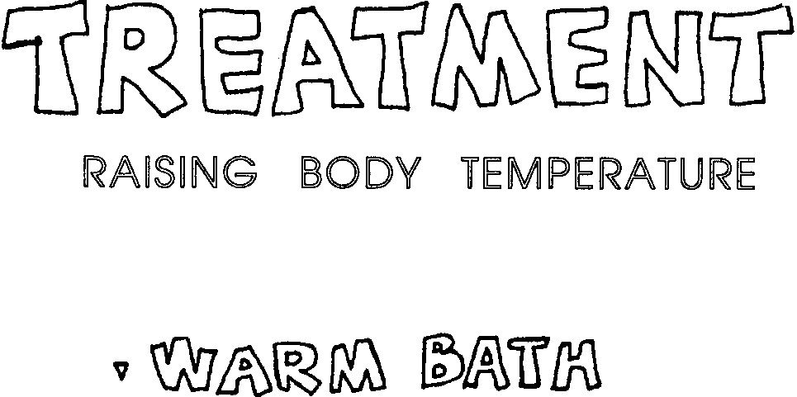

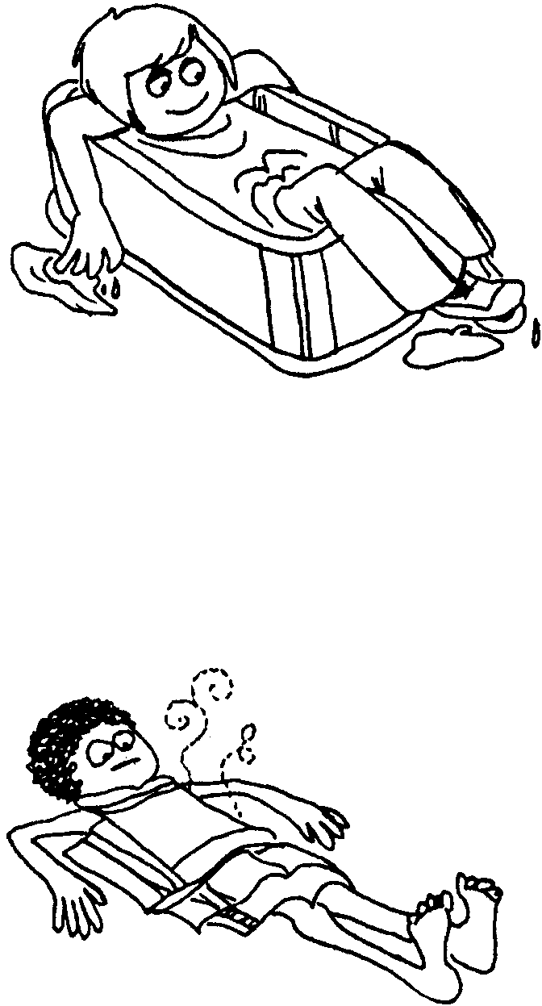
Victim: Must be conscious

Rescuer: Concentrate heat on trunk to prevent “after-drop"

- Start water at 20° C (70° F) raise to 42° C (110° F) (comfortable to elbow test) over 10 minute time span

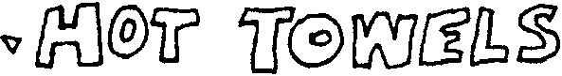

Victim: May be unconscious

Rescuer: Wrap trunk (not limbs) in hot towels or blankets

- Keep warming with warmer water (like bath)

- Hot water bottle or wrapped, hot rocks OK too

- Beware of causing superficial burns

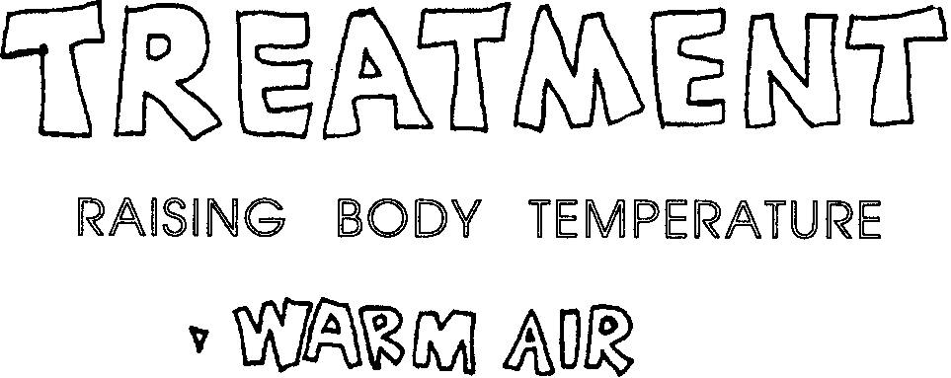

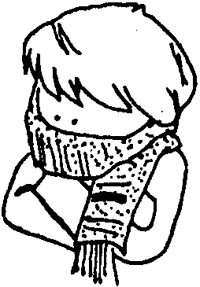
Victim: Must be handled GENTLY

Rescuer: Do not try to get the victim to swallow warm drinks

- Scarf over mouth and nose will trap warmth from exhaled air and pre-warm next breath

- Mouth-to-mouth resuscitation transfers warm air to victim (conscious or not)

- Special respirators provide warmed, moisture-laden air

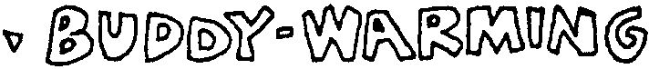

Victim: Must be handled gently (conscious or not)

Rescuer: Remove all wet clothing (cut away to avoid jostling)

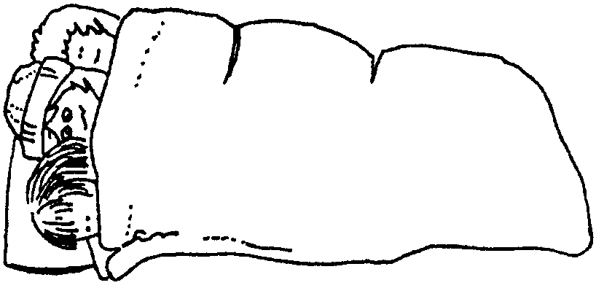
- Place victim on side in sleeping bag or blankets

- Warmth donor(s) should strip too

- Position donor(s) for direct skin-to-skin, heat transfer to front and back of victim

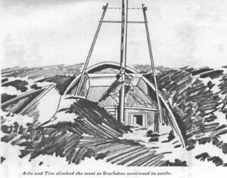
Hypothermia

What would have happened to the Barlows if Captain Jack von Kelly took longer to reach the Starfisher? How long could Arlo and Tim have survived in the cold water? What could they, or you, have done to survive?

The temperature of the water is a major factor in determining how long the Barlows could have survived. In water at 10° C (50° F) the brothers predicted survival time without life jackets would be one and a half to two hours. In 5° C (40° F) water survival time is reduced to about 30 minutes.

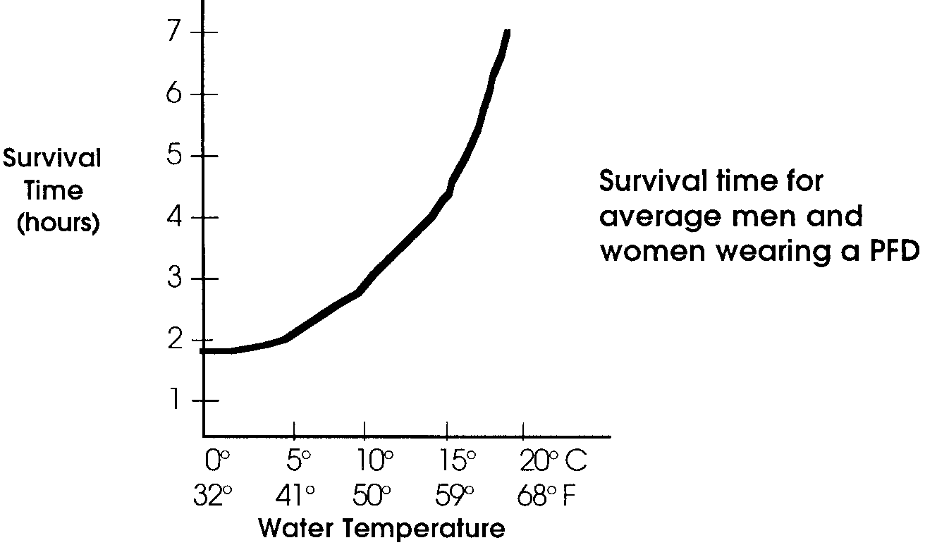
1. Personal Flotation Devices (PFDs), formerly called life jackets, increase the predicted survival time. The graph below shows survival time for “average” men and women wearing a PFD.

a. With PFDs, how long could the Barlows survive in 10° C?
(Hint: This is easy. Draw a line straight up from the 10° C water temperature to the curve. From the point where the line meets the curve, draw a straight line over to the survival time-line. Read the number from the scale on the survival time-line)

b. With PFDs, how long could they survive in 5° C?

How does cold water kill? The answer is hypothermia. What does that mean? Hypothermia means low (hypo) temperature (thermia). We use it here to mean lowered, core (deep-body) temperature. Hypothermia occurs when the body loses heat faster than it can produce heat.

In cold water, the skin becomes cooled very rapidly. It takes only 10-15 minutes before the temperature of the heart and brain begin to cool. Unconsciousness can occur when the core temperature falls to about 90° F (32° C). If the temperature continues to fall, heart failure usually causes death when the body “core” cools to about 85° F (30° C) or below.

2. What is hypothermia?

3. What might be something you could do to help someone with hypothermia?

The Barlows were in danger because they were immersed in water. While hypothermia can also strike unsuspecting people on the beach or in the mountains, it more often strikes people in water. Why is this? It is because water conducts heat faster than air. This means that people in cold water lose heat faster than people in air of the same temperature.

The following activities will help you learn what you can do to avoid hypothermia.

BE PREPARED! - here’s what you need to do ahead of time.

AN ALERT MIND IS THE BEST SURVIVAL TOOL!

Plan ahead for emergencies:
- file trip or float plan
- plan checkpoints and signals
- monitor the weather
- enforce the buddy system
- select a sensible leader
- keep a positive outlook!

A PREPARED BODY IS THE BEST SURVIVAL KIT!

Be in good condition and carry gear to:
- stay dry (rain gear, spare large plastic bag)
- stay warm (spare wool layers, a hat)
- fuel up (energy foods, hot drinks)
- produce heat (dry tinder, waterproof matches)
- stay afloat (life jacket)
- signal distress (whistle, light, flares)

PROTECT CRITICAL HEAT LOSS AREAS:

- “When your feet are cold, put on a hat.” From 25% to 50% of total body heat loss radiates from the head.

- Assume H.E.L.P. position to protect sides of chest and groin, other major areas where blood vessels are close to the surface.

- If in water without flotation, don’t drownproof (relaxed, face down floating) - with the head under water the combined effect of major head heat-loss and faster water conductivity cuts survival time drastically (75%!). Slowly treading water is twice as effective as drown-proofing.

MAXIMIZE INSULATION:

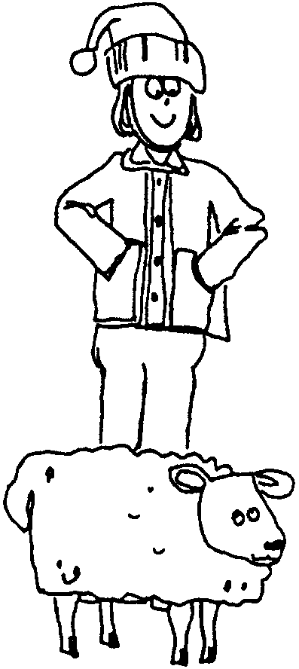
- Wear layers of wool clothing rather than one heavy garment. Layers insulate as body heat warms the trapped air. Top layer should be windproof and waterproof. Apply this to feet too - leather or rubber shoes are warmer than canvas.

- On water, wear PFD (Personal Flotation Device = life-jacket) on top of other layers. Insulating properties of a float coat quadruple survival time. Fitted foam vest triples time, with kapok vest, then bib-type PFDs least warm.

- Keep collar, hood, and cuffs snug to prevent moving air or water from exchanging cold for warmed layers.

- Insulate against cold surfaces. Avoid sitting, kneeling, or lying down without padding (grass, leaves, newspapers.)

- Wear gloves when handling cold objects.

- Keep metal tools, knives, axes, sheathed away from the body.

4. Why is it better to wear several layers of clothing rather than one heavy garment?

Before venturing out in the cold, try this...

Compare cotton and wool when wet.

Here’s what you’ll need:
• cotton sweatshirt
• wool sweater
• cotton sock
• wool sock
• piece of cardboard for fan

Here’s what to do:
a. Dip a cotton sweatshirt cuff and a wool sweater cuff into about an inch of water. Watch one “wick”.

Which would stay drier and warmer?

b. Put on one wet wool sock and one wet cotton sock (you may choose to use a glove, or sleeve).

Which feels warmer?

c. Have someone fan your sock with a piece of cardboard.

Which feels warmer in a “wind”?

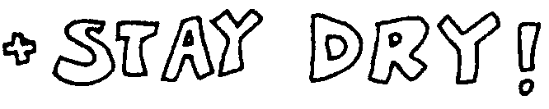
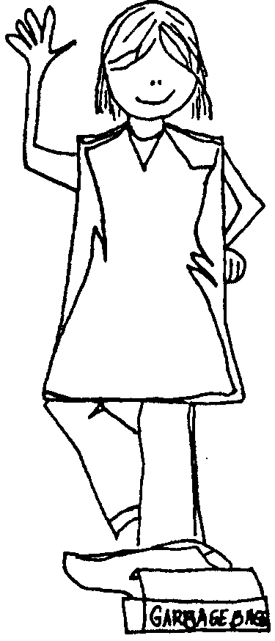
- Cover up before getting wet or change to dry clothes and keep them dry! Wet clothes lose up to 90% of their insulating value.

- Wear wool. It is still 40-60% effective even when wet.

- Avoid cotton. It “wicks”, spreading moisture from fiber-to-fiber making a larger area to cool by evaporation.

- Avoid plastic alone. It has poor insulating qualities and body moisture builds up inside unless well ventilated.

- Avoid wearing a poncho in wet or windy weather. It “leaks” as moisture drips in and heat flows out. Keep one handy to rig a shelter or windbreak.

- Keep up “loft” of down. If down gets wet or matted, insulating air spaces between feathers are lost.

Before venturing out in the wet, try this...

Test foul-weather gear when under a shower or sprayed by a hose.

Here’s what you’ll need:
• foul weather gear of different materials
• shower or hose

Here’s what to do:

Exercise and perspire in foul-weather gear.

a. Does it leak?

b. Does it “breathe”?

- “Quit while you’re ahead!” means to quit while your head can still think safely. Cool blood slows, delivers less oxygen; the brain suffers. Use energy only to make things snug and sheltered before reserves and reason are lost.

- Reduce perspiration by reducing activity. Perspiration means the body is dumping heat and moisture. Energy can go into producing heat rather than motion if the body is at rest.

- Make short rest stops. Five to seven minutes is long enough for muscles to relieve the “tired feeling”.

- Rig a distress signal to show without constantly expending more energy. Wave, splash, shout, or whistle only when rescuers are likely to see or hear.

- Swim only if it counts. Be certain of reaching a worthy goal (flotation, other people, shore.) Swimming sends warm blood to shoulders and limbs, greatly increasing heat-loss. In 10° C (50° F) water, hypothermia hits a “good” swimmer wearing a life-jacket after swimming only 1300 meters (1400 yards). In 0° C (32° F) water, 185 meters (200 yards) is the limit!

5. If you’re in trouble, why does constant swimming, splashing and shouting often decrease your survival chances?

Before venturing out too far from shore, try this...

Practice getting people’s attention.

Here’s what you’ll need:
• life buoys
• PFDs
• emergency flares (under adult supervision)

Here’s what to do:
a. Practice distress signals.

b. Use the best attention getter: CONTRAST.

c. Why is emergency gear “international orange”?

d. Under adult supervision learn to set off a flare.

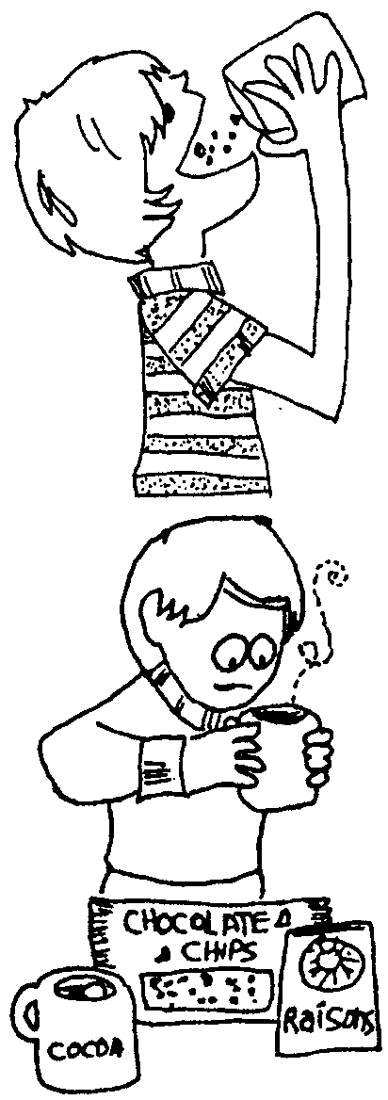
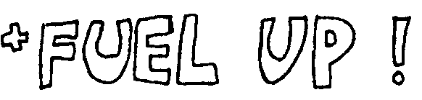
- Eat well regularly. Maintain an energy reserve with a balanced diet.

- For quick, ready energy, have frequent sugary snacks. Gorp, raisins, chocolate, and candy will keep up the body’s heat-production without burning the reserve supply.

- Provide hot drinks to warm the inner core. Energy levels will benefit too, if drinks are healthful (soup, bouillon, broth, cocoa, tea with sugar, or hot fruit drinks.) Avoid too much coffee.

- Don’t have alcoholic drinks. Alcohol gives a false impression of warmth by reducing shivering. Actually, surface blood vessels are relaxing, allowing more blood to circulate and cool more.

6. Traditionally, hypothermia victims were given brandy or rum to drink. Why was this a bad practice?

Before venturing out in wet weather, try this...

Light a fire with wet matches.

Here’s what you’ll need:
• matches
• a variety of match holders (containers)
• pail of water
• fire building materials and area
• sprinkler or rain

Here’s what to do:

a. Test water-proof matches and match holders by dunking them in water. Then, in the rain or under a sprinkler, light a fire.

b. Boil water for energy drinks. (You may wish to make hot chocolate, tea, or instant soup mixes.)
- Put on a Personal Flotation Device (PFD, formerly called a life-jacket)

- If forced to enter the water, go in slowly. Sudden immersion may cause “Immediate Disappearance Syndrome” with uncontrollable rapid breathing, dizziness, and acute pain. Surviving such cold shock may be possible only if wearing a PFD. Relieved of the struggle to keep from gulping water and sinking, the body has a chance to adjust to the cold.

- If forced to jump in, be prepared for cold shock. Increase buoyancy by pinching nose and holding breath, hopefully long enough to surface and control breathing.

- Once in, try to get out of the water and stick with the boat or a nearby floating object. Rig protection from any wind.

- If nothing floating is around, stick with other people. Form a HUDDLE.

- If alone, assume H.E.L.P..

- If not wearing a PFD, layers of clothing increase buoyancy. Blow down into front of jacket to improvise flotation. If possible, trap air in boots for buoyancy. Inflated pants make a float too.

7. What is “H.E.L.P.”?

Before venturing out on the water, do the following...

Try staying afloat.

Here’s what you’ll need:
• different types of PFDs
• common objects that might be found on a boat that could be used for flotation such as ice chests, inverted pails, empty thermos bottles

Here’s what to do:
a. Test different types of PFDs for buoyancy and warmth.
b. Practice H.E.L.P. and HUDDLE positions.
c. Improvise flotation aids.

So ....you’ve learned to prevent hypothermia and you’re prepared. What kind of warnings should you look for once you’re outside ?

If the inner core temperature deviates only 1 degree C (2° F), distress signals from the brain warn of the onset of trouble. Recognize the symptoms!

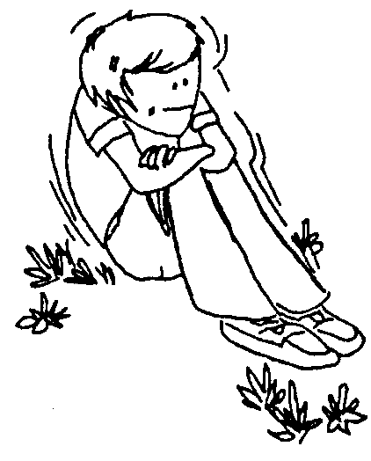
Shivering is usually the first sign of possible hypothermia. The body is using bursts of energy in an effort to produce heat, but the heat loss goes on. “Cold hands mean a warm heart.” The body constricts surface blood vessels to reserve warm blood for the inner core. Since the temperature of the extremities may drop to 4° C (40° F), without damage, frostbite is not necessarily associated with hypothermia. Symptoms of hypothermia demand treatment before symptoms of frostbite.

STOP! Recognizing and attending to these first symptoms may only require helping the victim put on dry clothes. Don’t ignore the symptoms.

8. a. How should you treat shivering, cold hands and cold feet?

b. When should you treat shivering, cold hands and feet?
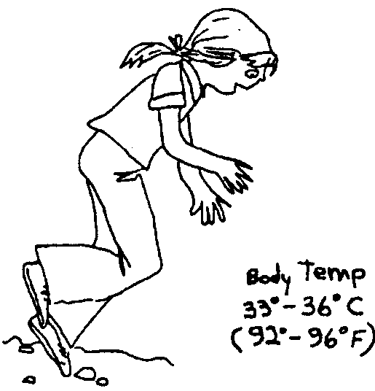

As the limbs receive less and less warm blood, responsive movement becomes more and more difficult. Muscle control centers are also affected because less oxygen is transferred by cold blood in constricted blood vessels. The victim stumbles and fumbles. Along with growing numbness, the victim is unable to get going after a rest stop.

STOP! Don’t believe a victim’s claim of “I’ll catch up”. She really CAN’T. Find or rig shelter and start rewarming!

9. Stumbling and numbness are symptoms that can lead to severe hypothermia. What is the treatment for people suffering these symptoms?

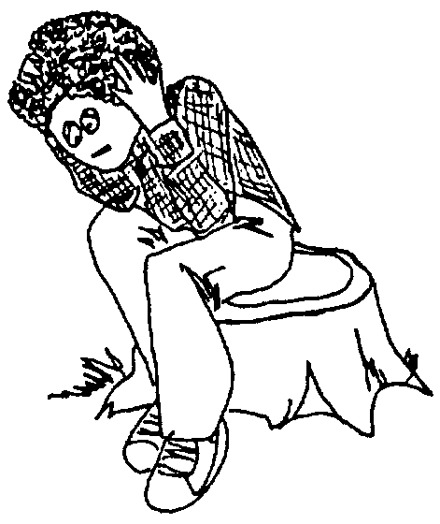
The brain’s thought control centers, starved for warm, oxygen-rich blood, start closing down. The victim acts careless and dazed. Responses may be inappropriate or show loss of memory. Speech is slow and slurred. Without reason, the victim may over-exercise, using up energy reserve to the point of collapse. Beyond caring, the victim may give in to conditions, dozing off without protection from the elements.

STOP! Don’t believe victim’s claims of “I’m okay.” The victim really doesn’t know better! Before it’s too late, keep the victim awake and provide protection and heat.

10. What causes hypothermia victims to show loss of memory and slow, slurred speech?

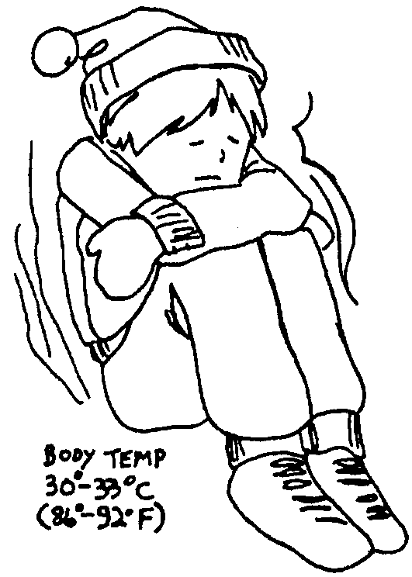
The exhausted body gathers futile and wasteful bursts of energy, at times shaking the victim violently. Since cold, slowly moving blood stagnates, body chemistry is altered and muscles become rigid. With a slow and irregular pulse, breathing is also erratic. Skin may appear discolored and feels very cold and puffy to touch.

BEWARE! Cold shock to vital organs, abnormally low blood pressure, and chemical imbalances may be fatal, even hours after warming treatment has apparently “cured” the victim. MEDICAL ASSISTANCE IS CRITICAL!!!

11. When the deep-body temperature reaches 30° - 33° C (86° - 92° F) shaking and muscular rigidity occur. What is required after you have succeeded in warming the victim?

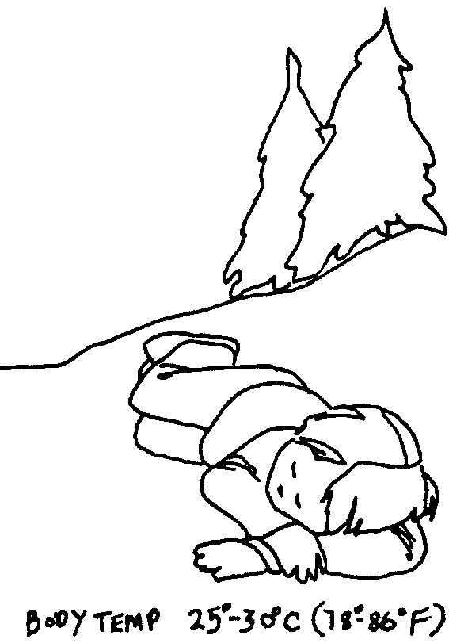

When the brain control centers fail, vital organs struggle on with increasing difficulty and irregularity. Breathing and heart beat finally stop. Lungs may hemorrhage, causing frothing at the mouth.

Begin warming treatment. Warm body core first. If arms and legs are heated first then cold blood from them rushes to the core. This cold blood causes a rapid drop in core temperature called “after drop”.

DON’T GIVE UP! Although fatal after-drop (a further lowering of body temperature after warming treatment has begun) is likely, don’ t assume death until the victim is warm and dead. MEDICAL ASSISTANCE IS IMPERATIVE.

12. Collapse...Things have gone too far at this point. The first three groups of symptoms of hypothermia are easily recognized and corrected. What are these first three groups?

a.

b.

c.


Of course, you’ll never get hypothermia because you know how to protect yourself . But what do you do if you find someone else suffering from hypothermia?

Provide selective and gradual warming to raise lowered body temperature. Take care! Beware of after- drop.

- insulate victim against cold
- protect victim from wind and wet
- minimize movement of victim’s body (even walking takes energy)
- try to keep victim awake
- keep victim’s head low, feet up (get warm blood to head first)
- beware of after-drop
- protect victim from helicopter wind-chill
- SEEK MEDICAL ASSISTANCE

- never leave victim without a heat source
- never massage or rub the victim (especially NOT with snow!)
- never jostle the victim (such movement could cause heart stoppage)
- never give alcohol
- never give a sedative, tranquilizer, or pain reliever
- never give up without medical advice


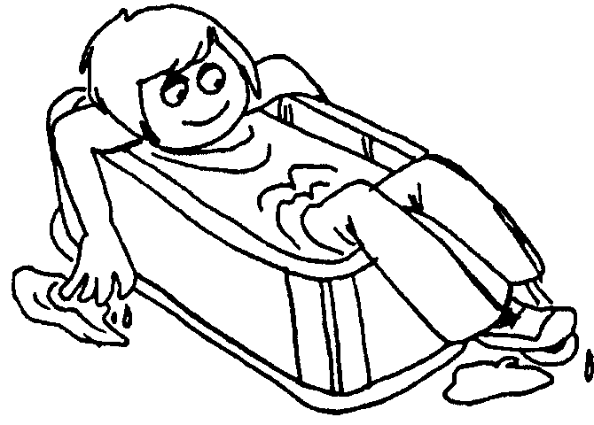
Victim: Must be conscious

Rescuer: Concentrate heat on trunk to prevent “after-drop”

- Start water at 20° C (70° F) raise to 42° C (110° F) (comfortable to elbow test) over 10 minute time span

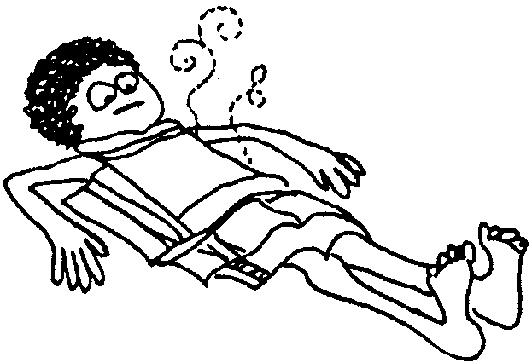
Victim: May be unconscious

Rescuer: Wrap trunk (not limbs) in hot towels or blankets
- Keep warming with warmer water (like bath)
- Hot water bottle or wrapped, hot rocks OK too
- Beware of causing superficial burns


Victim: Must be handled GENTLY

Rescuer: Do not try to get the victim to swallow warm drinks

- Scarf over mouth and nose will trap warmth from exhaled air and pre-warm next breath

- Mouth-to-mouth resuscitation transfers warm air to victim (conscious or not)

- Special respirators provide warmed, moisture-laden air

Victim: Must be handled gently (conscious or not)

Rescuer: Remove all wet clothing (cut away to avoid jostling)
- Place victim on side in sleeping bag or blankets

- Warmth donor(s) should strip, too

- Position donor(s) for direct skin-to-skin, heat transfer to front and back of victim

13. Why should you keep the victim’s head low, and feet up?

14. Of the four warming techniques mentioned which ones may be used on unconscious victims?

15. What is meant by the saying “The best treatment for hypothermia is prevention”?

16. Gray whales spend a lot of time in very cold water. How do gray whales avoid hypothermia?

Experiments to Do, Things to Try...

Remember the blubber lab activity in “Returning South - October 1”? In that activity you experienced cold water endurance by holding a hand in cold water. Here are some more cold water activities to try.

How well does water conduct temperature? Do the following experiment with “water baths” to see.

Here’s what you’ll need:

Materials

• 3 containers (beakers, drinking glasses, or jars) the same size and shape

• aquatic thermometer

• 2 dish tubs or sinks of the same material, size, and shape

• ice (cubes, chips, or block)
Here’s what to do:

Procedure

1. Fill each container 3/4 full of tap water. Take the temperature of the water in each container. It should be the same for each. If not, allow the containers to stand for several minutes and take temperatures again until all containers read the same.

Record the beginning temperature: °.

2. Prepare two “water baths”. Here’s how. Fill one dish tub with cold water and ice to the level of the water in the containers. (Use one of the containers of water to check water levels in both tubs.)
If you fill the tub too full, the container of water will float and spill. Fill the other tub to the same level with hot water from the tap.

3. Set aside the container of water you used to check the water levels in the tubs. Place one of the remaining containers of water in the cold water bath (tub of cold water). Be careful it does not tip and spill. Place the other container of water in the hot water bath (tub of hot water).

Record the time: .

Record the temperature of the cold water in the tub: °.

Record the temperature of the hot water in the tub: °.

Predict how long it might take for the water temperatures in the containers to equal those in the water baths (tub water).

cold water minutes

hot water minutes

4. Wait 10 minutes.

Record the time .

Then record:
the temperature of the water in the container in the cold water
bath °.

the temperature of the water in the container in the hot water
bath °.

How do these readings compare with your predictions?

5. How much colder or warmer is the water in each container than it was in the beginning?

6. Subtract the cold water temperature you recorded in step “d” above from the beginning temperature in step “a”. Record the difference here.

In ten minutes in a cold water bath of °, water temperature decreased by °.

7. Subtract the beginning temperature in step “a” from the warm water temperature you recorded in step “d” above. Record the difference here.

In ten minutes in a water bath of °, water temperature increased by °.

8. Make a generalization about water temperature changes in a container immersed in water of a different temperature.

9. Think about the generalization you made in step 8. Remember that your body is mostly water. What will happen to the temperature of the water in your body if you are immersed in cold water?

