Storm Warning

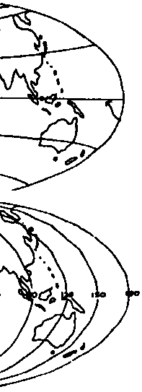
Key Concepts
1. Safety and survival at sea depend on weather and sea conditions, sea worthiness of a vessel and thinking skills of the crew.
2. Speed, time, and distance can be calculated for storms and vessels.

Background

Weather affects life, be it the migration of California gray whales or the crew on board a fishing boat in the Bering Sea. Throughout most of history, weather forecasting efforts at any given site depended solely on observations that could be made at the site. Observations of sky, wind, and temperature conditions and a knowledge of local climate history did not always yield accurate predictions.

All weather information for a particular area is derived by a local weather station. Average daily high and low temperature values, wind and humidity values are determined, and the daily rainfall and snowfall values are totaled, along with the number of days with rain, thunderstorms, freezing temperatures, and clear or cloudy skies. This information helps meteorologists understand weather patterns and aids them in predicting future weather. By studying weather records, atmospheric scientists are able to predict the weather ahead on scales of weeks to months with greater accuracy.

Meteorological observations taken around the world include reports from surface stations, ships at sea, aircraft, radar, and meteorological satellites. All of these reports are transmitted on the Global Telecommunications System (GTS) of the World Meteorological Organization to regional and global centers. There the data are collated, redistributed back across the GTS, and used in various numerical forecast models.

With the advent of satellites, communication of weather information to ships at sea has improved dramatically. As the accuracy of weather prediction, especially in regard to severe weather, increases, the safety of those who make a living on the world’s oceans will increase.

Materials

Parts 1 and 2

For each student:

• “Storm Tracking Chart 2”
• “Storm Warning” student activity pages

For the class:
• world maps, atlases, globes, and sea charts

Part 3

For each student:

• “Starfisher’s Last Voyage” student pages

Teaching Hints

The weather conditions our gray whale encounters in the Bering Straits in “October 1” provide a springboard for the activity “Storm Warning”, a three part activity:

Part 1 begins with a discussion of latitude and longitude coordinates and then provides a storm tracking chart on which your students will locate fishing boats and plot the course of a storm in the North Pacific Ocean. It familiarizes students with marine weather advisory terminology.

Part 2 involves them in weather predictions as they analyze the storm tracking chart and give advice to a fishing boat. Students learn to determine the time that a storm or vessel will arrive at a point from knowledge of its speed and distance.

Part 3 presents a factual history of a near disaster at sea in the story “Starfisher’s Last Voyage”. It encourages students to think about safety at sea. Many boating accidents could be prevented if boaters were prepared for emergencies before leaving port.

If your students need practice using coordinates to find locations, you might obtain grid maps of nearby hiking areas or have your students make a grid map of your school yard. Whether on land or at sea, grid coordinates and latitude and longitude lines are useful to travelers, scientists, amateur naturalists, wildlife enthusiasts, and others.

World maps, an atlas and a globe provide useful teaching aids for Parts 1 and 2. The concepts of latitude and longitude are most easily seen on a globe. You will likely need to provide a refresher in plotting techniques and the use of degrees in numbering latitude and longitude.

Duplicate the activity pages. One set is recommended per student. To save resources class sets of reading materials can be used by several classes. Parts 1 and 2 are best performed by individuals or pairs. Part 3 can be an in class or homework assignment. It is possible for your students to complete all three parts as either in-class assignments or as homework assignments. The method you select will depend upon the needs and expertise of your particular class.

Procedure

Introduce the activity by asking students to tell or write about a time when they were lost or caught in a storm, whether on land or at sea. Have them tell how they found out where they were, what emergencies were they prepared for and how they survived the ordeal. Next, tell them the activities they are about to do will help prepare them for survival at sea. Anyone who goes whale watching or researching on the water is likely to encounter a storm and the possibility of sinking. With some knowledge and preparation, seafarers increase their chances of survival.

Have students complete Parts 1, 2, and 3. Upon completion, plan to provide time for a discussion of the concepts presented. During your discussion provide the correct answers to the questions found in the student text pages.

If you are using the “Voyage Of The Mimi” in conjunction with this curriculum, “Episode 8: Tracking the Whale” correlates with this lesson.

Key Words

bearing - direction or relative position

bilge - an enclosed area between frames of a boat hull where seepage collects

bridge - a raised platform from which a power vessel is operated

Greenwich, England - the location from which geographic longitude is measured

knot - a unit of speed equal to one nautical mile an hour, about 1.15 conventional miles per hour

latitude - the angular distance north or south from the equator of a point on the earth’s surface

line of meridian - a great circle of the earth passing through the poles and any given point on the earth’s surface

longitude - angular distance east or west on the earth’s surface measured by the angle contained between the meridian of a particular place and some prime meridian such as that passing through Greenwich, England

prime meridian - the meridian running through Greenwich, England and from which longitude east and west is reckoned

strait - a narrow body of water separating two large bodies of water

swells - waves

Extensions

1. Visit a nearby weather station.

2. Build a class weather station. Obtain or make a wind speed indicator, rain gauge, barometer, and thermometer.

3. Have students record and chart daily temperatures, barometric pressure, wind speed and direction, rain or moisture levels. Also record weather reports from regional weather stations, perhaps from airports, coast guard bases, and news stations. Begin to predict weather for your area.

4. Have a guest speaker who has experience boating on the ocean in storms visit your classroom.

5. Use “Key Words” in a class story about a storm at sea. Have one student select a word and use it in a beginning sentence. The next student selects a different word and uses it in a sentence to continue the story. This can be done in small groups or as a whole class.

Answer Key

Text questions

1. Latitude lines tell us the distance (in degrees) north or south of the equator.

2. Longitude lines tell us the distance (in degrees) east or west of Prime Meridian.

3. The following chart shows the correct positions for the fishing boats.

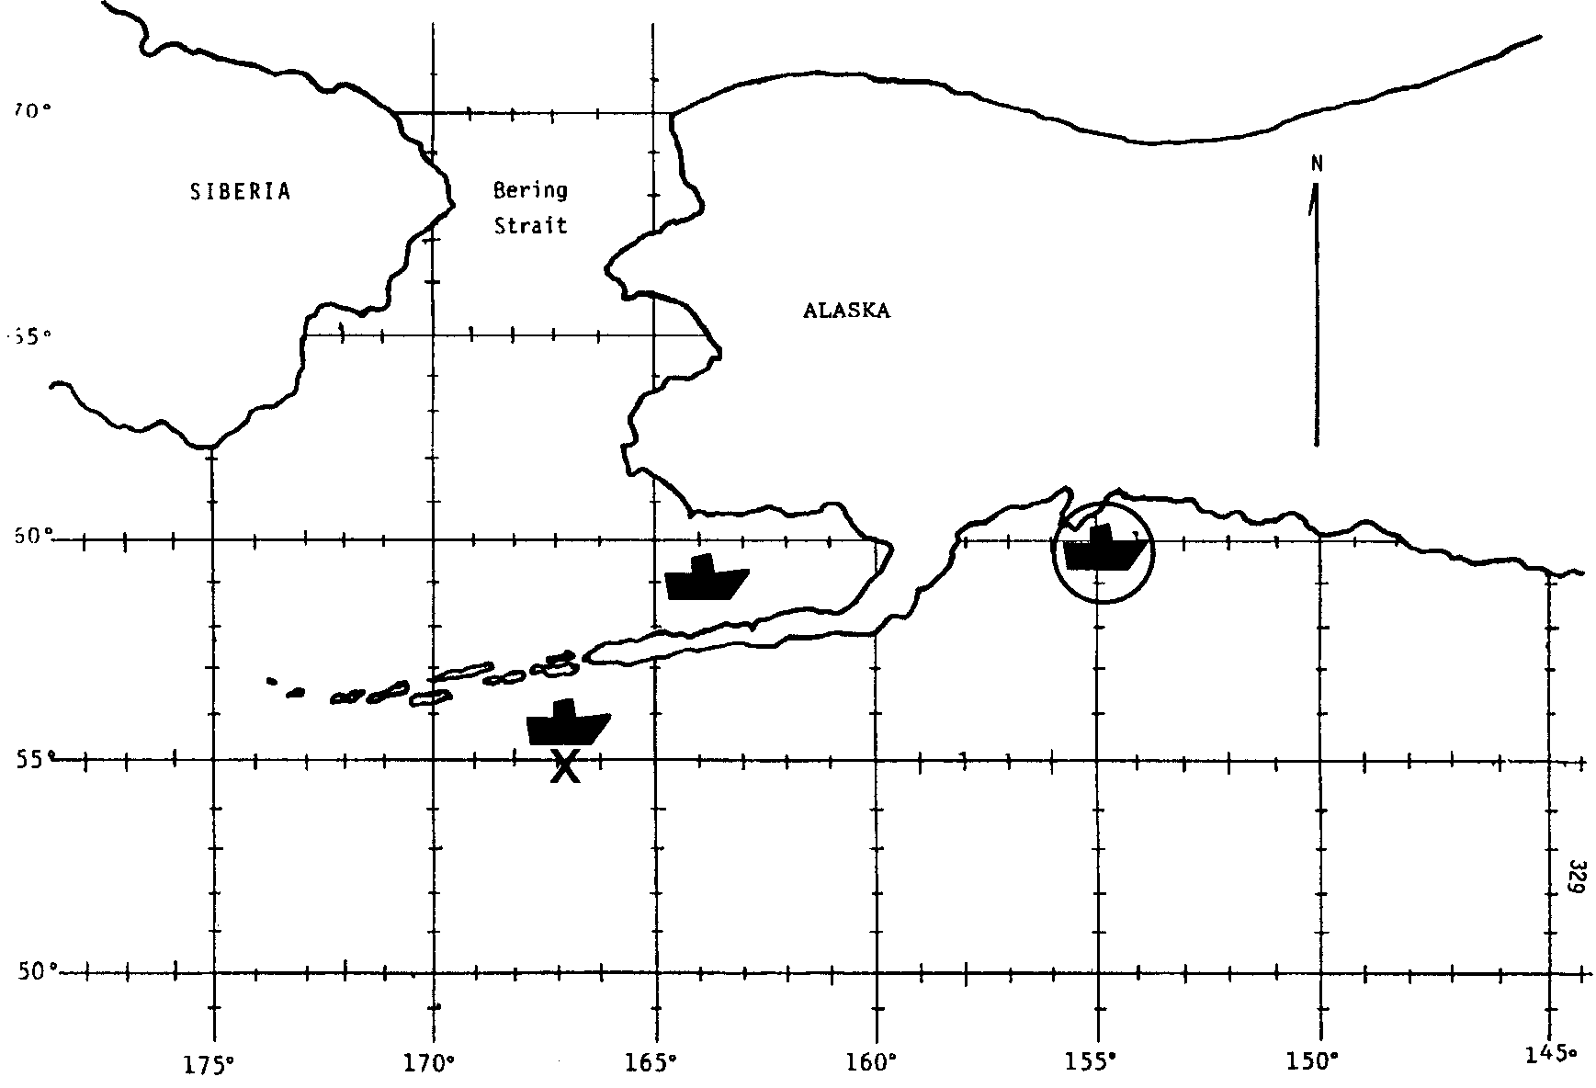
Part 1

2., 3., 4., 5. A correctly completed storm tracking chart follows this section.

6. a. The storm will begin going through the strait on October 31.

b. The storm will have a greater effect on the whales because they must come to the surface to breathe.

Part 2

1. a, b. A correctly completed storm tracking chart follows this section.

2. a. At 12 miles per hour it will take the Lady Mary about 3 days to reach the Bering Straits.

864 miles
(i.e., 12 miles/hr. x 24 hrs./day = 3 days

b. The storm tracked in Part 1 will reach the Bering Straits on October 31. (This question was already answered in 6. a. above but is repeated here to set the stage for the next question.)

c. Hopefully, your students will advise the skipper of the Lady Mary to alter their course and return to a weather-safe port.
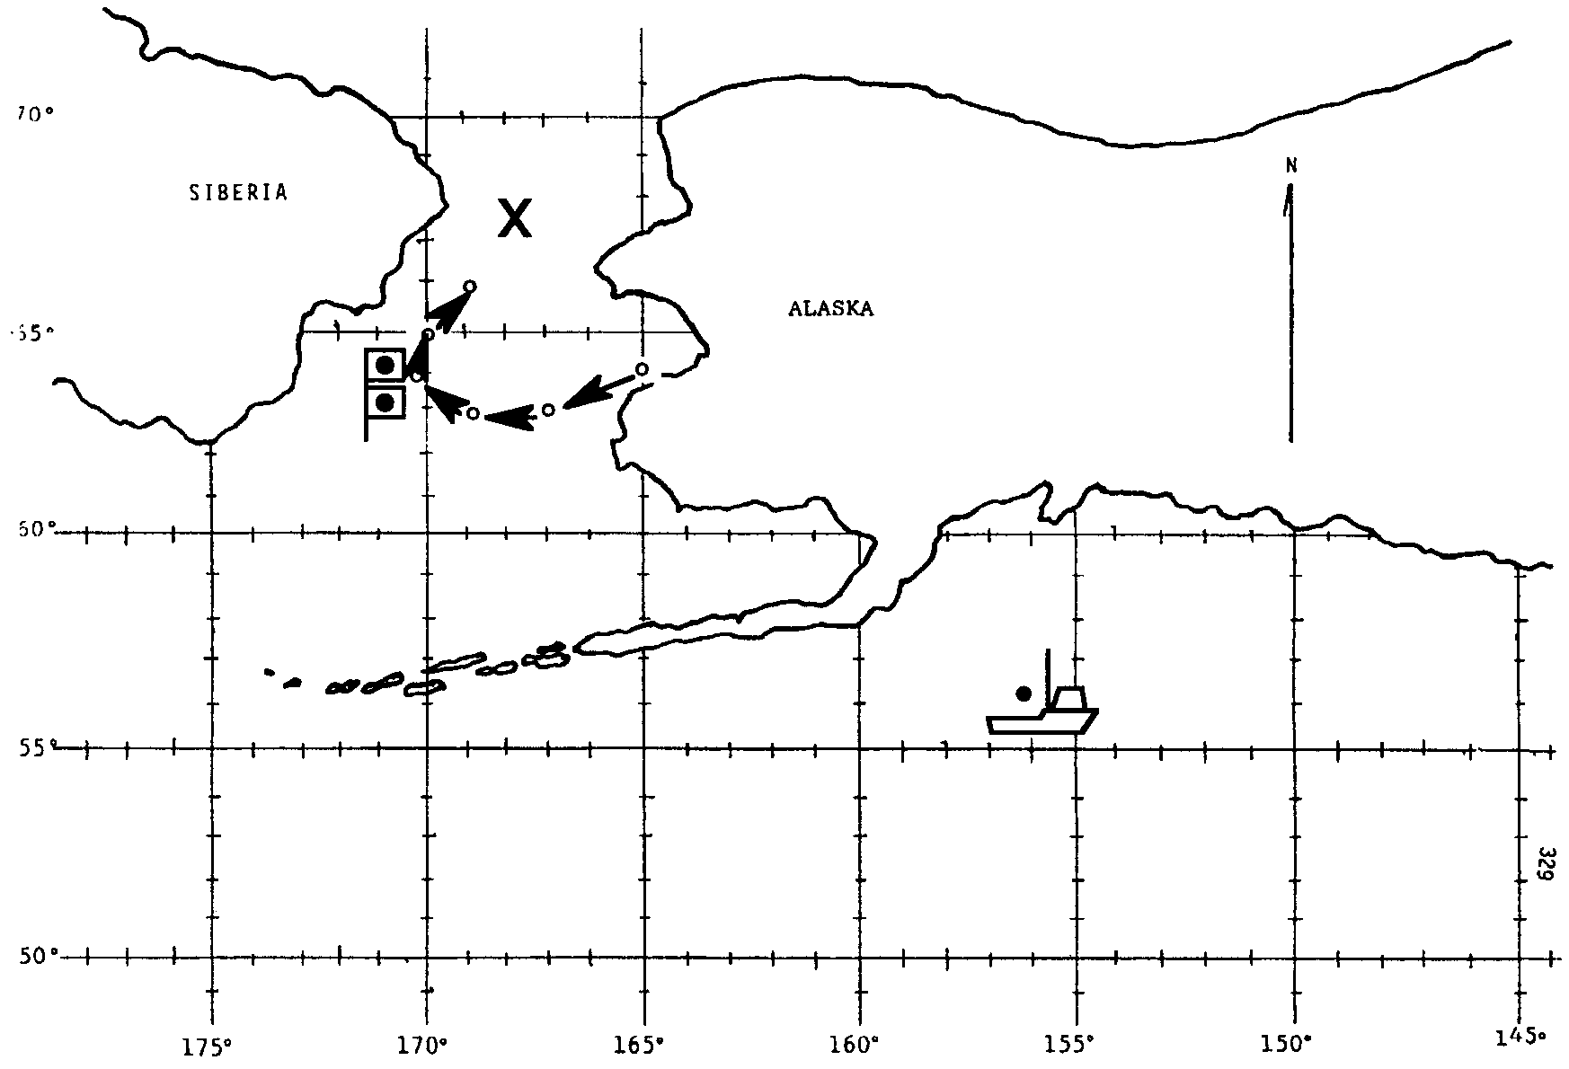
Storm Warning - Part 3

1. This question provides those “weather observers” who advised the Lady Mary to sail on a chance to change their advice. This story was included to show the very real power of the sea and the danger that can lie therein.

2. A number of actions might have helped. Pre-trip maintenance and checks would have prevented most of the problems. Also:

• A temporary patch over the hole on the inside might have slowed the inflow sufficiently to let the bilge pump empty the boat.

• A temporary patch made of plastic sheeting could have been put over the outside.

• Knowing the proper radio techniques for calling for help might have helped. Call “MAY DAY MAY DAY.” Give the boat’s name and description, position, and nature of difficulty. Then get off the air.

• Today commercial vessels must meet Coast Guard standards for safety. They must have the proper electronic equipment such as EPRB (Emergency Position Radio Broadcaster) that sends a position signal if a boat is sinking. They must also carry cold water survival suits and proper life rafts and flotation devices for the seas they will fish in. Operators are required to have up to date emergency first aid certification and to hold regular training sessions for emergency procedures aboard. For a complete up to date list of emergency and safety requirements write or call the U.S. Coast Guard.

Your students will have many other ideas. The following “points to ponder” come from the Oregon State University publication “Starfisher’s Last Voyage”, by Edward J. Condon, from which the material in the student text is excerpted.

Points to Ponder

1. What went wrong on Starfisher? The seam probably opened because the Barlows had not had her recalked in quite a long time. Wood boats need continual tender loving care. Without it their enemies --“dry rot” (really fungi), marine borers, normal wear and tear-- inevitably will put them in danger of sinking.

2. Could the Barlows have stopped or slowed the flooding? They should have stuffed the open seam from the inside, with rags, paper, anything that could plug the hole; then they should have nailed a temporary patch in place until they could make port. They could have slowed the leak considerably just by lashing a canvas, heavy plastic sheet, tarp, or even bed sheet to the outside of the hull, over the open seam.

3. What went wrong with the bilge pump? Why? Bilge suction is normally located at the low point of the bilge. Unless you take the pains to clean the bilge, you can count on clogging the bilge pump. In most hulls, the suction is located where it is difficult to clear when it does become fouled. The best precaution is to keep bilges clean.

4. What lessons can be learned from the missing standby pump? The obvious lesson is not to go to sea until quick checks ensure that all life-sustaining equipment is indeed on board and in working order.

5. What went wrong with the lifeboat? Two strong probabilities are: (a) in their excitement, the Barlows forgot the drain plug in the bottom of the lifeboat (This plug is normally kept out when a boat is out of water for long periods), or (b) if the lifeboat had sat on deck for a long time, the sun had dried (shrunk) the calking.

6. What happened to Starfisher’s radio? Perhaps nothing. Most likely, this was another example of poor maintenance: the brothers had probably not maintained the radio properly over the years. Marine radios are extremely reliable but do need periodic service checks by qualified electronics technicians. Then, what channel did Tim use for his distress message? Was it one of the International Distress Frequencies, which are monitored constantly by all U.S. Coast Guard stations (and by most ships and many boats at sea)?

7. Did Tim use the radio distress code word (the word that alerts all listeners for the message to follow)? It’s MAYDAY, MAYDAY. Next proper procedure calls for giving the name of your vessel, your approximate position, and the nature of your difficulty. Don’t jam the radio by transmitting continuously. Repeat your message twice every 10 minutes or so, and get off the air so someone can acknowledge your call.

8. What are the visual and audio signals for a boat in distress in daylight hours? At night? Visual signals: In daylight, flying the flag upside down is a generally recognized distress signal. At night, use a light to flash the Morse code letters SOS (short-short-short...long-long-long...short-short-short), repeated over and over again. Point the light directly at the other ship, boat, or airplane--or at houses on the beach. A lighted flare is a distress signal. Audio signals: Ringing your boat bell and blowing your horn are distress signals if someone is close enough to hear them.

9. Why didn’t the large ships stop and assist? Ships see thousands of boats on any given voyage. Unfortunately for the Barlows, many boats at sea flash lights at ships at night, just to ensure that the ships see them--and won’t run them down. In this case, the two freighters would have stopped if they had received an SOS by light, had seen a red flare, or had heard the whistle and bell--or (better yet) had both seen light and flares and heard whistle and bell.

10. Where were the life jackets? Like other seldom-used equipment on Starfisher, the life jackets were probably stowed in some forgotten nook, and had not been inspected in years.

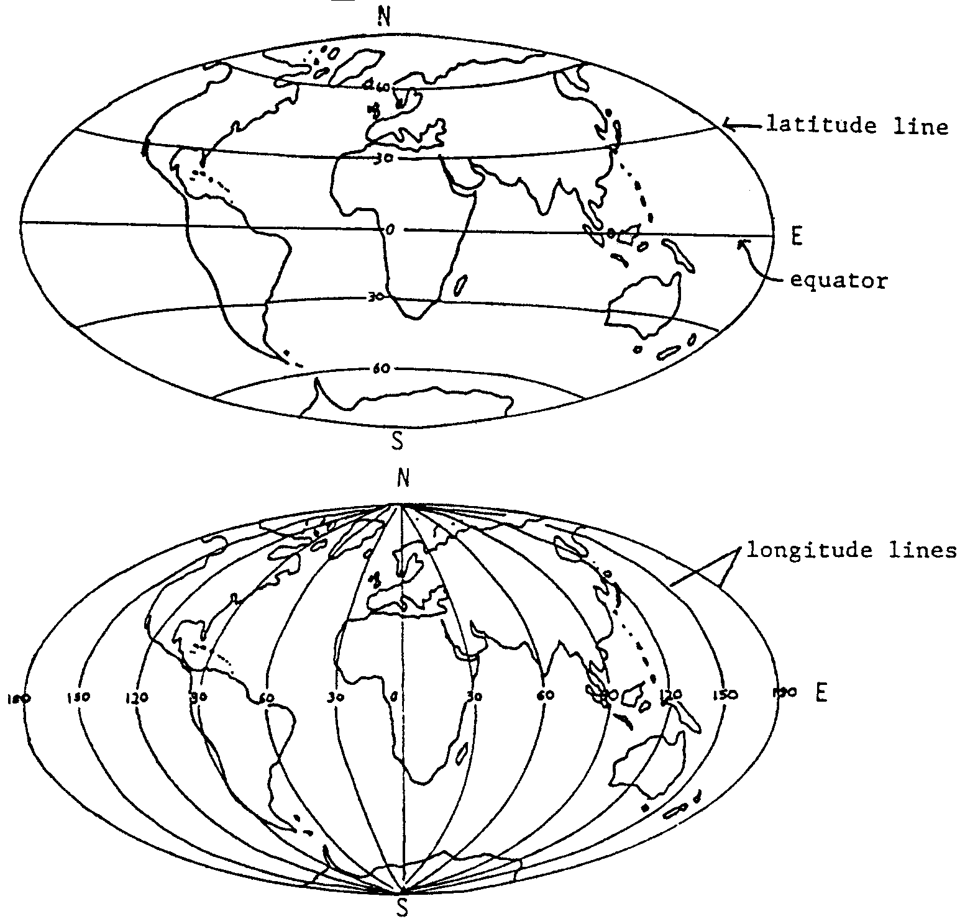
Storm Warning

Whales are not the only animals that race the ice to the Bering Strait. The crew of the ice-breaker Polar Star also turns south. As a mobile weather station, the Polar Star provides information to other ships in the area.

The Coast Guard crew on board the Polar Star broadcast the positions of storms. A message from the Polar Star saying “There is a storm centered 100 miles from here” would be of limited use. Where is “here”?

To help mariners locate their position, imaginary lines are drawn over the surface of the earth. These imaginary lines are called latitude and longitude. First a line called the equator is drawn halfway between the north and south poles. Evenly spaced lines are drawn parallel from the equator to the north pole and to the south pole. These evenly spaced latitude lines tell us the distance north or south of the equator

Longitude lines are drawn from the north pole to the south pole. Notice on the picture above that longitude lines are not parallel. They get closer together as you leave the equator. Longitude lines tell us east and west distance.
Latitude and longitude coordinates are given in terms of degrees. The zero latitude line is the equator. We can give a part of a location as “ten degrees north latitude”. The words “north latitude” tell us the location is north of the equator. The words “ten degrees” tell us how far north of the equator.

1. What information do we get from latitude lines?

2. What information do we get from longitude lines?

The zero longitude line is called the “Prime Meridian” because it is the “primary”, or “first”, longitude. Prime Meridian runs through Greenwich, England. We can give a part of a location as “10 degrees west longitude”. This tells us how far the location is west of Prime Meridian.

Latitude and longitude readings are called “bearings”. A combination of latitude and longitude bearings will pinpoint any place on earth. For example, there is only one place that would have a bearing of twenty-two degrees north latitude, eighty-eight degrees west longitude (22° N 88° W). The latitude number (coordinate) with its direction north or south is always written first. The longitude coordinate with its direction east or west is written next.

3. The “Storm Tracking Chart 1” (map) on the following page shows the North Pacific coastline. Three crab boats are fishing at the following points:

60 ° N 155 ° W 56 ° N 167 ° W 59 ° N 164 ° W

a. Draw each of the three crab boats in its proper location.

b. Circle the boat that is furthest north.

c. Make an X below the boat that is furthest west.

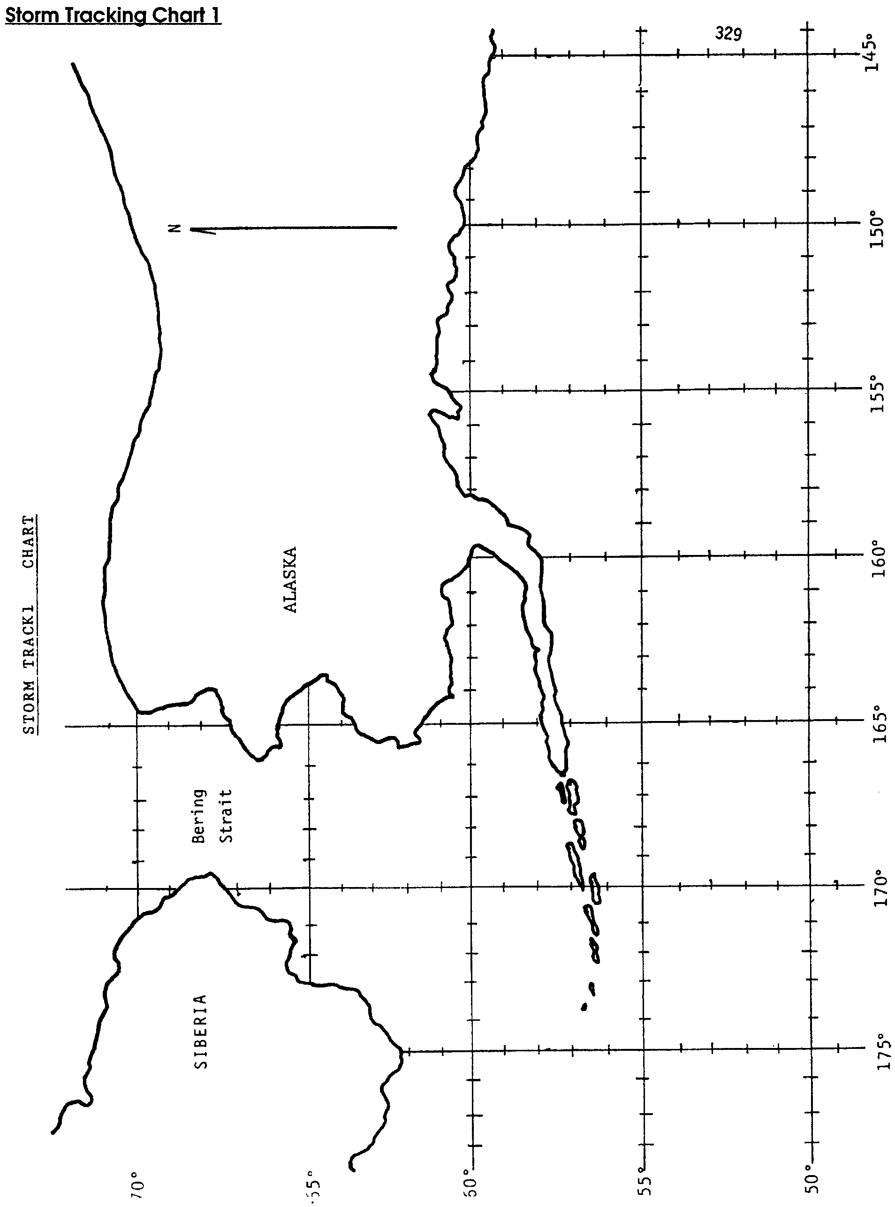

Just as you pin-pointed the location of the fishing boats, weather watchers can pin-point the location of storms. In this activity you will have a chance to see how weather information is provided to boaters. You will also have a chance to see how important it is for mariners to be aware of weather and prepared for changes.

Part 1

Materials
• storm tracking chart
• pencil

Procedure

1. Obtain “Storm Tracking Chart 2” which shows the shoreline of the North Pacific Ocean. Use the chart to answer these questions and solve these problems.

2. The Polar Star is watching a storm moving into the Bering Strait. They have broadcast the following positions for the center of the storm:

October 29 - midnight 64 ° N 165 ° W
noon 63 ° N 167 ° W

October 30 - midnight 63 ° N 169 ° W
noon 64 ° N 170 ° W

October 31 - midnight 64 ° N 170 ° W
noon 66 ° N 169 ° W

Plot these positions on your storm tracking chart. Plotting is easy. Here’s what to do:
a. Find the location of the storm at each time.
b. Make a dot on the map at that location.
c. Write the date and time at each location.

3. Connect the dots from midnight October 29 through noon October 31 to see the path of the storm.

4. The speed at which a storm moves tells something about its winds. Wind speed, however, is usually greater than the speed at which the storm moves. The weather service displays storm warning flags to alert mariners. Most mariners use radios for broadcasts of up-to-date marine weather information. They also use their radios to monitor or call for updates between broadcasts. The following warning flags and radio information alert mariners to wind conditions.

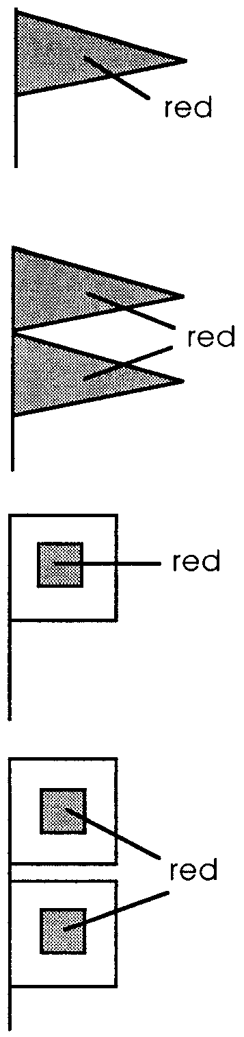
Small Craft Advisory: One red pennant flying indicates winds from 21 to 34 knots. (24 mph to 39 mph)

Gale Warning: Two red pennants indicate winds from 35 to 47 knots. (40 mph to 54 mph)

Storm Warning: One red flag with a black center indicates winds 48 knots and above. If the winds are associated with a typhoon or hurricane, the storm warning flag indicates winds from 48 to 64 knots (55 mph to 72 mph)

Hurricane Warning: Two red flags with black centers are used only in connection with typhoons and hurricanes to indicate winds 64 knots and above. (above 72 mph)

5. On October 30 the Polar Star detects 65 knot winds at noon bearing. On your storm tracking chart, draw in the warning flag the weather service would use to alert mariners.

6. Gray whales are moving through the Bering Strait as the storm approaches.

a. On approximately what day will the storm begin going through the straits?

b. Will the storm have a greater effect on the whales or on the fish in the straits? Why?

Part 2

“Polar Star”, this is Whiskey X-ray Tango two five, the Lady Mary, requesting a weather check.”

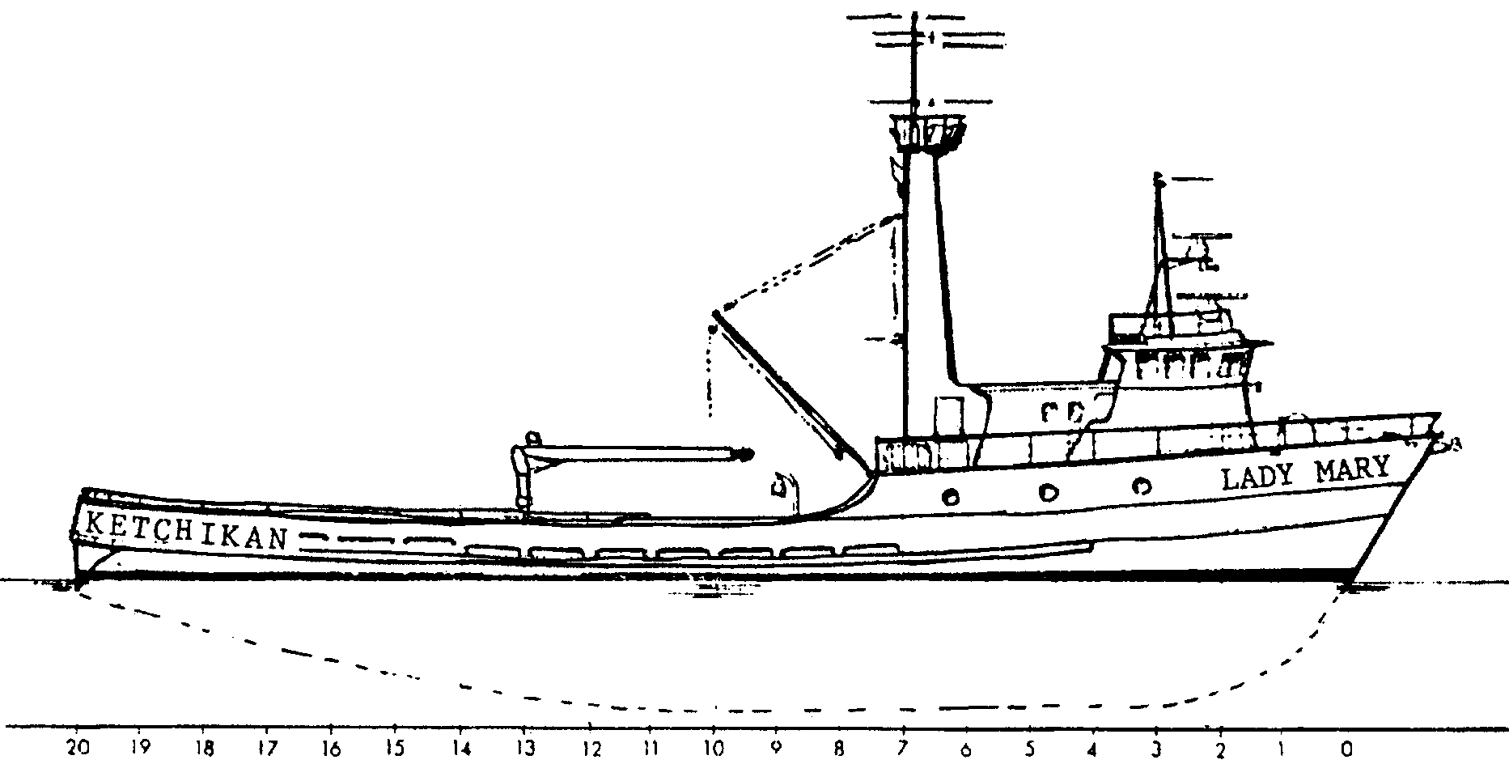
1. WXT 225, Lady Mary, is a 130 foot crab boat out of Ketchikan, Alaska bound for the Bering Strait. Its position at noon on October 29 is 56 ° N 161 ° W..

a. Mark the position of the Lady Mary on the storm tracking chart you used in Part 1 (“Storm Tracking Chart 2”).

b. Put a small X on the center of the Bering Strait.

2. The Lady Mary cruises at 12 miles per hour. Her position puts her about 864 miles southeast of the Bering Strait.

a. At her cruising speed, how long will it take her to reach the strait? (Hint: To work this problem boaters remember the formula as “D Street” or “D ST”. It means Distance = Speed X Time. Since your know the Distance, divide it by the Speed to find out the Time it will take to cover that distance.)

b. When will the storm tracked in Part 1 reach the Bering Strait?

c. As weather observer on the Polar Star what advice would you offer the skipper of the Lady Mary?

Part 3

Materials

• story, “Starfisher’s Last Voyage”

Procedure

The crew of the Lady Mary run a “tight ship.” Not all fishermen do the same. The story, “Starfisher’s Last Voyage”, is based on fact. Read the story then answer the questions.

1. Would you like to change the advice you gave to the skipper of the Lady Mary in Part 2 step 2. c.? If so, what is your new advice?

2. What are three actions that the Barlow brothers might have taken to increase their survival chances?

a.

b.

c.

