Ice Rescue - October 1988
Lesson by Kay Addington-McDonald, Port Angeles, WA

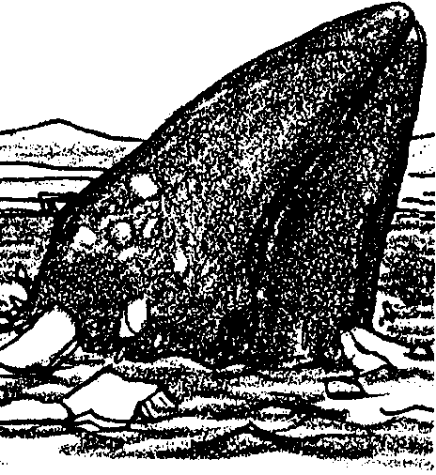
Key Concepts
1. Rapidly freezing arctic ice can trap marine mammals.
2. The rescue of trapped marine mammals requires decisions about the use of resources, including people, equipment, time, and money.

Background

In October, 1988, the world watched as efforts were made to free three California gray whales which had become trapped by rapidly freezing arctic ice. After heroic efforts, two of the whales were freed through an unusual cooperation of people and technology. Knowledge and technology from different sources influenced the success of the rescue mission. Private companies, public agencies, individuals, cultural groups, and governments, and nations contributed to the success of the event.

After the rescue, many people wondered if it was worth the money and time spent by all the governments and public and private organizations. Some people think that saving two gray whales was not worth the money and time. They feel that the organizations should have committed their limited resources to more pressing problems facing endangered species or human needs. Others argue that saving the whales was important because it focused worldwide attention on the environment.

While periodicals from the time of the rescue are replete with articles about the event, an account based on a talk by Mark A. Fraker, Senior Environmental Scientist for British Petroleum Exploration, (Alaska), Inc. presented at the American Cetacean Society conference in Monterey, Ca, in November, 1988 provides an excellent overview. The presentation was subsequently published as follows:

Fraker, Mark A., “A Rescue that Moved the World”, OCEANUS, Vol.32, No. 1. Spring, 1989.

Materials

For the class:

• 1 copy of the time line cut apart per date

• pieces of masking tape, one for each date

• chalk board or strip of butcher paper

• large pieces of butcher paper for charts and lists

For each student:

• “Ice Rescue - October 1988” activity pages

Teaching Hints

In “Ice Rescue - October 1988”, students make a time line of an account of three whales trapped in arctic ice that were freed by cooperative efforts of diverse people. They chart technology and thinking skills used in the rescue. Then they list “pros” and “cons” of using the resources involved and finally write a newspaper article or speech outlining their interpretation and analysis of the event, including their opinion about the rescue.

Duplicate the student text. Make one extra copy of the time line. Draw a line on the chalk board or butcher paper to be used for a large time line that the class will create in a group activity. Have students read their copy of the entire time line text as an in-class assignment or homework after the group activity to reinforce the concepts.

Procedure

If you select to make the time line as a whole group activity, cut the extra copy of the time line into sections along the dotted lines Give each student (or small groups of students) one section. Give a brief oral introduction to the problem. Then, find out who has the first date on the time line. Have that person read the date and the action (text) and tape the text at the left edge of the chalk board or butcher paper. Write the date in large letters next to the text. Proceed to the next date and so on until the time line is complete. Discuss the development of problems and strategies for solving them as you go through the time line and as a follow up.

You may prefer to have students work in groups of 3 or 4 students, each creating a separate time line. Have students simultaneously create a list of the problems and strategies for solving them as they go through the time line. Follow up with a brief classroom discussion.

If you are using the “Voyage Of The Mimi” in conjunction with this curriculum, “Expedition 8: World’s Worst Weather” correlates with this lesson.
Key Words

auger - a boring tool, in this case for making holes in the ice

ice floe - a large flat mass of floating ice

Inuit - a member of the Eskimo peoples inhabiting northern-most North America

pack ice - a large area of floating ice formed over a period of years and consisting of pieces of ice driven by wind, currents, etc.

shoal - a place where the sea or other body of water is shallow; sand bar

Extensions

1. Have students make a map of the region in which the rescue took place.

2. To expand understanding of the technology involved in the rescue, have students choose one piece of equipment (helicopters, ice breakers, de-icers or chainsaws) involved in the rescue; go to the library to find out about it; and, finally, make a display or write a report about the equipment.

3. Have students write and illustrate a story about the rescue from the perspective of one of the whales.

4. To demonstrate the different freezing of salt and fresh water, have students make an ice tray of fresh water and one of salt water. Have them put one food color in the tray of freshwater and another in the tray of salt water. Put the trays in the freezer at the same time and have students observe how long it takes for each one to freeze hard. Later thaw them both at the same time, having students observe how long it takes each to completely thaw.

5. Have students research ice fishing techniques or ice rescues in history, then compare and contrast the techniques to those used to free the whales.

6. Try recreating the time line with illustrations rather than text.

7. Have students write a script about the rescue for a play and, then produce the play.

Answer Key

Text questions

1. The whale probably uses blubber as an energy source to keep her swimming.

2. Answers are likely to vary. Since the question calls for an opinion, accept any answer. The question is included to start students thinking about the social issues involved in an attempted gray whale rescue.

Interpretation and Analysis

1., 2. Developing the chart may be done as a whole class, in small groups or individually. Have students reread the time line and then brainstorm to find answers. On a large piece of butcher paper, chalk board, or overhead projector, demonstrate how to chart technology and thinking skills as indicated in the student questions. Also show how to list “pros” and “cons”. List and discuss student responses objectively. Be sure all ideas are noted before evaluating them. Encourage students to respect each others views even though they may not agree.

3. Answers will vary. Plan to share the students’ newspaper articles in a publication or on a bulletin board and hold a forum for their speeches.

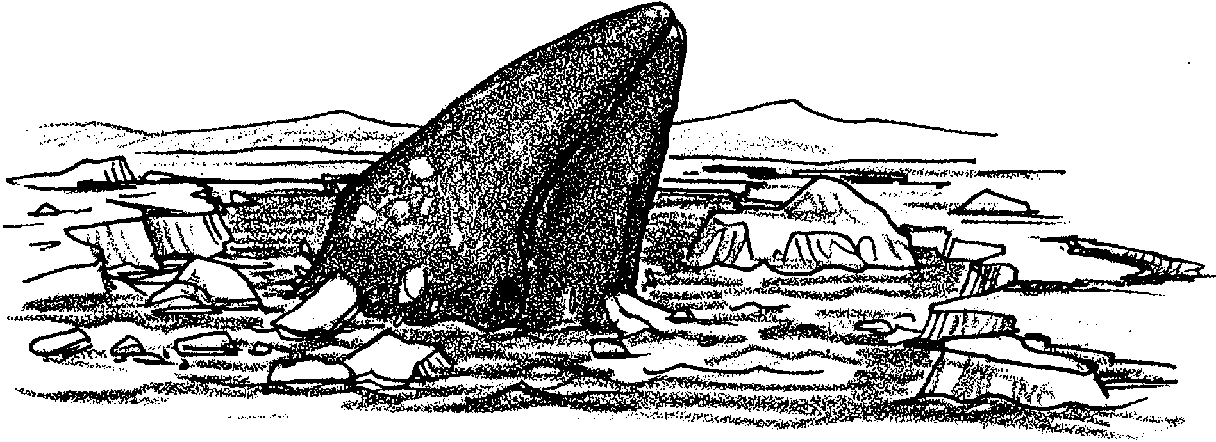
Ice Rescue - October 1988

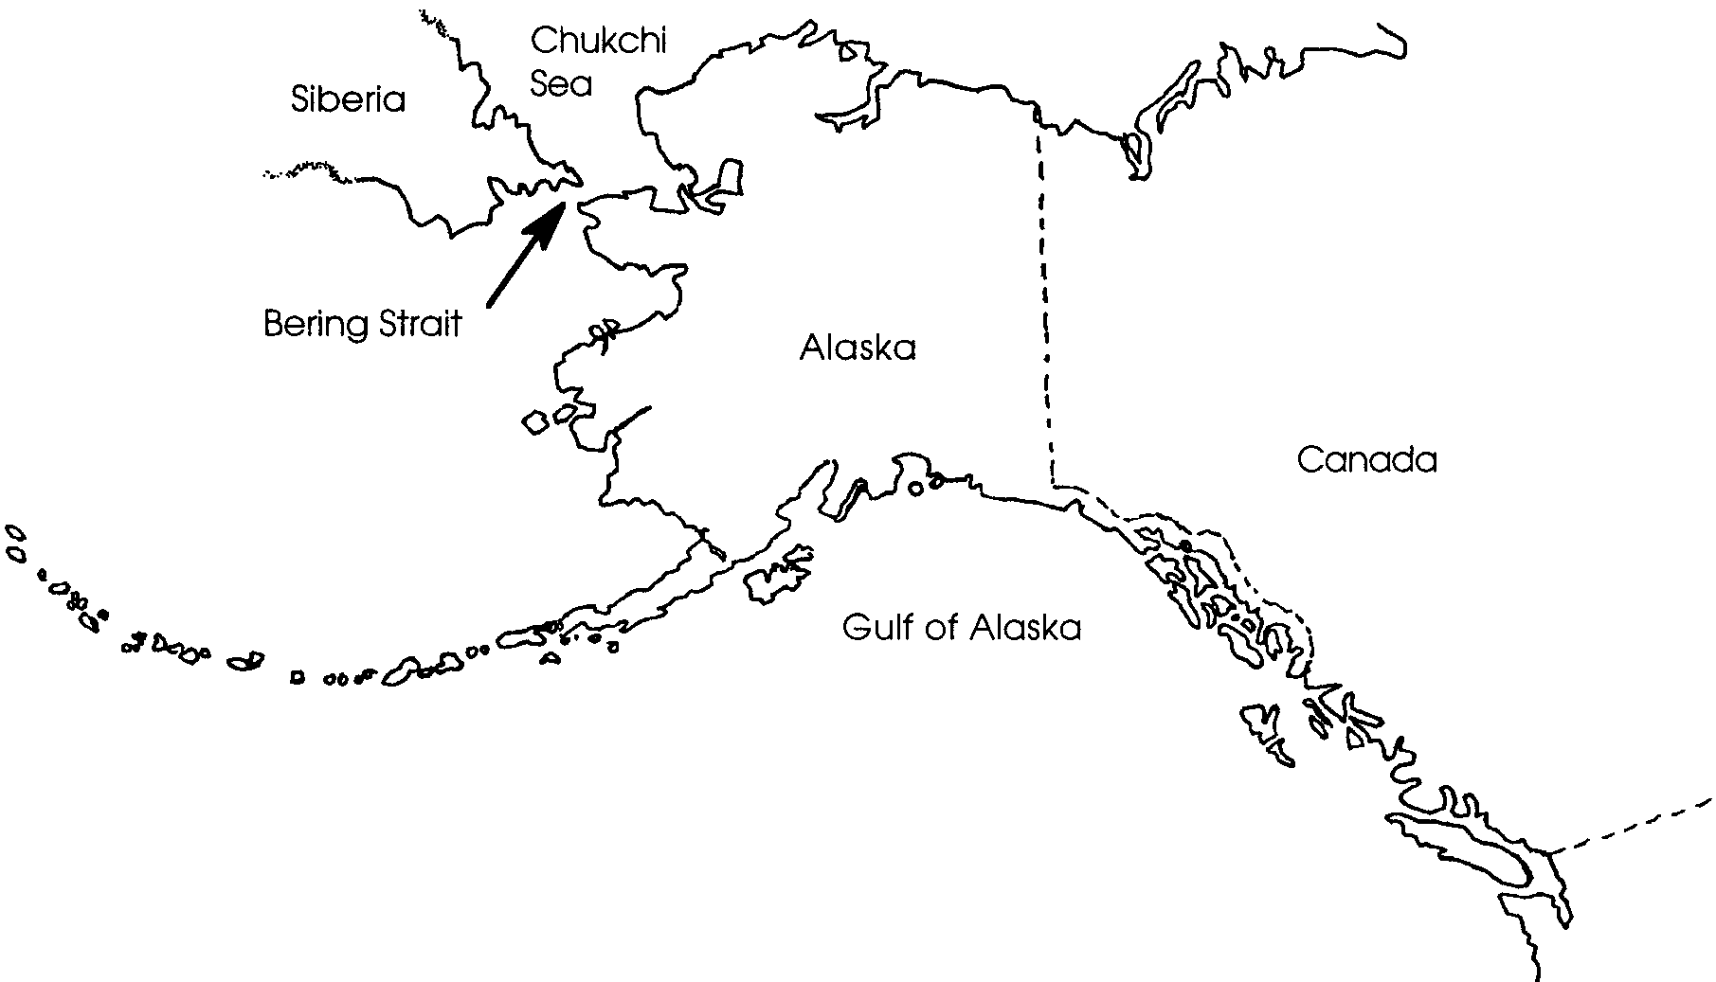
Along Siberia’s shallow coasts, our whale swims eastward through the Chukchi Sea. The sun is low on the horizon. Only a few weeks remain if she is to get through the Bering Strait before the bitter storms.

Each day brings more flurries of snow. The noon sun is cold and lifeless. Soon these waters will be covered with a thick layer of ice. Our whale is now swimming with other gray whales and minke whales. All are racing the ice to the narrow straits. The land turns to the south. The whales also turn south and pass through the strait in to the Bering Sea.
1. During her swim through the Bering Strait our whale does not eat. What does she probably use as an energy source to keep her swimming?

All around the Arctic Circle whales begin to move south. Temperatures drop. The pack ice expands and thickens rapidly. The whales must leave the arctic waters. What is their fate if they stay behind?

In October, 1988, three young gray whales lingered in the icy waters. Floating ice froze to floating ice forming a wall of ice. The whales were trapped by the pack ice. Roy Ahmaogak, an Inuit hunter, discovered the whales surrounded by ice. News of the whales spread quickly. Efforts to rescue these whales captured the attention of the world. In the following activity you will see how the world responded to the plight of these whales.

2. Before you continue, think about these whales. What do you think people should do?

Read on to find out what really happened.

Time Line of Events and Actions

7 October - Roy Ahmaogak, an Inuit hunter, discovered the whales surrounded by ice. The whales were just north of Plover Point, about 10 miles from Barrow, AK. The news spread quickly through Alaska. Then it was broadcast across the U.S. It soon spread around the world.

The whales were breathing through two holes in the ice, about 100 yards apart. Floating ice attached to the shore blocked some escape routes. A heavy, ice-ridge nearly a half-mile wide blocked the others. To reach open water, the whales would have to pass through this ice ridge.
---------------------------------------------------------------

12 October - Mark A. Fraker, Senior Environmental Scientist for British Petroleum (BP), read about the whales in a newspaper article.
He quickly realized that the whales needed a path to freedom dotted with holes for breathing. They would have to reach open water quickly in order to swim south. Soon, even the open water would be frozen with pack ice.
---------------------------------------------------------------

13 October - Susan Miller, Public Affairs Manager for BP Exploration Alaska, phoned Mr. Fraker. She asked what could be done to save the whales. Mr. Fraker felt nothing practical could be done. The arctic weather was severe and the location was remote. He suggested letting nature take its course.
---------------------------------------------------------------

15 October - People began to take actions to try to rescue the whales.

a. George N. Nelson, President of BP Exploration (AK),Inc., got on the phone. He asked Mark Fraker and Frank Baker, Public Affairs Associate, to go to Barrow and help with the rescue.
---------------------------------------------------------------

15 October - People began to take actions to try to rescue the whales.

b. The National Oceanic and Atmospheric Administration (NOAA) began working with ARCO Alaska and Veco, Inc. at Prudhoe Bay. They wanted to mobilize a “hoverbarge”. A hoverbarge is a heavy boat that could break the ice. It might even be able to cut a path to open water for the whales to escape.

They had two problems. The hoverbarge had not ben used for several years. It could only be moved by a large helicopter. In Alaska only the National Guard had such a powerful helicopter, a CH-54 Sky-Crane.
---------------------------------------------------------------

15 October - People began to take actions to try to rescue the whales.

c. Alaska Senator Ted Stevens considered the rescue group’s appeal, then contacted the Pentagon.

d. The Pentagon thought about the rescue mission. They quickly decided it would make a good training exercise for the National Guard. Soon two Sky-Cranes flew to Prudhoe Bay. A UH-1N Huey helicopter was sent to Barrow to help rescuers. It would transport people and equipment.

---------------------------------------------------------------

15 October - People began to take actions to try to rescue the whales.

e. Rescuers named the whales and estimated their age and size:
•“Bone” was 9 months old, 25 feet long, and 10,000 pounds.
•“Bonnet” was 9-21 months old, 27-29 feet long, and 14,000 pounds.
•“Cross” was 2.5 to 3.5 years old, 33-35 feet long, and 20,000 pounds.

---------------------------------------------------------------

17 October - Mark Fraker and Frank Baker arrived at the scene. They began working with four men from the local Department of Wildlife Management. Together, they used chainsaws to enlarge the holes. The holes had to be kept open for the whales. As they worked they glanced toward the sky, looking for the hoverbarge.
---------------------------------------------------------------

18 October - Rescuers enlarged hole number one. They also created two new holes about 40 to 60 paces from hole number two. The whales did not use the new holes.
---------------------------------------------------------------

19 October -

a. The day was spent enlarging hole number 2.

b. The temperature dropped. Snow swirled in the air. Ice formed in the holes faster than it could be shoveled out. Rescuers returned to Barrow Search and Rescue Center.
---------------------------------------------------------------

19 October -

c. Two men from Kasco Marine in Lakeland, Minnesota arrived in Barrow that afternoon. They brought de-icing machines. They had offered the machines earlier in the week. Their offer had been politely refused. They came anyway. People gathered generators and extension cords. The helicopter flew the men and equipment to the site. The first de-icers began working at about midnight.

De-icers are electric motors with a propeller. The propeller is inside a protective wire cage. They work because salt water freezes at a lower temperature than fresh water. The propellers replace cold fresh surface water with salt water. If surface water can be replaced before it freezes, a hole can be kept open.
---------------------------------------------------------------

19 October -

d. The whales continued to use hole number 1. They used it even when the first de-icer was working there. In fact, they showed an interest in the machine. When the second machine was placed in hole number 2, the whales entered that hole within minutes.
---------------------------------------------------------------

20 October - Rescuers tried an experiment. They noticed that the whales were attracted to the sounds of the de-icers. Perhaps, they reasoned, the whales would follow the sounds of the de-icers to new holes. If so, the rescuers could cut a path of holes to freedom.

Workers cut two new holes in the ice. Hole number 3 had frozen over. They cut hole number 5 next to it. Hole number 6 was cut beyond 5.

Then they shut down the de-icers in holes number 1 and 2. The whales entered hole number 5 within 15 minutes. After a normal series of breathing the whales returned to hole number 1. They had not moved on to hole number 6.

Two men stayed out on the ice that night. They observed the whales occasionally exploring the two new holes in the night.
---------------------------------------------------------------

21 October -

a. It was now two weeks since the whales had been discovered. Rescue work had been underway for about a week. The hoverbarge had been stopped by ice near Prudhoe Bay. But, Oregon chainsaws had arrived.

Eskimo whalers began to use the Oregon chainsaws. They cut a series of openings leading north. They aimed toward a narrow part of the ice ridge, about five miles away. To make an opening they worked together to cut a rectangular slab in the ice. Then a group of men on one side forced that side of the slab under water. At the same time, a group on the other side pushed with poles. Together, they forced the slab under the ice. Rescuers were able to create an opening about 6 to 8 feet wide and 30 feet long in about 15 minutes.
---------------------------------------------------------------

21 October -

b. The Eskimos created a series of openings. By 6 o’clock that evening, the openings stretch out one third of a mile long. While rescuers were warming themselves inside a trailer, the whales were using the openings. When they were noticed, everyone ran out onto the ice to celebrate.

“Bonnet” and “Cross” made the move. “Bone”, the smallest gray whale, was missing. He had disappeared. Perhaps he had become confused when the others moved to the new holes, and drowned.
---------------------------------------------------------------

21 October -

c. More equipment and workers would be needed. Some would make new holes. Others would keep them open in subzero temperatures. A mechanic would keep the chainsaws and generators working. Floodlights would light the 16 hours of darkness each day. Rescuers called BP Exploration’s base in Prudhoe Bay. The oil company rounded up equipment and made new poles. They sent two more men with the materials to keep the engines running. They stood by, ready to move more equipment from Prudhoe Bay as needs became known.
---------------------------------------------------------------

23 and 24 October -

a. The Eskimos continued making new openings. But “Bonnet” and “Cross” would only move so far. They would go no further. Rescuers were puzzled. The water over a shoal here was about 12 feet deep. It seemed deep enough. A longer hole was cut over the shoal so that the whales could more easily swim over it.

The rescuers had led the whales to the ice ridge. Chain saws were no match for the ridge. Ice breakers were needed to break through the wall created by the ice. The two U.S. Coast Guard ice breakers were not close enough to be helpful in time. Soviet ice breakers, however, were close enough. NOAA, Greenpeace, and the U.S. State Department spoke to the government of the USSR. The government agreed to send two Soviet ice breakers to the rescue. An easterly wind was forecast. The wind would help carry the broken ice seaward.
---------------------------------------------------------------

23 and 24 October -

b. An ice scientist from NOAA and one from BP Exploration met with Eskimo elders. Together, they worked to determine the ice conditions. They needed to find out how thick and dense the ice was. They wondered how the ice would break up and move. Would it go in sheets or chunks? They also needed to know how easily the ice breakers would be able to move through the broken ice. To test the ice they drilled with power augers. Augers are large drills that make a hole while pulling up the material being drilled. They tested the ice pulled up by the augers. They also made depth soundings to see how deep the water was. To do this, they lowered a weighted, marked line through the holes. With this information, they could help guide the ice breakers through the very shallow water.
---------------------------------------------------------------

23 and 24 October -

c. The Eskimo crews had been creating a narrow channel. The path had been leading the whales away from land toward open water. The ice breakers would be able to carve out a huge opening. The whales could now be led along a more direct route. They would travel from Plover Point past Point Barrow to the open sea.

The Eskimos began creating holes in deeper water. “Bonnet” and “Cross” moved to the new deeper holes.
---------------------------------------------------------------

25 October - The rescue crews worked to make new openings in the deeper water. At the same time, the Soviet ice breakers were working. Together, they ground about three square miles of the huge ice ridge barrier into mincemeat.
---------------------------------------------------------------

26 October -

a. More holes were created and more ice was broken. Everyone hoped that the whales would be freed that day. People and whales acted with more energy and enthusiasm. “Bonnet” and “Cross” entered new holes even before the chainsaws had finished all the cutting. Rescuers felt that the whales sensed that they were being led in the right direction. The whales seemed eager to get out to open water.
---------------------------------------------------------------

26 October -

b. The smaller ice breaker, ARSENIEV, had made a run into very shallow water. The ice was different from the other ice it had broken. The ice breaker left a trail of rubble with little open water. Much of this broken ice soon froze over again. Late in the afternoon the ship made another run along its first track. The whales entered the track. As night fell, the whales found the new track rough going.
---------------------------------------------------------------

27 October -

a. Before daylight, Eskimos were on the scene. The whales were in a small opening in the ice. The whales had suffered a difficult night. Their skin showed new cuts and abrasions. The good news was that the injuries were not serious. Better yet, “Bonnet” and “Cross” had travelled about a mile and a half in the right direction. They seemed to know the direction to travel.

The Eskimos continued to create a path toward an area where the whales could be freed into open water. Then something unexpected happened. ARSENIEV crossed the intended path. People could not move safely across the broken ice in the ship’s track. For people and whales, progress in the ice stopped for that day.
---------------------------------------------------------------

27 October -

b. Time became even more critical to the rescue mission now. The severe weather was getting worse. The Soviet ice breakers had been on a very long cruise. They were anxious to get back to their other duties in their home waters. Even ice breakers might become trapped in frozen water.

Rescuers decided to leave the ice. They left the whales at the last hole with a de-icer and a floodlight. The floodlight guided the ice breaker to the hole. The ice breaker approached to within 50 feet of the hole that night. At one point the ice breaker reported seeing one of the whales enter its track.
---------------------------------------------------------------

28 October - Early in the morning the whales were found in the last opening that the Eskimos had created for them. At 8:45 a.m., an Eskimo reported that “Bonnet” and “Cross” had made a final move down the new track. Some people flew over the location in a helicopter. They verified that the whales were missing. It appeared that the whales had made their escape from the frozen ice into open water.

At the same time others flew for about 15 miles along the open lead. They did not see an enormous amount of open water in which the whales could swim. They did not see the whales. The whales had not been tagged for tracking. Nobody has reported seeing them again.

No one is absolutely sure if the whales escaped. Rescuers and people all over the world hope that “Bonnet” and “Cross” swam south to warmer, safer waters. Perhaps someone will spot them again. Perhaps you may see them if you go whale watching.
Ice Rescue Concerns

Different people think about the ice rescue in different ways. Freeing the whales brought together many people for a common goal. The rescue challenged technology and thinking skills. It also gave people a lot to think about. Here is an opportunity for you to consider the “pros” and “cons” of the rescue and tell your opinion.

Interpretation and Analysis:
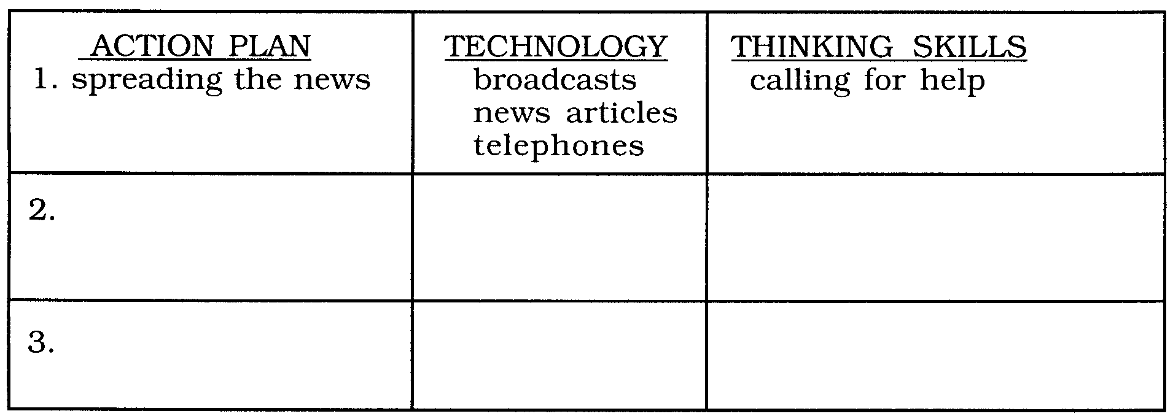
1. Make a chart that shows all the action plans, technology, and thinking skills involved in this rescue. Follow the examples below.

2. After the rescue, many people wondered if it was worth the effort. Some people think that saving two gray whales was not worth the money and time. Think about the problem. Examine the chart you made.

Now, list the “pros” and “cons” of the rescue mission.

PROs (+) CONs (-)

3. For many people, freeing two whales trapped in ice “felt good”. Write a newspaper article or prepare a speech that includes:

a. How you feel about the ice rescue.

b. The gains and losses made by the organizations and the whales.

c. Your answer to the question “Was it worth it?”

b. Write a newspaper article or prepare a short speech to tell how you feel about the rescue. Describe some important gains and losses made by the organizations and the whales? Was it worth it? Why or why not? Use examples from the chart and lists you just made.

