Returning South - October 1

Key Concepts
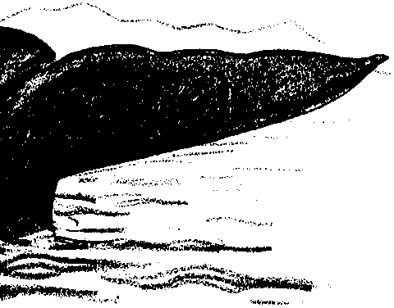
1. Blubber insulation is one adaptation that enables marine mammals to maintain a constant body temperature even in very cold water.
2. In addition to insulating against cold, blubber aids buoyancy, and stores and provides energy for their migration.
3. During the summer, gray whales increase their blubber supply.

Background

Even in the summer, the temperature of arctic waters hovers near freezing. Gray whales and almost all other marine mammals utilize the insulating properties of blubber to stay warm in such frigid water. Beluga whales, which spend their entire lives in frigid northern waters, have the thickest blubber with up to a foot of fat. Blubber is firmer and far thicker than the fatty tissue of land mammals and is laced with connective tissue.

Blubber is such an effective insulator that marine mammals must guard against overheating. Whales and seals have blood vessels close to the skin surface in their appendages and they can regulate blood flow to these extremities to dissipate or conserve heat. In this counter-current circulation system, warmed blood moving to the extremities passes near vessels carrying cooled blood back to the heart. The warm blood loses its heat to the returning blood instead of losing it to the cool water that surrounds the extremities. The returning blood is now slightly warmer and, therefore, will require less reheating when it returns to the body core.
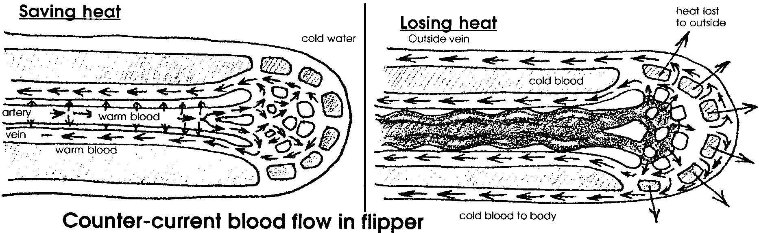
All of the marine mammals also stay warm by consuming large quantities of food. While cold-blooded animals, animals whose body temperatures vary with the temperature of their environment, generally are less active and eat less as temperatures fall, homeothermic, or warm-blooded, animals must eat more as the external temperature falls so that they can maintain a constant internal temperature.

While on the arctic feeding grounds, gray whales eat voraciously and increase the thickness of their blubber. The blubber provides warmth against the cold waters and energy for the migrating whales.

The high fat content of blubber brought whales and humans into conflict. Whalers sailing out of New Bedford and other U.S. ports hunted whales worldwide to supply oil for lamps and lubrication. Whalers boiled the blubber to extract oil. The gray whale’s blubber yielded inferior quality oil and less of it than the preferred Right whales and sperm whale. As a result, gray whales were not heavily exploited until after the other whales became scarce. The majority of gray whales were taken in the calving grounds rather than on the feeding grounds. Since they had less blubber at that time, the whales rendered less oil. Whalers made up for this by taking more whales.

Materials

For each pair of students

• 2 one-gallon or one-quart resealable freezer bags
• 36 oz. (3/4 of a large can) of vegetable shortening
• spatula
• ice
• thermometer
• bucket or tub
• clock or watch
• blindfold (optional)
•objects of various size, shapes, density: coins, paper clips
•pencil and paper
•shirt with buttons
•jacket with zipper
•towels
• “Returning South - October 1” student pages
Teaching Hints

In “Returning South”, students experience for themselves the discomfort of cold water for a homeothermic (warm-blooded) mammal. Then they experience the insulating properties of a blubber mitt. In a test of the effectiveness of insulation, students try to identify objects by touch and to perform some common activities.

In this lesson, students begin to consider the 5,000 to 7,000 mile return migration of the California gray whale, one of the most incredible migrations known to humans. In following activities, students debate a controversy in a case history of gray whales rescued from the polar ice pack and study storm tracking and cold water survival.

Preparation

A “blubber mitt” is a bag within a bag. Between the two bags is a layer of shortening representing the blubber. Either you or your students will need to make blubber mitts. If you can stand the mess, consider having your students make the mitts. Once a class set of mitts is constructed, you can use them year after year.

To construct a blubber mitt, turn one zip lock plastic bag inside out. Push it into a second zip lock bag. Line up the locking closures and make sure they can be “zipped” together. Remove the inner bag and set it aside.

Scoop the shortening into the first plastic bag. (Remove jewelry that may tear the plastic bags.) There should be enough shortening in the bag to form a cover around a student’s hand when the mitt is complete. Place the second (inside out) bag inside the shortening-filled bag and carefully push it into the bag of lard. Spread the lard around evenly between the bags.
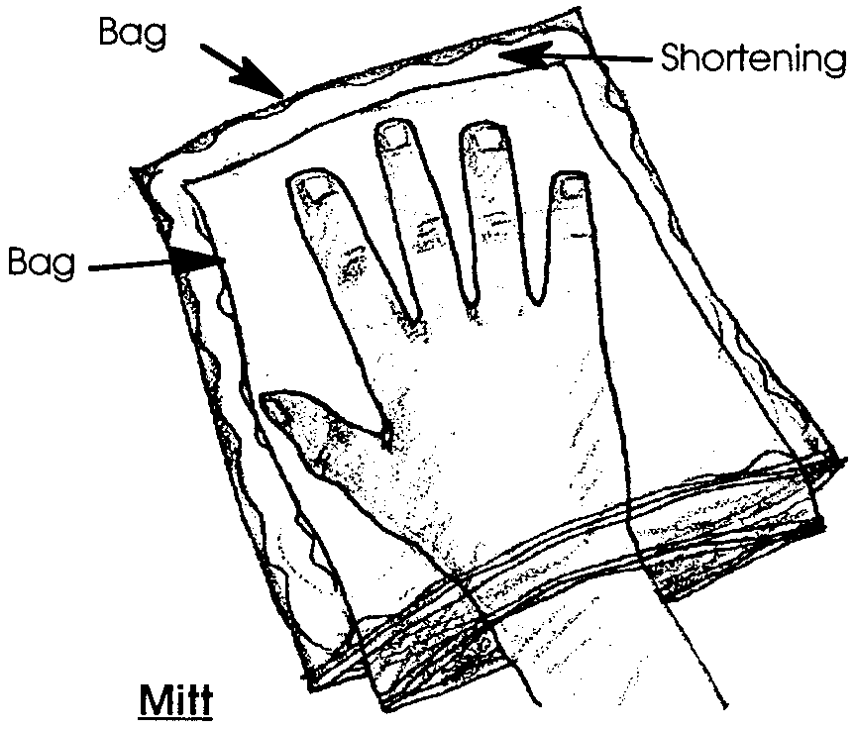
Start at one side seam and flatten the bag out and zip the two plastic bags together. If you keep the edges free of shortening, the seals will grip more securely. Use duct tape to secure any places where the bags do not seal.

Before students arrive, fill buckets or tubs with water and ice so the water has time to cool - about 40 degrees is ideal. During the lab, add more ice if needed to maintain a low temperature.

When students arrive, have them work in pairs. Each student will have a turn testing the blubber mitt in the cold water. Have the small objects, the pencil and paper, shirt and jacket nearby.

Although this activity is best performed by pairs of students, you may choose to set it up as a station for small groups of students to visit during the reading and analysis activities. If you choose this approach, consider asking some of your students to prepare and monitor the blubber lab.

Adjust the water temperature or duration of time in ice water if the effects of the ice water on fine motor dexterity are not obvious.

Duplicate the text and question pages. One set is recommended per student. Upon completion, plan to provide time for a discussion of the concepts presented. During your discussion provide the correct answers to the questions found in the student text pages.

If you are using the “Voyage Of The Mimi” in conjunction with this curriculum, “Episode 4: Counting Whales” correlates with this lesson.

Key Words

blubber - fat layer between muscle and skin of whales and other cetaceans; whale oil was derived from blubber

insulator - a material of such low conductivity that the flow of heat through it is greatly reduced or negligible

Extensions

1. Have students substitute other materials, such as Styrofoam packing peanuts, for the shortening, retry the experiment, and compare results.

Answer Key

Text questions

1. The major difference between the two tails lies in the fact that the whale’s tail is “horizontal” while the fish’s tail is “vertical”. Your students may miss this most obvious difference and note that fish tails have rays while whale tails do not. Other possibilities, such as the presence vs. absence of scales, etc., exist. In your discussions, however, emphasize the difference in orientation of the tails.

2. Three functions of whale blubber include:
a. insulation from cold water
b. flotation
c. food storage.

Analysis and Interpretation

1., 2. Answers depend on experimental results. Generally, the tasks are significantly more difficult with chilled hands. Although individual students may feel the effects of the ice water differently, most will have the similar results.

3. The effectiveness of the blubber as an insulator is a matter of opinion. Most students will agree that it is a more or less effective insulator because their writing abilities, etc., were diminished less than in the trial with no insulation.

4. The insulating ability of blubber is important for the survival of a gray whale because it reduces heat loss. This means that the whale has to consume fewer calories to maintain a constant body temperature. Blubber enables a whale to use the calories it consumes more efficiently.

One Step Further....

6. Summary of results: While answers depend upon experimental results, the blubber mitt is usually effective in insulating the hand, slowing heat loss to the water and maintaining a higher hand temperature.

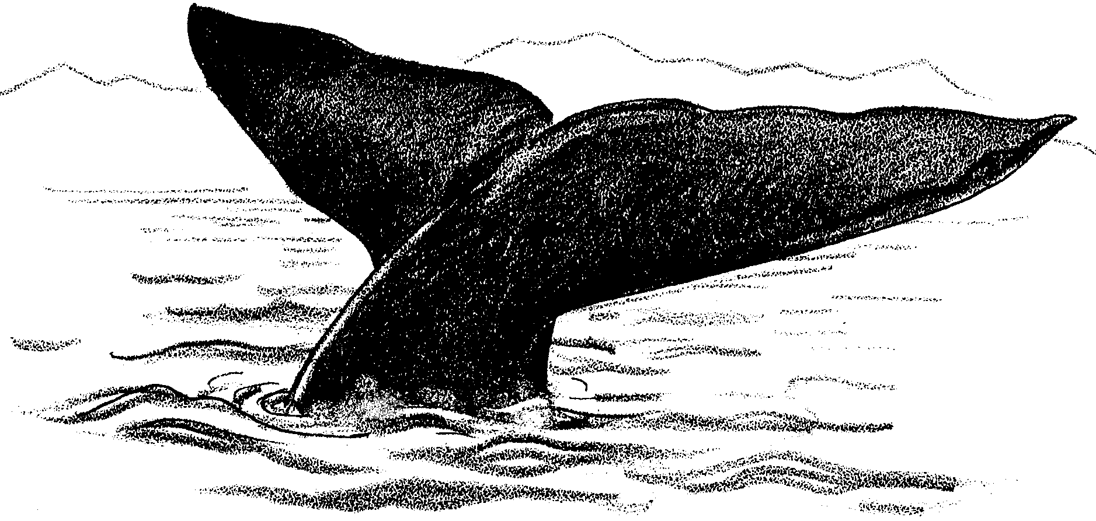
Returning South - October 1

The long days of the arctic summer have begun to shorten. Life in the arctic prepares for the lightless days to come. A chilling north breeze blows across the ice pack. Like so many nights for the past three months, our whales have spent the entire night feeding. But this morning, something is different. In response to this change, our mother whale begins to swim to the southeast. Her calf will follow, but they will not swim together. She has begun her long swim south.

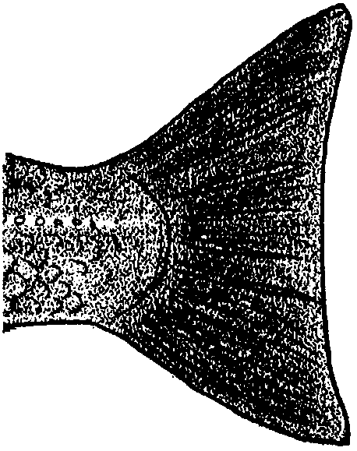
During the next few days she stays close to shore. Her swimming is leisurely (relaxed) but her motion is always southward. As the days pass, her swimming becomes more purposeful. Each stroke of her huge tail flukes move her southward.

1. Compare a whale fluke with the picture of a fish tail on the right.

What is one major difference between the two tails?

The cold water rushes along our whale’s skin as she swims. Three months of constant eating have given our whale a thick layer of blubber. This blubber helps insulate her from the cold water. Blubber is lighter than water. As such, her blubber also helps counteract the heaviness of her body. Blubber helps her float. Her blubber serves one more important role. The blubber is used as food storage.

2. What are three functions of whale blubber?

a.

b.

c.

Gray whales, just like all mammals, must maintain a constant internal body temperature. This is an incredible challenge. They spend most of their time in water as much as 30° C cooler than their bodies. Just how well does blubber work as an insulator? In the following activity you will have a chance to experience the role of blubber as an insulator.

Your group will need:

• one blubber mitt

• thermometers

• a bucket or tub filled with ice water

• clock or watch

• blindfold (optional)

•objects of various size, shapes, density: coins, paper clips

•pencil and paper

•shirt with buttons

•jacket with zipper

•towels

Here’s what to do:

1. Work in a team of three students. Select a beginning role for each team member. Each of you will rotate through all three roles as the lab progresses. Select one person to wear the blubber mitt. This person will submerge his or her hand in the ice water. Select another person to time the submersion in water. Select a third person to read temperatures and record data.
2. Do the following before the blubber mitt is placed on the “wearer’s” writing hand. As the recorder makes notes, the blubber mitt wearer will:
• write his or her signature in cursive
• button the button and zip the zipper and,
• blindfolded (or eyes closed), pick up and identify the small objects and coins.

Be sure the recorder notes any difficulties and whether the identifications are correct.

3. The “wearer” places his or her writing hand in the blubber mitt. Then, places this hand in the ice water for five minutes. Stop if the cold becomes unbearable. Record the amount of time in ice water.

DO NOT IMMERSE THE BLUBBER MITT DEEPER THAN THE TOP OF THE MITT. YOU WON’T WANT WATER SPILLING INTO THE MITT.

4. Repeat step 2 above. The wearer writes his or her name next to the original signature. Be sure the recorder notes changes in any of the tasks.

5. The wearer now removes the blubber mitt. He or she places the writing hand in the ice water for the same period of time as before. Stop if the cold becomes unbearable. Record the amount of time in ice water.

6. Repeat step 2 above. The wearer writes his or her name next to the previous signatures. Be sure the recorder notes changes in any of the tasks.

7. Trade roles. Repeat the procedure until all three team members have tested the mitt. Record all data in the table below.

Analysis and Interpretation

1. Look at your three signatures. Which one is least legible?

2. Look at your data table.
a. Were there differences in your ability to button or zip? If so, what were they?

b. Were there differences in your ability to identify the items? If so, what were they? Which item was easiest to identify? Which was hardest?

3. An effective insulator slows heat loss. People have better fine motor movement with warm hands. How effective an insulator was the blubber mitt? Please explain your answer.

4. How is the insulating ability of blubber important for the survival of a gray whale?

Returning South - October 1
One Step Further....

So, the blubber mitt does have an effect on heat loss. But just how much of an effect? The following activity will help you find out.

Your group will need:

• one blubber mitt

• 2 thermometers

• a bucket or tub filled with ice water

• graph paper

• clock or watch

Here’s what to do:

1. Again, work in a team of three students. Select a beginning role for each team member. Each of you will rotate through all three roles as the lab progresses. Select one person to wear the blubber mitt. This person will submerge his or her hand in the ice water. Select another person to time the submersion in water. Select a third person to read temperatures and record data.

2. This time the “wearer” puts the blubber mitt on one hand. Then, he or she inserts a thermometer inside the mitt. The wearer should hold the second thermometer in the other hand. (Hold the thermometers gently so they will not shatter.) Place both hands in the bucket of water at the same time. DO NOT IMMERSE THE BLUBBER MITT DEEPER THAN THE TOP OF THE MITT. YOU WON’T WANT WATER SPILLING INTO THE MITT.

The timer and recorder should take temperature readings every 30 seconds for two minutes.

3. Record the results in this table:

Team Member #1

Time Temperature in Temperature of hand
blubber mitt without mitt

30 sec.
60 sec.
90 sec.
120 sec.

Team Member #2

Time Temperature in Temperature of hand
blubber mitt without mitt

30 sec.
60 sec.
90 sec.
120 sec.

Team Member #3

Time Temperature in Temperature of hand
blubber mitt without mitt

30 sec.
60 sec.
90 sec.
120 sec.

4. Trade roles. Repeat the procedure until all three team members have tested the mitt. Record all data in the charts above.

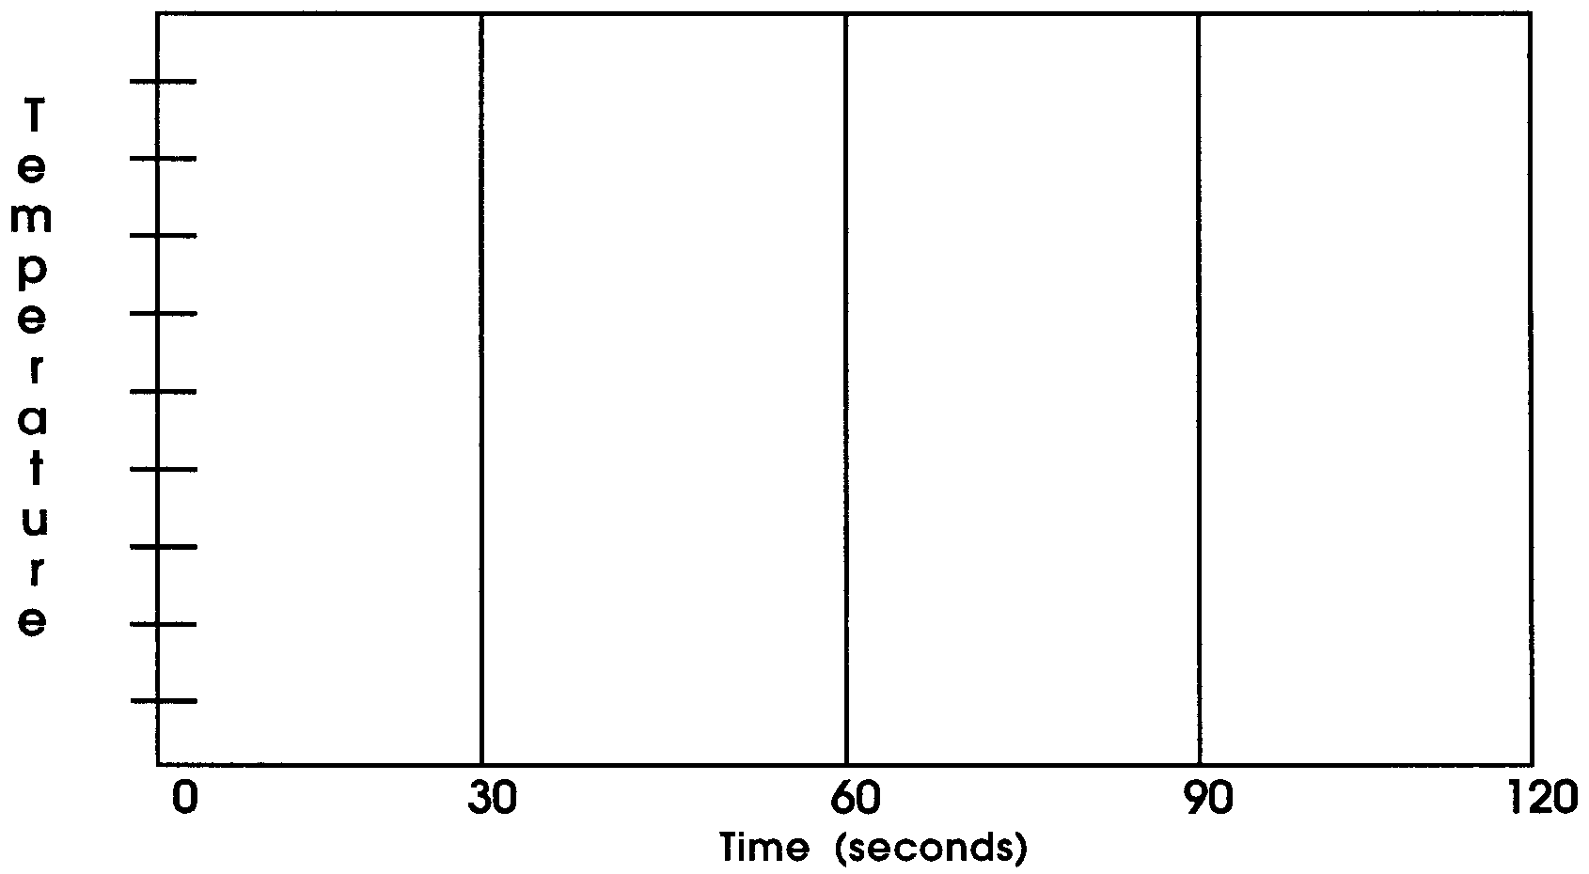
5. Use a line graph to show your results. Your graph will have two lines. One for temperatures without the mitt. The other for temperatures of the hand in the mitt.
Be sure to label the graph. Make the labels clear. Someone who did not do the experiment should be able to understand the graph.

6. Summarize your results. What effect did the blubber mitt have on the temperature of your hand?

Returning South - October 1 Data Sheet
