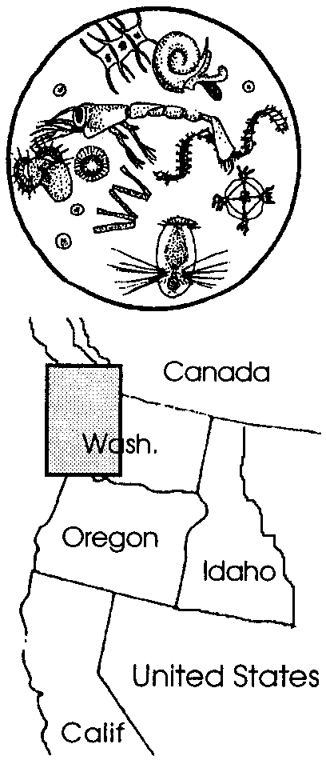
Plankton - A Case Study

Key Concepts
1. Northern waters support enormous plankton growth and sea life in summer, largely as a result of extended hours of daylight.
2. Nutrients, vital to plankton growth, are brought to the surface water by differences in water density, by tidal currents, by freshwater runoff from land, and by wind mixing.
3. Cycles of plankton bloom and demise play a role in the timing of migration and in the abundance of many marine animals.

Background

All of the life in the sea is interrelated through the plankton. Plankton are the basis of all life in the sea in the sense that all other animals depend either directly or indirectly on plankton for the nutrients they require to live.

Northern waters produce enormous amounts of food and sea life in summer. The long summer days in the arctic contribute to the presence of tremendous populations of phytoplankton. Phytoplankton blooms, in turn, support rapid growth of zooplankton and, eventually, growth in the organisms that feed on zooplankton, and so on up the food chain. As the rapidly growing phytoplankton locally depletes the nutrients in the water, the phytoplankton population “crashes”, rapidly decreasing in size. In the arctic, as elsewhere, fluctuations in phytoplankton growth are mirrored by fluctuations in zooplankton and other animals.

Much research on plankton population dynamics has occurred in Washington’s Puget Sound, one of the Pacific coastal regions where conditions for plankton growth are ideal. Researchers have found that there are four major paths which bring nutrients to the surface waters of Puget Sound are:
a. freshwater runoff from land

b. mixing deep water ocean nutrients by outflow of surface waters and inflow of deep Pacific Ocean waters
c. upwelling by tidal currents
d. wind mixing
It appears from these and other studies, that the interplay between sunlight and nutrient availability is critical in determining the magnitude and duration of plankton “blooms” and “busts”.

For more information about plankton studies see the previous activity, “Observing Living Plankton” or any of the following:

Eddy II, John. “Plankton: the basis of life in the sea”, The Seattle Aquarium Journal, September/October 1977, Vol. 1, No. 1.

Oxenhorn, Harvey. 1990. Tuning the Rig, a Journey to the Arctic. Harper and Row, New York.

Strickland, Richard M. 1983. The Fertile Fjord, Plankton in Puget Sound. University of Washington Press, Seattle, WA.

Materials

For each student

• “Plankton - A Case Study” student activity sheets

For each group of 3 or 4 students

• 2 beakers or clear jars

• tap water

• food coloring

• salt

• tablespoons

• stir sticks

Teaching Hints

“Plankton - A Case Study” provides your students with a look at the factors which contribute to the abundance of plankton by focusing on a particular location, the Puget Sound, as a microcosm of the world ocean.

This activity is best completed by individual students as a homework or in-class assignment. Provide time for a discussion during which you elicit answers for the study questions.

If you are using the “Voyage of Mimi” in conjunction with this curriculum, “Episode 11: The Feast” correlates with this lesson.

Key Words

bloom - in this case, very rapid growth of phytoplankton due to favorable conditions of light and nutrients

food chain - outline of who eats whom showing path of energy transfer in an ecological community

phytoplankton - plant plankton; the primary producers of the sea

plankton - the mostly microscopic plants and animals that drift in water; singular = plankter

upwelling - the process by which warm, less-dense surface water is drawn away from a shore by offshore currents and replaced by cold, denser water brought up from subsurface

zooplankton - animal plankton

Extensions

1. Make a model of a watershed that drains to an estuary. Have the estuary flow to an oceanic basin. Show how nutrients flow and mix in the water.

2. Make a post card from a gray whale who stops to feed along the migration route. Draw it on a 5" x 8" unlined index card. Show “a good place to eat” or “fun things to do” or “spectacular sights to see” on your trip to the feeding grounds. On the back of the card, write a descriptive note and address it to another gray whale.

3. Find out what kinds of pollution flows through watersheds into salt water along the migration route. Make a plan to improve the water quality in your watershed to help preserve whale habitat.

4. Visit an estuary. Observe how fresh water brings nutrients from the land and sea. Observe a food chain you find there.

5. Look at a map of your watershed. Trace the path of water that flows from your school to the ocean. Look for tributaries that unite into rivers that flow to the ocean. If you have a wall mural of the gray whale’s migration route and if your watershed connects to the route, draw the nutrient path from your watershed to the Pacific Ocean on the mural. Remember that some water flows in aquifers underground, too.

6. List the ways people affect the food chain from their watersheds and shorelines.
Answer Key

1. The two types of plankton mentioned are phytoplankton (plant plankton) and zooplankton (animal plankton).

2. Phytoplankton require sunlight and nutrients for survival.

3. One would expect to find more fish in areas of high plankton counts because the fish depend either directly or indirectly upon the plankton for their food.

4. Freshwater runoff adds nutrients that the streams and rivers have eroded from the land. These nutrients benefit the plankton populations.

5. The inflow of deep ocean waters helps replenish the nutrients the growing phytoplankton strip from the surface water. The water flowing out at the surface and in at depth make Puget Sound a nutrient trap.

6.a. While the answer depends upon the care with which the experiment is performed, generally the colored, salty water will form a distinct layer at the bottom of the jar.

b. The colored salt water is more dense than the clear freshwater.

c. The fact that the salty, colored water sank when slowly added to the clear freshwater is evidence that the colored salt water is more dense than the clear freshwater.

d. The colored salt water represents the nutrient-rich deeper waters.

e. The clear freshwater represents the surface waters.

7. Diagrams will vary but, in general, the diagram should show a tidal current moving over a sill. An arrow should show deep water moving up to get over the sill but since not all of it can flow over the sill, some of the water will return to the basin. This is best shown by a circular arrow showing the nutrient-rich deep water circulating back into the basin. A sample diagram is shown below:
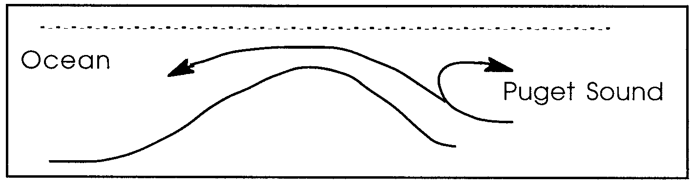
8. Since the zooplankton eat the phytoplankton, the phytoplankton must increase first to provide food to enable the zooplankton to increase. The population growth curves for the phytoplankton and the zooplankton are very similar in shape but they are slightly out of phase. First comes the food, then comes the feeder.

9. The four major paths which bring nutrients to the surface waters of Puget Sound are:
a. freshwater runoff from land

b. mixing deep water ocean nutrients by outflow of surface waters and inflow of deep Pacific Ocean waters
c. upwelling by tidal currents
d. wind mixing

10. b. A completed food chain follows:

sun → phytoplankton → zooplankton → herring → salmon → orca whale

c. A completed food chain follows:

sun → phytoplankton → zooplankton → ghost shrimp → gray whale

11. Plankton are the basis of all life in the sea in the sense that all other animals depend either directly or indirectly on plankton for the nutrients they require to live. This answer reflects the central concept of this activity: All of the life in the sea is interrelated through the plankton.

12. This question challenges students reasoning skills. The key to one of the two factors that contribute to plankton growth in the arctic is found in the word “summer”. Longer days of summer provide increased sunlight which is vital to plankton growth. Longer days mean more sunlight which grows more plankton. The second contributing factor is nutrient availability.

13. The timing of the gray whale’s southern migration is signaled by the decline in plankton numbers as the bloom period ends with shortened day length. Their northern migration is such that they arrive in the arctic after phytoplankton blooms have started. How these events in the arctic could directly affect the northern migration is unclear. Since the plankton blooms are followed by an increase in many types of sea life, a great amount of food is available in the arctic in summer. Although the exact trigger is unclear, migration to where the food is most plentiful clearly could have a selective advantage. In discussion, you may explore questions concerning migration with your students as it relates to migrating animals who move through less hospitable areas to more hospitable areas for feeding and breeding - what was the advantage to the first gray whale to leave either the arctic or the lagoons to head across 7,000 miles of uncharted sea for the other?

