Magnifying the Problem

Key Concepts
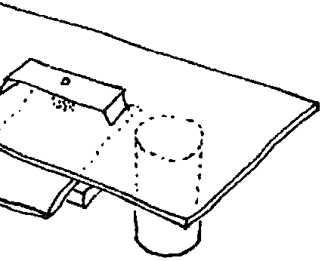
1. Water teems with microscopic organisms known as plankton.
2. Plankton are wanderers, drifting in water currents.
3. By closely observing these organisms we can learn something about their structures and behaviors.
4. Scientists classify plankton into two major groups- phytoplankton (plants) and zooplankton (animals).

Background

Plankton, the usually microscopic plants and animals that drift wherever water currents take, are the crucial foundation of the ecosystem which supports a varied and rich food web. Instruments as simple as a hand-lens to as complex as an electron microscope have been used to examine these interesting creatures. In this activity, a water lens microscope is constructed to enable magnified viewing of plankton.

Additional background information is found in the preceding activity, “Observing Living Plankton”.

Materials

For each pair of students

• sheet tin

• adhesive

• blocks of wood

• nail

• hammer

• pliers

• grease or cooking oil

• pencil

(student materials - cont.)

• water

• pane of window glass

• tin cans, two of same size mirror

• pepper, salt or sugar

• water sampler

• clear plastic ruler, mm

• paper

• eye dropper

• plankton sample

For the class

• tin snips

• file

• tape ruler

Teaching Hints

“Magnifying the Problem” provides your students with the opportunity to make a water lens microscope and to observe live plankton. Constructed from simple materials, the microscope enables your students to examine the plankton samples they have collected with their plankton nets. The curiosity generated in this activity can be profitably turned toward the use of the conventional microscope and the different world that it opens.

“Magnifying the Problem” is best accomplished in pairs or small groups. Your students can provide most of the materials needed. Small pieces of window glass can often be obtained from your maintenance department when they replace broken windows (6" X 12" is ideal). As a precaution against cuts, “break” the corners and edges (lightly sand the glass edges with wet/dry sandpaper wetted with a light oil). Introduce the activity with a brief history of the microscope and provide a model water lens microscope for your students to use as a construction aid. During the construction and use phases, circulate through the class and provide any aid that may be required.

The drawings provided in the text are not intended to serve as definitive identification keys. At this point, it seems that identification should be limited to distinguishing phytoplankton from zooplankton. If you have students who are interested in specific identification refer them to the following:

Cupp, E. E. 1943. Marine Plankton Diatoms of the West Coast of North America. University of California Press, Berkeley, Calif.

Hardy, A. H. 1961. The Open Sea: Its Natural History: Part I The World of Plankton. Houghton-Mifflin Co., Boston.

Newell, G. E., and R. C. Newell. 1963. Marine Plankton - A Practical Guide. Hutchinson Education, London.

Smith, Deboyd L. 1977. A Guide to Marine Coastal Plankton and Marine Invertebrate Larvae. Kendall/Hunt Publishing Company, Dubuque, Iowa.

Smith, R. I., and Carlton, J. T. 1975. Light’s Manual, Intertidal Invertebrates of the Central California Coast. University of California Press, Berkeley, Calif.

Strickland, Richard M. 1983. The Fertile Fjord. University of Washington Press, Seattle, WA.

Wimpenny, R. S. 1966. The Plankton of the Sea. American Elsevier Publishing Co., New York.

Key Words

estimate - an approximate calculation

phytoplankton - plant plankton; the primary producers of the sea

plankton - the mostly microscopic plants and animals that drift in water; singular = plankter

zooplankton - animal plankton

Answer Key

Procedure questions
17. Sketches will vary depending on the plankton samples.

18. Answers will vary depending upon experimental results but, in general, should be similar within the class.

Analysis and interpretation:
1. The answer depends upon experimental results.

2. In general, one would expect to find more phytoplankton than zooplankton. Since the phytoplankton provide food for the zooplankton, they would be expected to be more numerous. While phytoplankton are more numerous in the seas, it does not necessarily follow that our plankton nets capture a representative proportion of phytoplankton and zooplankton. Because of their small size, phytoplankton are often under-sampled.

3. a., b., c. Answers depend upon experimental results.

4. Answers will vary with the creativity of your class. One improvement of the microscope might be replacing the drop of water with a ground glass lens. Your students will have other specific suggestions after their construction and use experiences.

5. Plankton are the basis of all life in the sea in the sense that all other animals depend either directly or indirectly on plankton for the nutrients required for life. Emphasize this point as you summarize these activities.

