In Search of the Wild Plankton

Key Concepts
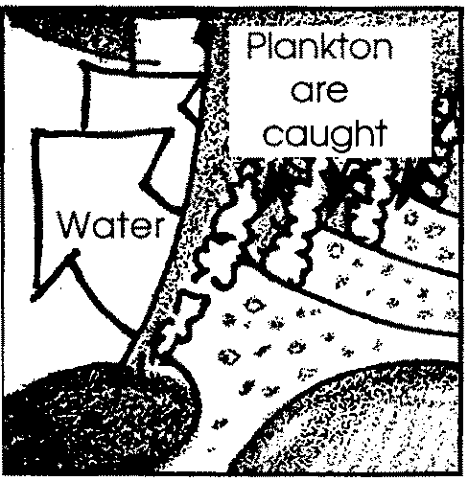
1. Water teems with microscopic organisms known as plankton.
2. Plankton are wanderers, drifting in water currents.
3. By closely observing these organisms we can learn something about their structures and behaviors.
4. Scientists classify plankton into two major groups- phytoplankton (plants) and zooplankton (animals).

Background

“In Search of the Wild Plankton” outlines the construction of a simple plankton net. Although the copepod crustaceans eaten by gray whales are, in fact, easily visible to the unaided eye, your students will be capturing and observing the more numerous, smaller planktonic forms.

Plankton may be obtained from ponds, lakes, streams, bays, sounds, oceans, aquaria, etc. This activity provides “hands on” work with plankton. Although plankton nets are available for purchase from scientific supply houses, there is much to recommend home construction as opposed to purchase. In addition to being economically sound, this activity provides your students with some practice in direction following. Ideally, you will be able to organize a class field trip to sample plankton. Alternatively, you may let your students sample plankton on their own and later bring their samples to class. Field trips mean extra work and preparation for you. The return in student enthusiasm and learning, however, more than pays for the extra work. You can lead a successful field trip by following the instructions found earlier in this text.

Materials

For each student:

• wire (coat hanger wire works well)

• tape (plastic electrical works well)

• nylon stocking or single leg cut from panty hose

• needle and thread (heavy)

• small bottle (preferably with neck indentation)

• string

• scissors

Teaching Hints

“In Search of The Wild Plankton” is best accomplished in pairs although you may wish to have each student construct her own net. Have your students provide the stockings, coat hangers, and bottles. Provide a completed plankton net as a construction guide.

Circulate through the room as your students make their nets. Provide any aid and reassurance that may be required to make this a positive experience for your students.

Several sampling methods will provide you with adequate plankton. Pulling the net behind a slowly moving boat (1 - 2 knots) is a standard method for collecting plankton. If a boat is not available, good results can be obtained by towing the net as you walk along on a dock. You can also lower the net from a bridge or pier into a fast tidal current. While these techniques make it more difficult to determine how much water has passed through the net, they will give good supplies of plankton for observation. Your students will greatly profit from performing the actual collecting.

Lower the net vertically into the water until the bottle is full of water. Then pull until the net is extended. Commence towing. Record the starting time and location so that the distance towed can be recorded. For surface depth sampling, tie a weight to a separate line and fasten the line to the front swivel. Bring in the net at the end of the tow and allow it to hang for a few minutes. Wash all of the plankton from the sides of the net into the bottle by running water from the outside of the net. Because stocking material stretches, changes in towing speed change the mesh size. Slow speeds will have the smallest mesh size. Because of this, your nets will tend to capture more of the smaller phytoplankton at slow speeds.

After sampling is completed, the plankton captured may be viewed with a conventional microscope, hand lens, or the water lens microscope constructed in “Magnifying the Problem”. Live plankton are preferred for observation. Try to maintain the same water temperature as the plankton’s natural habitat. If there will be a delay of more than one or two hours between sampling and observing, preserve the sample by adding 5% formalin.

Key Words

phytoplankton - plant plankton; the primary producers of the sea

plankton - the mostly microscopic plants and animals that drift in water; singular = plankter

zooplankton - animal plankton

