Observing Living Plankton - June 20

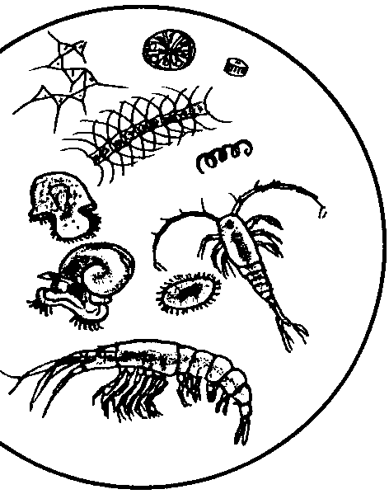
Key Concepts
1. Water teems with microscopic organisms known as plankton.
2. Plankton are wanderers, drifting in water currents.
3. By closely observing these organisms we can learn something about their structures and behaviors.
4. Scientists classify plankton into two major groups - phytoplankton (plants) and zooplankton (animals).

Background

The word “plankton” means “wanderers”. These usually microscopic plants and animals drift wherever water currents take them and thrive where those same currents provide optimum conditions. The plankton are the crucial foundation of the ecosystem which supports a varied and rich food web.

Technically, to be a member of the plankton an organism must not be able to swim or move against the power of a current in the water; they are controlled by the sea’s surges. Depending upon environmental conditions, plankton may be extremely abundant (millions per liter) or very scarce (tens per liter). These little organisms are largely responsible for coloring the seas and in some cases, making them cloudy and murky. Crystal clear waters indicate a lack of planktonic life, a kind of aquatic desert.

Plankton have a great range in size from .005 mm (at this size, 200 could line up side-by-side on a line about this long -) to more than one meter (three feet) in size. Size is often used to classify plankton:

Nanno plankton ranges from .005 mm to .060 m

Micro plankton ranges from .060 mm to 1.0 mm

Macro plankton includes plankton larger than 1mm

Mega plankton which includes the jellyfish and relatives with sizes up to one meter across.

Plankton are also grouped according to how they obtain energy. Using this system, the two main types of plankton are: zooplankton (the animals) and phytoplankton (the plants).

Zooplankton

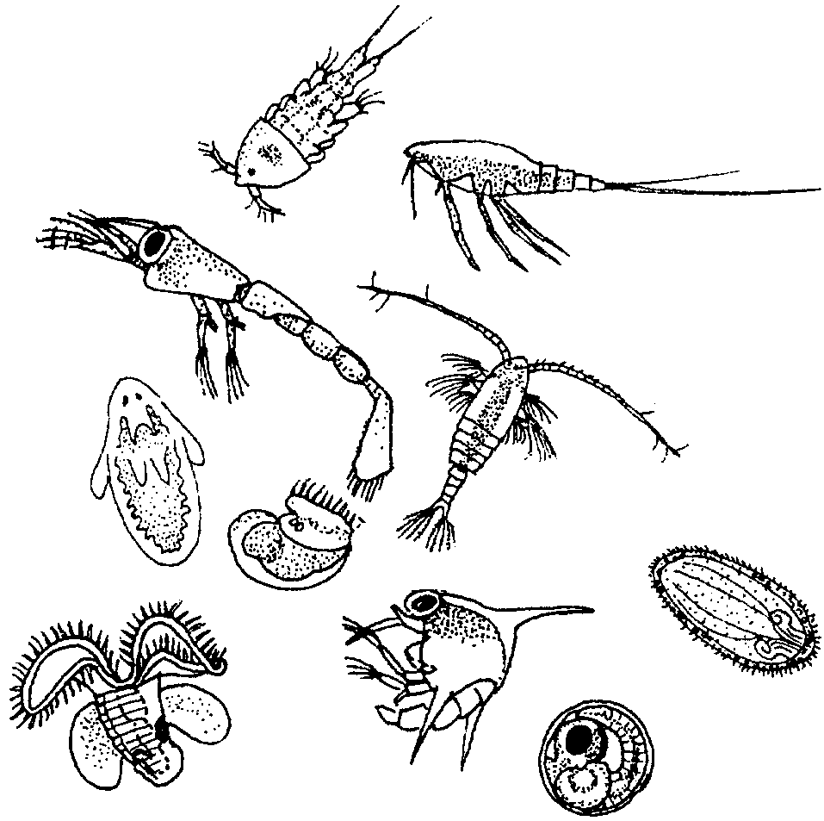
Incredible diversity exists among animal plankton. In a single quart of sea water some 3,000 different kinds of zooplankton have been found! Some animals exist in planktonic form their whole lives. These are called permanent plankton, or holoplankton. Others are members of the zooplankton a short while before drifting off to become adults such as barnacles, crabs, shrimps, mussels, sea stars, etc. Organisms living only part of their lives as plankton are called temporary plankton, or meroplankton.

Zooplankton

Some fish also spend their early days maturing and growing as part of the zooplankton. As soon as the fish are able to swim against the current or water flow they are no longer considered part of the plankton. Being planktonic for a part of their lives proves advantageous to these organisms as it provides opportunities for dispersal into new areas as the ever constant ocean swirls these beings to and fro.

Zooplankton may be carnivores, herbivores or omnivores (animals that eat both plants and other animals). Regardless of their precise dietary preferences, zooplankton are dependent on phytoplankton (plant plankton). If they do not eat the phytoplankton directly, they eat other zooplankton that do eat phytoplankton, and so on. Phytoplankton, for their part, strive to stay near the lighted surface of the water to maximize their ability to photosynthesize. As a result, it is vital that zooplankton also remain close to the surface of the water to be near their food, the phytoplankton.
Zooplankton often must struggle to remain near the surface. They must not quite float at the surface, but they must remain buoyant enough not to sink. While these little organisms can not fight the strength of the current, they have adapted other ingenious ways to remain near the surface. For example, many zooplankton decrease their rate of sinking by having “feathered” appendages. The advantage of such appendages in increasing “drag” and slowing the rate of descent can be easily demonstrated by simultaneously dropping two sheets of paper: one unfolded; the other crumpled into a tight wad. The unfolded paper which represents an animal with appendages takes considerably longer to fall to the ground.

Although zooplankton are not much of a match for ocean currents, they actually do perform some rather amazing swimming feats. Many zooplankton migrate considerable distances vertically each day. As the sun rises, they settle to less lighted depths where their predators cannot see them as well as they could if they remained near the surface. As the sun sets, these zooplankton return to the surface waters to again feed on the “phytoplankton soup”.

Phytoplankton

The sunlit layer of water is dominated by single-celled plants known as phytoplankton. There are two main types of phytoplankton: diatoms and dinoflagellates. Both types use nutrients, such as carbon, nitrogen and phosphorus dissolved in the water. Most phytoplankton engage in photosynthesis, using energy from the sun to produce food. However, some dinoflagellates do eat other plankton.

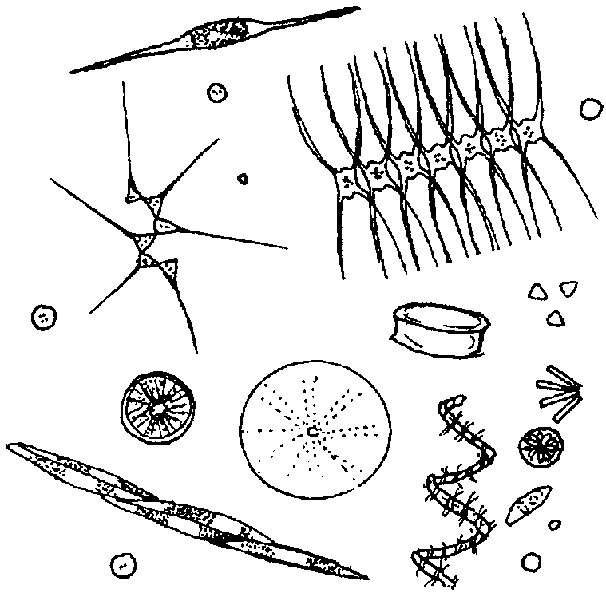

Phytoplankton

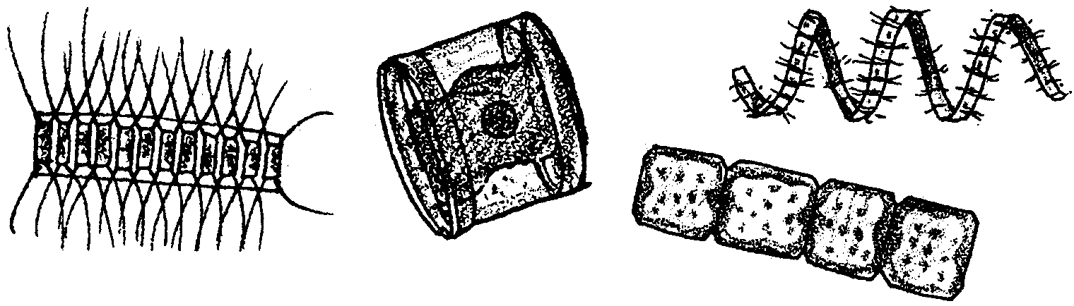
Diatoms have a cell wall made of silica, a glass-like substance. Diatom means “cut in two”; the diatom exists within a two-part shell of silica, with one half fitting over the other half, like a box. Diatoms are so minute that millions may exist in as little as a gallon of sea water. They come in many different geometric shapes and can be found alone or chained together in groups or colonies.

Diatoms

Diatoms have interesting adaptations which keep them at the surface to continue capturing sunlight. Many have spikes and other projections to disperse their weight. Some produce oil, which is lighter than water, to keep them from sinking. Some use air-filled floats to stay afloat.

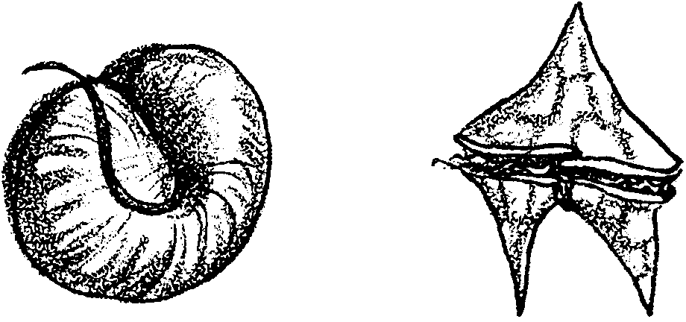
Dinoflagellates are very unusual plants because they can propel themselves with their two flagella, or whip-like appendages. Although they usually produce their own food like other plants, dinoflagellates can consume other plankton.

Dinoflagellates

Dinoflagellates are often responsible for “Red Tides” and incidents of Paralytic Shellfish Poisoning (PSP). Under the right conditions, these organisms reproduce rapidly, creating a “bloom.” Some dinoflagellates have a toxin. In a bloom situation, when filter feeders like clams and other shellfish consume huge amounts of the toxic dinoflagellates, the toxin can accumulate in their tissues. The toxic dinoflagellates do not harm these original filter feeders. Organisms that consume the filter feeders, however, may be harmed. If enough toxin is present it can cause paralytic shellfish poisoning, which can cause paralysis or death in humans and harm other animals consuming the shellfish.

The role of plankton as the basis for most oceanic life is well understood. Phytoplankton also produce a significant percentage of the earth’s oxygen. Other important roles of plankton are being investigated. For example, scientists studying global warming are examining the role of phytoplankton in absorbing the excess carbon dioxide that deforestation and burning of fossil fuels add to the atmosphere.

Materials

For each pair of students:

• plankton sample in a small, clear container (beakers, jars, cups, or bowls that hold 100 ml or more work well)

• 2 microscope slides or petri dishes

• eye droppers

• microscope

• 2 copies of “Observing Living Plankton” student pages (optional- you may choose another way for students to record observations)

• Plankton Identification Sheets found in Resource Files for this lesson

Teaching Hints

“Observing Living Plankton” takes advantage of the beauty and intrigue of living plankton to capture student interest and stimulate questions about plankton by providing students with concrete experience with plankton.

1. Collect plankton. You may collect plankton for your students, but it would be even better, if logistics permit, for you to engage them in constructing their own plankton nets and collecting their own plankton.

Directions for constructing a plankton net are found in the activity “In Search of the Wild Plankton” which immediately follows this lesson.

Both saltwater and freshwater plankton will work well for this activity, so if you have access to a pier, breakwater, bank, or shoreline, in salt water, a river or stream, pond or lake, a marsh or any other fairly natural body of water, you will be able to collect living plankton. The plankton identification guide in the student pages is for west coast saltwater plankton. If your plankton is from elsewhere, you may want to provide other references.

For best results, you will need about 50-100 ml of plankton sample per pair of students so they can watch the plankton sample in a container as described in the introductory section of the lesson. Acquiring a sufficiently large stock sample may require several plankton tows.

2. Introduce to the students the context for the plankton observation lesson. Explain that, now that they have some knowledge about marine food chains, they will have an opportunity to learn about the marine life that forms the base for most those food chains. Today they will look at a kind of marine life, called plankton, that is generally so tiny it is difficult to see with the naked eye. The plankton are drifters, traveling wherever the currents take them.

Let the students know that the goals of the lesson will be:

A. to notice patterns in the behavior and distribution of the plankton in a sample of water;

B. to draw and describe from microscopic observation the shapes, structures and behaviors of specific plankton; and

C.to identify phytoplankton (plants) and zooplankton (animals).

3. Distribute the student worksheet, “Observing Living Plankton”, to each student or prepare another means for the students to record their observations. You may prefer that students use their own paper, create group posters, or write on overheads or the chalkboard.

4. Provide each pair of students with a small, clear container holding a plankton sample. A beaker, jar or bowl with 50-100 ml of a plankton sample will work well. You may wish to give the students a moment or two to move and handle their sample. Then ask them to leave their sample undisturbed and complete the observations on the “Observing Living Plankton” worksheet.

You may wish to model for the students how to siphon some plankton into an eye dropper and either drop it onto a microscope slide or make small drops in a petri dish. Review microscope skills as needed.

Key Words

phytoplankton - plant plankton; the primary producers of the sea

plankton - the mostly microscopic plants and animals that drift in water; singular = plankter

zooplankton - animal plankton

Extensions

Try some of the following experiments based on student observations:

1. Review observations
Ask the students to share as small groups or as a whole class the behaviors, body parts, types of plankton and any other observations they noted as they looked at plankton. This discussion may bring up questions the students have that you can use to guide your next lessons. What types of plankton do they want identified? Which ones do they want to know more about? What did they notice that they would like explained?

2. Theorizing
Now ask the students, what do they think the plankton were doing? Why were they behaving as they did? What might the body parts the students noticed be for? How might a particular body shape help a plankter?

3. Selecting a variable to test
Explain that one way to learn more and to test a theory is to experiment. Have the students brainstorm things they can change in their plankton sample. For example, the students might suggest warming or cooling the sample, decreasing or increasing the salinity, or shining a light on the plankton or shading them.

As a class, go over the ideas and eliminate for the time being any that are too impractical or harmful to do at this time. Have each pair of students choose one variable from the remaining list to test.

4.Testing and interpreting test results
Ask the students to:

a. predict how they think the plankton will respond to the change they have chosen; their prediction will be based on whatever they theorize the behaviors and structures of the plankton are for;

b. set up a control with a plankton sample that they will not change;

c. conduct the test by changing the variable selected

d. record what happens in their test;

e. write a potential explanation for their results;

f. list questions they now have and what they would try next if they had time.

The students may be fascinated by what they learn or they may find the process frustrating. In any case, they have had the opportunity to practice both the creative and organizational skills of doing science. They will have thought for themselves and the more they practice, the better they will get at doing science.
Answer Key

Text questions
1. Our whales have traveled about 4,600 kilometers, or 2,800 miles, since they left the Straits of Juan de Fuca. Answers will vary depending upon the exact route selected.

2. While gray whales use baleen to capture their food, they differ from the bowhead (and other skimmers) and from the fin whale (and other gulpers) in that gray whales are bottom feeders, taking in mouthfuls of bottom sediment and water from which they filter mysids and other detritus feeders.

Estimating Plankton Populations
1. Answers will depend on the plankton sample. Mesh size plays an important role in determining the composition of the sample. Often, the larger zooplankton will be more numerous.

It is worth noting that both numbers and kinds of plankton vary over time. Typically, plankton growth is cyclical. After spring or fall wind and rain stirs nutrients in the water, phytoplankton bloom. The size and duration of the bloom are related to the amount of daylight and the availability of nutrients. After the phytoplankton bloom, the phtoplankton-feeding zooplankton proliferate. Feeding on smaller animals, the larger plankton then increase in number. As nutrients are consumed, the phytoplankton eventually die, followed by the zooplankton populations. The dead plankton are fed upon by decomposing bacteria, releasing nutrients to start the cycle anew.

2. Answers will vary depending on the plankton sample.

3. a. Juvenile forms of barnacles, crabs, snails, and worms are common temporary zooplankton in marine waters.

b. Copepods are probably the most common permanent zooplankton in both fresh and salt water.

4. a. Answers will vary. The most common technique employs the use of a sampling procedure to estimate the number of plankton in a gallon of seawater. For example, count the number of plankton in a known size drop and multiply the number of plankton times the number of drops in a gallon.

b. For the entire body of water, “just” estimate the number of gallons in the body of water and multiply that number times the answer in 4. a. These manipulations assume uniform distribution of plankton in the larger samples. They also assume that the drop is representative of the larger body of water from which it was collected. Discuss these assumptions with your class.

Even if we knew the number of gallons in the body of water sampled, these answers are not very realistic because they ignore the fact that the plankton net concentrates the plankton. For a more accurate answer one would also need to know the size of the net, the distance the net was towed, at what water level, during which season, at what time of day, at what location, etc. The important thing to emphasize is that a sampling procedure can be used to estimate large quantities and that every sampling procedure is based on a set of assumptions which determine the veracity of the results.

