Who's For Dinner?

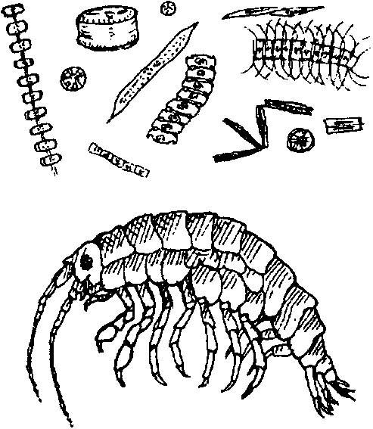
Key Concepts
1. Detritus feeders play an important role in some ocean food chains.
2. Damage to a specific organism or group of organisms can have a major or minor effect on the food web.
3. While people are part of the food chain, they also can make decisions effecting the balance of a food chain.

Background

A food chain is a linear relationship that shows who eats whom or, more importantly, how energy is transferred in the food system. Phytoplankton serve as the basis for most ocean food chains. Most life in the ocean depends directly or indirectly upon the phytoplankton’s ability to harness energy from sunlight. The energy passes to the animals that consume the phytoplankton and then to the animals that feed on these consumers.

A food web is a complex weaving of food chains. It shows the variety of organisms one animal might consume and the complex cycles through which nutrients are transferred from one organism to another through consumption. Many organisms receive nourishment by eating several kinds of prey. All eventually die and decay, returning nutrients to the water for use by the phytoplankton and other organisms. These fragments of dead and decaying plants and animals are called “detritus”.

At the beginning of most food chains is the sun. Plants use the energy from the sun, water and nutrients from the soil to make or “produce” their own food so they are called producers. Animals eat or “consume” the plants or other plant-eating animals so they are called consumers. When producers or consumers die, their remains, along with waste products from living animals, become food for decomposers. In a sense, new food chains begin as the detritus is eaten by decomposers. As an example, gray whales eat mysids and other decomposers which they dislodge from bottom sediments.

An example of a simple ocean detritus food chain is:

detritus → mysids → gray whale

Arrows in a food chain show the direction of the movement of the food energy and matter.

Materials

• 4-5 liters of popped corn

• clipboard and paper for results

• marking pen

• kitchen timer with bell

• roll of l" masking tape

• 1 plastic sandwich bag for each student

• 2 colored, 8 1/2" x 11", pieces of paper for each student (see next section) or 1 sash about 20 cm x lOO cm for each student.

• 2 safety pins for each student

Teaching Hints

“Who’s for Dinner?” is a role playing game designed to help your students understand the food chain concept. In this game, your students play the roles of “shrimp” (mysids and other shrimp-like crustaceans), gray whales, and hunters (people, orca whales, and some sharks) in a food chain. The first link in the food chain is detritus, represented by popcorn spread over the game area. The shrimp eat the detritus, the gray whales eat the shrimp and are, in turn, eaten by the hunters. The object of the game is for each animal to get something to eat without being eaten during the timed course of the game. After a few runs of the game, students will have the opportunity to try “managing” aspects of the food chain. At least 10 students are needed for best results.

“Who’s for Dinner?” is not an accurate model of nature because of the small population sizes. Natural populations are usually able to withstand the loss of some of their individuals. In our populations, if even one of each kind of animal survive, the model is considered a success. The community is “balanced” and will survive.

Preparation

Before you are ready to begin the role playing, you will need to prepare the following:

stomachs: The plastic sandwich bags will be animal stomachs. Place a strip of masking tape 4 cm from the bottom running across the bottom edge.

name tags: The colored paper will serve to identify the animals. You will need three colors: one for the shrimp, one for the gray whales, and the third for the hunters. Have enough of each color to allow 3/4 of the class to be shrimp, 1/3 to be gray whales, and 1/3 to be hunters. The fact that you have a surplus of shrimp tags will allow you to change population numbers as the game progresses. You will pin a piece of the colored paper on the front and on the back of each student.

Procedure

Introduce the activity with a brief review of food chains. You might ask your students if they know what shrimp eat and what eats shrimp. They may respond “shrimp eat dead animals and whales eat shrimp”. Diagram the relationship they describe and introduce it as a food chain. Remind them that people of many cultures have historically eaten whale meat and have also used the meat for meal to make animal food, the most common use of whale meat today. The orca whale and some species of sharks, notably the Great White, also prey upon the gray whale when the opportunity presents itself.

detritus → shrimp → gray whales → people/orca

Ask your students if they can think of other food chains, including some food chains that contain humans.

Objective of the Game

For individual students, the object is to survive as an animal in a food chain by getting enough to eat while avoiding being eaten. The object for the class is to create a “balanced community”, one in which each animal is represented.

How to Play

1. Outline the boundaries of the game area. An area about 15 meters square is adequate. A grass area is best, but a gymnasium, a parking lot, etc. will work. Outdoors missed popcorn “detritus” will be eaten by birds or other small animals.

2. Spread about 3/4 of the detritus (popcorn) over the area. Tell your class you are spreading out the detritus that the shrimp will eat.

3. Hand out a plastic bag stomach and two shrimp name tags to each person in 1/3 of your class. Tell your students to put their food (popcorn) into their stomachs when the game begins.

4. Hand out a bag and two gray whale name tags to each person in a second 1/3 of the group, and bags and two hunter (people, orca, or shark) name tags to the people in the last 1/3. When the game starts gray whales will try to capture (tag) shrimp and hunters will try to capture (tag) gray whales. When a gray whale captures a shrimp, the shrimp’s stomach contents are transferred to the stomach of the gray whale. When the hunter captures a gray whale, he takes the gray whale’s whole stomach. Note that hunters do not eat shrimp in this game.

5. State the challenge. Set the timer for five minutes and say “Go!” The first game usually lasts only a few seconds with one of two things happening. The shrimp are gobbled up before they have a chance to forage, or the gray whales are gobbled up and the shrimp continue to eat popcorn and get fat.

6. Analysis. How many animals survive? For a shrimp to survive, popcorn must fill the stomach bag to the bottom of the tape (4 cm). For a gray whale or a hunter to survive, popcorn must fill the stomach bag to the top of the tape (6 1/2 cm). If at least one of each kind of animal survives, you have an on-going food chain. Return the popcorn to the activity area after each game.

7. Encore: Learning by making rule variations. Ask for suggestions on rule changes (“natural resource management”) that might result in more of a balance after the five minute “day”. Usually one rule is changed for each replay. When you have settled on your new rules, play again. Suggest these changes if your students can’t offer any:

a. Change the number of shrimp and/or gray whales and/or hunters. Perhaps there has been a ban on whaling or whaling has increased. Perhaps many orca whales have been captured for display in public aquariums or Great White sharks have been hunted so their numbers decrease.

b. Let each shrimp come back as another shrimp once after being captured and transferring stomach contents.

c. Provide a “safety zone” for shrimp and/or gray whales where they can be safe for a certain period of time. A “safety zone” might be a marine sanctuary such as the Olympic National Marine Sanctuary along Washington’s outer coast.

d. Timed releases. Let shrimp go first to forage unmolested. One minute later release the gray whales, and later the hunters. This represents what happens in the Arctic as sunnier and longer days “produce” more plankton, then more shrimp. Later, the gray whales appear to feed on the abundance. Hunters follow the whales.

e. Spread out more popcorn. The growing season has produced a great abundance of plankton and detritus.

To reduce discontent over who will be which organism, draw markers from a hat to assign roles for replays.

Afterword.............

Analyze the results of each game. How many shrimp got a full stomach? How many gray whales? How many hunters? Compare game results after each rule change and comment on how the game “balance” compares with the balance in the real world. In nature, there is m ore detritus than detritus eaters and more detritus eaters than animal eaters. Questions involving natural resource management or human interference issues will likely arise from this experience.

Here are some questions to consider back in the classroom:

1. What would happen if there were only half as many popcorn detritus?

2. If there were no gray whales, what would happen to the detritus population? The shrimp population? The hunter population?

3. So hunters need plants to survive? Explain!

4. Can you describe some food chains that you are part of?

5. Are there any plants or animals that are not part of any food chains?

6. Which variation provided the most realistic conditions?

7. In what ways do people try to manage food chains (natural resources)? Do you feel people should try to manage food chains or let them take care of themselves naturally? If so, who should be responsible for the management (individual, state, nation)?

If you are using “Voyage of the Mimi” in conjunction with this unit, “Episode 11: The Feast” correlates well with the above lesson.

Extensions

1. Incorporate echolocation, using blindfolds, as in the preceding lesson entitled “Hear-Sighted”.

Adapted from “Food Chain Game” by Outdoor Biology Instructional Strategies (OBIS), Lawrence Hall Of Science, University of California, Berkeley, California.

