What Wiggles In the Mud?
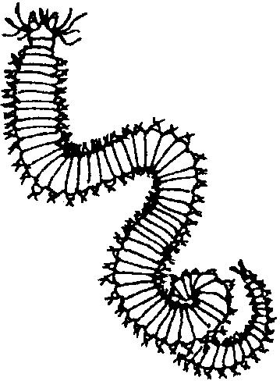

Key Concepts
1. A rich assortment of animals may be found living in bottom sediments.
2. Sediment animals may be used to determine the general quality of an aquatic habitat.

Background

Gray whales feed on organisms found in near-shore marine sediments; however, a fascinating assortment of animals can also be found living in muddy sediments of lakes and ponds as well as muddy beaches and salt marshes. Large enough to be seen without a microscope, these animals can be dug, sieved and observed in the field, or carried back to the classroom for further study.

The organisms found in these habitats vary somewhat but include worms (primarily segmented worms), clams, snails, shrimp-like crustaceans and, especially in freshwater habitats, insects and insect larvae. The insects are usually immature stages of adults, spending most of their time in the water before they “emerge” winged and ready for mating. Aquatic insects usually look quite different as larval forms than adults.

Sediment animals play an important role in aquatic habitats. Often, they are decomposers, feeding on detritus - fragments of dead plants and animals. Many are the main food of fish and other predators.

Unfortunately, near-shore marine sediments, muddy sediments of lakes and ponds as well as muddy beaches and salt marshes, are often the “sink” or recipient of an assortment of pollutants carried from the land. Often, we can not see the pollutants. Sediment animals living in the aquatic habitat, however, can and do feel the effects of these pollutants. Unlike fish, they can not move out of the path of the pollutant. Each of the many kinds of sediment animals have different tolerances for the various pollutants. Their ability to live and reproduce are directly affected by the pollution in the water and sediments. As a result, these animals have become key indicators of the habitat quality.

Materials

On the Field Trip

For each group of 2-3 students

• trowel

• plastic dishpan

• kitchen strainer (or sieves built from design below)

• bottle or covered plastic container as needed for transporting specimens

In the Classroom

For each student

• Petri dish

• dissecting microscope or hand lens

• colored pencils and paper

Teaching Hints

In “What Wiggles in the Mud?”, students collect sediment animals from a nearby freshwater or saltwater wetland. Back in the classroom, they observe and draw animals living in the sediment.

In selecting a sampling site, look for an aquatic wetland or protected beach where you will be able to obtain permission to bring students and where collecting is permitted. In requesting permission, know that collecting need not be destructive of the environment if students are prepared beforehand to take sediment samples in a careful and sensitive manner. The wetland should be accessible from a reasonably firm shoreline so that students can get close to the sediment without becoming entrapped in soft mud.

Field equipment used by the students in this activity includes common household items. If you or your school cannot provide enough kitchen strainers, you might ask students to bring some of these items from home. The strainers should not suffer damage if students are collecting from soft sediments. If you plan to visit a beach with rock or sand, you might consider making a set of marine sediment strainers, using the plan below.
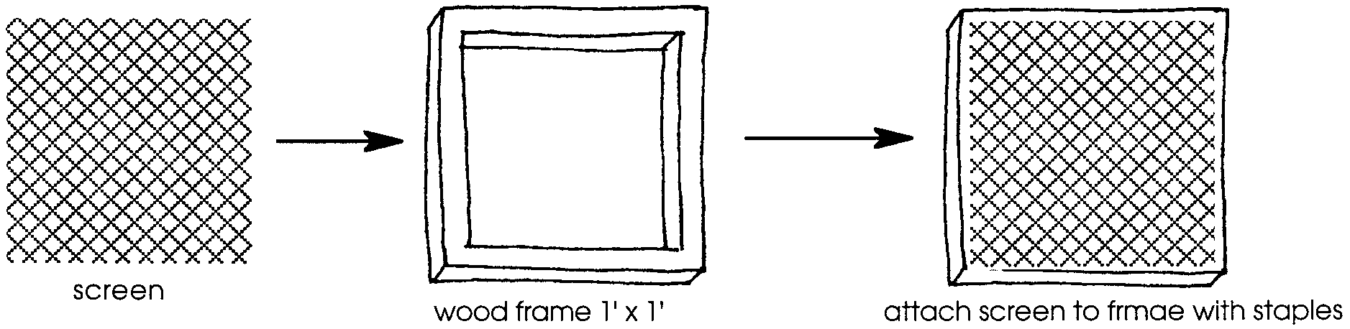
wood frame 1' x 1'

attach screen to frame wth staples

These sieves will float, and students can sieve their samples right on the surface of the lake or pond, or the sieves can be placed in a dishpan of water and used on the shore or in the classroom.

The organisms found in this habitat will include worms (primarily segmented worms), clams, snails, shrimp-like crustaceans and, especially in freshwater habitats, insects and insect larvae. Unless this is an area in which you are experienced and comfortable, don’t go overboard trying to identify the animals your students find. Instead, have them look for adaptations in the animals which suit them for life in this environment: appendages for burrowing, crawling, swimming, or food-gathering; defenses against their enemies; or camouflage strategies. If names are important, students can consult a field guide on pond or marine life. Or, take the alternative approach and have them invent creative names of their own!

Making careful drawings is one of the best ways of encouraging your students to observe with patience and care. You may want to prepare students for this kind of drawing by giving them practice drawing other small objects well before they are asked to draw live, crawling worms or insects. Encourage students to make their drawings to a large size and include lots of detail.

If a field trip with students is for some reason entirely out of the question, you might consider conducting this lab in the classroom using sediment you collect yourself. Although doing the collecting with students is strongly recommended, the activity has merit even if a field trip is not practical.

Preparation

Introduce “What Wiggles in the Mud?” by explaining that gray whales have tapped a resource that other whales have not, small organisms that live below the surface near the shore. There are many interesting animals that live in these kinds of environments, both marine and fresh water. This is a rich habitat for life because of an abundance of food, mostly found on the bottom in the form of detritus, the dead and waste material from plants and animals in the water or on the shore. If detritus is a new word for students, relate it to leaf litter in a forest.

Organize students into groups that can share equipment. They will all need access to a strainer or sieve, a dishpan or tub into which the strainer or sieve will fit, and a covered container for bringing specimens back to class.

Discuss with students the goal of sampling while leaving the site impacted as little as possible from your presence.
At the wetland

1. Have student teams collect sediment animals by first examining the surface for visible animals. Have them carefully move any bottom material as they examine the surface. As they find animals, have them place the specimens in the collecting bottle.

2. Next have student teams use the trowel, strainer or sieve, and dishpan to collect animals from beneath the surface. A trowel-full of sediment is placed in the strainer or sieve which is positioned over the dishpan. Water is poured through or swished over the sediment, washing away the fine particles and leaving bigger items behind (including, hopefully, the sediment animals). Caution each student to look closely for animals as they move in the strainer or sieve. As a team finds animals, have it place the specimens in its collecting bottle.

3. Examination of the animals may take place on the site or in the classroom. As noted above, you may wish to focus on adaptations possessed by the animals which suit them for life in this environment: appendages for burrowing, crawling, swimming, or food-gathering; defenses against their enemies; or camouflage strategies. The level of detail pursued in classification and naming will depend on your expertise. Using observable characteristics, students should be able to lump organisms into various groups roughly reflecting the scientific classes (Insecta, Crustacea, etc.) into which the organisms are placed by taxonomists. If more specific names are important, students can consult a field guide on pond or marine life. You may wish to have students count the number of animals in each group and determine which group has the largest representation. Be sure that students record their findings.

4. Conclude with a discussion of the importance of sediment animals in the food chain, stressing their dual role as decomposers and as food for predators. During your discussion, ask students how they think tracking the number and kinds of sediment animals over time could be valuable in determining water quality (Pollutants often end up in the sediments where they may affect sediment animals. Different sediment animals have different tolerances for the various pollutants. Their ability to live and reproduce is directly affected by the pollution in the water and sediments. As a result, these animals can serve key indicators of the habitat quality.)

