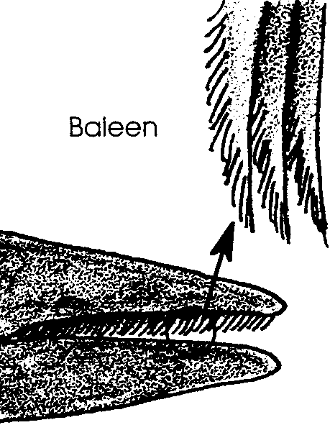
Feast Waters - April 20

Key Concepts
1. Whales have special feeding adaptations to help them survive in the marine environment.
2. Baleen is an adaptation that allows baleen whales to strain plankton out of the water.

Background

Baleen whales, the group of whales which includes the California gray whales, have no real teeth. Instead, they have parallel rows of stiff, brush-like plates called baleen to filter large quantities of small food animals (plankton) from the ocean water. The two or three hundred flat baleen plates are set crosswise along the edge of the upper jaw and hang from it.

Baleen plates are fibrous and tough but flexible. They are made of keratin a material similar to human fingernails. On the inside of the mouth the edges of the plates are frayed into long bristles or strands resembling the strands of a horse’s tail. The strands of baleen from adjacent plates overlap forming a “hairy” mat which serves as a strainer to trap the food while letting the water flow through.

Several different feeding strategies are found within the baleen whales. Some baleen whales skim at the surface, others “gulp” or bottom feed. Skimmers, like the bowhead or right whales, have long baleen plates (graduating up to 10 feet or more length). The skimmers feed by swimming at the surface with their mouths open. The plates, short in the front and long in the middle, passively trap the plankton as the water passes through.

Gulpers include the swift and active rorquals like the blue and humpback whales. These whales have long grooves or pleats on their throats. As they gulp in hundreds of gallons of water, their pleats expand like an accordion. When the mouth is full, muscles contract around these pleats and push the water out through the sides of their mouths. The strainer mats created by their three to four feet long baleen plates trap the plankton.

Unique among the baleen whales, gray whales are primarily bottom feeders (occasionally they “skim for their supper”). To feed, gray whales roll on their side and bite chunks out of the sediment. They then swish the sediment around to filter out the benthic organisms.
Materials

Part 1

For each student:

• a small cup

• cake decorative sprinkles

• 1/8 teaspoon measure

• water

Part 2

For each group of four students:

• paint brush

• pepper shaker

• 1/8 teaspoon measure

• tub, dishpan, or plastic shoebox

• water

Teaching Hints

In “Feast Waters - April 20”, your students will try to strain “food” out of the water with their own teeth and then with paint brushes. Since the first part of this activity which involves straining with teeth can get messy, you might want to conduct it outside.

“Feast Waters - April 20” is the first of several lessons dealing with feeding, sediment organisms, plankton, and food chain dynamics.

Key Words

baleen - an elastic, hair like material growing in place of teeth in the upper jaw of certain whales and forming a series of thin, parallel plates used to strain food out of the water, also called whalebone

keratin - a protein material found in fingernails, baleen, hair, horns, etc.

mysid - one of a group of small, shrimp-like crustaceans

Extensions

1. Have students research the number of baleen plates found in each species of whale and how large the whale mouths must be to hold them.

Answer Key

Text Questions

1. Gray whales roll on one side and use the baleen on that side to stir up bottom sediments and strain out tiny organisms. The fact that one side is usually more worn down than the other suggests that they prefer one side over the other. Perhaps whales are “left-handed” or “right-handed” like we are!

2. Members of the group are called “skimmers” because these whales skim plankton off the surface of the water by swimming with their mouths open and straining out plankton as they swim.

3.a. A physical adaptation shared by “gulpers” is the highly expandable throat grooves which allow rorqual whales to take in and filter a much greater volume of water than their mouth cavity would hold otherwise.

b. A behavioral adaptation found in some rorqual whales is the utilization of a “bubble net” which acts almost like a real net in trapping and concentrating small animals. By doing this they can catch much more food in a smaller area of water.

4. An animal which has only one source of food can be more easily threatened by food shortages than one which eats from a variety of sources.

Procedure Questions

4.,5. Descriptions of successful strategies will vary.

Analysis and Interpretation

1.a. Answers will vary regarding success of using teeth as baleen.

b. Answers will vary regarding changes made.

2.a. Answers will vary, but hopefully the paint brush is better than their teeth.

b. Answers will vary regarding changes made.

3. Answers will vary regarding how to change the paintbrush so it could collect more pepper plankton.

4. Answers will vary but once the whales have the plankton in their baleen they use their tongue, saliva, and mucus to get it out.

5. Answers will vary but whales get the energy they need to live during the winter from the food they ate in the summer, stored as fat.
Food For Thought: Polar regions are rich in whale food (plankton) because of the long days and significant nutrient upwelling. (Most nutrients are on the bottom where decomposers are recycling the dead organisms that drift down.) Lots of nutrients, lots of light cause plankton blooms. On the other hand, very few nutrients are found in warm tropical waters because there is less mixing and upwelling of nutrients from below. In the tropics, a permanent layer of warm water at the surface resists the upward mixing of nutrients from below. (The FOR SEA activity “Ocean Currents” may be used to teach about water density differences and their affect on plankton blooms.)

