Researching Gray Whales - March 21
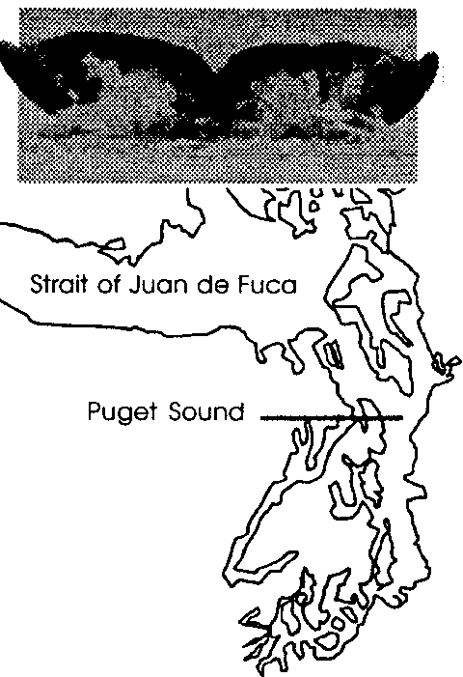

Key Concepts
l. Individual gray whales can be recognized by natural markings around the dorsal region of the whale.
2. Population information can be derived once individuals are identified.
3. During their migrations, gray whales sometimes enter Puget Sound and other inland waters where they are extensively studied.

Background

Each year, some migrating gray whales enter Puget Sound and other inland waters. These “side trips” put the whales in close contact with humans. This, of course, is a delight for whale watchers. It is also a boon to cetologists, those scientists who study whales and dolphins. The shared interests of the whale watchers and scientists have sometimes fostered the creation of effective partnerships in which whale watchers provide sighting information and photographs to scientists who catalog and analyze this data. For example, in Washington state, Cascadia Research Collective produced a comprehensive status report entitled “Gray Whales of Washington State: Natural History and Photographic Catalog” based on such collaborative efforts.

Even when gray whales are observed in inland waters, the fleeting time they spend at the surface makes the identification and study of individual whales difficult. Under ideal circumstances both the left and right sides of the whale’s back around the dorsal hump and the ventral side of the flukes are photographed. Since gray whales do not always raise their flukes out of the water and observers sometimes only see one side of a whale, the catalog listings are not always complete, a fact which complicates the task of identification.

None-the-less, a great deal has been learned about gray whales. Once thought to strictly travel between breeding grounds along the coast of Baja California, Mexico and feeding grounds in Alaska waters, we now know that some animals return year after year to inland waters such as Puget Sound where they may spend four months or more. Other animals spend the summer off the coasts of Mexico, California, Oregon, and Washington. We also know that many feed as they migrate and have a good idea of their diet.
It seems certain that collaborations between scientists and whale watchers will increase and that they will continue to provide valuable information toward our understanding of gray whales.

Teaching Hints

“Researching Gray Whales - March 21” continues the story line of a mother and calf gray whale migration while providing your students with an opportunity to use original research data to learn how gray whale research is conducted, as well as some of the findings of that research. The activity is comprised of three parts: “Part 1 - Pausing in Puget Sound” which furthers the story line, “Part 2 - Gray Whale Study” in which students analyze text from a research paper, and “Part 3 - What Was Learned” in which students analyze the graphically presented results of the study.

Part 1 - Pausing in Puget Sound
Have students read “Pausing in Puget Sound” and answer the three questions by themselves. Then have students gather in pairs or groups of 3-4 to discuss their responses to questions 2 and 3. Have each group prepare a list of what scientists might be interested in learning about gray whales. On left hand side of the list, have each student initial the questions she or he would like to study if the student was a scientist.

Part 2 - Gray Whale Study
Part 2 includes excerpts from a published scientific paper. Be aware that the reading level may be difficult for some of your students. The interspersed questions are designed to decrease the difficult and highlight pertinent items in the excerpts. Depending on the abilities of your class, you may choose to have students complete “Gray Whale Study” either individually or as a cooperative reading assignment patterned after that used in Part 1. Alternatively, you may wish to have each student read a different section of the article and share the highlights with the group. After students have shared information from the article, the group discusses the study questions. Finally, each student answers the questions herself.

Part 3 - What Was Learned
Part 3 provides one of the bar graphs from the same scientific paper excerpted in Part 2. Strategies similar to those used in Part 2 are called for in the student analysis of the graphically presented data. Choose the approach that will work best with your class.

Key Words

catalog - a list or record, in this case a collection of the best photographs of each individual gray whale and text regarding those gray whales

dorsal - of, or pertaining to, or situated at the back

flukes - the triangular shaped tail fin of whales

inland waters - in this case, more or less protected bays and inlets connected to the ocean (e.g., Puget Sound)

knuckles - in this case, protuberances (bumps) along the back of gray whales

mottling - markings characterized by pots or blotches of a different color or shade

pigmentation - in this case, coloration of the skin

photo-identification - a technique for identifying individual whales by studying characteristic markings recorded on photographs

scarring - markings left as a result of the healing of some injury

species - the basic category of biological classification, composed of related individuals that resemble one another, are able to breed among themselves but not able to breed with members of another species

stranding - in this case, a gray whale has died and washed ashore

ventral - of, or pertaining to, or situated at the belly or abdomen

Extensions

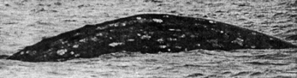
1. Consider “adopting” a gray whale. For a modest donation, the Cascadia Research Collective Gray Whale Adoption Project provides an annual adoption which includes an adoption certificate, a custom photograph of the whale you have adopted, information and sighting history of that whale, and an annual update on the status of Cascadia’s research and new findings on gray whales.

Whale 21 - (name needed)

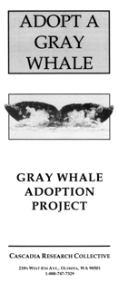

Like to have a whale named after you or your school? For an additional donation, you can even choose a name for one of the whales now only identified by a number. The project supports Cascadia’s research and educational efforts in identifying and tracking gray whales, examining strandings, and providing information on gray whales to the public and students. For more information, contact: Cascadia Research Collective; 218 1/2 W. Fourth Avenue; Olympia, Washington 98501; 1-800-747-7329.

Answer Key

Part 1 - Pausing in Puget Sound

1. Answers will vary, but most students will be able to define “inland sea” as a bay or inlet connected to the ocean.

2.a. Answers will vary, but may include such topics as: life span, feeding preferences, swimming mechanics, social relationships, population size, diseases, physical features, distribution, timing of migration, how they navigate, how they locate food, and causes of mortality.

2.b., 3. Answers will vary depending upon student preferences and prior knowledge.

Part 2 - Gray Whale Study

1. Scientists used information provided by the public to help determine the arrival and departure dates of whales in inland waters. Using the public essentially increased the “eyes” of the scientists; many people where watching for the whales rather than only a few scientists.

2. Cascadia Research Collective encouraged the public to sent them information by sending letters asking for information to people who live and work on the water who had reported sightings in previous years. Use of existing hotline telephone numbers also encouraged public participation.

3. The boat surveys were conducted primarily to take identification photographs of whales.

4. The scientists photograph both the left and right sides of the whale’s back around the dorsal hump and the ventral side of the flukes when possible. These parts were chosen because they are often visible above the surface of the water.

5. Markings such as pigmentation of the skin, mottling, scarring, and barnacles, which varied between individuals, are useful and a reliable means of identifying gray whales.

6. Answers will vary. Since the question calls for an opinion, accept any reasonable answer. Many things make it difficult to identify a whale using a photograph taken several years earlier, including: fading of scars, additional scarring, changes in barnacle numbers or locations, and changes in pigmentation or mottling.

7. The Northwest Marine Mammal Stranding Network is the organization that coordinates the examination of stranded marine mammals along the northwest coast.

8. A variety of information can be learned from a stranded whale carcass, including a confirmation of the species, length and other external measurements, blubber thickness, sex, and condition. Contaminant analyses of some of tissues can also provide valuable information.

9. Answers will vary but should be an expanded version of what students noted in question 2, Part 1 (i.e., topics as: life span, feeding preferences, swimming mechanics, social relationships, population size, diseases, physical features, distribution, timing of migration, how they navigate, how they locate food, and causes of mortality).

Part 3 - What Was Learned

1. Photo-identification is used to verify that some of the same whales return from one year to the next.

2.a., b., c. March, April, and May had the highest number of whale sightings.

3.a. Most whales are observed in spring and early summer with the peak in May.

b. The spring and early summer observations are during the northbound portion of the whale migration. Gray whales spend the summer in arctic waters and are, hence, en route.

4. Since ghost shrimp live in the mud and are favorite food for gray whales, it is not too great a leap to think that the trail of mud the gray whales leave behind might be related to feeding.

5. A possible answer as to why gray whales might be low on stored food reserves in late spring or early summer is derived from the following facts:

• Gray whales spend the summer months eating vast quantities of food.

• They eat little while on the breeding grounds and, apparently, during open ocean migration.

• The Washington portion of their northern migration is very near the end of the migration.

In short, when whales arrive off Washington in March and April, they have not fed much since the previous summer and are low on stored food reserves.

6. It could be argued that the gray whales are a barometer of the health of the environment; like the proverbial canary send down with coal miners to forewarn of a deterioration of the mine environment. In this sense, we should selfishly be concerned about levels of pollutants in the bodies of gray whales. It can be easily argued that, since all life is part of the whole, we should be concerned for the sake of the whales, as well.

