July 1

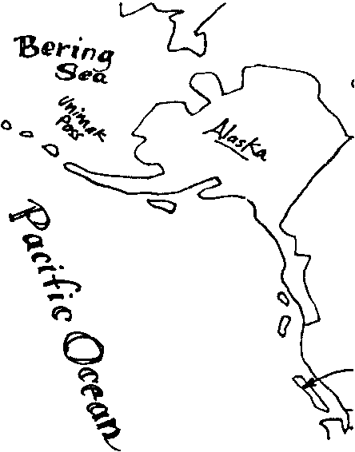
Key Concepts
1. Gray whales feed by sifting through bottom sediments for tiny organisms.
2. Sediment animals play an important role in some ecosystems.
3. In the summer, gray whales feed in arctic waters, producing blubber for food storage and insulation.

Background
Baleen whales, the group of whales which includes the California gray whales, have no real teeth. Instead, they have parallel rows of stiff, brush-like plates called baleen to filter large quantities of small food animals (plankton) from the ocean water. The two or three hundred flat baleen plates are set crosswise along the edge of the upper jaw and hang from it.

Baleen plates are fibrous and tough but flexible. They are made of keratin a material similar to human fingernails. On the inside of the mouth the edges of the plates are frayed into long bristles or strands resembling the strands of a horse’s tail. The strands of baleen from adjacent plates overlap forming a “hairy” mat which serves as a strainer to trap the food while letting the water flow through.

Although several different feeding strategies are found within the baleen whales, gray whales are unique in that they are primarily bottom feeders. To feed, gray whales roll on their side and bite chunks out of the sediment. They then swish the sediment around to filter out the benthic organisms.

Gray whales join other species of whales on the summer feeding grounds. Many of the other baleen whales depend on “krill”, the shrimp-like euphasids that are so abundant in polar waters. In what has become somewhat of a concern for whale enthusiasts, several nations have begun harvesting krill from Antarctic and Arctic waters. The U.S. is not currently harvesting krill. An international agreement regulating activities on the continent of Antarctica is periodically renewed. The International Whaling Commission (IWC) has proposed regulation of the krill harvest from polar waters. This is an issue where individuals, including students, have the opportunity to become involved in international politics and decision making. Past history indicates that informed letters to the IWC influences their decision making. Write to them for information about the proposal and to lend your class’s support and ideas.

A good summary of the issues surrounding krill harvest is found in: “Krill, Food for the Future?” by Stephen Nicol in Sea Frontiers/Sea Secrets. Jan-Feb 1987.

Additional background information is found in the previous activity, “Feast Waters”.

Materials
For groups of 3-4 students:

• dish tub or a sink

• water

• tablespoon of herb like Basil or Oregano

• tea strainer or kitchen sieve

• whisk broom

For each student:

• “July 1” student activity pages

Teaching Hints
“July l” provides students with a brief glimpse of the summer feeding regime of gray whales. Through a background reading, students learn about how the gray whale feeds and what it eats. Next, they simulate gray whale feeding. Finally, they write a proposal for an international agreement to regulate the harvest of krill.

Duplicate the text pages. One set is recommended per student. The background reading is best accomplished by individual students as a homework or in-class assignment. Allow some time for a discussion of the material and to provide answers for the text questions.

If class time is short, you might consider having students complete the baleen feeding simulation at home in the kitchen sink.

If you are using “Voyage of the Mimi” in conjunction with this unit, “Episode 5: Going Fishing correlates well with this lesson.

Key Words
baleen - an elastic, horny, fingernail-like material growing in place of teeth in the upper jaw of certain whales and forming a series of thin, parallel plates on each side of the palate

benthic community - the assemblage of bottom dwelling organisms, representing the slow moving or sometimes sessile (non-moving) forms. In the coastal zones, chiton, barnacles, crabs, sea anemones, and the like, are part of the benthos. In the deeper abyss, specialized sea stars, urchins, snails, and bivalves are examples.

blubber - fat layer between muscle and skin of whales and other cetaceans; whale oil was derived from blubber

decomposer - organism that cannot produce its own food but breaks down dead material from which it derives its needed energy and nutrients

ecosystem - the non-living and living environment in a given space

euphausid - a shrimp-like crustacean found in great numbers in certain parts of the ocean; a major food source for some baleen whales

plankton - the mostly microscopic plants and animals that drift in water; singular = plankter

Extensions
1. Write a menu for a “whale cafe”. Name the cafe. List and describe selections for appetizers, sandwiches, soup, dinners, deserts, and a “daily special”. Use ingredients from the gray whale’s real food choices. Make your menu look appealing to the customer, the gray whale. You might provide a “kiddie menu” section for calves.

2. Make a reproduction of baleen plates. Use several paper plates or plastic coffee can lids. Cut them at an angle. Trim the angled edge into a shaggy fringe. Place them side by side as baleen plates hang in a whale’s mouth.

3. Have students write to the International Whaling Commission requesting a copy of their proposed international agreement to regulate the harvest of krill. Also ask for the progress status of the agreement including a list of which nations support the agreement and which do not. Have students debate the issue and write letters supporting their positions to the International Whaling Commission.

Answer Key
Text questions

1. “Floating pastures” is a metaphor that means phytoplankton floating in the ocean is like a pasture of hay, alfalfa, grass or other feed for land mammals since animals graze on the greens in a pasture.

2.a. Gray whales eat shrimp-like amphipods and other small animals including euphausid shrimps, copepods, pteropod molluscs, amphipods, squid and small fishes such as lanternfish and candlefish. They also eat marine worms, ghost shrimp and other benthic dwelling animals, as well as organisms living on kelp. The diet of the gray whale is perhaps the most varied of whales. Very likely this varied diet has helped the gray whale make such a magnificent come back from near extinction.

b. They feed mostly on the bottom, plowing through the soft sand and mud with their snouts. Their primary feeding grounds are in arctic waters where they spend the summer. Gray whales also feed throughout the water column, eating small schooling fish, squid, and krill. They sometimes eat from kelp in kelp beds. Some students may recall that some gray whales feed in waters along the migration route and 400 to 500 summer off the Oregon and Washington coasts.

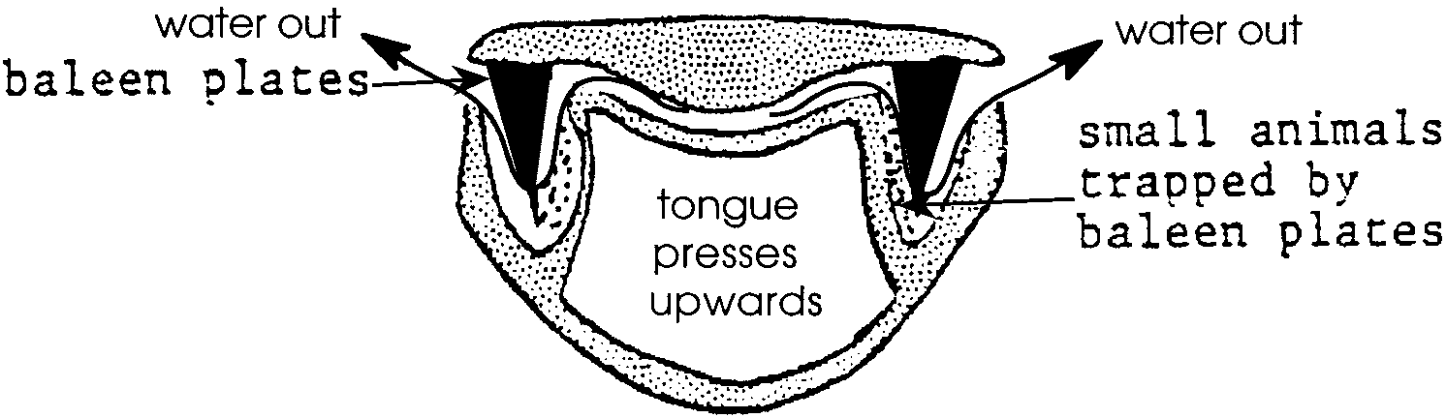
3. Answers will vary but should include the following information. Baleen whales, including the gray whale, are filter feeders. A gray whale feeds by first diving to the bottom, then taking a mouthful of water complete with bottom sediments. The whale then presses its tongue against the roof of its mouth and forces the water out through its baleen plates. The benthic animals upon which the whale feeds remain behind, stuck to the “hairs” of the baleen. A swish of the tongue and a swallow completes the process.

4. Two important functions served by blubber in the life of whales include insulation to reduce heat loss and food-energy storage. Students may recall that blubber also plays a role in buoyancy in gray whales.
5. A reduction in food supply in the arctic might have several consequences for gray whales. They might: feed on other organisms, move to other areas to feed, eat en route during migration, or starve.

6. Since these fish swim in the water column, rather than live in the mud, gray whales may use a different feeding strategy. Student answers regarding how they might change their hunting methods may vary but will likely include “skimming”, swimming near the surface with their mouths open to funnel the fish inward, or “gulping”, taking in large mouthfuls of water which is then forced out through the baleen leaving the fish behind. Note that the question calls for an opinion. As such, accept any thoughtful answer.

Grazing the Ocean Pastures simulation

2., 3., 4., 6., 7., 8., 9. Answers depend upon experimental results.

One Step Further....

Student proposals should be reasonable and the language clear and concise. To gain the best support, they should think about how to make the agreement inviting to everyone concerned while protecting and preserving krill. As much as possible, they should try to make everyone understand that everyone wins if krill is protected and managed wisely. Also to have a good chance of gaining acceptance, the proposals should not be too one-sided, either for or against the regulations. Help students to be objective and to see that a variety of view points is possible regarding this issue.

As you discuss this problem, you may wish to list all the proposals and as a class revise them into a single proposal. This will be an exercise in concessions and thinking skills, as well as social studies and language arts. You could then have your class mail your final proposal to the International Whaling Commission.

July 1
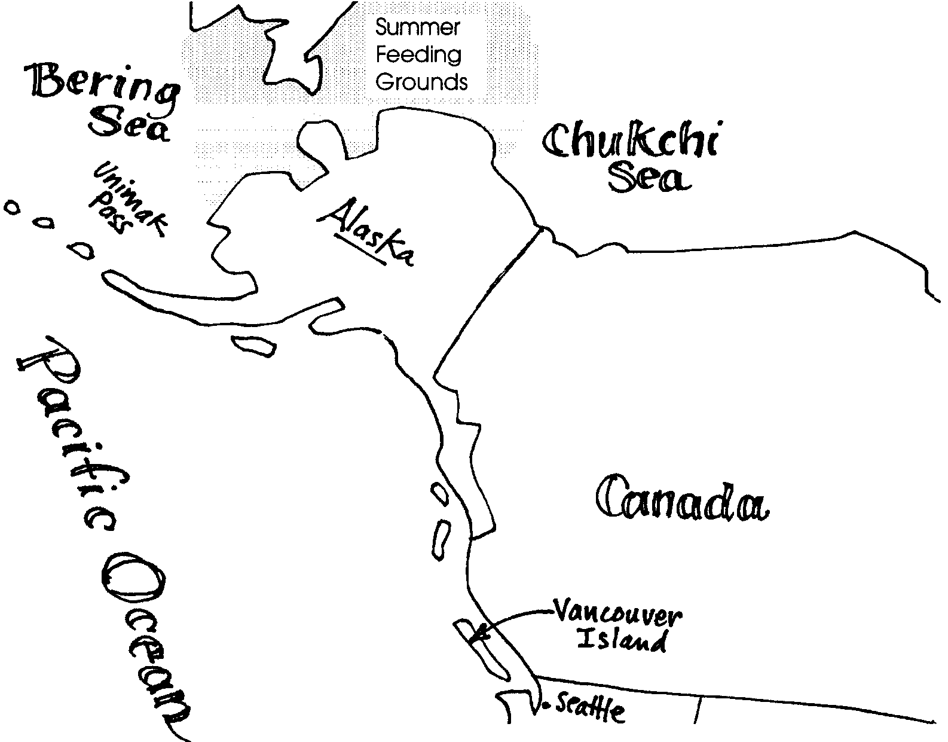
Summer time and the living is easy. The long summer days cast their light on the Arctic Sea. In the shallow waters of the Bering Sea our mother California gray whale swims with her calf. Fourteen thousand miles of travel has brought the mother back to the Siberian Arctic. It looks much the same as it did when she left in October. For the next three months, she and her calf will swim among the ice floes.

The abundant sunlight favors phytoplankton growth. Their numbers have rapidly increased, or “bloomed”. There are lots of these tiny plants available to be eaten. As a result, zooplankton populations have exploded. Other animal populations, including the bottom dwellers, have also increased. These populations of bottom dwellers provide food for our whale calf.
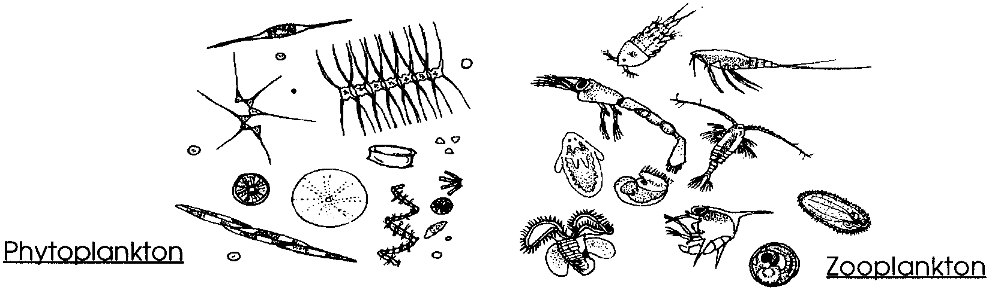
1. Why do you think the summer arctic seas are sometimes called “floating pastures”?

Her head breaks the surface of the water. Her blowholes open and a rush of warm air rises. The air forms a heart-shaped “spout” as it condenses. She inhales cool air before her flukes break the surface as she dives.

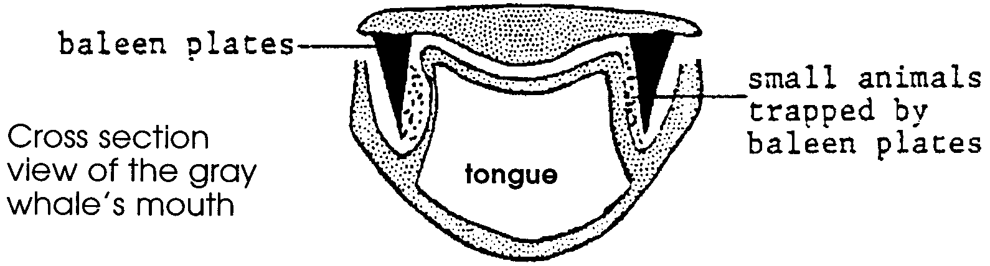
In a few minutes she is plowing through the soft sand and mud bottom with her snout. She stirs up great clouds of small shrimp-like amphipods. She sucks in a mouthful of water, mud, and amphipods. Pressing her tongue against the roof of her mouth, she forces the muddy water out through her baleen plates. The amphipods and other small animals remain behind stuck to the bristles of her baleen. She gulps and strains another mouthful of water. She feeds for five minutes before swimming to the surface. A muddy trail of water follows her as she filters the mud for her food.

2. a. What do gray whales eat?

b. In what part of seas do they feed?

3. In your own words, tell how a gray whale feeds. Draw an illustration to help your explanation.

Her calf tags along and learns to feed herself in the same way. Our calf depends less and less on mother’s milk. Gray whale calves are usually weaned by the time they are about seven months old.

The cold arctic waters supply a lot of whale food. Our whales begin to increase their layers of blubber. Blubber is a fatty layer important for a whale’s survival. If you have had to swim in cold water, you know how quickly you become chilled. The chilling comes from a loss of body heat. Blubber acts as insulation to reduce this heat loss. Like a warm coat, blubber traps body heat from escaping into the surrounding waters or air.

Blubber is important for another reason. Blubber stores food energy. The energy will be needed in the long migration south to the breeding grounds. Many gray whales do not stop to eat on the way.

4. What are two ways in which blubber is important for a whale’s survival?

a.

b.

5. Some years there are fewer amphipods in the arctic. What might this mean for gray whales?

How Gray Whales Feed

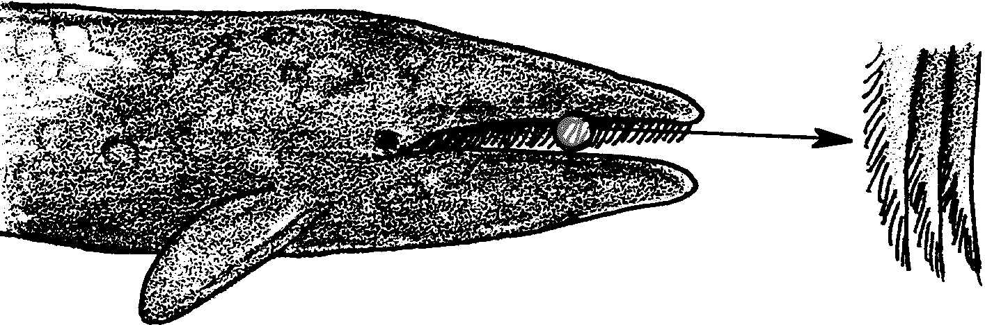
Gray whales belong to a group called “baleen whales.” Baleen whales do not have teeth. Instead, they have rows of baleen plates. The baleen plates are made of a fingernail-like material. They hang from the top jaw and form a kind of comb. The plates act as a sieve when a baleen whale feeds.
Gray whale baleen, the heaviest of all the baleen, is shaggy and short. It is only about 6 inches long in the front of the mouth. Further back in the mouth, it is up to about 18 inches long. One edge is smooth, the other is fringed. The fringed edge faces the inside the mouth.
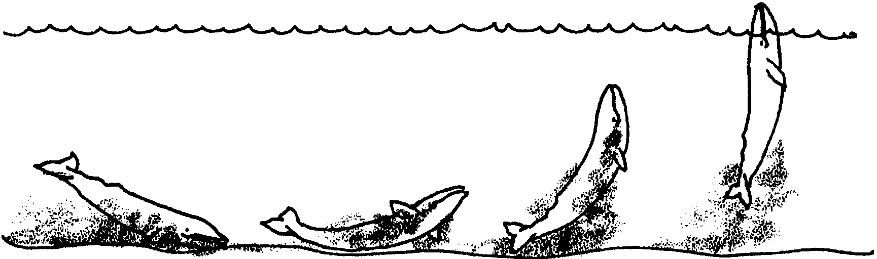
To feed, a gray whale dives to the bottom and turns on its side. There it bites chunks out of the mud or sand. Also stirred up are small animals which live buried in the mud or sand. The whale sucks this water mixture into its mouth. It then closes its mouth and raises its massive tongue. The water is forced out between the baleen plates. The small organisms are trapped inside the mouth by the plates.

Gray Whale Feeding

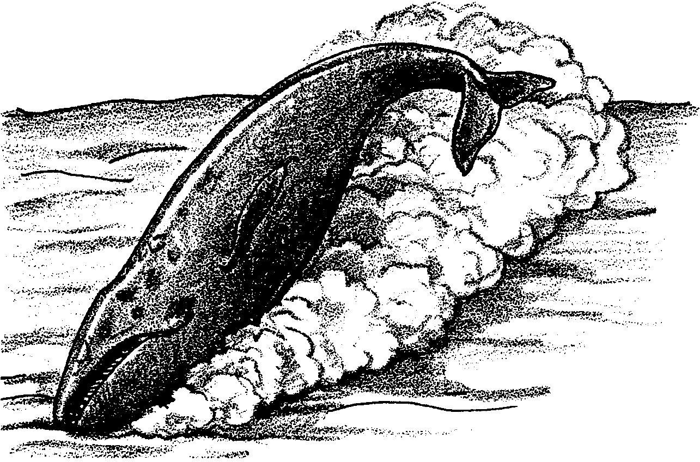

What do Gray Whales Eat? Whale Soup!

Summer life is indeed easy. Our gray whales feed on a variety of animals. Most of their food lives on the bottom. Most, but not all. Sometimes they eat squid or small fish. Sometimes they even strain kelp seaweed through their mouths to rub off crabs and shrimp. Like good recyclers, they return the kelp, unharmed but empty, to the sea.

6. Gray whales sometimes eat lantern, candle, and other small fishes. Think about how gray whales usually feed. How might they change their hunting methods to catch these fish?

Grazing the Ocean Pastures

Baleen whales make feeding at the surface or on the bottom look easy. In the following activity, you will have your chance to strain water for “food”.
Here’s what you’ll need:

Materials

For your group:
• dish tub
• water
• 1 tablespoon of herb “shrimp”
• tea strainer or kitchen sieve
• whisk broom

Here’s what to do:

Procedure

1. Fill a dish tub with water to within a few inches of the top. This water is your “ocean”.

2. Sprinkle the herb “shrimp” across the surface of the water. The herbs represent shrimp drifting on the surface. Watch what happens. Do some of them drift together? Do some of them sink slowly to the bottom? Describe what you observe.

3. Now’s your chance. The strainer or sieve is your “baleen”. Try catching “shrimp” at the surface.

a. What method did you try?

b. How successful was your first try at filtering the ocean for food?

c. Think about anything you’d like to change and try again. Describe your results.

4. Now try a different kind of “baleen”. Use the whisk broom “baleen” to try to catch “shrimp” at the surface.

a. What method did you try?

b. How successful was this feeding strategy?

c. Was this method more successful than the tea strainer? Describe the results.

5. By now some of the “shrimp” have probably sunk to the bottom. If not, add a little more herb “food” and gently swish the water. Wait until some “shrimp” become water logged and sink. These represent the shrimp living in the bottom sand and mud.

6. Now, try catching “shrimp” at the bottom. Use your strainer “baleen” first.

a. What method did you try?

b. How successful was your first try at filtering the ocean for food?

c. Think about anything you’d like to change and try again. Describe your results.

7. Now, use the whisk broom “baleen” to try to catch “shrimp” at the bottom.

a. What method did you try?

b. How successful was this feeding strategy?

c. Was this method more successful than the tea strainer? Describe the results.

8. Compare feeding at the surface and at the bottom. Which was easier? Which caught more food? Which kind of “baleen” worked best in each place?

9. Think about how much of the food is missed using your “baleen”. Describe a way to feed that a whale could use to get the most food from an area in the ocean.

One Step Further...

People make laws to protect fish, shellfish, whales and lots of other animals. The laws aim to protect or manage the supply of these animals. People can only make laws and enforce them within their own boundaries. There are no boundaries in the open ocean. Who protects the shrimp-like animals, called “krill”, in the arctic? Perhaps you can help.
Write a proposal for an agreement among nations that will protect the supply of food for whales. Be specific about what must be done or not done.

a. State exactly where and when the agreement is effective.

b. Say who must follow the terms of the agreement.

c. Include a proposal for how to enforce the agreement.

d. Consider how much it will cost for the proposal to be effective and who will pay the cost.

e. Some nations want to catch the krill for human food. How much will these nations lose under your agreement? How can they be compensated (paid) for their losses?

