The Journey Begins - February 21
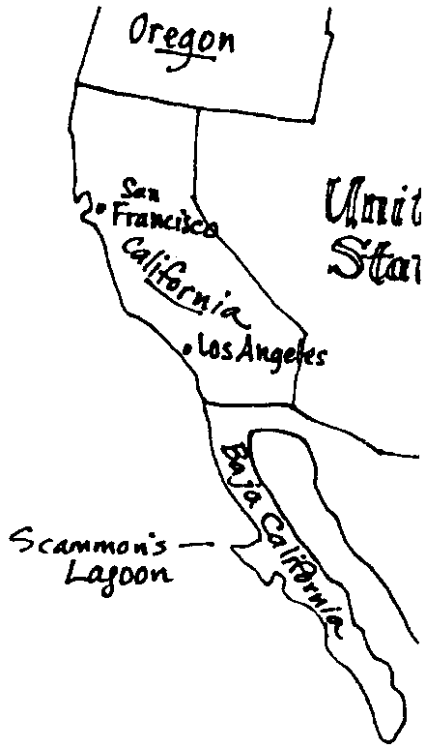

Key Concepts
1. The northward migration of the gray whale is not fully understood.
2. A gray whale’s northward migration takes about four months, even though it could swim the distance faster.
3. Whale species swim at different rates.

Background

A good portion of the gray whale’s annual migration remains somewhat of a mystery to scientists. Most gray whales migrate between the breeding grounds along the coast of Baja California where they spend the winter to their main feeding grounds in the Bering and Chukchi Seas where they spend their summer.

Gray whales frequent the coast of Baja California from November to May. During these months the females enter the lagoons and bring forth their young from December to March, while the males generally remain outside along the sea-shore. As the calving season slackens, males are occasionally seen in the lagoons with the females.

By February, mothers and calves are seen leaving the lagoons and, along with males, begin to work their way northward. During the northern migration, gray whales tend to be remain near the coastlines, seldom being seen far out at sea. There appear to be two distinct “waves” of northward migration. Evidence for this comes from observations of the gray whales off the Washington coast. The first, and largest, group of animals, passes along the Washington coast in late March or early April and includes most of the males, immature animals, as well as some females and calves. The second, smaller wave passes the coast in May through early June and is comprised mostly of females with their calves.

During the less well-understood southern migration, gray whales appear to travel further off shore and in a less congregated fashion. From October to January, gray whales appear off the coast of Washington, Oregon and California as they move southward.

It now seems that not all animals make the entire migration to the arctic seas. In recent years, some gray whales were observed to feed along the coasts of Mexico and California, others along the Oregon, Washington, or British Columbia coasts rather than continue migrating to the northern-most feeding grounds. Whether the extended feeding range is a reflection of the increasing population numbers since the gray whales were protected is a matter of debate.

The near-shore migration of California gray whales which once made them easy targets for whalers, now makes them a favorite with whale watchers. Their near-shore migration also puts gray whales at risk from the adverse impacts of human near-shore activities including oil exploration, shoreline development, and shipping.

Materials

For the class

• a map covering the migration route along the Pacific Coast from Baja, California, Mexico to the Arctic Ocean

For each student

• “The Journey North Begins - February 21” student pages

• calculator (optional)

Teaching Hints

“The Journey North Begins - February 21” sees our gray whale and her calf leave the nursery grounds of Scammon’s Lagoon and enter the “mystery” portion of the gray whale northern migration. Although there has been much scientific research conducted to identify the northward path of the migration, much remains to be learned. In this activity, your students have the opportunity to design a scientific research study to find out more about the gray whale’s migration northward.

In a preliminary class discussion, have your students examine the migration route to become familiar with the path the gray whales follow along the Pacific coast. Use available maps, globes, bathymetric charts, etc., to look for geographic features, human population centers, shallow shelves and submarine canyons that may affect the gray whale’s migration route and pattern. Discuss methods researchers may have used so far to study the migration. Ask what technological developments have made studies more feasible. Lead into the activity by asking what other technologies or strategies could be used to study whale migration.
Duplicate the text and study pages. This activity is best assigned as in-class work for small groups or individuals.

Follow up with a discussion of the students research study plans.

If you are using “Voyage of the Mimi” in conjunction with this unit, “Expedition 1: Planet Ocean”, “Episode 2: Setting Sail”, and “Episode 6: Home Movies” correlate well with the above lesson.

Key Words

blubber - the fat of whales and some other marine mammals, lying under the skin and over the muscles, which serves as a food reserve and insulates the animal from heat loss

calf - in this case, a term used to describe the offspring of California gray whales in their first year of life

migration - the seasonal movement of animals from one place or region to another; the act or process of migrating

Extensions

1. Have students research the migrations of other whales and other animals. Then have them make a map showing the different migration routes and times. Notice any similarities and differences in the speeds, times, distances, and routes.

Answer Key

1. From the text, the newborn whales will spend their first summer in the Arctic.

2. This question calls for an opinion. As such, accept any reasonable answer. The arctic seas provide a rich source of food for gray whales.

3. a. The swimming rate for the gray whale is 4-12 km/hr and is found on the chart.

b. The average speed for each species given is:
Fin whale: 24 km/hr
Sperm whale: 27.5 km/hr
Right whale: 6 km/hr
Gray whale: 8 km/hr
Humpback whale: 14 km/hr
c. The fastest whale species given is the Sperm whale at 37 km/hr and an average speed of 27.5 km/hr.

d. The slowest whale species given is the Right whale at 3km/hr and an average speed of 6 km/hr.

e. The Gray whale is next to the slowest, or fourth on this list.

f. Swimming at the average speed, our gray whales will cover 192 kilometers per day (i.e., 8 km/hr average speed x 24 hrs/day).

g. Some scientific studies seem to indicate that whales swim 24 hours a day. If our whales swim 24 hours a day, how many days will it take them to make the migration trip to the Arctic? Assume they swim their average speed. (Hint: the migration trip is 7,000 miles long. Great, but how many kilometers is it? To find out, multiply the distance by 1.66 kilometers/mile. Then find out the number of days.)

Swimming 24 hours a day at the average speed of 8 km/hr, the migration will take 60.5 days.

(i.e., 7000 miles/migration x 1.66 kilometers/mile = 11,620 kilometers/migration

11,620 kilometers/migration x 1 day/192 kilometers = 60.5 days/migration)

4. The design of the scientific study will vary per individual or group. Use this question as a springboard for a discussion of the scientific data gathering process.

The format of the question is designed to encourage student study plans patterned after the scientific process starting with a problem or question leading to a hypothesis and the design of a way to test that hypothesis. The equipment and materials needed are determined by the design of the research study. Students may have to design equipment specific to their study needs. Discuss the plans with the class.

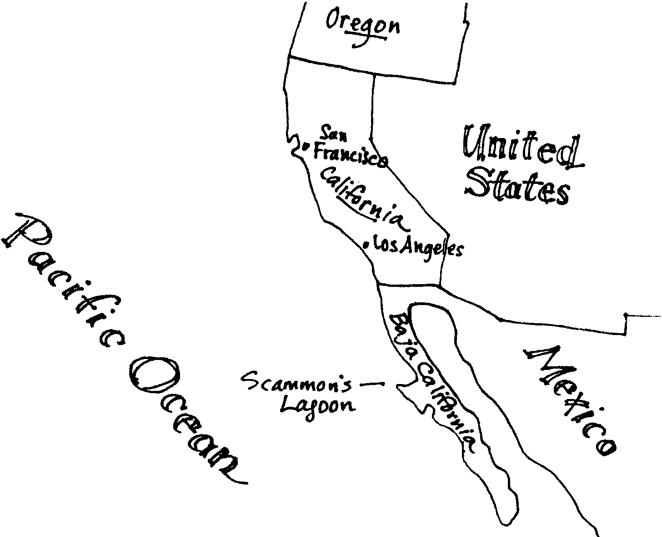
The Journey Begins - February 21

Time has come for the long journey north. Once again the most incredible migration known to humans begins. Our whale and her baby leave the nursery area. Together they swim the nearly thirty miles to the mouth of the lagoon. Our little female calf has grown to nearly 20 feet in length. She has more than doubled her weight. Her new blubber and stronger muscles will help her to make the long swim north to the Arctic feeding grounds. Our mother and calf join others near the entrance to the lagoon.
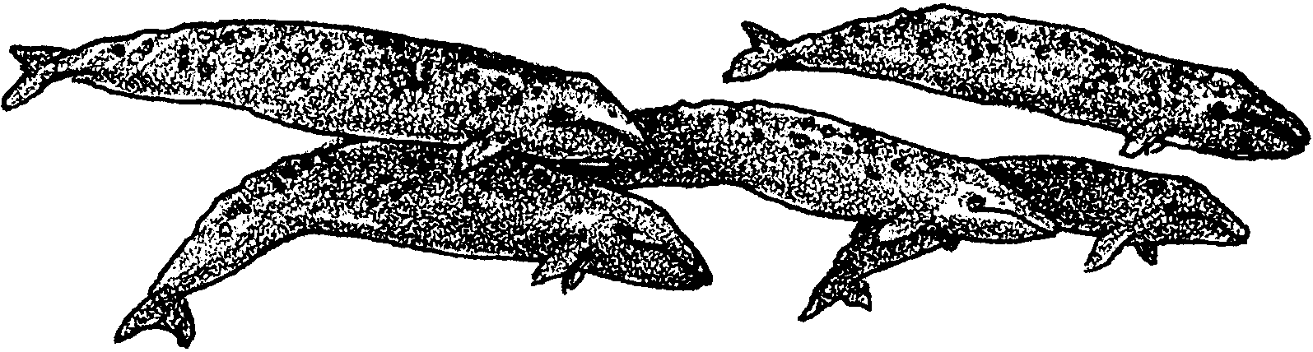
Swimming near the entrance, the whales wait for calm seas and a high outgoing tide. These conditions let the weaker nurslings leave the lagoon with little risk. Not all of the these newborns will spend the summer in the Arctic. Already the carcasses of a number of baby whales are scattered along the beaches. Nor will all of the adults be returning north. The beaches also have become the final resting place for over a dozen adults.
1. Where will the newborn whales spend their first summer?

2. What do you think the arctic seas provide for gray whales?

The tide changes. Our healthy female calf follows close by her mother’s side. They pass through the narrow channel and into the open ocean. On this day we lose sight of our whales.

In spite of extensive surveys and studies, we know very little about the next four months of our whales’ lives. Some gray whales are seen migrating north past California, Oregon and Washington. These whales tend to be males and females without calves. In April, large groups of gray whales gather off of Washington’s Olympic Peninsula and British Columbia’s Vancouver Island. But, here again, very few females and calves are seen from shore.

Our mother and calf seem to have gone westward toward the open waters of the Pacific Ocean. In June, they will arrive in the Arctic.

3. Whales can travel for long periods of time at rates from 3 kilometers to 46 kilometers (2 to 29 miles) per hour. The chart below shows some whales and their long distance swimming speeds.

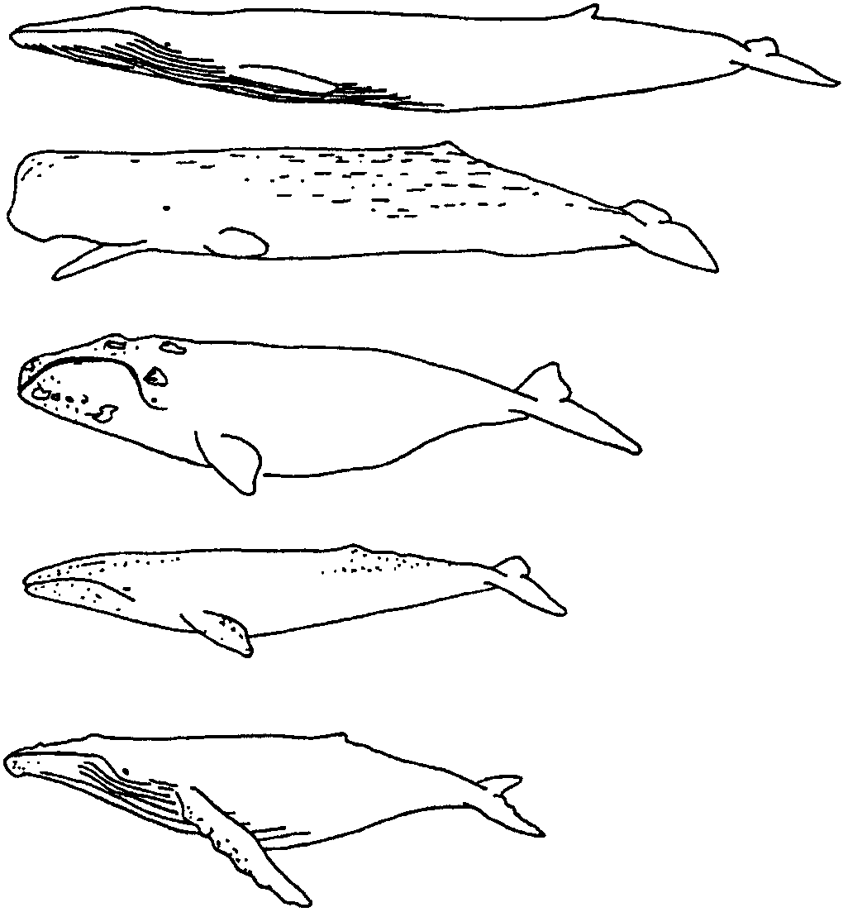
Fin whale
(22-26 km/hr)

Sperm whale
(18-37 km/hr)

Right whale
(3-9 km/hr)

Gray whale
(4-12 km/hr)

Humpback whale
(10-18 km/hr)

Use the chart of whales speeds to answer these questions:

a. What is the swimming rate for the gray whale?

b. What is the average swimming speed for each whale?

(Hint: This is easy. For each whale species, add the slowest speed to the fastest speed. Then divide the sum by 2. Your answer is the average swimming speed for that species.) Record your answers in the table below. Please show your work.

Whale species Your work goes here Average speed

Fin whale

Sperm whale

Right whale

Gray whale

Humpback whale

c. Which whale is the fastest?

d. Which whale is the slowest?

e. How does the gray whale rank for speed on this list?

f. Swimming at the average speed, how many kilometers per day will our gray whales cover? (Hint: A day is 24 hours long.)

g. Some scientific studies seem to indicate that whales swim 24 hours a day. If our whales swim 24 hours a day, how many days will it take them to make the migration trip to the Arctic? Assume they swim their average speed.
(Hint: the migration trip is 7,000 miles long. Great, but how many kilometers is it? To find out, multiply the distance by 1.66 kilometers/mile. Then find out the number of days)

Please show your work.

Scientists are still learning about the travels of mother and calf gray whales after they leave Scammon’s Lagoon. The trip is not always straightforward. Storms, predators and other hazards can cause delays. People also wonder whether whales take side trips.

4. Perhaps you could help scientists gather information about these travels. Design a research study that will provide you with new information. Follow the format below:

a. The Research Study - What I will try to find out:

b. Methods - Ways I will gather the information:

c. Equipment - What I will need to use the following things:

