Family Tree

Key Concepts
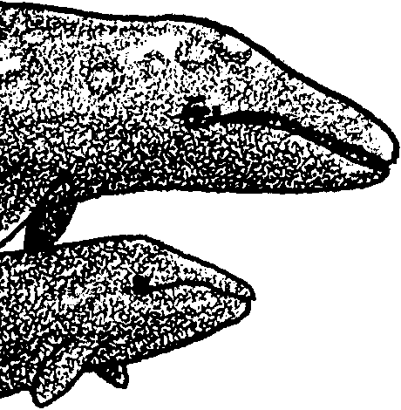
1. The ancestors of whales were land mammals that returned to water around 50 million years ago to take advantage of abundant food resources.
2. The bodies of whales have undergone important changes which enable them to live in water, but they retain some characteristics of their land-dwelling ancestors.
3. Whales, dolphins, and porpoises are grouped together by scientists into the order Cetacea. They are further divided into baleen whales and toothed whales by the characteristics of their feeding apparatus.
4. Scientists classify living things by characteristics which reflect the evolutionary history of those organisms, to the extent that it is known.

Background
All organisms, both living and extinct, are classified by scientists according to a system called taxonomy. Through taxonomic classification, scientists attempt to place organisms into groups and sub-groups which reflect probable evolutionary relationships. Although the system of taxonomic classification originated in the work of Karl Linnaeus in 1735, it was Charles Darwin who provided evolution as its guiding principle a century later. The field of taxonomy is now so intimately connected to the study of evolution that it is impossible to discuss the science of taxonomy in a meaningful way without also discussing its underpinnings in evolution science.

It should also be stressed that taxonomy is much more than a system for naming and organizing living organisms. It is a true science, for as new information is gained about relationships between organisms, taxonomists make adjustments in the way they are classified. For example, recombinant DNA research has given us a new way of inferring how long ago living organisms may have diverged from a common ancestor, based on similarities or differences in their DNA or RNA structures. This new information may prompt us to reclassify some closely related organisms if it challenges earlier assumptions.
Let’s see how modern marine mammals are classified under the taxonomic system. We know that some cetaceans capture their prey with teeth, while others use baleen plates to strain fine particles from the water. Because the separation of these traits is thought to have occurred early in the history of cetaceans, these characteristics are used to separate cetaceans into two important groups, the toothed whales, or Odontoceti, and the baleen whales, or Mysticeti. These groups are subdivided further using other characteristics, e.g., fin shape and position which are thought to have developed more recently.

Until a few years ago, our knowledge of the origin of marine mammal groups was very limited. We now know they evolved over a relatively short period of time around 50 million years ago. Recent fossil discoveries in western Asia have helped provide a picture of some marine mammals which formed the link with land-dwelling mammals.

One reason it has taken so long to put these pieces in place is that paleontologists, scientists who study prehistoric life, have not known where to look for the fossil remains of ancestral marine mammals. Paleontologists once thought species evolved gradually, and for this reason, they searched for “missing links” over a great expanse of time in the fossil record. A dramatic new theory among paleontologists now holds that species originate extremely rapidly. Armed with this new perspective, paleontologists have been able to locate the precise sediments in which fossilized ancestral whales are buried.

According to current thinking, species originate rapidly, and once established, they are usually stable over long periods of time. When species do go extinct, it is more likely the result of chance circumstance than lack of fitness. For this reason, one should use caution in calling one organism “primitive” and another “advanced,” for it is important to understand that neither is necessarily more “fit” or likely to survive than the other. In actuality, all organisms are highly adapted to their environments, whether they have retained ancient features or whether their bodies reflect more recent modifications.

An important case in point is the gray whale, which has been called the most “primitive” of the baleen whales because its body form and feeding structures are thought to resemble some of the ancestors of living baleen whales. Primitive or not, the gray whale is certainly as well adapted to its environment and way of life as any other marine mammal species.

A final point is that organisms which superficially appear to have similar features may have taken different routes to arrive there. Marine mammals are a superb example. The streamlined body shape and paddle-like flippers of seals, whales, sea cows, and prehistoric ichthyosaurs for that matter are all adaptations to mobility under water, but each of these groups had different ancestors and took up life in the water at different times. This phenomenon, where different groups of organisms make independent adaptations to a similar way of life, is known as “convergent evolution.” Other examples abound in nature.

Additional background information is found in the preceding activity, “Putting All the Pieces Together”.

Materials
For the class:

• transparencies of: “Cetacean Key”, whale card set, and “Cetacean Taxonomy Chart”

For each pair of students

• one set of whale cards

• “Cetacean Key”

• game marker (button, shell, etc.)

• “Cetacean Key Answer Sheet”

For each student

• “Family Tree” and “Return to the Sea” student text pages

• Optional: Cetacean Taxonomy Chart

Teaching Hints
In “Family Tree”, students engage in four activities related to the classification of whales. Parts 1 and 2 make use of a set of ten Whale Cards. In the first activity, students practice sorting them into groups based on observable characteristics of the whales. This prepares students for a later activity on whale taxonomy. In the second activity, students use a “Cetacean Key” to identify the whales pictured on the cards.

Parts 3 and 4 are student readings. “Family Tree” introduces the classification system for all life forms, taxonomy, and explains how whales are divided into sub-groups based on some of the same characteristics the students observed in the Whale Cards. “Return to the Sea” describes some recently discovered fossil whales which enable us to see how the lineage of whales may have originated.

Part 1: Sorting Marine Mammals

Preparation

Explain to students that scientists who study whales (cetologists) have long been faced by the interesting problem of how and why this group of mammals, whose ancestors originated on land, returned to live in the water and have become so well adapted to living there.

One way cetologists have studied this problem is to explore the families of existing whales, to try to learn relationships which may provide clues about how and when they originated.

Tell students you’re going to have them be the cetologists, and they will work together in pairs to try to decide which marine mammals might be most closely related to one another. Remind students that families of people share characteristics that non-family members may not share. Tell them they are to use clues in the pictures you are going to give them to help put the marine mammals into groups, groups that might show possible family relationships.

Procedure

1. Pass out sets of whale cards to students and allow them to work in pairs to classify the whales in a way that makes sense to them. Remind them that when finished, they should be able to explain their reasoning to someone else. Emphasize that there is no one right way to do this, nor is their any correct number of groups.

2. Allow students sufficient time to try a variety of classification patterns if interest is there.

3. Have each pair of students share some of the criteria used in making their classification systems. They will probably refer to characteristics such as color, size, presence or absence of a dorsal fin (the fin on the back of some whales), and whether or not it has teeth or baleen in its mouth. This is a good time to discuss such terms as dorsal fin, pectoral fin, and baleen vs. toothed whales.

4. You may also want to have students consider which characteristics would be most useful in evaluating the ancestral relationships of these mammals. For example, your students may recognize that color and size are traits which may not be stable over time, whereas the presence or absence of baleen or a dorsal fin might indicate a more fundamental division.

Part 2: Cetacean Key

Preparation
If your students have never before used a key, you may want to introduce the concept by making a “Key of Shoes.”

“Key of Shoes”
Have each student remove one shoe and place it in the center of the room where all can see. Ask the students to suggest a way of dividing the pile of shoes into two groups. For example, someone might suggest, tennis shoes in one pile and everything else in another. Make the division and record the two category names on the board or overhead. Then start with one of the piles and ask students how to divide this pile into two groups. Again divide the pile and record the criteria used to make the division. Repeat the process until all shoes are distinguished from all other shoes, and give the final grouping (now just one shoe) the name of the shoe’s owner. Mix all the shoes together, pick out one of them, and have the class follow the key to identify to whom the shoe belongs.

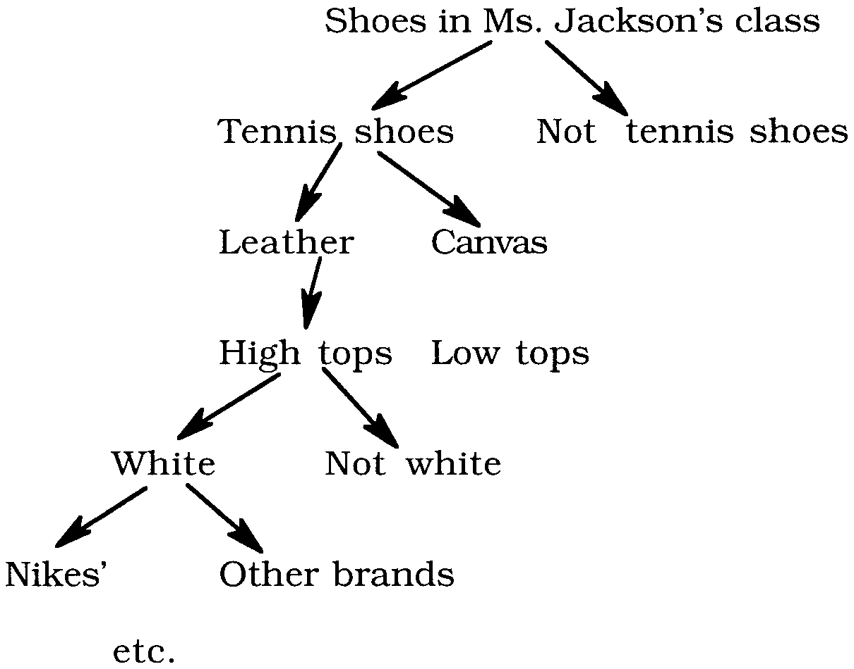
For example:

Explain that a key is a tool one person leaves for another to help that person identify something from a collection of similar objects. The divisions in a key are made for convenience and do not necessarily imply a particular relationship between the objects in the key. The “Cetacean Key” will help students identify the whales on the cards.

Procedure
1. Use the transparencies of the whale cards and the “Cetacean Key” to model how to use the key:

a. Have a student pick one of the cards, place it in the center of the key, and place a marker in the square labeled “START.”

b. At the first box, have students decide whether the whale has teeth or baleen. That choice will determine where to go next.

c. Have the student continue moving as the boxes direct until the marker reaches the box which tells the name of the marine mammal.

2. Have students use the above procedure to determine the names of the marine mammals shown on the cards, recording the name of each on the “Cetacean Key Answer Sheet”.

3. When students finish, summarize with them the current thinking of scientists on the classification of cetaceans, using the Cetacean Taxonomy Chart, either as a transparency on the overhead or by giving students copies of the chart. Invite students to offer ideas on why scientists might classify cetaceans in this manner.

Parts 3 and 4: Family Tree and Return to the Sea

Two student readings are provided. “Family Tree”, takes students further into the classification of the gray whale by introducing some terminology in the science of taxonomy. You may use this text as an individual assignment, as a group assignment, or you may prefer to introduce and discuss this information as part of a classroom lesson.

“Return to the Sea” introduces the field of cetacean paleontology which is the study of prehistoric marine mammals, as a means of exploring how mammals first took to the sea around 50 million years ago.

If you are using “Voyage of the Mimi” in conjunction with this unit, “Expedition 2: Whale Watch” correlates well with the above lesson.

Key Words
baleen - plates of a horn-like substance that hang from the upper jaws of baleen whales

baleen whale - whale which feeds with baleen, member of the Mysticeti

Class - a division in taxonomy, between Phylum and Order

cetologist - a scientist who studies cetaceans

Cetacea - the group, or order, of mammals that includes whales, dolphins and porpoises

dorsal fin - the fin on the back of some whales

Family - a division in taxonomy, between Order and Genus

fossil - any remains, impression, or trace of a living thing of a former geologic age, as a skeleton, footprint, etc.

Mysticeti - the group, or suborder, of cetaceans which feed with baleen

Odontoceti - the group, or suborder, of cetaceans which feed with true teeth

Order - a division in taxonomy, between Class and Family

pectoral fins - the side fins on a whale, comparable to the front legs of a land mammal

rorqual - a family of baleen whales which include blue whales and humpback whales

right whale - a family of baleen whales which include bowhead whales and right whales

Suborder - a subdivision in taxonomy, below Order but above Family

taxonomist - a scientist who classifies living things using characteristics that are thought to indicate evolutionary relationships

taxonomy - the study of the description, identification, naming and classification of living things and the evolutionary relationships between those living things

toothed whale - whale which feeds with teeth, member of the Odontoceti

Extensions
1. Look into the origins of a scientific name like Eschrichtius robustus with your students. In this case, the name “Eschrichtius” was given in honor of Daniel Eschricht, a Danish zoologist, but the name “robustus” is more descriptive. A great many scientific names are based on Latin or Greek descriptive roots which your students can investigate. One approach is to find other words in English which share the roots found in a scientific name, such as “sol” and “aster” as in Solaster, a sea star. “Solarium, solar and solstice” all share the first root, which, of course, means “sun,” and “asteroid, astronomy and astronaut” share the second, which means “star.” A good English dictionary, or even better a Latin or Greek dictionary is also helpful. By collecting and sharing some of these roots, students can invent original scientific words of their own, an activity which might develop into some creative language arts and graphic arts extension projects.

2. Have students conduct further research on individual cetacean species, providing information on taxonomic relationships, life histories, etc.

3. Explore the work of a cetologist, paleontologist, or taxonomist with your students. Depending on your location, you may be able to invite one or more of these scientists to visit your classroom. Have the class play “20 Questions” to learn what the mystery guests do for a living. Invite the scientists to tell the story of how they became involved in this line of work. Encourage them to share what they enjoy about their job.

Answer Key
Part 1: Sorting Marine Mammals

3. Student classification systems will vary depending upon the criteria used. Discuss the merit of systems based on characteristics that are “absolute” such as length or weight versus characteristics that are “relative” such as pretty, ugly.

Part 2: Cetacean Key

2. The order of the names of the marine mammals shown on the cards as recorded on the “Cetacean Key Answer Sheet” follows:
A. Humpback Whale
B. Bowhead Whale
C. Bottlenose Dolphin
D. Pilot Whale
E. Blue Whale
F. Orca Whale
G. Right Whale
H. Gray Whale
I. Beluga Whale
J. Sperm Whale
Part 3: Family Tree

1. The science of taxonomy is the study of how organisms can be classified. It is a science, because it is based on what we know and continue to learn about how life forms are related. As new information is gathered, scientists sometimes change their minds about how they place living things into groups.

2. Taxonomy of the Dog
Kingdom - Animal
Phylum - Chordata
Class - Mammalia
Order - Carnivora
Family - Canidae
Genus - Canis
Species - familiaris

3. Cetacean is the name for members of the order Cetacea, which includes whales, dolphins, and porpoises. It comes from the Greek work, “Cetos,” meaning “whale.”

4. Whales and their relatives are divided into two groups by whether they have mouths with teeth or with baleen.

5. The largest of the Odontoceti is the sperm whale, about 65 feet in length.

6. The smallest Mysticeti is the pygmy right whale, about 20 feet in length.

7. Each group has unique characteristics. The rorqual whales have a small dorsal fin and distinctive expandable throat grooves used in their method of feeding. The Right whales have no dorsal fin, no throat grooves, long baleen, and they feed while swimming. The gray whale has a dorsal hump and short baleen which it uses to filter mud. Cetologists used all of these characteristics to divide the baleen whales into three groups.

8. Taxonomy of the Gray Whale
Kingdom - Animal
Phylum - Chordata
Class - Mammalia
Order - Cetacea
Suborder - Mysticeti
Family - Eschrichtidae
Genus - Eschrichtius
Species - robustus

Part 4: Return to the Sea

1. Characteristics of mammals include:

a. warm-blooded,

b. breathe air,

c. hair on their bodies at some time in their lives,

d. bear their young live (not in an egg), and

e. nurse their young with mother’s milk produced in mammary glands.

2. The bodies of whales have undergone these modifications:

a. front legs have become pectoral fins,

b. lost their hind limbs entirely,

c. tails have become paddles, or flukes,

d. a thick layer of blubber insulates their bodies,

e. nostrils have moved to the top of the head, above the eyes, and

f. skulls and ear bones have changed to enable whales to make and receive complex sounds under water.

3. The pectoral fins of whales still contain most of the bones in the foreleg of a land-dwelling mammal. Located toward the tail, some whales have small bones which are derived from the hind legs of their ancestors.

4. The shallow seas of those times were rich with fish and shellfish. It is thought that the ancestors of whales ventured into the water after food.

5. Prehistoric whales lived along the shoreline of an ancient ocean, the Tethys. Although the ocean itself is gone, material from its ancient beaches is preserved in the deserts of Pakistan.

6. Ambulocetus natans means “walking-swimming whale”

7. Ambulocetus natans swam with an up and down motion of its back and legs. This is very similar to the up and down tail motion in modern whales.

8.a. The fossil record indicates that as whales adapted to life in the seas, their legs became shorter.

b. The fossil record also indicates that as whales adapted to life in the seas, their tail flukes became larger, the muscles to propel them increased, and the spine became increasingly flexible.
9. Pakicetus had not yet developed the bone structure to hear well under water.

10. A camel is more closely related to the gray whale than a seal, because they diverged from a common ancestor more recently than did the whale and the seal. Cetaceans and camels were both derived from even-toed hoofed ancestors.

11. Seals are related to dogs and cats. All are in the order carnivora.

12. The elephant is related to sea cows and dugongs. If students are not familiar with sea cows and dugongs, you may wish to use this question as extra credit and provide additional information on these interesting and highly endangered animals.

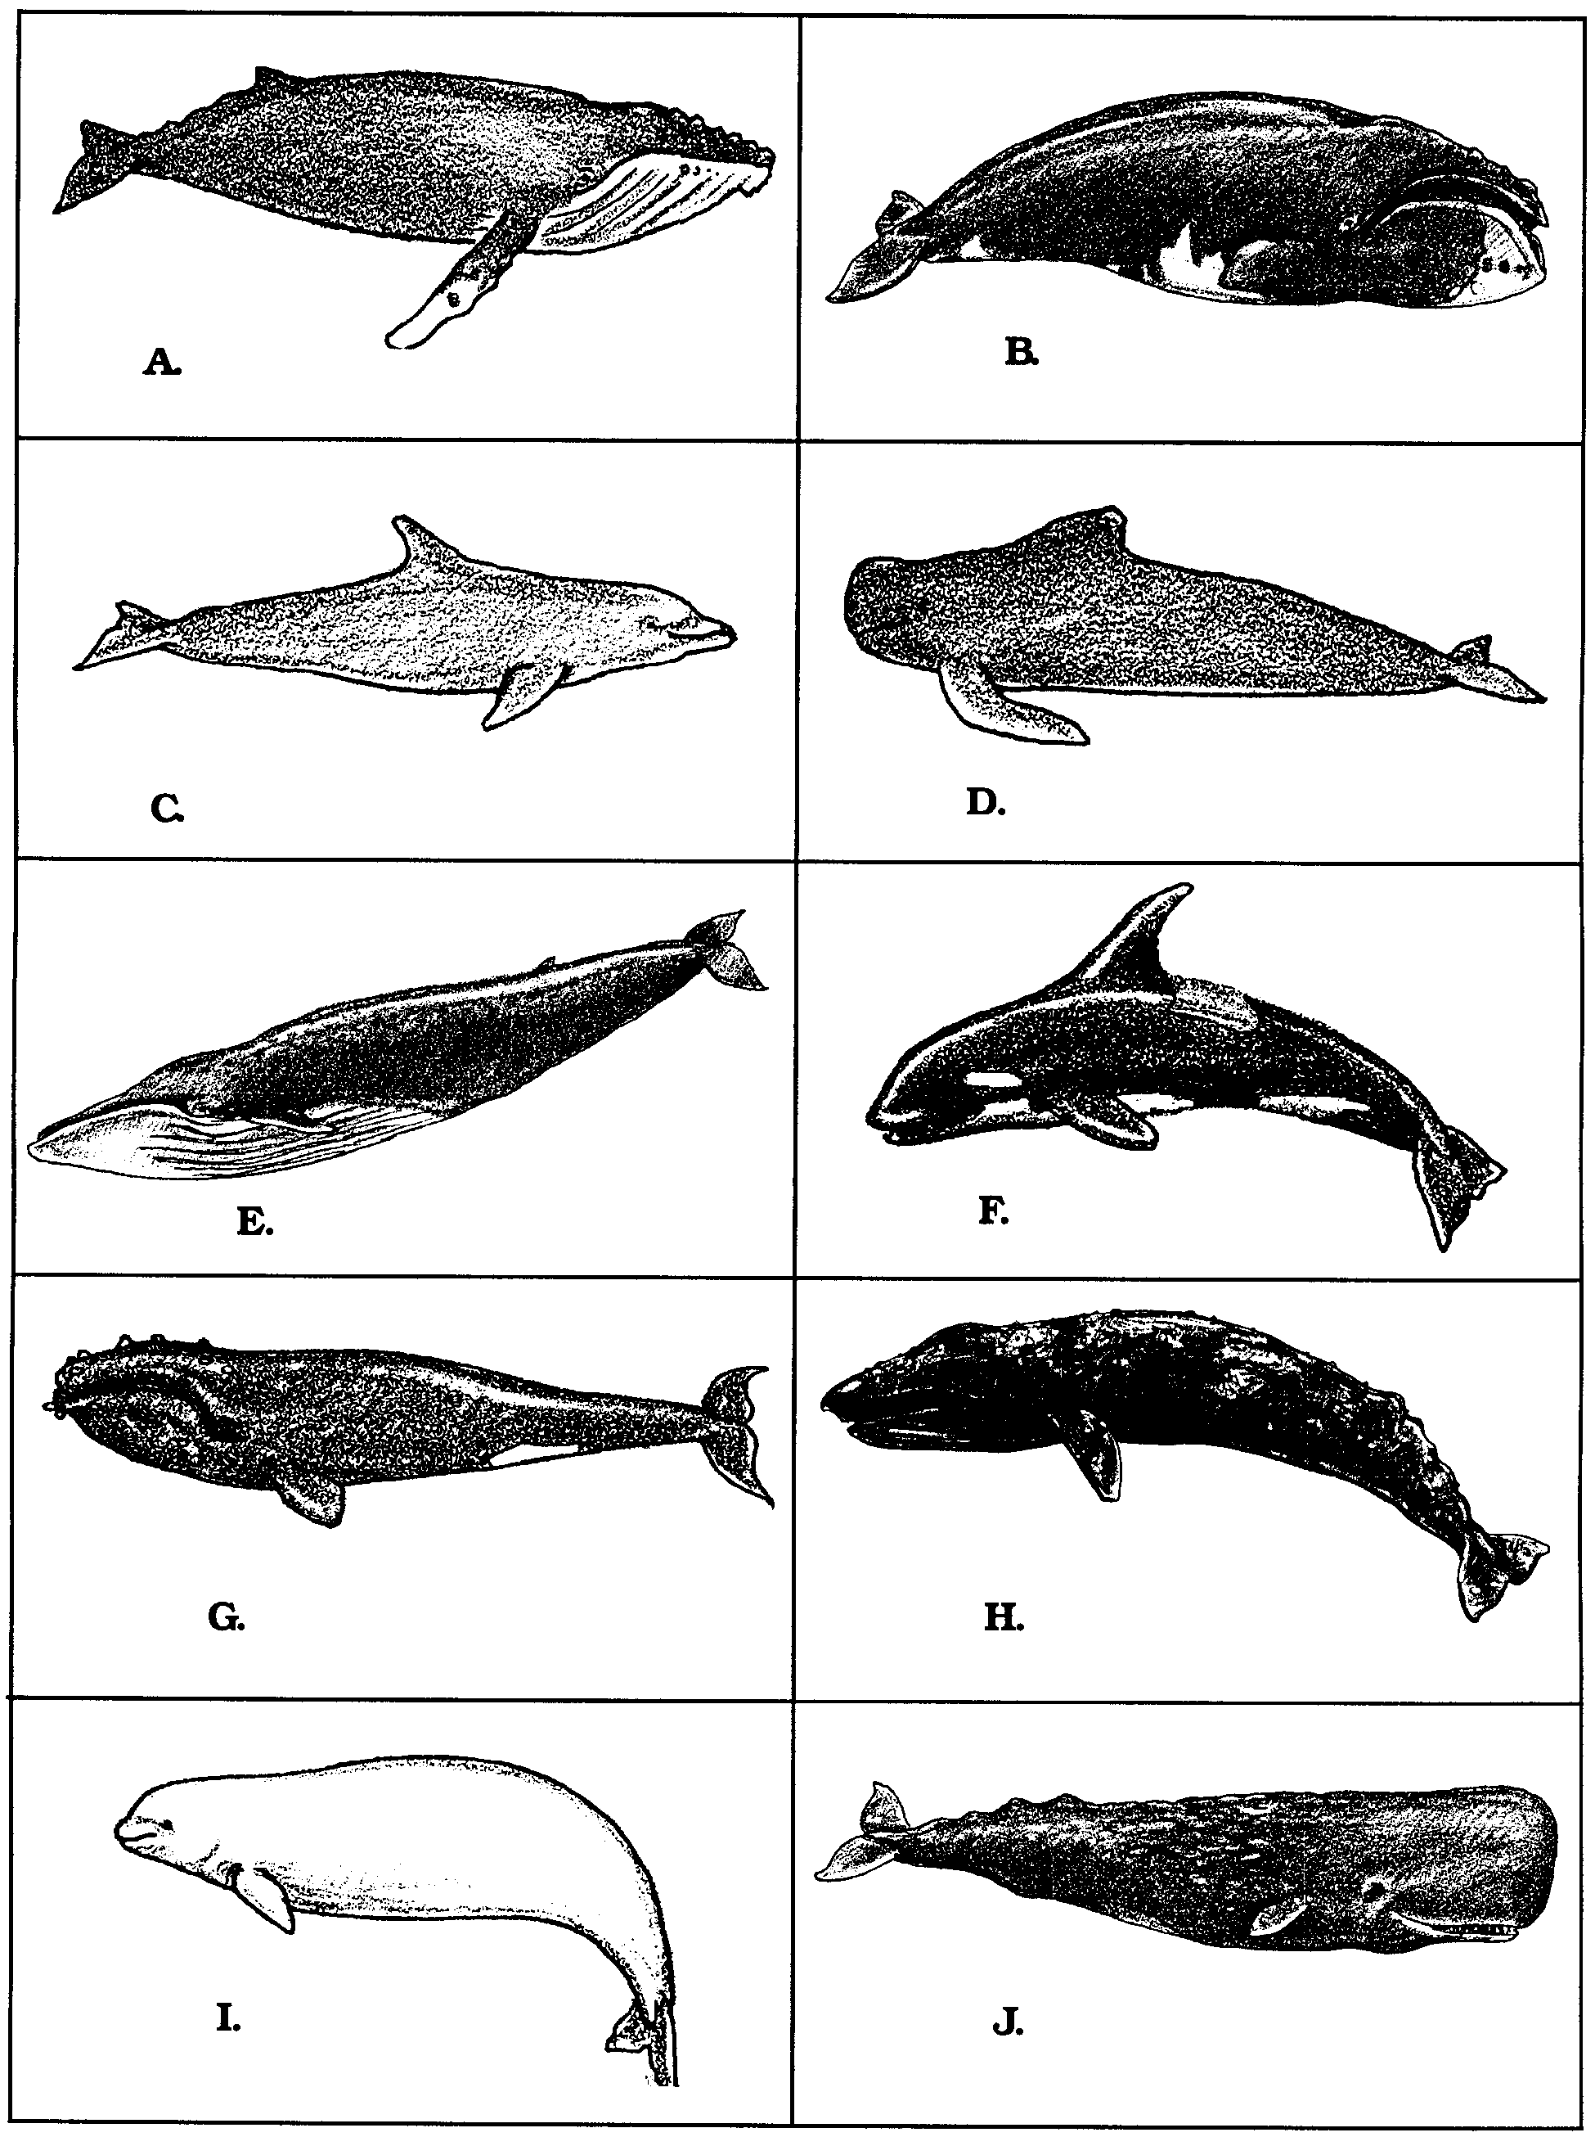
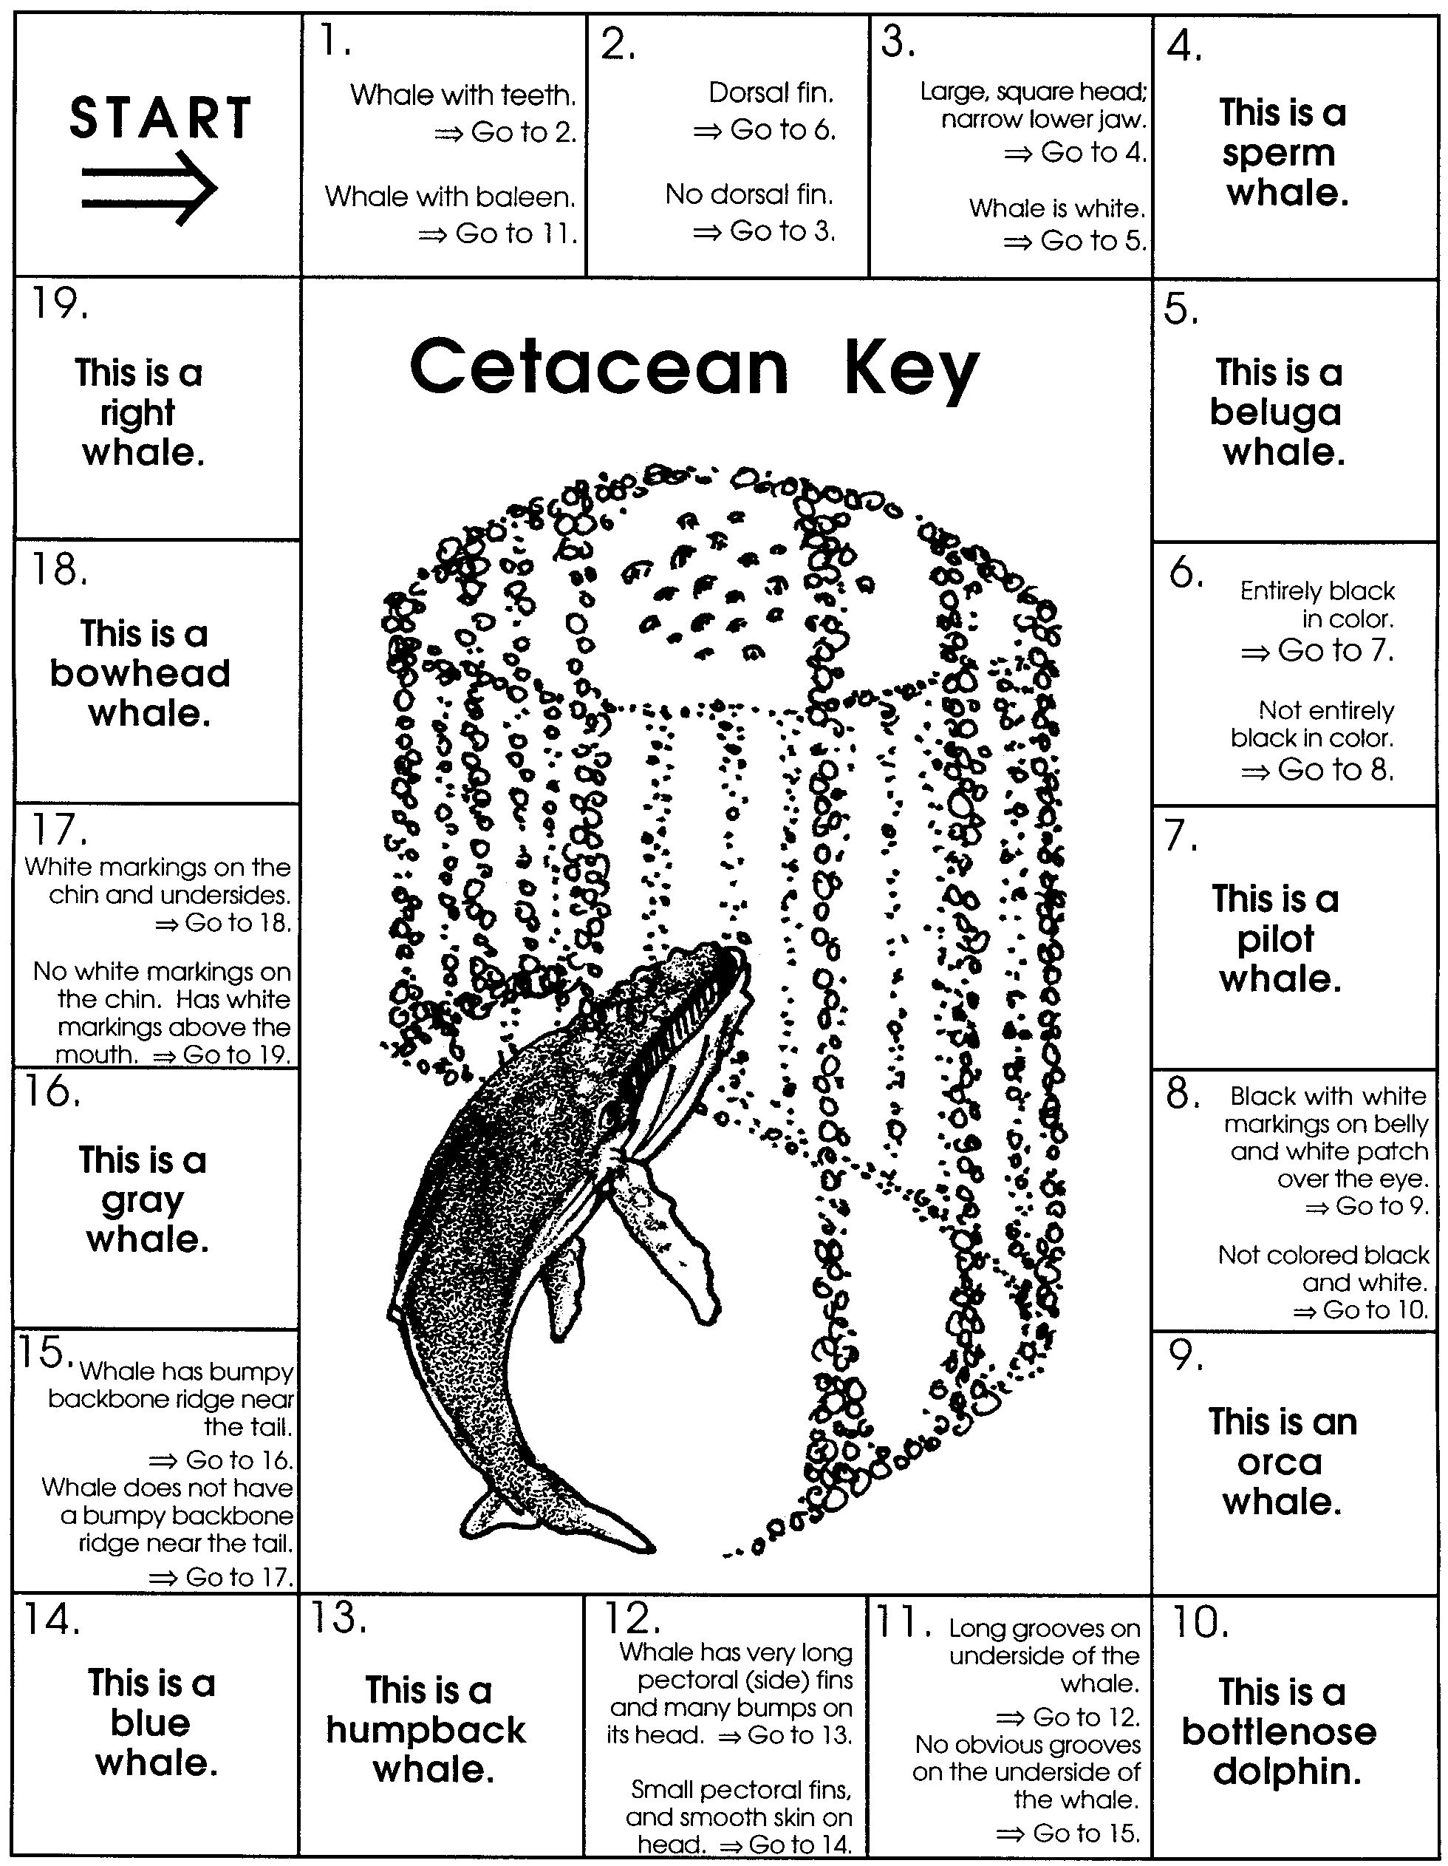

Cetacean Key Answer Sheet
Name(s)

A.

B.

C.

D.

E.

F.

G.

H.

I.

J.

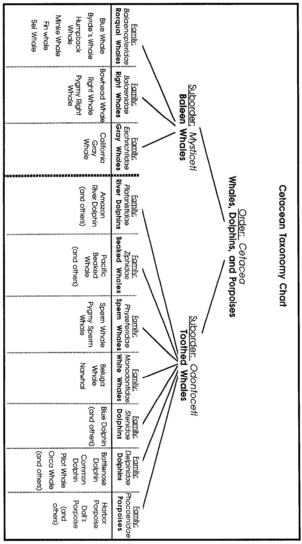

Family Tree
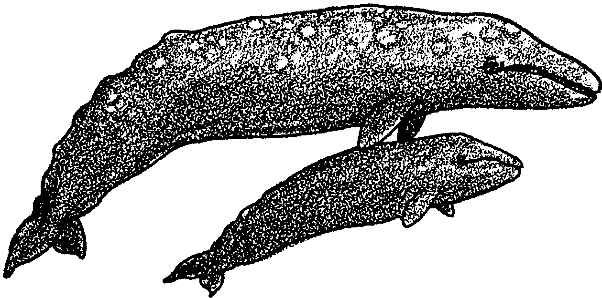
Part 3
People have always tried to make sense of their world. We give things names. We try to see how things are related. People have given whales lots of names. Scientists have too. How do scientists classify, or group, whales and their relatives?

Let’s begin with a quick look at the science of taxonomy. Taxonomy is the system for naming and classifying all forms of life. It is more than just a set of names and rules. Taxonomy is a science. It is based on what we know and continue to learn about how life forms are related. New information continues to be gathered. As it is, scientists sometimes change the way they classify living things.

1. What is taxonomy? Why is it called a science?



Let’s start by classifying your dog. We’ll call him Ralph.

2. There are lots of rungs in the ladder of taxonomy for Ralph. The names for all the rungs are shown below. Let’s give Ralph his full taxonomic ID. We’ll need to fill in all the names on the ladder.

Taxonomy of the Dog

Kingdom -
Phylum -
Class -
Order -
Family -
Genus -
Species -

Start at the top. The first step is to decide Ralph’s Kingdom. Is he a plant, animal, or bacteria, etc.?

Of course, he’s an animal. So, we can write:

Kingdom - Animal

The next rung of the classification ladder is Phylum. Our choices include Mollusca (animals with shells) and Echinodermata (animals with spiny skins). They also include Chordata (animals with backbones) and many others.

Which of the above is most likely the Phylum of the dog? Record your choice beside the title Phylum.

After Phylum comes Class. Here we need to decide whether Ralph is a reptile, mammal, fish, bird, etc. We know some things about Ralph. He is warm-blooded, is covered with hair, was born live and nursed with milk. These are things that mammals share. You can place Ralph in the Class, Mammalia.

Now we need to know the Order to which Ralph belongs. Dogs are members of the order Carnivora. Other mammal orders include Rodentia (mice and rats), Primate, (monkeys and apes), and Cetacea (whales, dolphins and porpoises).

Below order comes Family. As a dog, Ralph belongs in the Family, Canidae. Wolves and foxes are in the same Family. Cats (Felidae) and Bears (Ursidae) are other families.
The last two headings, Genus, and Species are also an animal’s scientific name. For example, our Genus as humans is Homo and our species is sapiens, so we are called Homo sapiens. The dog’s genus is Canis and his species is familiaris. What is his scientific name?

You should now have completed Ralph’s scientific ID. Check to see that all steps of the chart, “Taxonomy of the Dog” are complete.

Now we’ll apply this principle to whales.

Scientists place whales, dolphins, and porpoises in a group, or order, called “Cetacea” The word cetacea comes from the Greek word for whales, “cetos.” This is why we often call these animals cetaceans. This is also why we call scientists who study whales “cetologists.”

3. What does the word “cetacean” mean? Where does it come from?

Cetologists divide the whales and their relatives into two groups: those with teeth and those without teeth. The groups are called suborders. Toothed whales belong to the group Odontoceti. (Odonto is the Greek word for tooth.) Whales without teeth belong to the group Mysticeti. (“Mysti” is from the Greek word for moustache.)

4. What is the main feature is used to separate whales into two groups?

Odontoceti - the Toothed Whales

The Odontoceti is the largest group of whales. There are at least 67 different species in the group. The orca whale and sperm whale belong to this group. So do all porpoises and dolphins. Except for one kind, the toothed whales are carnivorous. Carnivorous means they eat meat. Toothed whales eat fish, squid and other marine mammals.

Whales, Dolphins, and Porpoises
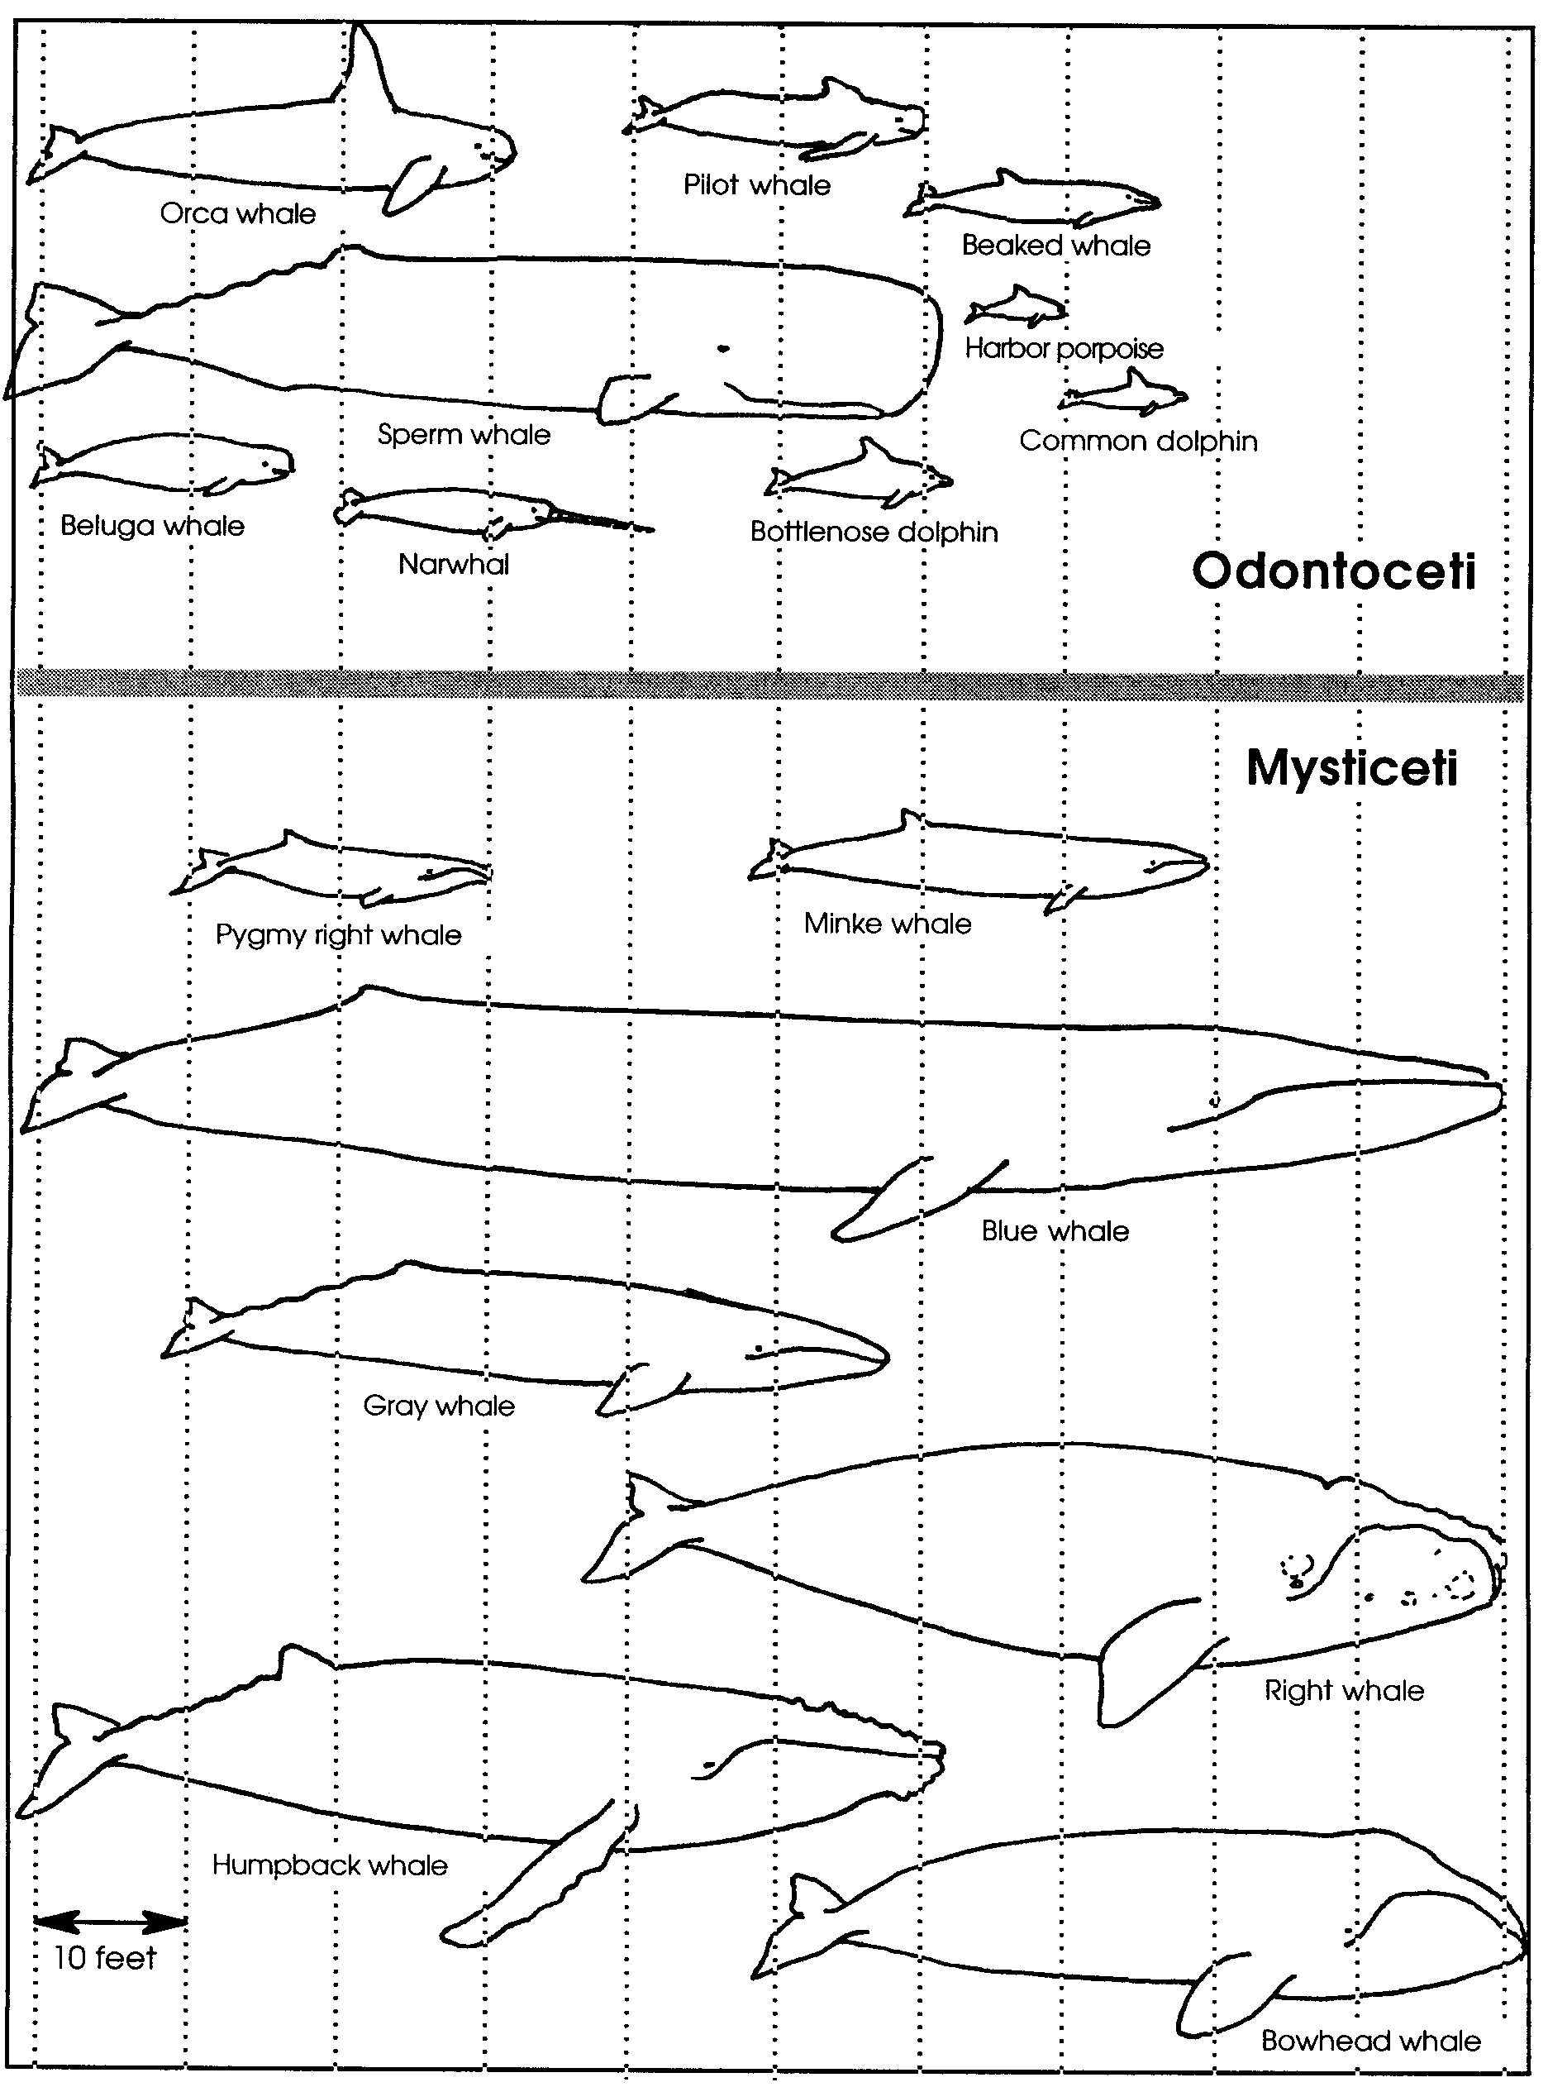

5. Look at the chart, “Whales, Dolphins, and Porpoises”. On the chart, find the group, Odontoceti.

a. Which is the largest member of the Odontoceti?

b. What is its length?

There are seven families of toothed whales. Some are very interesting. But, we’re looking for the gray whale. Gray whales belong to the group Mysticeti. Let’s take a look at that group.

Mysticeti - the Baleen Whales

The Mysticeti do not have teeth. Instead, they have a row of long baleen plates on either side of the jaw. The plates have a shaggy fringe. They are made of fingernail-like material. Whales use baleen to strain food from the water. Most baleen whales eat krill which are small shrimp-like crustaceans, and small fish. That doesn’t sound like much food for a whale. Even so, the Mysticeti group includes the giant blue whale, the largest animal of all time. The gray whale is also a member of the Mysticeti.

6. Look at the chart, “Whales, Dolphins, and Porpoises”. On the chart, find the group, Mysticeti.

a. Which is the smallest Mysticeti?

b. What is its length?

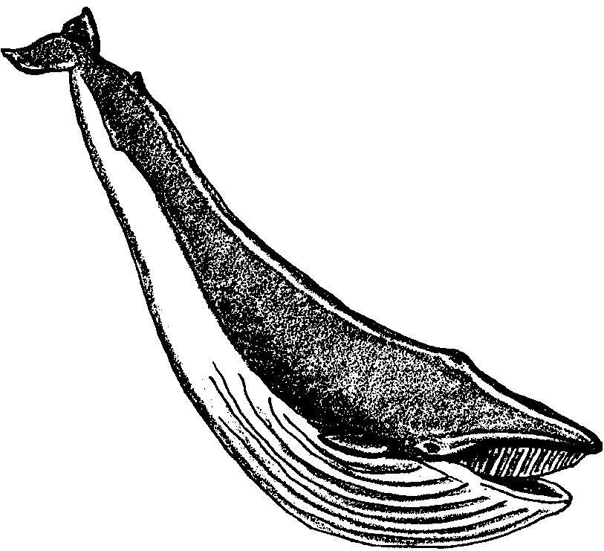
There are only 10 species of baleen whales alive in the world today. These whales are further divided into three groups.

Rorqual Whales - A rorqual whale has a torpedo-shaped head and a small dorsal fin. These whales have a series of folds in the skin under their throats. They use these folds to expand their throats while feeding on schools of fish. There are six species of rorqual whales.
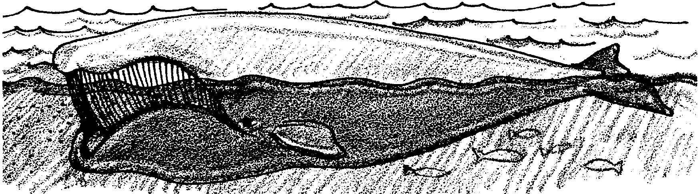
Right Whales - Right whales have rounded heads. They have a highly arched upper jaw and extremely long baleen plates. They have no dorsal fin and no throat grooves. Right whales feed while swimming. They strain plankton from the water as it passes through their baleen plates. There are three species of right whales. All right whales are highly endangered.

Gray Whales - Gray whales have very short and coarse baleen. They have two to four short throat grooves. They also have a dorsal hump, but no dorsal fin. Gray whales use their baleen in a different way from other baleen whales. They don’t filter plankton. Instead, they trap small animals from the muddy sea floor. There is only one species of gray whale, the California gray whale.
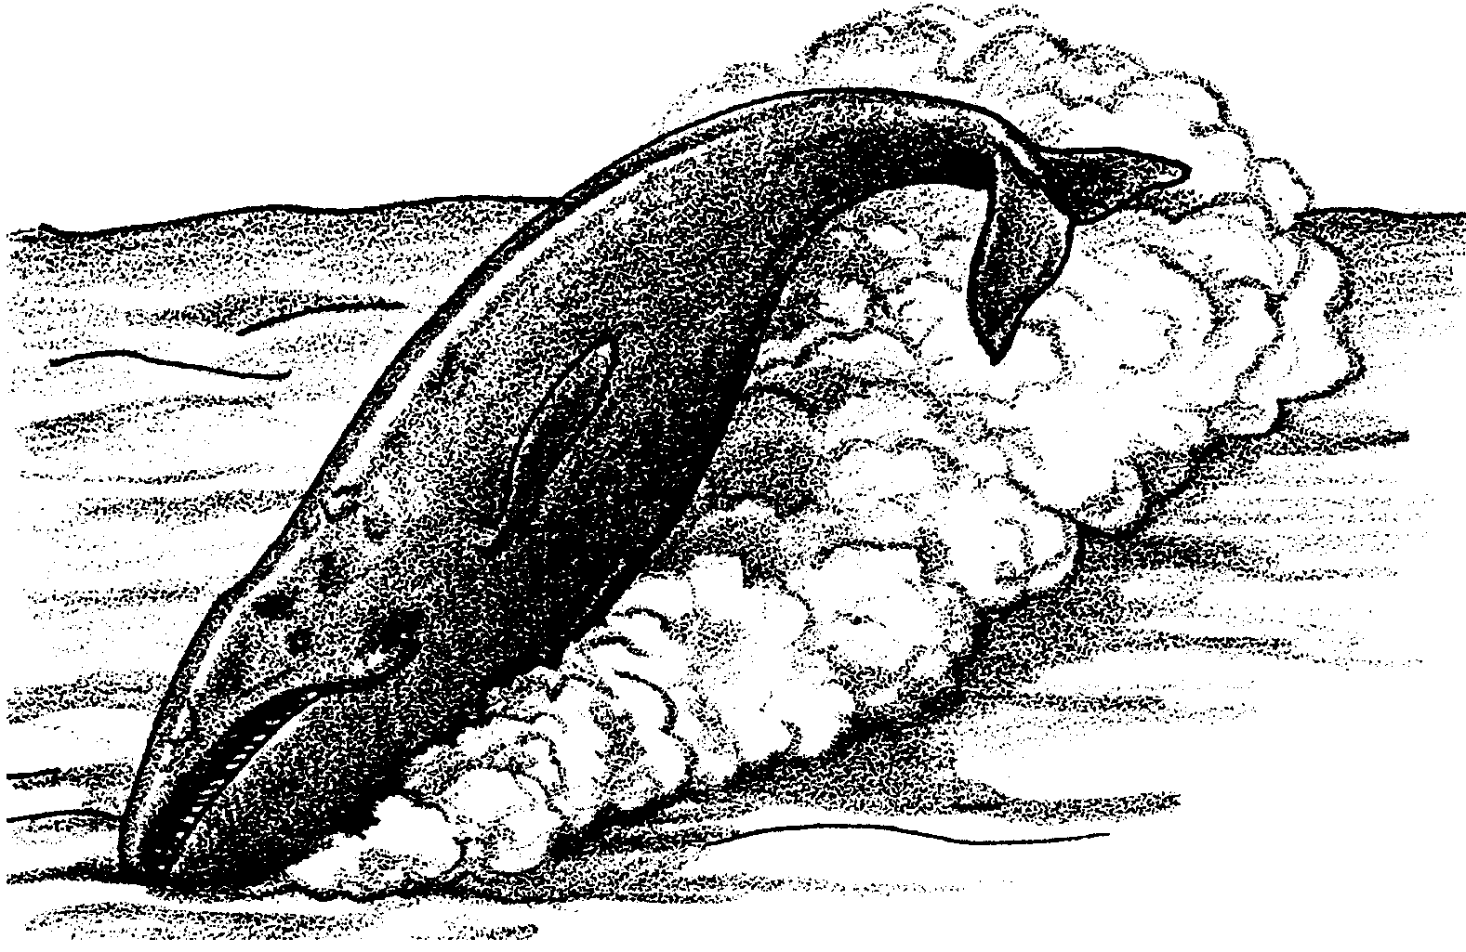

Cetologists have divided baleen whales into the above three groups. All of the baleen whales are related in some ways. They believe the whales in a group are more closely related to other members of the same group. Members of one group are less closely related to those of a different group.

7. What are some of the things cetologists used to group the whales in this way?

8. Fill in the missing lines on the following chart:

Taxonomy Chart for the Gray Whale

Kingdom -
Phylum -
Class -
Order -
Suborder -
Family -
Genus -
Species -

(Hint: Since the whale is also a mammal, the Kingdom, Phylum, and Class will all be the same as for the dog.)

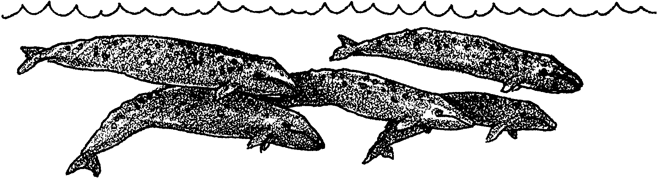
Part 4 - Return to the Sea

Like their ancestors, modern whales are mammals. Scientists put whales into the same group of animals to which we belong. They call that group a Class. Like humans, whales are warm blooded and breathe air. Likewise, they bear their young live (not in an egg). They also nurse them with milk produced in mammary glands. Like other mammals, they have true hair at some time during their lives.

1. What are four characteristics shared by all mammals?

a.

b.

c.

d.

Since entering the water, whales have undergone many changes. The changes let them spend their whole lives in water. Their front legs have changed into flippers, called pectoral fins. They have no hind limbs at all. Their tails have become powerful horizontal paddles, called flukes. A thick layer of blubber helps them to stay warm. Their nostrils are located on the top of the head, above the eyes. This helps them breathe as they swim. Finally, their skulls and ear bones have changed. The changes allow whales to make and receive complex sounds under water. In a way, whales use their sense of hearing to “see”. It helps them to find their way. It also helps them to communicate through the vast distances of the ocean.

2. What are four ways whales’ bodies have become modified for life in the water?

a.

b.

c.

d.

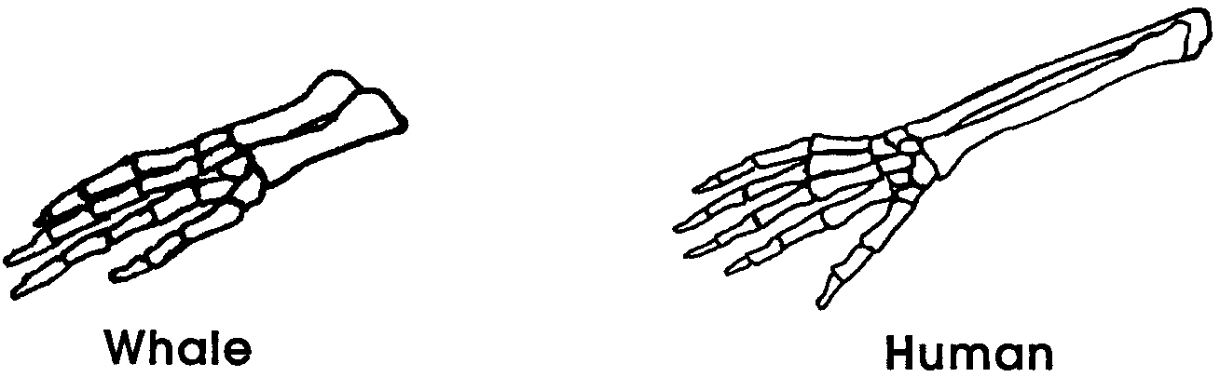
Despite these special adaptations, we know their ancestors must have once lived on land. Whales carry clues within their bodies of these earlier times. Compare a whale’s pectoral fin and the foreleg of a land mammal. The fins still contain most of the same bones.

Moreover, many whales carry tiny bones hidden on either side of their smooth sides. These bones are the last traces of their hind legs.

3. What clues are present in the bodies of whales that their ancestors walked on land?

So, some of our information on the history of early whales comes from living whales. Most of it comes from fossils. A fossil is a trace a living thing of a former geologic age. A fossil might be a skeleton or a footprint.

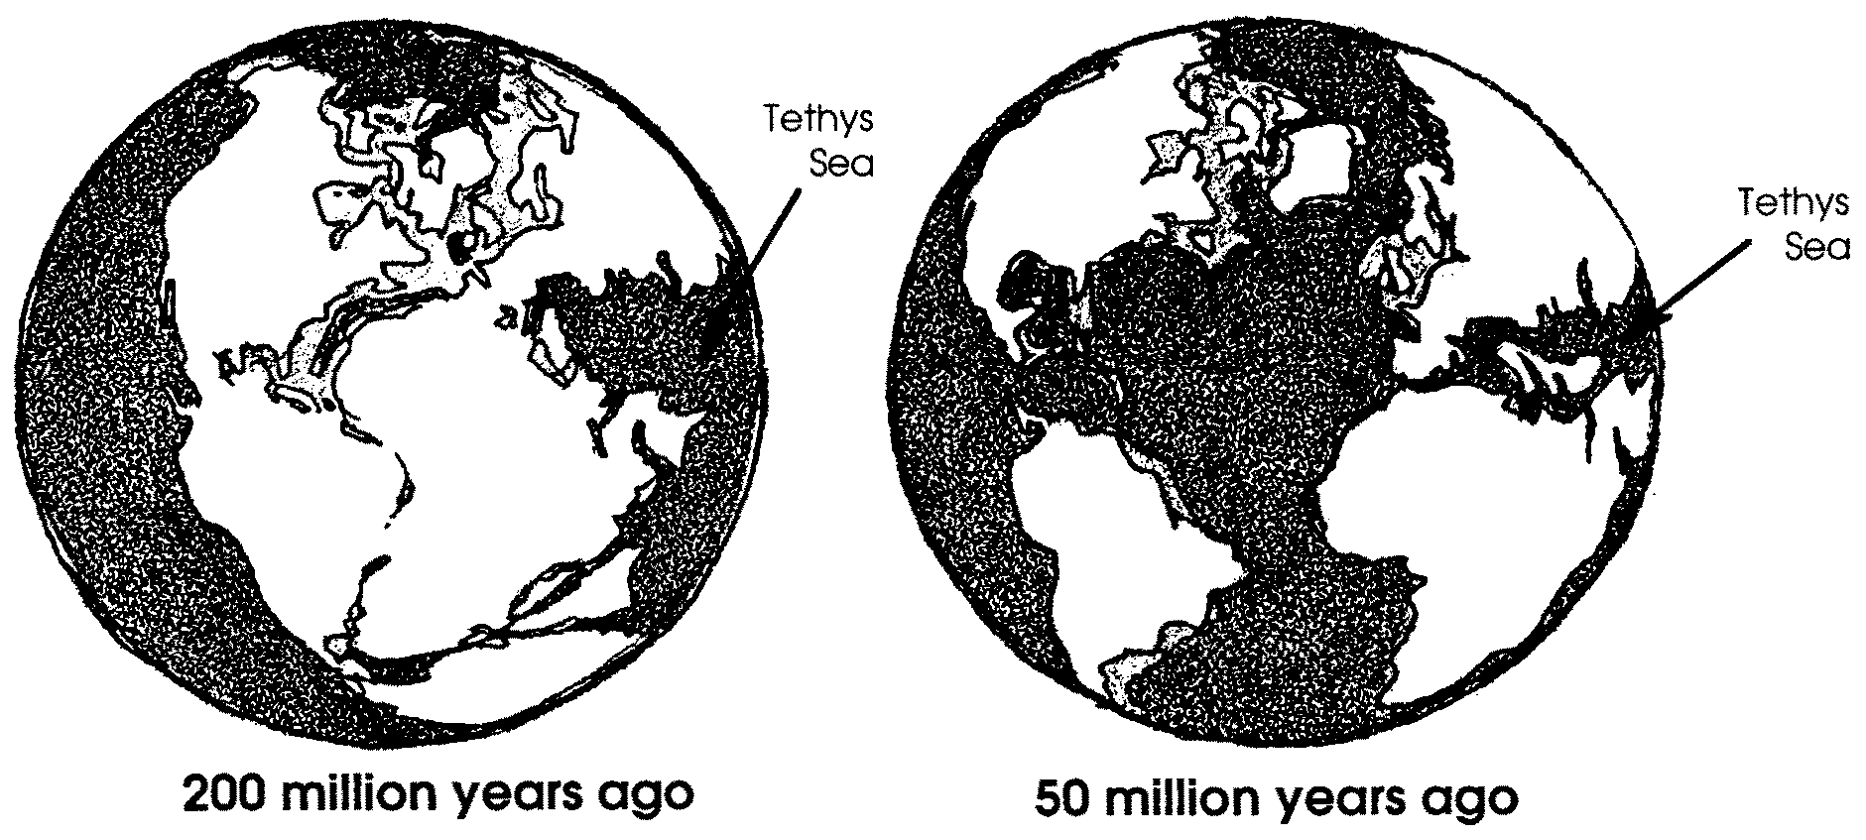
The best place to look for fossils are the banks of an ancient ocean. Such an ocean circled half the globe for more than 500 million years. Called the Tethys, it divided the earth’s continents into two land masses. One mass was to the north and one to the south. The Tethys was a tropical ocean.

Let’s travel back in time 50 million years. A walk on the shores of the Tethys shows us a shallow, warm ocean. The water teams with fish and shellfish. Mammals live on the water’s edge. They have good reason to venture back into the water.

4. What might have caused mammals to begin living in the water 50 million years ago?

We know that continents are slowly moving. In the last 50 million years, India, Arabia and Africa pushed north into Europe and Asia. The Tethys Ocean has now all but disappeared. But one can still visit the shores of the Tethys. Ancient sea beds are found in the deserts of Pakistan. It is there that scientists who study fossils come to find the ancestors of whales. A scientist who studies fossils is called a paleontologist.

5. Why are fossils of prehistoric whales found in the deserts of Pakistan?

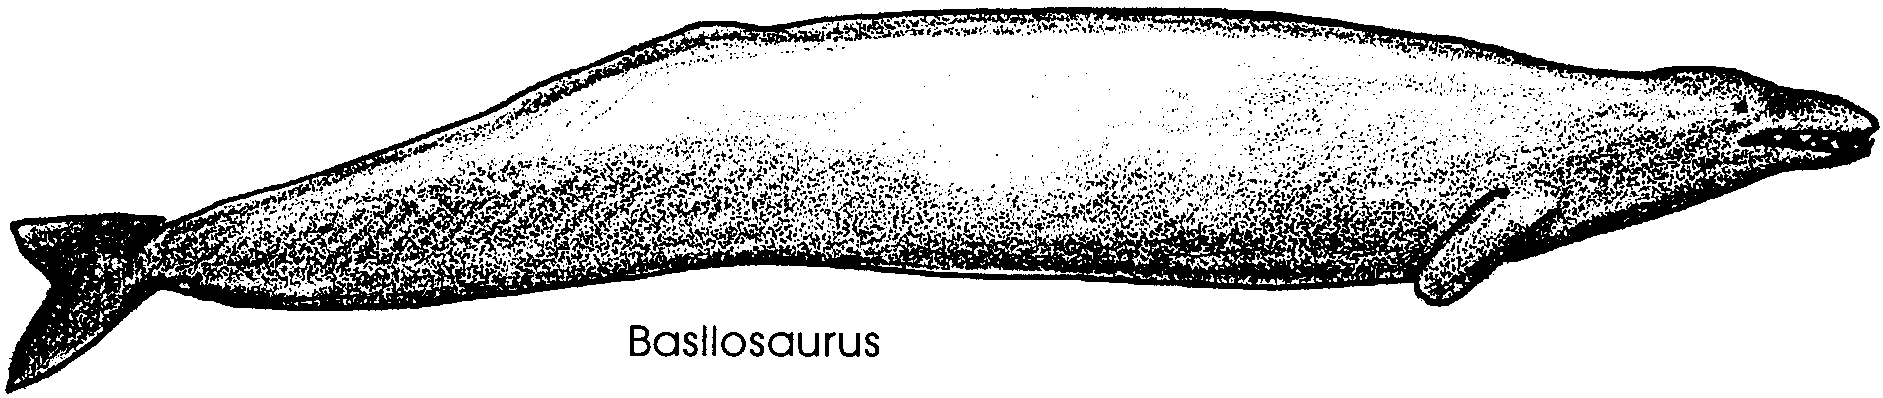
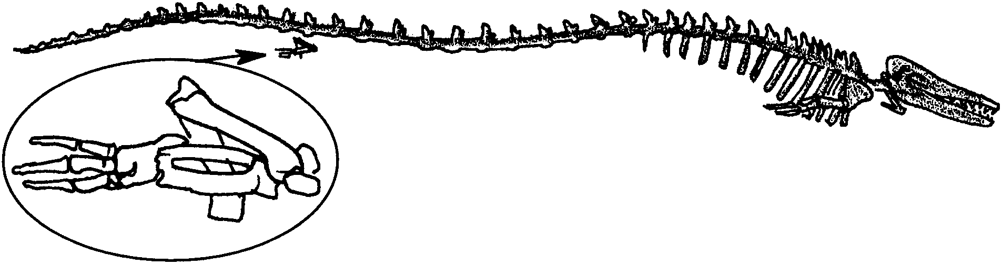
The most famous early whale was a terrifying 50-foot creature. It had a very long tail. Its discoverer gave it the name, Basilosaurus. The name means “King Lizard”. Apparently, the discovered thought that it was a reptile, not a whale. We now know that it was indeed a whale. Moreover, this whale had a tiny pair of hind legs.

The legs of Basilosaurus were small. Even so, they contained most of the same bones we have in our own legs.

Paleontologists kept looking. They have now found an even earlier whale. This one has been given the interesting name Ambulocetus natans.

6. Try translating the name, Ambulocetus natans to English. Ambulo means “walking,” cetus means “whale,” and natans means “swimming.” What would this whale be called in English?

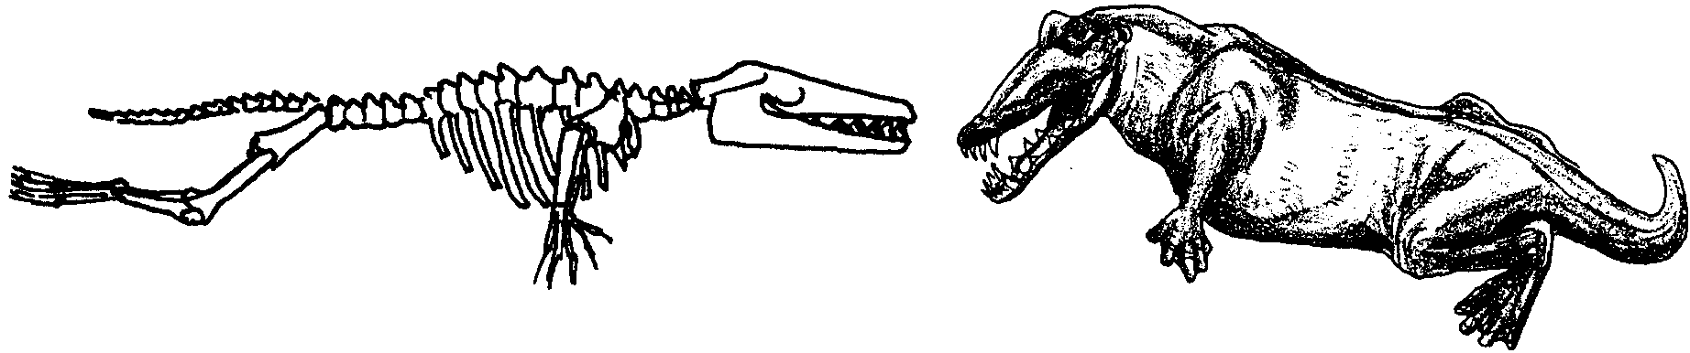
One needs only to look at the skeleton to understand why it was given such a name!

Paleontologists can tell a lot by studying the skeleton of Ambulocetus natans. They can see how this whale swam. It moved its back legs and tail up and down.

7. Modern whales swim with an up and down motion of the tail. Fish use a side to side motion. Which of these two swimming styles is most similar to that of Ambulocetus natans ?

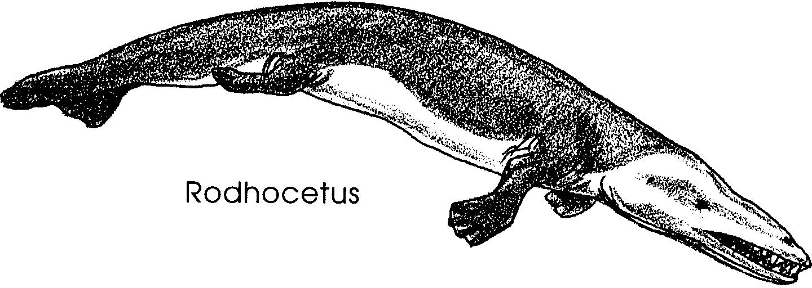
Ambulocetus natans is not the only whale ancestor we know about. Fossils of a 46 million year old whale have been found in Pakistan. This whale had legs a third smaller than those of Ambulocetus. The whale was given the name, Rodhocetus kasrani. Its legs let it waddle, crocodile-like on land. However, it also had very big tale vertebrae. These show that it had a powerful tail for swimming. Its flexible spine moved the horizontal tail fluke in the same way as that of modern whales.
8. As whales adapted to life in the seas, their bodies changed.

a. What was happening to the legs?

b. What was happening to the tail?

We only have the skull of the oldest whale found to date. Pakicetus, (named for Pakistan, where it was found) is clearly a whale. It lived about 50 million years old. We know from its bone structure that it probably could not hear well underwater. Hearing is the most important sense for all whales, both modern and prehistoric. Because under water hearing was not well developed in Pakicetus, it must have been a primitive whale indeed.

9. What adaptation to living water had not yet been made by Pakicetus ?
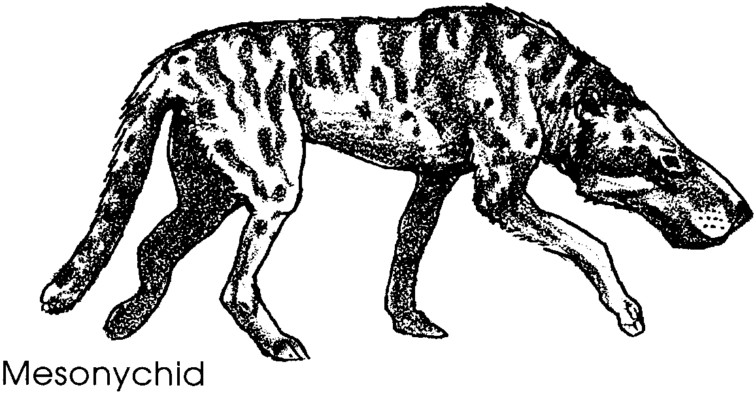
Let’s take our time machine back again to these early times. We might also encounter the land-dwelling relatives of Pakicetus. These belong to a group known as the mesonychids. Curiously, these mammals had hoofs. But, unlike any of today’s hoofed mammals, they were meat-eaters.

One of these mammals was Andrewsarchus, which probably lived somewhat like modern- day bears.

Scientists study the bones and teeth of modern and prehistoric mammals. This lets them map the relationships between living mammals. Some of what they have found is shown in the following diagram.
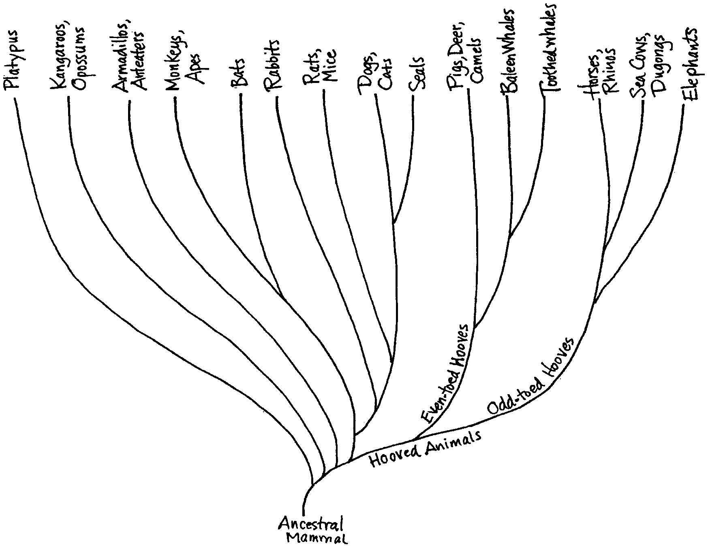

Relationships between Mammal Groups

10. Look the above diagram. Which would you say is more closely related to the gray whale, a seal or a camel?

11. Which group of marine mammals is most closely related to dogs and cats?

12. The elephant is related to one group of marine mammals. Which group is it?

