Putting All the Pieces Together

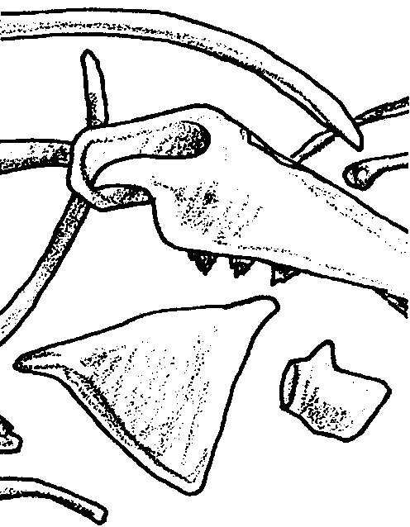
Key Concepts
1. Fossils are studied by paleontologists to learn about species that lived on the earth in earlier times and to help answer questions about the origins of species alive today.
2. Assembling a full skeleton from disarticulated pieces can be challenging even for trained paleontologists. Mistakes can result in errors in identification.

Background
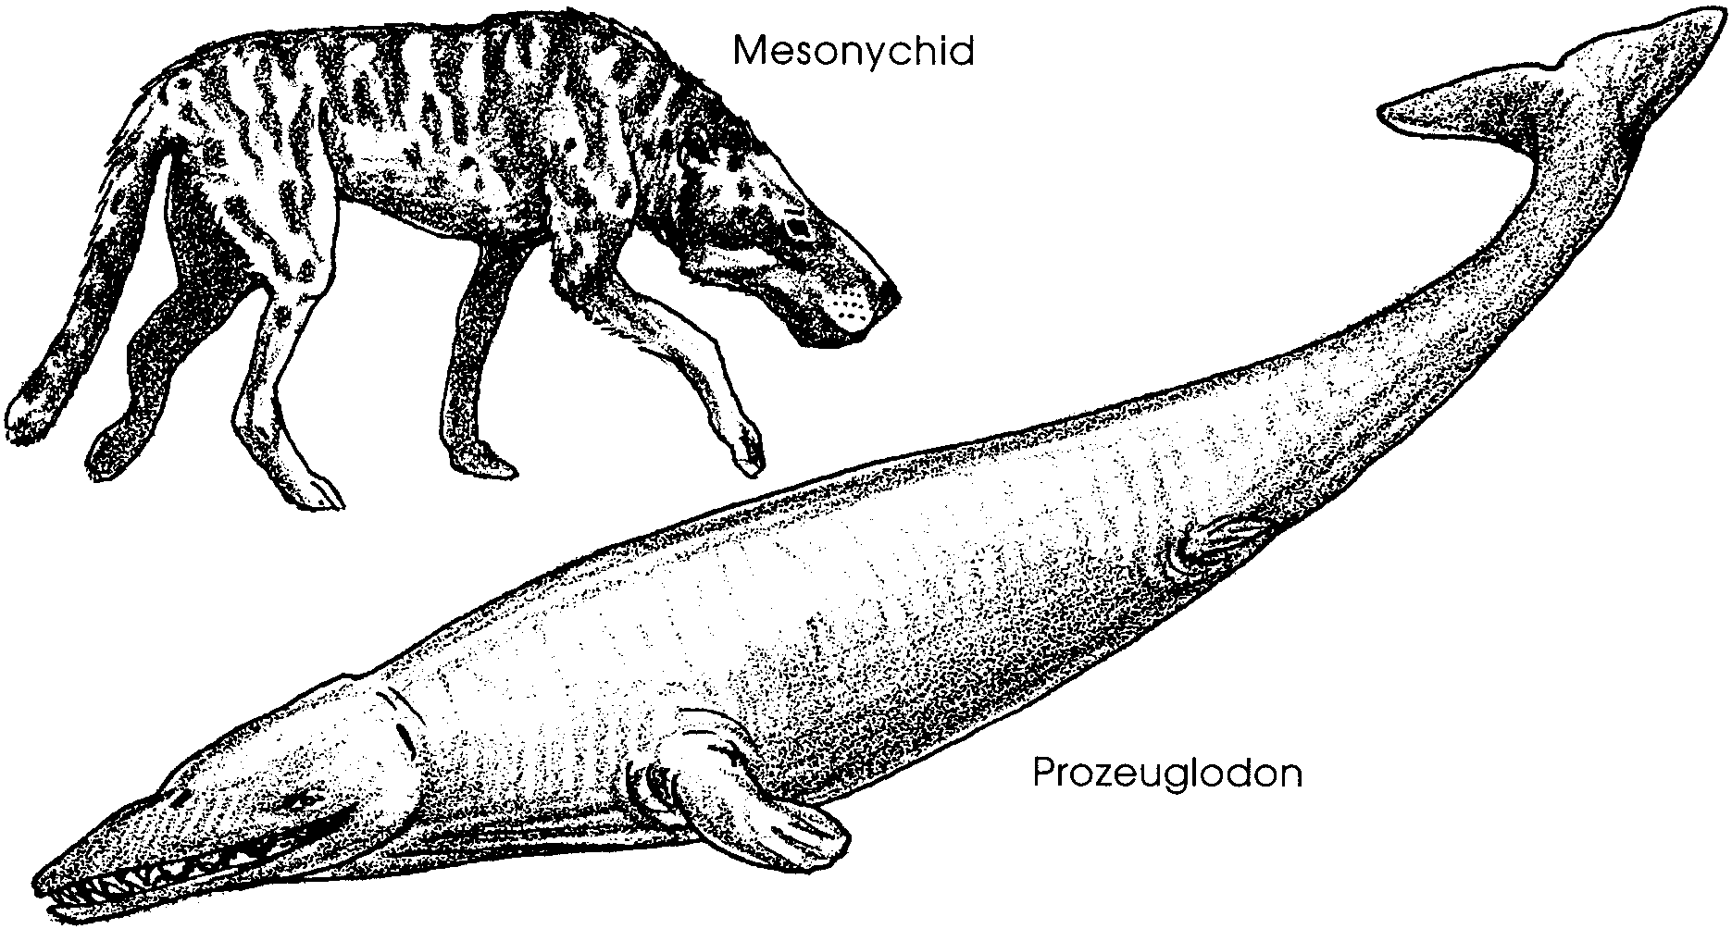
What does the fossil record tell us about the origins of the whales we see today? For decades, paleontologists have pointed to an extinct hyena-like animal, called a mesonychid, as the land dwelling ancestor of modern whales. From fossil evidence, they believe that mesonychid walked back into the sea between 50 and 60 million years ago. Other evidence from the fossil whale called Prozeuglodon indicates that the transition to life in the sea was nearly complete by 40 million years ago. Although perfectly adapted for life at sea, Prozeuglodon still had a pair of vestigial 6-inch legs.

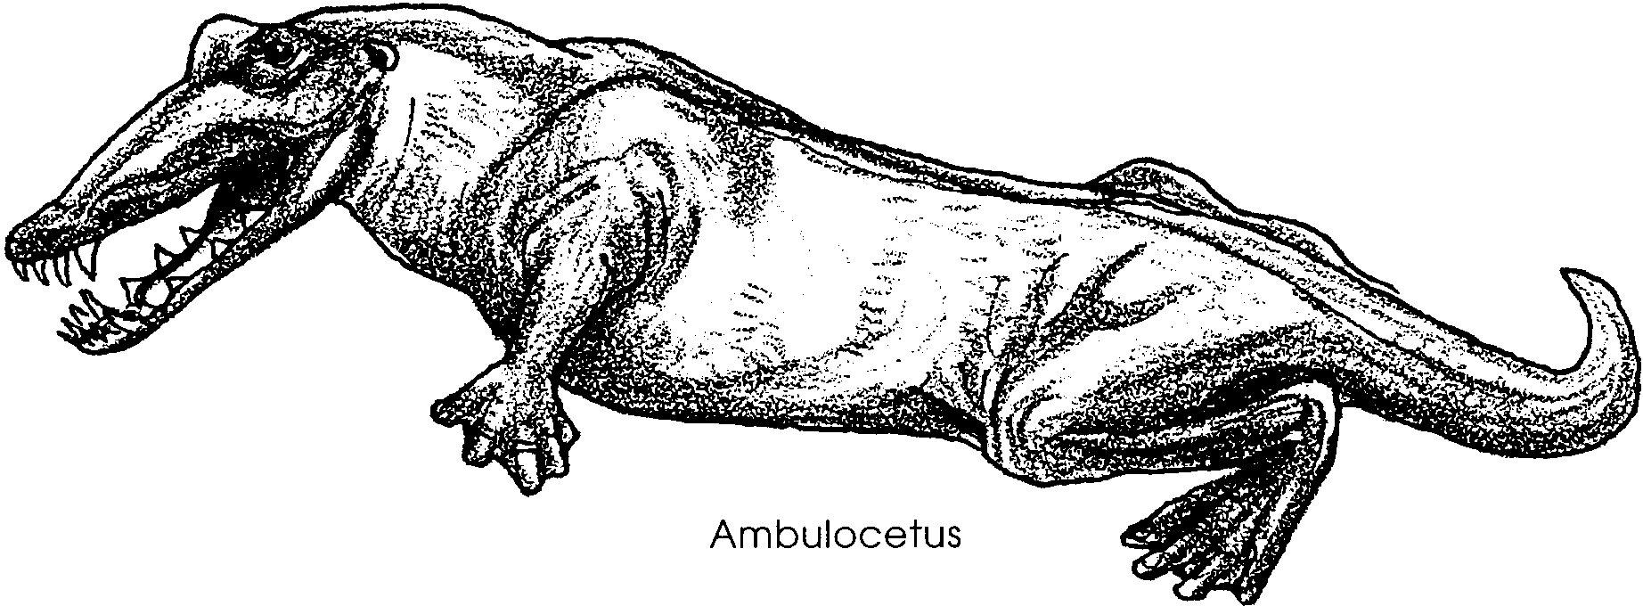
Just what happened between mesonychid walking back into the sea and Prozeuglodon swimming off into the sunset was not very clear until two new fossils were discovered in Pakistan in 1994. In January of that year, paleontologist Hans Thewissen announced the discovery of the first known whale with legs made for walking. He called it Ambulocetus natans, a name which means swimming-walking whale. The legs on this seven to 10 foot animal were shorter than those of a mesonychid but they still had feet with toes (probably webbed toes) and were strong enough to carry Ambulocetus on land. It didn’t yet have the tail flukes that modern whales use to swim. Instead, it seems that Ambulocetus flexed its spine up and down and kicked its legs otter-style.

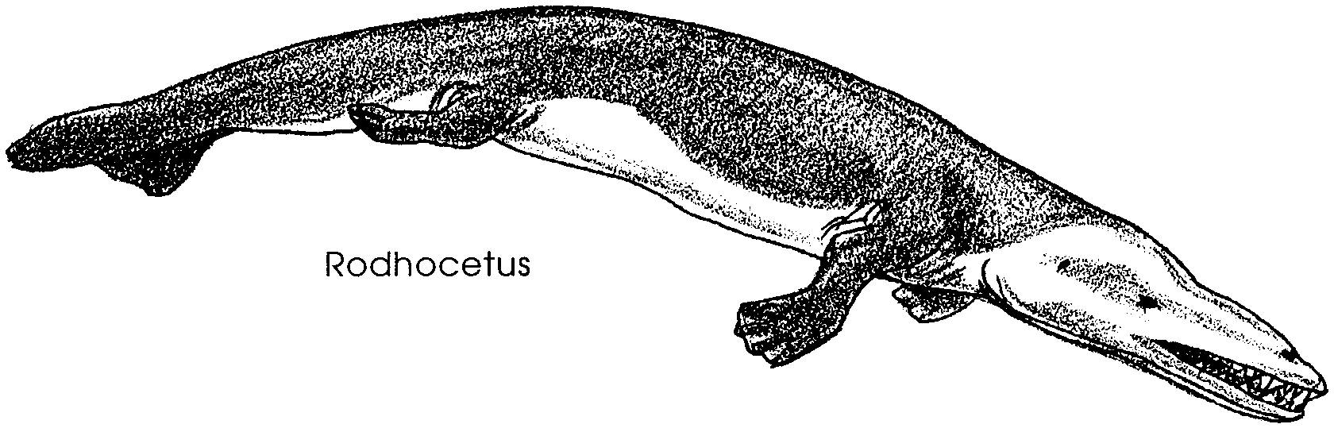
In April of the same year, paleontologist Philip Gingerich reported the find of fossils of a 46 million year old whale with a life style between that of the shore-hugging Ambulocetus and the water-bound Prozeuglodon. Given the name, Rodhocetus kasrani, this whale had legs a third smaller than those of Ambulocetus and an anatomy adapted for swimming like a whale. The legs enabled Rodhocetus to waddle, crocodile-like on land. However, its massive tale vertebrae indicate that it had a powerful tail that allowed it to go where no whale had gone before. Its fully flexible rear spinal column could produce the motions for the powerful beat of a horizontal tail fluke that propels modern whales.

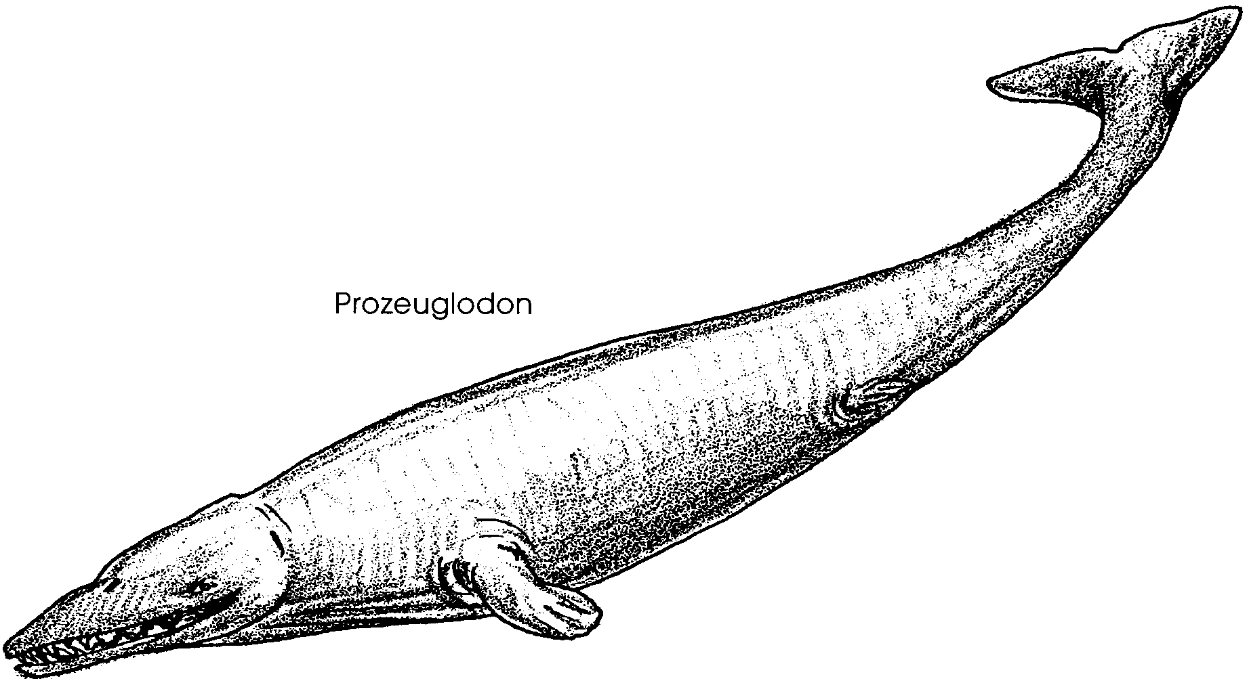
Within a few million years, whales like Prozeuglodon had mastered life in the sea and given up land completely. About 30 million years ago, whales in their present form began appearing. Today, whale flippers are what remain of the forelegs of their terrestrial past and the only hints of their hind legs are the vestiges of a pelvis and femur, upper leg bone, embedded in the body wall.

A discussion of research into marine mammal origins is also found in the following lesson, “Family Tree”.

Materials
For each pair of students:

• skeleton set

• bone set

• scissors

• transparent tape

• colored pencils, felt-tipped pens, or crayons in black, red, blue, green, and yellow

For each student

• “Putting all the Pieces Together” student activity pages

Teaching Hints
“Putting All the Pieces Together” gives your students a chance to reconstruct whale skeletons from skeletal fragments. The activity is designed to give your students a small taste of the work of paleontologists. This will help them to understand the difficulty scientists have had in determining the origins of whales.

Ideally, you would provide your students with a disarticulated skeleton or skeletons to reconstruct. Practically, this is seldom possible. The two dimensional “skeleton sets” provided in this activity are a reasonable substitution in that they require some of the reasoning and observational skills used by paleontologists in reconstructing actual skeletons. Hopefully, this activity and your support will encourage them to explore the field more fully on their own.

This activity is best accomplished by pairs of students as an in-class assignment, however, you will probably want to provide all students with the activity pages.

In Part 1, the skeletons are complete with the exception of a few vertebrae. An additional skull has been included to add to the challenge. If you wish to make the activity in Part 1 more challenging, you can do so by reducing the size of the pieces through judicious use of your scissors. Then make a paste-up of the new pieces for duplication.

Part 2 contains all of the bones needed to make the flipper of a bottlenose dolphin. No additional bones are included.

In Part 3, students compare skeletons of a blue whale and an orca whale with a human skeleton. You may want to give students an opportunity to compare and discuss their strategies for completing several of the activities in this lesson.

Display completed skeletons on a classroom bulletin board. The display facilitates the comparisons your students are asked to make, as well as generates interest from other classes using the room.

“Voyage Of The Mimi” - Expedition 4: Whale Bones can be used to enhance this lesson.

Key Words
excavation - in this context, a hole in the ground, made in a search for fossils

forelimb - a front leg of a fourlegged animal

fossil - any remains, impression, or trace of a living thing of a former geologic age, as a skeleton, footprint, etc.

paleontologist - a scientist who studies prehistoric life through examination of fossils

vertebrae - the interlocking bones of a vertebrate spine

Extensions
1. Explore some of the similarities and differences between several vertebrate skeletons. You may not be able to locate a marine mammal skeleton, but you may be able to borrow a human skeleton from a university or from a medical facility. Look for others, such as cat, snake, and bird, from high school and university science departments for comparison. The experience for your students of assembling a disarticulated skeleton is worth the trouble of obtaining and preparing such a skeleton for future use.

2. Visit a natural history museum or science center in your area that has skeletons of whales or other marine animals on display.

Answer Key
Completed skeletons are found at the end of this Teacher Background section.

Analysis and Interpretation - Part 1

1. While the answers depend upon the individual outcomes, most of your students will construct three complete skeletons.

2. Students will probably have at least one incomplete skeleton (the skull only).

3.a. While the answer depends upon the class results, it is doubtful that all of the skeletons are exactly the same.

b. The differences among the skeletons come from differences in the students’ interpretation of skeletal features.

4. Paleontologists use information from other fossil associations to determine which reconstruction is most accurate. A comparison of skeletons and parts of skeletons from different sites may help them know which reconstruction is most likely. Some fossils are also found as near perfect skeletons. These are especially valuable in interpreting the incomplete specimens.

5. There are many things that might cause part of a skeleton to be missing. Predation on the animal after death might have scattered the bones. Only part of the skeleton may have been fossilized. Part of the fossil skeleton may have been carried away when the rock beds in which it was found were eroded. More recent differential excavation may have caused part of the skeleton to disappear.

b. Two or more skeletons are commonly found in a single site. There are several possible reasons for this: (l) The site may have been frequented by many animals during some past era (e.g., a watering hole); (2) The site may have been particularly well-suited to the formation of fossils from deceased animals (e.g., some of the warm, shallow seas); (3) The site may have had a unique combination of features that favored fossil formation (e.g., the La Brea tar pits). Your students may have some other, more original, ideas.

6. It is more difficult to assemble a skeleton from completely disarticulated bones because the number of possible combinations increases tremendously. The partially completed skeletons also provide some clues which help direct assembly. The clues are missing in the completely disarticulated skeleton.

Part 2
1. If the bones are correctly assembled, the completed body part should appear to be a hand, foot or flipper. The skeleton part is actually a bottlenose dolphin flipper.

2.a. While the answers will vary, most of your students will find it more difficult to assemble the flipper in Part 2.

b. The flipper is more difficult to reassemble because it is totally disarticulated. There are few reference points. Your students are also likely to have fewer preconceived notions about the expected results.

3.a. While the answer depends upon the class results, it is doubtful that all of the body parts are exactly the same.

b. Again, the differences among the constructed body parts come from differences in interpretation and observation.

4. After experiencing some of the difficulties inherent in reconstructing skeletons, your students should more readily accept the fact that differences in the interpretation and observation of the fossil bones could account for one person making a 114 foot long skeleton and another person making two 55 foot long skeletons out of the same bones. In all fairness to paleontologists, it should be mentioned that Dr. Koch had somewhat questionable credentials and was looking for a bit of sensationalism and fortune (both of which he found). He exhibited his mounted skeleton in New York and Europe and caused quite a sensation both here and abroad.

Part 3

Text questions

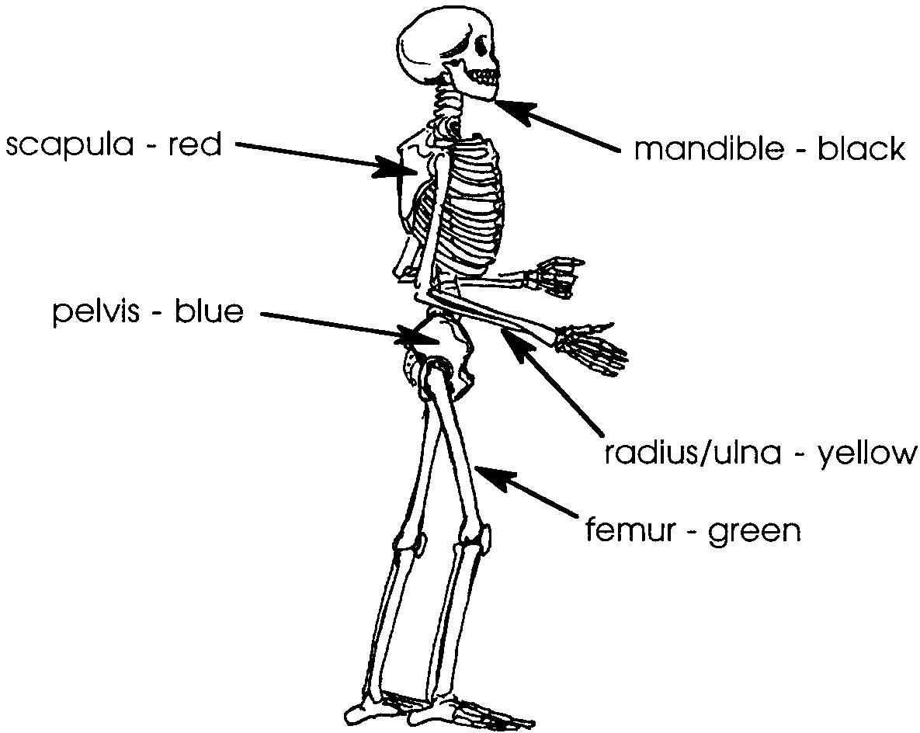
1.

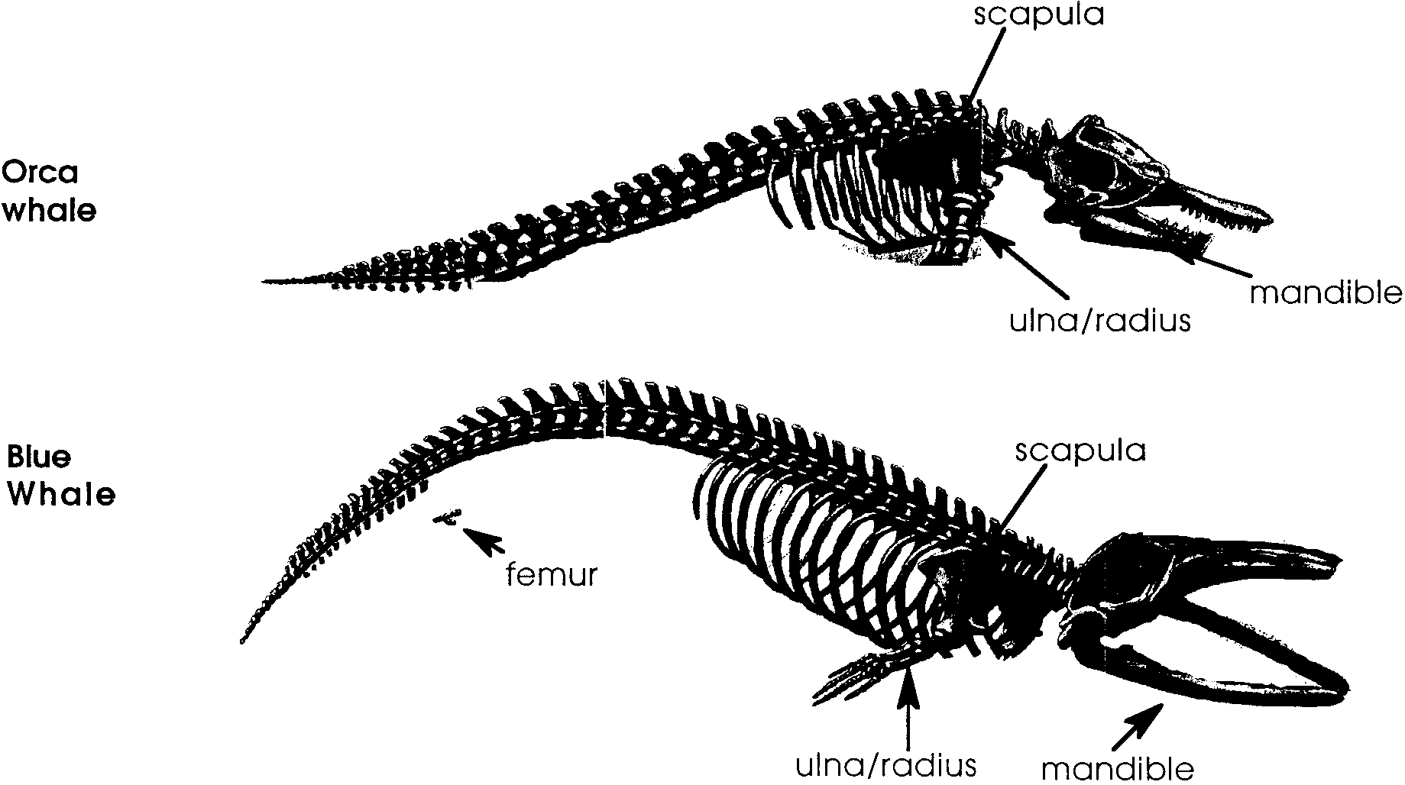
2.

Analysis and Interpretation

1.a. The blue whale is missing the pelvis.

b. The orca whale is missing both the pelvis and the femur.

2. Both whale skeletons have considerably more vertebrae in their spines than the human skeleton.

3. Whales apparently had little use for hind legs in their method of swimming. Students may suggest that they lost them because they weren’t needed. While this is true, organisms generally retain unused features long after they stop being used, because they remain programmed into the developmental machinery of the organism until this information is replaced. These are known as vestigial features.

4. The bones of the whales’ forelegs are shortened and thickened for strength, and toe bones have expanded to form a paddle.

5. The extensive and powerful muscles which attach along the whale’s spine control the up and down motion of the tail. Such muscles require strong points of attachment, such as the prongs on the whale’s vertebrae.

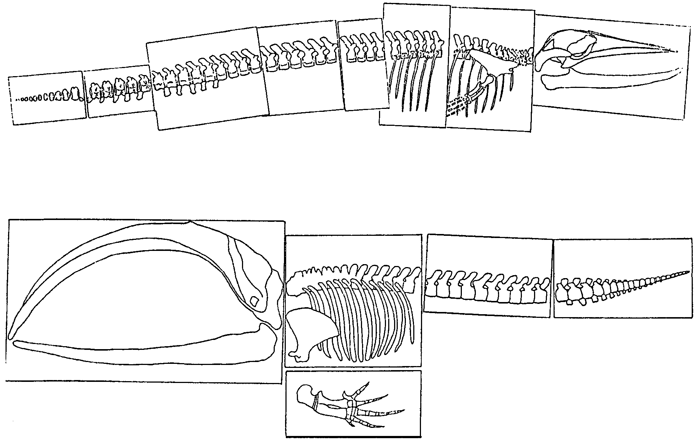
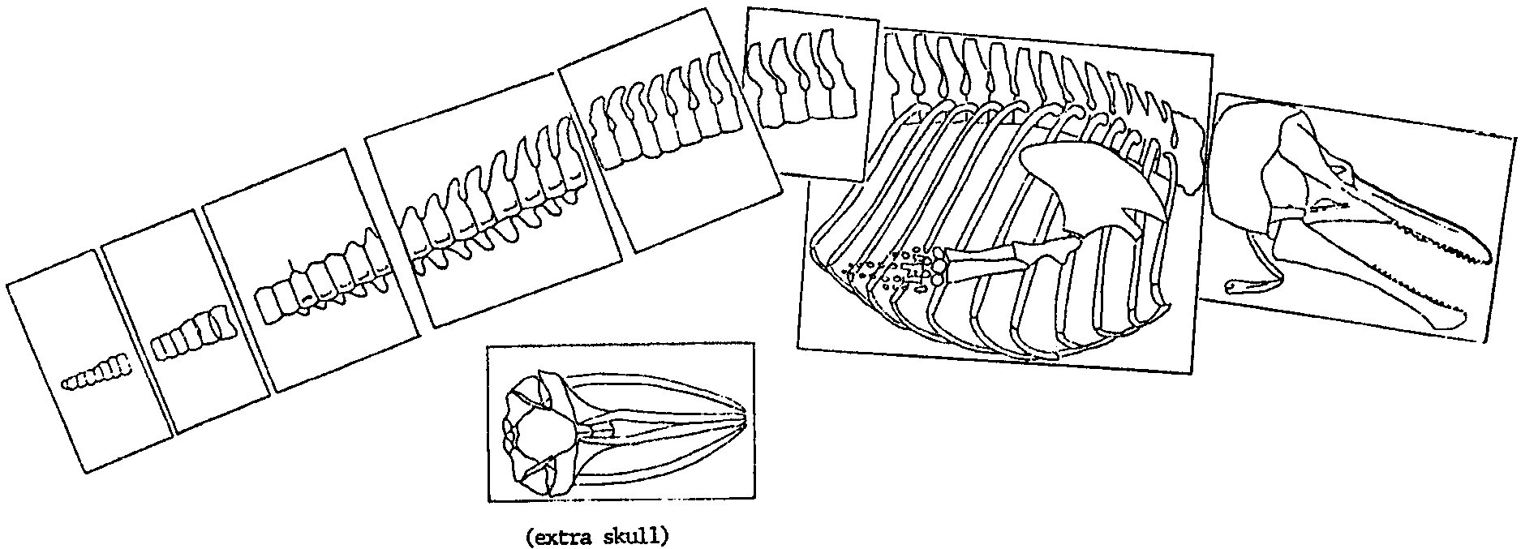
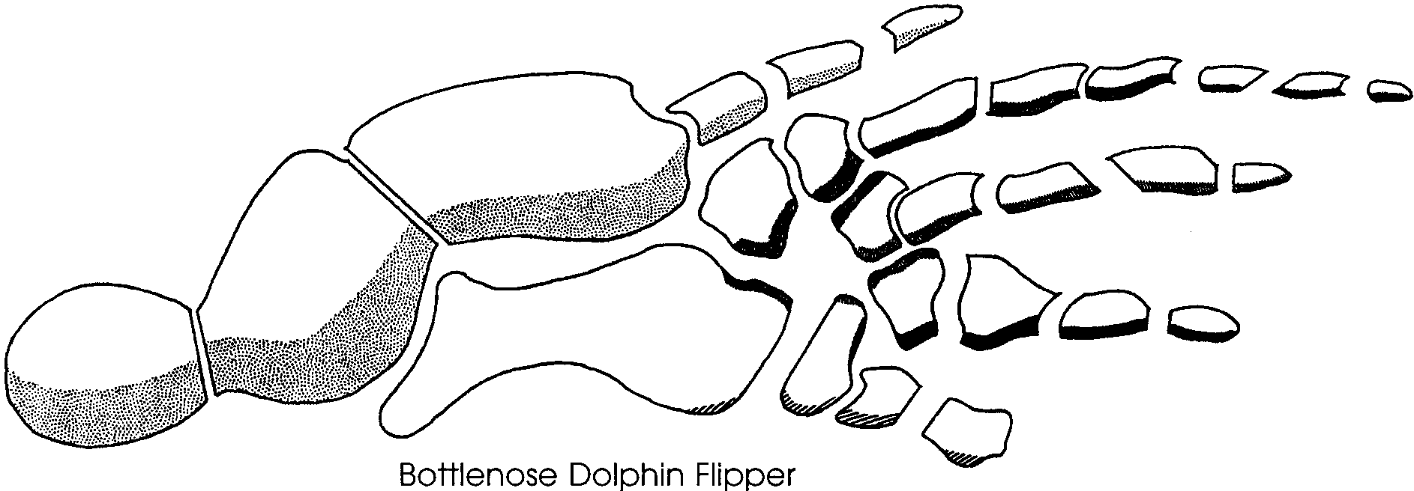

Bone Set 1
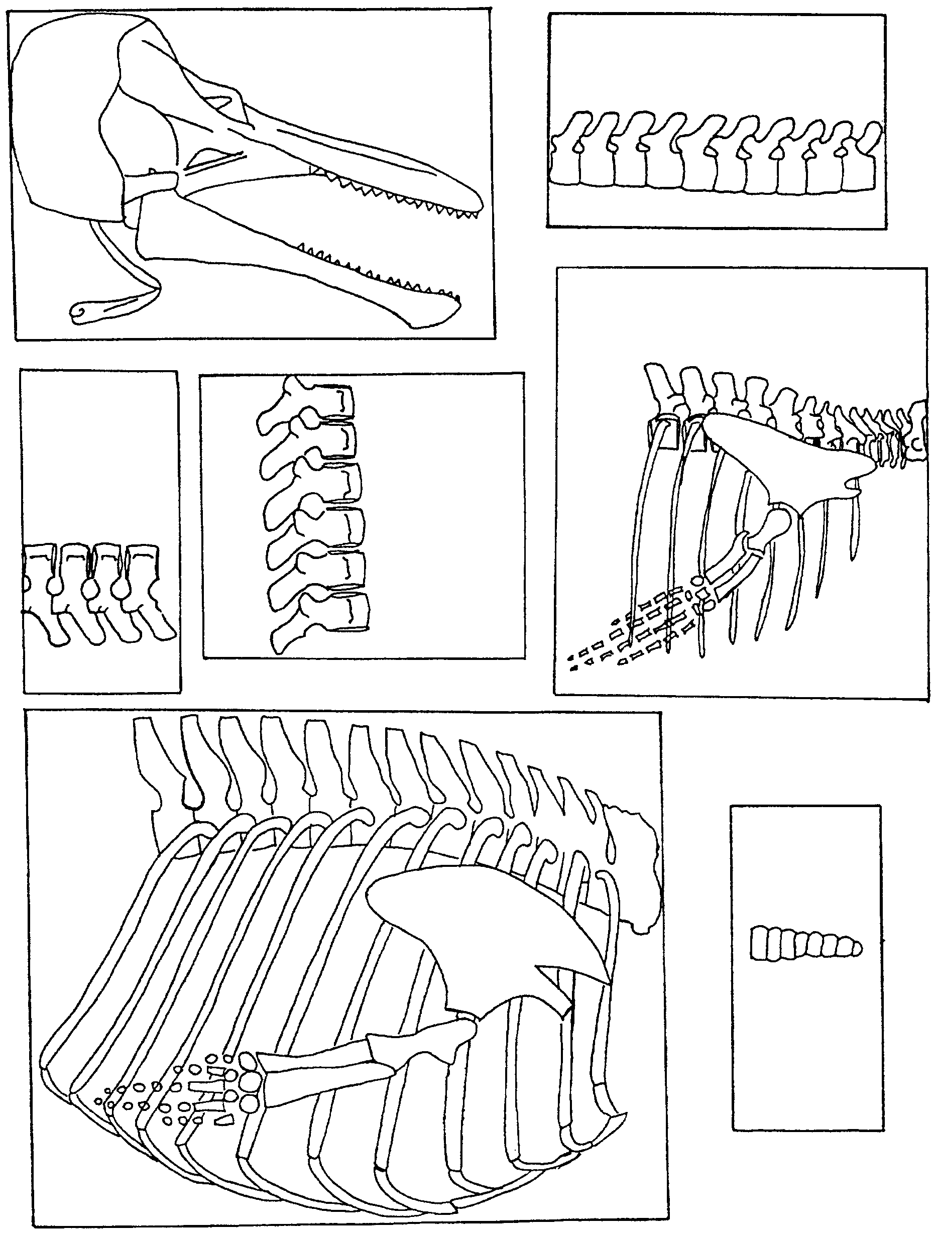

Bone Set 2
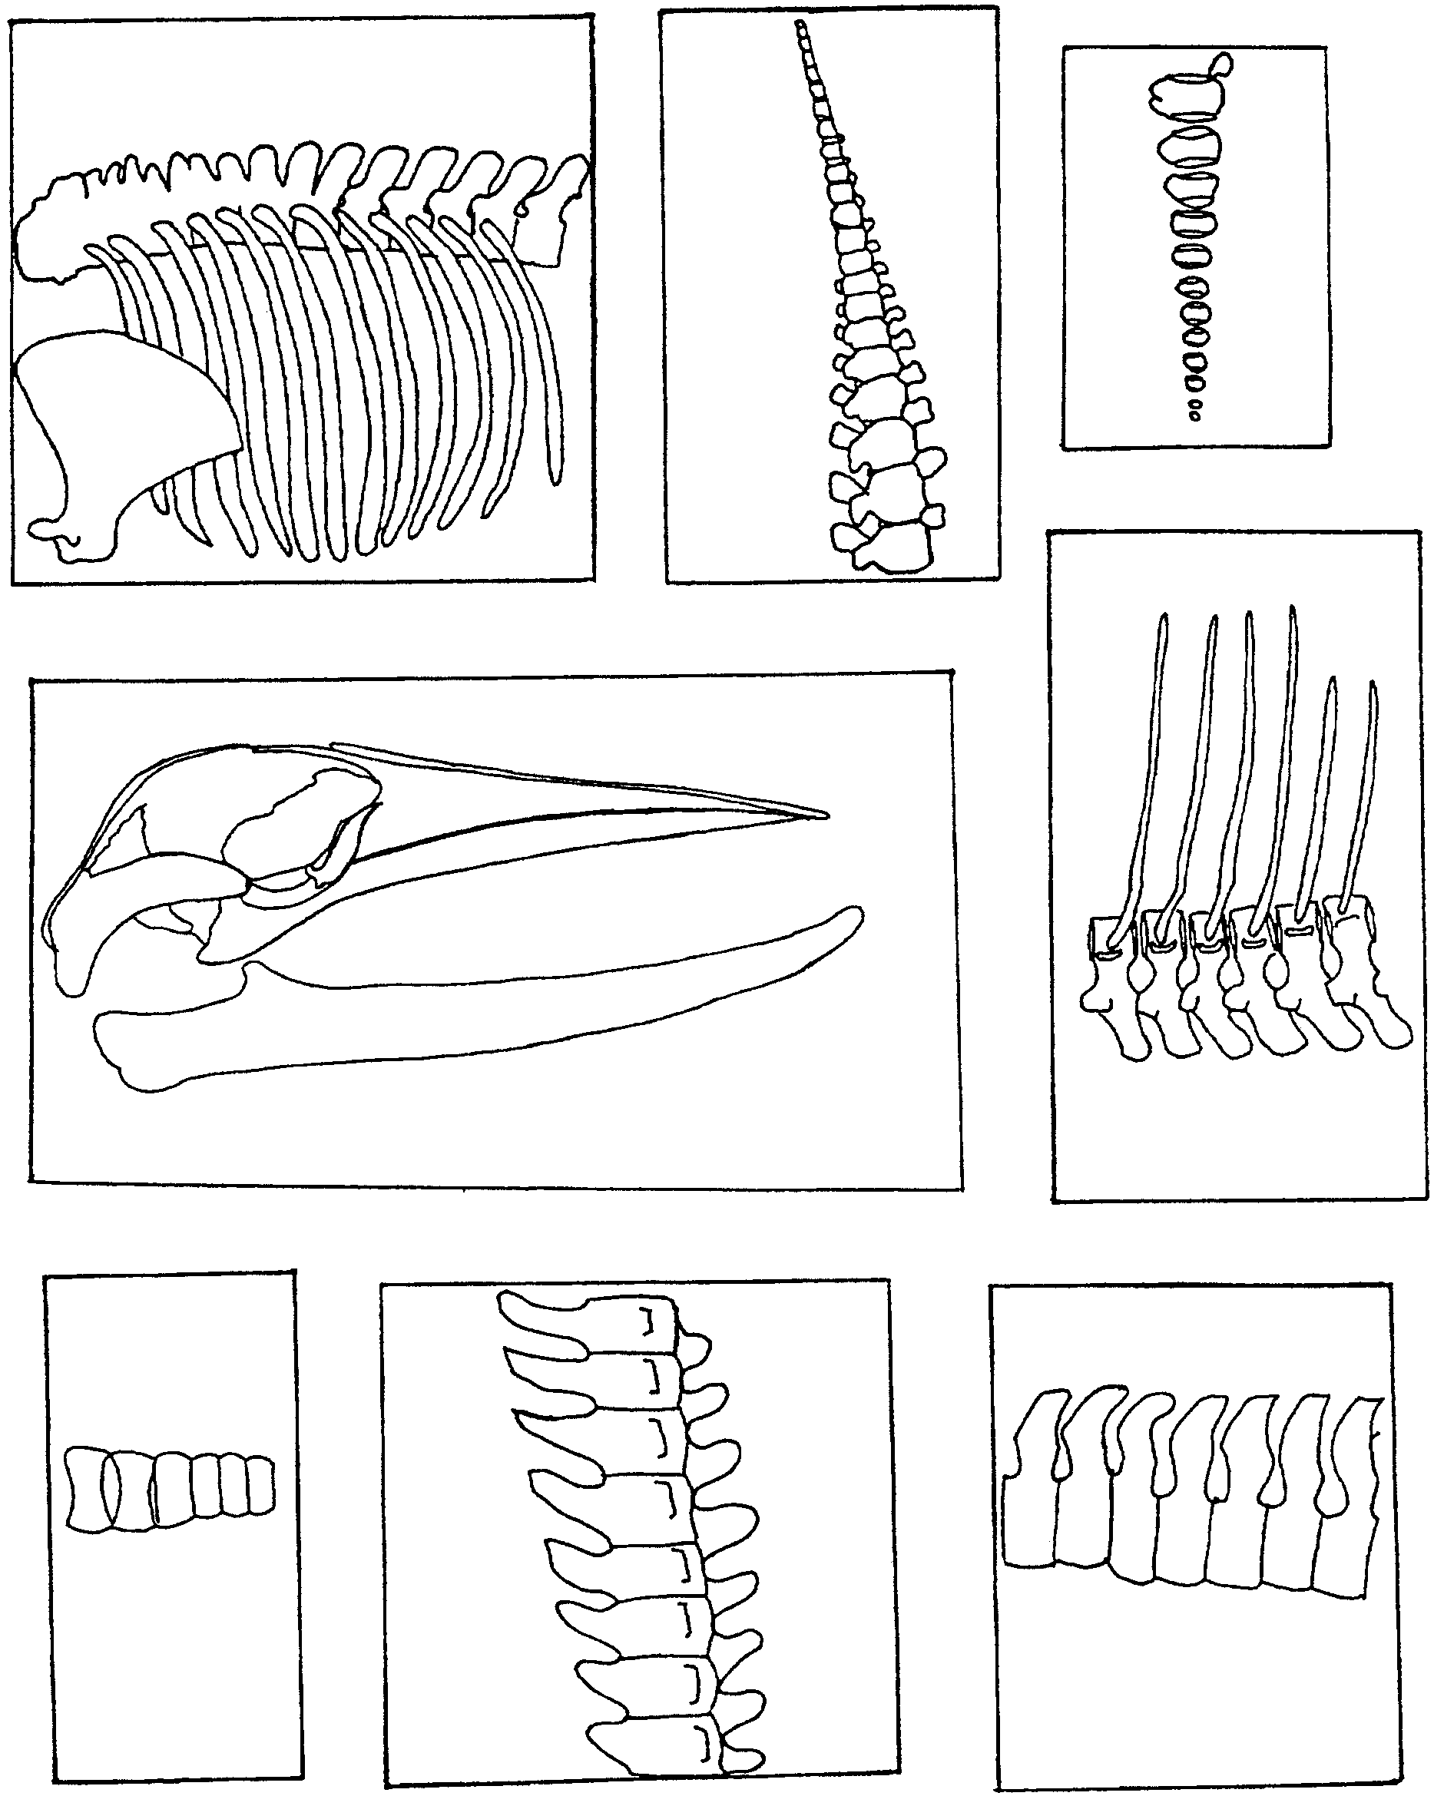

Bone Set 3
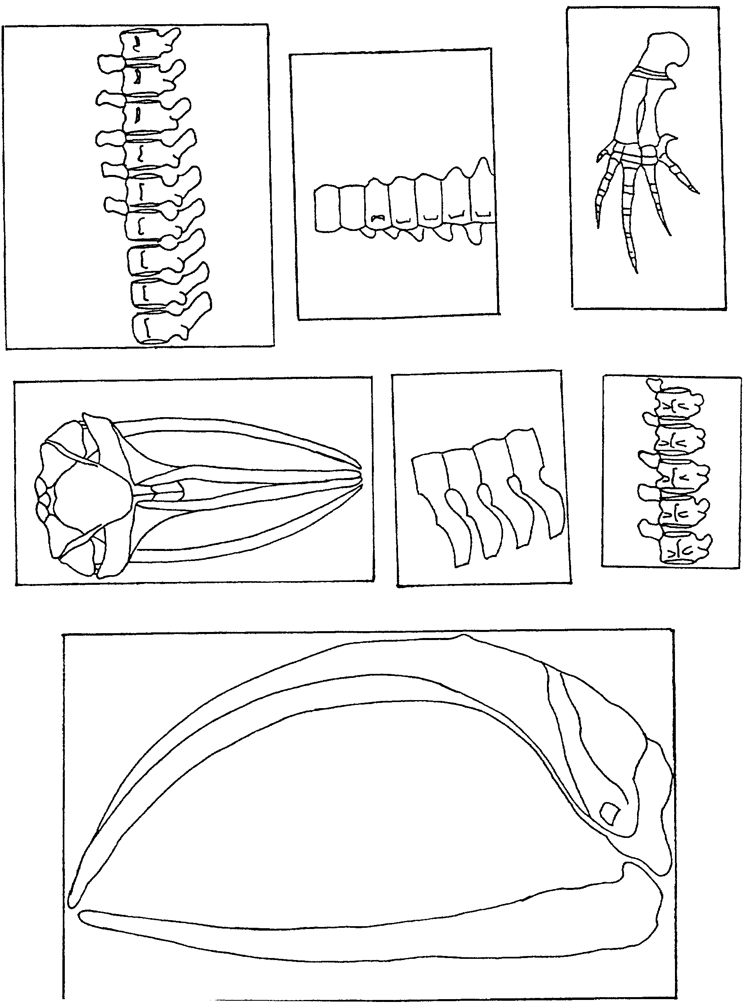

Bone Set 4
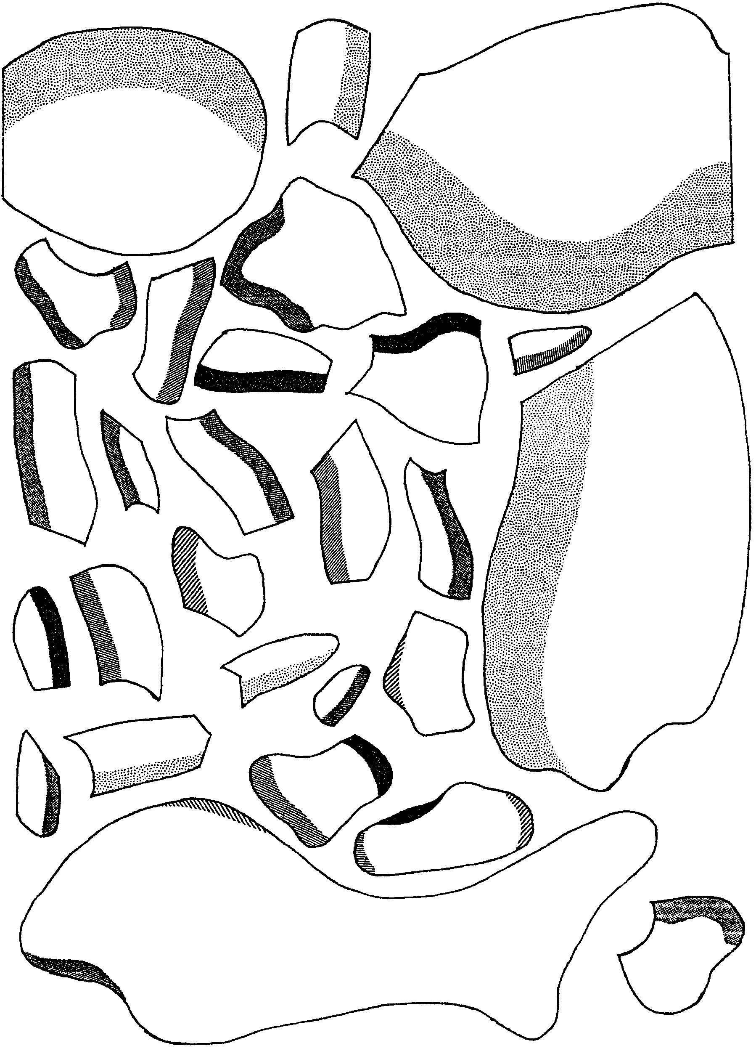

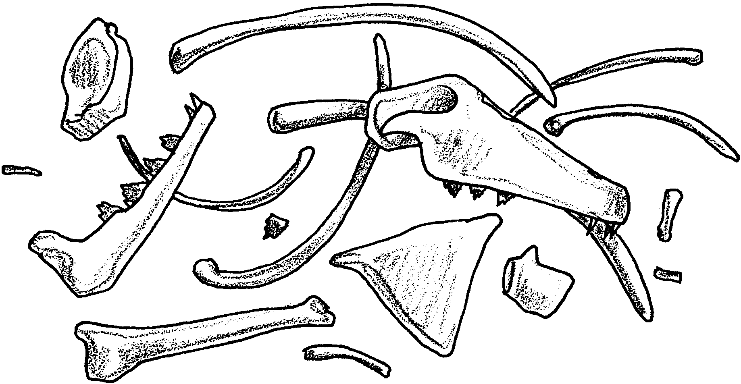
Putting All the Pieces Together

In 1845, Dr. Albert Koch dug up some enormous vertebrae. He then found some other bones and a skull. He mounted all these bones into a single skeleton. Dr. Koch presented the skeleton as that of a sea serpent. He named this 114-foot long animal, Hydrarchos, the “water chief.”

A later scientist, Richard Owen, suggested that the skeleton was really made up of two separate animals. The skeletons were, in fact, the remains of some early whales. Owen reconstructed a creature that was still 55 feet long. It was a snake-shaped animal with a dog-shaped skull. The fore-limb was a flipper with an elbow and a five-fingered hand, and the animal had traces of a thigh bone.

How do paleontologists go about reconstructing fossil animals? How could it happen that one person would make a 114-foot long skeleton and another person two 55-foot long skeletons out of the same bones? In the following activity you will have a chance to answer these and other questions as you “put all the pieces together”.

Here’s what you’ll need:
• skeleton/bone sets
• scissors
• tape
• colored pencils, felt-tipped pens, or crayons in black, red, blue, green, and yellow

Part 1

Your first set of bones is skeleton set A. You will also need scissors and tape.

Here’s what to do:

1. Use your scissors to cut out the skeleton pieces.

2. Spread out the skeleton pieces on your desk top. Use whatever clues you can to fit the pieces together into one or more animals or parts of animals. Some bones may be missing. Some may be extra.

3. After you are satisfied with your skeleton(s), tape the pieces together.

4. Put your name on the reconstructed skeleton(s). Use the skeleton(s) to answer the questions that follow.

Analysis and Interpretation - Part 1:

1. How many complete skeletons did you construct?

2. Did you have any incomplete skeletons?

3. Compare your skeleton(s) with those of others in your class.
a. Are all of the skeletons exactly the same?

b. If not, how can you account for the differences?

4. What other information might help real paleontologists determine which of the skeleton reconstructions is most accurate?

5. Paleontologists work carefully to collect all of the fossils at an excavation site.

a. What might cause part of a skeleton to be missing?

b. What might account for two or more skeletons being found in the same site?

6. The skeleton pieces you “dug up” were made of several bones still connected. If you were given a set of individual bones, would it be easier or more difficult to assemble the skeletons? Why?

Part 2

Now you’re an old hand at skeleton reconstruction. Let’s see what you can do with bone set B.

Here’s what to do:

1. Use your scissors to cut out the bones.

2. Spread out the “bones” on your desk top. Use whatever clues you can to fit the pieces together into a whale body part. (Hint: all of the bones fit together to form one structure)

3. After you are satisfied with your creation, tape the bones together.

4. Put your name on the reconstructed body part. Use it to answer the questions that follow.
Analysis and Interpretation - Part 2:

1. What does your completed whale body part appear to be?

2. a. Was it more or less difficult for you to assemble this part of a skeleton than the whole skeletons in Part A?

b. What made it more or less difficult?

3. Compare the body part you made with those of other students in your class.

a. Are all of the body parts exactly the same?

b. If not, how can you account for the differences?

4. Now let’s go back to our original question. How could one person make a 114 foot long skeleton and another person make two 55 foot long skeletons out of the same bones?

Part 3

Now let’s look at some modern whale skeletons. Whales are built very differently from humans. Even so, there are some interesting similarities between our skeletons and theirs. There are also some interesting differences.

We’ll compare the skeletons of an orca whale and a blue whale with a human.

Here’s what to do:
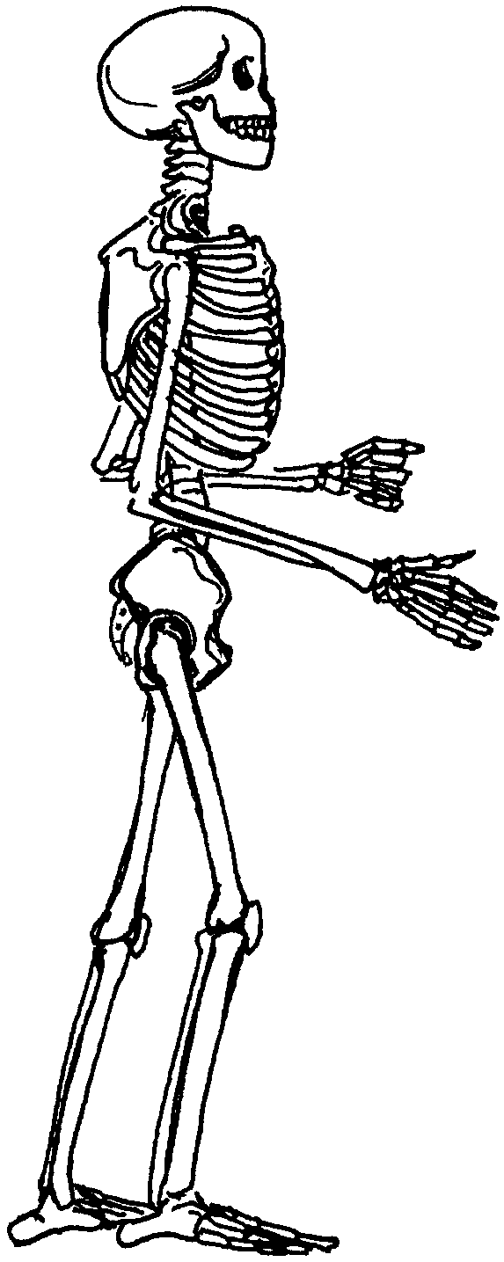
1. Find and color following bones on the human skeleton:
scapula (“shoulder blade”) - red
mandible (“lower jaw”) - black
pelvis (“hips”) - blue
ulna and radius (“forearm”)- yellow
femur (“thigh”) - green

2. Now look for the same bones on the orca whale and blue whale skeletons.
(Hint: not all the bones are present.)
Label these bones. Color them the same colors as on the human skeleton.
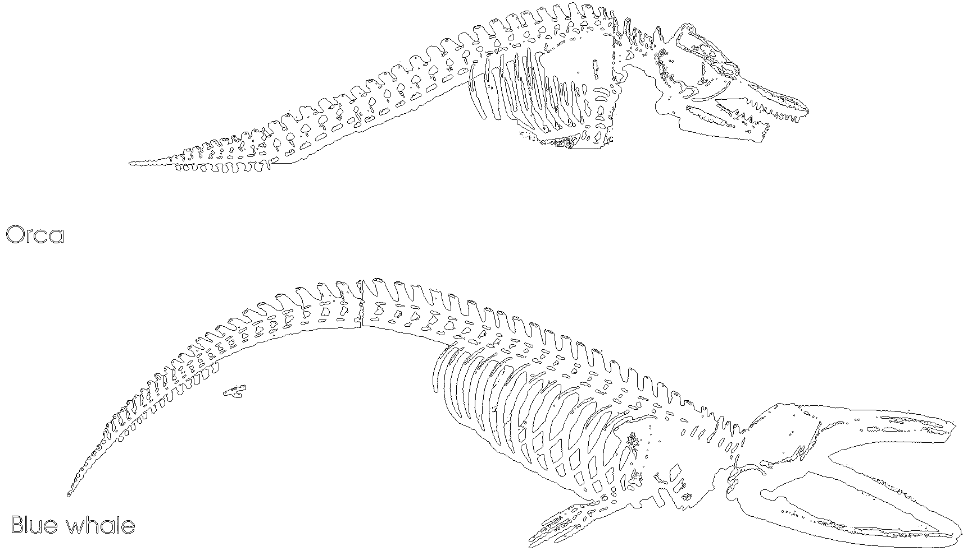

3. Use your skeletons to answer the following questions.

Analysis and Interpretation - Part 3

1. a. One bone present in the human skeleton is missing in the blue whale. Which bone is missing?

b. Which two bones are missing in the orca whale?

2. Do the whales have any bones that the human skeleton doesn’t have? Explain your answer.

3. Whales have lost most of the bones in their hind legs. Why might this have happened?

4. Look at the part of the whale skeleton that would be the forelimb of a land mammal. How has this part adapted for life in the sea?

5. Look for the upright prongs on a whale’s vertebrae. These are places where powerful muscles attach. What might be the muscles along the whale’s spine do?

