How Old?

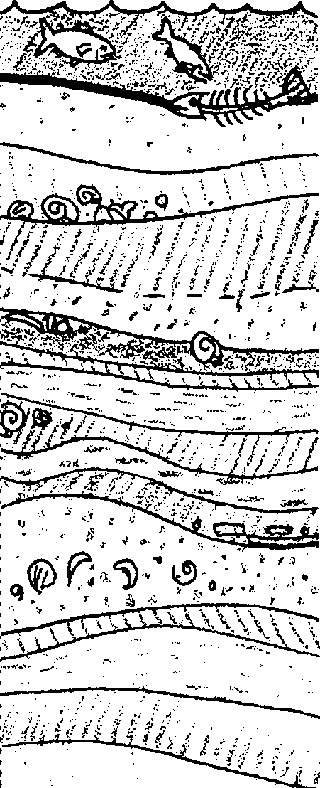
Key Concepts
1. The age of sedimentary deposits can be determined through knowledge of rates of sedimentation, the presence of index fossils, and by measurement of radioactive decay.
2. An index fossil is a fossil from an organism, about which we have a very clear understanding when it lived, or the conditions under which it lived. The presence of an index fossil enables us to make inferences about the age and/or environmental conditions of the sediments in which it is found.
3. By knowing the time and conditions under which fossils were deposited, we are able to better reconstruct the origins of species like the California gray whale.

Background
How can we learn about the origins of an animal such as the California gray whale? The sciences of geology and paleontology are especially useful in determining the evolutionary history of a species since most of the information comes from the rocks of the earth itself. Geology includes the study of earth’s crust and rocks, and the age and origins of rocks. Paleontology is the scientific study of forms of life existing in former geologic periods, as represented by their fossils. Both disciplines contribute to our understanding of the origins of whales and both have branches which form integral parts of the marine sciences.

Certain geologic principles are especially helpful in determining the age of origin of a species. The law of original horizontality states that materials are deposited in horizontal layers. The principle of superposition states that when the layers of rock are horizontal, or nearly so, each overlying bed of rock is younger than the one beneath it. And finally, the principle of uniformitarianism states that the processes (erosion, deposition, etc.) which we observe today have been occurring throughout the history of the earth. These three principals let us “read” rock formations and determine their relative ages; that is, which is oldest, youngest etc., not their age in years.
Paleontologists also contribute important information through the identification of “index fossils”. Index fossils are found in rock layers of only one geologic age. They serve to identify specific rock layers no matter where they are found. Not only do index fossils tell scientists the age of the rock formation in which they are found, they also provide information about the environmental conditions present during the time the rock layer was formed.

By understanding the clues found in rock strata and the fossil record, we can reconstruct the origin of whales. It is wise to point out, however, that fossils can be transported and redeposited. As such, index fossils are not a fool-proof method of aging rock formations. For example, whale fossils have been moved from the ocean floor to Pacific coastlines by the spreading of the sea floor. Such observations are the anomalies that make geology and paleontology such exciting fields of study.

Materials
For each group of 2-3 students

• one “fossil-bearing” cupcake

• scalpel or sharp knife

• 2 centimeter rulers

• recycled paper cut in quarters

For each student

• “Sweet Stratigraphy” and “How Old?” activity pages

Teaching Hints
“How Old?” is a two part lesson that provides information about the detective processes of geology, archaeology and paleontology which have given us our current picture of whale descent. In Part 1, “Sweet Stratigraphy”, students determine the age of a “fossil” in a sample of “rock strata”. In Part 2, students explore basic geologic principles and the role of index fossils in determining geologic ages.

Note that “How Old?” is not intended to be a comprehensive coverage of stratigraphy. It is intended to provide supporting evidence for theories on origins of cetaceans and to provide a springboard for further explorations in geology. Earth science texts provide a good source for additional information about the topics covered in this section.

Part 1, “Sweet Stratigraphy”, is designed to give your students experience determining the age of a fossil in a sample of rock strata containing fossils of known ages, known as index fossils. In this activity, a cupcake or piece of layer cake with layers of colored batter will serve as rock strata, an m&m candy will be the specimen of uncertain age, and peanuts, raisins and chocolate chips will be index fossils.

An added twist in this activity is that students are not given all information about their sample and its index fossils outright. They must generate specific questions to ask, much as scientists need to generate questions to find out what is already known about a field prior to embarking on research, as well when they design their actual study.

Directions are given for cupcakes; however, you may find that squares of cake baked in a sheet pan provide more uniform samples. If you choose the latter, be sure to place sufficient m&m specimens in the samples that students can locate one easily.

If you are using “Voyage of the Mimi” in conjunction with this unit, “Expedition 4: Whale Bones” correlates well with the above lesson.

Part 1 - Sweet Stratigraphy

Preparation

1. Use white cake mix to prepare the fossil-bearing cupcakes. In determining the number of cupcakes needed, recall that this activity is best accomplished by student teams of 2-3. Preheat oven and line muffin tins with paper liners.

2. Prepare the white cake mix according to the package directions. The batter should be the consistency of heavy cream so that objects you add to the batter don’t settle out. If it is too thin, add additional flour to the batter. Stir the batter as you add the flower to keep the batter from getting too stiff. If the batter is too stiff, you may find it difficult to form horizontal layers.

3. Divide batter into three parts. Tint one portion red, one portion green, and leave the third white.

4. Assemble the following materials close to where you will be working: peanuts, chocolate chips, raisins, and m&m candies. (If you can find them, white raisins are preferable to dark raisins in that they are easier to distinguish from chocolate chips.)

5. Add 1/4 cup chocolate chips and 1/4 cup peanuts to the green batter and place about a 1/2 inch of this mixture into each tin.

6. Over the green batter, lightly place 4-5 m&m candies, including some so close to the edge that they are likely to be visible once the paper liner is removed.

7. Add 1/4 cup chocolate chips and 1/4 cup of raisins to the white batter and gently place about 1/2 inch of this mixture over the m&ms and green batter.

8. Stir 1/4 cup of raisins into the red batter and place a final 1/2 inch of this batter over the other layers.

9. Bake as directed on package mix.

Procedure

1. Provide each student team with a sample “rock” (cupcake). You may wish to call the cupcake “fossil-bearing strata” or some similar term. Explain to them that they are teams of paleontologists in search of a rare prehistoric fossil. (Show them an m&m.) Their job is to pinpoint as nearly as possible the age of the fossil. They will probably have to make use of any and all clues available to them, such as the kind of sedimentary material it is found in, or knowledge other prehistoric creatures that may have lived at about the same time about which more information is known. As paleontologists, they may need to make careful excavations into exposed outcroppings of strata layers to gather more information.

2. Suggest that students begin by finding a specimen of the fossil in their rock sample, but caution them against removing it for fear of destroying important clues.

3. Offer students the use centimeter rulers and introduce the procedure for mapping an outcrop of their “fossil-bearing rock.” You may wish to have them us the grid found on their student activity pages to make a full-scale diagram of a vertical “rock face”. Their diagram should show the position of rock layers, the m&m fossil, and additional fossils (e.g., peanuts, chocolate chips, and raisins) they find in the layers. Students will need to make horizontal and vertical measurements using a centimeter ruler in order to apply all features to the grid paper on their data sheet.

4. Tell students that certain information about these sedimentary deposits is known, but that they will have to make inquiries of “scientific literature” to gain access to this information. To do this, student groups may send one representative to ask you a specific question about a characteristic of the sedimentary materials in their samples. Stress that you will answer no vague questions. In order to encourage thoughtful and systematic questioning, you may want to limit the number of questions groups can to ask to 5. Answer only one question at a time per group, and to eliminate eavesdropping, communicate with student representatives through the written word only. Tell them that some questions do not yet have answers, and therefore you may not be able to answer every question you are asked.

Information you may give out if asked:

• Chocolate chips first appeared about 1,000,000 years ago and went extinct 400,000 years ago.

• Peanuts appeared on earth about 1,500,00 years ago and went extinct about 600,000 years ago.

• Raisins appeared 400,000 years ago and are still living today.

In the discussion that follows the activity, you might point out that fossils can be transported and redeposited, and allow students to suggest possible ways that could happen. Students should understand that index fossils are not a fool-proof method of aging rock formations.

Part 2 - “How Old?”

Note that although the student reading “How Old?” is presented here as following “Sweet Stratigraphy” as a way of reinforcing the concepts presented, it can be used before that activity to introduce those concepts.

Key Words
cross-section - a vertical section or slice of anything, such as rock layers

dating - to determine the age of something

erosion - the weathering or wearing away of land features

fossil - any remains, impression, or trace of a living thing of a former geologic age, as a skeleton, footprint, etc.

index fossil - a fossil of an organism of known age or habitat needs, useful for dating or characterizing the strata in which it is found

lead 206 - a form of lead found naturally in the environment, used in dating rocks through measurement of radioactive decay

radioactive decay - the transformation of a radioactive element into a different element through release of radioactive particles

sediment - materials which settles out of water

strata - layers

uranium 238 - a form of uranium found naturally in the environment, used in dating rocks through measurement of radioactive decay

Extensions
1. Take your class on a fossil hunt at a known site. To find out about possible destinations, a phone call to the geology department of your local university is usually a good starting place. Be sure to get permission of any property owners, and make sure you have a clear understanding of whether you and your students may take materials from the site. A trip of this nature provides abundant opportunities for recording observations, student reporting, and involving your class in creating a display on paleontology in your school.

2. Natural history museums are a resource not to be overlooked. In addition to providing interpretive displays on prehistoric life and geology, many also make loans of fossil specimens for classroom use.

3. As an art extension, have students “make” fossils by pressing shells, leaves or bones into a soft substance, such as damp pottery clay to leave a negative imprint. Then plaster of Paris can be poured into the negative mold. Other substances to try include salt-flour dough and even pottery clay, which can later be fired in a kiln.

Answer Key
Part 1 - Sweet Stratigraphy

Procedure
2. Students diagrams will vary, depending on the characteristics of their “strata.” Students are asked to include the depth of each sediment layer, the placement of the index fossil, and the location and labeling of other fossils.

Analysis and Interpretation

1.a. If the students’ fossils have remained in the position they were placed during the baking process, they should arrive at the age of 600,000 years.

b. Answers will vary depending upon the strategies employed to determine the age. Do not be too concerned if dates vary so long as students have followed a rational process to arrive at their answers.

2. The answer will depend somewhat on the properties of the cake. If the fossil is 3 cm below the surface and its age is 600,000 years, one centimeter of sediment would have taken 200,000 years to accumulate.

3. a. The presence of an index fossil allows us to apply known information on age and environmental conditions of the index species to other organisms found in the same sediments.

b. In this activity the chocolate chips and raisins served as index fossils for dating the m&ms.

Part 2 - How Old?

1. A correctly labeled drawing is found below.
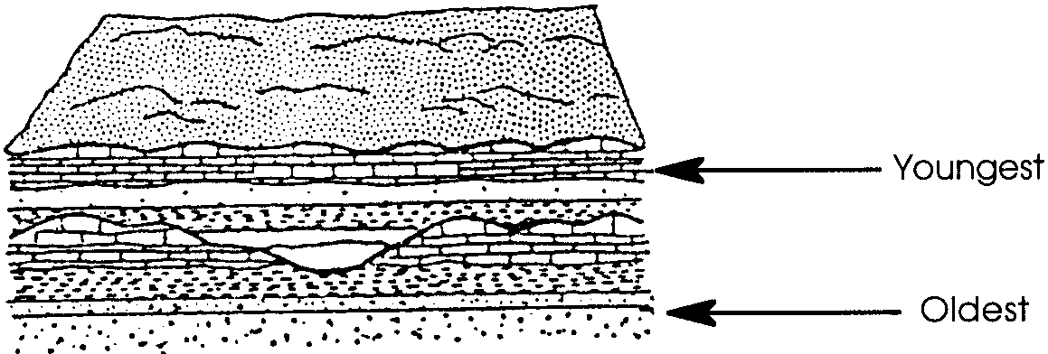

2. We can assume the principle is true of most rock layers because sedimentary materials are continually deposited from above. If no other disruptive forces are at work, the youngest sediments will always lie above older layers.

3. Since the question calls for an opinion, students should be encouraged to speculate. As such, answers may vary. Some of the layers appear to be folded by movements of the earth’s crust. There has probably been erosion and then additional layers deposited over much earlier ones. Volcanic lava intrusions are extending up into the layers as well.

4. This simple math problem may cause your students some initial frustration. If this is the case, provide them with help useful in setting up this (and other similar) problems.

1 centimeter/year = 1 km/? years
Since 1 km = 1000 meters and 1 meter = 100 cm, then 1 km = 100,000 cm. At the rate of 1 cm/year, the it has taken 100,000 years to deposit 1 km of sedimentary rock.
5. a. Your students can determine the approximate age of the rock by noting that the uranium has decayed to 50% of its original amount, the definition of half life indirectly given in the text. So, 50% of Uranium left = 1 half life = 4.5 billion years.

b. If a rock contains 25% lead and 75% uranium, .5 half life has elapsed or 2.25 billion years

This is the best answer your students can give based on the information they have. This answer is only an estimate, however, because radioactive decay is not a straight line function. In reality, during each year that passes, 1/7,700,000,000 of the amount of uranium is changed to lead.

6. Index fossils are found in rock layers of only one geologic age and hence are useful in providing information about when the first whales lived. They serve to identify specific rock layers no matter where they are found.

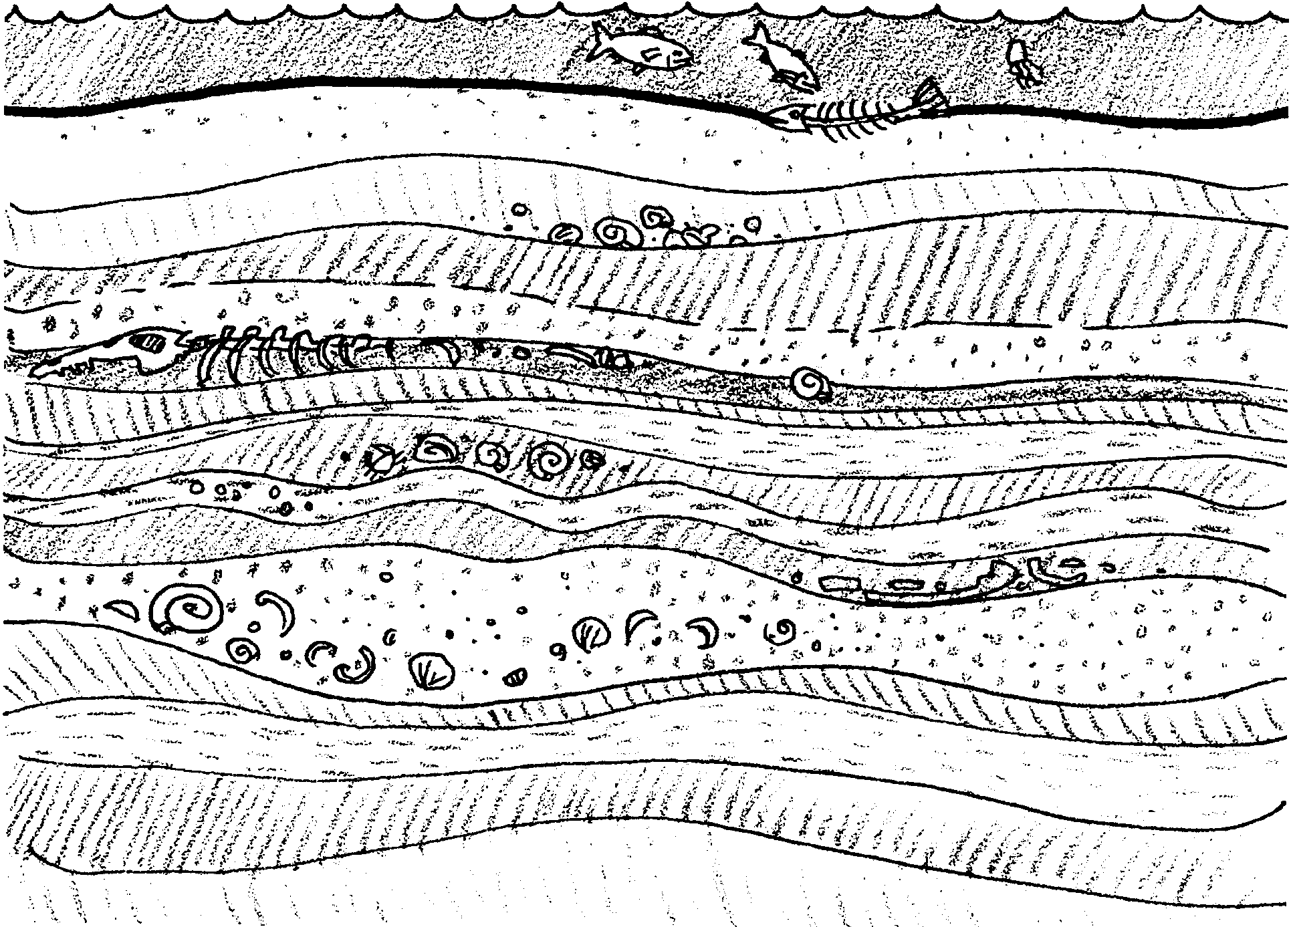
How Old?

Part 1 - Sweet Stratigraphy

You are on the trail of a rare prehistoric animal. It lived only a short time. Few fossils of the exotic animal are in existence. You will be given a sample of rock from the time period it is thought to have lived. The rock was formed as sediment settled in layers called strata. Fossils are also found in the strata. Your task is to find out when this animal lived.

How to date your sample:

1. Look for the sediment layers. Can you see them clearly? If not, gently cut one rock face so that you can. Find a fossil specimen, but leave it in place. You don’t want to destroy any important clues!

2. Now, record the depth of each sediment layer in your sample. Use a centimeter ruler to measure each layer. Use this information to make a scale drawing of the sample.

(Hint: You can use two centimeter rulers to help you make your drawing. First, place one centimeter ruler along the bottom of your sample. Put the end of the ruler next to the end of the sample.
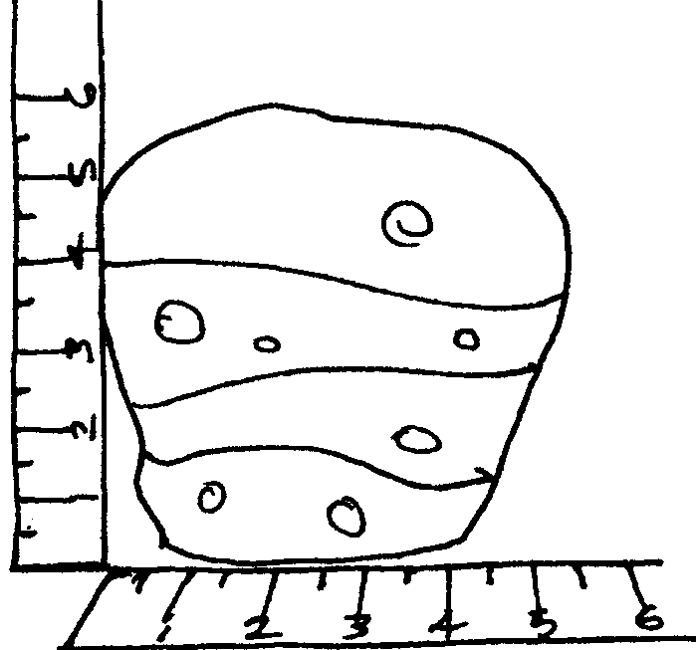

Hold the second upright so that the 0 point is directly over the end of the first ruler.

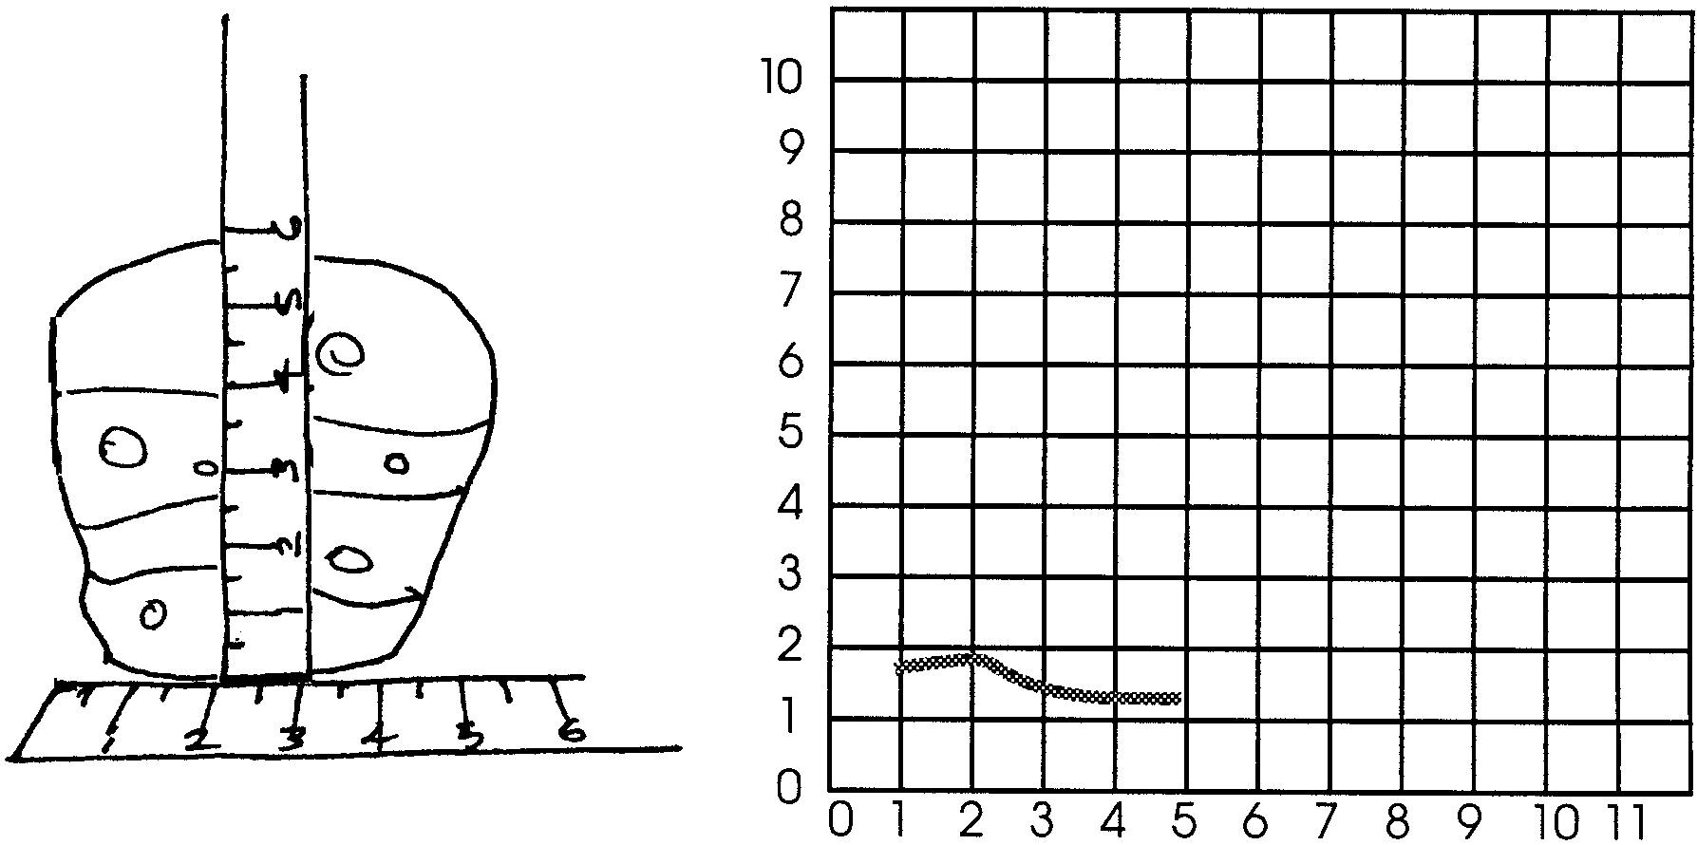
Measure the height of each sediment layer. Record this information on your data grid. Continue by moving the upright ruler to the 1 cm mark on the horizontal ruler and repeating your steps.

Continue until all sediment layers are marked.

3. Locate the fossil in the strata sample. Accurately place it in your drawing. The ruler may be a help.

4. On your drawing, note the presence of other fossils. Label the location with the name of the fossil. These other fossils may provide important clues. They may help you age the rare fossil.

5. Some things are known about these layers of rock. Your teacher has that information. With your group, decide on questions to ask your teacher. Write down each question on a piece of scratch paper. You may give your teacher one question at a time.

As you work, you may learn the ages of some of the features of your strata. Add this information to your drawing.

Analysis and Interpretation

1. a. Age of your rare fossil

b. How do you know this?

2. Let’s say that no sediments have been removed from the surface. Let’s also say that sediments have always built up at the same rate. How long has it taken for a centimeter of sedimentary rock to form on your sample?

(Hint: Take the age of the fossil and divide that number by its depth in centimeters.)

3. Some fossils are known as index fossils. Index fossils tell us certain things. They may give us a very clear understanding of when that animal or plant lived. Or, they may let us know the conditions under which it lived.

a. How does the presence of an index fossil help us increase our knowledge of other plants and animals found in the same sediment layer?

b. In this activity, which items served as index fossils for determining the age of the m&m candies?

Part 2 - How Old?

What evidence do scientists use to reconstruct the story of the first whales? Most of the information comes from the rocks of the earth itself. Today, at many places on earth, we can watch the wearing away of rocks. This wearing away is called erosion. Scientists believe erosion has been happening for as long as the history of the earth. Over the years, in other places, the tiny worn away pieces have come together. New rocks, built up of layers, or strata have formed. These rock layers give us a clue to the past.

A simple rule helps us understand the record of these rock strata. Let’s look at rocks where the layers are horizontal, or nearly so. In these rocks, each overlying bed is younger than the one beneath it. This is called the principle of “superposition”. (This makes sense. Think about the clothes in your laundry basket (or on your floor). The ones on the bottom have been there the longest time.)

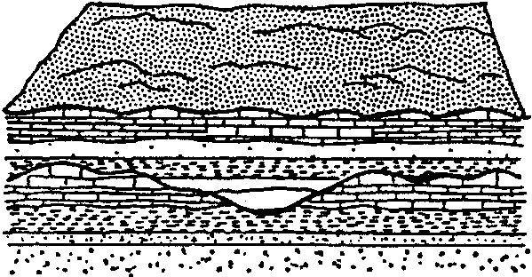
1. Look at the drawing below. Label the oldest and youngest rock layers (strata).

2. Why can we assume this principle is true of most rock layers?

However, the earth’s crust is in motion. This means that it is not always as easy as it might sound to tell the age of the different layers. The diagram below shows a cross-section of a piece of the earth’s crust. Motion in the crust has moved sections of layers of rocks and soil. This rearranged section of earth is difficult to “read.” Geologists are scientists that study the earth. They have devised methods to “read” these confusing rock records.

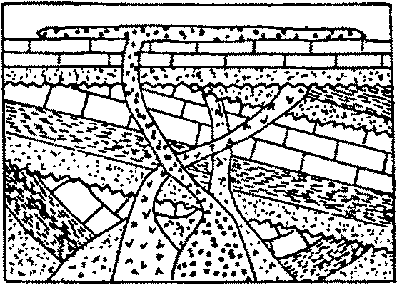
3. What might have occurred in the rock layers to the right to make it difficult to “read” their age?

The position of the layers of rock tells us which rocks are oldest. It does not tell us how old the rocks are in terms of years. How can we tell their age in years? Geologists can make reasonable guesses of the age of rocks. First, they note how long it takes to deposit, or lay down, a layer of rock. This is called the rate of deposition. They then measure the thickness of the layers. From this information, they can determine the age of the layer. Let’s see how.

4. The diagram below shows a series of rock layers. The labeled section is 1 kilometer deep. It was deposited at a rate of 1 centimeter per year. How old is the bottom layer? Please show your work.

(Hint: Let’s write the question mathematically: 1 centimeter/year = 1 kilometer/? years. This is the same as:

1 centimeter = 1 kilometer
year ?years

This is easy! Remember that 1 kilometer = 1000 meters and 1 meter = 100 centimeters. All you need to find out is the number of centimeters in a kilometer.)
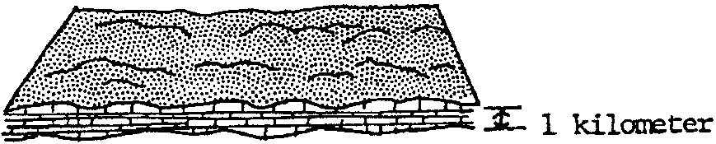
These methods gave early geologists an idea of the age of certain rock layers. Today, scientists have powerful new tools to date rocks. We know that radioactive atoms are unstable. These unstable atoms change from one form to another over time. This is called radioactive decay. We also know the rate at which the change takes place. For any rock, we can measure how many atoms have changed and how many have not. From this information we can determine the age of the rock in which these materials are found.

5. Uranium 238 changes to Lead 206 by radioactive decay. It takes 4,500,000,000 (4.5 billion) years for half (50%) of the uranium in a given rock to change to lead.

a. If a rock contains 50% lead and 50% uranium, how old is the rock?

b. If a rock contains 25% lead and 75% uranium, how old is the rock?

So, now we have an idea of what the layers of rocks tell us and how old each layer is. How does this information relate to our history of the whale?

Early whales lived near coasts. When they died, some settled into the soft mud and sands. Most of the whales disappeared. But in some cases, their skeletal materials were replaced by harder minerals. These skeletons were transformed into rock. We call these special rocks “fossils”. Fossils are naturally preserved remains of animals and plants.

Certain fossils are called index fossils. Index fossils are useful to geologists. They are found in rock layers of only one geologic age. They serve to identify specific rock layers no matter where they are found. By understanding the clues found in rock strata and the fossil record, we can reconstruct the origin of whales.

6. How can index fossils be helpful in telling when the first whales lived?

