Name That Whale: Cetacean Key
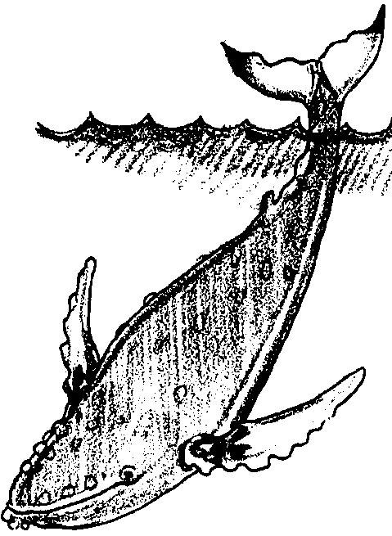

Key Concepts
1. Scientists group whales according to similar characteristics and use dichotomous keys as a tool in grouping and identification.
2. Scientists divide whales (cetaceans) into two groups based on how they feed: toothed whales (Odontocetes) and baleen whales (Mysticetes).

Background

Scientists divide whales into two groups based on how they feed. One group, called toothed whales, contains sperm whales, orca whales, and other predatory whales which have real teeth and feed primarily on fish and squid. There are about 60 species of oceanic toothed whales, including dolphins and porpoises. Technically, these whales are placed in a subgroup called “Odontocetes” which, oddly enough, translates as “toothed whales”.

Members of the second group, called baleen whales, have no real teeth. Instead, they have parallel rows of stiff, brush-like plates called baleen which they use to filter large quantities of small food animals (plankton) from the ocean water. The two or three hundred flat baleen plates set crosswise along the edge of the upper jaw and hang from it.

Baleen plates are fibrous and tough but flexible. They are made of keratin a material similar to human fingernails. On the inside of the mouth the edges of the plates are frayed into long bristles or strands resembling the strands of a horses tail. The strands of baleen from adjacent plates overlap forming a “hairy” mat which serves as a strainer to trap the food while letting the water flow through. This “hairy” appearance gives rise to the subgroup name of “Mysticetes” which means “moustache whale”. There are ten species of baleen whales.

Baleen and toothed whales differ in other ways, too. Baleen whales have two blow holes and toothed whales have only one. The skulls of baleen whales are symmetrical while those of toothed whales are asymmetrical. Baleen whales tend to be much larger than toothed whales, one of the largest animals that has ever lived is the Blue whale, reaching 100 feet (bigger than all but one of the dinosaurs).
Baleen whales migrate great distances from their summer feeding grounds in polar regions to winter mating and calving grounds in the tropics. Outside of the mating grounds, baleen whales rarely congregate while toothed whales frequently travel and live with many other individuals in groups called “pods”. Baleen whale young spend about two years with their mothers. Parental investment for toothed whales is much longer; some, like orca whales, stay with their mother their entire lives leaving their mother’s pod only to mate.

With the exception of the toothed sperm whale, baleen whales have been hunted much more than the toothed whales, primarily due to their large body size and high blubber yield. Most baleen whales are on the endangered species list. An exception is the gray whale which is a success story of recovery and has been removed from the list. Because of the low birth rate (one offspring every 3-4 years for baleen whales and 4-7 years for toothed whales) and the long term parental investment, individuals in both sub orders are recovering very slowly.

Although hunting has been greatly reduced from past levels, whales face other challenges to their recovery. As consumers of fish and squid, toothed whales are more adversely affected by those forms of pollution and heavy metals that concentrate as they move up the food chain. All whales are at risk for entanglement in drift nets or discarded fishing gear.

As an aside, the groups “Mysticetes” and “Odontocetes” are called by scientists “suborders” of the “order” Cetacea (which includes the whales) which is part of the “class” Mammalia, which is part of the “subphylum” Vertebra, which is part of the “phylum” Chordata. All of these terms reflect groupings made by scientists based on increasing similarities between the animals within a group as we move from phylum to suborder (actually, we can move even further to “genus” and “species”). While it is prudent to remember that these groupings are human constructs, they are very helpful in making sense out of a wide variety of organisms.

Materials

For each group of 2-4 students:

• scissors

• “Name That Whale Key” activity page

• whale picture set

• “Parts of a Whale” activity page

Teaching Hints

“Name That Whale” uses a dichotomous key to provide an introduction to how western scientists catalog their observations of marine animals. Unlike systems in other cultures that identify organisms by their technological uses or by their spiritual or ecological importance, the scientific system groups organisms by similar physical structures and similar development.

Identifying whales or any other group of animals can be difficult because there are so many of them. Scientists and others use a tool called a dichotomous key to help them distinguish between members of the group. The word “dichotomous” means “divided or cut into two parts”. A dichotomous key repeatedly divides and subdivides a group of animals (or other things) into two groups. In the “Name That Whale” key, a student must chose between two characteristics at each box. The arrow and number within the box tell the students where to next look for information or identification.

Laminating the whale picture cards lets you use them with future classes. You may wish to cut out and laminate the pictures yourself or have students help you with the task as they do the activity.

Be sure to have the students physically move the whale pictures (placing the correct picture next to its corresponding box) until they have keyed all the whales.

Key Words

baleen - an elastic, hair like material growing in place of teeth in the upper jaw of certain whales and forming a series of thin, parallel plates used to strain food out of the water, also called whalebone

beak - front of whale, similar to our nose but lacking nostrils

blowhole - “nostrils” of the whale, located on the dorsal side

dichotomous key - a tool used to distinguish between members of a group by repeatedly dividing and subdividing the group into two groups

dorsal - situated on or toward the back (top or upper side of whale)

dorsal fin - fin on dorsal or top side

flukes - the triangular portions of a whale’s tail

melon - an organ located in the head of toothed whales comprised of fatty tissue surrounded by muscle that is thought to contract to generate sound waves for echolocation

throat grooves - pleats which expand to accommodate water that is engulfed with food; muscles in the pleats contract to force water out through the baleen

ventral - situated on or toward the belly (the bottom or lower side of whale)

Extensions

1. Have students create their own dichotomous key for other types of whales.

Answer Key

1. Answers will vary but characteristics that are unique to a specific whale make identification easier.

2. a. Answers will vary; generally, the more similar whales (e.g., right whale and bowhead whale) are difficult to key.

b. Answers will vary.

3. The number of whales decreases as you move father into the key, because you are identifying them along the way.

4. Two differences between toothed and baleen whales noted in the “Parts of the Whale” handout include: teeth vs. baleen, one blowhole vs. two blowholes, and no melon vs. melon.
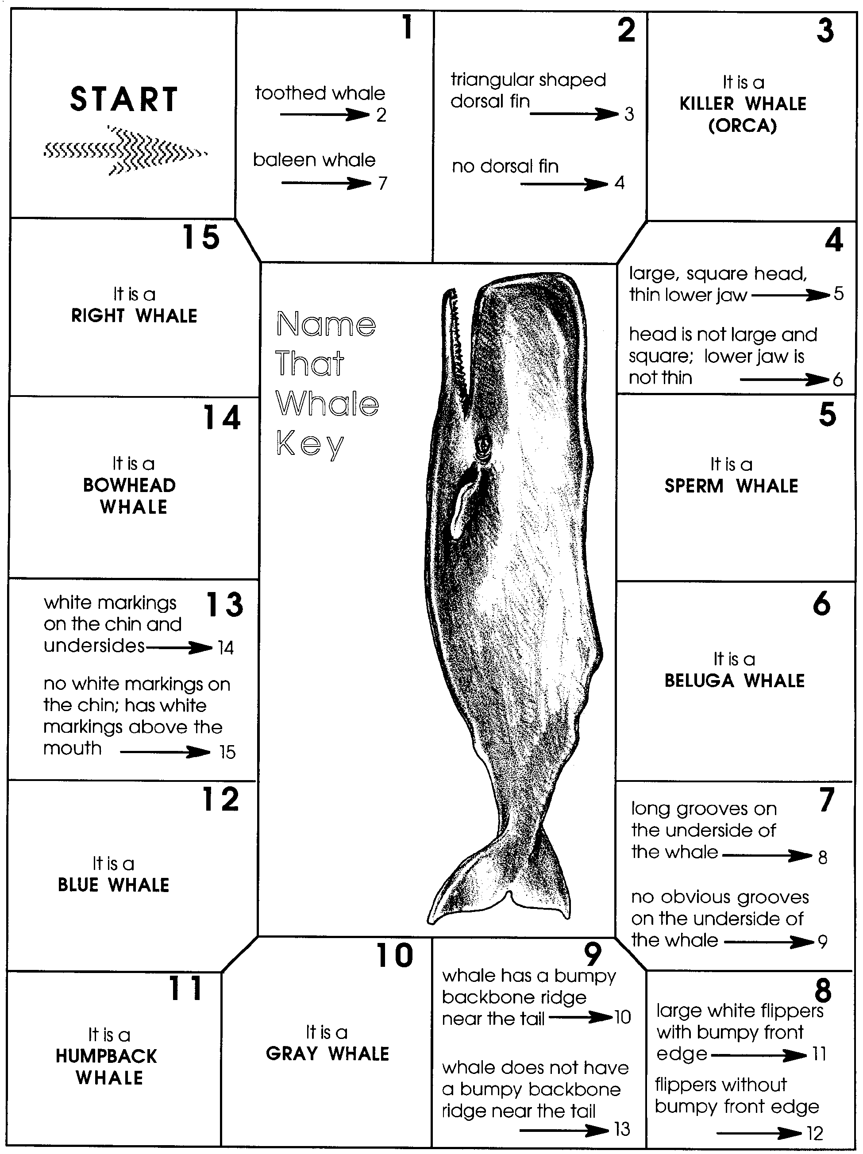
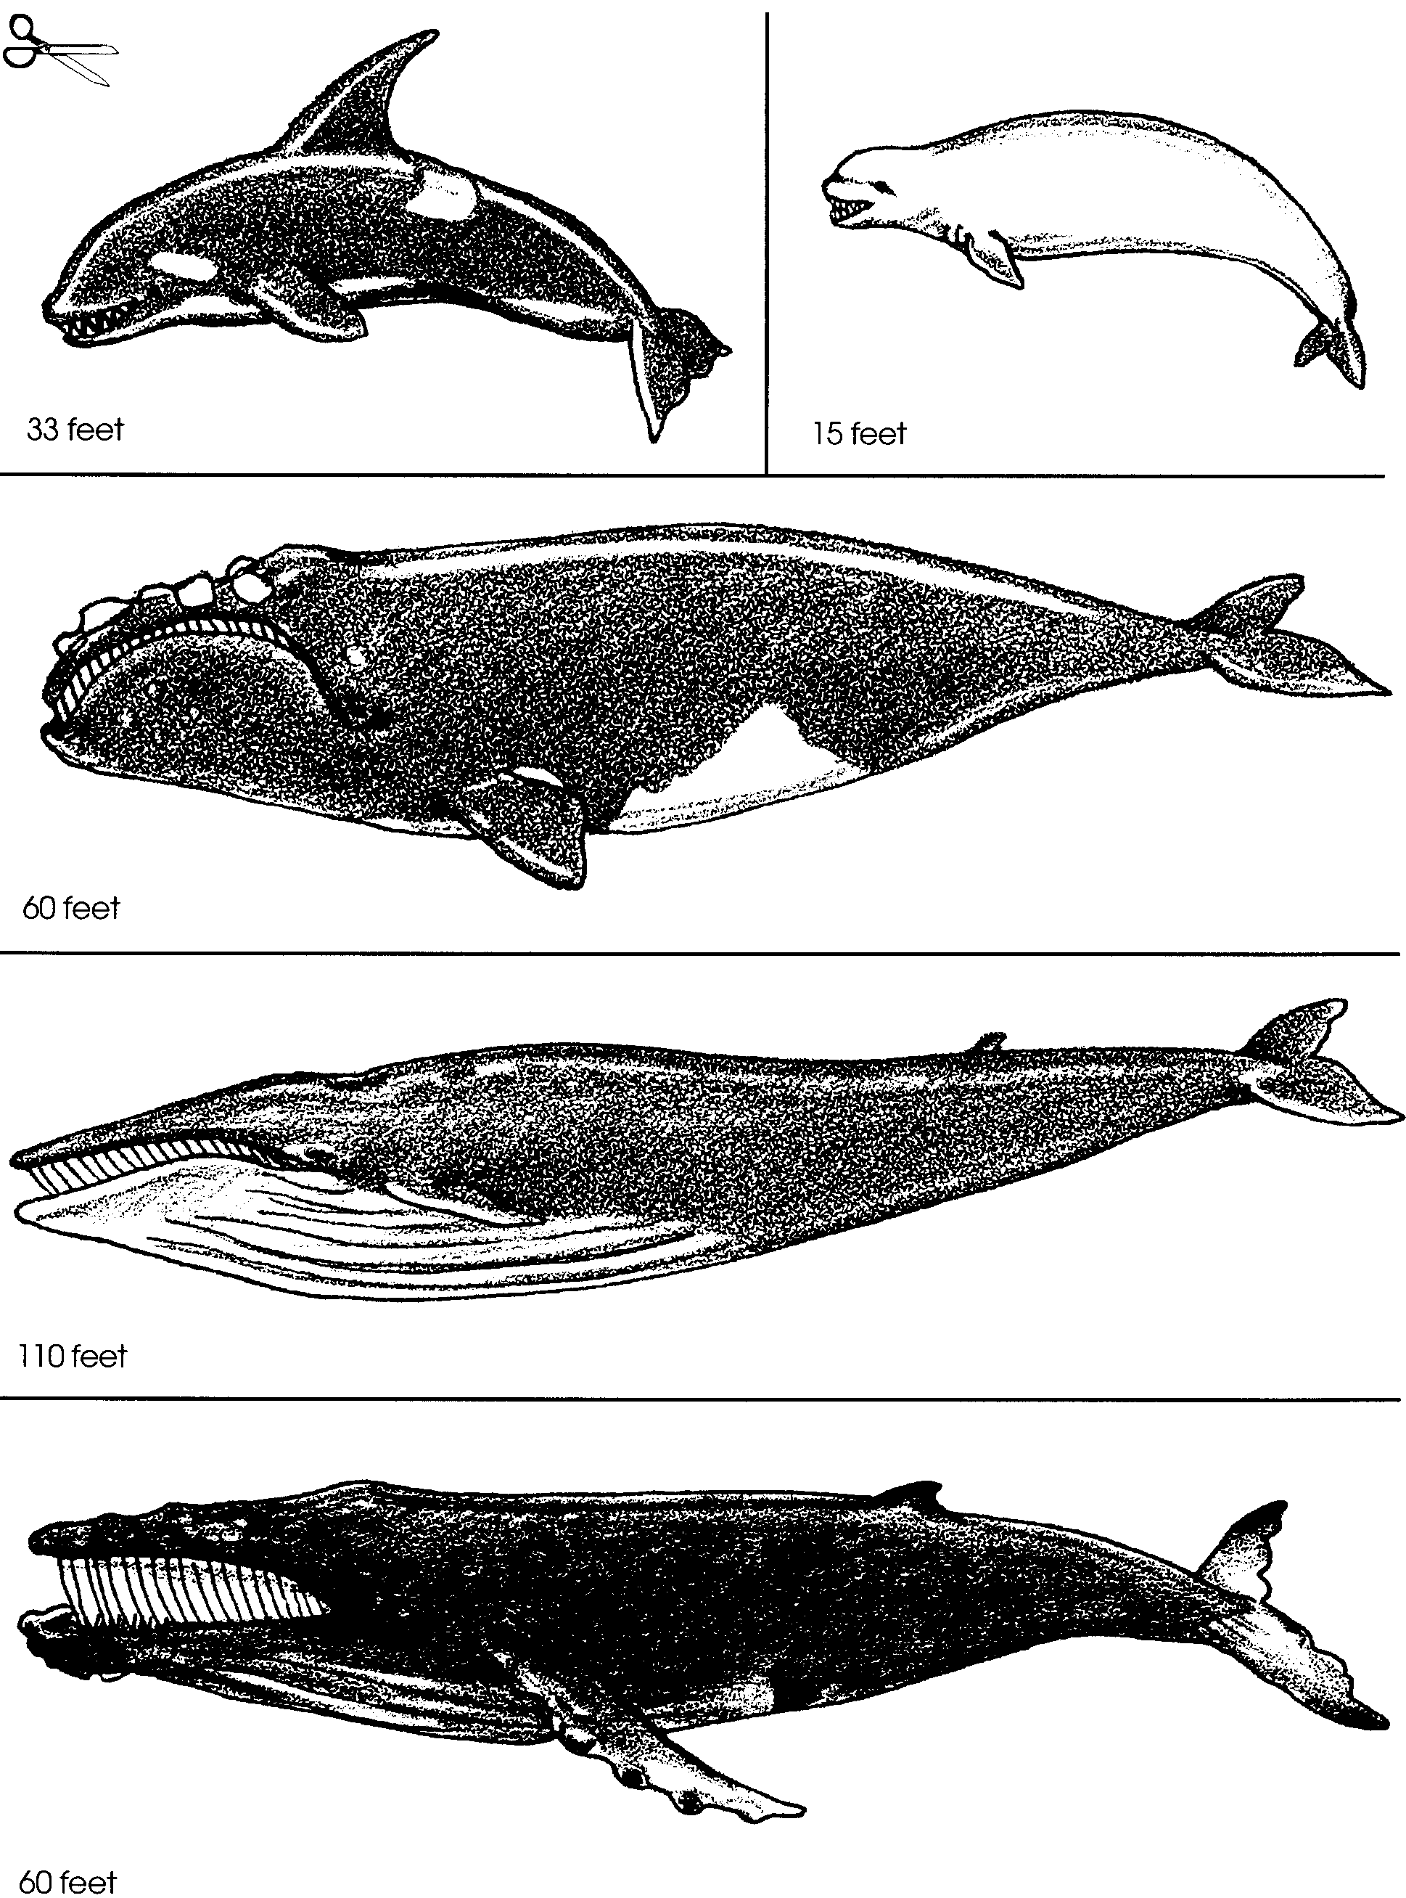
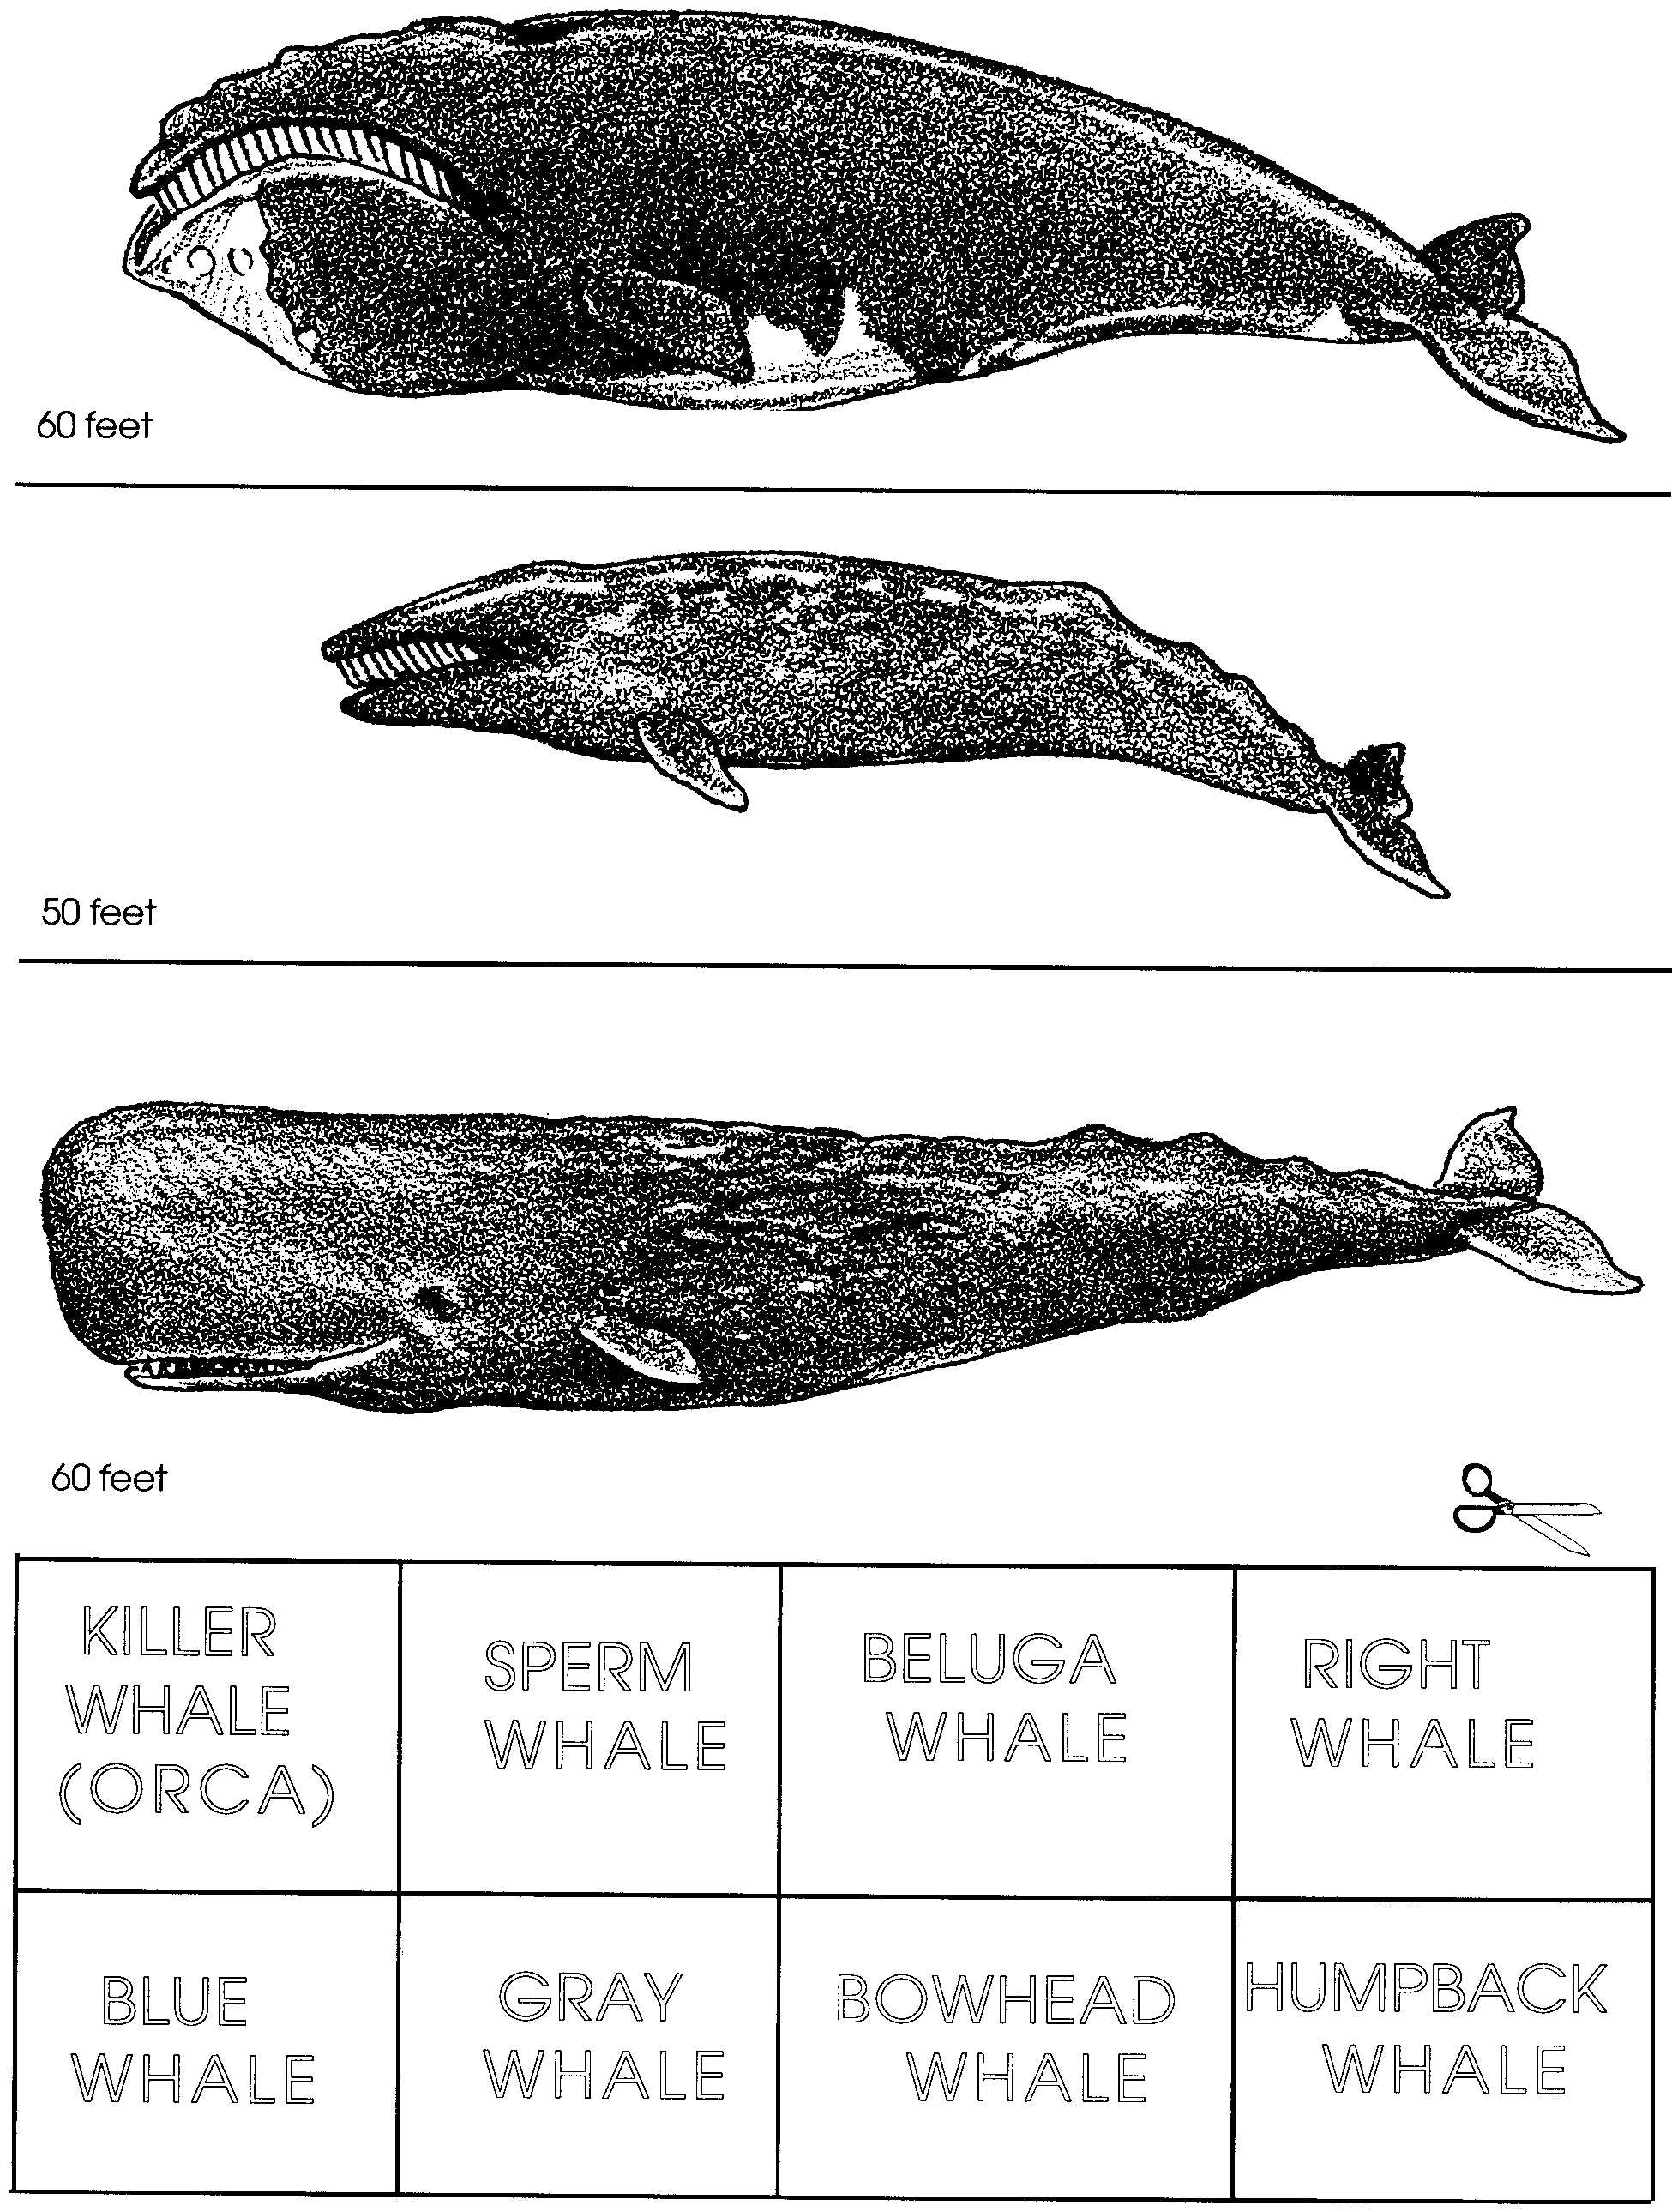

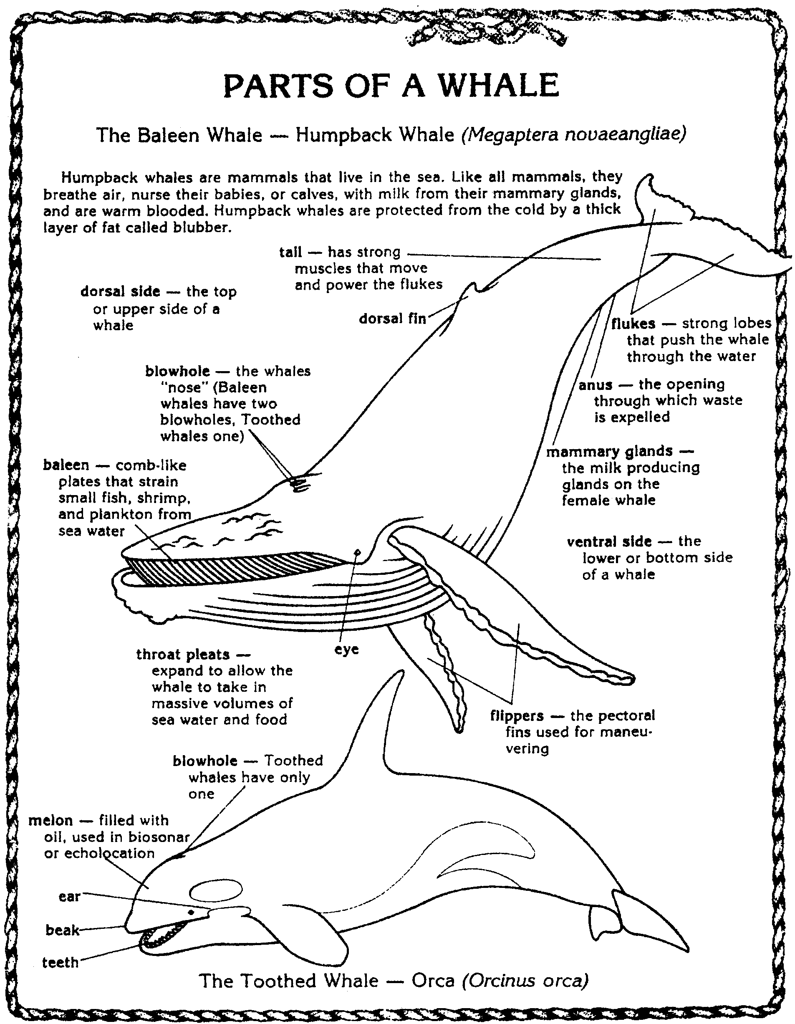

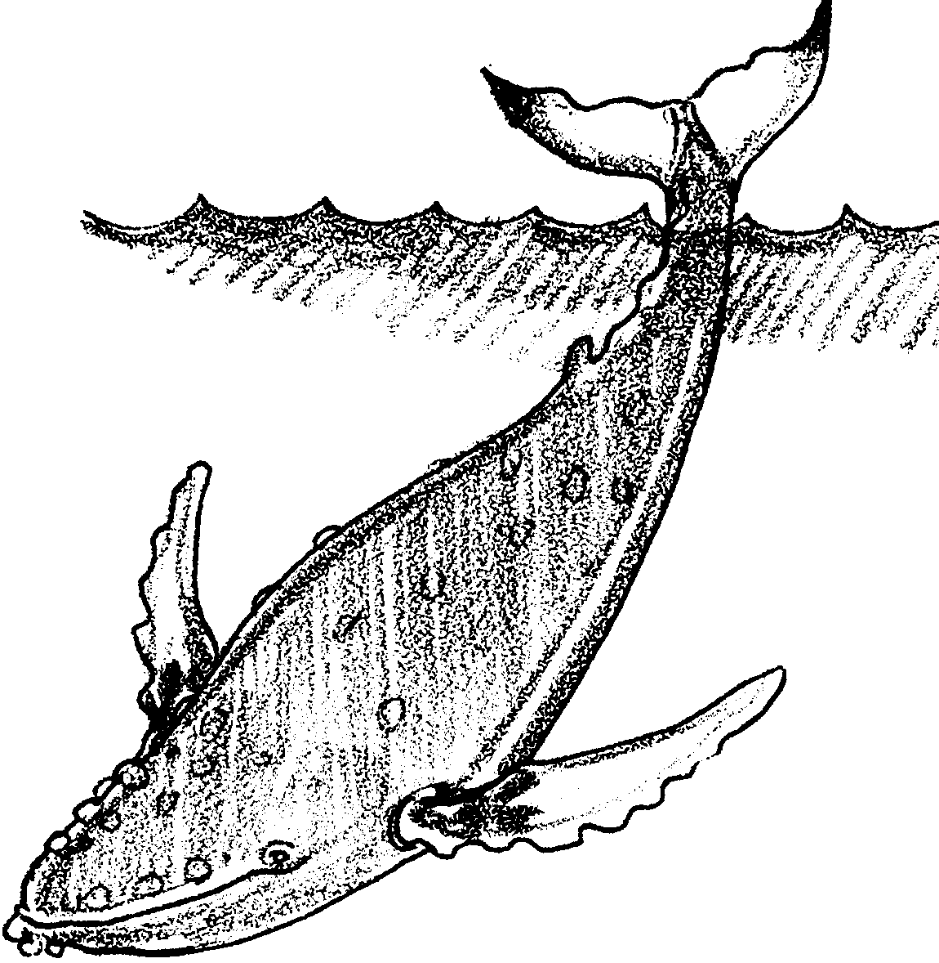
Name That Whale: Cetacean Key

There are lots of different kinds of whales. How can one person keep track of all of the names? To help, scientists put whales into groups based on similar characteristics. First they divide whales into two groups based on how they feed. One group, called toothed whales, contains 60 kinds of whales. Sperm whales, orca whales, dolphins and porpoises belong to this group. These whales have real teeth and eat fish and squid.

The second group is called baleen whales. These whales have no real teeth. Instead, they have two or three hundred flat plates growing from the upper jaw. The plates are called baleen. They are made of keratin, a material similar to human fingernails. On the inside of the mouth the edges of the plates form long bristles or strands. They look like the strands of a horse’s tail. The strands of baleen from the plates overlap forming a “hairy” mat. The mat works like a strainer to trap the food while letting the water flow through.

In the following activity, you will identify some of the whales within these two groups.

Materials
• scissors
• “Name That Whale Key” activity page
• whale picture set
• “Parts of a Whale” activity page

Procedure:

1. Get a whale picture set. Cut out each of the whales (this may have already been done for you).

2. Begin at the box labeled START. Read the clues in the box. Divide the whales based on the information in box number 1. (Hint: For this box, you’ll make two piles of pictures: one of all the toothed whales, another of all the baleen whales.)

3. Pick one of the piles. Go to the box shown by the arrow under the information in box one. (Hint: If you start with the toothed whales, go to box number 2. If you start with baleen whales, go to box number 7.)

4. Read the clues in box number 2 or box number 7. Do what the clues say.

5. Read the clues and follow the arrows. As you learn “who’s who”, put the picture of each whale next to its name.

6. Keep working until you have keyed out all the whales.

Summary Questions:

1. Which characteristics were helpful in identifying the whales?

2. a. Which whales were difficult to key?

b. How were they difficult?

3. What happened to the number of whale cut outs as you moved farther into the key?

4. Use the “Parts of the Whale” handout. What are two differences between toothed and baleen whales?

a.

b.

