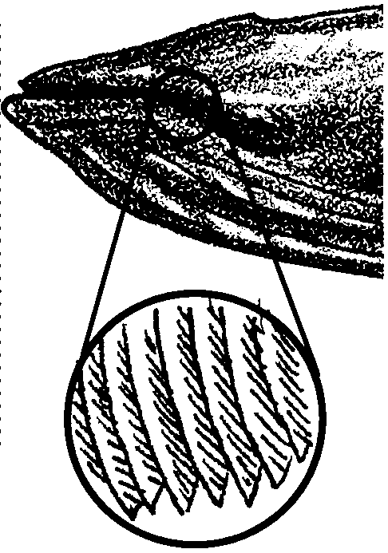
Baleen Strains

Key Concepts
1. Toothed whales and baleen whales are the major groups of whales.
2. Baleen is an adaptation that allows baleen whales to strain plankton out of the water.

Background

Whales make use of the food supplies in the sea in two different ways. In the first, they feed, mostly on squid and fish, by catching their prey one at a time. These whales have teeth and accordingly are called toothed whales. Sperm whales and orca whales are examples of toothed whales.

Members of the second group, called baleen whales, have no real teeth. Instead, they have parallel rows of stiff, brush-like plates called baleen to filter large quantities of small food animals (plankton) from the ocean water. The two or three hundred flat baleen plates set crosswise along the edge of the upper jaw and hang from it.

Baleen plates are fibrous and tough but flexible. They are made of keratin a material similar to human fingernails. On the inside of the mouth the edges of the plates are frayed into long bristles or strands resembling the strands of a horse's tail. The strands of baleen from adjacent plates overlap forming a “hairy” mat which serves as a strainer to trap the food while letting the water flow through.

Several different feeding strategies are found within the baleen whales. Some baleen whales skim at the surface, others “gulp” or bottom feed. Skimmers, like the bowhead or right whales, have long baleen plates (graduating up to 10 feet or more length). The skimmers feed by swimming at the surface with their mouths open. The plates, short in the front and long in the middle, passively trap the plankton as the water passes through.

Gulpers include the swift and active rorquals like the blue and humpback whales. These whales have long grooves or pleats on their throats. As they gulp in hundreds of gallons of water, their pleats expand like an accordion. When the mouth is full, muscles contract around these pleats and push the water out through the sides of their mouths. The strainer mats created by their three to four feet long baleen plates trap the plankton.

Unique among the baleen whales, gray whales are primarily bottom feeders (occasionally they “skim for their supper”). To feed, gray whales roll on their side and bite chunks out of the sediment. They then swish the sediment around to filter out the benthic organisms.

Materials

Part I

For each student:

• a small cup

• cake decorative sprinkles

• 1/8 teaspoon measure

• water

Part II

For each group of four students:

• paint brush

• pepper shaker

• 1/8 teaspoon measure

• tub, dishpan, or plastic shoebox

• water

Teaching Hints

In “Baleen Strains”, your students try to strain “food” out of the water with their own teeth and then with paint brushes. Since the first part of this activity which involves straining with teeth can get messy, you might want to conduct it outside.

Key Words

baleen - an elastic, hair like material growing in place of teeth in the upper jaw of certain whales and forming a series of thin, parallel plates used to strain food out of the water, also called whalebone

keratin - a protein material found in fingernails, baleen, hair, horns, etc.

Extensions

1. Have students research the number of baleen plates found in each species of whale and how large the whale mouths must be to hold them.

Answer Key

Procedure Questions

4.,5. Descriptions of successful strategies will vary.

Analysis and Interpretation

1. a. Answers will vary regarding success of using teeth as baleen.

b. Answers will vary regarding changes made.

2. a. Answers will vary, but hopefully the paint brush is better than their teeth.

b. Answers will vary regarding changes made.

3. Answers will vary regarding how to change the paintbrush so it could collect more pepper plankton.

4. Answers will vary but once the whales have the plankton in their baleen they use their tongue, saliva, and mucus to get it out.

5. Answers will vary but whales get the energy they need to live during the winter from the food they ate in the summer, stored as fat.

Food For Thought: Polar regions are rich in whale food (plankton) because of the long days and significant nutrient upwelling. (Most nutrients are on the bottom where decomposers are recycling the dead organisms that drift down.) Lots of nutrients, lots of light cause plankton blooms. On the other hand, very few nutrients are found in warm tropical waters because there is less mixing and upwelling of nutrients from below. In the tropics, a permanent layer of warm water at the surface resists the upward mixing of nutrients from below. (The FOR SEA activity “Ocean Currents” may be used to teach about water density differences and their affect on plankton blooms.)

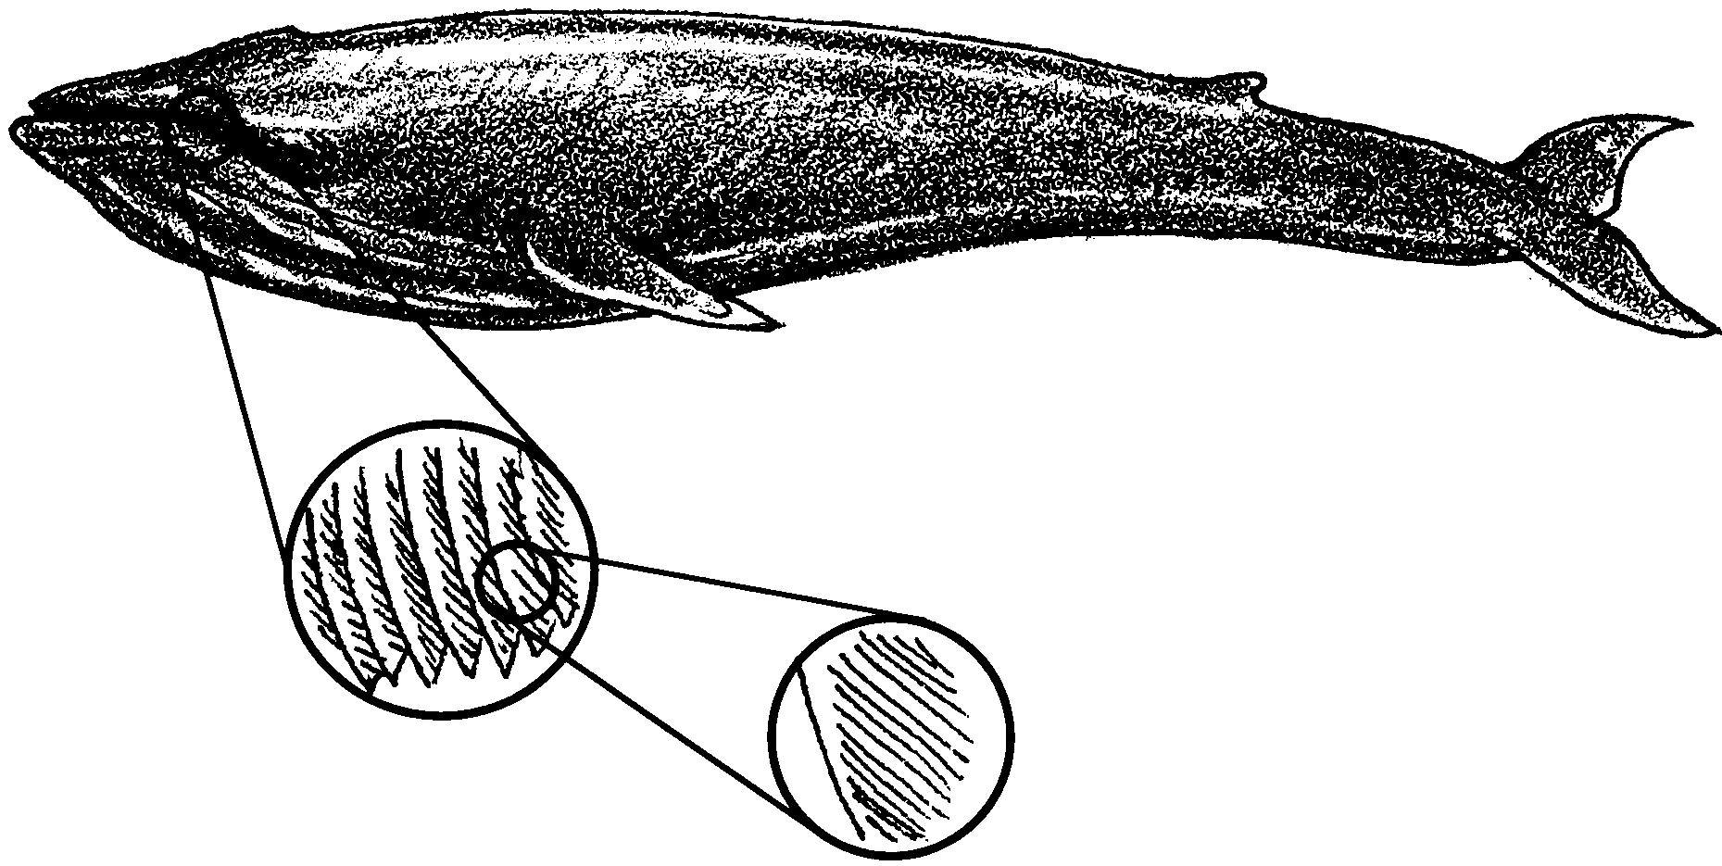
Baleen Strains

Scientists divide whales into two groups based on how they feed. One group eats fish and squid. They have teeth in their jaws and are called toothed whales. They catch their food one at a time. Sperm whales and orca whales are toothed whales.

Members of the second group have no real teeth. Instead, they have two or three hundred flat plates growing from the upper jaw. The plates are called baleen. They are made of keratin, a material similar to human fingernails. On the inside of the mouth the edges of the plates form long bristles or strands. They look like the strands of a horse’s tail. The strands of baleen from the plates overlap forming a “hairy” mat. The mat works like a strainer to trap the food while letting the water flow through. Baleen whales, as this group is called, strain large numbers of small food animals from the ocean water.

Baleen whales are the largest animals that have ever lived. The blue whale can reach 100 feet long. Even these giant baleen whales eat very small food. They filter small animal plankton out of the water. (Plankton are the drifting plants and animals of the sea.) They eat tons of shrimp-like krill, crab larvae, copepods, and small schooling fish. A single blue whale can easily eat a ton of food a day during the summer. In this activity you will see how baleen works.

Materials

Part I
• a small cup
• candy sprinkles
• 1/8 teaspoon measure
• water

Part II
• paint brush
• pepper shaker
• 1/8 teaspoon measure
• tub
• water

Procedure:

Part I - On Your Own:

1. Fill your cup with water and add 1/8 teaspoon of candy sprinkles.

2. Put some water from the cup in your mouth (DON’T SWALLOW!). Try to squish the water out between your teeth. What happens to the sprinkles?

3. Try different ways of trapping the sprinkles inside your mouth.

4. Describe your most successful method of extracting the sprinkles from the water.

Part II - With A Little Help From Your Group

1. Fill your tub with water.

2. Add 1/8 teaspoon of pepper to the water.

3. Use your paint brush to try and collect the pepper “plankton”.

4. Try different ways of trapping the pepper.

5. Describe your most successful strategy:
Analysis and Interpretation

1. a. How successful were you at using your teeth as baleen?

b. What changes did you make to improve your success?

2. a. How successful was the paint brush?

b. What changes did you make to improve your success?

3. How would you change the paintbrush so it could collect more pepper plankton?

4. Once the whales have the plankton in their baleen, how do you suppose they get it out? (Hint, how did you get it out of your teeth?)

5. In the summer, baleen whales feed in plankton rich polar waters. The whales spend the winter in the tropics. During the winter, they eat very little. Where do you think whales get the energy they need to live during the winter?

Food For Thought: Recall what you know about plankton. Why is there so much food for whales in the summer in polar regions? (Hint: What do the plant plankton need to grow?) Why is there not much food for whales in the tropics? (Same hint!)

