Whales and Food Chains

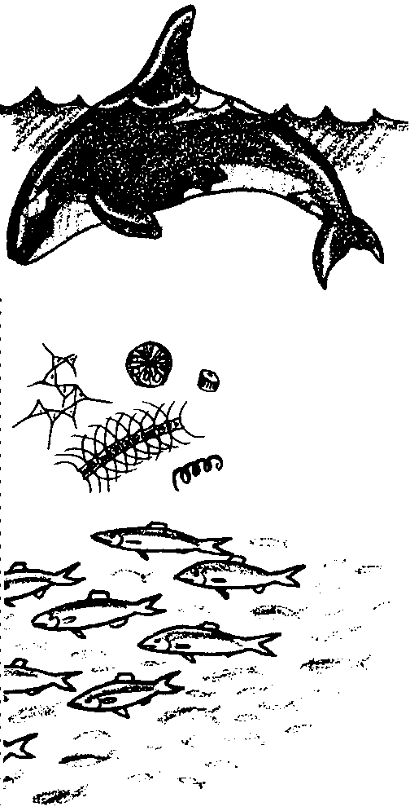
Key Concepts
1. Whales, descendents of land animals that returned to the sea long ago, have special adaptations to help them survive in the marine environment.
2. The movement of energy and matter from one organism to another in an ecosystem is often diagrammed as a food chain.
3. At each step in a food chain, only about 10% of the available energy is transferred to the next level; about 90% of the available energy is lost, much of it as heat energy.
4. Food chains interconnect to form food webs, which are an integral part of the ecosystem.

Background

Introduction to Marine Mammals

Marine mammals (whales, dolphins, sea otters, seals and sea lions) are a high interest topic for most students and many adults. They represent the descendents of land animals that returned to the sea millions of years ago. Marine mammals still breathe air and suckle their young, unlike most sea-dwelling animals. Their skeletal structures still bear the traces of a land existence. For example, the bones in a whales flipper as shown in the following diagram have five “fingers” similar to our hand.

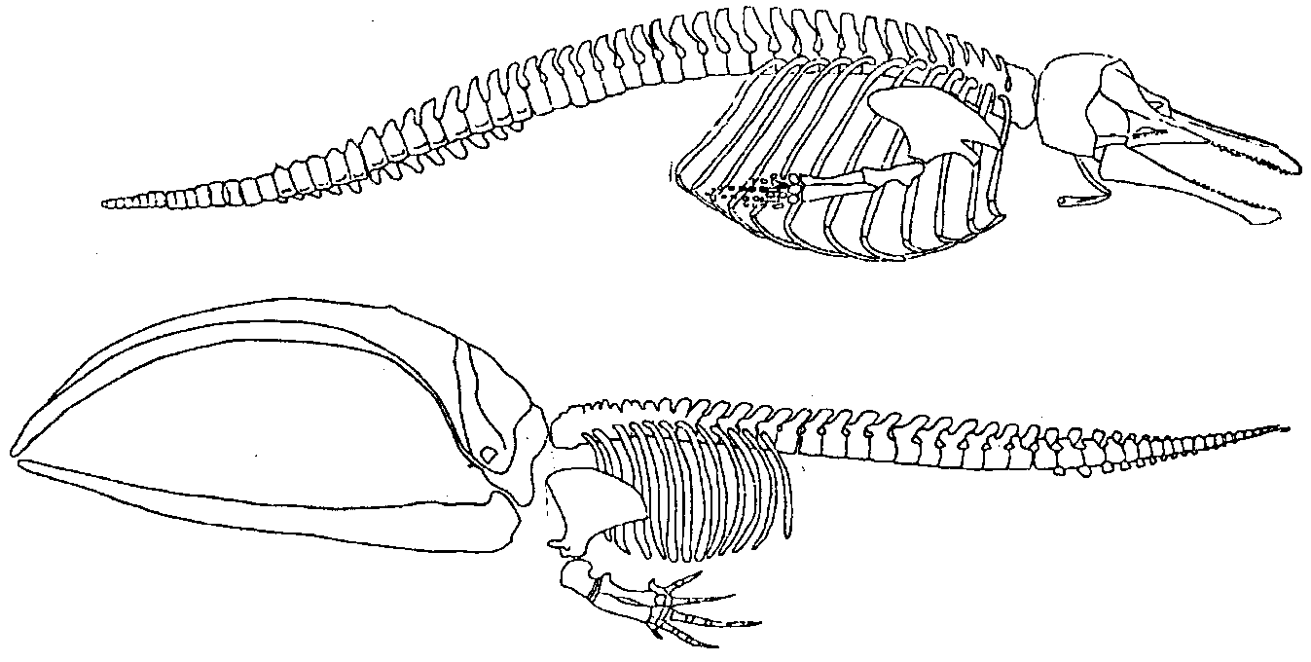
Part of the wonder of these creatures is their ability live in an environment that is hostile to other warm-blooded, air breathing animals. In terms of marine mammals, whales are the most completely adapted to an ocean existence. They do not have to return to land to give birth, as seals, walruses, sea lions do. They have adapted completely to their watery environment and can breathe, stay warm, give birth, and find food without returning to land. The following diagram highlights some of the external adaptations of whales.
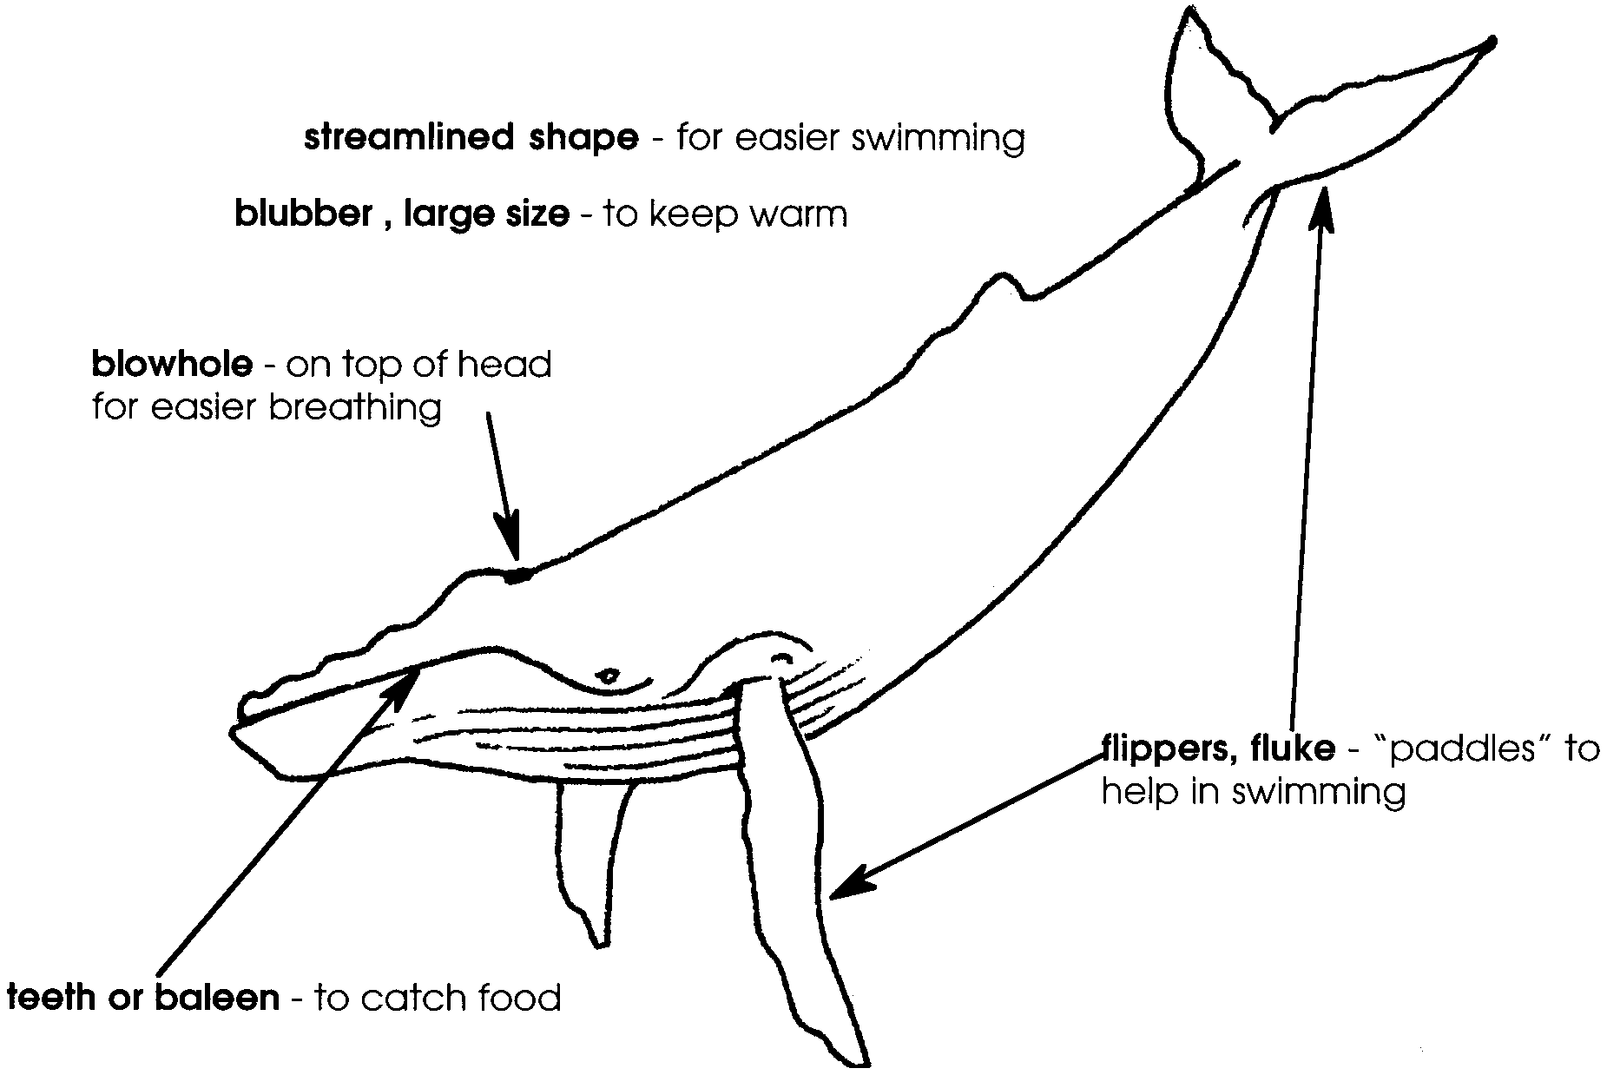
Scientists divide whales into two groups based on how they feed. One group, called toothed whales, contains sperm whales, orcas, and other predatory whales which have real teeth and feed primarily on fish and squid.

Members of the second group, called baleen whales, have no real teeth. Instead, they have parallel rows of fingernail-like material which forms strainers which they use to filter large quantities of small food animals from the ocean water.

Like all consumers, whales are dependent on their food source. For example, some baleen whales migrate great distances to feed on shrimp-like krill , energy rich members of the animal plankton. Their destination is the feeding areas of the cold, nutrient rich polar waters. The upwelling of deeper water and the long summer days fuel phytoplankton blooms in these areas. An abundance of phytoplankton means plenty of food for the consumers in the food chain.
The baleen whales gorge themselves in summer polar waters, building a reserve of calories to help them to survive the winter months in the nutrient and plankton poor tropical waters where they give birth to their young.

While toothed whales feed primarily on fish and squid, some orcas feed on other marine mammals (primarily seals). There is some evidence that marine mammal populations segregate on the basis of food preferences. For example the San Juan Islands in Washington state appear to support two distinct populations of orcas. One “race” of mammal-eating orcas (called the Transients) visits the islands. Another “race” of orcas (called the Residents) spends the majority of its time in the San Juan Islands and feeds on fish.

During each step in the food chain, only about 10% of the available energy is transferred to the next level. About 90% is unavailable to be passed on to the next level, much of it is lost as heat energy. (1st and 2nd Law of Thermodynamics, if you’re interested.)

Materials

For each student:

• “Whales and Food Chains” activity pages

Teaching Hints

Introduction

In “Whales and Food Chains” and the following five activities, your students will explore the role of toothed and baleen whales in the ocean food chain. They will use “baleen” to strain “food” from water and participate in simulated field identification of orca whales.

Many sixth graders know that whales are mammals as we are. They can even recite the features we share as mammals: hair, feed young with milk, warm blooded and air breathing. But your students may not understand what it takes for an air-breathing mammal to live in the sea.

One way to introduce the wonder of marine mammal adaptation to the ocean environment is by asking the following question:

“Whales are mammals just as we are. (Refer to list of mammal characteristics). So, why can’t WE live in the ocean and never come back to land? Suppose (name a student) jumped off of a ship and decided to live with the whales. What would he/she need to survive?”

Ask the students to work in small groups and come up with a list of “needs” for a human to live in the ocean. Follow with a discussion and listing on the board of student suggestions. Relate the needs a human would have to live in the ocean (e.g., breathing, keeping warm, swim easily, finding food) to ways that whales have adapted to meet those needs.

Whales and Food Chains

In “Whales and Food Chains”, your students will calculate the energy flow in a food chain that includes Killer Whales and baleen whales.

Discuss with your students the resident and transient groups of orca whales and their differences in diet. Resident orca whales feed on fish, while Transient orca whales eat seals.

As needed, refresh student memories regarding phytoplankton and zooplankton.

Key Words

biomass - the weight of all the living organisms in a particular area

diatoms - silica rich phytoplankton frequently connected together in chains

krill - shrimp-like zooplankton

phytoplankton - plant plankton; usually microscopic drifting plants of the water column

Resident - in this case, a race of orca whales that spends the summer in the San Juan Islands of Washington state feeding primarily on fish

Transient - in this case, a race of orca whales that spends part of its time in the San Juan Islands of Washington state feeding on other marine mammals

zooplankton - animal plankton; usually microscopic drifting animals of the water column

Extensions

1. Have students create their own marine food chain. Have them include humans and label primary producers, 1st, 2nd, and 3rd order consumers.

2. At the end of the lesson tell the class that an important aspect of energy transfer in a food web has been left out of the discussion. Ask the students to come back to class tomorrow with their ideas on what that aspect might be. Give them a hint: “When you are REALLY hungry, do you eat salad or steak?” (While it is true that 90% of the energy is lost at each step of the food chain, some food sources are more “energy-rich” than others. Animals higher on the food chain don’t have to eat AS OFTEN because their food (meat) is densely packed with energy in the form of fat.

Answer Key

1. a. 10 pounds of seal are needed to make one pound of a Transient killer whale.

b. 200 pounds of seal are needed to make 20 pounds of a Transient killer whale.

c. 20,000 pounds of seal are needed to make one ton of a Transient killer whale.

d. 200,000 pounds of seal are needed for an orca to reach 10 tons.

2. 1,400,000 pounds of fish are needed for a 7 ton female Resident killer whale.

3. a. 1,000 pounds of krill are needed for 100 pounds of blue whale.

b. 3,040,000 pounds of krill are needed for a 152 ton blue whale. (i.e. 152 tons x 2,000 lbs/ton = 304,000 lbs. 304,000 lbs. of blue whale x 10 pounds of krill/lb of whale = 3,040,000 pounds of krill)

4. a. When a human eats salmon, he/she becomes a third order consumer.

b. 100 pounds of fish are necessary to make one pound of student.

c. Answers will vary regarding pounds of fish needed at present weight but the answers are found by multiplying present weight by 100.

5. a. Answers will vary. A fisher might get upset with whales because of the large quantity of fish they consume.

b. Answers will vary. Most will think the whales have a reason to get upset with the fisherman because of the large quantity of fish they remove from the water.

c. Answers will vary regarding proposed solutions to resolve the conflict.

6. Decomposers should be added to the student’s food pyramid.

Whales and Food Chains

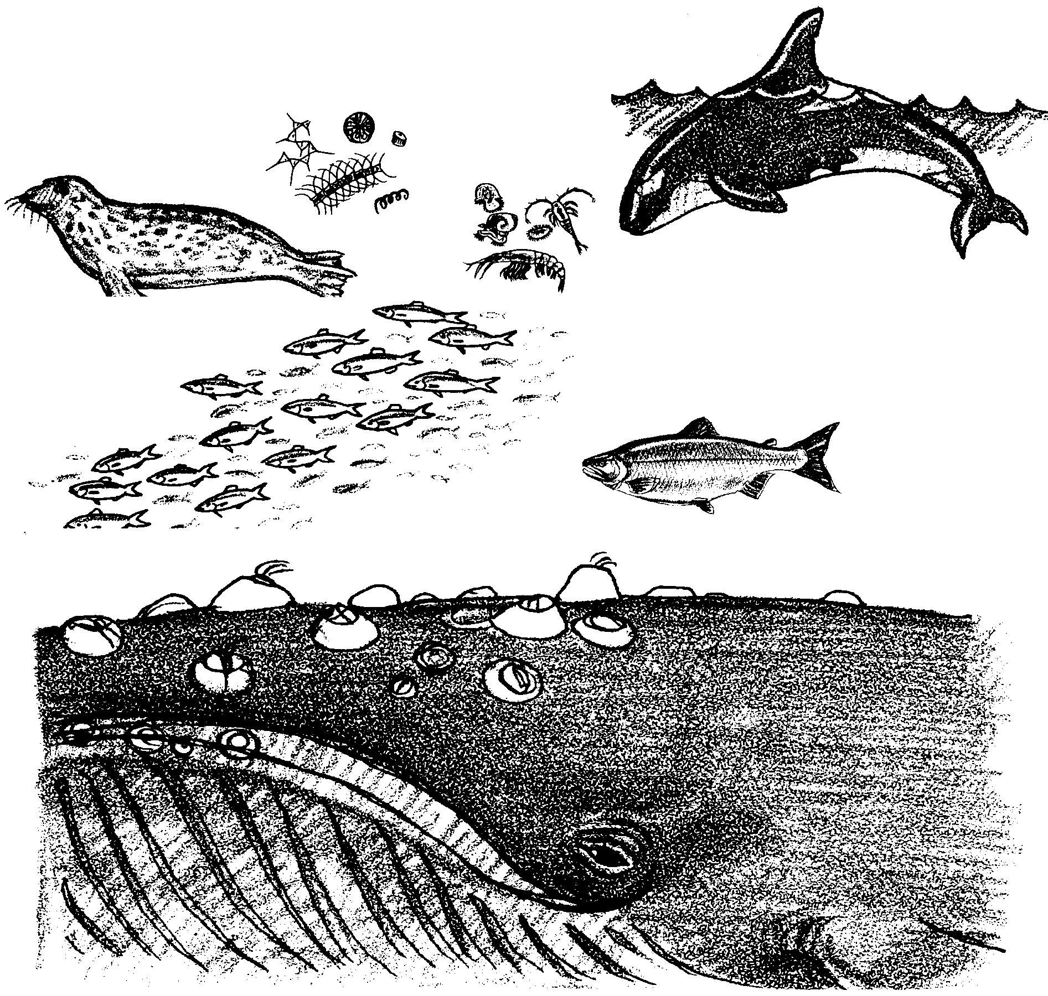
Plants and animals depend upon each other and their environment for the things they need to live. One of the basic needs for all animals is food. Some of the biggest animals in the sea eat some of the smallest. Life in the oceans begins with phytoplankton, drifting plants. Most phytoplankton are very small. Phytoplankton use carbon dioxide and water, plus energy from the sun, to grow. A single liter of sea water may contain millions of phytoplankton.

The zooplankton, or drifting animals, eat phytoplankton and each other. Practically all life in the sea depends directly or indirectly upon phytoplankton and zooplankton. The relationships of who eats whom form food chains. The chains join to form food webs.
Green plants are often called “producers”. They are the “food makers” or producers in most ecosystems. Some animals eat green plants directly. These animals are called “first order consumers”. They are the “first” to get energy from the green plants. Other animals eat the animals that ate the plants directly. They are called second order consumers. Many ecosystems will have third and fourth order consumers as well.

Through feeding, the energy and matter move from one organism to the next. This movement is often shown as a food chain. Not all of the energy is available to transfer to the next level in a food chain. Some energy is lost at each step in a food chain. In fact, 90% of the energy is used or lost at each level in a food chain. Only 10% of the energy found in one level is available to the next level.

Use the “Biomass Pyramid” to answer the following questions about food webs. Please show all of your work.

1. a. How many pounds of seal are needed to make one pound of a Transient killer whale?

b. How many pounds of seal are needed to make 20 pounds of a Transient killer whale?

c. How many pounds of seal are needed to make one ton of a Transient killer whale? (Hint: There are 2,000 pounds in one ton)

d. An adult male Transient orca can weigh up to 10 tons. How many pounds of seal are needed for an orca to reach this weight?

2. Resident killer whales feed mainly on fish. How many pounds of fish are needed for a 7 ton female Resident killer whale?

3. a. Blue whales feed on krill, a small shrimp-like organism. How many pounds of krill are needed for 100 pounds of blue whale?

b. A blue whale can weigh 152 tons. How many pounds of krill are needed for a 152 ton blue whale?

4. a. When you eat salmon, what order consumer are you?

b. How many pounds of fish are necessary to make one pound of you?

c. How many pounds of fish do you need at your present weight?

5. a. Why might a fisher might get upset with whales?

b. Fishers can easily take 2,000 pounds of fish in one catch. Do you think the whales might have a reason to get upset with the fisherman? Why?

c. What would you propose to resolve this conflict?

6. One important part of the food web is missing in the pyramid. Animals and plants called decomposers are also found in all ecosystems. Decomposers feed on dead plants and animals. They return the raw materials of life such as minerals and water to the soil. Add decomposers to your food pyramid.

