Bathymetric Mapping
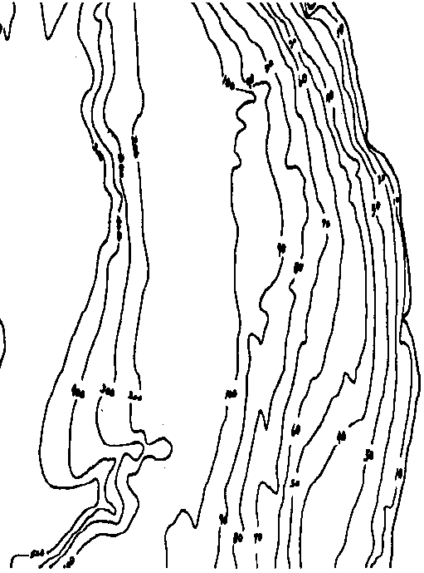

Key Concepts
1. The floor of the ocean is made up of hills, plains, ridges, trenches, and seamounts.
2. Natural features on the earth, such as mountains and valleys, can be represented on a two-dimensional map.
3. Geologists and oceanographers use maps of the sea floor as tools.

Background

Oceanographers have discovered the shape of the ocean floor by measuring the depth of the ocean in many places. From such depth readings, scientists gradually built a picture of the ocean floor they could not see. This information was presented in the form of maps.

Maps catalog and display a wealth of information. On land, topographic maps provide an image of the shape of the land. At sea, bathymetric maps provide an image of the bottom of the oceans. Turning three dimensional objects like mountains or guyots into accurate two-dimensional representations on a map is a complicated process involving many steps.

Information on topographic maps as well as demonstration models can be obtained from:

U. S. Geological Survey
Education Office
345 Middlefield Road
Menlo Park, CA 94025
(415) 329-4006

Information on bathymetric maps can be obtained from:

National Ocean Service
1315 East West Highway
Silver Spring, MD 20910

Materials

For each student:

• “Bathymetric Mapping” Maps 1, 2, 3

• “Ocean Floor” drawing (from preceding activity “Measuring the Ocean Depths”)

• pencil

Teaching Hints

“Bathymetric Mapping” gives your students an introduction to the creation and utilization of topographic maps and is a logical extension of the preceding activity entitled “Measuring the Ocean Depths”. The activity culminates with a “self-check” of sorts in which Map 3 can be used to evaluate the success of the activity. If done properly, a dolphin fish will appear.

Duplicate the activity. Each student should have a set of materials. Although this activity is best performed on an individual basis, some pooling of results can be helpful.

The maps your students construct will be simple but useful. Supplement their efforts with a display of bathymetric maps, topographic maps, and navigation charts (available from the National Ocean Service and the U.S. Geologic Survey, or through marine and sporting goods stores).

Key Words

bathymetric - measurement of the depths of the oceans; also the data derived from such measurement, especially as compiled in a topographic map

contour line - a line joining points of equal elevation or depth on a surface or the representation of such a line on a map

interval - in this sense, the change in elevation between two contour lines

sounding - measuring water depth

Answer Key

1. Answers will depend upon the location of the features selected for labeling. There are several possibilities.

2. Answers will vary depending upon student prior knowledge. The geologic formations were probably found by sounding the depths and recording the figures. From the data, charts were prepared.
3. As skipper of the Mary Kay, you would want to study a chart to keep from running aground and to keep from getting your fishing gear stuck on the bottom.

4. a. Answers will vary depending upon differences observed between the two maps.

b. Differences between the two maps may be due to practice or, perhaps, the professionals had additional information that was not provided to the students.

Bathymetric Mapping

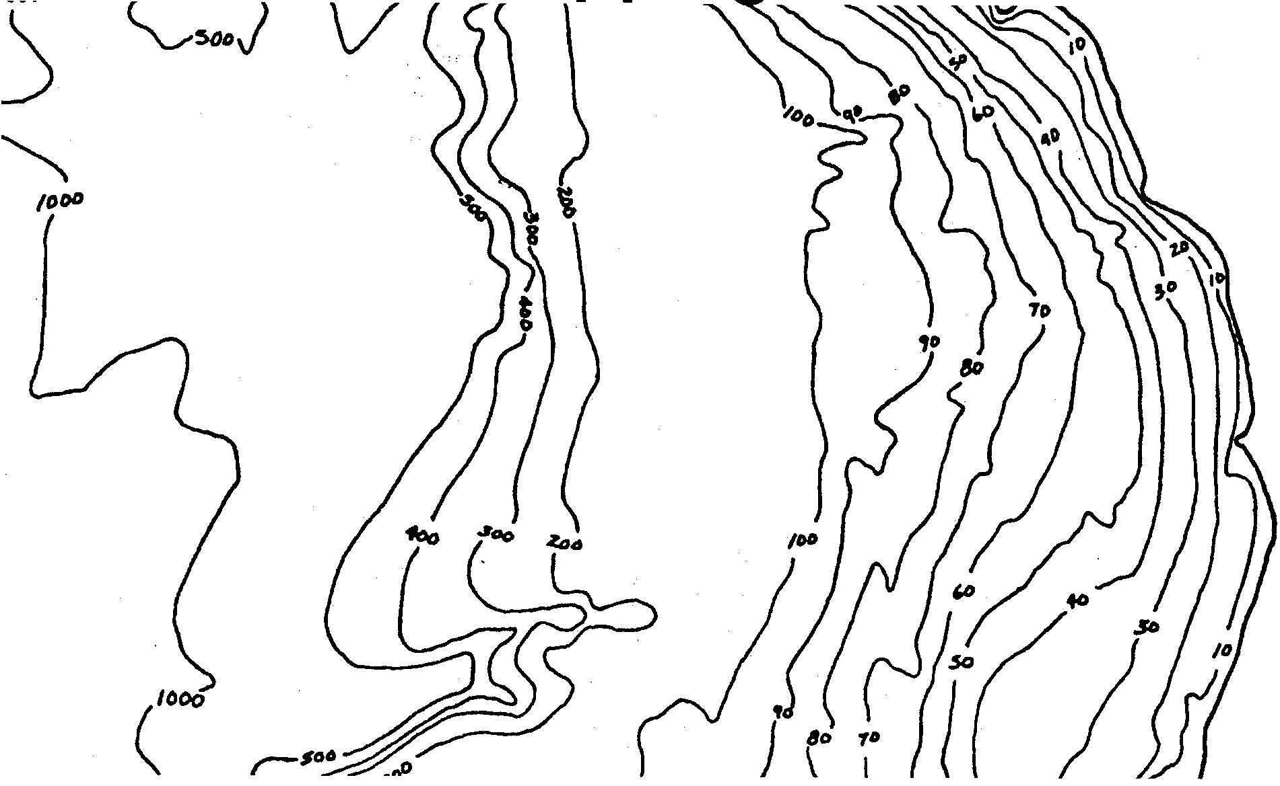
The activity “Measuring the Ocean Depths” let you see how the information to make bathymetric maps is gathered. In this activity the National Oceanic and Atmospheric Administration has done all the work for you. All of the soundings are made. All you have to do is draw the contour lines to connect places of similar depth.

Materials
• maps 1, 2, 3
• “Ocean Floor” activity page
• pencil

Procedure:

Map 1 - Cape Blanco to Cape Sebastian

1. Find Map 1. Connect areas of equal depth with pencil lines. See the diagram below.

Connect the depths in this way:

a. From zero depth to 100 meters the interval between contour lines next to each other is 20 meters. Begin by connecting the 20 m marks with a continuous line. Draw additional lines at 40 m, 60 m, 80 m and 100 m.

b. From 100 meters depth to 500 meters, the interval between adjacent lines is 100 meters. Draw equal depth lines at 200 m, 300 m, 400 m, and 500 m.

c. Connect the 1000 foot contour.

REMEMBER: Equal depth contour lines never cross each other!

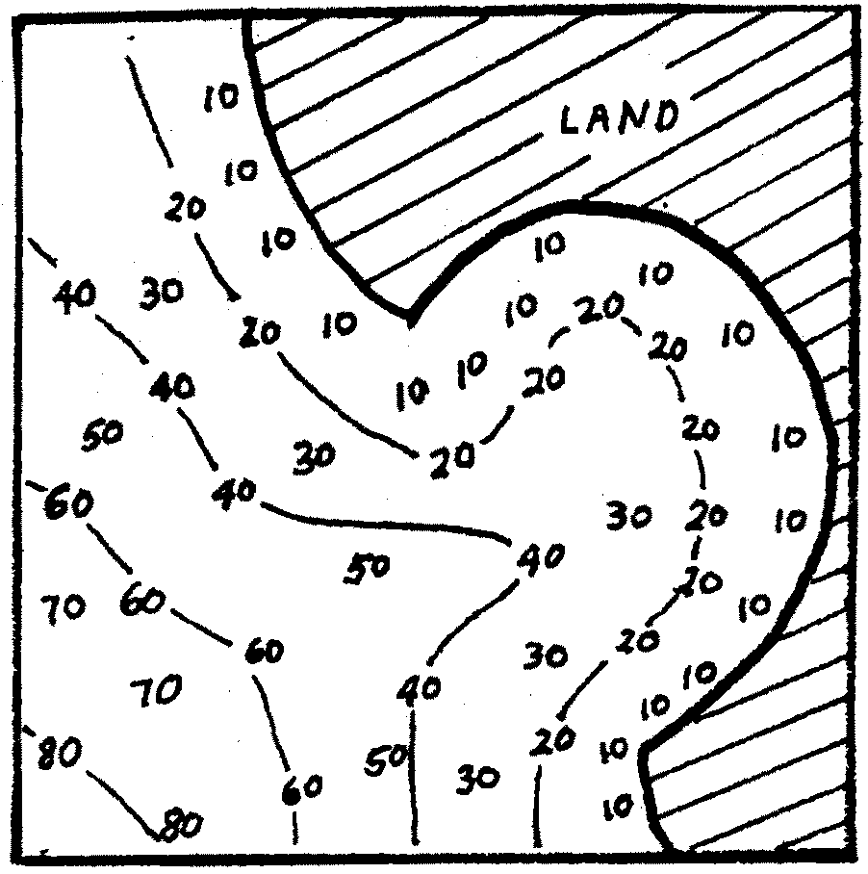
sample:

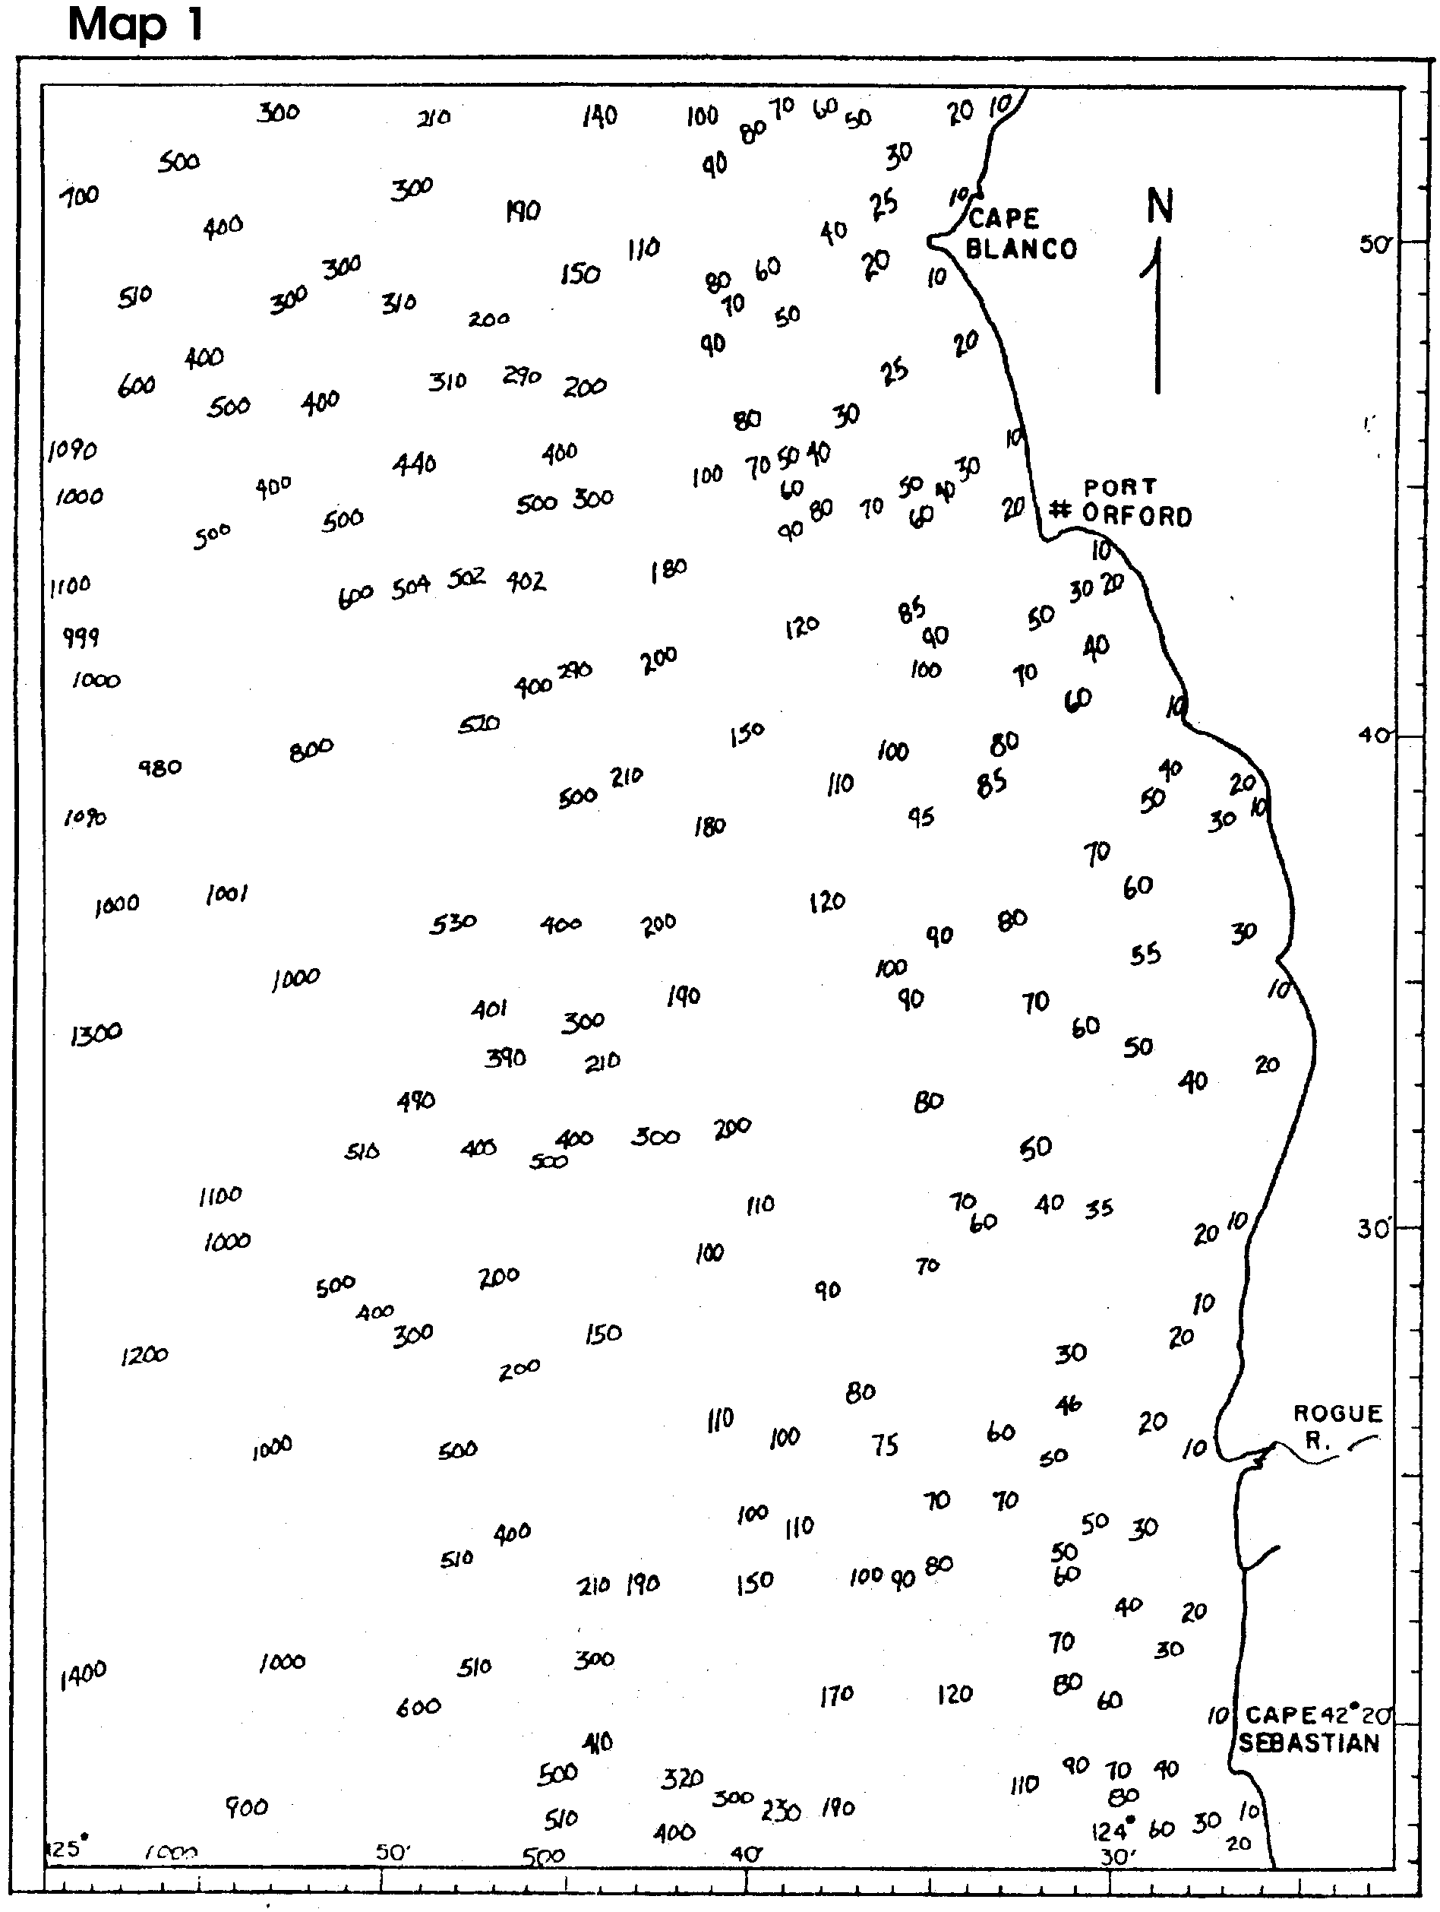

Map 2 - Completed Cape Blanco to Cape Sebastian

1. Map 2 is a map of the area drawn by ocean scientists. Compare your map with map 2.
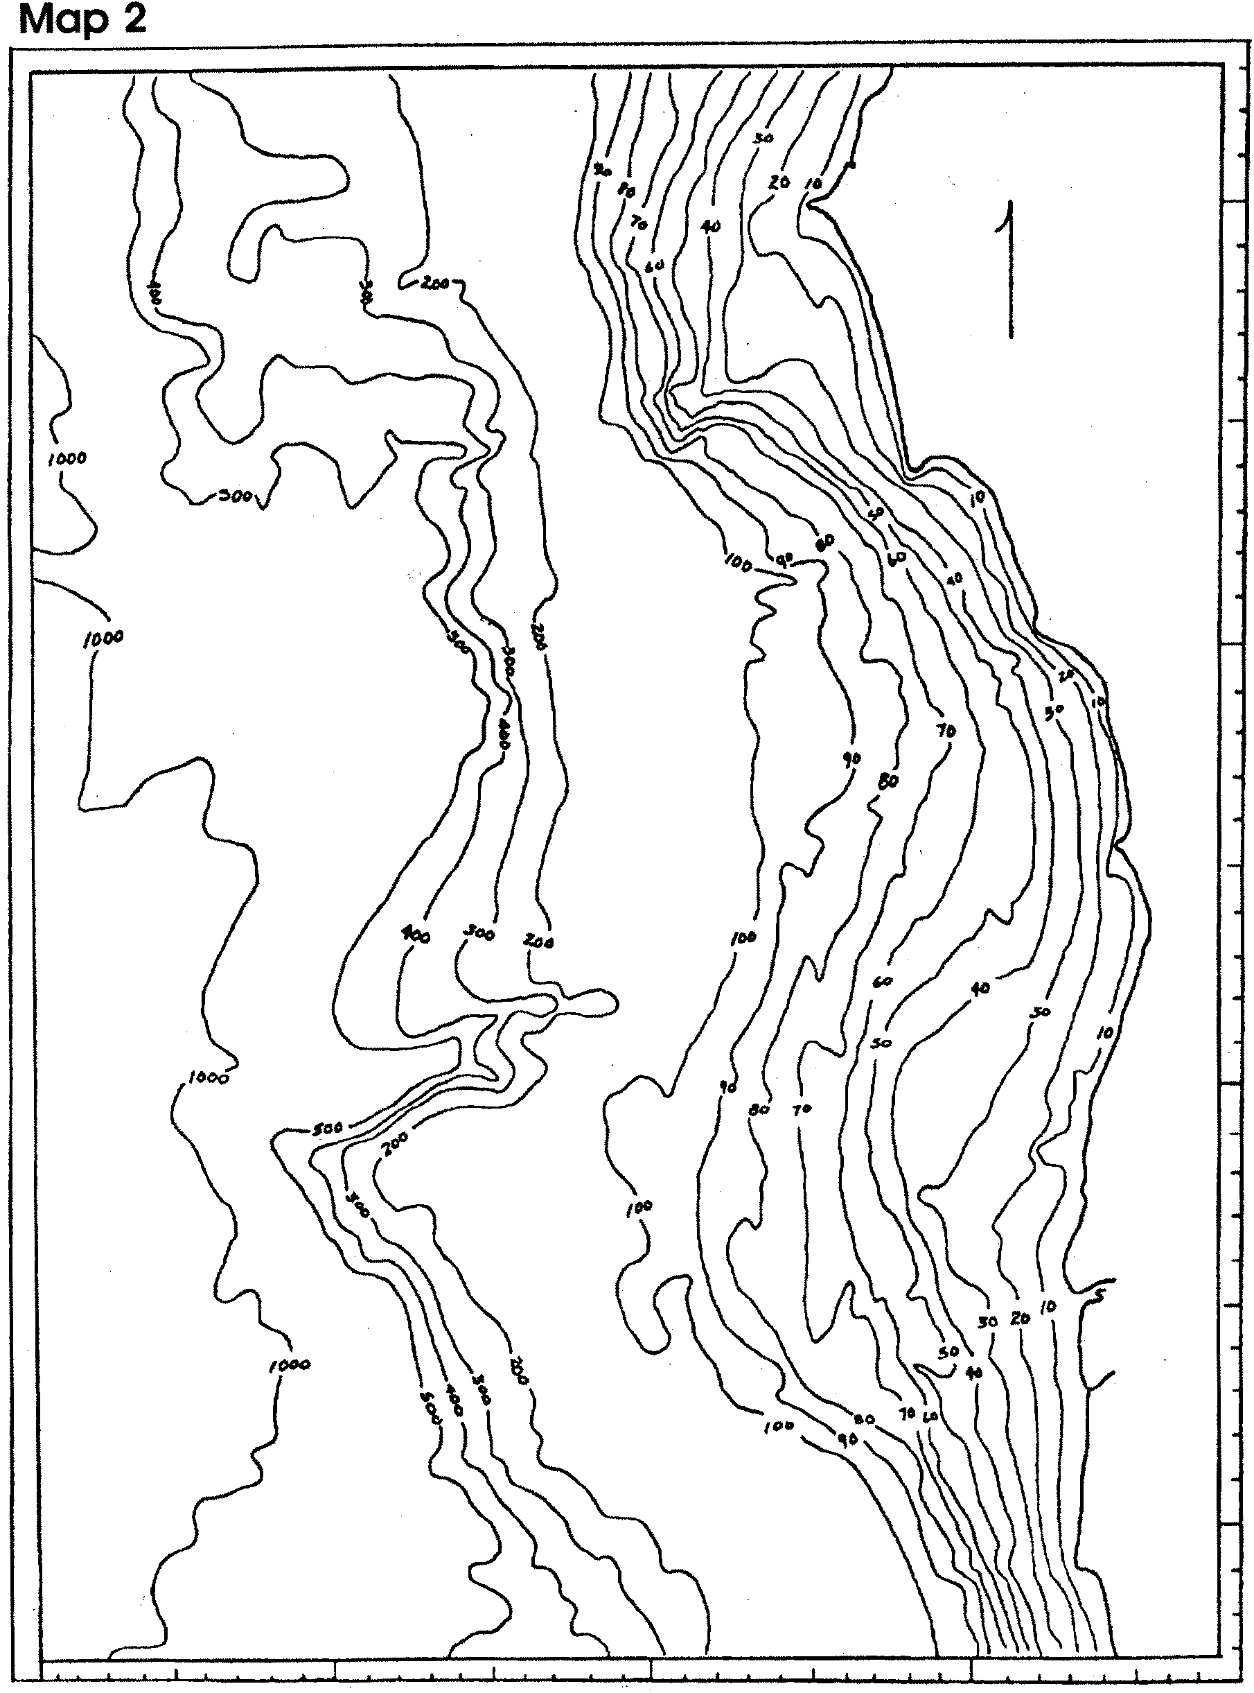

Analysis and Interpretation

1. Study your map and label the following things:
a. the continental shelf
b. the continental slope
c. a submarine (underwater) canyon
d. a seamount (underwater mountain)
e. the abyssal plain

2. How might the geologic formations (mountains, canyons, etc.) shown on your map have been found?

3. Suppose you are the skipper of the Mary Kay, a salmon troller. You hear of good fishing near Cape Blanco and head for the area. What are two reasons you would want to study a bathymetric chart before you begin fishing?

a.

b.

4. a. How is map you drew different from the map drawn by professionals?

b. How can you account for the differences?

Map 3 - Mystery Area

1. Plot the equal depth contours for 2 m, 4 m, and 6 m. Connect areas of similar depth with a pencil line. Remember not to cross any lines.
