Measuring the Ocean Depths
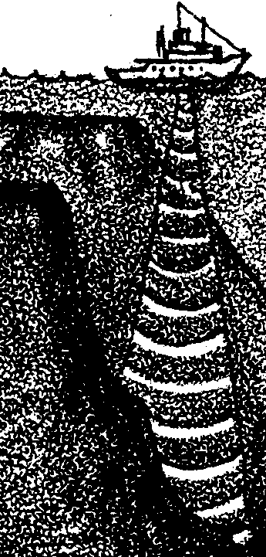

Key Concepts
1. Ocean floor features can be determined by probing in a regular pattern.
2. Modern oceanographers use sonar as the “probe”.

Background

The floor of the ocean has always been “out of sight” for us as land dwellers. In years past, the depth measurements which led to guesses about ocean floor topography were made using a weighted line. The line was dropped over the side of a ship and lowered until it stopped. Sometimes the lead on the end of the line might hit something that would make an impression in the lead and give the sailors an idea of what was “down there”. Imagine how tedious and time-consuming it was to let out thousands of feet of line. Once the depth was recorded, all of that line had to be pulled in again!

Additional background information is found in the preceding activity entitled “What’s That Sound?”.

Materials

For each pair of students:

• shoe box with lid

• 500 ml flour (250 ml = 1 cup)

• 500 ml salt

• 250 ml water

• plastic soda straw or bamboo skewer

• graph paper (1 cm)

• felt-tipped pen

• ruler marked in centimeters

• pencil, drawing compass for making holes in lid

Teaching Hints

In “Measuring the Ocean Depths” students use bamboo skewers to probe the topography of a shoebox ocean that they have built. They then use this information to create a bathymetric map. This activity provides an opportunity for a 3-D experience with ocean floor features. It also provides practice in graphing and point plotting. Although this activity can be a bit messy, the rewards are worth the spilled flour and paper clippings on the floor.

“Measuring the Ocean Depths” is best accomplished by pairs, but the use of larger groups is possible. It is also possible for individual students to complete the activity.

The student procedure suggests the use of baker’s dough for modeling the ocean floor. Other materials suggested for saving you time in class include modeling clay, play dough, plaster of Paris. Another option for model construction is to use cardboard, cups, spools, small boxes, etc., to form the ocean floor features. These items can be brought from home by the students and taped or glued into the box. Ask the class to think about what they could bring to build their ocean models. Regardless of the materials used, caution your students to keep their models simple.

Shoe box oceans may be exchanged within the class or between classes. Both techniques have merit. Use the one that best suits your particular circumstances.

The second day activities provide the major learning experiences. The mechanics of the second day activities are simpler than the directions might seem to indicate. You can minimize problems by a brief introductory demonstration. Have a completed box available as a model. Choose a technique for punching the holes in the grid that will not result in injury to your students. Make holes large enough so markings on the probe (straw or bamboo skewer) will not rub off. Allow time for a discussion of the procedure and to provide answers to the questions posed in the activity. Arrange to display your students’ shoebox oceans. Be sure the models are labeled with student names and with the names of the ocean features shown.

Key Word

sounding - measuring water depth

Answer Key

1.-2. Answers depend upon the features present in the shoe box ocean. In spite of what most of your students may feel, they could indeed have missed a feature. If the feature ran between the sampling points it could have been missed.

3. Small and/or long, thin features would be the easiest to miss.

4. a. A long stick calibrated in some convenient units could be used to measure the depth by simply poking the stick straight down until it reaches the bottom. The depth is read at the intersection of the water surface and the stick. Earliest soundings employed this technique. The technique was quickly modified by substituting a weighted line for the stick.

b. The major disadvantage of using a probe involves the length of the probe. A 5000m long probe could be a bit unwieldy.

5. Two alternative ways to get information about the bottom of the ocean include: sounding with a rope or cable, echo-sounding or sonar, and/or visiting it in a submersible. Your students may have other, more creative alternatives.

6. A probe with a hollow end (like the soda straw used in the activity) could be driven into the surface to determine the bottom composition.

7. a., b. Answers depend upon the experimental results.

8. The simplest way to obtain a better picture of the bottom would be to poke more holes and make more profiles.

9. Early oceanographers obviously did not obtain a completely accurate picture of the ocean floor. The fact that a single sounding might take the better part of a day underscores the problems encountered before the advent of electronic depth finders.

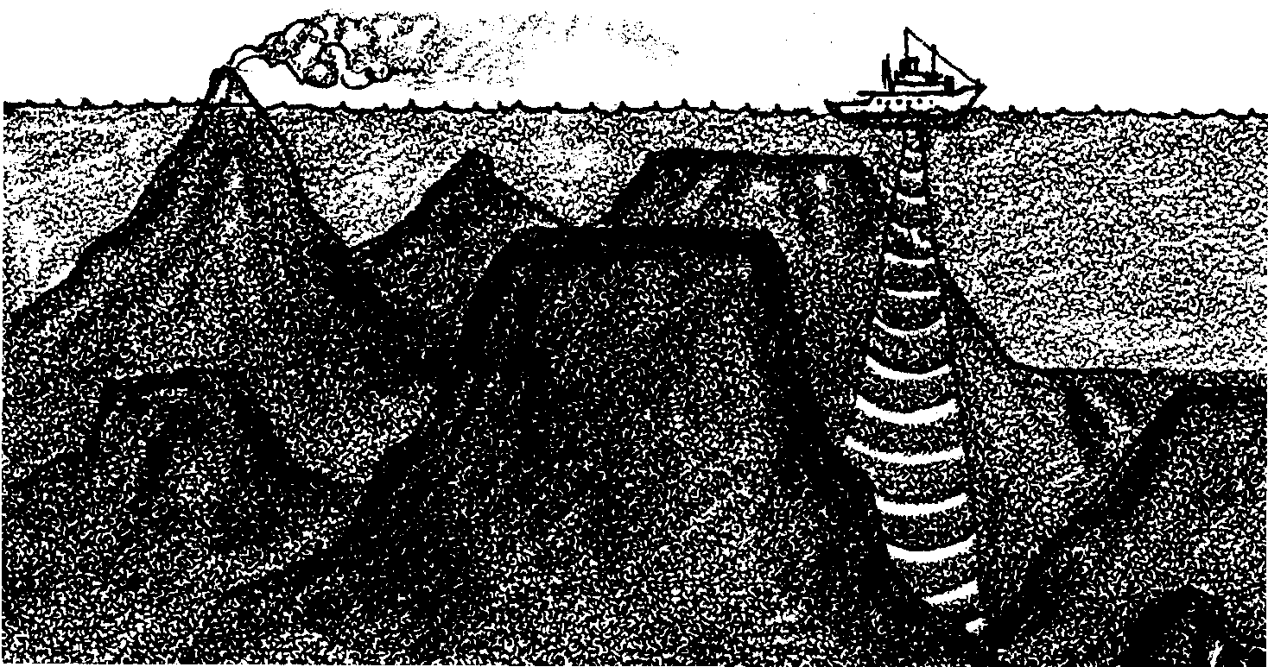
Measuring the Ocean Depths

Oceanographers have discovered the shape of the ocean floor by measuring the depths of the water. Because of the great depths, these oceanographers can not see the bottom where they are working. They have to sense the bottom by “feel”. In the following activity you will make and exchange a shoe box ocean. Using a probe you will then “sound” the depths of your unknown ocean and make a bottom profile. The next page shows some of the landmarks you might see on the ocean floor.

Materials
• shoe box with lid
• flour, 500 milliliters (ml) *
• salt, 500 ml
• water, 250 ml
• mixing container (eg. 2 pound coffee can)
• plastic soda straw or bamboo skewer
• graph paper
• felt-tipped pen
• ruler marked in centimeters (cm)
• pencil, compass or scissors
• scissors
• glue or tape

*250 ml = 1 cup

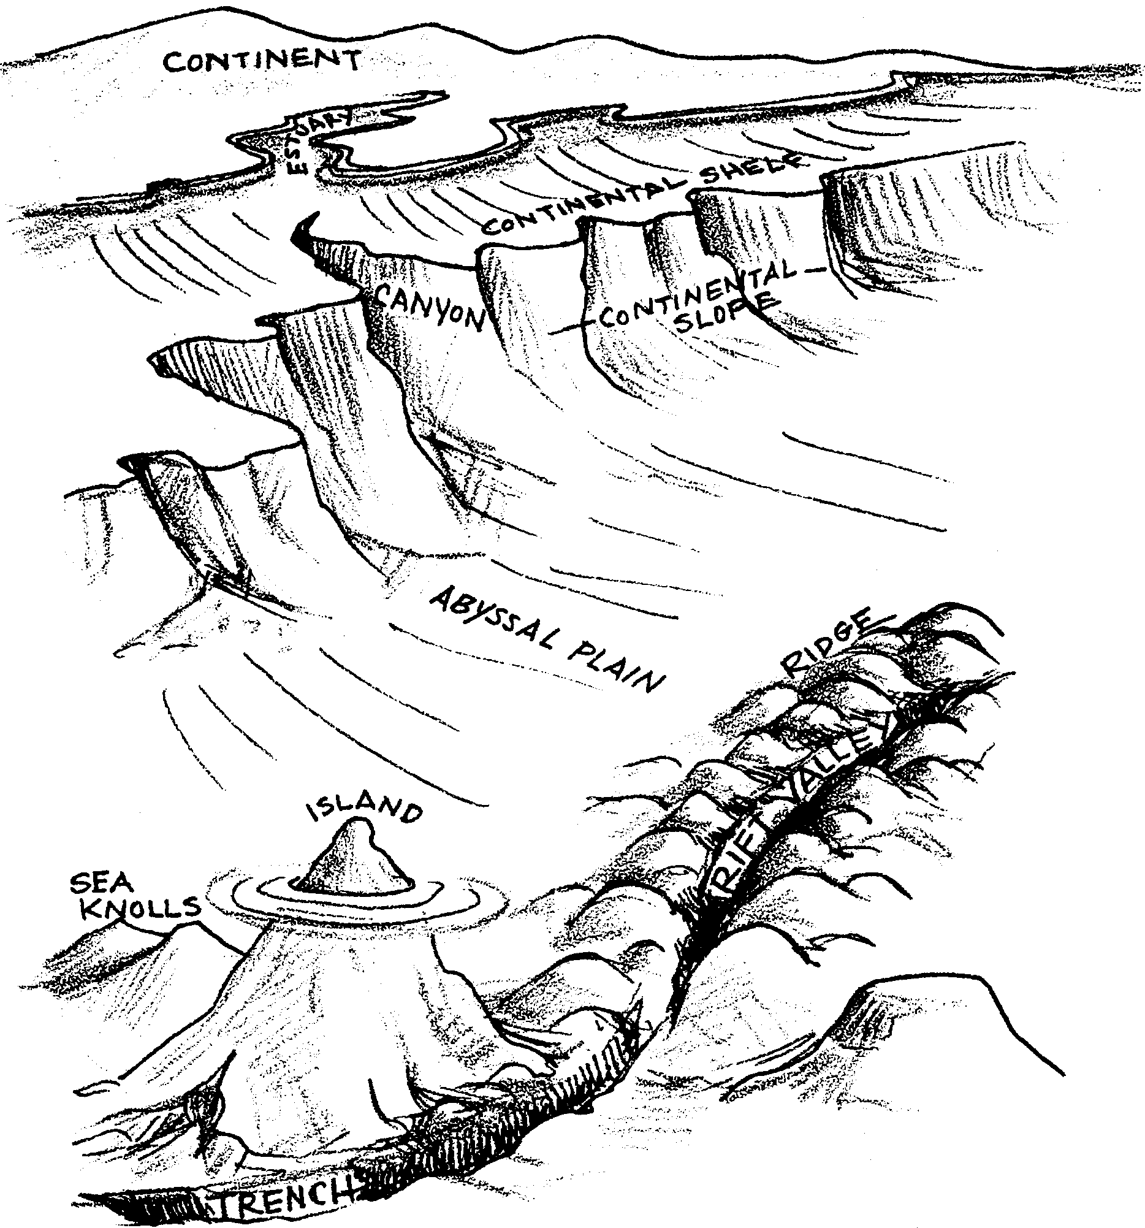
Procedure

Day 1

1. Work in pairs. Mix the 500 ml flour and 500 ml of salt.

2. Add the 250 ml of water to the dry mix of flour and salt. Mix well. The mixture should be like a stiff putty.

3. Use the plaster to build a model of the ocean floor in the shoe box. Use the ocean floor drawings as a guide. Keep the models simple. (For example, an ocean floor with a mountain or one that has a trench or continental shelf).
4. Put your names on the box.

5. Allow the plaster to dry.

Day 2

1. Again, work in pairs. Replace box top and seal with tape

2. Exchange boxes (preferably with another class!). DO NOT open your mini ocean. Remember oceanographers cannot see the bottom of the ocean. To get the feel of how an oceanographer works, it is better if you do not see the bottom. When you are all done you will have a chance to see the inside of the box. Record the name on your box. Use the same box each day.

3. Tape a piece of graph paper to your box. On one side label each line with a letter beginning with “a” (a, b, c, d, etc.).

4. Across the bottom, label with numbers beginning with “1” (1, 2, 3, etc.). See illustration below.

5. The grid will be used to locate sample sites on the box.

Each box should look something like this.
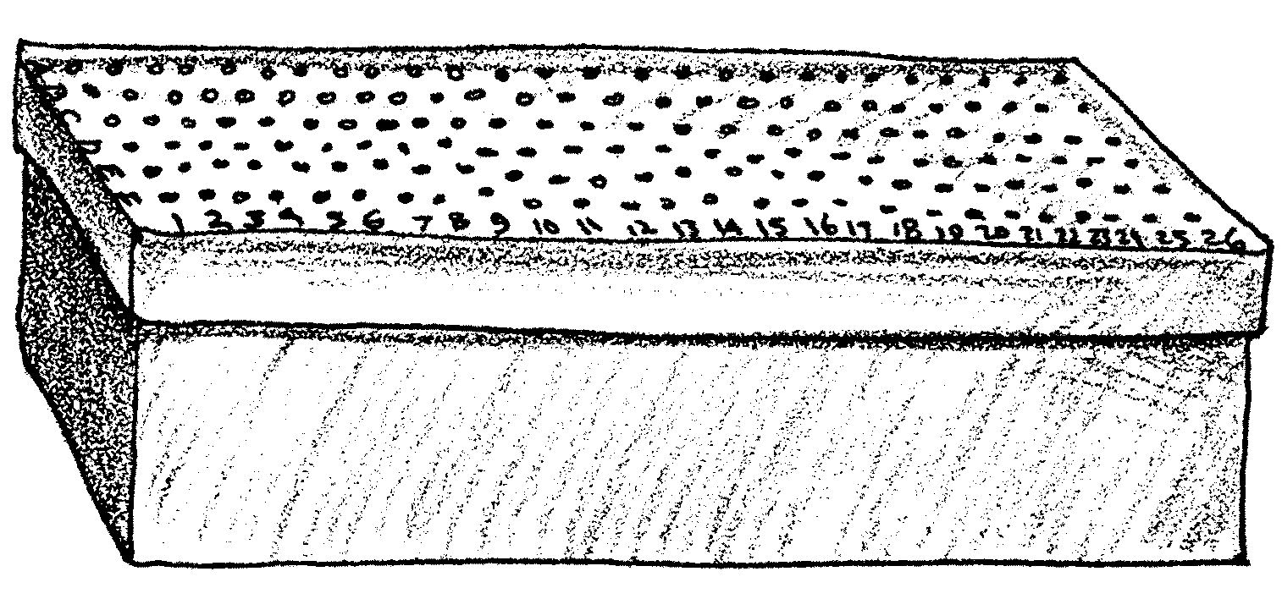

6. Where the lines intersect (cross), punch small holes (the size of the diameter of the soda straw) with a pencil, compass or scissors. These holes will be the sample sites. You can locate the sample sites by use of letters and numbers on the edges of the top. For example, sample site c-1, c-2, etc.

7. Use the ruler and felt tip pen to mark off the soda straw or skewer into 1 cm intervals.

8. Take depth readings (soundings) in the box. Insert the straw straight down until it touches the ocean floor. Record the depth reading directly at the site on your box lid.

9. Take as many depth readings as you think are necessary to determine the nature of the ocean floor.

10. After all depth readings have been recorded, draw a pencil line connecting all the depth readings that are the SAME. For example, connect all readings that are 5 cm, then connect all those that are 8 cm, etc. The lines should not have sharp angles and they SHOULD NEVER CROSS. These lines are called contour lines and show the features of the ocean floor.

Analysis and Interpretation

1. What features are present in your piece of ocean floor?

2. Could you have missed a feature? Explain.

3. What kind of features would be the easiest to miss?

4. a. The straw or skewer was used as a probe. How could you use a probe to find the shape of the real ocean floor?

b. What would be one disadvantage of using a probe to measure the real ocean floor?

5. What are two ways (other than a probe) to get information about the bottom of the ocean?

a.

b.

6. How could the probe be used to determine what the bottom was made of?

REMOVE THE TAPE AND OPEN YOUR BOX

7. How does your map compare with what is really present?

a. In what ways is it similar?

b. In what ways is it different?

8. Other than opening the box, what is one way you could get a better picture of the bottom?

9. The techniques you used are essentially the same as those used by early navigators to chart the depths of the ocean. Do you think they obtained a completely accurate picture of the ocean floor using these methods? Please explain your answer.

