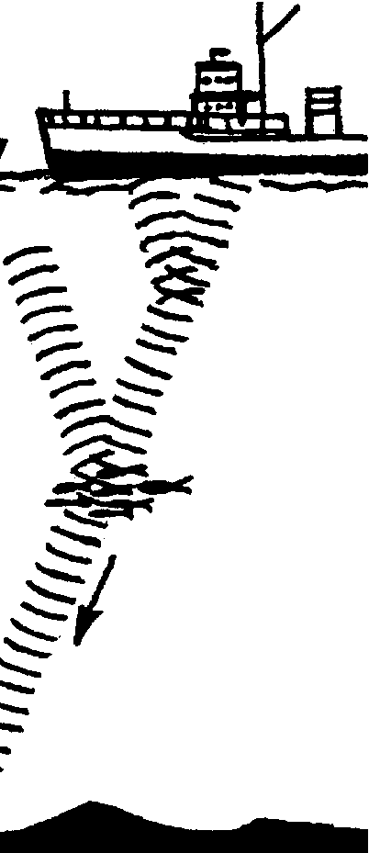
What's That Sound?

Key Concepts
1. It is possible to know what something looks like without seeing it.
2. Oceanographers use echo sounding, or sonar, to determine the bottom contours of the ocean floor.
3. Land forms on the sea floor are similar to land forms on the continents.
4. Many factors affect the accuracy of scientific investigations.

Background

For centuries people have sailed the surface of the oceans. Sailors wondered about the shape of the bottom of the ocean. For most of our history, they could do little more than wonder. Within the last century, oceanographers have begun to reveal the shape of the ocean floor by measuring the depth of the ocean in many places. Early tools included lead weights, lowered on marked ropes or cables to the ocean floor to measure or “sound” the depth of water. From such depth readings, scientists gradually built a picture of the ocean floor they could not see. These methods were very slow.

Today, scientists use a technique called echo-sounding to determine the depth of the ocean. Originally developed for submarines and submarine warfare, echo-sounding and sonar equipment became more widely available to oceanographers after World War II. Echo sounders bounce sound off of the bottom of the ocean. We know how fast sound travels in water, so depth can be determined by measuring the time it takes for the sound to go from the boat to the bottom and back to the boat.

Sound travels faster in water than it does in air. In water sound travels at an average speed of 5,000 feet per second (about 1,460 meters/sec.) We can use this information to determine the depth when we know the time it takes for a sound wave to travel to the bottom and back to the ship.

Depth = time down and back x 1460 mi/sec. (speed of sound in water)
2

(It is necessary to divide by 2 to obtain a “one way” distance or depth.)
While early echo-sounding and sonar devices were a vast improvement over mechanical sounding with a lead line, they produced but a single beam of sound which could be used to trace a single depth profile line across the bottom. Recently, multi-beam sonars have been developed which trace a swath across the bottom. These devices have truly revolutionized bathymetric mapping (the charting of bottom features). Multi-beam sonars have permitted us to make continuous recordings of depth and thereby map the bottom with considerable ease and accuracy.

Today, sophisticated side-scan sonar and satellite data are fed into computers that are giving us the most detailed pictures of the ocean floor ever obtained. All of the methods allow us to “see” the bottom of the ocean.

Materials

For each student:

• “What’s That Sound?” activity pages

• calculator (optional)

Teaching Hints

“What’s That Sound” examines echo sounding, a technique used to determine the bottom contours of the ocean. In this activity, your students will gain practice in plotting data points on a graph.

Note that very good model or sketch of the ocean floor shows all features as both taller and steeper than they actually are. This occurs for a very practical reason. If the model or sketch were prepared to exact scale, it would need to be very large. Vertical exaggeration is the price we pay to get the model down to a workable size.

Key Words

echo sounder - device used to detect ocean features by measuring the time required for a sound wave to travel from the device to the feature and back (echolocation)

sonar - a method for detecting and locating objects submerged in water by echolocation; also the device used in sonar

sonar ping - the sound wave emitted by an echo sounder

sounding - measuring water depth

Answer Key

Station No. Time down & back (sec.) Depth (feet)
1 .......................................... 3.0 ..................................... 7,500
2 .......................................... 2.5 ..................................... 6,250
3 .......................................... 1.5 ..................................... 3,750
4 .......................................... 2.8 ..................................... 7,000
5 .......................................... 2.7 ..................................... 6,750
6 .......................................... 4.0 ................................... 10,000
7 .......................................... 3.1 ..................................... 7,750
8 .......................................... 3.3 ..................................... 8,250

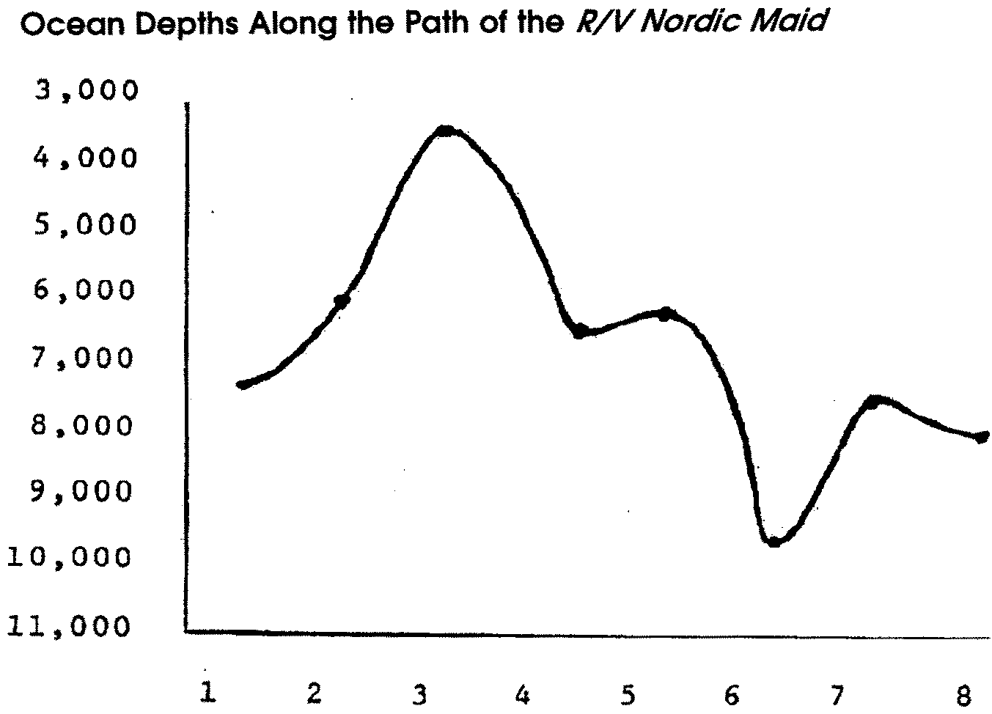
Analysis and Interpretation

1. Students usually call the feature an undersea mountain. The term seamount is introduced in subsequent activities.

2. Students usually call the feature an undersea valley. The term ocean trench is introduced in subsequent activities.

3. The false bottom can be used to locate schools of fish.

4. Fishers maintain echo sounders to help locate fish, keep gear from fouling on bottom, keep boat from running aground etc.

What's That Sound?
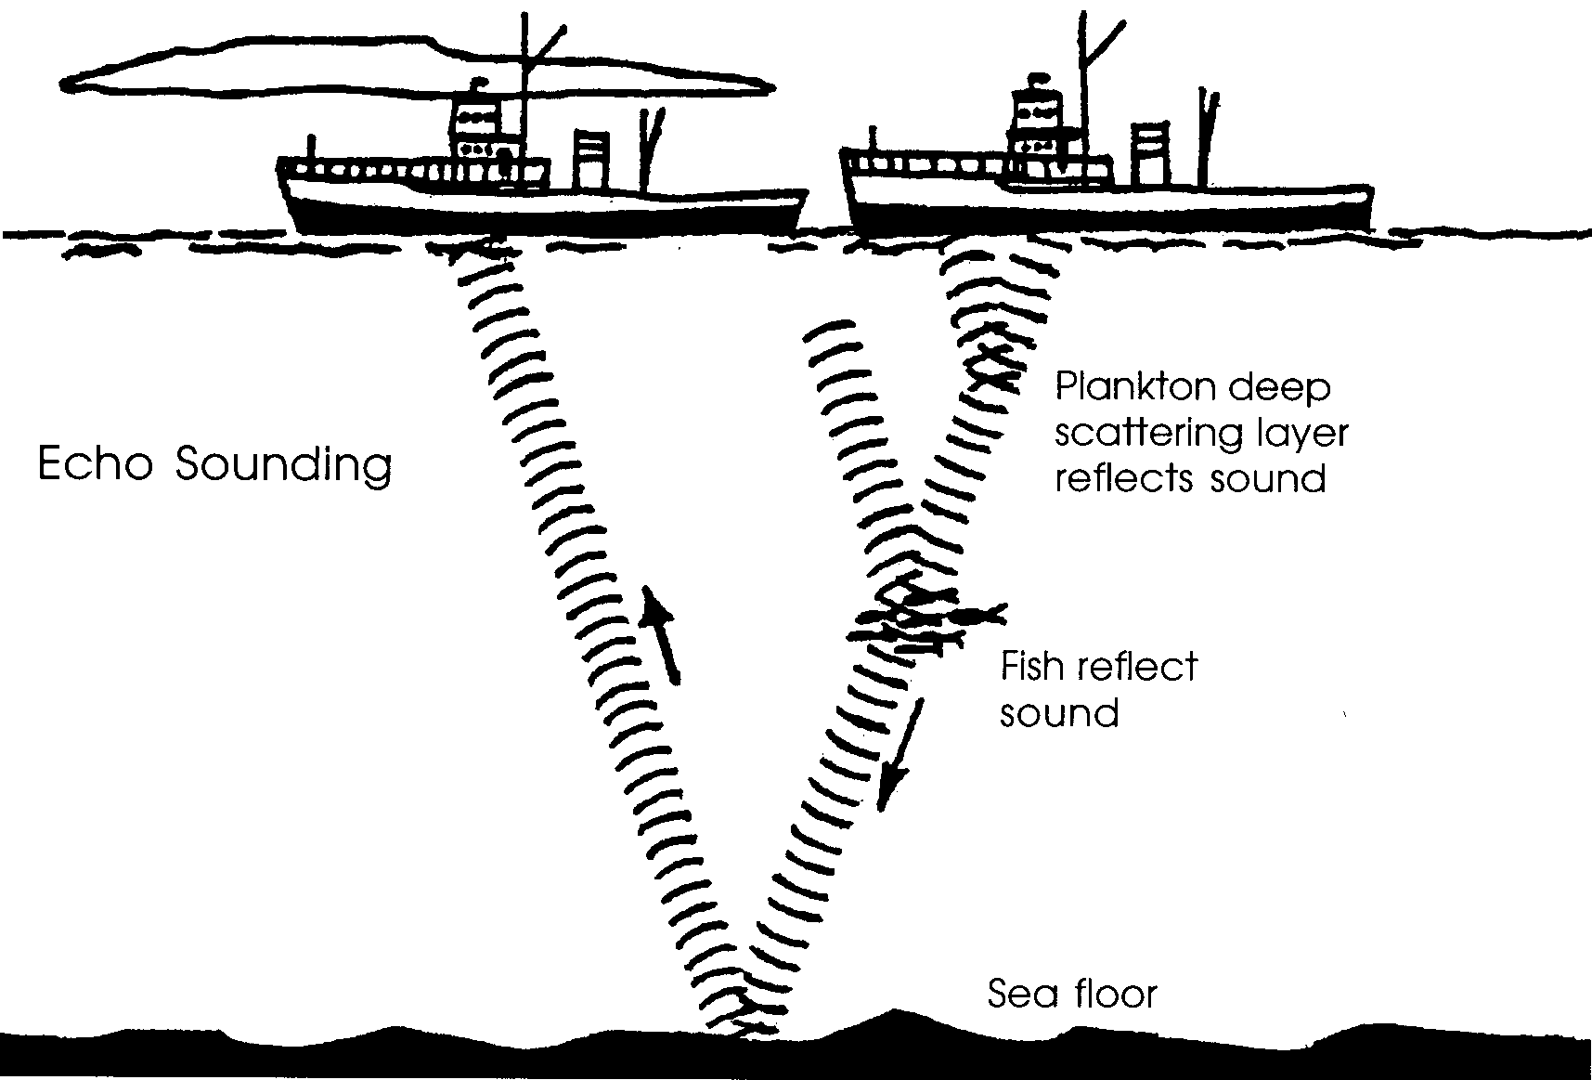

Sounding the ocean depths means measuring how deep the water is at a given point. For years the standard method for sounding involved letting a marked line with a weight on the end over the side of the boat. The depth was recorded when the weight hit the bottom.

Today echo sounders are used to determine depth. Echo sounders bounce sound off of the bottom of the ocean. We know how fast sound travels in water. We can determine the depth by knowing how long it takes for sound to go from the boat to the bottom and back to the boat. Sound travels faster in water than it does in air. In water sound travels at the rate of 5,000 feet per second. This speed can also be written as 1,460 meters per second. (5,000 ft./sec. = 1,460 m./ sec.)

In the picture above the “sonar ping” or sound wave is traveling from the ship to the bottom and back to the ship. The sound wave is traveling at the rate of 5,000 ft./sec. The water is 250 ft. deep. The sound wave travels 250 ft. down and 250 ft. back for a total of 500 ft. The sonar ping takes 1/10 of a second to travel this distance. Here’s how to figure the time:

Time = depth = (total distance down and back)
speed 5000 ft. / sec.

OR

Time = depth = (500 ft.) = 1/10 second
speed 5000 ft./sec.
Usually we know the time and want to find out the depth. Here’s the same relationship in a different form:

Depth = time down and back x 5000 ft./sec.
2

(we divide by 2 to obtain a “one-way” depth or distance)

Let’s look at some sounding data. The R/V Nordic Maid is cruising due north mapping the ocean bottom. Eight stations have been sampled. The time it took for a sound wave to travel from the boat to the bottom and back to the boat is given for each station.

Use this data to determine the depth of the ocean along the route of the R/V Nordic Maid.
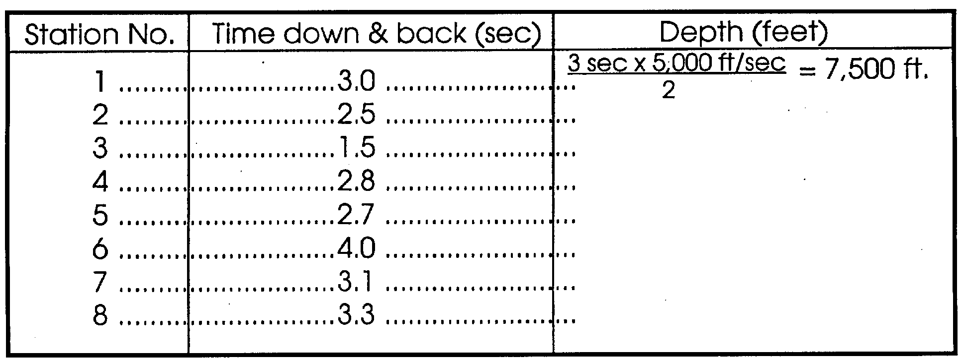
Now you have some figures for depths. Let’s plot these figures to see what a profile of the bottom would look like. The bottom of the graph on the next page shows the station numbers. The left hand side of the graph gives the ocean depth.

Here’s how to graph the data. First, find the station number you wish to plot. Then move up the graph directly above the station number until you reach the depth determined for that station. For example, station 1 was 7,500 feet deep. Look at the graph. See that the dot above station 1 is at the level of the 7,500 foot depth.

Now, plot the depths at stations 2 to 8. After you have plotted the depths connect the points (dots) with a smooth pencil line. This line reflects the shape of the ocean bottom along the path of the R/V Nordic Maid.

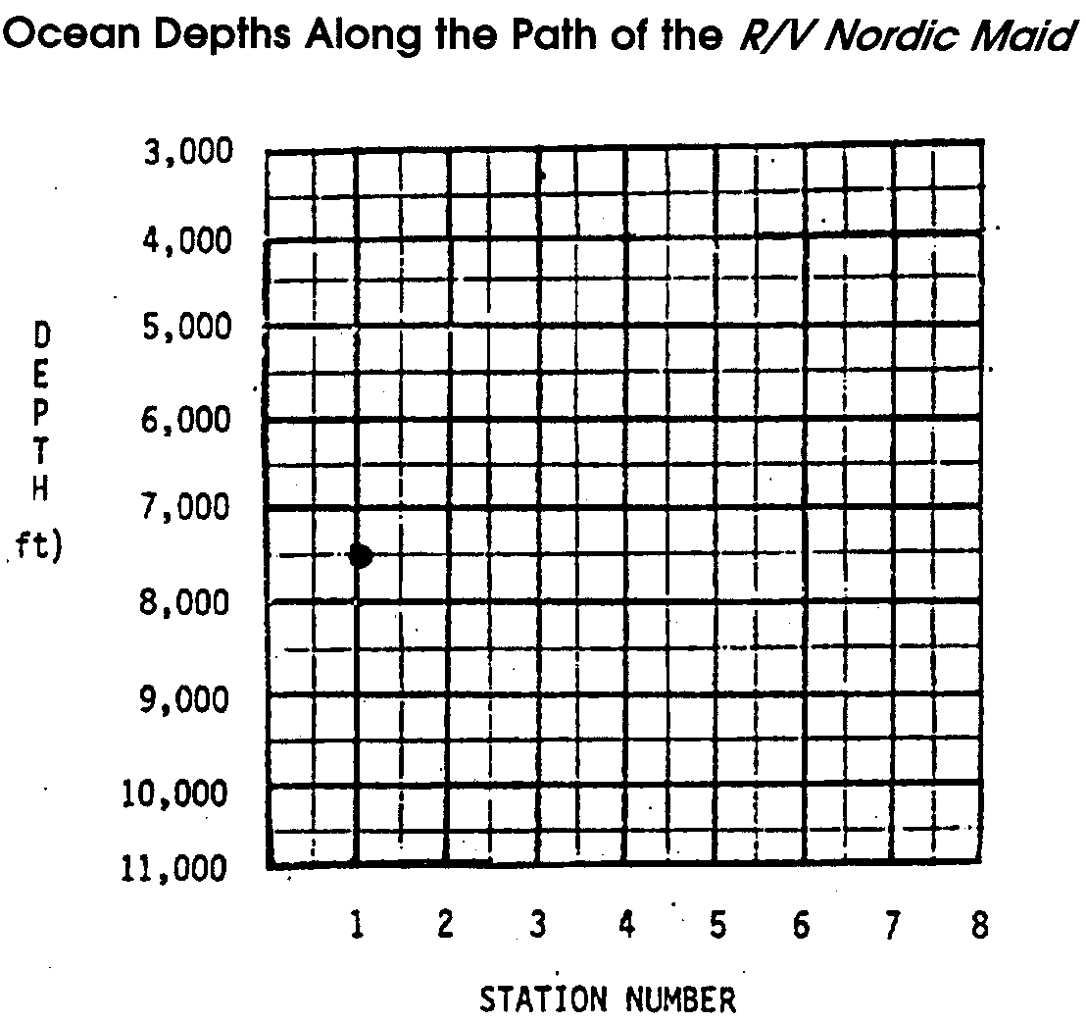

Analysis and Interpretation

1. What might you call the ocean feature seen at station 3?

2. What might you call the ocean feature seen at station 6?

3. If a school of fish is present under the R/V Nordic Maid, the echo sounder will show a “false bottom” where the school of fish is located. How might these “false bottoms” be of use to fishers?

4. What are two reasons many fishers have echo sounding equipment on board their boats?

a.

b.

