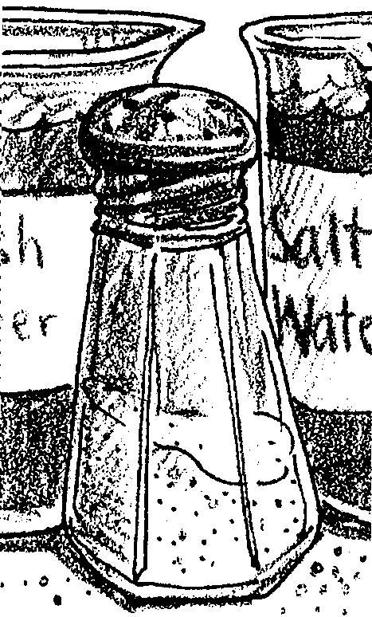
Salty Dog

Key Concepts
1. When seawater evaporates, the dissolved salts remain behind.
2. It is possible to calculate the percentage of salt present in a given sample of seawater.

Background

In the world oceans, about 3.5% of the weight of seawater is due to dissolved salt. In other words, in a typical 1000g of seawater, 35g is dissolved salt. Salinity varies somewhat at different places in the ocean with evaporation and rainfall influencing the salinity of surface waters.

The original sources of the salts in the ocean are both the crust and the interior of the earth. Chemical weathering of crustal rock, such as granite, provides positively-charged ions (i.e. sodium) in river runoff. Negatively charged ions (such as chloride) are present in the earth’s interior. Volcanic eruption release the negative ions into the atmosphere where they are dissolved in rainwater and carried to the sea. Vents release the negative ions directly into the sea.

Is the sea becoming more salty? Not particularly. There is a salt balance in seawater because salt is removed in a number of ways. Sea spray deposits a salt film along the shore. This salt is later returned to the sea by runoff from the land. Biological activity in the ocean concentrates salts in the bodies of organisms. These salts are removed if the organisms are harvested. Shallow arms of the sea have been isolated and evaporated over time. The salts remain behind as land deposits. Many fine particles are also trapped in sediments and are no longer available to the seawater until geologic processes “recycle” them.

Materials

For each group of 3 or 4:

• beaker (150 or 250 ml)

• thermometer

• sea water

• beaker tongs

• heat resistant tray

• balance and weights

• graduated cylinder

• hot plate

• stopwatch or timer

Teaching Hints

“Salty Dog” is a quantitative look at sea water in which students determine just how much salt is in a given sample of sea water. This investigation provides an opportunity for careful measurement.

This activity is material intensive. If you do not have access to sufficient equipment, consider doing this investigation as a demonstration. While a demonstration is less preferable than student inquiry, it will still provide your students with a concrete experience concerning the salts dissolved in sea water. If you do choose the demonstration route, demonstrate without providing all of the answers. Provide the data and let the students work out the solutions to the questions you pose.

Balances and weights or scales capable of weighing 50 grams accurately are required.

If you are not close to a source of sea water, you can make your own for this experiment, dissolve 32 grams of table salt (sodium chloride) in one liter (1000 ml) of tap water. If you find that the solution is cloudy, you can let it stand and the cloudy precipitate will settle. The precipitate is usually aluminum silicate, a material that keeps the salt from caking. (While making us shiny inside?)

Note the “CAUTION” included in the student pages: Do not let the beakers boil dry on the hot plate. They will crack even though they are heat resistant Pyrex glass. Have the students reduce the temperature as they near total evaporation. It is also helpful at this point to slightly tilt the beaker to reduce the spattering of salt.

Key Words

evaporate - remove the water from

salinity - concentration of dissolved salt in water, usually measured as concentration of sodium chloride

Answer Key

Procedure:

1.-9. Answers in the experimental procedure section will depend upon results.

Analysis and Interpretation

1. Answers depend upon results. The samples should fall within the range.

2. Results will most likely differ. Differences may come from errors in weighing, errors in measuring, errors in recording, etc.

3. Salt enters the sea from fresh water rivers. The salt is in very low concentration in the fresh water. As water evaporates from the surface of the ocean, the salts are left behind maintaining or increasing the concentration of salts or salinity of the ocean. (REFER TO TEACHER BACKGROUND)

4. Salinity can change from place to place in the ocean due to evaporation which increases salinity, and rainfall and river runoff which decrease salinity.

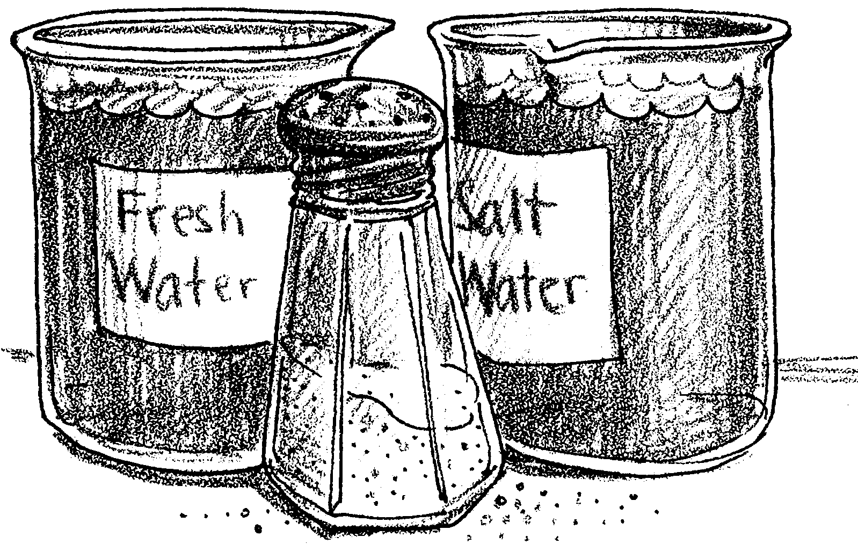
Salty Dog

Most of us know that when we compare sea water with fresh water it tastes salty. But just how salty is sea water and what are some ways in which salt makes sea water different from fresh water?

Materials
• beaker (150 or 250 ml)
• thermometer
• sea water
• beaker tongs
• tray - heat resistant
• balance and weights
• graduated cylinder
• hot plate
• stopwatch or timer
• safety goggles

In this activity, you will weigh and measure 50 ml of sea water using the above mentioned equipment. Then evaporate the water and calculate the per cent of salt as well as the salinity of the sample.

Procedure:

1. Weigh empty beaker using balance: grams.

2. Measure 50 ml sea water using a graduated cylinder, then pour into the beaker.

3. Weigh beaker with the sea water in it.

4. To determine weight of water, subtract #1 from #3.
Beaker with sea water (#3) grams
Subtract beaker empty (#1) grams

Weight of water (#4) = grams

5. Place beaker on hot plate and evaporate all the water. As the water is being evaporated, record the temperature every 2 minutes.

NOTE: Record the time and temperature at which the sea water begins to boil. CAUTION: Don’t let the beaker boil completely dry as beaker will crack. Be sure to wear safety goggles.

Starting Temp. 10 min. 20 min.
2 min. 12 min. 22 min.
4 min. 14 min. 24 min.
6 min. 16 min.
8 min. 18 min.

Boiling Temperature:

Remove beaker from hot plate and place on tray.

6. Weigh beaker with dry salt residue left in it.

7. To find the weight of salt, subtract #1 from #6.

Beaker with dry salt (#6): grams
Subtract empty beaker (#)1: grams

Weight of Salt (#7): grams
8. The percent of salt is found by dividing the weight of residue by the weight of sea water used then multiplying by 100.

Weight of (#7) grams = grams x 100 = %
Weight of (#4) grams

9. The salinity of ocean water is commonly expressed as so many parts of salt material per 1000 parts of water. We use the symbol ‰ to express parts per thousand. To determine parts per thousand multiply the per cent of salt by 10.

Percent of salt x 10 = ‰

Analysis and Interpretation

1. The salinity of sea water usually ranges from 25 parts per thousand to 34 parts per thousand. Does your sample fall in that range?

2. Compare the salinity of sea water that you obtained with the results of other groups. Do they differ? If so, what might have caused the differences?

3. How does salt get into the sea?

4. What might cause salinity changes from place to place in the ocean?

