Cold As Ice
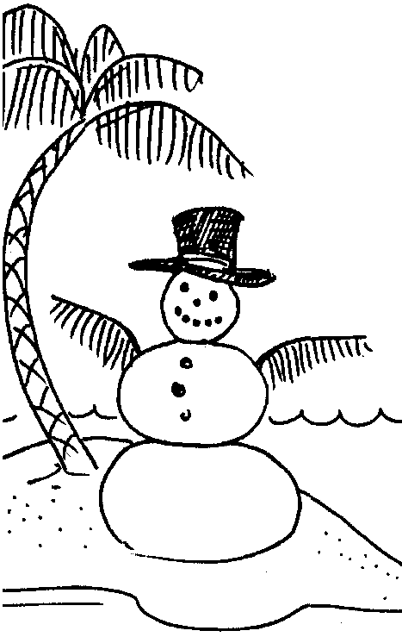

Key Concepts
1. Salinity level affects the time it takes water to freeze: saltier water freezes more slowly than fresh water.
2. As salt water freezes, the salt is squeezed out of the ice crystal, therefore, ice is fresh water.
3. Ice is less dense than liquid water, so it floats (See the preceding activity entitled “Ocean Currents” for hints on teaching density.)

Background

Water is a truly amazing solvent, able to retain large amounts of salts and other materials in solution. The salt dissolved in water depresses the freezing temperature of the water. Very salty water may not freeze in an ordinary kitchen freezer, because the temperature is not cold enough. The freezing point of water (0° C) refers to FRESH water; salt water freezes at less than 0° C. Typical seawater freezes at -2 or -3° C. As ice forms in salt water, there is no room in the crystal for salt. The salt is squeezed out of the ice structure and the resulting ice is “fresh”.

In the polar regions where seawater freezes to form sea ice, the ice is not salty. Sea ice, which is different from icebergs, looks like flat ice “plates” floating at the surface in polar seas. Icebergs, on the other hand, are formed on land. Most icebergs are pieces of glaciers which have broken off and floated away as the glaciers reached the edge of the sea. They are jagged chunks of ice that can take many shapes. Icebergs are fresh water, and so are glaciers.

Materials

For each group of 3-4 students:

• table salt, 18 tablespoons

• tap water, 4 cups

• tablespoon measure

• plastic ice cube tray with divided, water-tight sections

• small (400 ml) jars or beakers, 4

• waterproof labels or grease pencil
Teaching Hints

In “Cold As Ice?”, your students will observe the freezing times of waters with varying levels of salinity. They will also investigate the resulting ice to determine whether the ice is “fresh” or “salt” ice.

If limited freezer space is available, this activity may be performed as a demonstration. Freezer space can usually be borrowed from the kitchen crew in exchange for a smile and a kind word. Should you be unsuccessful, consider asking the students to perform this experiment at home.

Key Words

compound - combination of chemical elements

H2O - the chemical symbol for water representing: 2 atoms of Hydrogen, 1 atom of Oxygen.

icebergs - chunks of land ice, usually of glacial origin, that have broken off and floated to sea

properties - characteristics of a given substance

sea ice - flat “plate” ice formed when seawater freezes

Answer Key

1. Depends upon the experimental results. Usually, solution 4 freezes first. The highest salt concentration, solution 1, does not completely freeze.

2. Answers depend upon the experimental results. Usually solution 1 fails to freeze.

3. Answers depend upon the experimental results. Usually solution 4 is the first to freeze.

4. A generalization might be: The higher the salinity, the longer it takes to freeze. Actually, we see that the higher the salinity the lower the freezing point.

5. Icebergs are fresh water. Solutions 2 and 3 which show partial freezing show the fresh water portion leaving as ice.

6. a. Yes, the water at the surface will freeze.

b. The process will continue until the water is ice from top to bottom.

7. No, they would run into the ice mass.

8. a. The lakes and ponds would freeze solid from bottom to top.

b. The ice would be as thick as the lake is deep.

c. The fish would be caught in the ice and freeze to death.

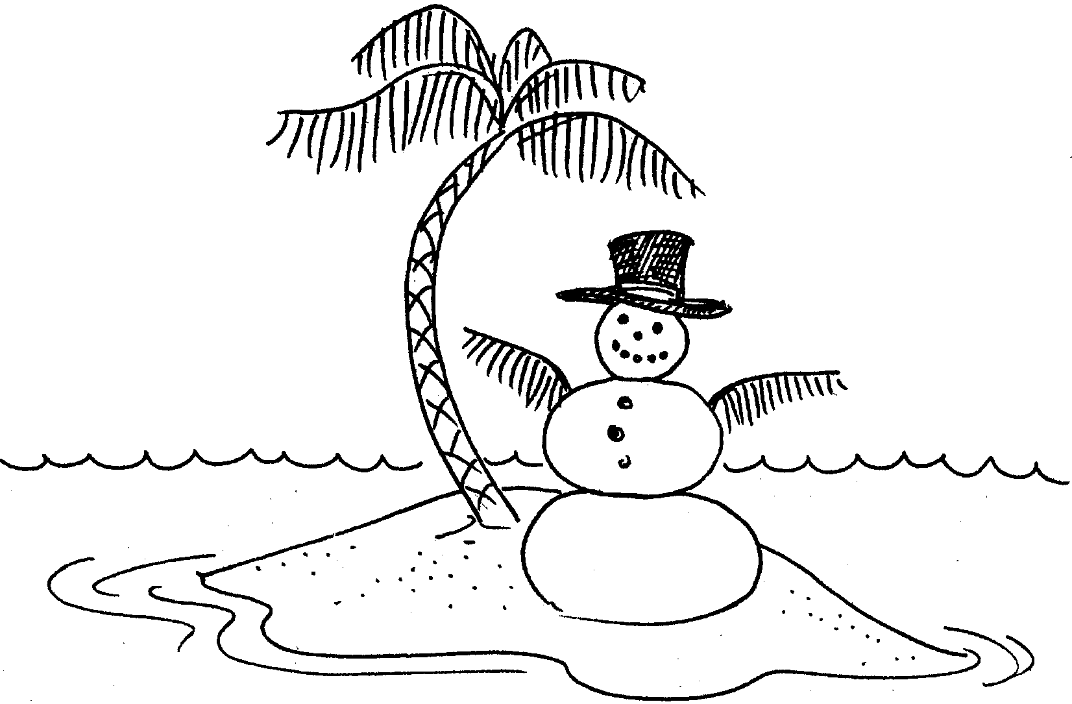
Cold As Ice

We know that water freezes at 0°C (32°F) or does it? Ice and water are the same chemical compound (H2O). Yet, we know they look and behave differently. This activity will give you a chance to learn something about the properties of ice and water.

Materials
• table salt, 18 tablespoons
• tap water, 4 cups
• tablespoon measure
• plastic ice cube tray with divided, water-tight sections
• small(400 ml) jars or beakers, 4
• waterproof labels or grease pencil

Procedure:

1. In separate containers, mix four solutions as follows:
Solution No. 1: mix 9 level tablespoons salt with 1 cup tap water.
Solution No. 2: mix 6 level tablespoons salt with 1 cup tap water.
Solution No. 3: mix 3 level tablespoons salt with 1 cup tap water
Solution No. 4: Pure tap water, 1 cup.

2. Label one-fourth of the sections of the ice tray (how many is that? Hint: multiply the number of sections by .25) with number 1, one-fourth with number two, and so on.

3. Pour solution No. 1 into the sections of the ice cube tray marked with No. 1.

4. Pour solution No. 2 into the sections of the ice cube tray marked with No. 2 and so on. (Make sure the water in each section does not mix with that in other sections.)

5. Place the tray in a freezer.

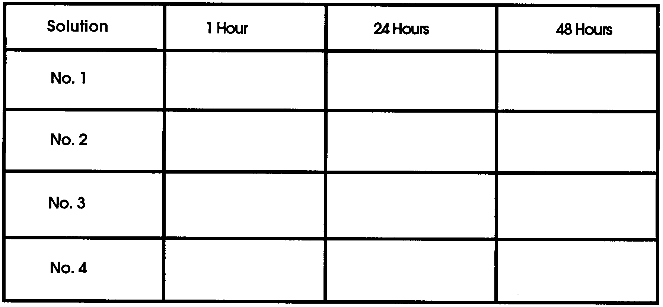
6. Observe and record conditions after 1 hour, 24 hours and 48 hours.

Analysis and Interpretation

1. List the results you obtained for each of the four solutions:

Solution No. 1

Solution No. 2

Solution No. 3

Solution No. 4

2. Did any solution fail to freeze? If yes, which one?

3. Which solution was first to freeze?

4. State a generalization ( a statement that covers many situations) that describes what happens to the speed at which water freezes as the salinity changes.

5. From your experimental results, are icebergs salt or fresh water?

(Hint: you might taste the ice from the fresh water and compare it with the ice from the salt water sample.)

Explain how you reached your conclusion.

Most materials get more dense (“heavier”) as they change from a liquid to a solid. Water is unusual in that it is most dense at about 4°C. If it was most dense as a solid, ice would sink.

6. Let’s imagine that you’re captain of the Polar Star, an ice breaker, on duty in the Arctic Ocean. The temperature drops to below zero and the water begins to freeze on the surface. But instead of floating, the ice sinks!

a. Will the water now at the surface freeze if the temperature remains the same?

b. How long will this process continue if the ice continues to sink?

7. If ice sank, would nuclear submarines be able to sail under the frozen north pole? Explain.

8. a. What would happen to lakes and ponds that freeze in the winter if ice sank?

b. How thick would the ice be?

c. What would happen to the fish in the lake?

