Hydrometer Connection
Edited by Michael Stevenson, Salinas, CA

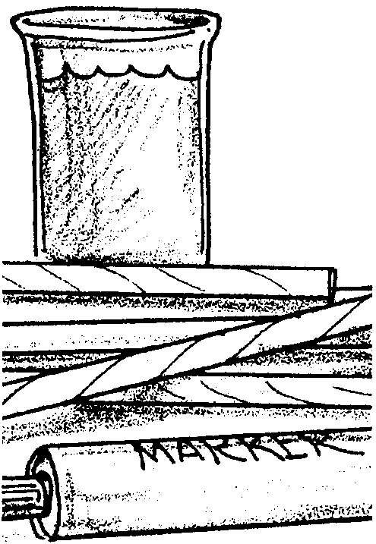
Key Concepts
1. Oceanographers measure the water’s salt content, or salinity, in grams of salt per kilogram of sea water (g/kg) which is usually expressed as parts per thousand (‰).
2. Average ocean salinity is approximately 35 ‰.
3. A hydrometer is a tool used to determine salinity of a water sample.

Background

Salinity (“saltiness”) influences all life in the sea. It is one of the factors which determines where animals and plants live in an aquatic habitat. Each organism has its own range of tolerance. Aquatic animals must maintain a constant salt concentration in their bodies. Fresh water fish have special adaptations allowing them to retain salts and excrete water so that the fresh water does not dilute their body fluids. Marine fish, on the other hand, excrete salts while retaining water so that they do not lose fluids to the salt water around them. It is important, then to maintain salinities in aquariums appropriate for the organisms. Most marine fish cannot tolerate sudden changes in salinity.

Perhaps you have been swimming in the ocean and observed that in one spot the water tasted really salty while in another, it tasted not so salty, in fact almost fresh. No, it wasn’t an illusion. Salinities near shore vary due to the addition of fresh water by rivers and rainfall. Local conditions of temperature and water circulation may also increase or decrease salinity. On a large scale, salinities also vary. Notice the variation of salinity in these bodies of water:

Red Sea = 40 ‰
Mediterranean Sea = 38 ‰
“Average” sea water = 35 ‰
Black Sea = 18 ‰
Baltic Sea = 8 ‰

Interestingly, the salinity of the open ocean is amazingly constant. In order to locate and study the effects different salinities have on ocean environments, marine scientists use an instrument called a hydrometer. What is a hydrometer and how does it work?
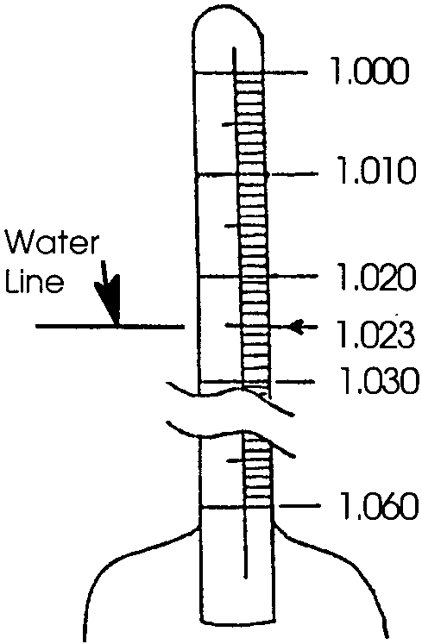
A hydrometer is basically a weighted, glass cylinder. The cylinder has a thin glass tube at the top with a scale. Just like the floating egg, the saltier the water, the higher the hydrometer floats. The higher the hydrometer floats, the higher the reading on the hydrometer scale.

Technically, a hydrometer measures the specific gravity of a liquid. Specific gravity is the ratio of the density of a substance relative to the density of pure water at 4° Celsius. The specific gravity of pure fresh
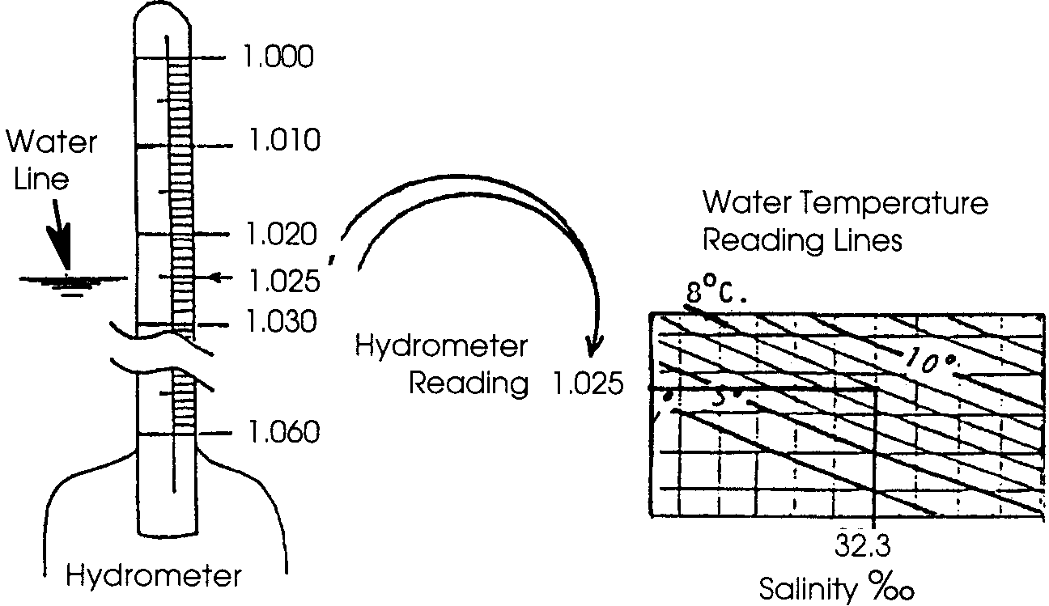
water at 4° Celsius is 1.000. This provides the standard. As something (like salt) is added to pure water, the density of the water increases and the hydrometer reads above 1.000. The terms, density and specific gravity, are usually used interchangeably. Density which equals the mass per unit volume is expressed in grams/cubic centimeter (cc3 or cm3) or grams/milliliter (g/ml). Since temperature, as well as salinity, affects the density of a water sample, the reading on the hydrometer must be corrected for temperature in order to ascertain the density due only to salt content. A correction graph is used for this purpose. To use the graph, one must know the temperature of the water in degrees Celsius and the hydrometer density reading. The procedure used to reveal the salinity of the water sample in parts per thousand (‰) is outlined below:

Materials

Part I - Soda Straw Hydrometers

For each class:

• “real” hydrometer (one for demonstration or, if possible, one per group)

For each group:

• distilled water (one gallon)

• “Constructing a Soda Straw Hydrometer” activity sheets

• 100 ml graduated cylinder or similar container

• plasticine clay (oil based)

• permanent marking pen

• plastic soda straw

Part II - Using A Hydrometer to Determine Density

For each group:

• a “real” hydrometer, if available

• 100 ml graduated cylinder or similar container

• Celsius thermometer

• straw hydrometers from Part I

• 2 premixed water samples (one labeled “A”, representing a surface ocean sample; and one labeled “B”, representing a deep water, bottom sample)

• correction graph, which uses the temperature and hydrometer reading to find salinity in ‰

• “Using A Hydrometer to Determine Salinity” activity sheets

Teaching Hints

Through the construction of a simple hydrometer, “The Hydrometer Connection” introduces your students to an instrument commonly used to determine salinity of sea water samples.

Part I - Soda Straw Hydrometers

In this first activity, students construct a very simple hydrometer and discuss the use of the instrument.

While the concepts can all be taught with the soda straw hydrometer, it is recommended you have at least one hydrometer for students to observe and use. Hydrometers are available in aquarium shops for a reasonable sum. They can also usually be borrowed from high school chemistry or biology teachers. This is a good chance for some vertical integration in your curriculum!

Each group will need a clear container capable of floating the hydrometer. A 100 ml graduated cylinder, a clear plastic cylinder, or tall glass jar will work equally well. Just make certain the hydrometer can float in the volume of water contained.

A balance or scale accurate to a gram will be necessary to make the saline solutions. The use of distilled water guarantees a supply of “pure” fresh water. If your water supply has lots of dissolved minerals, you may need to use distilled water to assure that the salt dissolves properly. Note that in Part I, the amount of salt added to the student cylinders may have to be increased depending upon the size of the container. Determine the proper amounts to add by doing the activity before hand.

Make an “unknown” salt solution for Part I by adding three teaspoons of salt to a 100 ml sample of fresh water.

Procedure:

1. Begin the lesson by discussing personal experiences with bodies of water with differing salinities. Define salinity and discuss how the dissolved salts in sea water entered the oceans from rivers and streams in tiny quantities over long periods of time. Explain that while salinity in the oceans is remarkably constant, some areas such as tidepools show large variations. Note that these different salinities have effects on organisms living in the water. Ask students to identify some of the effects.

Explain that scientists use a tool called a hydrometer to monitor the salinity of a water sample.

2. Distribute the student worksheet, “Constructing a Soda Straw Hydrometer”, and the necessary materials to each group.

3. When students have completed the activity, discuss the calibrations on the soda straw. Students should observe that the hydrometer floats higher as the water gets saltier. Correspondingly, the numbers on the hydrometer scale increase as you move down from the top of the straw .

4. Show students a “real” hydrometer and ask them for observations on the scale on the hydrometer. They may notice:

a. the numbers increase as you move down the scale (just like the soda straw).

b. the top number is 1.000 (explain that pure fresh water at 4°C is arbitrarily assigned a density of 1.000).

5. If you have sufficient “real” hydrometers, have students put the hydrometer in fresh and salt water of varying salinities to confirm that it behaves in the same way as the soda straw hydrometer (the saltier the water, the higher in the water it floats). If your water supply has lots of dissolved minerals, you may need to use distilled water. If you are short on “real” hydrometers, do this as a demonstration .

Part II - Using A Hydrometer to Determine Salinity

In “Using A Hydrometer to Determine Salinity”, students use a hydrometer to test two samples of “sea water” and infer which sample represents water from a surface sample and which represents water from the bottom.

Ideally, you will obtain two water samples using a piece of oceanographic equipment called a Van Dorn water bottle. One sample should come from the surface and the second should come from the bottom. Recognizing that sampling in this fashion may not be possible, you can easily simulate these samples using table salt or Instant Ocean (available from pet stores for use in aquariums) in the following manner:

Top sample = 29 grams of table salt (sodium chloride) dissolved in one liter (1000 ml) of tap water.

Bottom sample = 33 grams of table salt (sodium chloride) dissolved in one liter (1000 ml) of tap water.

Procedure:

1. Begin the lesson by reviewing the conclusions drawn from the activity, “Ocean Currents”,( i.e. salt water is more dense than fresh water; cold water is more dense than warm water).

2. Note that students will be using two water samples (surface and bottom) in this investigation. Do not identify which sample is from the surface and which is from the bottom. Have them predict which sample will have the highest salinity.

3. Distribute the student worksheet, “Using Hydrometers to Determine Salinity”, and the necessary materials. Have students conduct the investigation in teams of two to four.

4. Discuss the results of the investigation when all have finished.

Key Words

density - mass per unit volume of a substance. More dense seawater tends to sink, less dense seawater tends to rise in the ocean.

hydrometer - instrument used to measure density or specific gravity of a liquid.

salinity - measure of the quantity of dissolved salts in seawater

Extensions

Part I - Soda Straw Hydrometers

1. Have students use their soda straw hydrometers to compare the behavior of the hydrometer in other liquids: rubbing alcohol, vinegar, mineral oil.

2. On your next field trip to the tide pools, take a hydrometer to test several “pool” sites between the upper and lower tide zones. Predict where the more saline samples will be found.

3. Visit an estuary and test water found near the mouth of a river versus a water sample from elsewhere in the estuary.

Part II - Using A Hydrometer to Determine Salinity

1. Have students calculate the average salinity for each of the salt solutions tested. Explain that scientists have found that they can obtain more accurate results if they repeat a procedure several times and take an average. Because of variability in technique and equipment, the average figure that they obtain is more likely to be correct than is any individual figure.

Calculate the average salinity for each of the salt solutions tested as shown in the following example for a surface sample,

sum of salinity estimates (for the surface sample) = average salinity estimate
number of salinity estimates (for surface sample) (for the surface sample)

Answer Key

Text Questions

Part I - Constructing A Soda Straw Hydrometer

10. Estimates will vary but should correspond to the number of teaspoons added to the unknown, (3 teaspoons per 100 ml was suggested in “Teaching Hints” section.

Part II - Using A Hydrometer to Determine Salinity

6. Results depend upon the salinity of the solutions used.

Analysis and Interpretation

1. Answers depend upon the results, usually the bottom sample will be more saline.

2. Answers depend upon the results, but both should fall within the given range.

3. Many things can help explain the range in salinities: fresh water inflows, rain water, evaporation, mixing, etc.

4. Lowest salinities would be found in areas with fresh water inflows, lots of rain, and low evaporation rates. Usually these conditions are more prevalent in the temperate zones.

5. Highest salinities would be found in areas with low fresh water inflow, low rainfall, and high evaporation rates. Usually these conditions are more prevalent in tropical areas.

Hydrometer Connection

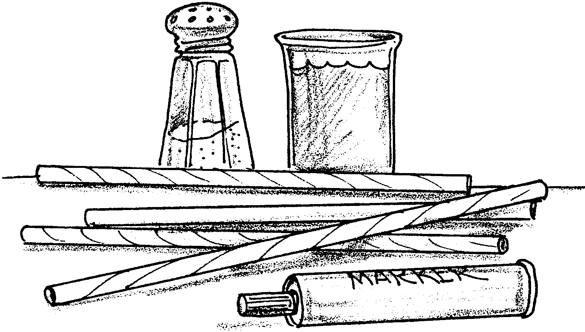

Part I - Constructing a Soda Straw Hydrometer

You may have observed that the saltier the water, the higher an object floats in it. Scientists use a weighted glass cylinder to determine salinity. This instrument is called a hydrometer (hi-dram-a-ter). In the following activity, you will make your own hydrometer and use it to measure salinity.

Materials
• plastic soda straw
• 100 ml graduated cylinder or similar container
• permanent marking pen
• plasticine clay
• salt
• spoon to measure water
• unknown salt solution

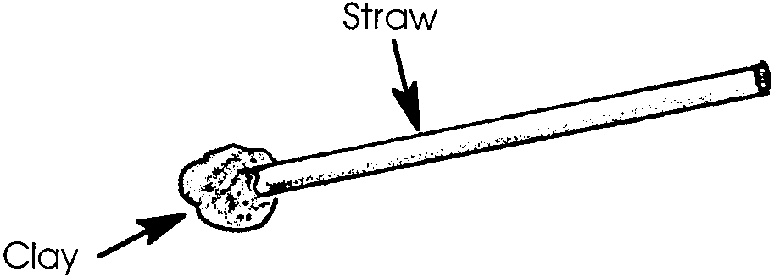
Procedure:

1. Press a small ball of plasticine clay into one end of a straw. The clay should act as a plug so water cannot get into the straw.

2. Add fresh water to your cylinder until the water is about 1" from the top.

3. Put the hydrometer in the fresh water. Remove or add clay until the hydrometer just rests on the bottom of the container.

4. Mark the water level on the straw with a permanent marker and label it zero (meaning no salt added).

5. Remove the hydrometer. Add 2 teaspoons of salt to the water. (NOTE: If this is not enough salt to raise the hydrometer from the bottom, add more salt but keep track of how many teaspoons you add). Dissolve all the salt in the water. Put the hydrometer into the water.

6. Use the marking pen to mark the water line. Label the line with the number of teaspoons of salt that you added.

7. Remove the hydrometer. Add the same number of teaspoons of salt to the water that you added in #5. Put the hydrometer into the water.

8. Mark the water line. Label the line with the total number of teaspoons of salt that you added.

9. Examine the calibrations on the straw. Write a statement about the scale created on the soda straw.

10. Use your hydrometer to test the unknown salt solution. Here’s how:

a. Put the hydrometer in the solution.

b. Mark the water line with a letter “U”.

c. Look at the “U” mark and your numbers indicating how many teaspoons of salt you added.

d. Estimate the number of teaspoons of salt that were dissolved in the unknown sample.

e. Write your estimate here: teaspoons of salt

The Hydrometer Connection

Part II - Using a Hydrometer to Determine Salinity

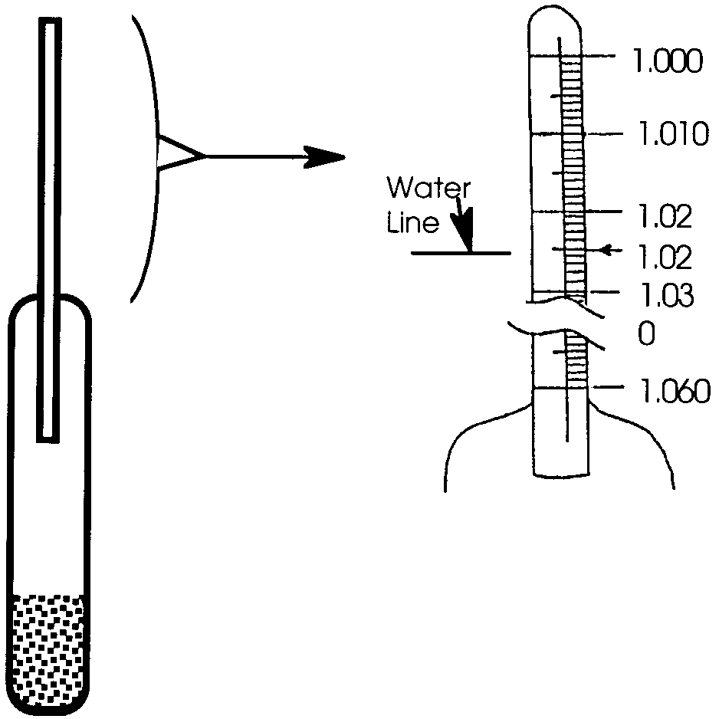
The hydrometer scientists use to determine salinity is a bit fancier than your straw hydrometer. The cylinder has a thin glass tube at the top with a scale printed inside (see diagram). The higher the salinity, the higher the tube floats and the larger the number that lines up with the water’s surface.

In the next activity, you will use a hydrometer to determine the salinity of two salt water samples. One sample comes from the ocean surface, the other from the bottom. Your results will let you infer which sample comes from the surface and which comes from the bottom.

1. Based on what you already know, predict which sample will be the saltiest. Circle your prediction: surface or bottom

Materials
• salt water solutions, “A” and “B”
• Celsius thermometer
• hydrometer
• 100 ml graduated cylinder or similar container
• correction graph - temperature/salinity

Procedure:

1. Fill the graduated cylinder with sea water sample “A”.
2. Record water temperature: degrees C.

3. Put the hydrometer in the sample. Use the diagram to help you read the measurement.
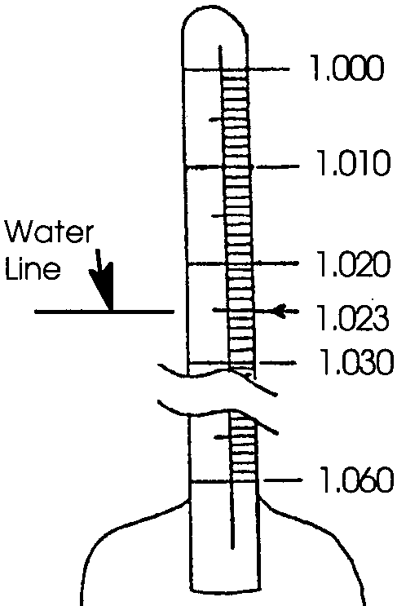

4. The hydrometer reading is .

Use the graph to determine salinity. Here’s how:

a. On the graph, find the diagonal line that matches your water temperature reading.

b. Find your hydrometer reading on the graph.

c. Follow hydrometer reading line over until you meet the correct temperature line.

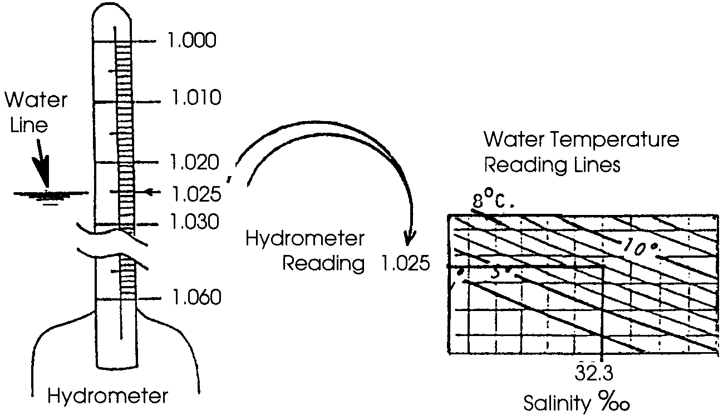
d. From this meeting point, move straight down and read the salinity of your sample in parts per thousand (‰).
5. Repeat the above procedure with water sample “B”.

6. a. The salinity for water sample A is .

b. The salinity for water sample B is .

7. Water sample A is the surface/bottom sample. (Circle one)

Water sample B is the surface/bottom sample. (Circle one)

Analysis and Interpretation

1. Which solution was the saltiest?

2. The salinity of sea water ranges from about 25 parts salt per thousand parts of water (25ppt) to about 34 parts per thousand. Did either or both solutions fall in this range? If yes, which one(s)?

3. What are two conditions that might help account for this range (from 25 ppt to 34 ppt) in ocean salinities rather than a single uniform salinity?

a.

b.

4. Where would you expect the lowest salinities to be found? Explain.

5. Where would you expect the highest salinities to be found? Explain.
